Supporting Information

Sustainable Regeneration of High-Purity Quartz Sand from Silica Waste via Purification System and Sol-gel Method.

Zehui Zhang^{a,b}, Dake Zhang^{a,b}, Guoqing Zhang^{a,b}, Kun Wang^{a,b,*}, Deren Yang^{a,b}, Xuegong Yu ^{a,b,*}

ª State Key Laboratory of Silicon and Advanced Semiconductor Materials & School of Materials Science and Engineering, Zhejiang University, Hangzhou 310027, PR China
^{b} Institute of Information and Functional Materials, ZJU-Hangzhou Global Scientific and Technological Innovation Center, Hangzhou 311215, PR China

*Corresponding authors.
E-mail addresses: msekunwang@zju.edu.cn, yuxuegong@zju.edu.cn

Supplementary Tables
Table S1 The metal-impurities content of the silica-based waste materials (unit: ppm).
Element | Content
Element | pyrogenic silica | quartz sand | quartz glass
Ni | 0.12 | 0.12 | 0.59
Fe | 5.77 | 5.77 | 3.86
Ge | 0.00 | 0.00 | 0.00
Cr | 0.28 | 0.28 | 0.43
Mg | 0.02 | 0.02 | 1.53
Mn | 0.07 | 0.07 | 0.78
Cu | 0.00 | 0.00 | 0.16
Ti | 0.27 | 0.27 | 4.07
Zr | 0.40 | 0.40 | 0.71
Ca | 0.00 | 0.00 | 11.61
Al | 305.63 | 305.63 | 16.80
Ba | 0.00 | 0.00 | 0.38
Na | 4.56 | 4.56 | 5.17
Li | 0.84 | 0.84 | 0.24
K | 1.26 | 1.26 | 1.58
Total | 319.22 | 319.22 | 47.92

Table S2 Composition test results of 8% sodium hydroxide used for dissolving silica fume. (unit: ppm)
Element | Content
Ni | 3.25
Fe | 5.51
Ge | 0.00
Cr | 0.87
Mg | 0.06
Mn | 0.00
Cu | 0.00
Ti | 2.46
Zr | 2.23
Ca | 2.35
Al | 4.01
Ba | 0.00
Na | 21795.67
Li | 0.03
K | 130.26
Total | 21947.69

Table S3 Composition test results of the gel obtained after the sodium silicate solution directly passing through 732 resin. (unit: ppm)
Element | Content
Ni | 0.082
Fe | 5.418
Ge | 0.647
Cr | 0.998
Mg | 4.738
Mn | 0.241
Cu | 0.111
Ti | 4.478
Zr | 5.868
Ca | 4.336
Al | 22.95
Ba | 0.076
Na | 162.253
Li | 0.016
K | 0.699
Total | 212.911

Table S4 The metal impurities content of the silica-based waste materials (unit: ppm).
Element | Content
C | 1.6
H | 3.2
N | 4.8

Supplementary Figures
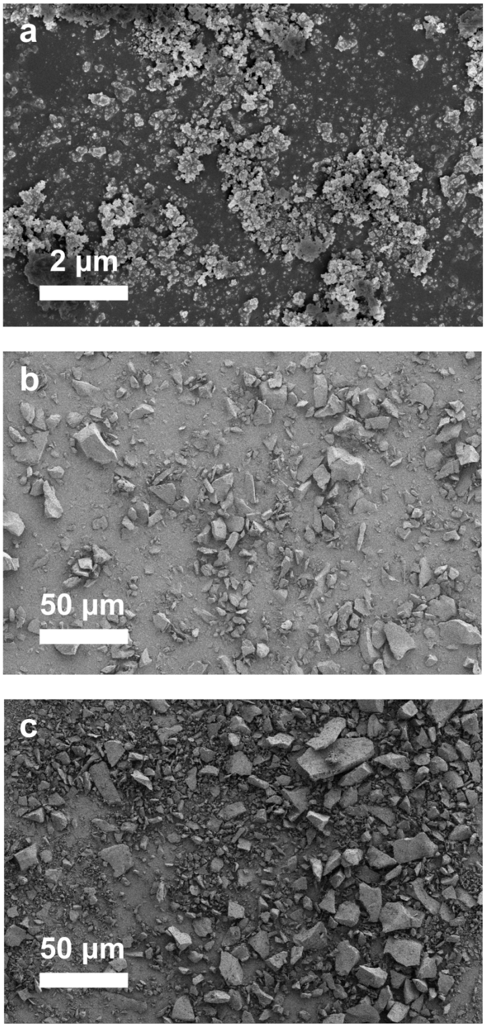
Figure S1. The micro-morphology of the silica waste materials: (a) silica fume, (b) natural quartz sand, (c) quartz products.

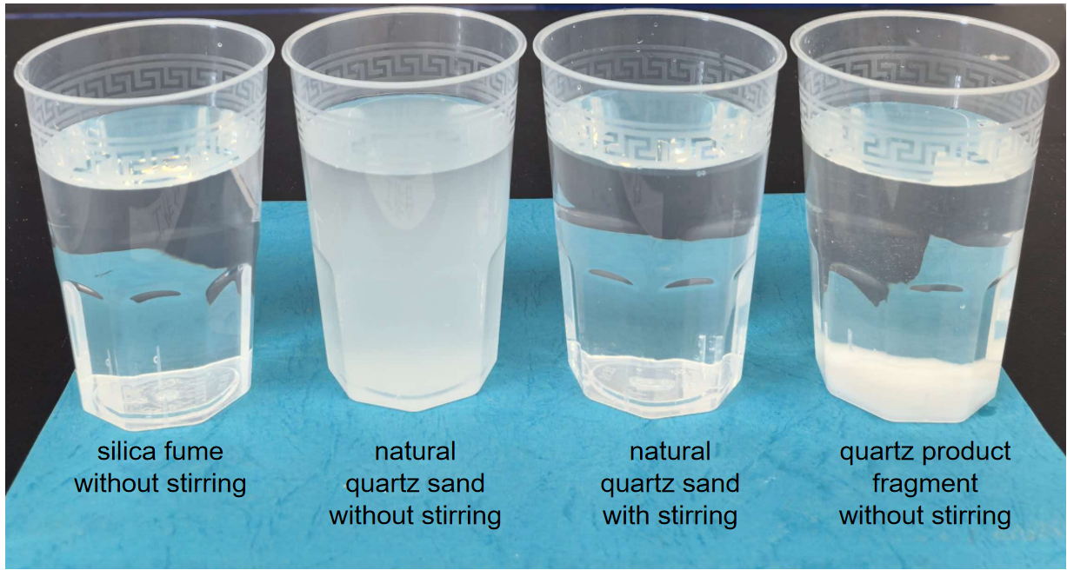
Figure S2 The dissolved reactants of three types of silica waste materials.

