Supplementary Information

Magnetoplasmonic keychains for multiplexed polarization-encoded tags
Jin Hyeok Park,^{1, †} Hyojung Kang,^{2, †} Seojin Lee,^{3,4} Ye-Eun Choi, ^{3,4} Hyerim Hwang,^{3,4} So-Jung Park^{2,3,5,*} and Tae Soup Shim^{1,6,*}
¹Department of Energy Systems Research, Ajou University, Suwon 16499, Republic of Korea
²Department of Chemistry and Nanoscience, Ewha Womans University, Seoul 03760, Republic of Korea
³Institute for Multiscale Matter and Systems (IMMS), Ewha Womans University, Seoul 03760, Republic of Korea
⁴Department of Chemical Engineering and Materials Science, Ewha Womans University, Seoul 03760, Republic of Korea
⁵Graduate Program in Innovative Biomaterials Convergence, Ewha Womans University, Seoul 03760, Republic of Korea
⁶Department of Chemical Engineering, Ajou University, Suwon 16499, Republic of Korea
†These authors contributed equally to this work.

*Corresponding authors. Email: sojungpark@ewha.ac.kr, tsshim@ajou.ac.kr

Methods

Materials. Gold(III) chloride trihydrate (HAuCl₄·3H₂O; ≥99.9%), Cetyltrimethylammonium bromide (CTAB, ≥98%), sodium borohydride (NaBH₄; 99%), trisodium citrate, silver nitrate (AgNO₃; 99.9999%), L-ascorbic acid (reagent grade), cetyltrimethylammonium chloride (CTAC, ≥98%), citric acid (ACS reagent, ≥99.5%), sodium iodide (NaI; ACS reagent, ≥99.5%), trisodium citrate dihydrate, potassium tetrachloroplatinate(II) (K₂PtCl₄; 99.99%), iron(II) chloride tetrahydrate (FeCl₂·4H₂O; 98%), ammonium hydroxide solution (NH₄OH; 28-30%), poly(ethylene glycol) diacrylate (PEGDA, average Mn 575 g mol⁻¹), Omnirad 1173 were purchased from Sigma-Aldrich (St. Louis, MO, USA). Sodium oleate (>97.0%) and tetraethyl orthosilicate (TEOS; >98.0%) were purchased from Tokyo Chemical Industry Co., Ltd. (Tokyo, Japan), Hydrochloric acid (HCl; 37% in water) was purchased from Daejung (Siheung, South Korea). Ethyl alcohol (99.9%) was purchased from Duksan (Seoul, South Korea). Sylgard 184A and B were purchased from Sewang-Hitech (Gimpo, South Korea).

Characterization. Transmission electron microscopy (TEM) was performed on a JEOL JEM-2100 Plus operated at an accelerating voltage of 200 kV. Elemental mapping and energy-dispersive X-ray spectroscopy (EDS) were conducted using a JEM-ARM200F NEOARM instrument. Optical transmission spectra were measured using an Agilent 8453 UV–Vis spectrophotometer or an Ocean Optics QE Pro spectrometer.

Synthesis of gold nanorods (AuNRs). AuNRs were synthesized using a seed-mediated growth method¹. Gold seed particles were prepared by mixing 5.0 mL of 0.5 mM HAuCl₄·3H₂O with 5.0 mL of 0.2 M CTAB, followed by the rapid injection of 0.6 mL of freshly prepared, ice-cold 0.01 M NaBH₄ under vigorous stirring. The seed solution was stirred for 2 min and aged at room temperature for 3 h before use. To prepare the growth solution, 0.7 g of CTAB and 0.1234 g of NaOL were dissolved in 25 mL of warm water (~50 °C). The solution was then allowed to cool to 30 °C. Next, 1.8 mL of a 4 mM AgNO₃ solution was introduced and incubated at 30 °C for 15 min without stirring. 25 mL of 1 mM HAuCl₄·3H₂O was added and the mixture was stirred at 700 rpm for 90 min. The pH was adjusted by adding 150 μL of HCl (37 wt%, 12.1 M), followed by gentle stirring at 400 rpm for 15 min. Subsequently, 125 μL of 0.064 M L-ascorbic acid was introduced as a reducing agent, and the solution was stirred vigorously at 1200 rpm for 30 s. Then, 100 μL of seed solution was injected rapidly under the same stirring conditions. The reaction mixture was further stirred for 30 s, then allowed to stand undisturbed at 30 °C for 12 h to facilitate nanorod growth. The resulting AuNRs were collected by centrifugation at 5441 × g for 30 min, washed once, and redispersed in water. The final product exhibited a longitudinal surface plasmon resonance peak around 730 nm, and the AuNR concentration was determined spectrophotometrically using an extinction coefficient of 1.1 × 10⁹ M⁻¹ cm⁻¹ at the longitudinal peak position.

Synthesis of magnetically controllable plasmonic nanoparticles (MPs). Synthesis of MPs was carried out based on a previously reported method². 4.4 nM of AuNRs stabilized with CTAB were washed once with 5 mL of 0.15 mM CTAC to exchange the surfactant. Then, 300 μL of 0.4 mM K₂PtCl₄ solution was added to the AuNR dispersion and incubated for 2 min, allowing PtCl₄²⁻ ions to adsorb onto the AuNR surface. Subsequently, 500 μL of freshly prepared 10 mM FeCl₂·4H₂O solution and 4.2 mL of water were sequentially introduced with gentle shaking. The reaction mixture was then heated to 100 °C and maintained for 1 h to induce hydrolysis and oxidation of Fe²⁺, forming a iron oxyhydroxide (FeOOH) shell around the AuNRs. The resulting AuNR/FeOOH nanostructures were isolated by centrifugation (7120 × g, 10 min) and redispersed in 1 mL of water. For silica encapsulation, 5 mL of the AuNR/FeOOH dispersion was mixed with 20 mL of ethanol, followed by the addition of 300 μL of NH₄OH under stirring. TEOS was added to initiate silica condensation, and the reaction proceeded for 30 min under vigorous stirring. The silica-coated nanorods (AuNR/FeOOH/SiO₂) were collected by centrifugation (7120 × g, 5 min), washed twice with ethanol, and dried at 60 °C overnight. Thermal reduction was carried out by placing the dried powder in a tube furnace at 310 °C under a reducing gas atmosphere (5% H₂ in Ar) for 2 h. After natural cooling to room temperature under continued gas flow, the reduced nanorods (AuNR/Fe_{x}O_{y}/SiO₂) were collected and redispersed in water via brief sonication (~5 s) for further use. In this study, these particles are referred to as MPs.

Preparation of PPI. The PEGDA hydrogel prepolymer was prepared by dissolving Omnirad 1173 at 5 wt% in a 50 wt% PEGDA aqueous solution. Subsequently, MPs were added at a concentration of 2 mg mL⁻¹. The resulting prepolymer mixture was sonicated for 60 s to ensure homogeneous MP dispersion.

Fabrication of PDMS well array. A master mold with a hexagonal pillar array was fabricated using a 3D printer and treated with a commercial release agent to facilitate demolding. A PDMS prepolymer of Sylgard 184 was poured onto the master mold, degassed under vacuum, and thermally cured at 70 °C for 12 h after mixing the base and curing agent at a weight ratio of 10 to 1. After curing, the PDMS layer was peeled off from the master mold to obtain a PDMS hole array, which was subsequently bonded to a glass slide by oxygen plasma treatment followed by immediate conformal contact to induce irreversible bonding, thereby forming a millimeter-scale PDMS well array with a hexagonal geometry, a diameter of 2 mm, and a depth of 1.3 mm.

Hydrogel patterning. To conduct photomask-based lithography, a mold was fabricated by placing a PDMS spacer on a glass substrate and covering it with a transparent overhead projector (OHP) film. The hydrogel prepolymer solution was injected into the mold, and a photomask was carefully placed on the OHP film. Magnets were placed on both sides of the mold assembly to align the MPs. Selective patterning was achieved by masking a portion of the photomask with black film, followed by UV exposure using a UV aligner for 30 s. Subsequently, the photomask was removed, and the entire sample was irradiated to polymerize the background region.
For the PDMS well array patterning, the MP prepolymer dispersion was carefully dispensed into the wells using either a dispenser or a pipette, ensuring minimal bubble formation. A customized circular magnet holder was placed underneath the well array to align the MPs. The filled wells were then exposed to UV irradiation for 40 s to fully polymerize the hydrogel. To fabricate multi-patterns, a sequential filling and polymerization process was employed. A subset of wells was first filled with PPI under a selected magnetic field configuration and then polymerized by UV irradiation. Subsequently, another subset of wells was filled with PPI under a different magnetic field configuration, and then polymerized. This cycle of filling and curing was repeated until the entire array was filled. For visualization purposes, the background of the hexagonal plasmonic tag was digitally rendered black to improve the visibility of the plasmonic colors.

Quantitative analysis of pixel-wise plasmonic signatures. To quantitatively validate the simulated plasmonic patterns against experimental observations, two complementary statistical descriptors, mean hue consistency and intra-pixel hue variation consistency, were analyzed. For each 60-pixel plasmonic tag, the mean hue value of each pixel was extracted and assembled into a 60-dimensional vector representing the spatial optical signature of the tag. The corresponding vectors obtained from experimental and simulated plasmonic patterns were compared using Spearman correlation.
Because individual pixels exhibited locally heterogeneous colors arising from variations in MP orientation, intra-pixel hue variation was further quantified. Each pixel was subdivided into fine spatial elements, and the distribution of hue values within each pixel was analyzed to obtain a hue variation score. The resulting scores were assembled into a second 60-dimensional vector and compared between experimental and simulated tags using Spearman correlation.
To evaluate the discriminative power of these descriptors, the experimentally measured plasmonic tag was compared with 120,000 randomly selected simulated decoy tags generated from different magnetic field configurations. Genuine and decoy tags were evaluated using both mean hue consistency and intra-pixel hue variation consistency.

Deep-learning-based decoding of magnetic configurations. A supervised Transformer-based decoder incorporating a cross-attention mechanism was trained to infer the magnetic configuration, ($M_{i}$), from pixelated plasmonic tags. Each magnetic field configuration was represented by its eight-character magnet orientation sequence. The decoder was trained using 50,000 simulated plasmonic tags and was subsequently evaluated using experimentally generated tags that were not included in the training dataset. Cross-attention weights were analyzed to identify the spatial contributions of individual pixels during magnetic configuration inference.
To determine the minimum number of pixels required for reliable decoding, partial-observation datasets were generated by repeatedly and randomly subsampling (N) pixels from the 60-pixel array using 120,000 simulated plasmonic tags. The decoding threshold, ($N_{th}$), was defined as the minimum number of observed pixels required to achieve an identification accuracy greater than 95%. Decoding accuracy was evaluated as a function of (N) for both the deep-learning decoder and the statistical correlation-based analysis to compare their information requirements.

Supplementary Notes

Supplementary Note 1 | Calculation of the Number of Unique Magnetic Arrangements
The magnetic holder consists of eight discrete slots, each of which can be occupied by a cubic magnet in one of six orientation states: Inward (I), Outward (O), Left (L), Right (R), Normal (N), and Blank (B). Mathematically, this defines a nominal design space of 6⁸ = 1,679,616 possible sequence codes. In our system, the plasmonic color of MPs is determined by their orientation angle; therefore, the system yields identical results for magnetic fields with opposite polarities (180° reversal). Consequently, certain complementary in-plane configurations generate magnetically equivalent color patterns (Supplementary Fig. 3).

Specifically, when a configuration contains only in-plane states (I, O, L, R) and blanks (B), simultaneously swapping inward with outward and left with right across all eight magnets yields a global sign inversion of the magnetic field. Because of the angle-dependent optical response of the MPs, such complementary pairs are treated as a single distinct magnetic arrangement. This redundancy applies to configurations that do not include the out-of-plane state N.

N-free subset: The number of codes composed only of the five states (I, O, L, R, B) is 5⁸ = 390,625. Under the global in-plane swap operation, these codes form complementary pairs, except for the single fixed point consisting of all blanks (BBBBBBBB). The number of distinct arrangements in this subset is:
$$\frac{5^{8} + 1 }{2} = 195,313$$

N-containing subset: All remaining configurations that contain at least one N are counted without this pairing reduction
$$6^{8} - 5^{8} = 1,288,991$$

Summing the two contributions yields the total number of distinct magnetic arrangements:

$$(6^{8} - 5^{8}) + \frac{5^{8} + 1 }{2} = 1,484,304$$

Supplementary Note 2 | Construction of the Orientation-Dependent Color Library
To ensure that the simulated plasmonic patterns reproduce experimentally observed optical appearances, an experimentally calibrated color library was constructed using reference samples (Supplementary Fig. 5a). The primary reference sample consisted of uniformly aligned MPs fixed within a PEGDA hydrogel matrix with in-plane alignment. Digital photographs were acquired under various polarization configurations achieved by rotating the output analyzer relative to a fixed input polarizer. To build the in-plane color library, the reference sample was rotated from 0° to 180° in 10° increments, and representative color values were extracted from the captured images in hexadecimal RGB format by spatially averaging pixels within a selected region of interest. These discrete experimental datasets were numerically interpolated to generate continuous look-up tables (LUTs) for the simulation. In parallel, a separate reference sample with vertically aligned MPs (θz = 90°), prepared by applying a vertical magnetic field during photopolymerization, was imaged under identical conditions to establish the reference color for the out-of-plane orientation used in the simulation. (Supplementary Fig. 5b).

Supplementary Note 3 | Algorithm for Mapping Simulated 3D Magnetic Fields to Plasmonic Colors
The visualization of the simulated magnetic fields is performed by mapping the local magnetic field vectors, B(x,y,z) to RGB color values. This mapping process utilizes the experimentally calibrated LUT described in Note S2 and consists of the following steps:

Step 1. Determination of in-plane azimuthal color First, the local in-plane azimuthal angle φ, at each simulation grid point is calculated from the magnetic field components B_{x} and B_{y}:
$$ϕ=arctan\left(\frac{B_{y}}{B_{x}}\right)$$

φ is used as an index to query the LUT, yielding a planar color value, C_{planar}(φ), through linear interpolation of the discrete experimental data points.

Step 2. Calculation of gated blending weight To account for the non-linear response of the MPs and the detection sensitivity of the system, a gated blending weight ω is introduced. First, the in-plane ratio $ρ$ is defined as:

$$ρ=\frac{\sqrt{B_{x}^{2}+B_{y}^{2}}}{\left|B\right|}$$

Here, $\left|B\right|= \sqrt{B_{x}^{2}+B_{y}^{2}+B_{z}^{2}}$. The value of ρ ranges from 0 (fully vertical) to 1 (fully in-plane).

The weight ω is then calculated by applying a threshold τ and a gamma exponent γ:

$$ω= \left\{\begin{aligned}0, \text{ if} ρ ≤ τ \\ {\left(\frac{ρ- τ}{1-τ}\right)}^{γ}, \text{if} ρ > τ\end{aligned}\right.$$

In this simulation, the parameters were set to τ = 0.6 and γ = 0.5.

Step 3. Final color blending The resultant pixel color, C_{final} is computed by linearly mixing the planar color (C_{planar}(φ)) with the reference color corresponding to the vertically aligned state, C_{vertical}, which was obtained from the vertically aligned reference sample. The mixing equation is given by:

$$C_{final}= ω∙C_{planar}\left(ϕ\right)+(1-ω)∙C_{vertical}$$

This algorithm generates the final polarization-resolved color patterns by determining the RGB values for every pixel based on the calculated local field geometry.

Color mapping under unpolarized conditions Under this condition, the optical response becomes insensitive to the azimuthal orientation (φ) of the magnetic field, as the incident light consists of randomly distributed polarization states. Consequently, the system does not resolve the specific in-plane direction of the field. Instead, the observed plasmonic color is governed by the relative magnitudes of the in-plane and out-of-plane magnetic field components, effectively dictate the tilt angle of MPs with respect to the z-axis.

To simulate this condition, the color-mapping procedure is simplified to a binary blending model. Instead of querying azimuthal-dependent colors from the LUT, the algorithm employs a horizontal reference color (C_{horizontal}) and a vertical reference color (C_{vertical}). Here, C_{horizontal} is defined as a representative color obtained under single-polarizer condition when the polarization direction is aligned with the nanorod orientation, corresponding to the maximum achievable in-plane plasmonic response. This reference color is introduced as a representative indicator to visualize the weak contribution of the in-plane magnetic field component under unpolarized conditions.
Under unpolarized conditions, the final color, C_{unpolarized}, is determined by linearly blending the two reference colors using the gated blending weight ω, which reflects the degree of MP inclination relative to the z-axis. The resulting color is expressed as:

$$C_{unpolarized}= ω∙C_{horizontal}+(1-ω)∙C_{\text{vertical}}$$

Supplementary Note 4 | Correlation-based statistical identification of plasmonic tags
To evaluate whether plasmonic tags generated under different magnetic field configurations can be statistically distinguished, a correlation-based identification framework was established. A decoy library was constructed using simulated plasmonic tags generated from approximately 120,000 of randomly generated magnetic field configurations. For each simulated tag, the mean hue and intra-pixel hue variation were extracted from all 60 spatially indexed dots according to their predefined coordinates. In this framework, the simulated plasmonic tag corresponding to the IIORORIL magnetic configuration was treated as the ground-truth reference, as it matches the magnetic field used in the experimental fabrication. Experimental plasmonic tag images were processed using the same pipeline to extract the mean hue and hue variation descriptors from the corresponding 60 dots. Spearman correlation coefficients were then computed between the experimental tag and each simulated candidate in the decoy library using these two metrics. For our information, Spearman correlation was used to evaluate monotonic agreement without assuming linearity. Statistical identification was defined as successful when the correlation values between the experimental plasmonic tag and the ground-truth simulated tag exceeded those obtained for all decoy tags generated from other magnetic field configurations. Using this criterion, the genuine plasmonic tag consistently ranked highest among the 120,000 simulated candidates when both correlation metrics were considered jointly. Visualization of the joint distribution of the two Spearman correlation coefficients further confirms that the ground-truth tag and decoy tags occupy separable regions in correlation space (Supplementary Fig. 11).

Supplementary Note 5 | Deep-learning based magnetic configuration decoder architecture
In this study, a supervised deep-learning decoder was developed to directly infer the orientation states (I, O, L, R, N, B) of eight permanent magnets from pixelated plasmonic tags. The model takes RGB optical images as input and formulates the task as a multi-output classification problem, where each magnet's orientation is independently predicted from spatially distributed dot-level information. To achieve this, the model integrates a patch-wise ResNet encoder with a Transformer architecture.
As illustrated in Supplementary Fig. 5, simultaneously flipping the in-plane orientations of all eight magnets yields a configuration F(s) (I ↔ O, L ↔ R, with N and B invariant) that produces a color pattern identical to the original configuration s. This symmetry is broken when an N orientation is present. Furthermore, because the color of each dot is determined by the combined contributions of all eight magnets, the decoder must synthesize the spatial pattern across multiple dots to resolve this ambiguity and infer the orientation of each individual magnet.

5.1 Decoder Architecture
The decoder takes an RGB image as input and simultaneously predicts the orientation (I, O, L, R, N, B) of each of the eight magnets through four sequential stages.
(1) Local color feature extraction: Because each dot's color reflects only the local magnetic field at its position, rather than processing the entire image at once, the decoder extracts individual 24 × 24 pixel patches centered on each of the 60 dot coordinates. Each patch is passed through a convolutional neural network (CNN) optimized for small-scale inputs, which compresses the color information into a compact feature vector. Processing patches independently prevents color information from neighboring dots from interfering with one another. A learnable positional embedding encoding the spatial location of each dot is added to its feature vector. For occluded dots, a learnable placeholder vector representing "unobserved" is assigned in place of the CNN output.
(2) Inter-dot pattern comparison: The color of a single dot alone is insufficient to disentangle the combined contributions of eight magnets; however, comparing the color combinations exhibited by dots at different spatial positions enables inference of each magnet's individual influence. To this end, a self-attention mechanism is employed, allowing the 60 feature vectors to reference one another and update their representations accordingly. Occluded dots are entirely excluded from this comparison process.
(3) Per-magnet information aggregation: For each of the eight magnets, a learned query vector attends to the updated dot feature vectors from stage (2) via cross-attention, automatically selecting and performing a weighted aggregation of the dots most informative for inferring that magnet's orientation.
(4) Classification: The aggregated representation for each magnet is passed through a linear classifier to predict one of the six possible orientations.

5.2 Training Procedure
Data augmentation: The training data consist of synthetic images generated from magnetic field simulations. However, actual optical microscopy conditions introduce a variety of optical variations not captured by the simulations. To bridge this domain gap, we designed augmentations tailored specifically to plasmonic dot imaging, in addition to standard image augmentations. These include spatially non-uniform illumination arising from light source positioning, specular reflections from the glossy cell surface (bright spots, streaks, and edge highlights), elevated saturation and color temperature variations characteristic of experimental images, texture perturbations from dust and sensor noise, and camera optical aberrations such as chromatic aberration and Gaussian blur. All augmentations are applied in real time on the GPU during training.
Curriculum learning: To promote robustness to partial occlusion, a curriculum learning strategy was adopted: in the early stages of training, most dots (50–60) are kept visible so that the model first learns basic spatial correlations, while the minimum number of visible dots is progressively reduced in later stages (down to as few as 10), enabling accurate inference even from sparse observations.
Symmetry-aware loss function: As noted above, a configuration s and its flipped counterpart F(s) can produce identical images. Under conventional training with a single ground-truth label, predicting either configuration would cause the other to be penalized as incorrect. To resolve this ambiguity, for each training sample we compare the model’s prediction with both the original and flipped labels and select the label that better matches the prediction. The loss is then computed with respect to the selected label. For samples containing an N orientation, the flip symmetry does not hold, and the original label s is used unconditionally.

5.3 Training Details
The model comprises a ResNet-34 based CNN encoder, a single-layer self-attention module, and a 4-head cross-attention module. Training was performed using the AdamW optimizer with a cosine annealing learning rate scheduler. Automatic mixed precision (AMP) and gradient clipping were applied for training stability. The model was trained for 23 epochs with a batch size of 64. The dataset was split into training and validation sets with an approximate ratio of 80:20 based on unique sample identifiers. All experiments were performed on a system equipped with an AMD Ryzen 9 9900X CPU, 64 GB RAM, and an NVIDIA RTX 4070 Ti SUPER GPU with 16 GB VRAM.

Supplementary Note 6 | Determination of the decoding threshold under partial dot observation
To quantify the minimum amount of spatial information required for reliable identification of a plasmonic tag, a decoding threshold analysis was performed under partial dot observation conditions. From the full 60-dot hexagonal array, random subsets of N dots were sampled without replacement, where N was systematically varied. For each value of N, the random subsampling procedure was repeated multiple times to account for sampling variability. For statistical correlation analysis, identification success was evaluated using the criterion defined in Note S4, namely that the correlation values between the experimental tag and the ground-truth simulated tag must exceed those obtained for all decoy tags. The success rate was defined as the fraction of trials in which this condition was satisfied, and the decoding threshold was defined as the minimum number of observed dots required to achieve a success rate exceeding 95%. Using this protocol, statistical correlation analysis required approximately N ~ 22 dots to reliably identify the genuine plasmonic tag. An analogous threshold analysis was performed for the supervised deep-learning decoder using the same partial-observation protocol. The deep-learning model was trained exclusively on simulated plasmonic tags and evaluated on a set of 120,000 unseen simulated plasmonic tags corresponding to unknown magnetic configurations. For each trial, only N randomly selected dots from the 60-dot array were provided as input, and this random subsampling was repeated 100 times for each value of N. Decoding success was defined as correctly predicting the magnetic configuration of the unseen tag. The decoding threshold for the deep-learning approach was defined as the minimum number of observed dots required to achieve an average decoding accuracy exceeding 95% across these repeated trials. Under this criterion, the deep-learning decoder successfully inferred the correct magnetic configuration with as few as N ~ 17 observed dots.

Supplementary Figs.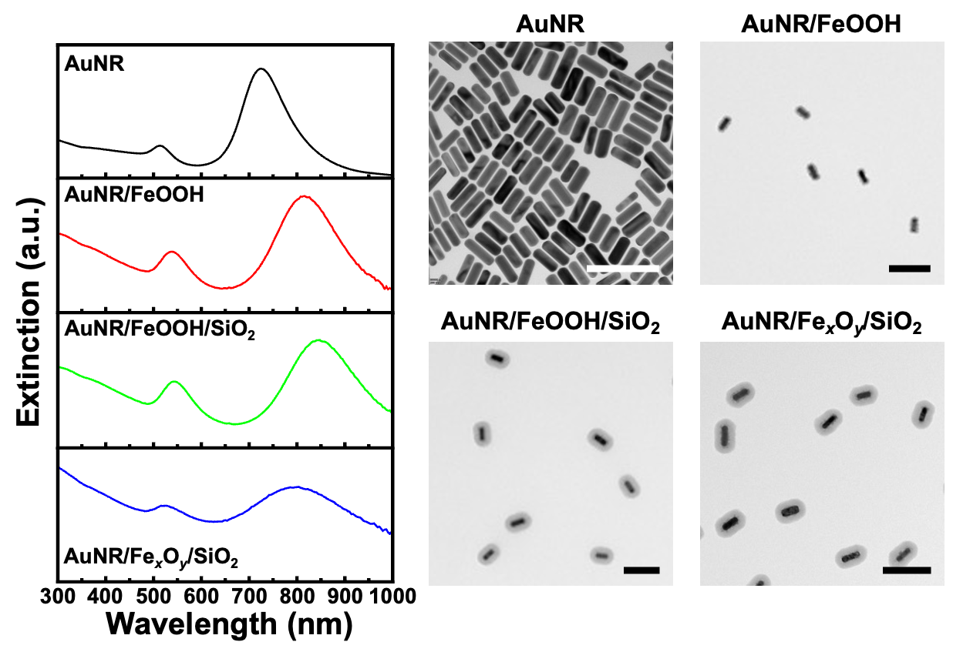

Supplementary Fig. 1 | Extinction spectra and TEM images of MPs during the synthesis process. Extinction spectra of AuNR (black), AuNR/FeOOH (red), AuNR/FeOOH/SiO₂ (green), and AuNR/Fe_{x}O_{y}/SiO₂ (blue). TEM images of AuNR, AuNR/FeOOH, AuNR/FeOOH/SiO₂, and AuNR/Fe_{x}O_{y}/SiO₂. Scale bars indicate 200 nm.

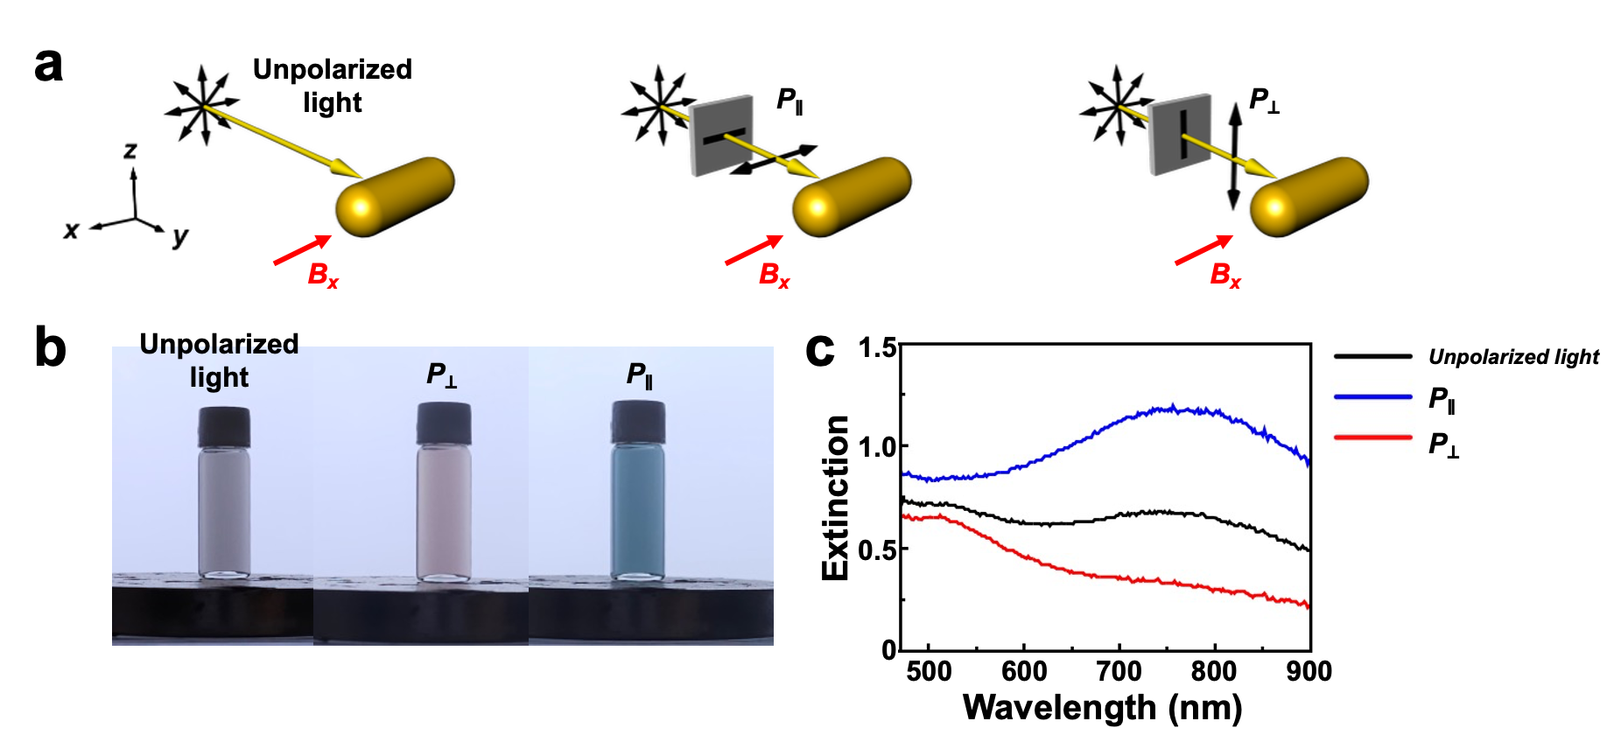

Supplementary Fig. 2 | Polarization-dependent optical responses of MPs. a Schematics of the optical configurations under unpolarized light and single-polarized light with polarization parallel (P∥) or perpendicular (P⊥) to the MP long axis. Black and red arrows indicate the polarizer axis and the applied magnetic field, respectively. b Photographs of the MP dispersion under each illumination condition. c Extinction spectra of the MP dispersion under unpolarized light, P∥ and P⊥.

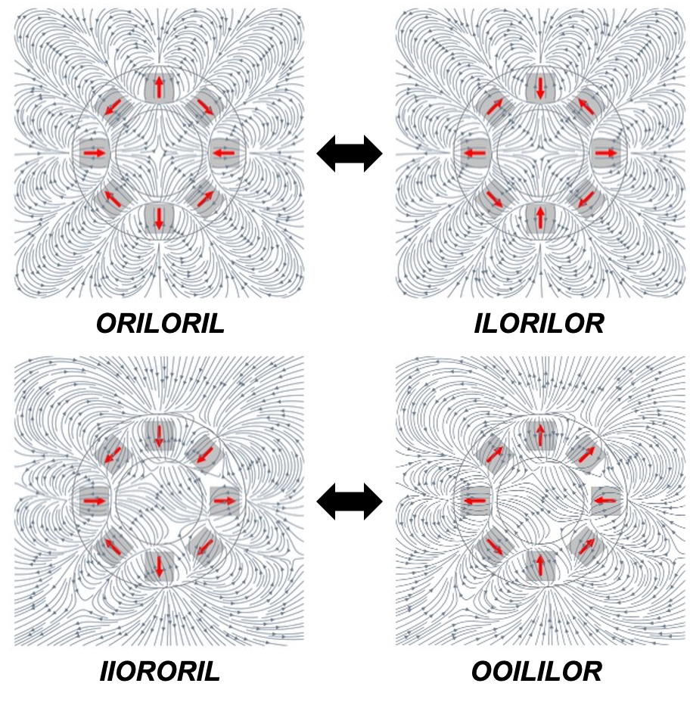

Supplementary Fig. 3 | Complementary in-plane magnet configurations generating equivalent magnetic fields. Representative examples of complementary in-plane magnet orientation pairs that produce equivalent magnetic field distributions. Although the magnet orientation codes differ (e.g., ORILORIL and ILORILOR), the resulting magnetic field topologies are indistinguishable up to in-plane symmetry, leading to equivalent MP alignment outcomes.

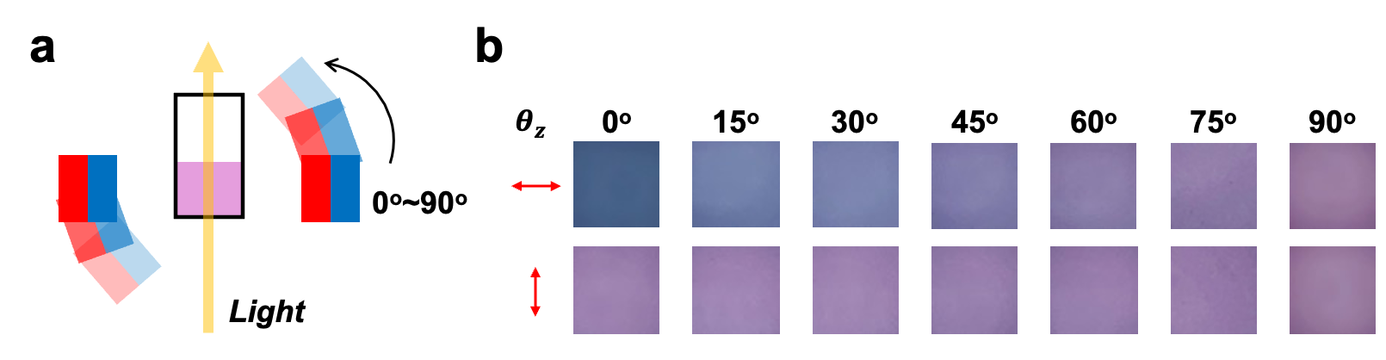 Supplementary Fig. 4 | Polarization-dependent optical response of MPs as a function of out-of-plane tilt angle. a Schematic illustration of the optical measurement setup used to probe the polarization-dependent color response of MPs with controlled out-of-plane tilt angle (θ_{z}). b Optical images of MP solutions observed under single-polarizer as θ_{z} is varied from 0° to 90°.

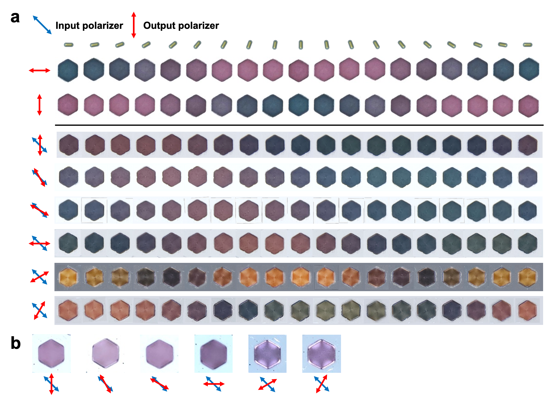

Supplementary Fig. 5 | Polarization-dependent color library of MPs. a Optical images of MP hydrogels recorded under various polarization conditions while varying the MP alignment direction. The upper two and lower six rows correspond to single-polarizer and dual-polarizer configurations, respectively. b Optical images of a reference MP hydrogel with particles aligned along the z-axis under polarization analysis. All images correspond to θ_{z} = 0°.

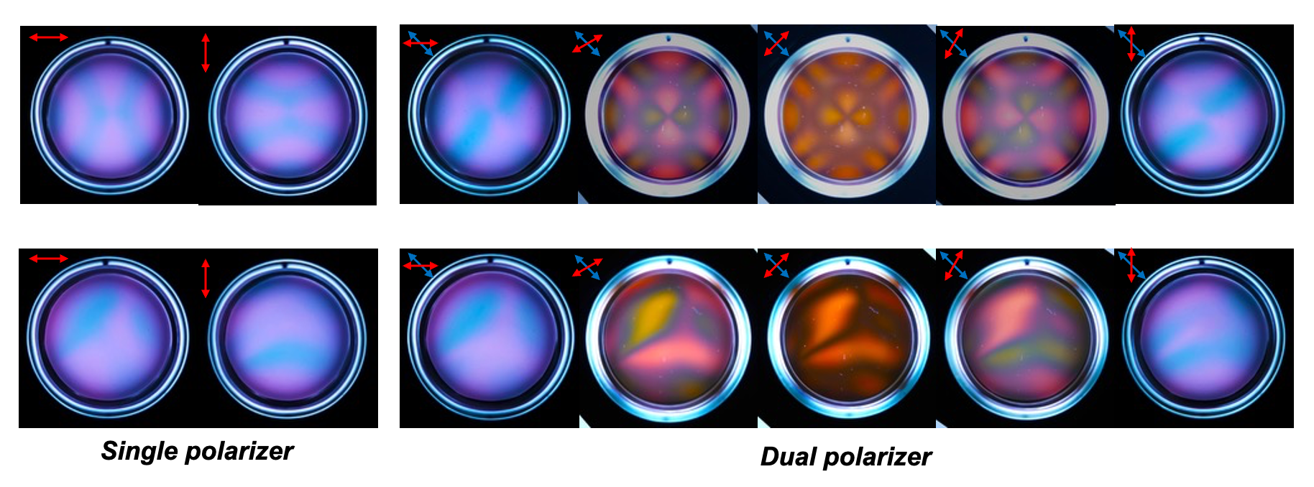

Supplementary Fig. 6 | Polarization-dependent plasmonic color patterns of MP solutions under multiple polarization configurations. Plasmonic color patterns of MP solutions recorded under various polarization configurations for complex magnetic fields. The upper and lower rows correspond to representative magnetic field configurations ORILORIL and IIORORIL, respectively. For the dual-polarizer configuration, the input polarizer was fixed at 135°, while the output polarizer was sequentially set to 0°, 30°, 45°, 60°, and 90° from left to right.

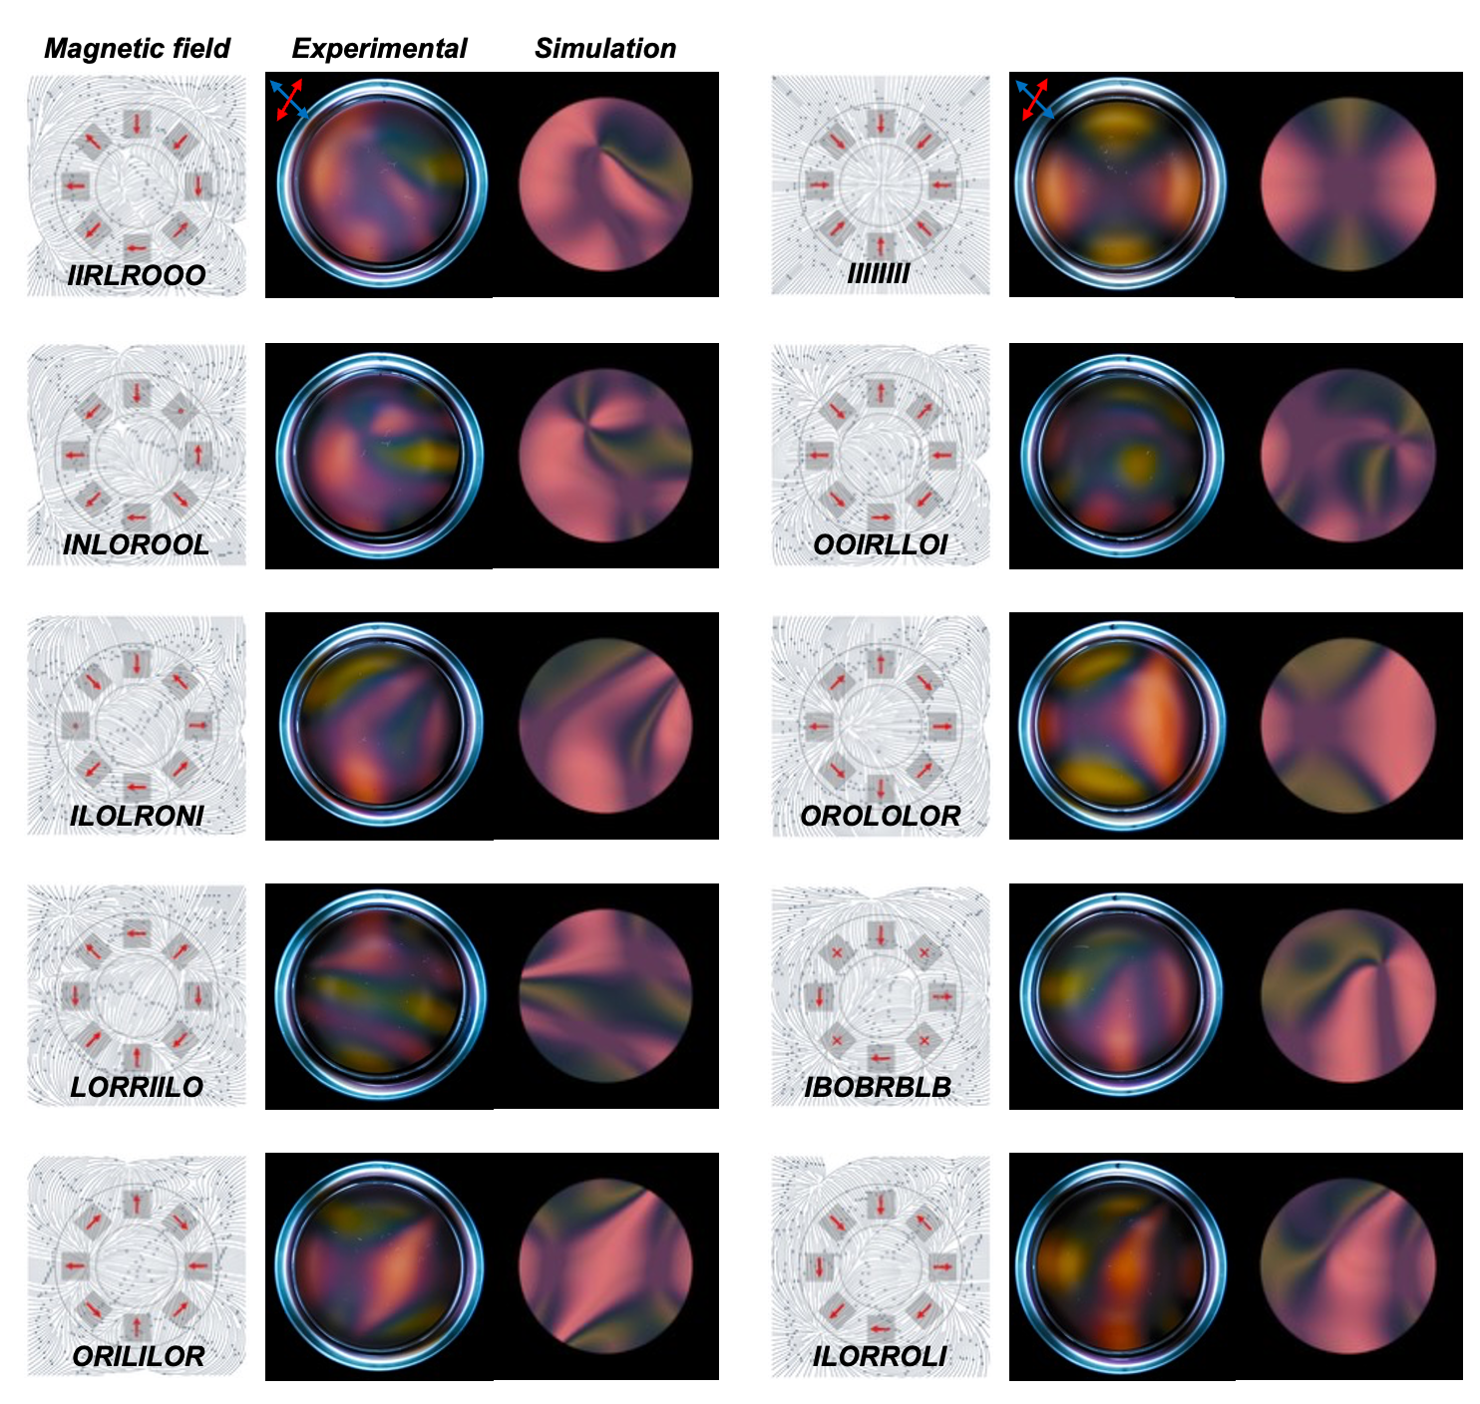

Supplementary Fig. 7 | Comparison between experimental and simulated plasmonic color patterns.

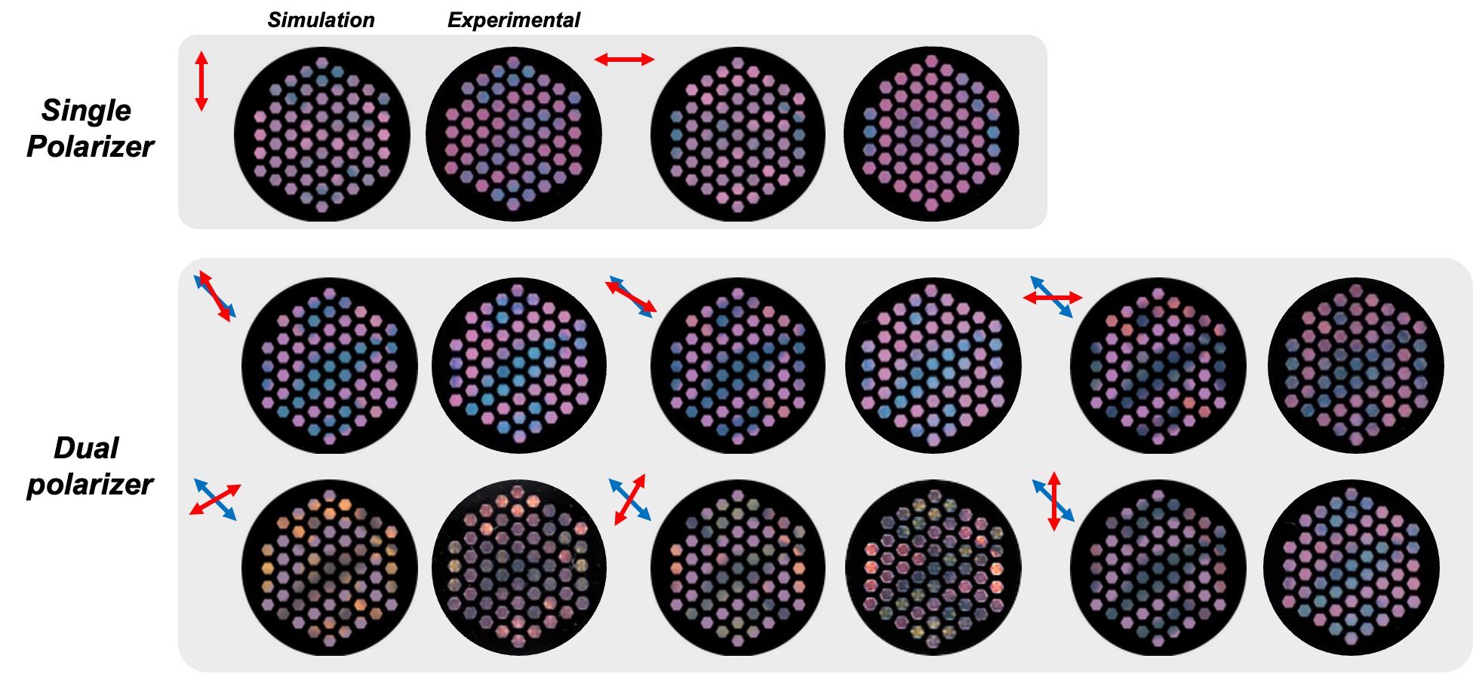

Supplementary Fig. 8 | Plasmonic tag patterns and corresponding simulations under single- and dual-polarizer configurations (IIORORIL).

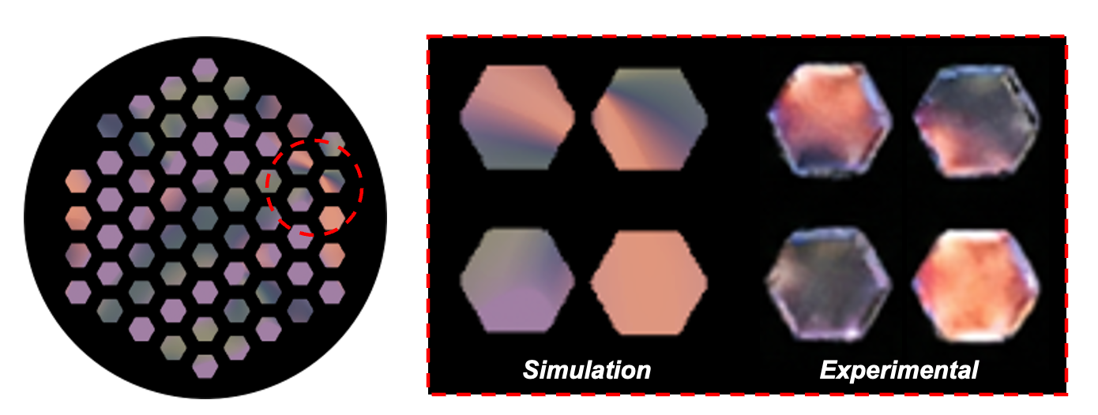
Supplementary Fig. 9 | Intra-pixel plasmonic color heterogeneity in pixelated plasmonic tags.

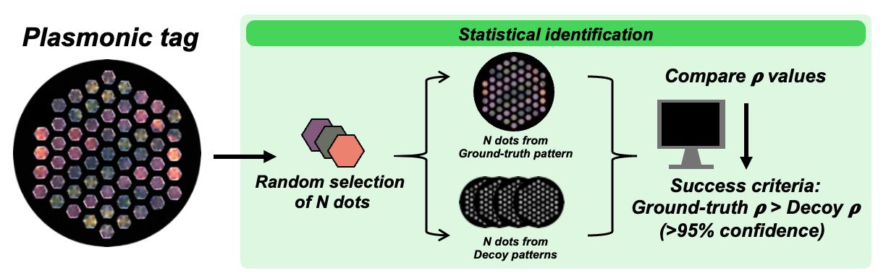

Supplementary Fig. 10 | Statistical identification of genuine plasmonic tags using correlation-based metrics.
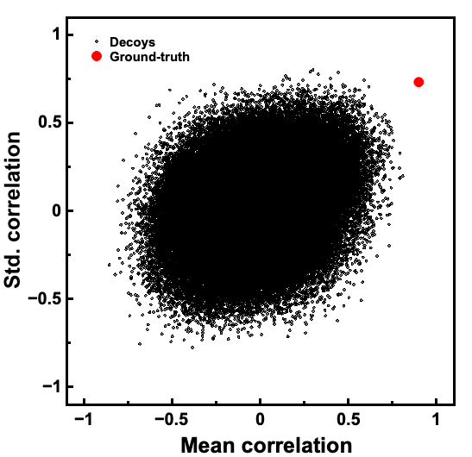

Supplementary Fig. 11 | Scatter plot of mean-hue and hue-variation Spearman correlations for genuine and decoy plasmonic tags.

Supplementary Table 1 | Alphanumeric encoding table for magnetic codes
Plaintext | Code | Modulo operation (Code mod 6) |  | Mag. code
Plaintext | Code | Mag 1 (Quotient) | Mag 2 (Remainder) | Mag. code
A | 0 | 0 | 0 | II
B | 1 | 0 | 1 | IO
C | 2 | 0 | 2 | IL
D | 3 | 0 | 3 | IR
E | 4 | 0 | 4 | IN
F | 5 | 0 | 5 | IB
G | 6 | 1 | 0 | OI
H | 7 | 1 | 1 | OO
I | 8 | 1 | 2 | OL
J | 9 | 1 | 3 | OR
K | 10 | 1 | 4 | ON
L | 11 | 1 | 5 | OB
M | 12 | 2 | 0 | LI
N | 13 | 2 | 1 | LO
O | 14 | 2 | 2 | LL
P | 15 | 2 | 3 | LR
Q | 16 | 2 | 4 | LN
R | 17 | 2 | 5 | LB
S | 18 | 3 | 0 | RI
T | 19 | 3 | 1 | RO
U | 20 | 3 | 2 | RL
V | 21 | 3 | 3 | RR
W | 22 | 3 | 4 | RN
X | 23 | 3 | 5 | RB
Y | 24 | 4 | 0 | NI
Z | 25 | 4 | 1 | NO
0 | 26 | 4 | 2 | NL
1 | 27 | 4 | 3 | NR
2 | 28 | 4 | 4 | NN
3 | 29 | 4 | 5 | NB
4 | 30 | 5 | 0 | BI
5 | 31 | 5 | 1 | BO
6 | 32 | 5 | 2 | BL
7 | 33 | 5 | 3 | BR
8 | 34 | 5 | 4 | BN
9 | 35 | 5 | 5 | BB

References
1. Ye, X., Zheng, C., Chen, J., Gao, Y. & Murray, C. B. Using Binary Surfactant Mixtures To Simultaneously Improve the Dimensional Tunability and Monodispersity in the Seeded Growth of Gold Nanorods. Nano Lett. 13, 765–771 (2013).
2. Kang, H. et al. Dynamic birefringence and chirality of magnetically controllable assemblies of anisotropic plasmonic nanoparticles in dispersion. Nat. Commun. 16, 7076 (2025).

