Supporting information

Electrophotographic Nano-Patterning in Solution

Hyungmok Joh¹, Jiazheng Bao^{1#}, Kyoungtae Park^{1#}, Bin Lian^{1#}, Nolan Cummins^{2#}, Jang-Hwan Han^{3, 4}, Peer Fischer^{3, 4, 5, 6*} and Donglei Emma Fan^{1, 2, 7*}

¹ Materials Science and Engineering Program, Texas Materials Institute, The University of Texas at Austin

² Walker Department of Mechanical Engineering, University of Texas at Austin, Austin, TX 78712, USA

³ Institute for Molecular Systems Engineering and Advanced Materials, Heidelberg University, INF 255, 69120 Heidelberg, Germany

⁴ Max Planck Institute for Medical Research, Jahnstrasse 29, 69120 Heidelberg, Germany

⁵ Center for Nanomedicine, Institute for Basic Science (IBS), Seoul 03722, Republic of Korea

⁶ Department of Nano Biomedical Engineering (NanoBME), Advanced Science Institute, Yonsei University, Seoul, 03722, Republic of Korea

⁷ Chandra Family Department of Electrical and Computer Engineering, University of Texas at Austin, Austin, TX 78712, USA

# These authors contributed equally.

*Authors to whom correspondence should be addressed.

Supplementary Information Table of Content:

Supplementary Notes:
1. Supplementary Note 1: Brownian motion and particle deposition speed.
2. Supplementary Note 2: Double layer suppression in high-ionic solutions.
3. Supplementary Note 3: Solution exchange-based particle deposition.
4. Supplementary Note 4: Selective pattern transfer.
5. Supplementary Note 4: Electric connection measurement.

Supplementary Figures:
6. Supplementary Figure S1: Particle deposition versus time.
7. Supplementary Figure S2: Positive-charge functionalized PS nanospheres and the deposition performance.
8. Supplementary Figure S3: PVP functionalized PS nanospheres and their deposition performance.
9. Supplementary Figure S4: Feasibility of deposition on electrically conducting surfaces.
10. Supplementary Figure S5: Deposition of PS spheres on surface-modified a-Si:H substrates.
11. Supplementary Figure S6: 2.5 and 3D assembly.
12. Supplementary Figure S7: Additional pattern resolution characterization data.
13. Supplementary Figure S8: Original Image and input sequence of “Girl with a Pearl Earring” and an astronaut on the Moon, Apollo 13 Moon landing.
14. Supplementary Figure S9: Schematic comparison of in-electrolyte-deposition and solution exchange-based particle deposition.
15. Supplementary Figure S10: Particle deposition based on the solution-exchange method.
16. Supplementary Figure S11: SEM and Raman spectrum of deposited graphene oxide.
17. Supplementary Figure S12: Deposition pattern of carbon nanotubes.
18. Supplementary Figure S13: Direct deposition of Na2SO4 salt from the solution.
19. Supplementary Figure S14: Biological compatibility assessment.
20. Supplementary Figure S15: High-magnification SEM images of deposited Ag/SiO₂ nanocomposites.
21. Supplementary Figure S16: Zoom-in images of the particle-inked writing of Feynman’s science poem.
22. Supplementary Figure S17: High fidelity, effective pattern transfer.
23. Supplementary Figure S18: All-transfer and selective transfer processes of patterns made of heterogenous particles.
24. Supplementary Figure S19: Selective particle pattern transfer via adhesive hydrogel.
25. Supplementary Figure S20: Electrical connections made by Ag nanowire patterning.

Supplementary Tables:
26. Supplementary Table S1: Comparison between widely used deposition techniques in both industry and academia and this work.

Supplementary Movies:
27. Supplementary Movie S1: Particle deposition over time.
28. Supplementary Movie S2: Deposition of negative and positive images.
29. Supplementary Movie S3: The entire painting process of “Girl with a Pearl Earring”.

Supplementary text 1 – Brownian motion and particle deposition speed
The 1-D Brownian root-mean-square displacement can be calculated using the following equations:
$$<r^{2}> =2Dt \\ D= \frac{k_{B}T}{6πηa}$$

Where D, t, k_{B}, T, η, and a are the diffusion coefficient, time, Boltzmann constant, absolute temperature, dynamic viscosity of the fluid, and the hydrodynamic radius of the spherical particle. Here, we consider the 1D projection calculation case for the particle movement as we are only interested about its net movement to the sample surface. For a 200 nm particle in pure water at 298 K, the diffusion coefficient is 2.45 x 10⁻¹² m²/s (calculated using a temperature of 298.15 K, and a dynamic viscosity of 0.89 cP as an upper limit). Assuming a time of 1 sec one estimates a mean displacement of 2.2 µm. In contrast, the deposition speed obtained in experiments shows an average particle speed of ~0.1 µm/s, if one were to assume that the deposition resulted from directional transport of particles. Direct transport is thus estimated to be an order of magnitude smaller than Brownian diffusion. This estimate supports that the electrostatic assembly in the high ionic Na₂SO₄ solution occurs near the surface of the Si surface, where particles are brought close to the substrate by Brownian motion, but then adhere to the surface due to electrostatic interactions. The analysis is also in agreement with the substantial electric-field screening effect observed in high ionic solutions.

Supplementary text 2 – Double layer suppression in high-ionic solutions
The thickness of the electrical double layer in an electrolyte solution can be calculated by adding the thickness of the Debye screening length and the Stern layer thickness. The formula for the former is as follows:¹
$$λ_{D}=\sqrt{\frac{ε_{o}ε_{r}k_{B}T}{q_{e}^{2}\sum_{i=1}^{N}{z_{i}^{2}n_{i,∞}}}} ≈ \frac{0.304}{\sqrt{I}} \left[nm\right],$$
$$I= \frac{1}{2}\sum{z_{i}^{2}c_{i}}$$

Where ε₀, ε_{r}, k_{B}, T, q_{e}, z_{i}, n_{i}, c_{i} are, respectively, the permittivity of free space, relative permittivity of the solvent, Boltzmann constant, absolute temperature, elementary charge, valance, bulk number density and molar concentration of ion species i. The empirical expression is given for water and 298 K. I is the ionic strength of the solution. For a 0.75 M Na₂SO₄ solution, the estimated theoretical Debye length is only 0.20 nm.
The Stern layer thickness, on the other hand, may be approximated as the radius of the solvated ion on the surface. On a negative surface, the dominant ion in the Stern layer is Na⁺, leading to an approximate hydrated radius of 0.36 nm. On a positive surface, the dominant ion is SO₄²⁻, leading to an approximate hydrated radius of 0.38 nm.²
Combining the Debye screening length and the Stern layer thickness, the estimated effective electric double layer thickness for a 0.75 M Na₂SO₄ solution can be safely estimated to be < 1 nm, regardless of surface charge.

Supplementary text 3 – Solution exchange-based particle deposition
Here, an ionic solution, such as Na₂SO₄ at 0.75 M, was first dispersed into the PDMS well, after which an E-field was applied (Fig. S9). Then, the solution was exchanged with a particle suspension in DI water, and patterns were formed rapidly that can be readily washed and dried for further processing. As mentioned in the main text, the deposition speed is significantly accelerated. We obtained essentially the same particle density in 3 min as soon as the DI water solution exchange was completed. This is distinct from those assembled directly in high-ionic solution (Na₂SO₄ at 0.75 M), which reach a terminal density in about 20-30 min. The density of nanoparticles assembled in DI water were independent of the time the Si surface was immersed in the Na₂SO₄ solution (0.75 M) after E-field application and before the solution exchange (Fig. S10).

Supplementary text 4 – Selective pattern transfer
Applying a second set of polyelectrolyte immediately following the initial deposition step effectively locks the underlying particles in place, preventing their subsequent detachment or desorption back into the solution. Consequently, during subsequent rinsing or processing steps, only the particles deposited on top of this second set of polyelectrolyte layer are transferred (Fig. S17-18).

Supplementary text 5 – Electric connection measurement
It should be noted that the electrical measurement presented in Fig. 5C was conducted across two Ag nanowire network strips, as shown in Fig. S19, confirming Ohmic electric connection through multiple deposited metallic structures.

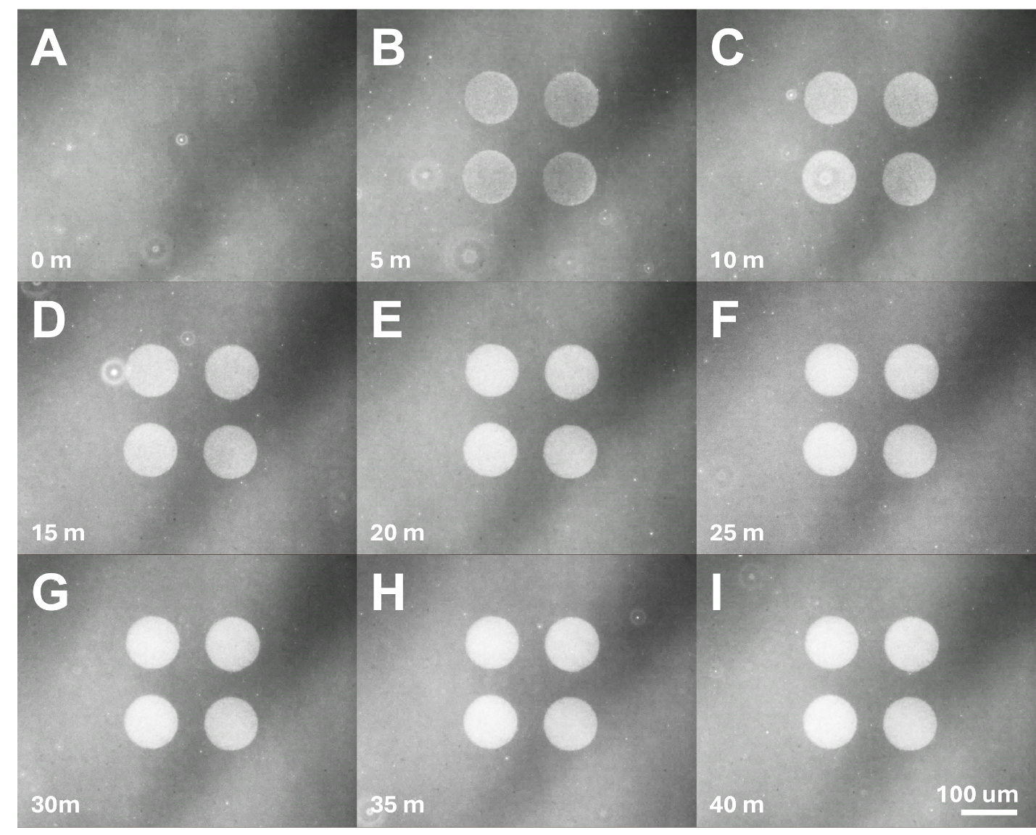

Fig. S1.
Particle deposition versus time. Frames are captured every 5 minutes from Movie S1.

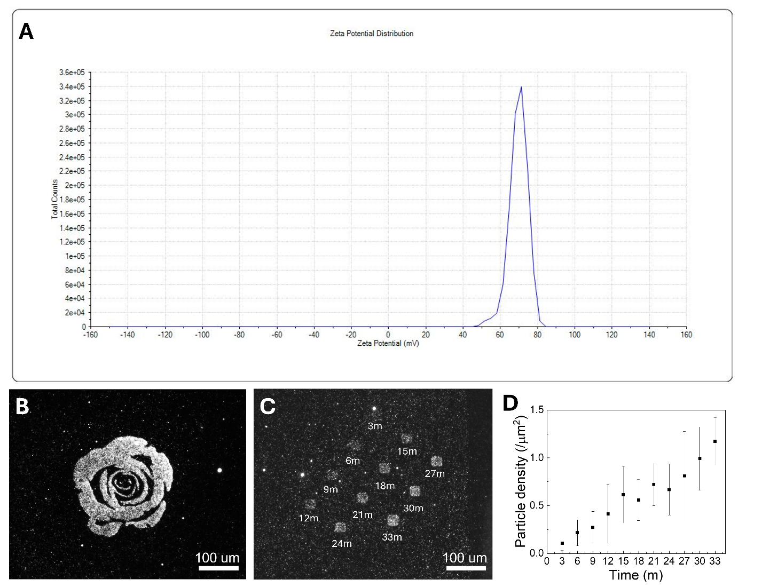
Time (min)

Fig. S2.
Positive-charge functionalized PS nanospheres and the deposition performance. (A) Measurement shows the Zeta potential of positively-functionalized PS spheres as 69.6 mV. (B) Fluorescent image of a rose formed by positively-charged particles patterned on a PDDA-treated surface. (C) Patterns of nanospheres deposited at 3 min intervals under a same AC electric field (E-field: 12 Vpp, 1.5 kHz, 200 ms, 1 pulse). (D) The corresponding particle density increases with time immersion in electrolyte solution after the E-field is turned off.

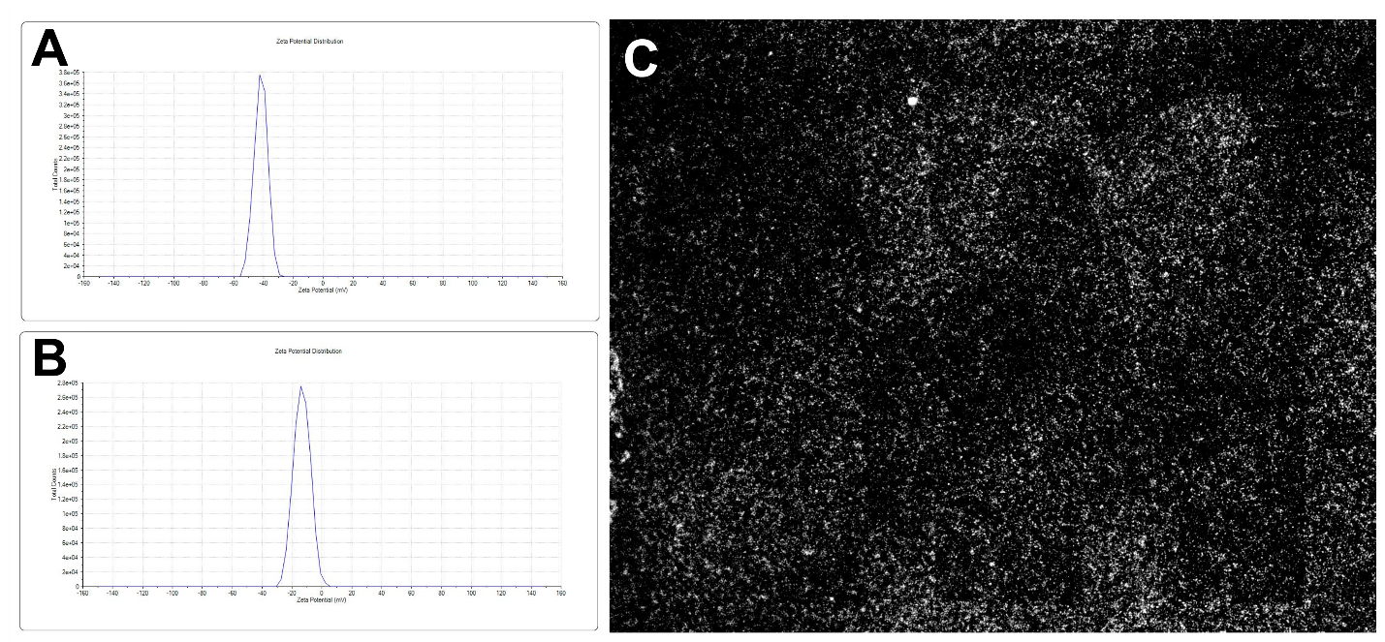

Fig. S3.
PVP functionalized PS nanospheres and their deposition performance. Zeta potential measurements of fluorescent PS spheres (A) before (Zeta potential: -41.9 mV) and (B) after PVP functionalization (Zeta potential: -13.4 mV). (C) The use of PVP-functionalized PS spheres with greatly reduced zeta potential leads to poor patterning. This stems from the nanospheres’ low zeta potential, which reduces deposition in the activated areas and significantly lowers contrast with the background. The results further support the electrostatic nature of the assembly.

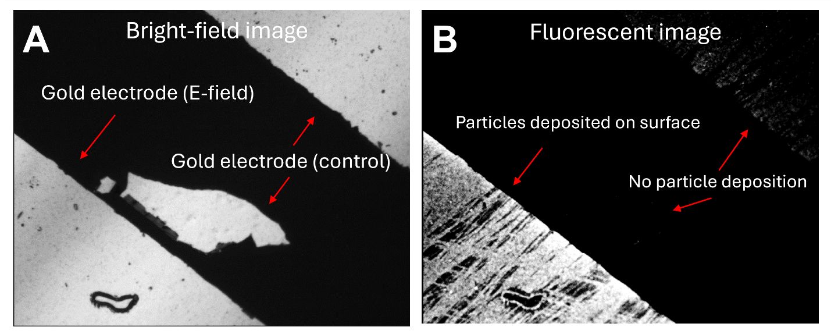

Fig. S4.
Feasibility of deposition on electrically conducting surfaces. (A) Bright-field and (B) fluorescent images show the deposition of negatively charged fluorescent PS nanospheres on a gold surface (bottom left) with an applied E-field, and gold surfaces without an applied E-field (top right and the central island). The counter electrode (not shown) covers the electrolyte-containing PDMS well. The AC E-field is 1.5 kHz, 10 Vpp, 200 ms, 10 pulses. The Au surface was functionalized by a single PDDA/PSS bilayer.

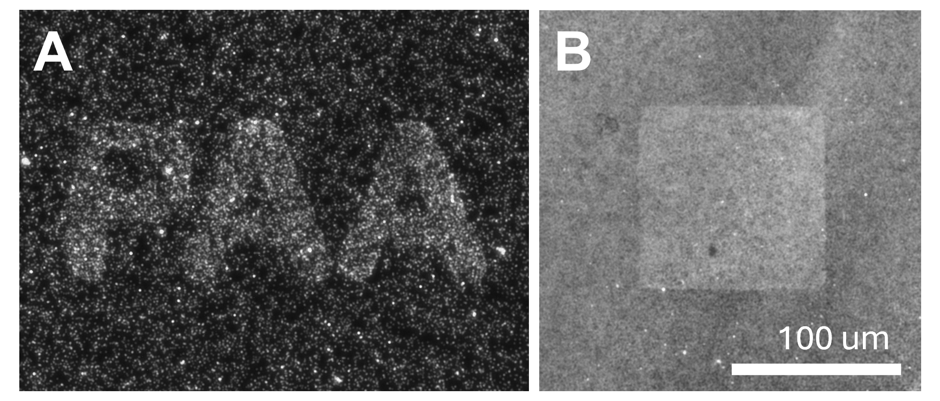

Fig. S5.
Deposition of PS spheres on surface-modified a-Si:H substrates. (A) Positively charged, PDDA-functionalized PS spheres on a positively charged, PAA-functionalized a-Si surface. (B) Negatively charged PS spheres on a negatively charged DNA/PDDA-functionalized a-Si surface.

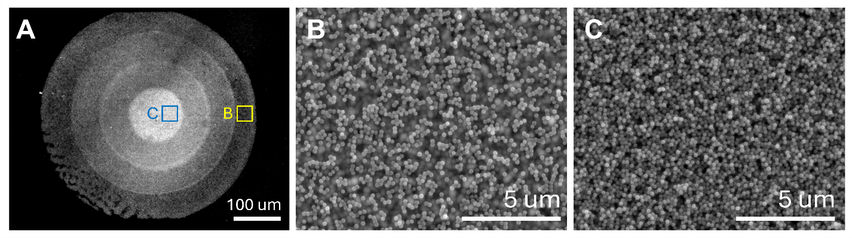

Fig. S6.
(A) 2.5 and 3D assembly. When adding a new layer of particles, an additional polyelectrolyte layer (PDDA/PSS) is first functionalized on top of already-patterned particles. The obtained particle density is lower in the outermost area (B), where only one deposition session was applied, compared to the innermost area (C), where four depositions were applied, each on top of a new PDDA/PSS layer. The assembly results in a concentric tower of disk patterns.

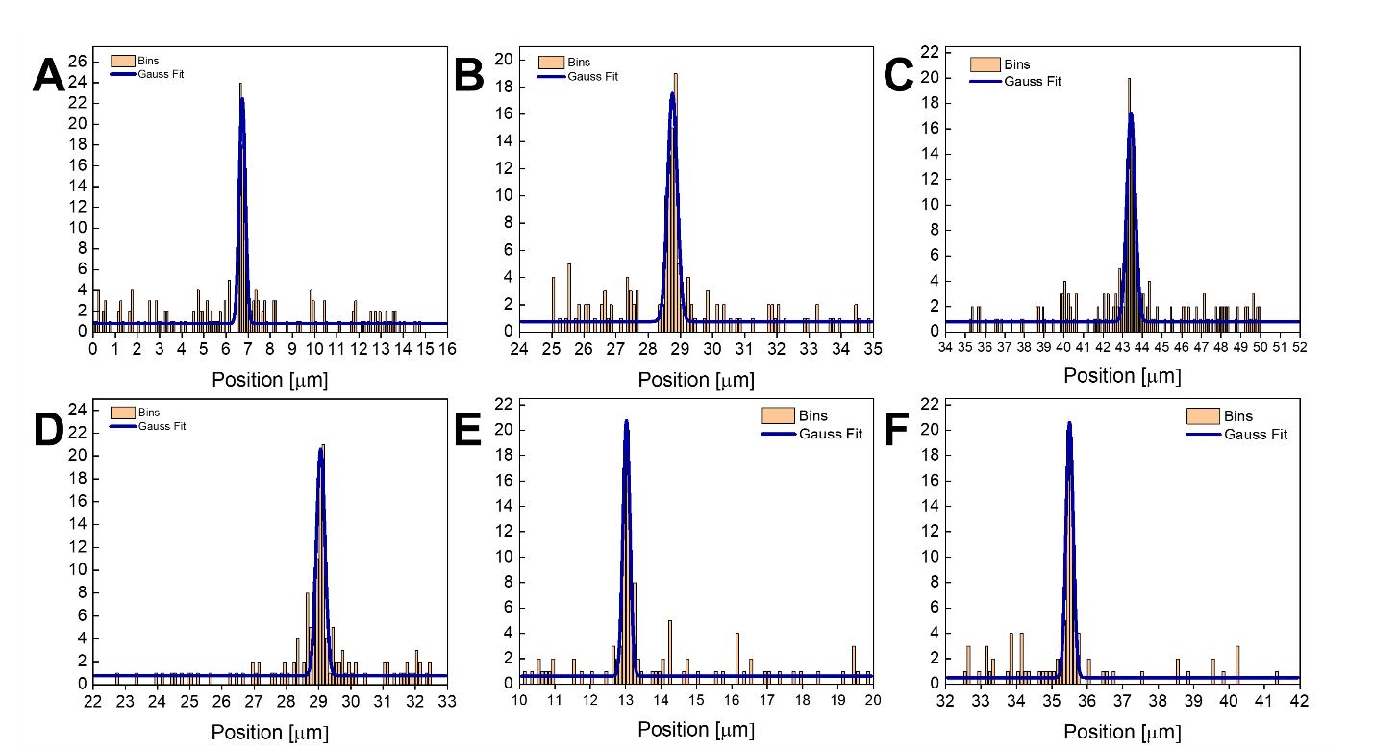

Fig. S7.
Additional pattern resolution characterization data. The patterning distribution relative to the center (x_{c}) reaches a standard deviation (σ) of 139.2 ± 38.9 nm, which characterizes the spread of particles based on Gaussian fit analysis given by Counts=y₀​+A exp[−(x−x_{c}​)²/(2σ²)​]. Here y₀ and A are constants, and x is position. The bin size is 100 nm, and the average was calculated using data points with >0.79 (~0.8) R² values.

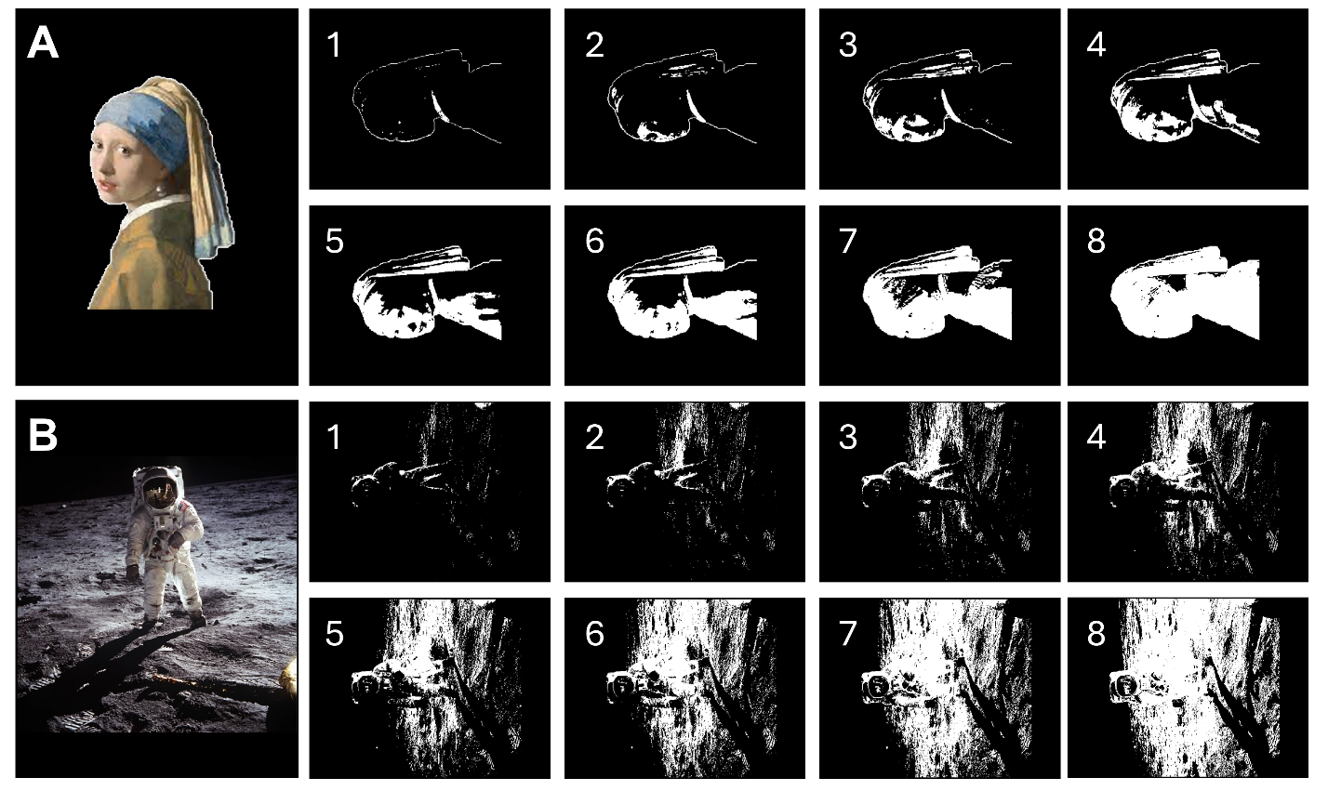

Fig. S8.
Original Image and input sequence of (A) “Girl with a Pearl Earring” and (B) an astronaut on the Moon, Apollo 13 Moon landing.
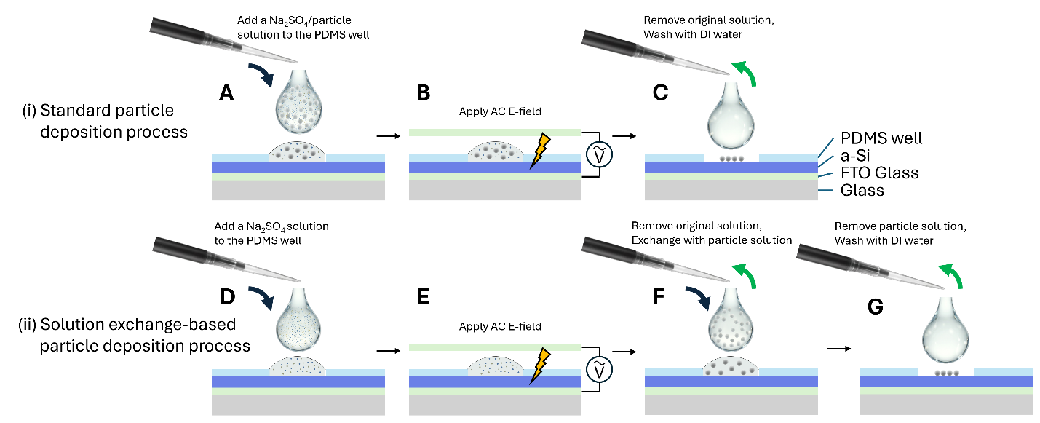

Fig. S9.
Schematic comparison of in-electrolyte-deposition and solution exchange-based particle deposition. In the protocol of in-electrolyte-deposition, (A) an aqueous mixture of Na₂SO₄ and particles is introduced into the PDMS well, followed by (B) the application of an AC E-field. (C) The surface is then rinsed with DI water and dried before SEM imaging.
In contrast, during solution exchange-based deposition, (D) a particle-free Na₂SO₄ solution (0.75 M) is introduced, and (E) the AC electric field is applied. (F) Then, this ionic solution is exchanged for an aqueous particle suspension dispersed in another solution, such as DI water, after which (G) the sample is rinsed by DI water.
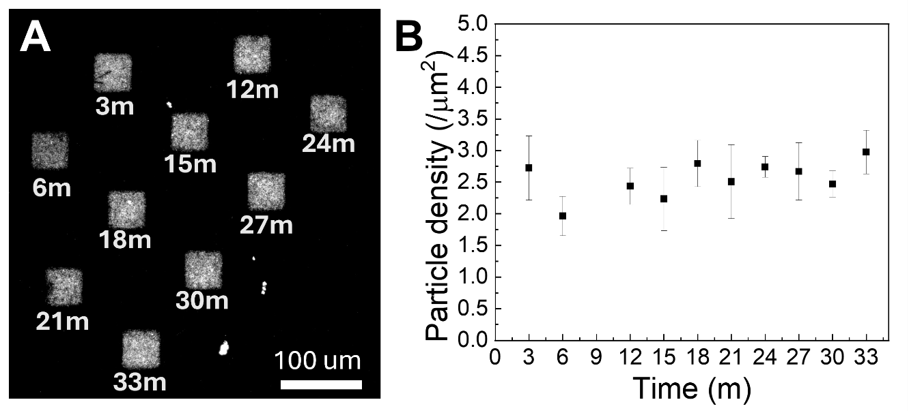
Time (min)

Fig. S10.
Particle deposition based on the solution-exchange method. An AC electric field was first applied to a Na₂SO₄ ionic solution without particles in a three-minute interval. After a 33 min total waiting period, the solution was exchanged with a particle suspension in DI water; this exchange process took approximately 3 min. The total time for which each patterned region remained immersed in the Na₂SO₄ solution after electric-field application is labeled on each square. After 3 min of incubation in the particle suspension, the system was rinsed with DI water, dried, and imaged. As shown in (A), particles deposited under all tested conditions, regardless of the elapsed time after electric-field application, resulting in (B) highly similar particle deposition densities. The result further supports the electrostatic assembly mechanism.

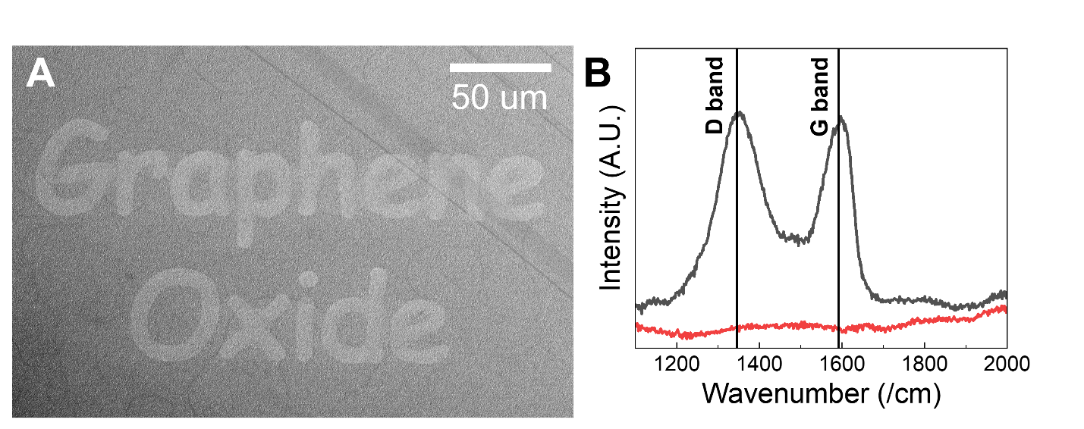

Fig. S11.
SEM and Raman spectrum of deposited graphene oxide. The (black curve) characteristic D and G bands are clearly determined compared to the (red curve) background silicon substrate.
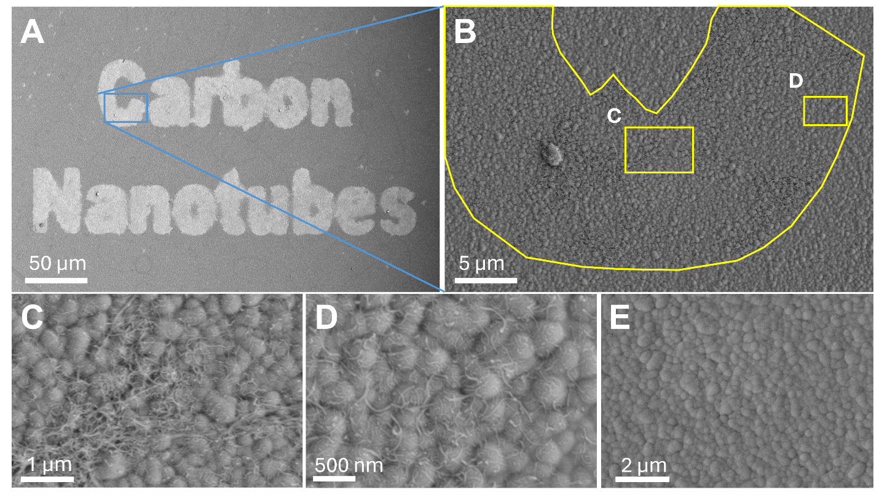

Fig. S12.
(A) Deposition pattern of carbon nanotubes and (B) a detailed view of the letter “C”. Higher-magnification images highlighting regions of (C) dense and (D) sparse carbon nanotube deposition. (E) Background image, showing clean Si surface.

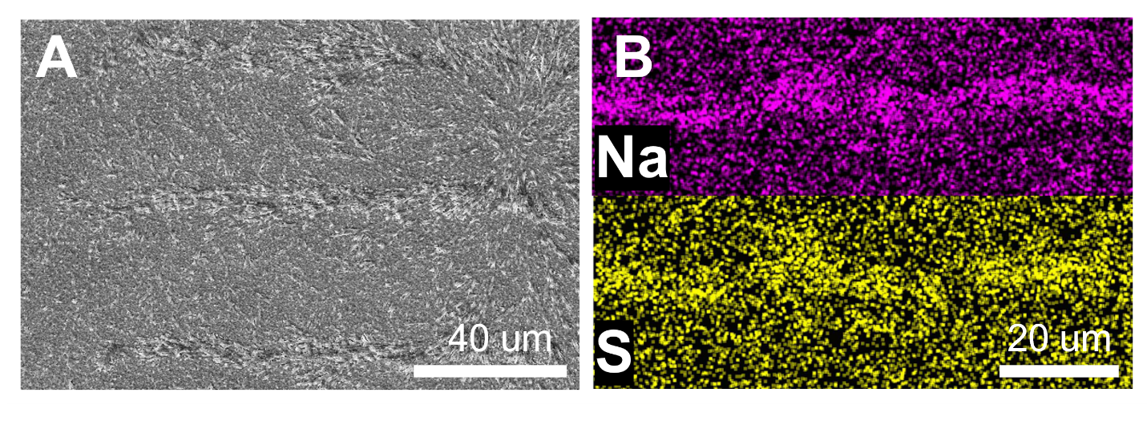

Fig. S13.
Direct deposition of Na₂SO₄ salt from the solution. (A) SEM and (B) EDX analysis results.

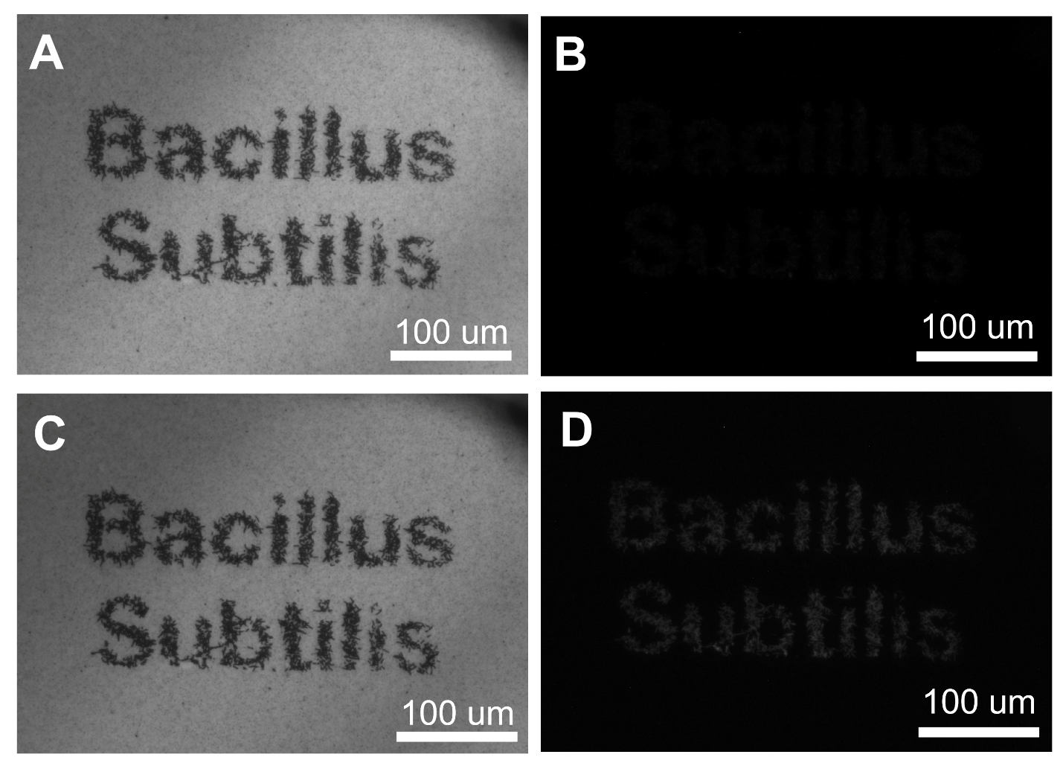

Fig. S14.
Biological compatibility assessment. Following (A) bacteria deposition, (B) no propidium iodide staining effect was observed, indicating bacteria’s high viability. Control experiment: (C) 70% ethanol treatment led to (D) substantial staining. (D) confirms the lysis of bacterial cells. The AC E-field used to print bacteria is 1.5 kHz, 10 Vpp, 200 ms, 30 pulses with a 5 second interval. The Au surface was functionalized by five PDDA/PSS bilayers.

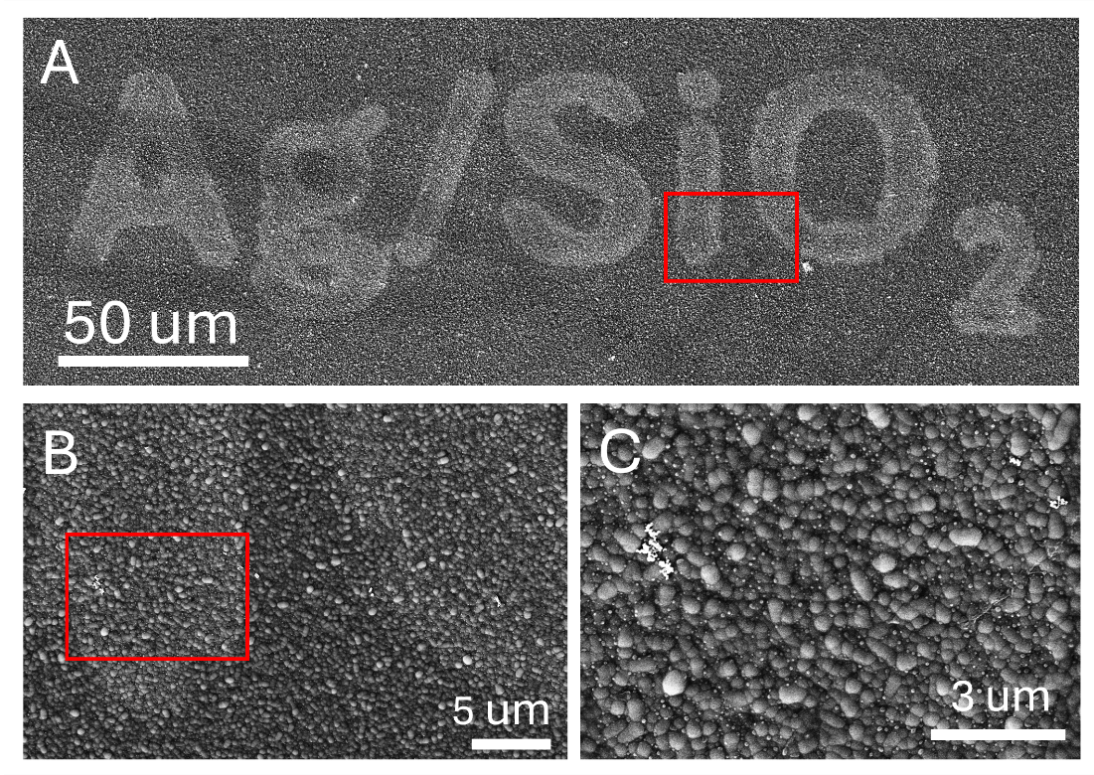

Fig. S15.
High-magnification SEM images of deposited Ag/SiO₂ nanocomposites. (B) Magnified view of the region indicated by the red square in (A). (C) Further magnified view of the region indicated by the red square in (B).
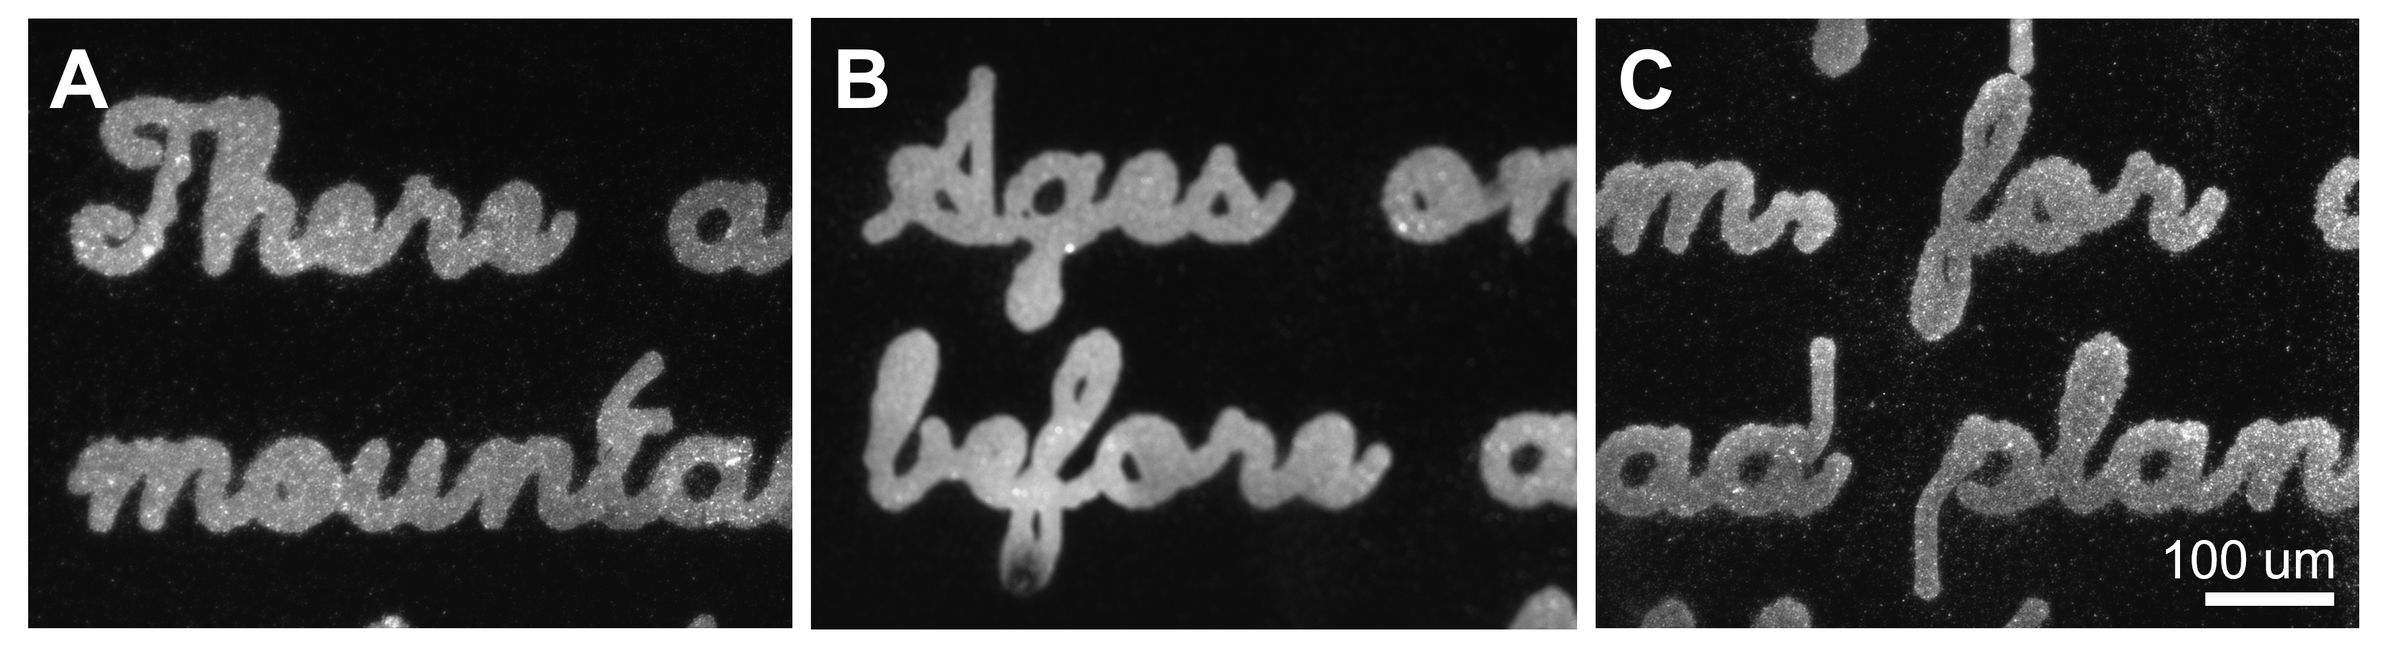

Fig. S16.
Zoom-in images of the particle-inked writing of Feynman’s science poem. Fluorescence and high-magnification images of Fig. 5B, demonstrating dense particle deposition.

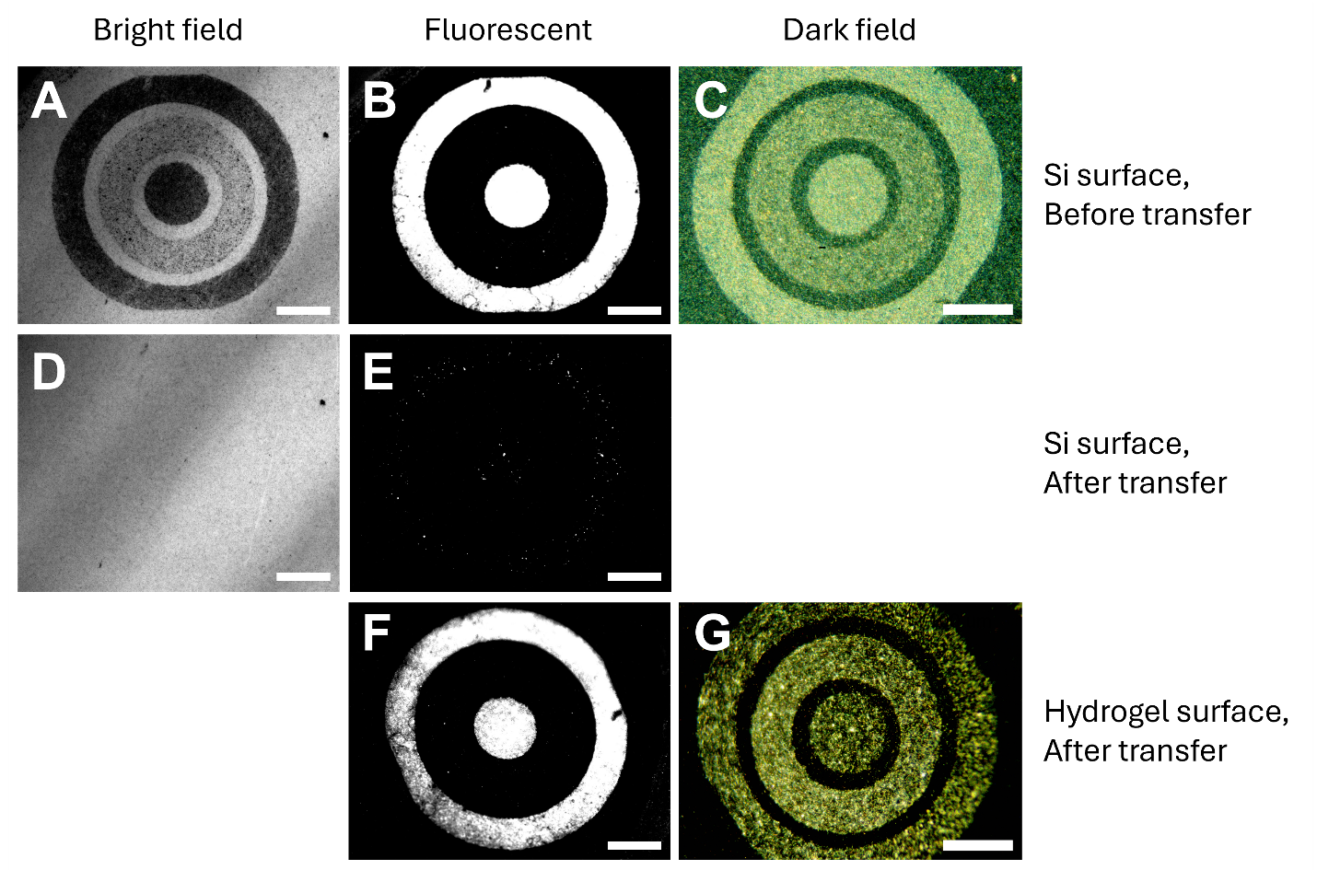

Fig. S17.
High fidelity, effective pattern transfer. Particle transfer via adhesive hydrogel. Before-and-after images of the silicon substrate and the resulting hydrogel surface demonstrate high fidelity, effective pattern transfer. Note: A dark-field image of the post-transfer Si surface could not be acquired due to the difficulty in locating the precise tracking coordinates after processing. Also, the three-fold higher exposure time used for (E) relative to (B) underscores the effectiveness of particle liftoff. The inner and outer concentric rings consist of deposited PS spheres (shown in both fluorescent and darkfield imaging), while the intermediate ring features deposited Ag nanowires (only shown in darkfield imaging). Scale bars: 100 μm.
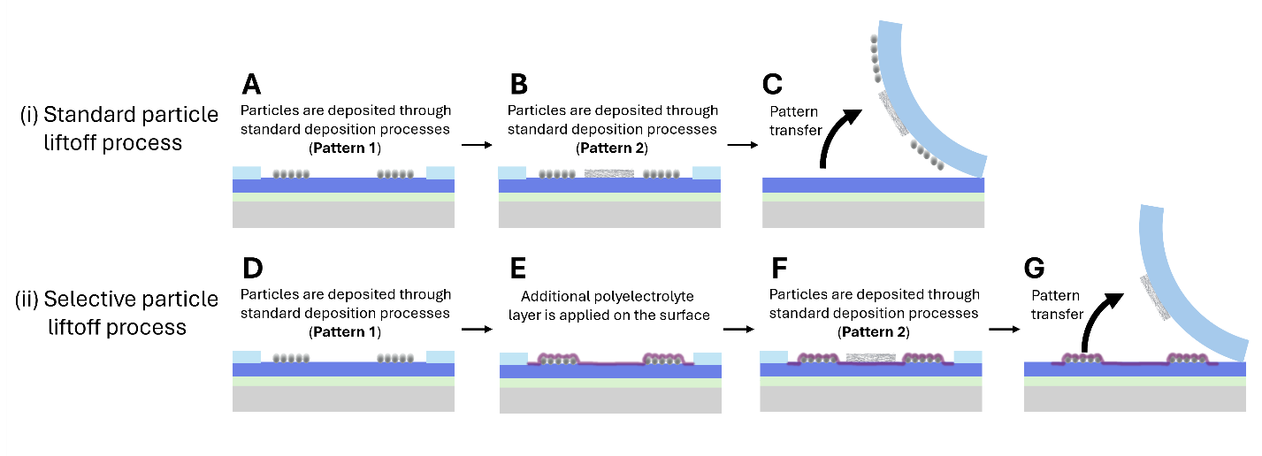

Fig. S18.
All-transfer (A-C) and selective transfer (D-G) processes of patterns made of heterogenous particles: Schematic comparison of simultaneous and selective particle transfer. (A–B) When depositing two distinct material patterns without any intervening modification, (C) both patterns are transferred to the adhesive hydrogel. In contrast, (D–F) when an additional polyelectrolyte layer is introduced between the deposition steps, (G) selective transfer is achieved, isolating only the second pattern on the hydrogel.

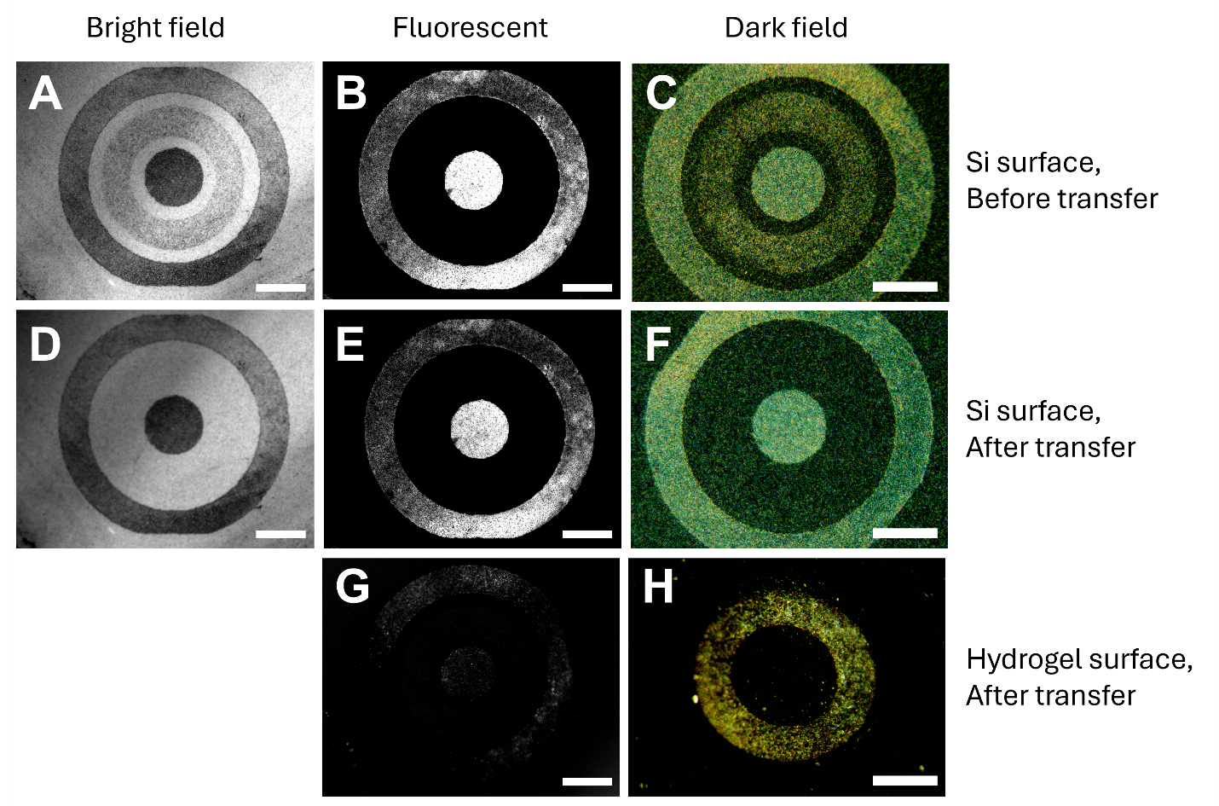

Fig. S19.
Selective particle pattern transfer via adhesive hydrogel. Before-and-after images of the silicon substrate and the resulting hydrogel surface demonstrate complete pattern transfer. An additional PDDA/PSS treatment effectively deters particle detachment and only allows Ag NW transfer onto the hydrogel surface. Note: a five-fold higher exposure time used for (G) relative to (E). The inner and outer concentric rings consist of deposited PS spheres, while the intermediate ring features deposited Ag nanowires. Scale bars: 100 μm.
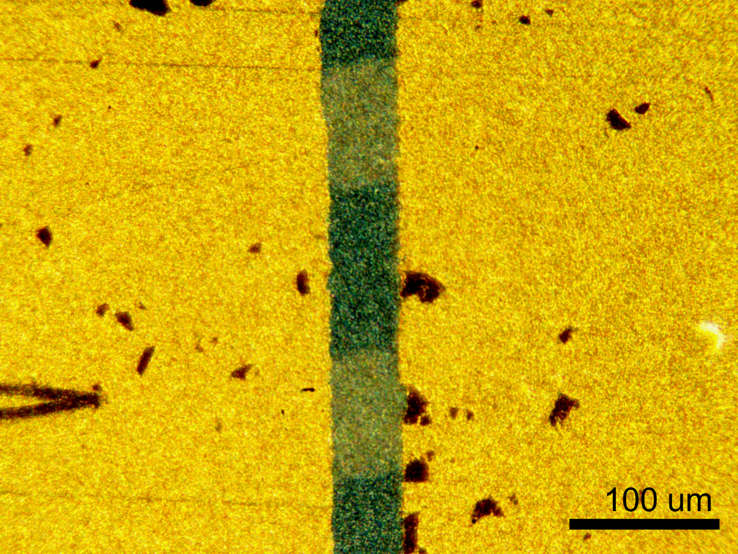

Fig. S20.
Electrical connections made by Ag nanowire patterning; the electric measurement results are shown in Fig. 5C. Optical microscopy image of directly printed Ag nanowire networks (two strips in light yellow at the center) that bridge two Au electrodes (bright yellow) lithographed on a-Si surface. The gap in dark green shows the a-Si surface, which is highly insulating as measured from these Au electrode pairs (control in Figure 5C).

Table S1.
Comparison between widely used deposition techniques in both industry and academia and this work.^{3–13}

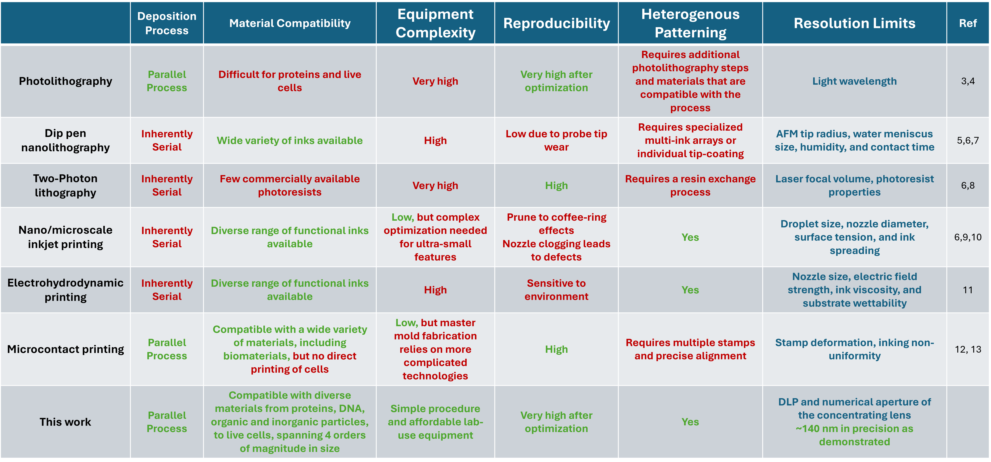

References:
1. Prakash, S. & Yeom, J. Fundamentals for Microscale and Nanoscale Flows. In Nanofluidics and Microfluidics (Elsevier, 2014).
2. Nightingale, E. R., Phenomenological Theory of Ion Solvation. Effective Radii of Hydrated Ions. J. Phys. Chem. 63, 1381–1387 (1959).
3. del Barrio, J. & Sánchez-Somolinos, C. Light to Shape the Future: From Photolithography to 4D Printing. Adv. Opt. Mater. 7, 1900598 (2019).
4. Sharma, E. et al. Evolution in Lithography Techniques: Microlithography to Nanolithography. Nanomaterials 12, 2754 (2022).
5. Liu, G., Petrosko, S. H., Zheng, Z., Mirkin, C. A. Evolution of Dip-Pen Nanolithography (DPN): From Molecular Patterning to Materials Discovery. Chem. Rev. 120, 6009–6047 (2020).
6. Muldoon, K., Song, Y., Ahmad, Z., Chen, X., & Chang, M.-W. High Precision 3D Printing for Micro to Nano Scale Biomedical and Electronic Devices. Micromachines 13, 642 (2022).
7. Bhagoria, P., Mathew Sebastian, E., Kumar Jain, S., Purohit, J., Purohit, R. Nanolithography and its alternate techniques. Mater. Today Proc. 26, 3048–3053 (2020).
8. Jaiswal, A. et al. Two decades of two-photon lithography: Materials science perspective for additive manufacturing of 2D/3D nano-microstructures. iScience 26 (2023).
9. von Bojnicic-Kninski, C. et al. Combinatorial Particle Patterning. Adv. Func. Mater. 27, 1703511 (2017).
10. Du, X. et al. A review of inkjet printing technology for personalized-healthcare wearable devices. J. Mater. Chem. C 10, 14091–14115 (2022).
11. Zhang, B., He, J., Li, X., Xu, F., Li, D. Micro/nanoscale electrohydrodynamic printing: from 2D to 3D. Nanoscale 8, 15376–15388 (2016).
12. Perl, A., Reinhoudt, D. N. & Huskens, J. Microcontact Printing: Limitations and Achievements. Adv. Mater. 21, 2257–2268 (2009).
13. Alom Ruiz, S. & Chen, C. S. Microcontact printing: A tool to pattern. Soft Matter 3, 168–177 (2007).

