The chest CT image of Patient 1 at admission.
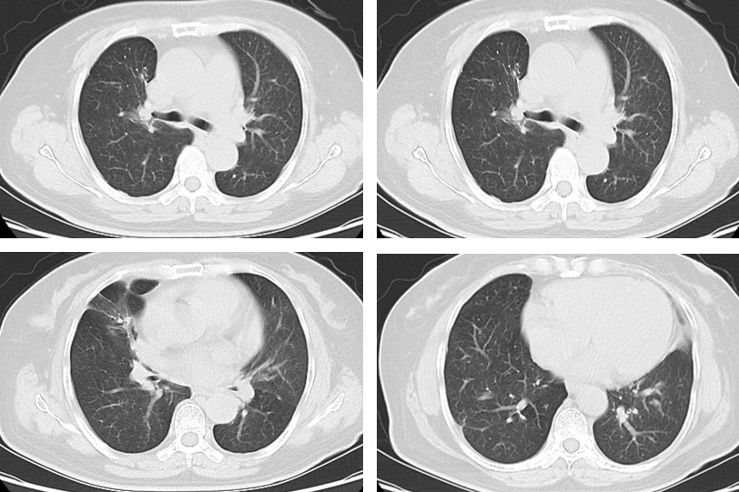
The chest CT image of Patient 2 at admission.
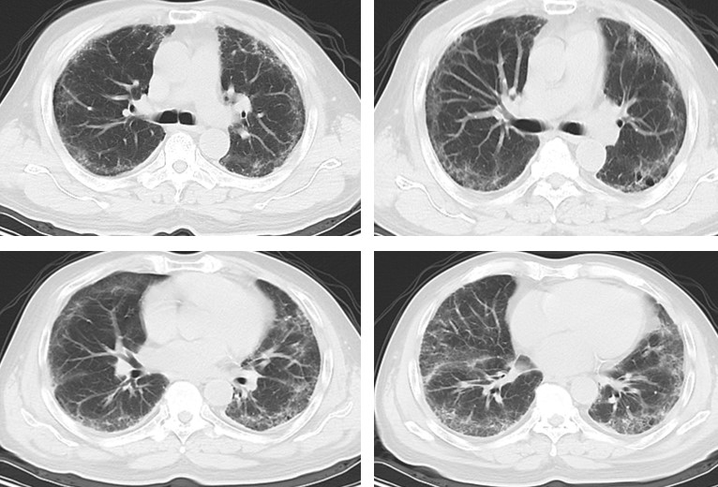
The chest CT image of Patient 3 at admission.
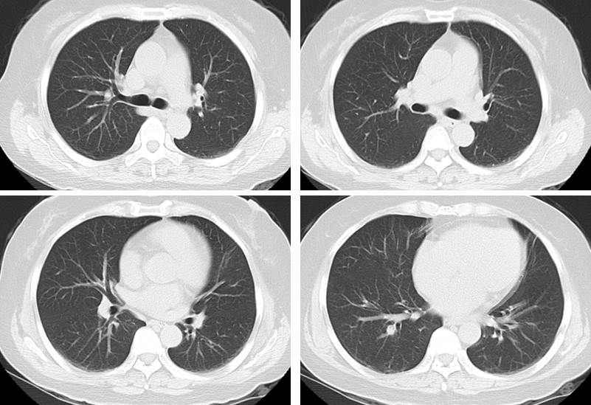

The chest CT image of Patient 4 at admission.
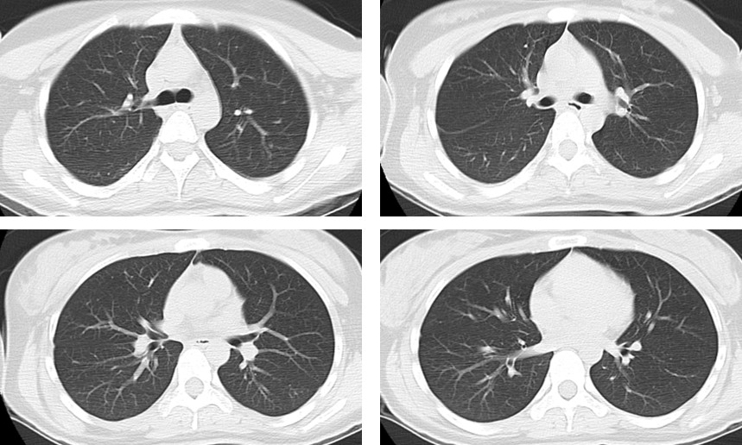
The chest CT image of Patient 5 at admission.
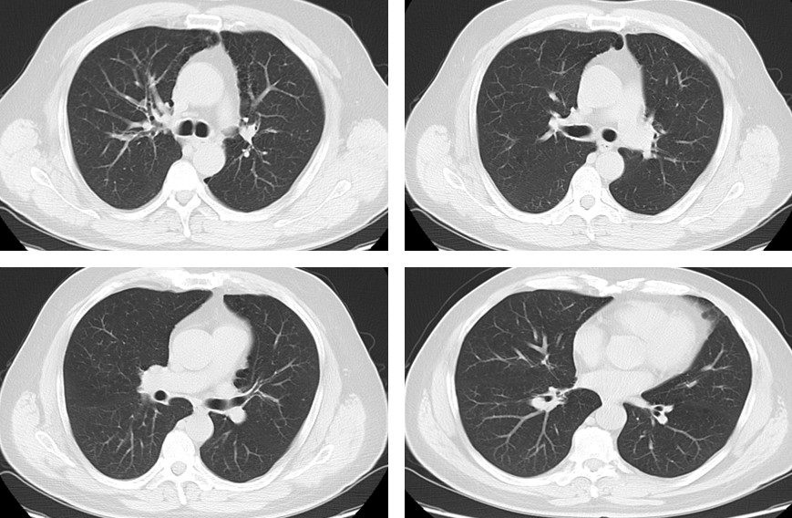
The chest CT image of Patient 7 at admission.
