Beyond Organic Synthesis: Impurity, Oxidative, and Solid-State Challenges in Pharmacopoeial-Grade Droperidol API Development
S1 General Information.
Reagents and solvents were purchased at the highest commercial quality and used without further purification, unless otherwise stated. TLC analyses were performed on Merck TLC Silica gel 60 F₂₅₄ plates using UV light visualization. The HPLC and LC-MS measurements were performed with an Agilent 1200 liquid chromatography system, coupled with a 6130-quadrupole mass spectrometer, equipped with an ESI ion source (Agilent Technologies, Palo Alto, CA, USA).
HPLC method:
Column: Waters Symmetry C18 150x4.6 mm; 3.5 µm
Eluents: A: 0.2% H₃PO₄/H₂O; B: 0.2% H₃PO₄/ACN
flow: 1.5 ml/min; T = 25°C, det: UV, 275 nm, grad: 97:3(3) – 15 – 60:40(5) – 5 – 20:80(2) – 0.1 – 97:3(4.9).
LC-MS method:
Column: Waters Symmetry C18 150x4.6 mm; 3.5 µm
Eluents: A: (0.1% HCOOH+0,1% NH₄HCOO)/H₂O; B: ACN
flow: 1.5 ml/min; T = 25°C, grad: 92:8(3) – 2 – 75:25(4) – 3 – 65:35(4) – 6 – 20:80(2) – 0.1 – 98:2(5.9).
¹H and ¹³C NMR spectra were recorded on a Bruker DRX-300 spectrometer at 300 and 75 MHz, respectively. Chemical shifts (δ) are reported in ppm relative to tetramethylsilane (TMS). Signal assignments were made based on ¹H and ¹³C NMR spectra and supported by literature data for droperidol-related structures.
Infrared spectra were recorded on a Shimadzu IRAFFINITY-1S FTIR instrument using the KBr pellet method.
Melting points were determined using a Franz Küstner KG HMK 69/2458 melting-point apparatus.

S2 Synthetic procedures
S2.1 Preparation of 1-[4-(4-fluorophenyl)-4-oxobutyl]-4-(2-oxo-2,3-dihydro-1H-benzimidazol-1-yl)pyridin-1-ium chloride (Imp-C)
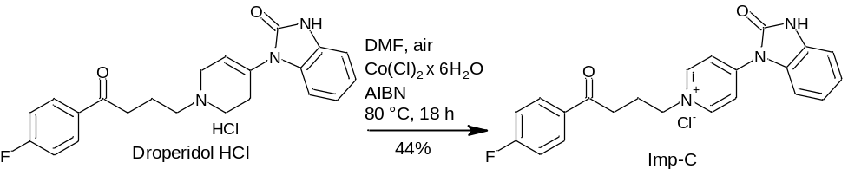
Scheme S1. Preparative synthesis pathway for the oxidative aromatization of droperidol hydrochloride to Imp-C.

A three-necked round-bottom flask equipped with a thermometer and a magnetic stirrer was connected through one neck to a mild vacuum line (950 mbar). Through the septum fitted to the second neck, a needle reaching to the bottom of the flask was inserted, and a small plug of loosely packed cotton wool was placed in the needle connector to allow gentle gas exchange.
Droperidol HCl (8.80 g, 21.16 mmol, 1.0 equiv), DMF (176 mL), and cobalt(II) chloride hexahydrate (CoCl₂·6H₂O, 252 mg, 1.06 mmol, 0.05 equiv) were added to the flask. The reaction mixture was heated to 80°C, after which azobisisobutyronitrile (AIBN, 500 mg, 3.04 mmol, 0.14 equiv) was added. The mixture was stirred at this temperature for 18 h under a continuous stream of air.
Upon completion, the reaction mixture was cooled to room temperature and acetone (260 mL) was added slowly. The resulting precipitate was collected by filtration, washed with acetone (3 × 10 mL), and dried in air to constant weight.
The product was obtained as a light green crystalline solid (3.84 g, 44% yield, 98.3% purity by HPLC, t_{R} = 14.4 min.).
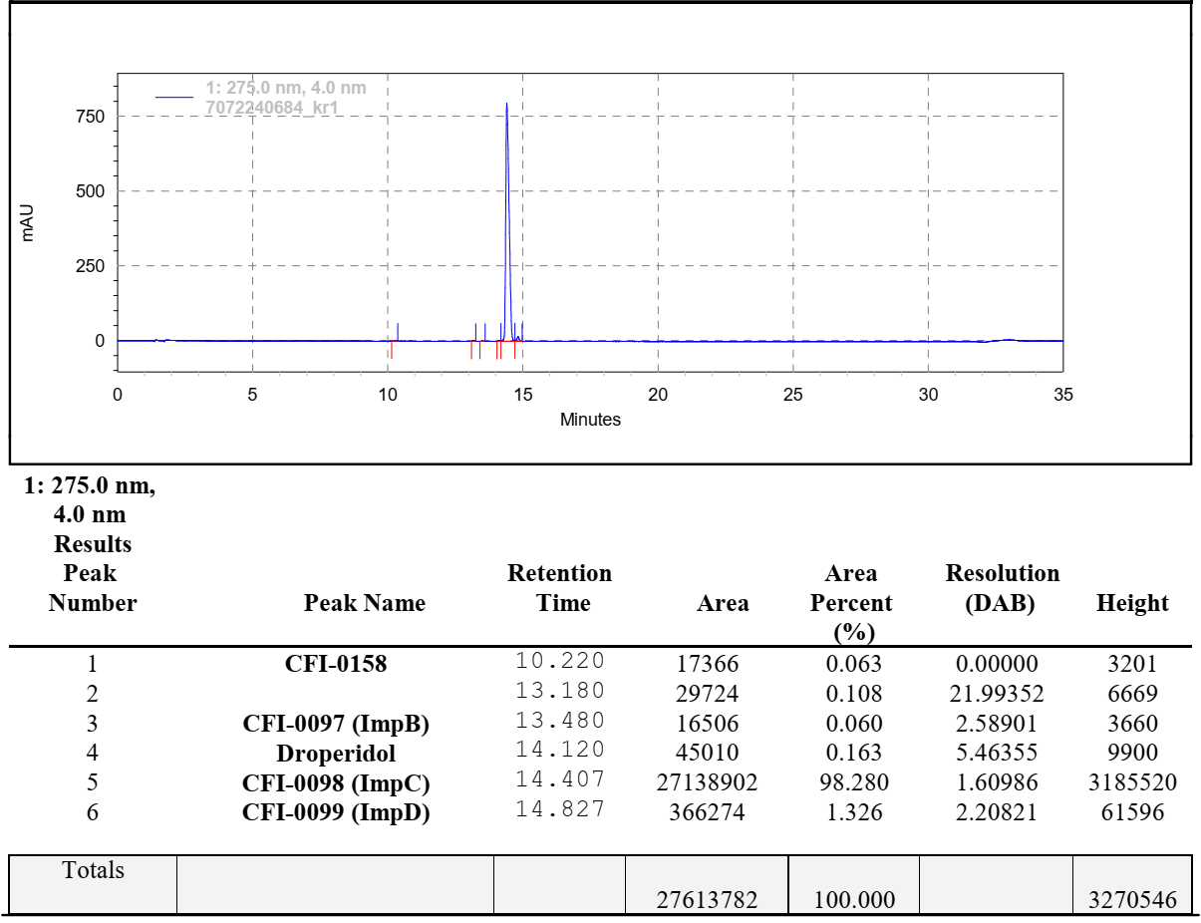
Figure S1. HPLC chromatogram of the isolated Imp-C reference standard.

MP = 265-266°C.
MS = 376.20 [M+H]⁺, expected: 376.15.
FTIR ν̄_{max} (cm⁻¹): 3551 (br, w, N–H), 3387 (br, w, N–H), 3086 (w, Ar–CH), 3033 (w, Ar–CH), 2972 (m, CH₂), 2872 (m, CH₂), 1723 (s, C=O, ketone), 1686 (s, C=O, lactam), 1635 (s, C=C/C=N, aromatic), 1595 (s, C=C, aromatic), 1506 (m, C–N/C=C, heteroaromatic), 1408 (m), 1332 (m, C–N), 1271 (m, C–F), 1211 (m, C–N), 1103 (m), 1033 (m), 840 (s, para-disubstituted Ar–CH), 760 (s, Ar–CH out-of-plane), 700 (s, Ar–CH out-of-plane).

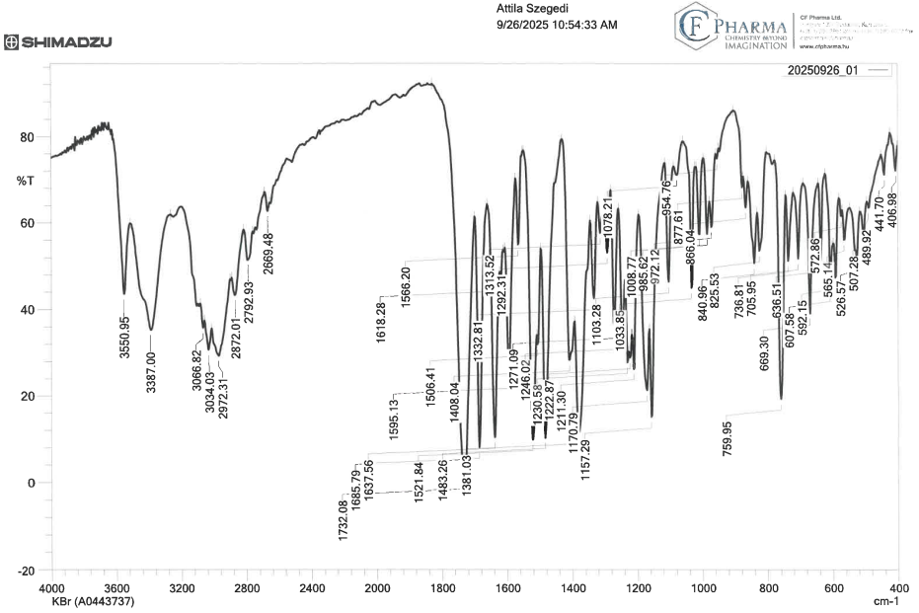
Figure S2. FTIR spectrum of the isolated Imp-C reference standard (KBr pellet).

¹H NMR (300 MHz, DMSO-d₆) δ 11.90 (s, 1H), 9.18 (d, J = 7.3 Hz, 2H), 8.47 (d, J = 6.9 Hz, 2H), 8.07 (dd, J = 8.9, 5.6 Hz, 2H), 7.59 (d, J = 7.9 Hz, 1H), 7.38 (t, J = 8.8 Hz, 2H), 7.30 – 7.11 (m, 3H), 4.70 (t, J = 7.4 Hz, 2H), 3.23 (t, J = 7.1 Hz, 2H), 2.31 (p, J = 6.8 Hz, 2H).
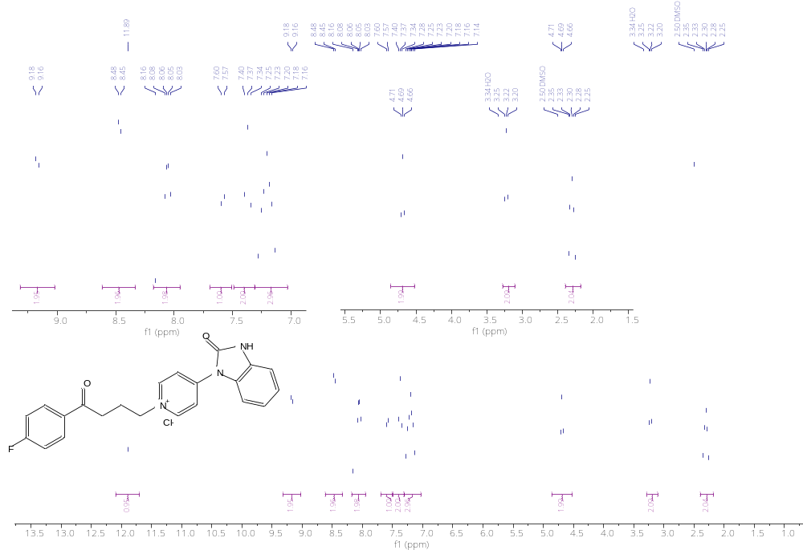
Figure S3. ¹H NMR spectrum (300 MHz, DMSO-d₆) of the isolated Imp-C reference standard.

¹³C NMR (75 MHz, DMSO-d₆) δ 198.21, 166.02 (d, J = 251.7 Hz), 152.98, 149.83, 146.79, 134.01 (d, J = 3.0 Hz), 131.87 (d, J = 9.6 Hz), 130.28, 127.71, 125.38, 122.50, 121.06, 116.67 (d, J = 22.0 Hz), 111.70, 111.19, 60.24, 35.47, 26.14.
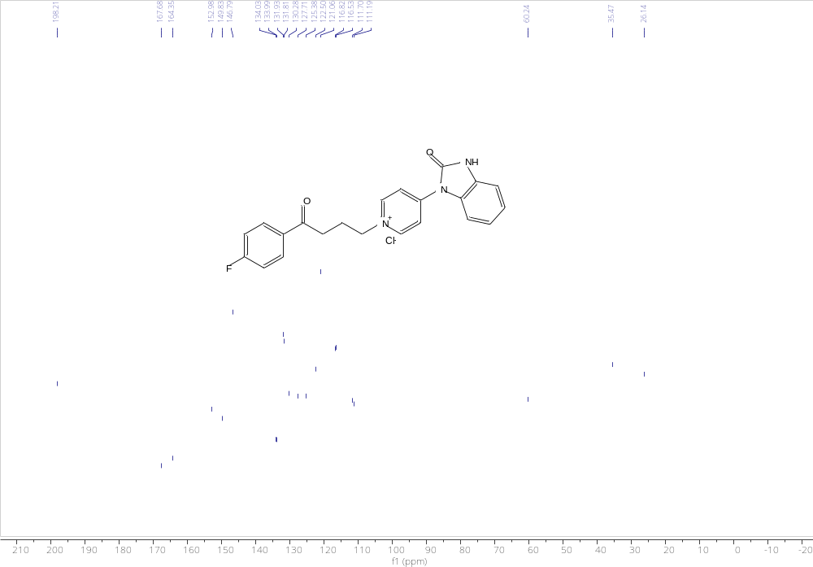
Figure S4. ¹³C NMR spectrum (75 MHz, DMSO-d₆) of the isolated Imp-C reference standard.

S2.2 Preparation of (rac)-1-[4-(4-fluorophenyl)-4-oxobutyl]-4-(2-oxo-2,3-dihydro-1H-benzimidazol-1-yl)-1,2,3,6-tetrahydropyridine-1-oxide (Imp-D)
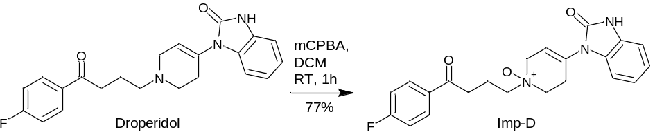
Scheme S2. Preparative synthesis pathway for the peroxide-mediated N-oxidation of droperidol to Imp-D.

A round-bottom flask equipped with a water condenser was charged with droperidol (2.00 g, 5.27 mmol, 1.00 equiv) and dissolved in dichloromethane (40.0 mL). To this solution, meta-chloroperbenzoic acid (mCPBA, 1.40 g, 5.27 mmol, 1.00 equiv, 77% purity) was added in one portion, and the reaction mixture was stirred for 1 h at room temperature. Saturated aqueous sodium bicarbonate solution (20 mL) was then added, and stirring was continued for an additional 90 min.
The resulting precipitate was collected by filtration, washed sequentially with dichloromethane (2 × 2 mL) and water (2 × 2 mL), and dried in a vacuum oven (0–5 mbar, 25°C) to constant weight.
The product was obtained as an off-white crystalline solid (1.60 g, 77% yield, 99.1% purity by HPLC, t_{R} = 14.6 min.).
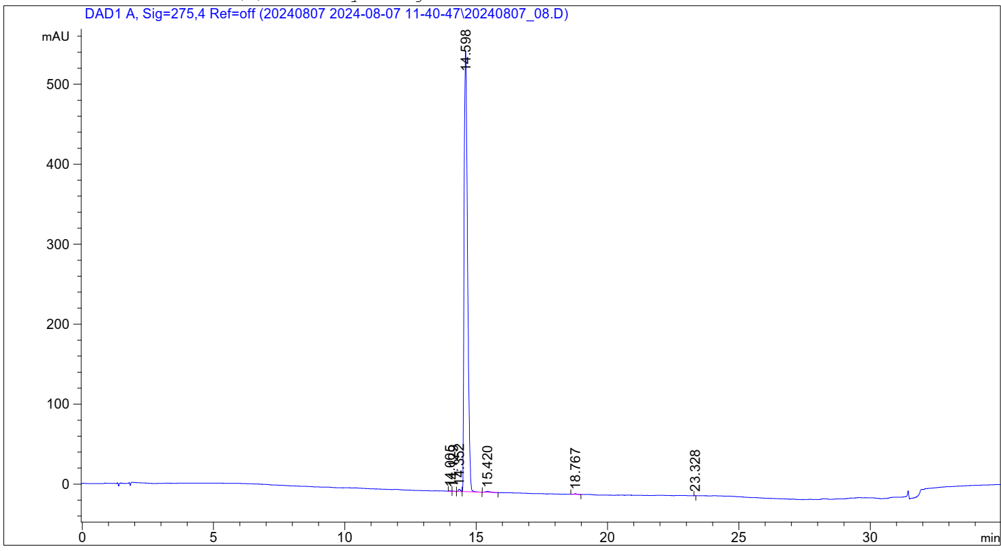
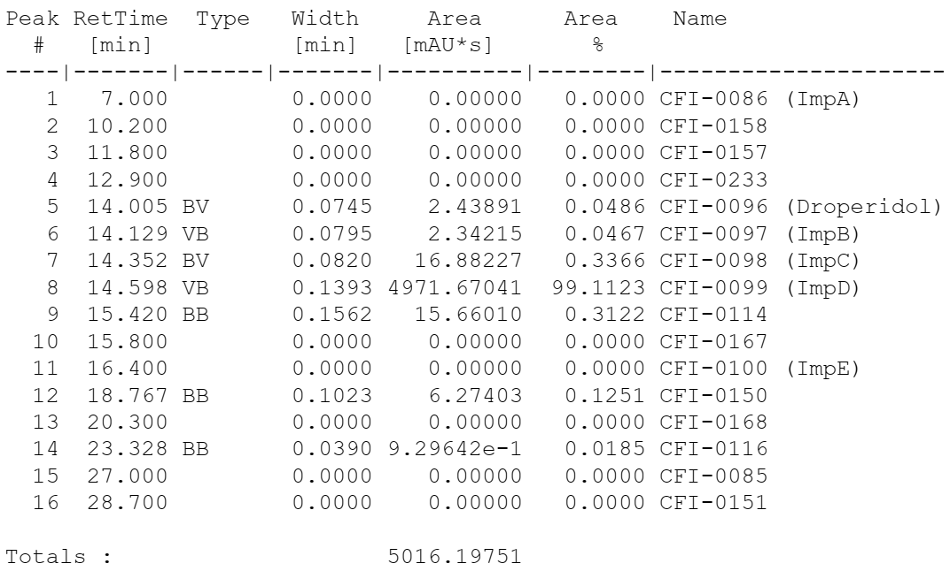
Figure S5. HPLC chromatogram of the isolated Imp-D reference standard.

MP = 116-118°C.
MS = 396.25 [M+H]⁺, expected: 396.17
FTIR ν̄_{max} (cm⁻¹): 3369 (br, w, N–H), 3072 (w, Ar–CH), 2938 (m, CH₂), 2865 (m, CH₂), 2780 (w), 1703 (s, C=O, ketone), 1681 (s, C=O, lactam), 1622 (m, C=N/C=C, aromatic), 1597 (m, C=C, aromatic), 1506 (m, C–N/C=C), 1487 (m), 1406 (m), 1336 (m, N→O or C–N stretch), 1300 (m, C–N/C–F), 1249 (m, C–F), 1228 (m, C–N), 1178 (m), 1157 (m), 1103 (m, C–N/C–O), 1046 (m), 974 (m), 885 (m), 827 (s, para-substituted Ar–CH), 754 (s, Ar–CH out-of-plane), 706 (s, Ar–CH out-of-plane), 607 (m), 525 (m), 490 (w).
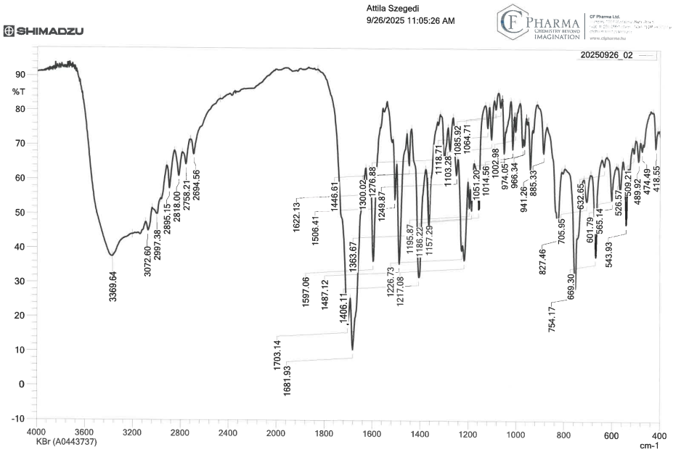
Figure S6. FTIR spectrum of the isolated Imp-D reference standard (KBr pellet).

¹H NMR (300 MHz, DMSO- d₆) δ 11.29 (s, 1H), 8.07 (dd, J = 8.9, 5.6 Hz, 2H), 7.37 (t, J = 8.9 Hz, 2H), 7.13 (d, J = 8.0 Hz, 1H), 7.01 (s, 2H), 6.97 (d, J = 6.4 Hz, 1H), 5.79 (s, 1H), 4.18 (d, J = 17.3 Hz, 1H), 3.79 (d, J = 17.3 Hz, 1H), 3.55 – 3.43 (m, 2H, overlapped with H₂O signal), 3.44 – 3.25 (m, 2H, under the H₂O signal) 3.22 (t, J = 6.9 Hz, 2H, overlapped with H₂O signal), 3.10 – 2.92 (m, 1H), 2.66 – 2.52(m, 1H), 2.34 – 2.13 (m, 2H).
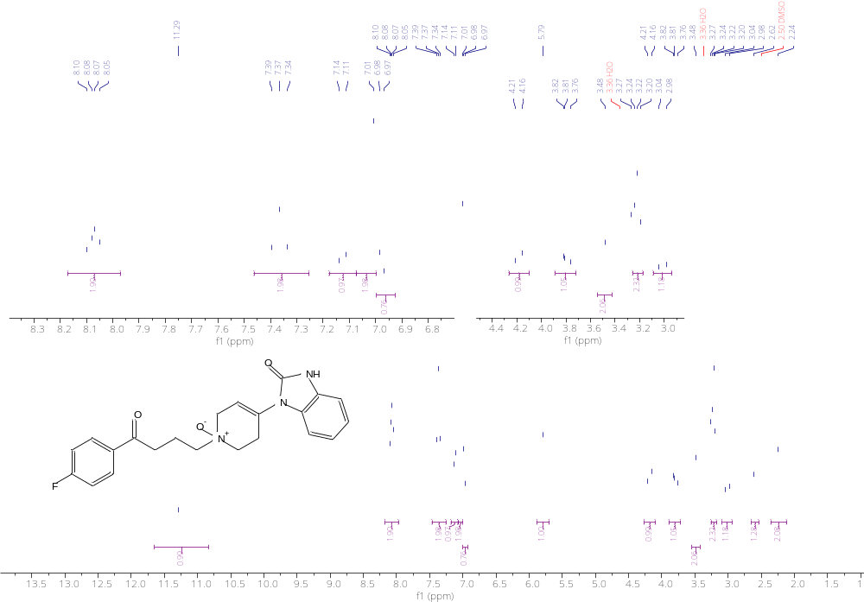
Figure S7. ¹H NMR spectrum (300 MHz, DMSO-d₆) of the isolated Imp-D reference standard.

¹³C NMR (75 MHz, DMSO-d₆) δ 198.92, 165.93 (d, J = 251.5 Hz), 154.15, 134.27, 131.81 (d, J = 9.5 Hz), 130.93, 130.64, 129.94, 122.33, 121.38, 118.61, 116.62 (d, J = 21.8 Hz), 110.01, 109.54, 68.55, 65.27, 61.81, 36.51, 24.45, 17.84.
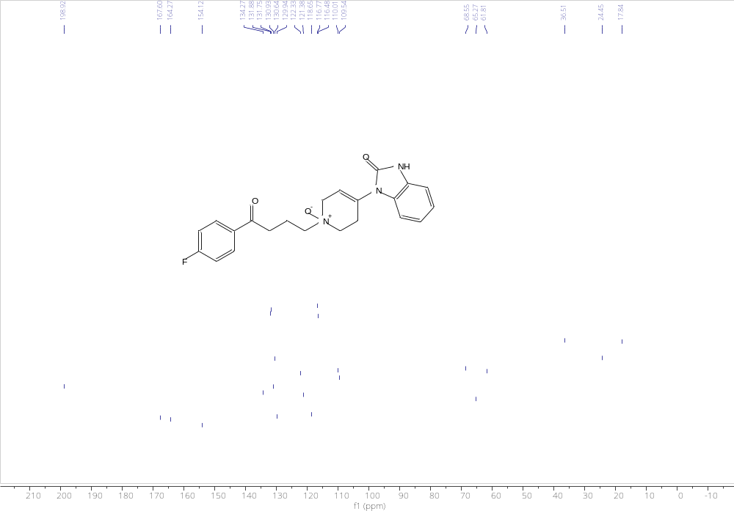
Figure S8. ¹³C NMR spectrum (75 MHz, DMSO-d₆) of the isolated Imp-D reference standard.

S2.3 Preparation of 1-(1-(4-(4-(4-(2-oxo-2,3-dihydro-1H-benzo[d]imidazol-1-yl)-3,6-dihydropyridin-1(2H)-yl)butanoyl)phenyl)-1,2,3,6-tetrahydropyridin-4-yl)-1,3-dihydro-2H-benzo[d]imidazol-2-one (Imp E)
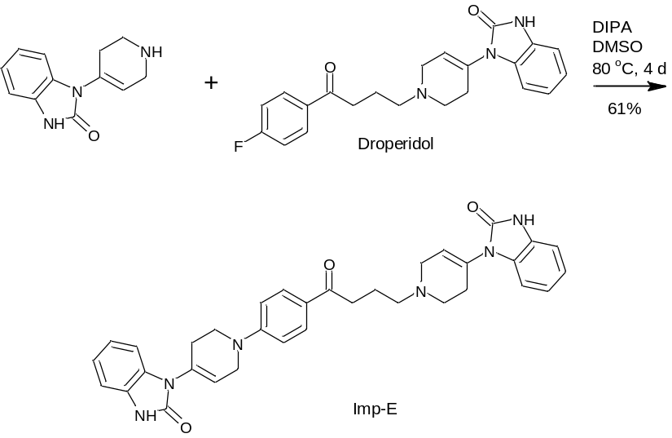
Scheme S3. Preparative synthesis pathway for the consecutive nucleophilic aromatic substitution forming Imp-E.

A round-bottom flask equipped with an oil bath was charged with droperidol (3.89 g, 10.0 mmol, 1.0 equiv), 1-(1,2,3,6-tetrahydropyridin-4-yl)-1,3-dihydro-2H-benzimidazol-2-one (4.30 g, 20.0 mmol, 2.0 equiv), DMSO (20 mL), and diisopropylamine (2.80 mL, 20.0 mmol, 2.0 equiv). The reaction mixture was stirred at 80°C for 2 days. An additional portion of diisopropylamine (2.80 mL, 20.0 mmol, 2.0 equiv) was then added, and stirring was continued for another 2 days at the same temperature.
After completion, the reaction mixture was cooled to room temperature, and methanol (100 mL) was added with stirring. After 20 min, the precipitated solid was collected by filtration, washed with methanol (20 mL), and air-dried. The crude product was suspended in dichloromethane (100 mL), stirred for 2 h, filtered, washed with dichloromethane (20 mL), and air-dried to constant weight.
The product was obtained as tan-colored crystals (3.49 g, 6.1 mmol, 61% yield, 84.9% purity by HPLC, t_{R} = 16.3 min).
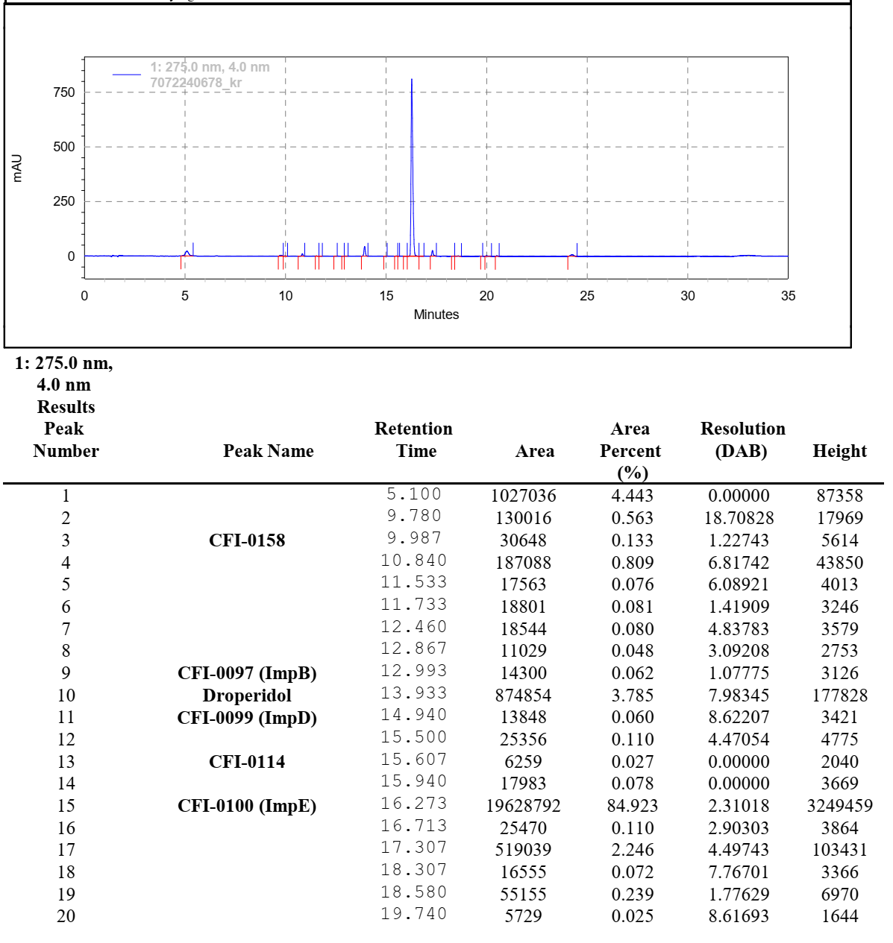
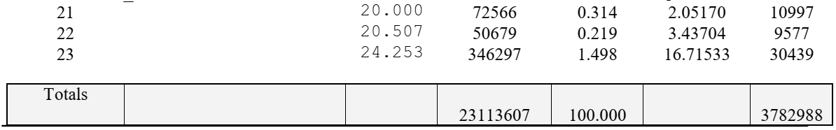
Figure S9. HPLC chromatogram of the isolated Imp-E reference standard.

Preparation of analytical sample:
The crude product (3.49 g) was dissolved in hot ethanol (70 mL) with stirring, then slowly cooled to room temperature. The recrystallized material was collected by filtration, washed with ethanol (3 × 7 mL), and dried in a vacuum oven (0–5 mbar, 25°C) to constant weight.
The purified product was obtained as tan crystals (2.44 g, 70% recovery, 95.8% purity by HPLC, t_{R} = 16.3 min).
MP = approx. 175°C (decomposition)
MS = 575.40 [M+H]⁺, expected: 575.28
FTIR ν̄_{max} (cm⁻¹): 3391 (br, w, N–H), 3172 (w, Ar–CH), 3136 (w, Ar–CH), 3091 (w, Ar–CH), 3014 (w, Ar–CH), 2916 (m, CH₂), 2852 (m, CH₂), 2757 (w), 1697 (s, C=O, lactam/amide), 1624 (s, C=O/C=N, conjugated carbonyl/heteroaromatic), 1601 (m, aromatic C=C/C=N), 1554 (m), 1425 (m), 1382 (m), 1286 (m, C–N/C–O), 1222 (m), 1184 (m), 1103 (m), 1008 (m), 960 (m), 887 (m), 746 (s, para/aryl C–H out-of-plane), 731 (s, Ar–CH out-of-plane), 673 (m), 609 (m), 574 (w), 507 (w).
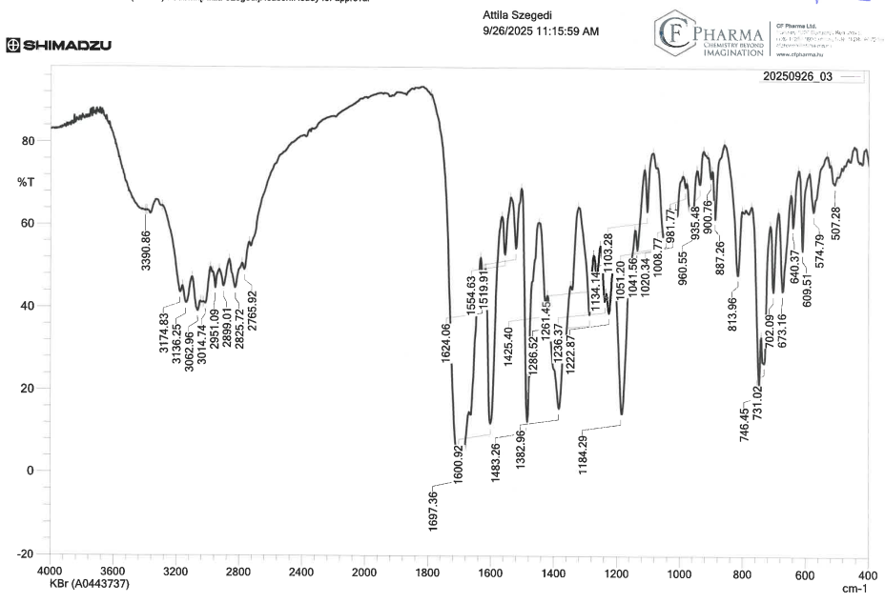
Figure S10. FTIR spectrum of the isolated Imp-E analytical reference standard (KBr pellet).
¹H NMR (300 MHz, DMSO- d₆) δ 10.99 (s, 1H), 10.91 (s, 1H), 7.89 (d, J = 8.8 Hz, 2H), 7.26 – 6.79 (m, 10H), 6.05 (s, 1H), 5.86 (s, 1H), 4.09 (s, 2H), 3.72 (t, J = 5.8 Hz, 2H), 3.13 (s, 2H), 2.96 (t, J = 7.1 Hz, 2H), 2.76 – 2.58 (m, 4H), 2.58 – 2.45 (m, 2H, under the DMSO signal), 2.45 – 2.33 (m, 2H), 1.85 (t, J = 6.8 Hz, 2H).
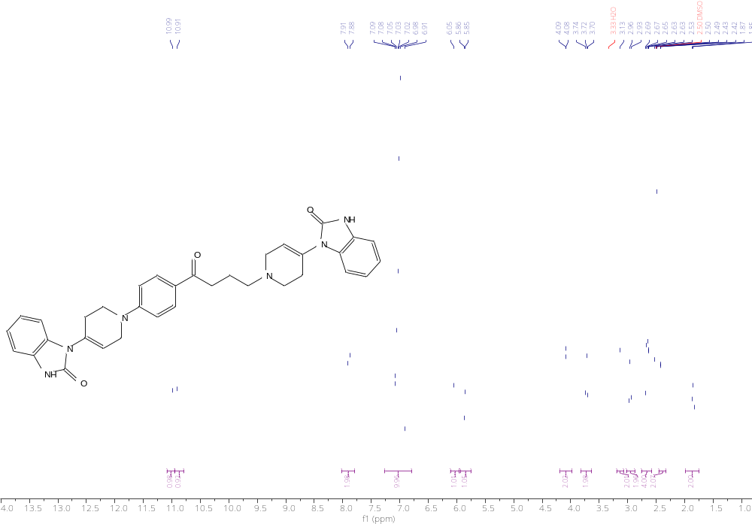
Figure S11. ¹H NMR spectrum (300 MHz, DMSO-d₆) of the isolated Imp-E analytical reference standard.

¹³C NMR (75 MHz, DMSO-d₆ + 1 eq. conc. HCl) δ 197.27, 153.98, 153.87, 153.72, 131.66, 131.42, 130.97, 130.67, 130.57, 129.55, 129.52, 126.77, 122.76, 122.64, 122.40, 121.70, 118.89, 113.71, 110.06, 110.00, 109.50, 55.53, 49.67, 48.89, 46.70, 44.40, 35.38, 27.45, 24.63, 19.43.
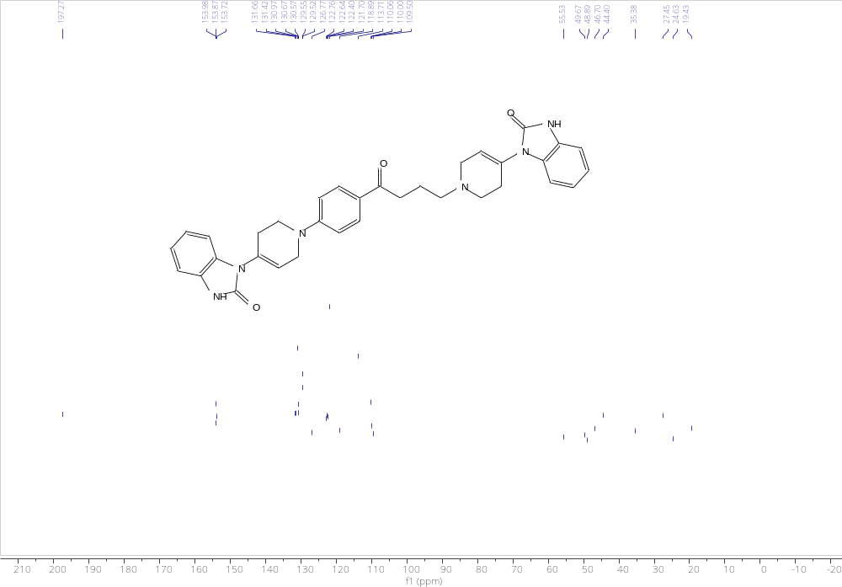
Figure S12. ¹³C NMR spectrum (75 MHz, DMSO-d₆ + 1 eq. conc. HCl) of the isolated analytical Imp-E reference standard.

