Urban mammals in Italy: the hidden role of common species in structuring communities

MAMMALIAN BIOLOGY
Limonciello L.^{1,2,3}, Mirone E^{2,3}., Avramo V.^{2,3}, Jamwal Singh P.^{2,3}, Ieraci G.⁴, Coccia C.⁴, Mori E.^{2,5}, Ancillotto L. ^{2,5}, Viviano A.⁵, Di Febbraro M.³, Loy A.^{2,3}
- Department of Earth and Marine Sciences, University of Palermo, Via Archirafi 22, 90123, Palermo, Italy.
- NBFC, National Future Biodiversity Centre, Piazza Marina, 61, 90133, Palermo, Italy.
- Envix Lab, Department of Biosciences and Territory, University of Molise, 96090 Pesche, Isernia, Italy.
- Department of Environmental Biology, Sapienza University, Piazzale Aldo Moro 5, 00185 Rome, Italy.
- Research Institute on Terrestrial Ecosystems (IRET), National Research Council of Italy (CNR), Via Madonna del Piano 10, 50019, Sesto Fiorentino (FI), Italy.
Corresponding author: Vasco Avramo, vasco.avramo@gmail.com

SUPPLEMENTARY FILES

ONLINE RESOURCE 1: Target species list
We focused on medium- and large-sized mammals. Rather than applying a strict body-mass threshold, we excluded micromammals (principally small rodents and shrews, which generally require dedicated sampling protocols) while retaining borderline-sized taxa such as the European hedgehog (Erinaceus europaeus) and the eastern cottontail (Sylvilagus floridanus). We considered species regularly present in Italy and potentially occurring in the study areas, for a total of 21 target species, distributed across the orders Carnivora (10 species), Artiodactyla (6 species), Eulipotyphla (1 species), Lagomorpha (2 native and 1 alien species), and Rodentia (1 species). The complete species list is provided in Table S1.
Order | Species | Order | Species
Carnivora | Canis lupus | Artiodactyla | Capreolus capreolus
Carnivora | Canis lupus familiaris | Artiodactyla | Cervus elaphus
Carnivora | Martes foina | Artiodactyla | Dama dama
Carnivora | Martes martes | Artiodactyla | Ovis aries
Carnivora | Meles meles | Artiodactyla | Sus scrofa
Carnivora | Felis catus | Eulipotyphla | Erinaceus europaeus
Carnivora | Felis silvestris | Lagomorpha | Lepus europaeus
Carnivora | Mustela nivalis | Lagomorpha | Oryctolagus cuniculus
Carnivora | Mustela putorius | Lagomorpha | Sylvilagus floridanus
Carnivora | Vulpes vulpes | Rodentia | Hystrix cristata
Artiodactyla | Bos taurus

Table S1. Complete target species list, with species listed by order.

ONLINE RESOURCE 2: Sampling design
We relied on a standardised design shared across the working groups of the National Biodiversity Future Centre (NBFC) – Spoke Urban. The study areas were divided into 1 × 1 km² grid cells, each characterised by a combination of green-area extent and fragmentation gradients, resulting in 16 cell categories. Green areas included all vegetated surfaces except agricultural land, based on the Land Cover and Land Use layers provided by ISPRA (2021 National Maps).
The extent of green areas was calculated as the cumulative area of all green patches intersecting a cell. Each cell was then assigned to one of the classes A–D (A: 0–0.02 km², B: 0.02–0.24 km², C: 0.24–1 km², D: >1 km²). An Aggregation Index (AI) for green-area fragmentation was computed within a 1.5 km radius circular buffer centred on the cell centroid. The index ranges from 0 to 100, with 0 indicating extreme fragmentation and 100 indicating no fragmentation. Cells were then assigned to classes 1–4 based on AI: 1 (<67, highly fragmented), 2 (67–73), 3 (73–81), and 4 (>81, minimally fragmented) (Dondina et al. 2025).
The final selection comprised 48 cells and 48 camera-trap sites: 11 in Milan, 14 in Florence, 14 in Rome, and 9 in Campobasso. Table S2 provides additional information for each grid cell.

Cell ID | Study Area | Green cover area (km²) | Green cover category | Green fragmentation index (AI) | Green fragmentation category | Cell Category | CT latitude | CT longitude
1184 | MI | 0.117185 | B | 55.59 | 1 | B1 | 45,40900 | 9,050600
1282 | MI | 0.145402 | B | 71.83 | 2 | B2 | 45,43386 | 9,077583
1041 | MI | 0.179138 | B | 76.09 | 3 | B3 | 45,44978 | 9,010441
1191 | MI | 0.095873 | B | 81.89 | 4 | B4 | 45,46773 | 9,048679
897 | MI | 0.282706 | C | 64.98 | 1 | C1 | 45,56076 | 8,966732
1049 | MI | 0.279198 | C | 69.13 | 2 | C2 | 45,52375 | 9,015411
1659 | MI | 0.51269 | C | 71.84 | 2 | C2 | 45,47393 | 9,181100
1570 | MI | 0.698538 | C | 78.25 | 3 | C3 | 45,50869 | 9,150497
893 | MI | 0.91913 | C | 81.18 | 4 | C4 | 45,51899 | 8,972986
405 | MI | 6378074 | D | 96.73 | 4 | D4 | 45,40959 | 8,850228
1380 | MI | 1711755 | D | 83.54 | 4 | D4 | 45,48586 | 9,098554
1948 | FI | 0.160405 | B | 72,08 | 2 | B2 | 43,83533 | 11,16804
3064 | FI | 0.145894 | B | 79.28 | 3 | B3 | 43,77983 | 11,33802
3150 | FI | 0.108894 | B | 83.29 | 4 | B4 | 43,77643 | 11,34992
2372 | FI | 0.307401 | C | 66.24 | 1 | C1 | 43,79468 | 11,23724
1940 | FI | 0.313912 | C | 69.71 | 2 | C2 | 43,75765 | 11,17579
2117 | FI | 0.783221 | C | 72.04 | 2 | C2 | 43,82141 | 11,19904
2034 | FI | 0.559317 | C | 75.99 | 3 | C3 | 43,84558 | 11,18421
2977 | FI | 0.313387 | C | 78.91 | 3 | C3 | 43,77503 | 11,32198
1945 | FI | 0.811942 | C | 82.35 | 4 | C4 | 43,80268 | 11,18028
2199 | FI | 1367032 | D | 77.87 | 3 | D3 | 43,78687 | 11,20946
2460 | FI | 2704757 | D | 80.20 | 3 | D3 | 43,81868 | 11,24136
1536 | FI | 2102794 | D | 82.46 | 4 | D4 | 43,76155 | 11,10604
2294 | FI | 499741847 | D | 97.70 | 4 | D4 | 43,86546 | 11,22460
2893 | FI | 1883311 | D | 86.74 | 4 | D4 | 43,80478 | 11,30557
2462 | RM | 0.158711 | B | 57.83 | 1 | B1 | 41,79798 | 12,37901
3411 | RM | 0.183562 | B | 71.76 | 2 | B2 | 41,90337 | 12,52099
4003 | RM | 0.138274 | B | 77.34 | 3 | B3 | 41,91316 | 12,58472
3612 | RM | 0.193496 | B | 79.36 | 3 | B3 | 41,99616 | 12,53891
2875 | RM | 0.226149 | B | 84.02 | 4 | B4 | 41,90954 | 12,44139
4015 | RM | 0.166687 | B | 85.91 | 4 | B4 | 42,01717 | 12,58742
3503 | RM | 0.298001 | C | 66.91 | 1 | C1 | 41,87336 | 12,52425
3045 | RM | 0.844293 | C | 72.62 | 2 | C2 | 41,89277 | 12,46268
3224 | RM | 0.639985 | C | 73.08 | 3 | C3 | 41,88321 | 12,49573
3912 | RM | 0.615309 | C | 88.12 | 4 | C4 | 42,01247 | 12,58529
3227 | RM | 0.991327 | C | 82.93 | 4 | C4 | 41,91462 | 12,49035
3220 | RM | 1446 | D | 72.51 | 2 | D2 | 41,84754 | 12,49531
3605 | RM | 1249 | D | 80.63 | 3 | D3 | 41,93256 | 12,54688
2873 | RM | 3353 | D | 86.97 | 4 | D4 | 41,88478 | 12,44565
1720 | CB | 0.228377 | B | 70.25 | 2 | B2 | 41,57749 | 14,69256
1721 | CB | 0.174764 | B | 78.09 | 3 | B3 | 41,59298 | 14,69659
1806 | CB | 0.147345 | B | 85.95 | 4 | B4 | 41,58717 | 14,70780
1473 | CB | 0.489465 | C | 72.26 | 2 | C2 | 41,56602 | 14,65434
1472 | CB | 0.346084 | C | 77.19 | 3 | C3 | 41,55583 | 14,64847
1395 | CB | 0.414519 | C | 87.79 | 4 | C4 | 41,58271 | 14,64607
1632 | CB | 1499501 | D | 70.58 | 2 | D2 | 41,53784 | 14,67930
1550 | CB | 1566705 | D | 77.78 | 3 | D3 | 41,53992 | 14,66932
1159 | CB | 22946103 | D | 97.88 | 4 | D4 | 41,54576 | 14,60430
Table S2. Gridcells selected for the study, listed by Study Area (MI = Milan, FI = Florence, RM = Rome, CB = Campobasso) and ID, with absolute and categorical values of green cover and green fragmentation. For the green cover gradient, categories range from A (lowest cover; category included in the sampling design but not represented in this dataset) to D (highest cover). For the green fragmentation gradient, categories span from 1 (most fragmented) to 4 (least fragmented). These two categories are then combined in the “Cell Category” column. The two columns on the right show the coordinates of the camera traps placed in each cell.

ONLINE RESOURCE 3: Species’ independent detections
We recorded a total of 24 mammal species (18 native, 3 domestic, and 3 exotic) over 8,759 trap-days. Because pine and stone martens were pooled as Martes spp., Table S3 contains 23 taxonomic entries. For each entry, the table reports the number of independent detection events.
Common name | Scientific name | # of ind. obs.  Independent detections | Common name | Scientific name | # of ind. obs.  Independent detections
Grey Wolf | Canis lupus | 18 | House mouse | Mus musculus | 30
Domestic dog | Canis lupus familiaris | 1649 | Least weasel | Mustela nivalis | 1
Roe deer | Capreolus capreolus | 239 | Western polecat | Mustela putorius | 6
Red deer | Cervus elaphus | 2 | Coypu | Myocastor coypus | 3
Fallow deer | Dama dama | 26 | Domestic sheep | Ovis aries | 24
European hedgehog | Erinaceus europaeus | 259 | Rats | Rattus spp. | 86
Domestic cat | Felis catus | 742 | Grey squirrel | Sciurus carolinensis | 604
Wild cat | Felis silvestris | 1 | Red squirrel | Sciurus vulgaris | 100
Crested porcupine | Hystrix cristata | 669 | Wild boar | Sus scrofa | 3678
European hare | Lepus europaeus | 204 | Eastern cottontail rabbit | Sylvilagus floridanus | 816
Pine and stone martens | Martes spp. | 104 | Red fox | Vulpes vulpes | 3003
European badger | Meles meles | 446

Table S3. Number of independent observations for the 24 mammal species detected in the study. Pine and stone martens were pooled as Martes spp.; therefore, the table contains 23 taxonomic entries. Entries are listed alphabetically by scientific name. Species included in the statistical analyses are underlined.

ONLINE RESOURCE 4: Species accumulation curves
The sampling effort varied among study areas due to personnel availability, ranging from 8 to 24 months of camera-trap activity. Devices were active from early May to the end of December 2024 in Milan; from early January 2023 to December 2024 in Florence (with intermittent sampling); from mid-March to December 2024 in Rome; and from January to mid-November 2024 in Campobasso.
Species accumulation curves were generated for all mammal species detected in the study to assess whether sampling effort was sufficient to capture species diversity in each study area. Curves were built using the vegan R package (Oksanen et al. 2008) and illustrate the relationship between species richness and sampling effort in the four cities.
The results suggest that Campobasso (CB) and Rome (RM) were sampled sufficiently to capture local diversity, whereas Milan (MI) and Florence (FI) could have benefited from a longer sampling period. Additional data collection is ongoing in the latter two cities and will be included in future analyses.
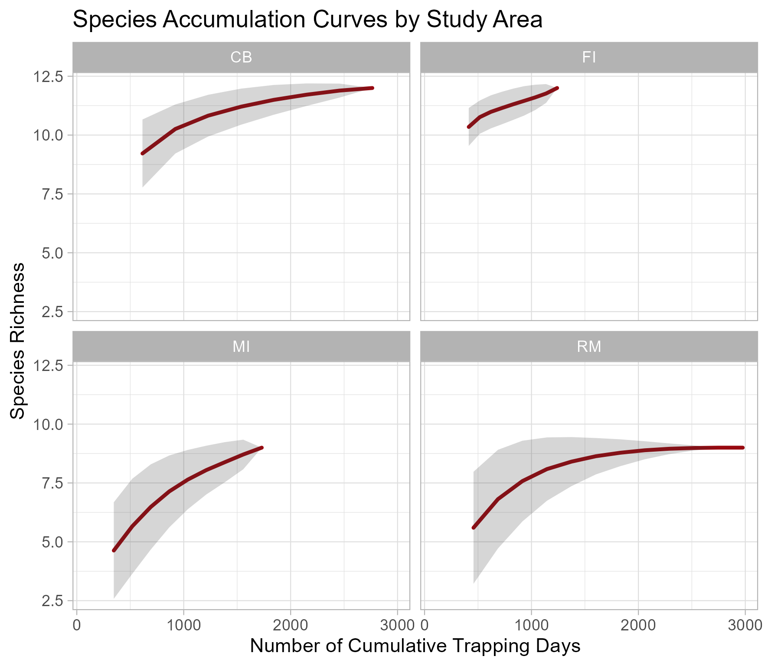
Figure S4. Species accumulation curves for all mammal species detected in each study area, illustrating the relationship between sampling effort (trap-days) and estimated species richness.

ONLINE RESOURCE 5: PERMANOVA results
We tested for differences in mean species observation frequencies using a PERMANOVA approach. Four tests were performed by grouping grid cells according to a different variable in each analysis: Study Area, Green Cover, Green Fragmentation, and Cell Category. Additionally, we performed pairwise comparisons for group dispersion (Tukey HSD test) and centroid separation (pairwise PERMANOVA).
This section presents the graphical results for the three grouping variables for which differences in mean species observation frequency were not significant: Green Cover, Green Fragmentation, and Cell Category. It also presents the pairwise-comparison results for each PERMANOVA test.
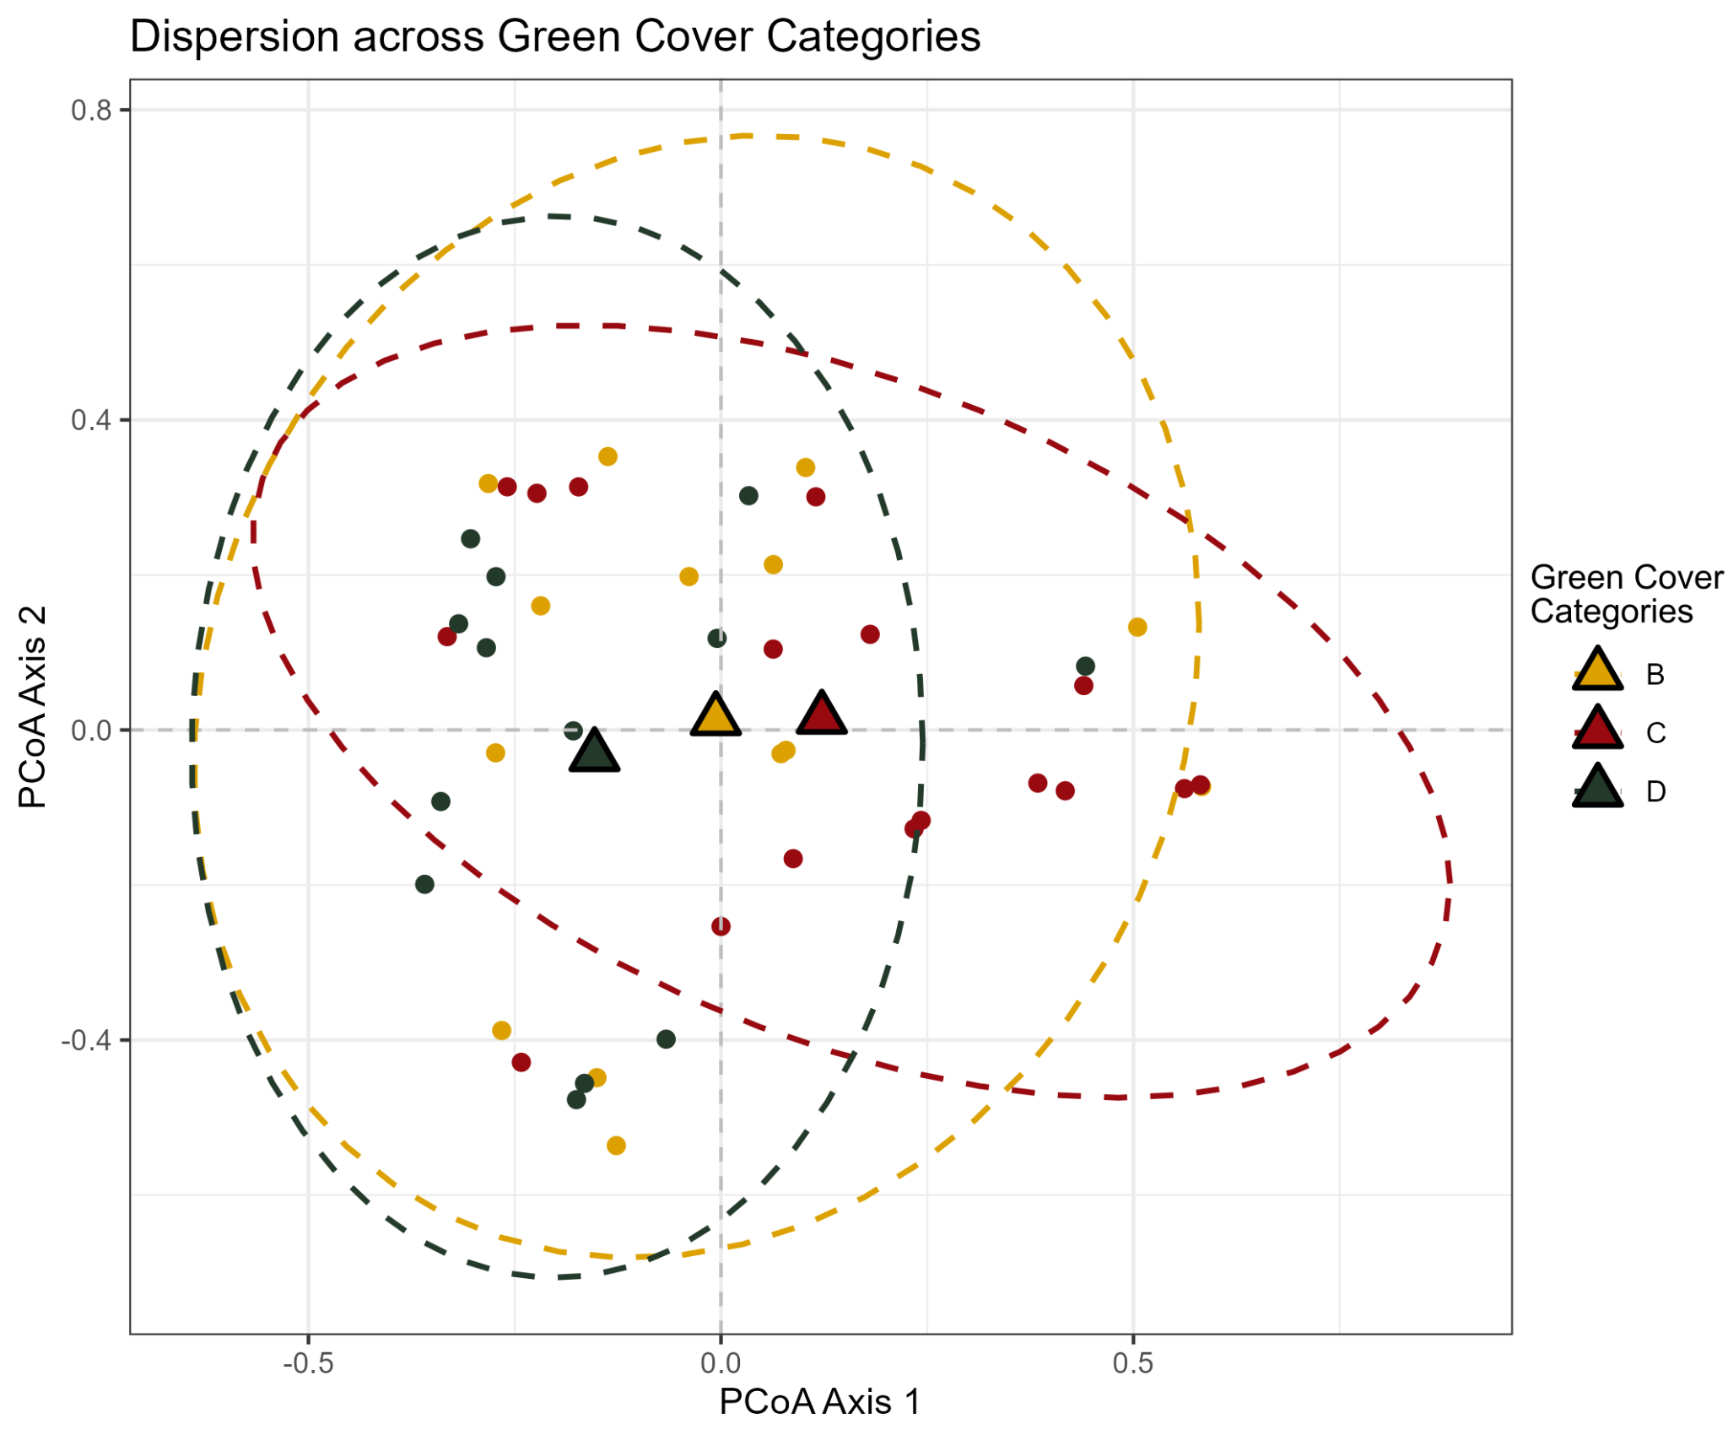
Figure S5a. Dispersion plot for the 48 sites grouped by Green Cover category.
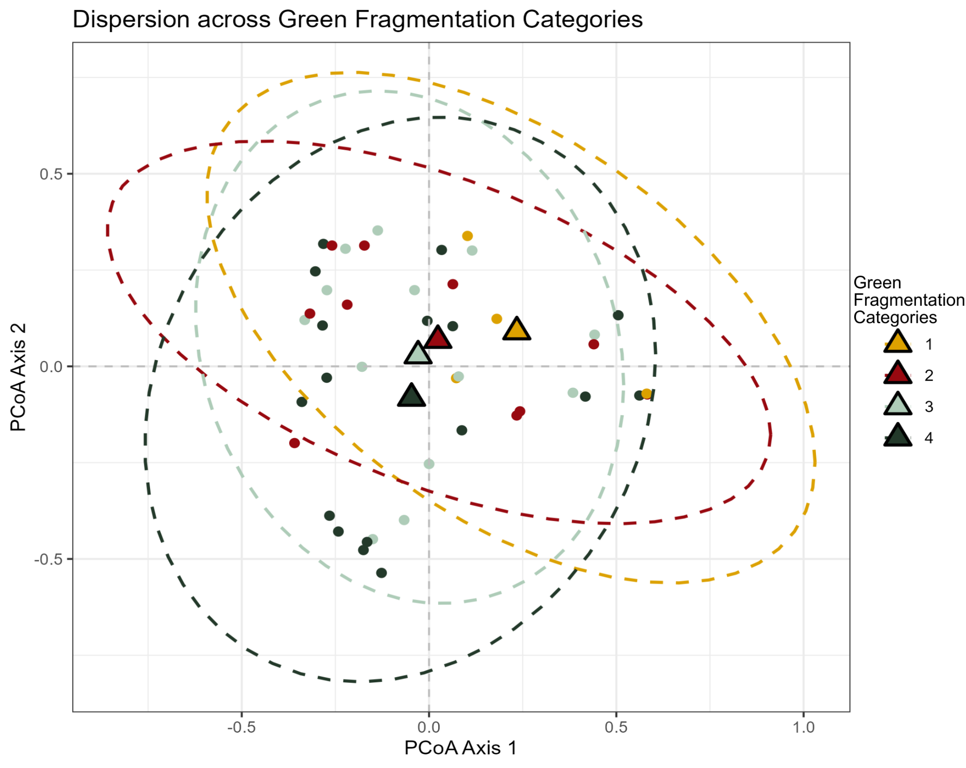
Figure S5b. Dispersion plot for the 48 sites grouped by Green Fragmentation category.
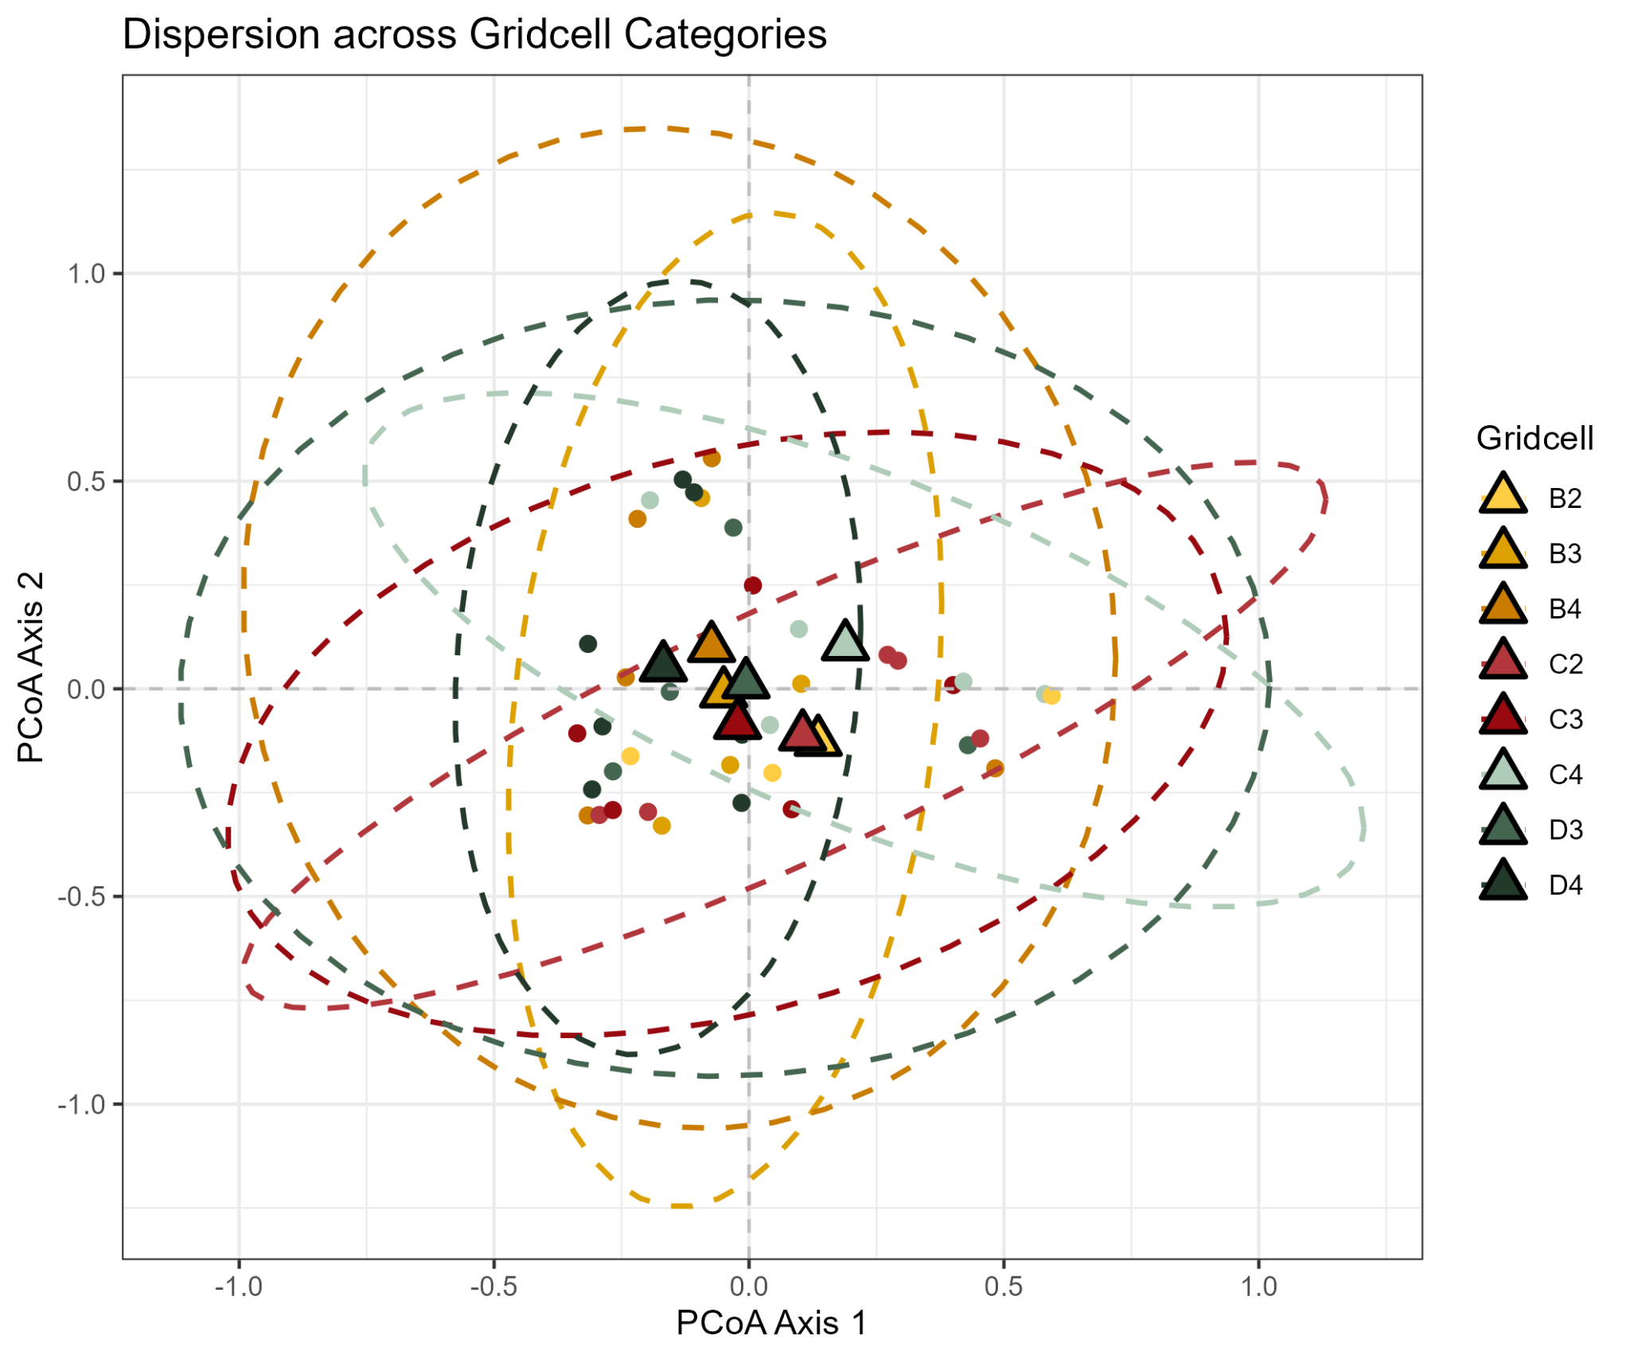
Figure S5c. Dispersion plot for the 48 sites grouped by grid-cell category.
pairs | Df | SumsOfSqs | F.Model | R² | p.value | p.adjusted
CELL CATEGORIES
B2 vs B3 | 1 | 0.3771158 | 1.0219359 | 0.1697022 | 0.470 | 1
B2 vs B4 | 1 | 0.2353409 | 0.6230264 | 0.0940697 | 0.727 | 1
B2 vs C2 | 1 | 0.2325475 | 0.5858204 | 0.0889518 | 0.710 | 1
B2 vs C3 | 1 | 0.1655735 | 0.3963087 | 0.0619590 | 0.934 | 1
B2 vs C4 | 1 | 0.2179218 | 0.4602244 | 0.0712397 | 1.000 | 1
B2 vs D3 | 1 | 0.2243485 | 0.4956670 | 0.0901923 | 0.918 | 1
B2 vs D4 | 1 | 0.3659406 | 1.0368262 | 0.1147334 | 0.387 | 1
B3 vs B4 | 1 | 0.4130436 | 1.3100592 | 0.1576474 | 0.213 | 1
B3 vs C2 | 1 | 0.5117693 | 1.5425779 | 0.1805752 | 0.145 | 1
B3 vs C3 | 1 | 0.3939123 | 1.1267014 | 0.1386419 | 0.335 | 1
B3 vs C4 | 1 | 0.6197349 | 1.5595602 | 0.1822010 | 0.077 | 1
B3 vs D3 | 1 | 0.4065529 | 1.1069336 | 0.1557540 | 0.362 | 1
B3 vs D4 | 1 | 0.2876812 | 0.9366934 | 0.0942661 | 0.486 | 1
B4 vs C2 | 1 | 0.4703930 | 1.3715773 | 0.1463550 | 0.239 | 1
B4 vs C3 | 1 | 0.3477526 | 0.9698070 | 0.1081190 | 0.484 | 1
B4 vs C4 | 1 | 0.3452204 | 0.8622506 | 0.0972948 | 0.499 | 1
B4 vs D3 | 1 | 0.2083442 | 0.5555853 | 0.0735331 | 0.781 | 1
B4 vs D4 | 1 | 0.1346264 | 0.4226302 | 0.0405493 | 0.885 | 1
C2 vs C3 | 1 | 0.3991144 | 1.0700238 | 0.1179736 | 0.369 | 1
C2 vs C4 | 1 | 0.4818942 | 1.1617845 | 0.1268077 | 0.319 | 1
C2 vs D3 | 1 | 0.3149492 | 0.8045183 | 0.1030837 | 0.556 | 1
C2 vs D4 | 1 | 0.5638714 | 1.7082995 | 0.1459050 | 0.105 | 1
C3 vs C4 | 1 | 0.3423684 | 0.7954482 | 0.0904386 | 0.654 | 1
C3 vs D3 | 1 | 0.2012232 | 0.4915931 | 0.0656193 | 0.875 | 1
C3 vs D4 | 1 | 0.2770214 | 0.8086451 | 0.0748147 | 0.625 | 1
C4 vs D3 | 1 | 0.3582187 | 0.7836921 | 0.1006839 | 0.773 | 1
C4 vs D4 | 1 | 0.5284701 | 1.4054737 | 0.1232280 | 0.158 | 1
D3 vs D4 | 1 | 0.2551931 | 0.7217657 | 0.0742422 | 0.737 | 1
GREEN COVER CATEGORIES
B vs C | 1 | 0.4415478 | 1.168310 | 0.0387264 | 0.297 | 0.891
B vs D | 1 | 0.3404165 | 1.041272 | 0.0399854 | 0.432 | 1.000
C vs D | 1 | 0.7441473 | 2.026555 | 0.0674921 | 0.027 | 0.081
GREEN FRAGMENTATION CATEGORIES
2 vs 3 | 1 | 0.2979554 | 0.8180116 | 0.0374925 | 0.570 | 1.000
2 vs 4 | 1 | 0.4297806 | 1.1972728 | 0.0457022 | 0.270 | 1.000
2 vs 1 | 1 | 0.4386492 | 1.2042347 | 0.0912006 | 0.297 | 1.000
3 vs 4 | 1 | 0.3536299 | 0.9740210 | 0.0336170 | 0.463 | 1.000
3 vs 1 | 1 | 0.3528127 | 0.9513810 | 0.0596425 | 0.497 | 1.000
4 vs 1 | 1 | 0.5478921 | 1.5113857 | 0.0736852 | 0.138 | 0.828
STUDY AREAS
CB vs FI | 1 | 0.5094409 | 1.450738 | 0.0709382 | 0.153 | 0.918
CB vs MI | 1 | 0.8515100 | 3.184732 | 0.1577793 | 0.004 | 0.024
CB vs RM | 1 | 0.6850967 | 2.014357 | 0.0915020 | 0.056 | 0.336
FI vs MI | 1 | 1.2108685 | 3.715092 | 0.1566552 | 0.001 | 0.006
FI vs RM | 1 | 0.4333024 | 1.135663 | 0.0470533 | 0.322 | 1.000
MI vs RM | 1 | 1.1649781 | 3.679573 | 0.1490939 | 0.002 | 0.012
Table S5. Pairwise comparisons for PERMANOVA tests performed after grouping grid cells according to four variables. Bonferroni-adjusted p-values are listed in the final column (significant values are bold and shown in green). Significant pairwise differences were found only for Study Area, specifically between Milan and each of the other cities.

ONLINE RESOURCE 6: Random Forest model selection
We used a Random Forest (RF) approach to identify the species most influential in group differentiation among the four cities.
To optimise model performance, we performed a full Cartesian grid search, evaluating every possible combination of four hyperparameters:
- the number of features considered at every split of the classification tree (m_{try}: 2, 2.8, 3.5, 4.0, 4.5);
- the complexity of each tree, represented by the minimum node size (the number of samples in a terminal node, min_rows: 1, 3, 5, 10) and the maximum number of splits (max_depth: 10, 20, 30);
- the sample rate, i.e., how many observations are drawn for each tree training (0.55, 0.632, 0.70, 0.80).
Model tuning was based on R² and root mean squared error (RMSE), while final model performance was evaluated using classification accuracy under a 10-fold cross-validation framework (Boehmke and Greenwell 2020). RF models were implemented in R using the h2o package (Fryda et al. 2014). The best-performing model included 120 classification trees and the following hyperparameter configuration:
mtry = 2, min_rows = 1, max_depth = 20, sample_rate = 0.70.

REFERENCES
Boehmke B, Greenwell B (2020) Hands-On Machine Learning with R, 1st edition. CRC Press
Dondina O, Tirozzi P, Viviano A, et al (2025) Spatial and habitat determinants of small-mammal biodiversity in urban green areas: Lessons for nature-based solutions. Urban For Urban Green 104:128641. https://doi.org/10.1016/J.UFUG.2024.128641
ISPRA (2019) Annuario dei dati ambientali - Turismo nei Parchi
Lim B, Pacheco V (2016) SMALL NON-VOLANT MAMMALS. In: Biodiversity Sampling Protocols
Loy A, Aloise G, Ancillotto L, et al (2019) Mammals of Italy: An annotated checklist. Hystrix 30:. https://doi.org/10.4404/hystrix-00196-2019
Oksanen J, Kindt R, Legendre P, et al (2008) The vegan package. Community ecology package

