SUPPLEMENTARY MATERIAL

APPENDIX 1
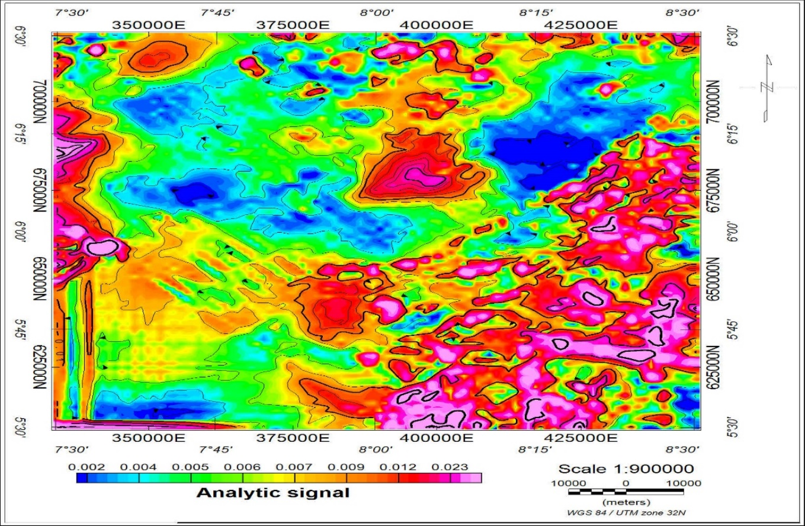
The Analytic Signal (AS) Map of the Study Area.

APPENDIX 2

Table 1: Spectral Analysis Calculation for the Basement Depth Estimation of the Study Area.

Location | Spectral Block | Latitude | Longitude | Estimated Depths (Km) |  | Slope 1 (Km) | Slope 2  (Km)
 |  | Northing | Easting | D₁ | D₂ | Depth to Basement | Depth to Shallower Basin
Uwet | Cell 1 | 347493.1 | 705514.9 | -5.377 | -0.673 | -3.338 | -4.226
Uwet | Cell 2 | 375487 | 705514.9 | -4.428 | -0.597 | -2.782 | -3.753
Adiasim | Cell 3 | 408519.9 | 706074.8 | -4.869 | -0.635 | -3.059 | -3.992
Adiasim | Cell 4 | 430355.2 | 705514.9 | -4.261 | -0.564 | -2.678 | -3.541
Ikot Ekpene | Cell 5 | 347493.1 | 678640.7 | -5.724 | -0.747 | -3.596 | -4.692
Ikot Ekpene | Cell 6 | 375487 | 678640.7 | -5.968 | -0.794 | -3.750 | -4.989
Aruchukwu | Cell 7 | 403481 | 678640.7 | -5.999 | -0.828 | -3.769 | -5.200
Aruchukwu | Cell 8 | 431474.9 | 681440.1 | -4.833 | -0.655 | -3.037 | -4.116
Oduro Ikpe | Cell 9 | 347493.1 | 649527 | -4.888 | -0.660 | -3.071 | -4.143
Oduro Ikpe | Cell 10 | 372127.8 | 652886.3 | -4.795 | -0.656 | -3.013 | -4.122
Ugep | Cell 11 | 404600.7 | 655125.8 | -4.865 | -0.671 | -3.057 | -4.212
Ugep | Cell 12 | 432034.8 | 648967.2 | -4.994 | -0.659 | -3.138 | -4.142
Afikpo | Cell 13 | 348053 | 623212.7 | -4.906 | -0.589 | -3.082 | -3.703
Afikpo | Cell 14 | 378846.3 | 622652.8 | -4.873 | -0.658 | -3.062 | -4.134
Abakiliki | Cell 15 | 404600.7 | 621533.1 | -4.881 | -0.662 | -3.067 | -4.159
Abakiliki | Cell 16 | 432034.8 | 622093 | -5.230 | -0.658 | -3.286 | -4.137

APPENDIX 3
Table 1: Calculated Average Curie Point Depth, Geothermal gradient, and Heat Flow from Spectral Analysis.
Blocks | Latitude (°N) | Longitude (°E) | Depth to Centroid (Z_{o}) (Km) | Depth to Centroid (Z_{t}) (Km) | Depth to the Bottom (Z_{b}) (Km) | Geothermal Gradient  $\frac{dT}{dZ}$ (°CKm⁻¹) | Heat Flow (q) (mWm⁻²)
 | Northing | Easting | D1 | D2 | $$Zb=2Z_{0}-Z_{t}$$ | θ /Z_{b}, at θ = 580. | $k\frac{dT}{dZ}$, at K=2.5Wm⁻¹K⁻¹
Cell 1 | 347493.1 | 705514.9 | 5.38 | 0.673 | 10.087 | 57.4998 | 147.7495
Cell 2 | 375487 | 705514.9 | 4.43 | 0.597 | 8.263 | 70.1924 | 175.4810
Cell 3 | 408519.9 | 706074.8 | 4.87 | 0.635 | 9.105 | 63.7012 | 159.2530
Cell 4 | 430355.2 | 705514.9 | 4.26 | 0.564 | 7.956 | 72.9010 | 182.2525
Cell 5 | 347493.1 | 678640.7 | 5.72 | 0.747 | 10.693 | 54.2411 | 135.6028
Cell 6 | 375487 | 678640.7 | 5.97 | 0.794 | 11.146 | 52.0366 | 130.0915
Cell 7 | 403481 | 678640.7 | 6.00 | 0.828 | 11.172 | 51.9155 | 129.7888
Cell 8 | 431474.9 | 681440.1 | 4.83 | 0.655 | 9.005 | 64.4087 | 161.0218
Cell 9 | 347493.1 | 649527 | 4.89 | 0.660 | 9.120 | 63.5965 | 158.9913
Cell 10 | 372127.8 | 652886.3 | 4.80 | 0.656 | 8.944 | 64.8479 | 162.1198
Cell 11 | 404600.7 | 655125.8 | 4.87 | 0.670 | 9.070 | 63.9471 | 159.8678
Cell 12 | 432034.8 | 648967.2 | 4.99 | 0.659 | 9.321 | 62.2251 | 155.5628
Cell 13 | 348053 | 623212.7 | 4.91 | 0.589 | 9.231 | 62.8318 | 157.0795
Cell 14 | 378846.3 | 622652.8 | 4.87 | 0.658 | 9.082 | 63.8626 | 159.6565
Cell 15 | 404600.7 | 621533.1 | 4.88 | 0.661 | 9.099 | 63.7433 | 159.3583
Cell 16 | 432034.8 | 622093 | 5.30 | 0.658 | 9.942 | 58.3384 | 145.8460

