Supplementary Material
For
ZnO functionalized sugarcane bagasse biochar via termal conversion of zinc hydroxichloride for photocatalytic degradation of paracetamol in aqueous medium
Erik Souza Pereiraª, Ralf R. Ramalho Juniorª*, Sandro José de Andradeª

ª Laboratory of Inorganic Synthesis and Enviromental Analytical Chemistry, Institute of Physics and Chemistry, Federal University of Itajubá, 3500-903, Minas Gerais, Brazil

Fig.S1. Photocount spectra of Hg vapor lamp used.

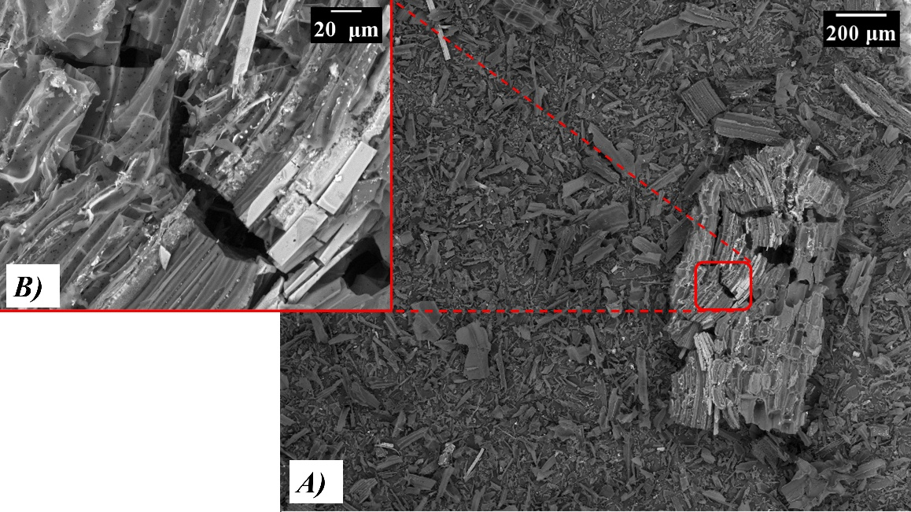
Fig. S2. SEM micrographs of BC at 100x (A) and 1000x magnification (B).

Table S1. EDS-general semi-quantification of ZnO@BC.

Element | Amount (wt%)
Zn | 41.31
O | 13.06
C | 43.93
Cl | 0.16
Na | 1.4
Si | 0.14
Total | 100.0

