Supporting Information for
Mitigation Benefits and Drivers of Compound Hot–Dry Events under the SSP2-com Scenario

Contents of this file

Figure S1 to S10

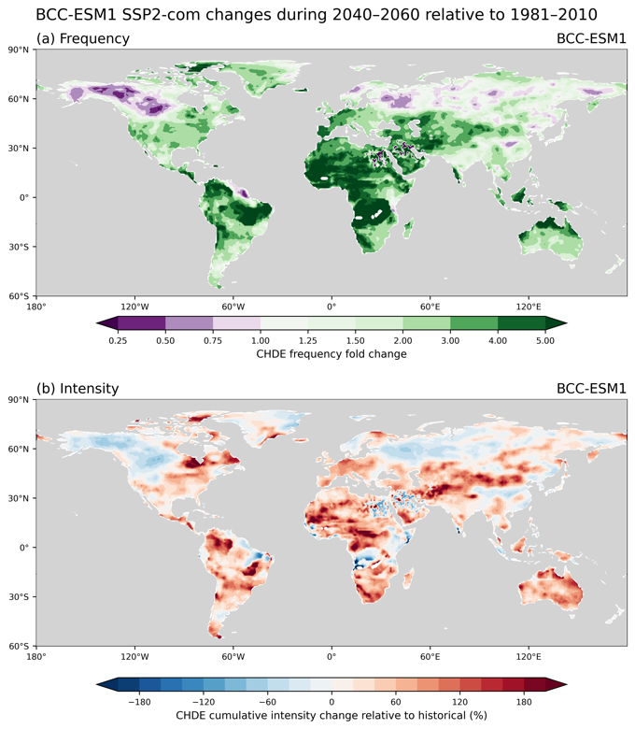
Figure S1. Projected changes in CHDE frequency and cumulative intensity under SSP2-com during the mid-twenty-first century (2040–2060) relative to the historical period (1980–2009), based on BCC-ESM1. (a) Spatial distribution of changes in CHDE frequency, expressed as the ratio of future to historical frequency. (b) Spatial distribution of percentage changes in CHDE cumulative intensity relative to the historical period.

.

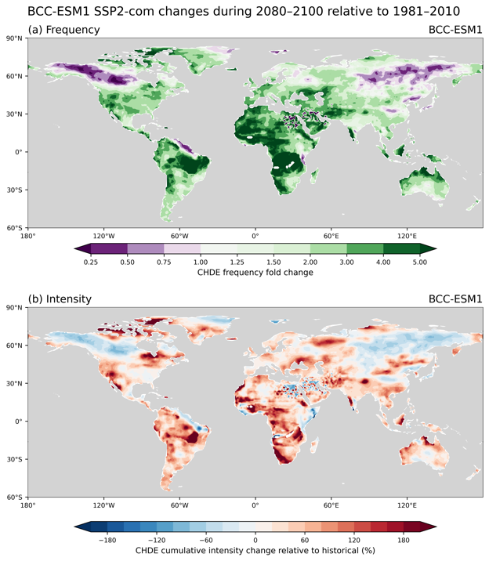
Figure S2. Same as Fig S1 but for late twenty-first century (2080–2100).

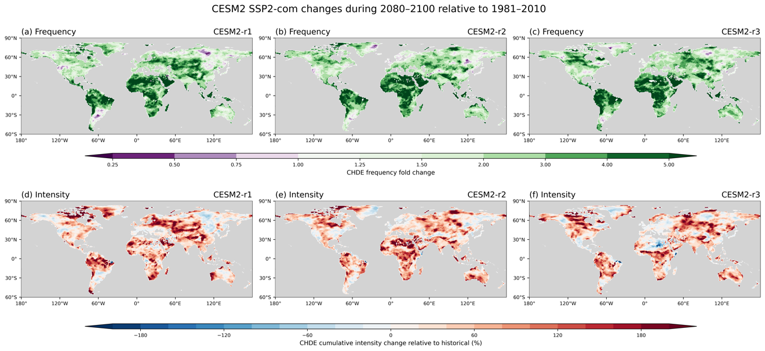
Figure S3. Same as Fig S1 but calculated using CESM2.

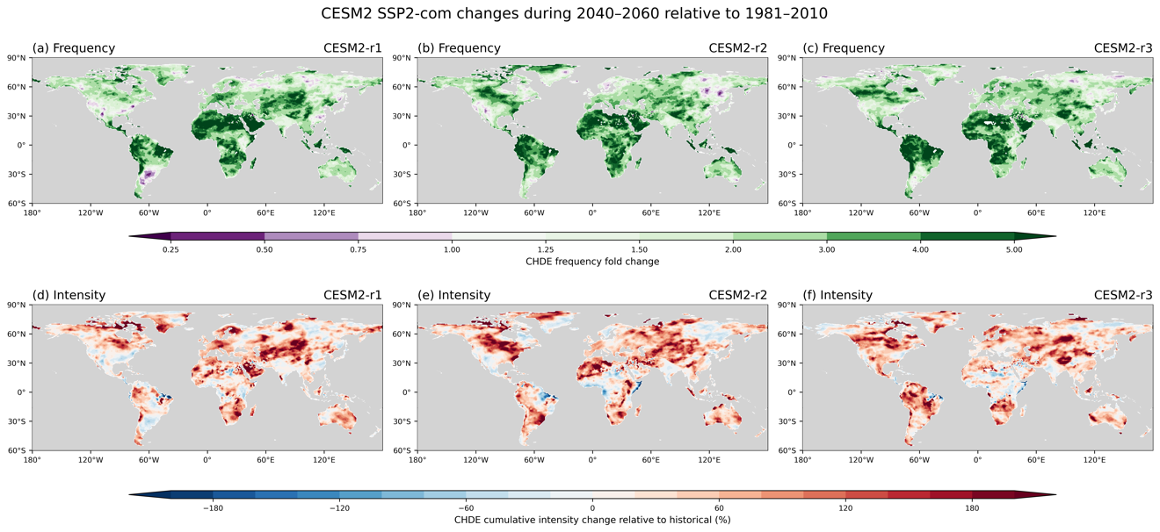
Figure S4. Same as Fig S1 but for late twenty-first century (2080–2100) and calculated using CESM2.

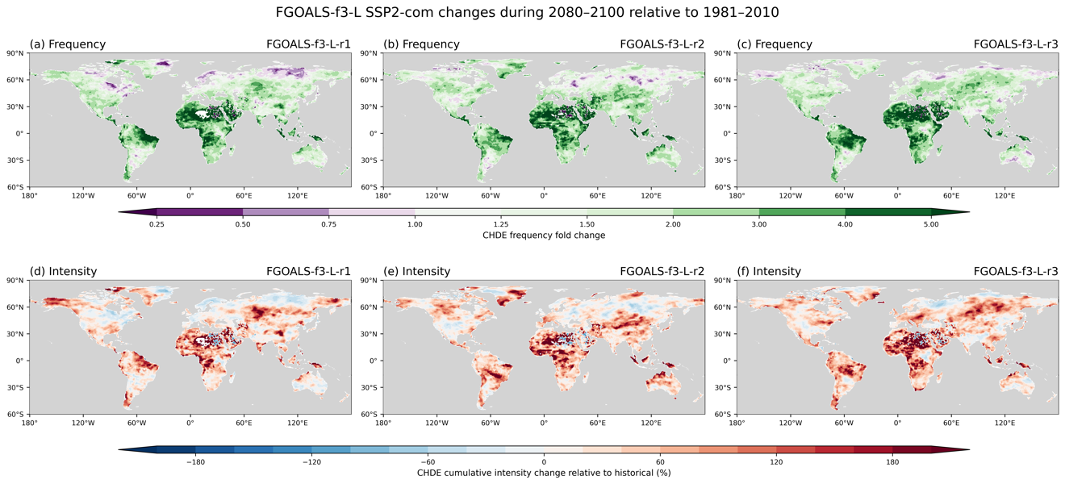
Figure S5. Same as Fig S1 but calculated using FGOALS-f3-L.

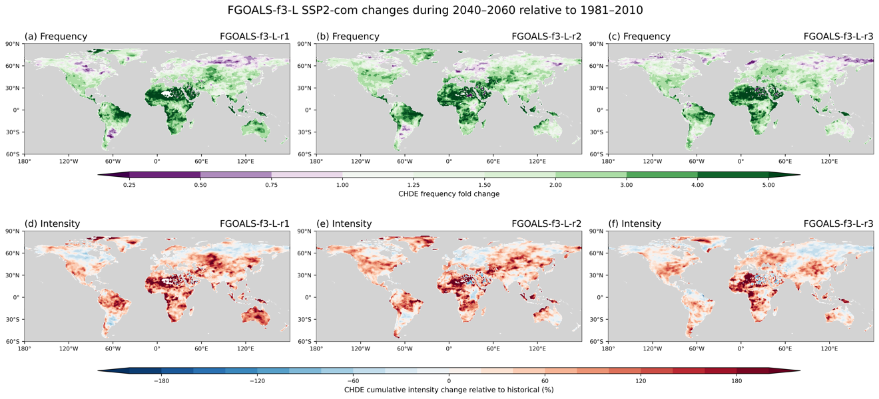
Figure S6. Same as Fig S1 but for late twenty-first century (2080–2100) and calculated using FGOALS-f3-L.

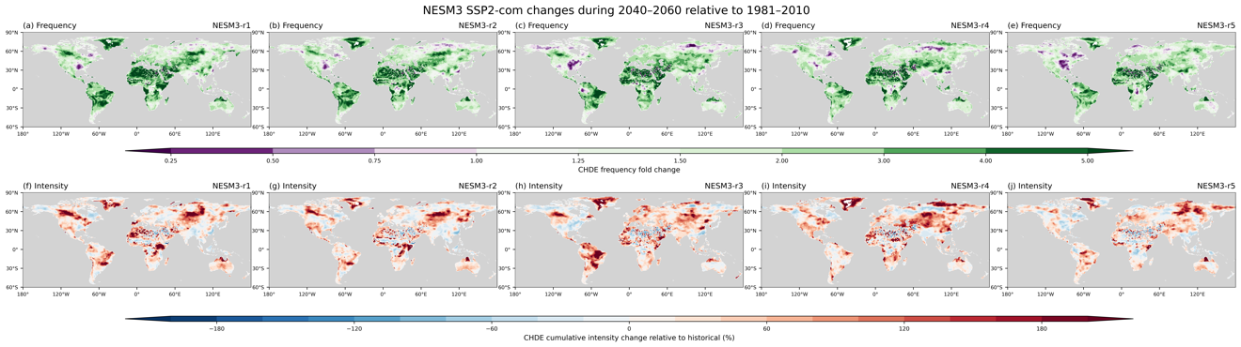
Figure S7. Same as Fig S1 but calculated using NESM3.

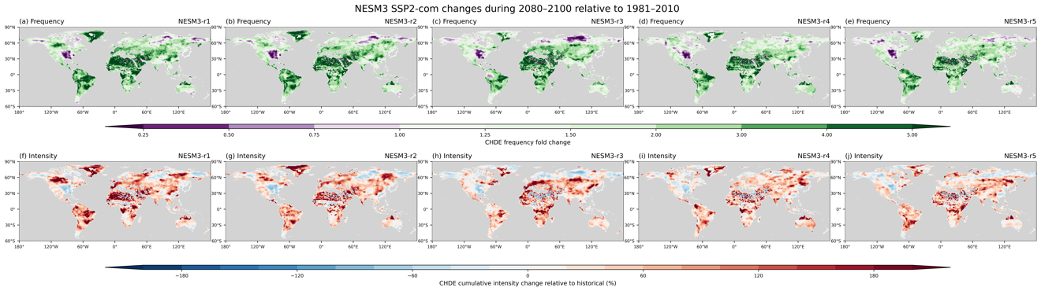
Figure S8. Same as Fig S1 but for late twenty-first century (2080–2100) and calculated using NESM3.

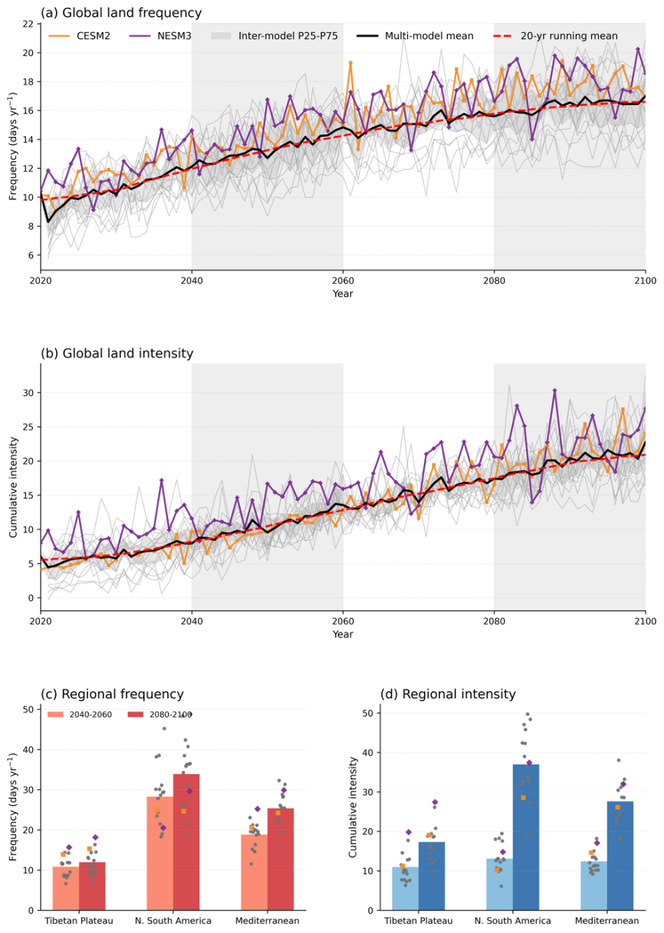
Figure S9. Projections of CHDE frequency and cumulative intensity under the SSP2-4.5 scenario based on 18 models. Panels (a) and (b) show the time series of CHDE frequency and cumulative intensity, respectively. The black solid line represents the multi-model mean, and the red dashed line represents the 20-year running mean of the multi-model mean. Panels (c) and (d) show the changes in regional-mean CHDE frequency and cumulative intensity in the mid- and late 21st century, respectively. The results from CESM2 and NESM3 are highlighted in yellow and purple, respectively; in this study, these two models are used to evaluate the mitigation effect of the SSP2-com scenario. Detailed information on the 18 models is provided in Table 1.

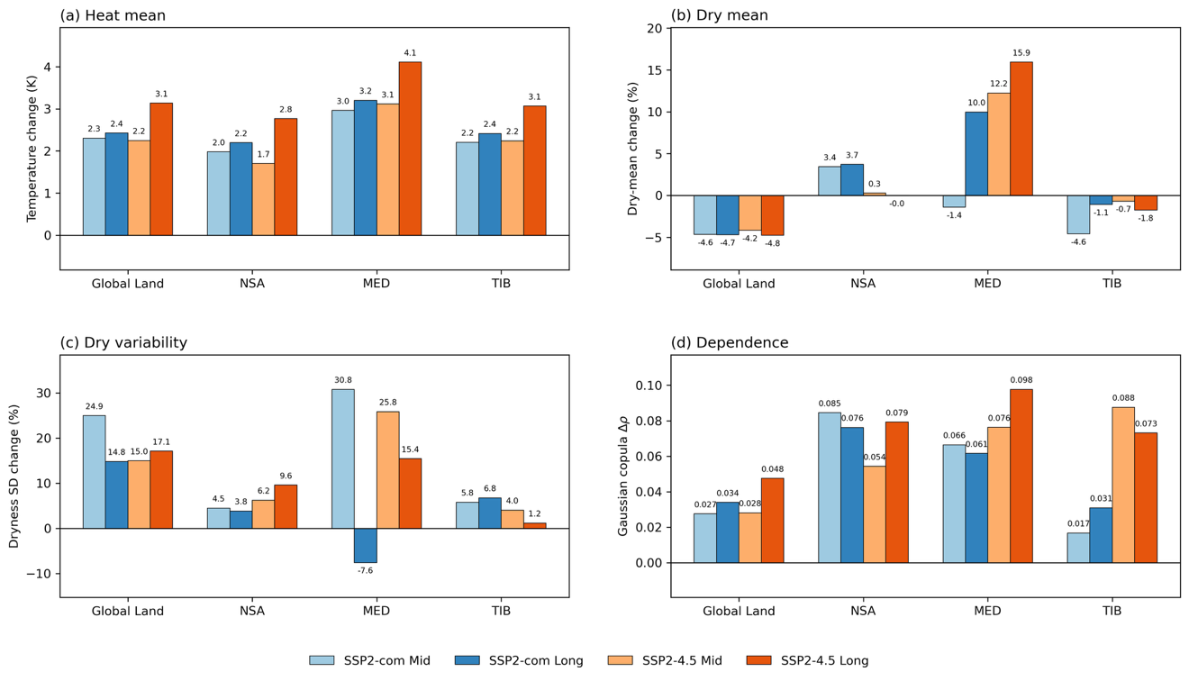
Figure S10. Projected changes in key climatic factors associated with CHDE risk under SSP2-com and SSP2-4.5 relative to the historical period (1980-2009) over Global Land, northern South America (NSA), the Mediterranean (MED), and the Tibetan Plateau (TIB). (a) Change in mean temperature (Heat mean; K), (b) percentage change in the mean of sign-reversed 30-day accumulated precipitation (Dry mean; %), (c) percentage change in the variability of sign-reversed 30-day accumulated precipitation (Dry variability; %), and (d) change in the Gaussian copula dependence parameter between heat and drought. Changes are calculated for both the mid-twenty-first century (2040–2060) and the late twenty-first century (2080–2100). Heat variability is not shown because its contribution to projected CHDE changes is negligible.

