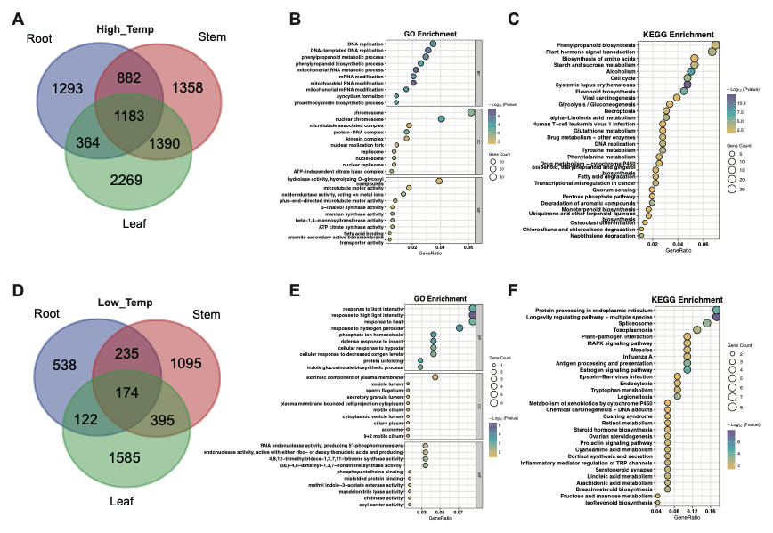
Supplementary Figure S1. Identification and functional enrichment analysis of shared differentially expressed genes (DEGs) across tissues under temperature stresses.
(A) Venn diagram illustrating the overlap of DEGs among three tissues (root, stem, and leaf) under high-temperature treatment. (B-C) Scatter plots detailing the Gene Ontology (GO) (B) and KEGG pathway (C) enrichment analyses for the shared DEGs in the high-temperature group. (D) Venn diagram showing the overlap of DEGs among the three tissues under low-temperature treatment. (E-F) Scatter plots displaying the GO (E) and KEGG pathway (F) enrichment analyses for the shared DEGs in the low-temperature group.

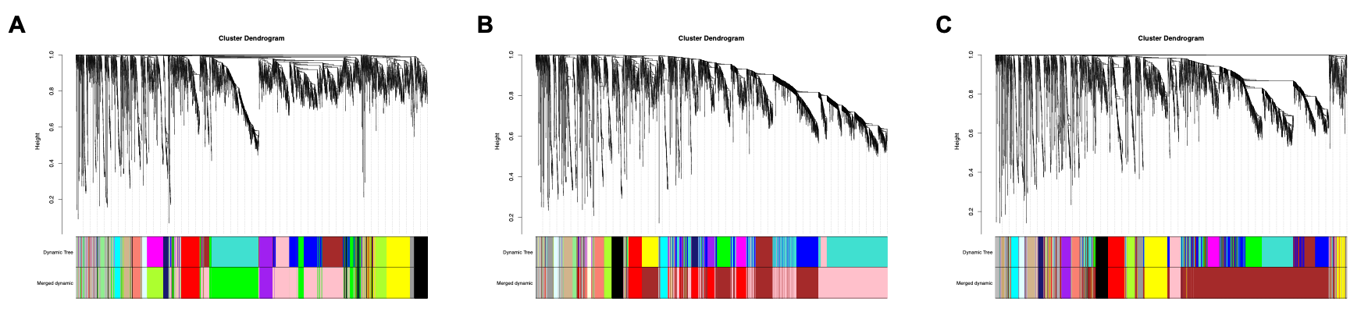
Supplementary Figure S2. WGCNA-based hierarchical clustering dendrograms of genes across different tissues.
(A-C) Gene clusters and co-expression modules identified in the root (A), stem (B), and leaf (C) tissues.

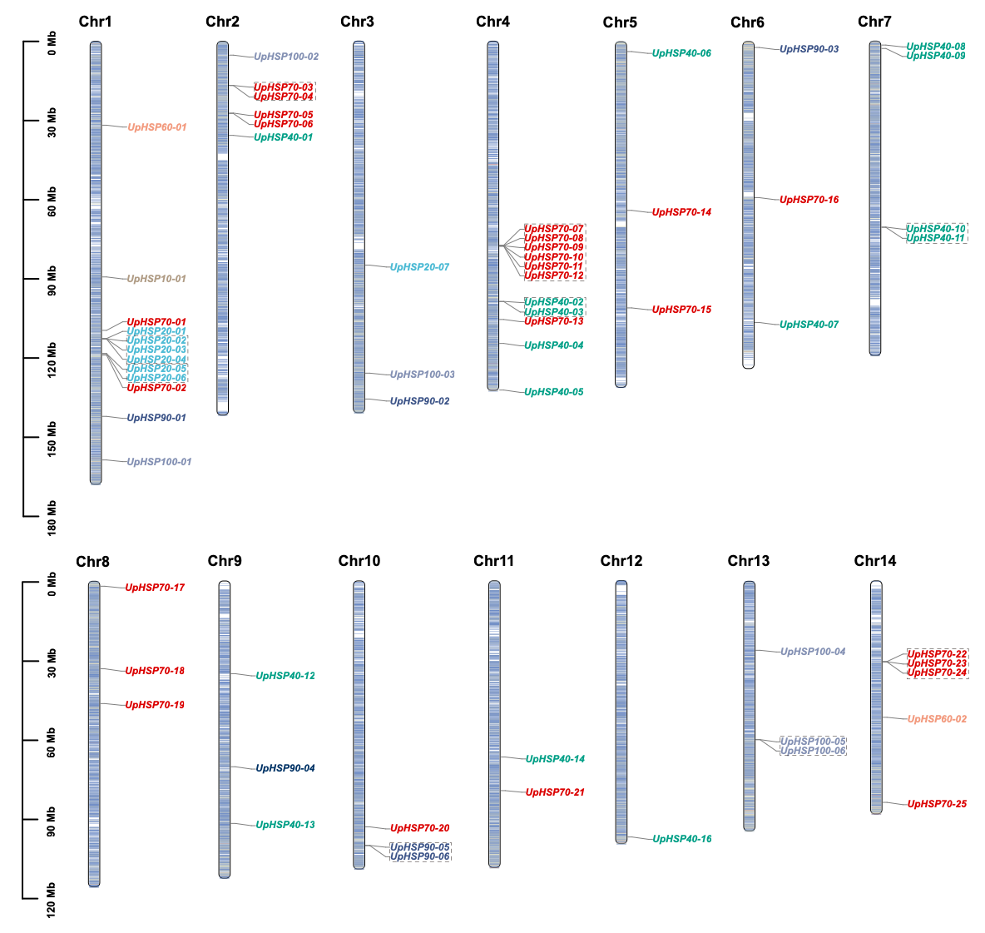
Supplementary Figure S3. Chromosomal distribution and tandem duplication events of HSP genes in U. parvifolia.
The 14 chromosomes are depicted as blue bars, with the left scale indicating physical length in megabases (Mb). Different font colors for gene names denote distinct HSP subfamilies. Dashed boxes highlight tandemly duplicated gene clusters.
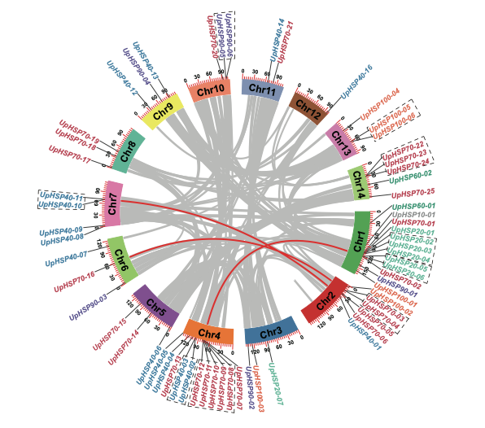
Supplementary Figure S4. Intraspecies synteny analysis and tandem duplication events of HSP genes in the U. parvifolia genome.
The outer circle represents the 14 chromosomes of U. parvifolia. The gray lines in the background indicate all syntenic blocks within the genome, while the red lines specifically connect syntenic UpHSP gene pairs, highlighting putative segmental duplication events. Gene names enclosed in dashed boxes denote tandemly duplicated gene clusters.

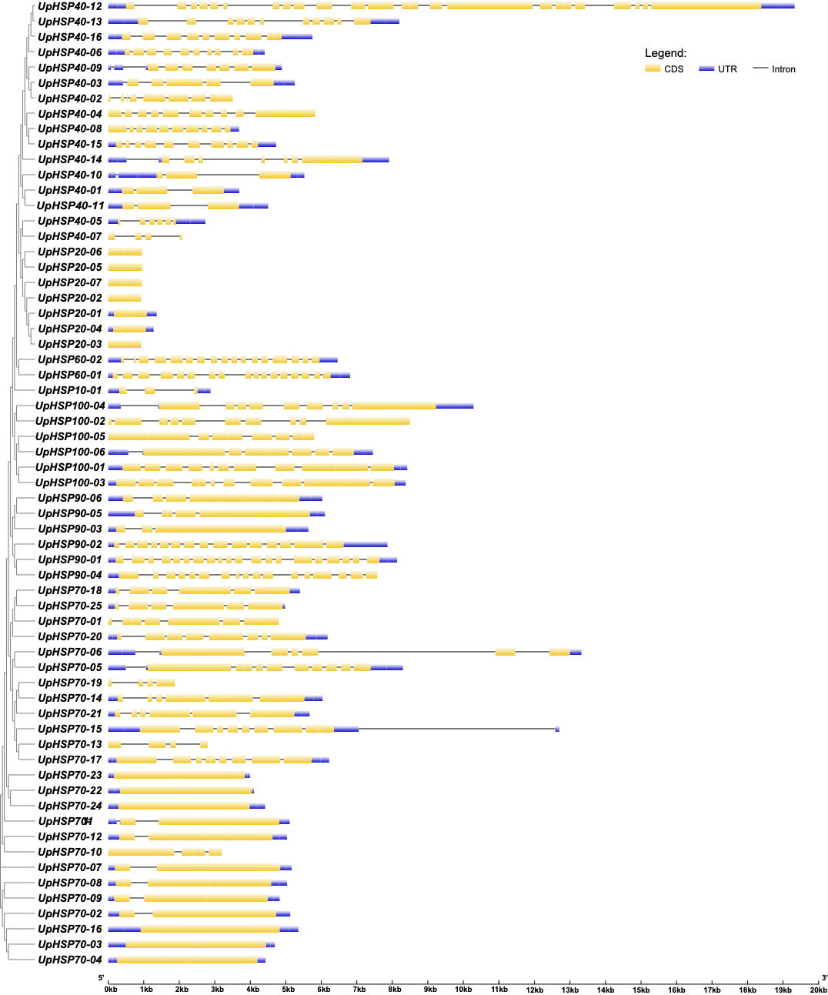
Supplementary Figure S5. Gene structures of the UpHSP family.
Yellow boxes indicate coding sequences (CDS), blue boxes denote untranslated regions (UTRs), and black lines represent introns. The lengths of exons and introns can be estimated using the bottom scale bar.

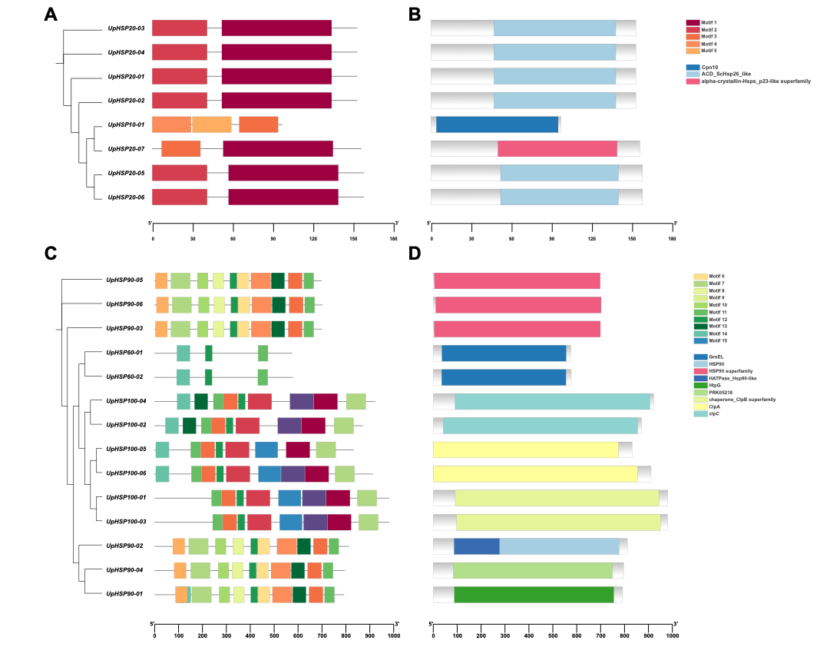
Supplementary Figure S6. Conserved motifs and domain architectures of specific HSP subfamilies in U. parvifolia.
(A-B) Conserved motif compositions (A) and domain architectures (B) of the UpHSP10 and UpHSP20 subfamilies. (C-D) Conserved motif compositions (C) and domain architectures (D) of the UpHSP60, UpHSP90, and UpHSP100 subfamilies.

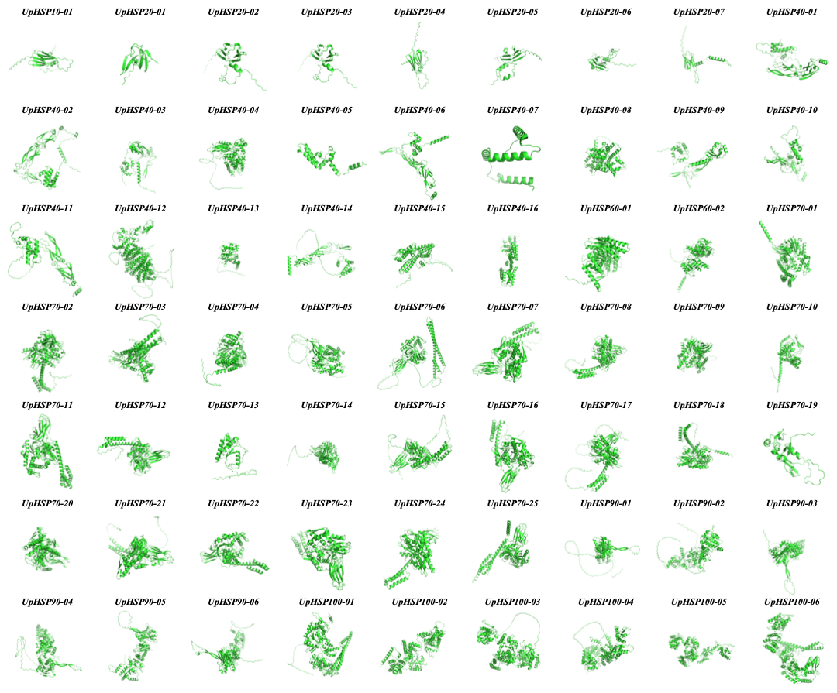
Supplementary Figure S7. Predicted three-dimensional (3D) structures of 56 UpHSP proteins.
Protein models were generated using AlphaFold3. The observed structural diversity reflects the functional differentiation among distinct HSP subfamilies in U. parvifolia.

