Table S1 The ATP7B gene mutation hotspots in 62 WD patients
Mutation hotspots | Cp≥140mg/L (n=28†) |  |  | Cp fluctuate (n=34†) |  | P
Mutation hotspots | Position | n (total=52‡) |  | Position | n (total=63‡) | P
1st Exon | 8 | 12 (23.1%) |  | 13 | 18 (28.6%) | 0.750
2nd Exon | 13 | 11 (21.2%) |  | 8 | 13 (20.6%) | 0.750
3rd Exon | 12 | 8 (15.4%) |  | 12 | 10 (15.9%) | 0.750
1st AA site | 778 | 9 (17.3%) |  | 992 | 11 (17.5%) | 0.332§
2nd AA site | 992 | 5 (9.6%) |  | 778 | 10 (15.9%) | 0.332§
3rd AA site | 616 | 5 (9.6%) |  | 943 | 5 (7.9%)
† The number of WD patients whose serum Cp concentrations were always higher than 140mg/L or fluctuated around 140mg/L. ‡ The frequency of ATP7B mutations. §, Chi-Square test between amino acid mutation sites of 778 and 992. AA, amino acid.

Table S2 Baseline characteristics of WD patients in validation sets of group A and B.
Variables | Group A | Group B | P
N | 43 | 49
Sex (male, %) | 17 (39.5%) | 36 (73.5%) | 0.001
Age | 23.0 (15.0, 35.0) | 49.8±12.8 | 0.000
Serum Cp (mg/L) | 180.4 (163.6, 209.1) | 227.7±63.7 | 0.052
Complete blood count
WBC (×10⁹/L) | 4.7±1.7 | 4.2±1.8 | 0.155
PLT (×10⁹/L) | 136.7±79.3 | 122.6±67.9 | 0.402
ALT (IU/L) | 37.0 (25.0, 66.0) | 85.0 (30.0, 223.5) | 0.010
AST (IU/L) | 37.0 (24.0, 71.0) | 54.0 (33.0, 132.5) | 0.020
γ-GT (IU/L) | 43.0 (24.0, 118.0) | 75.0 (49.5, 136.5) | 0.092
AP (IU/L) | 129.0 (79.8, 240.5) | 101.0 (79.5, 148.5) | 0.152
CHE (IU/L) | 5208.5 (2187.3, 6138.5) | 5138.0 (3605.0, 7679.5) | 0.190
Albumin (g/L) | 39.5 (32.0, 42.8) | 36.8±8.3 | 0.508
Total bilirubin (umol/L) | 17.9 (11.3, 35.3) | 20.0 (14.4, 44.5) | 0.234
Cr (umol/L) | 44.5 (35.3, 55.5) | 71.0±22.2 | 0.000
CHO (mmol/L) | 3.9 (3.2, 4.8) | 3.7±1.2 | 0.394
PT (s) | 13.8 (12.7, 18.0) | 13.9 (12.1, 15.5) | 0.441
INR | 1.1 (1.1, 1.4) | 1.2±0.2 | 0.527
Liver cirrhosis | 31 (72.1%) | 28 (57.1%) | 0.136
Child-Pugh scores | 5 (5, 9) | 6 (5, 8) | 0.706
class A (n) | 28 | 29 | 0.559
class B&C (n) | 15 | 20 | 0.559
The normal distribution parameters are shown as mean±standard deviation, or else median and quantile (25%, 75%).
Cp, ceruloplasmin. WBC, white blood cell. PLT, platelet. ALT, alanine aminotransferase. AST, aspartate aminotransferase. γ-GT, γ-glutamyltransferase. AP, alkaline phosphatase. CHE, cholinesterase. CB, conjugated bilirubin. Cr, creatine. PT, prothrombin time. INR, international normalised ratio.

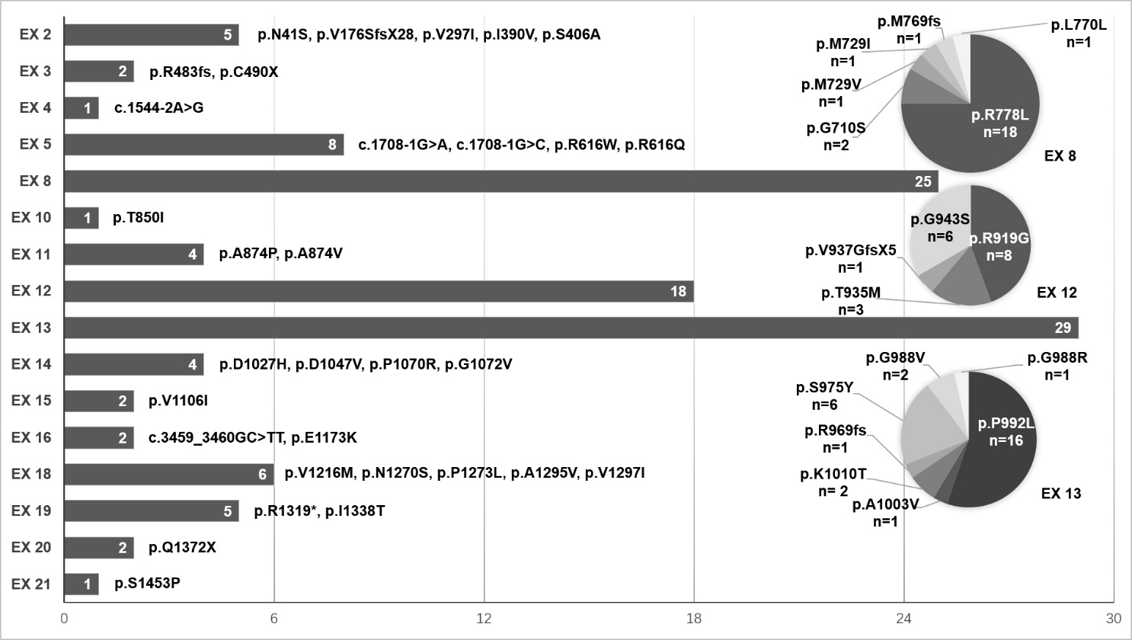
Fig. S1 The allele frequencies and distributions of 115 mutations of ATP7B gene in 62 WD Patients. The bars show the mutation frequencies of each exon (EX), and the pie charts represent the mutation frequencies, proportions on exons 8, 12 and 13.

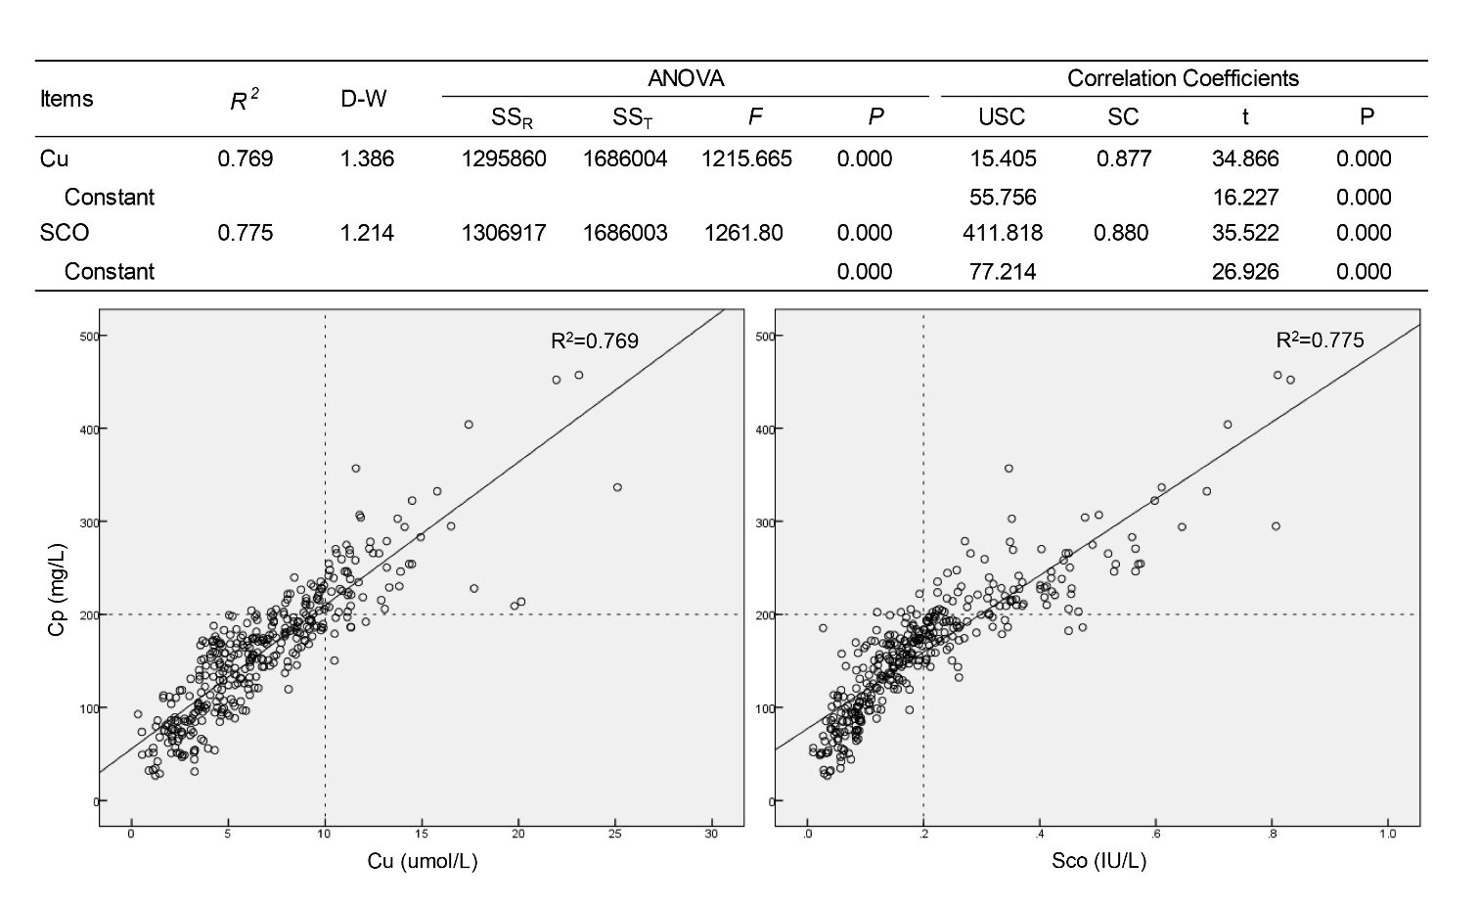
Fig. S2. The linear regression performance and scatterplot of serum Cp with serum Cu and Sco respectively. The dotted lines indicate the low limit of normal values of serum Cp (200 mg/L), Cu (10 umol/L) and Sco (0.2 IU/L).
.

