Supplementary Information

Bimetallic synergy boosts selective electrocatalytic nitrate reduction on CuFe layered double hydroxide nanosheets
Jinlong Liang, Na Li, Li Cui*, Jia Bao
School of Environmental and Chemical Engineering, Shenyang University of Technology, Shenyang 110870, P. R. China

Text S1. Materials
All the chemicals were analytical grade and used as received without further treatment. Ni foam was purchased from Suzhou Keshenghe Metal Materials Co., Ltd. Other reagents including ferric nitrate (Fe(NO₃)₃), copper nitrate (Cu(NO₃)₂), urea (H₂NCONH₂), ammonium fluoride (NH₄F), sodium sulfate (Na₂SO₄), sodium chloride (NaCl), sodium nitrate (NaNO₃), sodium nitrite (NaNO₂), ammonium sulfate ((NH₄)₂SO₄), hydrochloric acid (HCl), sodium hydroxide (NaOH), tert-butanol (TBA) and absolute alcohol were purchased from Sinopharm Chemical Reagent Co., Ltd (Shanghai, China). Deionized (DI) water was used in all experiments.

Text S2. Electrochemical measurements
Electrochemical tests were performed in a CHI 660E electrochemical workstation (Shanghai Chenhua) with a typical three-electrode system. Linear sweep voltammetry (LSV) curves were obtained in different electrolytes with and without nitrate addition at a scan rate of 5 mV s⁻¹ in the potential range of-1.6~0.1 V vs. SCE. Electrochemical impedance spectroscopy (EIS) was performed at frequencies ranging from 10⁻²Hz to 10⁶ Hz. To measure the electrochemically active surface area (ECSA), the electrochemical double-layer capacitance (Cdl) was first determined from the CV curves. This testing potential range was typically a ±0.1 V potential window centered at the open-circuit potential (OCP). All measured current in this non-Faradaic potential region is assumed to be associated with double-layer charging. The as-prepared layered double hydroxide electrodes were used in ECSA tests. The electrochemical double-layer capacitance (C_{dl}, mF) I calculated as given by the following Eq. (1)
j_{c} = v × C_{dl} (1)
Where j_{c} and v represented the charging current density (mA cm⁻²) and scan rate (mV s⁻¹), respectively. The ECSA of the layered double hydroxide electrode is then calculated from C_{dl} according to the following Eq. (2)
ECSA = C_{dl} / C_{s} (2)
Where C_{s} is the specific capacitance of the sample or the capacitance of an atomically smooth planar surface of the material per unit area under identical electrolyte conditions. In this work, all the electrodes shared the same substrate, NF, thus the same C_{s} value. ECSA was compared based on C_{dl}.

Text S3. DFT calculations
In this work, all density functional theory (DFT) calculations were performed using the Materials Studio software. The Perdew–Burke–Ernzerhof (PBE) functional within the generalized gradient approximation (GGA) was used to treat exchange–correlation(Kresse and Furthmuller, 1996; Perdew et al., 1996). Projected augmented wave (PAW) pseudopotentials with a kinetic energy cutoff of 450 eV were employed to describe the electronic wave functions(Blöchl, 1994). The vacuum thickness was set to 20 Å to minimize interlayer interactions. Brillouin zone integration was performed using a Γ-centered 4×4×1 Monkhorst–Pack k-point mesh. Partial occupancies of Kohn–Sham orbitals were allowed using a Gaussian smearing method with a width of 0.05 eV. The self-consistent convergence criterion for the electronic energy was set to an energy change less than 10⁻⁵ eV. The convergence criterion for geometry optimization was set to a force less than 0.02 eV Å⁻¹ on each atom. Weak interactions were modeled using the DFT+D3 method with empirical corrections according to the Grimme scheme. To account for strong correlation effects of transition metals, spin-polarized GGA with Hubbard U corrections was included in all calculations(Grimme, 2006; Xia et al., 2026; Yan et al., 2026).
The adsorption energy (E_{ads}) was calculated according to Eq. (3).
E_{ads} = E_{total} - E_{substrate} - E_{adsorbate} (3)
Where E_{total}, E_{substrate}, and E_{adsorbate} represent the energies of the adsorption structure, the substrate, and the adsorbate, respectively.
The Gibbs free energy change (ΔG) for each chemical reaction was calculated according to Eq. (4).
ΔG = ΔE + ΔE_{ZPE} - TΔS (4)
Where ΔE is the calculated total energy, E_{ZPE} is the zero-point energy, T is the temperature, and ΔS is the entropy.

Text S4. Ion concentration detection methods
Nitrite nitrogen, ammonia nitrogen, and nitrogen gas were the major products of nitrate nitrogen removal. Other nitrogen-containing compounds were negligible in quantity. After the nitrate removal experiment, the concentrations of nitrate nitrogen, nitrite nitrogen, and ammonia nitrogen in the solution were determined using a UV–vis spectrophotometer. The NO₃⁻-N concentration was obtained by measuring the absorbance at 220 nm and 275 nm, calculating the corrected absorbance, and deriving the concentration from the correction. The NO₂⁻-N concentration was measured at 540 nm. NH₄⁺-N was analyzed by Nessler’s reagent spectrophotometry at 420 nm.

Text S5. Calculation of the nitrate reduction performance indicators
The conversion of NO₃—N and product selectivity were calculated using Eq. (5)-Eq. (8)(Tang et al., 2019).
$$\begin{aligned}R\left({NO}_{3}^{-}-N\right)\left(\%\right)=\frac{C_{0}\left({NO}_{3}^{-}\right)-C_{t}\left({NO}_{3}^{-}\right)}{C_{0}\left({NO}_{3}^{-}\right)}×100\%\#\left(5\right)\end{aligned}$$
$$\begin{aligned}S\left({NH}_{4}^{+}-N\right)\left(\%\right)=\frac{C_{t}\left({NH}_{4}^{+}\right)}{C_{0}\left({NO}_{3}^{-}\right)-C_{t}\left({NO}_{3}^{-}\right)}×100\%\#\left(6\right)\end{aligned}$$
$$\begin{aligned}S\left({NO}_{2}^{-}-N\right)\left(\%\right)=\frac{C_{t}\left({NO}_{2}^{-}\right)}{C_{0}\left({NO}_{3}^{-}\right)-C_{t}\left({NO}_{3}^{-}\right)}×100\%\#\left(7\right)\end{aligned}$$
$$\begin{aligned}S\left(N_{2}\right)\left(\%\right)=\frac{C_{0}\left({NO}_{3}^{-}\right)-C_{t}\left({NO}_{3}^{-}\right)-C_{t}\left({NO}_{2}^{-}\right)-C_{t}\left({NH}_{4}^{+}\right)}{C_{0}\left({NO}_{3}^{-}\right)-C_{t}\left({NO}_{3}^{-}\right)}×100\%\#\left(8\right)\end{aligned}$$
Where C₀(NO₃⁻) represents the initial NO₃⁻-N concentration, C_{t}(NO₃⁻) represents the NO₃⁻-N concentration at the end of the reaction, and C_{t}(NO₂⁻) and C_{t}(NH₄⁺) are the NO₂⁻-N and NH₄⁺-N concentrations at the end of the reaction, respectively.

Figure captions
(b)
(a)
(c)
Figure. S1. The standard curves for (a) NO₃⁻-N, (b) NO₂⁻-N, (c) NH₄⁺-N determination.

(a)  (c) | (d)
Figure. S2. CV curves and Cdl of (a) CuFe LDH, (b) Cu LDH, (c) Fe LDH, (e) the calculated double layer capacitance of CuFe LDH, Cu LDH and Fe LDH.
(b)

Figure. S3. Projected density of states (PDOS) of catalysts d orbital. (a) DOS of CuFe d orbital and d band center, (b) DOS of Cu d orbital and d band center, (c) DOS of Fe d orbital and d band center.
(c)
(b)
(a)

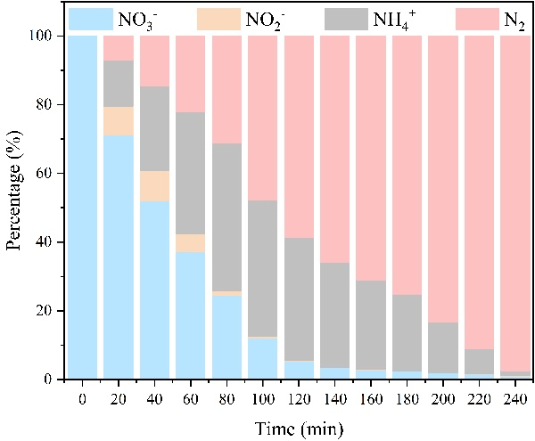 | 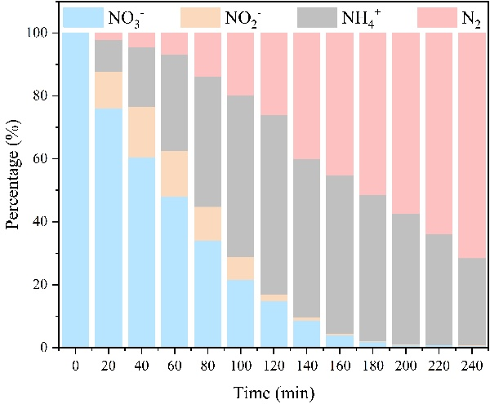

Figure. S4. Electrocatalytic nitrate reduction performance of CuFe LDH under different NO₃⁻-N initial concentrations. (a) NO₃⁻-N = 150 mg·L⁻¹, (b) NO₃⁻-N = 200 mg·L⁻¹
(b)
(a)
Reaction condition: 0.1 M Na₂SO₄, 0.02 M NaCl

Table S1 Comparison of the CuFe LDH electrochemical dinitrification performance to that of previously reported materials.
Electrocatalyst | Electrolyte | Time | NO₃⁻-N removal | N₂ selectivity | Cycle times | Ref.
CuFe LDH | 100 mg N L⁻¹  0.1 M Na₂SO₄  0.02 M NaCl | 2 h | 95.03% | 99.63% | 10 | This work
Fe plate | 100 mg N L⁻¹  0.04 M Na₂SO₄  0.02 M NaCl | 3.5 h | 81% | 100% |  | (Wu et al., 2019)
Pd-Cu/PNC | 100 mg N L⁻¹  0.1 M Na₂SO₄  0.1 M NaCl | 24 h | 97.1 | 83 | 8 | (Gu et al., 2020)
Fe₄N_{i}1 LDM | 30 mg N L⁻¹  0.05 M Na₂SO₄  250 ppm NaCl | 3 h | 98% | 100% | 5 | (Ma et al., 2023)
FeOOH@CC-160 | 100 mg N L⁻¹  0.03 M Na₂SO₄  0.02 M NaCl | 24 h | 96.89% | 97.60% | 24 | (Li et al., 2025)

References
Blöchl, P. E. (1994). Projector augmented-wave method. Phys. Rev. B: Condens. Matter, 50, 17953-17979.
Grimme, S. (2006). Semiempirical GGA‐type density functional constructed with a long‐range dispersion correction. Journal of Computational Chemistry, 27, 1787-1799.
Gu, T. H., Teng, W., Bai, N., Chen, Z. H., Fan, J., Zhang, W. X. & Zhao, D. Y. (2020). Nano-spatially confined Pd–Cu bimetals in porous N-doped carbon as an electrocatalyst for selective denitrification. Journal of Materials Chemistry A, 8, 9545-9553.
Kresse, G. & Furthmuller, J. (1996). Efficiency of ab-initio total energy calculations formetals and semiconductors using a plane-wave basis set. Computational Materials Science, 6, 15-50.
Li, R. F., Teng, W., Shi, Y. X., Li, S. L., Fan, J. W. & Zhang, W. X. (2025). High-performance electrocatalytic reduction of nitrate to dinitrogen (N₂) with self-supporting iron nanoarrays. Applied Catalysis B: Environment and Energy, 373, 125335.
Ma, X., Zhong, J. P., Huang, W. M., Wang, R. Y., Li, S., Zhou, Z. Y. & Li, C. H. (2023). Tuning the d-band centers of bimetallic FeNi catalysts derived from layered double hydroxides for selective electrocatalytic reduction of nitrates. Chemical Engineering Journal, 474, 145721.
Perdew, J. P., Burke, K. & Ernzerhof, M. (1996). Generalized gradient approximation made simple. Physical Review Letters, 77, 3865-3868.
Tang, T. T., Xing, Q. J., Zhang, S. H., Mu, Y., Jiang, X. H., Zhou, Z. G., Xiao, X. & Zou, J. P. (2019). High selective reduction of nitrate into nitrogen by novel Fe-Cu/D407 composite with excellent stability and activity. Environmental Pollution, 252, 888-896.
Wu, L. K., Shi, Y. J., Su, C., Cao, H. Z. & Zheng, G. Q. (2019). Efficient Electrochemical Reduction of High Concentration Nitrate by a Stepwise Method. Catalysis Letters, 149, 1216-1223.
Xia, T., Zhang, X., Wei, T., Duan, W., Sui, Y., Shao, W., Xu, K., Yang, Z., Wang, X., Nie, H. & Ge, Y. (2026). Capacitive deionization–electrocatalytic coupling strategy for efficient nitrate reduction to ammonia under nitrate-deficient conditions. Electrochimica Acta, 571, 149126.
Yan, B. B., Xu, D., Liu, T. C., Tang, K., Wang, J. L., Chen, G. Y. & Cheng, Z. J. (2026). High-throughput DFT screening of single-atom catalysts: unraveling the effects of transition metals and coordination environments for electrocatalytic nitrate-to-ammonia conversion. Applied Surface Science, 729, 166226.

