Supplementary Material
Table S1 Analysis of variance for the effects of nitrogen addition (N), drought (D), sampling year (Y), and their interactions on community - weighted mean leaf dry matter content (CWM_{LDMC}), community - weighted mean leaf area (CWM_{LA}), community - weighted mean specific leaf area (CWM_{SLA}), community - weighted mean organic carbon content in leaves (CWM_{LC}), community - weighted mean nitrogen content in leaves (CWM_{LN}), and community - weighted mean phosphorus content in leaves (CWM_{LP}).
 |  | N | D | Y | N×D | N×Y | D×Y | N×D×Y
CWM_{LDMC} | df | 1 | 1 | 4 | 1 | 4 | 4 | 4
CWM_{LDMC} | F | 0.022 | 0.832 | 3.317 | 1.72 | 0.95 | 3.64 | 0.313
CWM_{LDMC} | p | 0.885 | 0.380 | 0.018* | 0.214 | 0.444 | 0.011* | 0.868
CWM_{LA} | df | 1 | 1 | 4 | 1 | 4 | 4 | 4
CWM_{LA} | F | 5.549 | 1.663 | 5.065 | 1.988 | 4.083 | 1.402 | 2.323
CWM_{LA} | p | 0.037* | 0.222 | 0.002** | 0.185 | 0.006** | 0.248 | 0.071
CWM_{SLA} | df | 1 | 1 | 4 | 1 | 4 | 4 | 4
CWM_{SLA} | F | 2.736 | 3.035 | 2.376 | 2.154 | 1.345 | 1.43 | 0.58
CWM_{SLA} | p | 0.125 | 0.108 | 0.066 | 0.169 | 0.268 | 0.239 | 0.679
CWM_{LC} | df | 1 | 1 | 4 | 1 | 4 | 4 | 4
CWM_{LC} | F | 41.627 | 0.556 | 44.66 | 0.035 | 6.666 | 2.308 | 0.14
CWM_{LC} | p | <0.001*** | 0.119 | <0.001*** | 0.405 | 0.612 | 0.093 | 0.562
CWM_{LN} | df | 1 | 1 | 4 | 1 | 4 | 4 | 4
CWM_{LN} | F | 176.511 | 2.825 | 11.439 | 0.743 | 0.675 | 2.12 | 0.752
CWM_{LN} | p | <0.001*** | 0.119 | <0.001*** | 0.405 | 0.612 | 0.093 | 0.562
CWM_{LP} | df | 1 | 1 | 4 | 1 | 4 | 4 | 4
CWM_{LP} | F | 26.94 | 6.155 | 18.433 | 0.571 | 8.536 | 2.827 | 1.116
CWM_{LP} | p | 0.012* | 0.443 | 0.004** | 0.135 | 0.248 | 0.158 | 0.087
Where, *: P < 0.05, **: P < 0.01, ***: P < 0.001..
Table S2 Results of variance analysis for the effects of nitrogen addition (N), drought (D), sampling year (Y), and their interactions on species richness (S), .Shannon - wiener index (H'), Simpson index (D), Pielou index (J), functional richness (FRic), functional evenness (FEve), functional divergence (FDiv), functional dispersion (FDis), quadratic entropy (RaoQ), Comprehensive value of functional diversity (K), net relatedness index (NRI), and nearest taxon index (NTI).
 |  | N | D | Y | N×D | N×Y | D×Y | N×D×Y
S | df | 1 | 1 | 4 | 1 | 4 | 4 | 4
S | F | 48.119 | 1.216 | 1.012 | 0.547 | 4.006 | 2.782 | 0.18
S | p | <0.001*** | 0.292 | 0.411 | 0.474 | 0.007** | 0.037* | 0.948
H' | df | 1 | 1 | 4 | 1 | 4 | 4 | 4
H' | F | 21.647 | 1.292 | 0.424 | 1.231 | 1.403 | 2.452 | 0.463
H' | p | <0.001*** | 0.278 | 0.79 | 0.289 | 0.247 | 0.058 | 0.763
D | df | 1 | 1 | 4 | 1 | 4 | 4 | 4
D | F | 9.561 | 1.311 | 0.603 | 0.382 | 0.754 | 2.138 | 0.297
D | p | 0.009** | 0.275 | 0.662 | 0.548 | 0.56 | 0.09 | 0.879
J | df | 1 | 1 | 4 | 1 | 4 | 4 | 4
J | F | 3.542 | 4.585 | 0.701 | 0.401 | 0.496 | 2.239 | 0.292
J | p | 0.084 | 0.053 | 0.595 | 0.539 | 0.739 | 0.079 | 0.882
FRic | df | 1 | 1 | 4 | 1 | 4 | 4 | 4
FRic | F | 1.158 | 0.09 | 4.601 | 0.299 | 9.03 | 2.424 | 4.914
FRic | p | 0.302 | 0.769 | 0.003** | 0.594 | <0.001*** | 0.062 | 0.002**
FEve | df | 1 | 1 | 4 | 1 | 4 | 4 | 4
FEve | F | 1.132 | 3.987 | 0.152 | 0.206 | 1.008 | 0.416 | 1.544
FEve | p | 0.306 | 0.067 | 0.961 | 0.657 | 0.414 | 0.796 | 0.206
FDiv | df | 1 | 1 | 4 | 1 | 4 | 4 | 4
FDiv | F | 1.732 | 0.046 | 1.758 | 0 | 0.806 | 0.729 | 1.024
FDiv | p | 0.212 | 0.833 | 0.155 | 0.99 | 0.528 | 0.577 | 0.405
FDis | df | 1 | 1 | 4 | 1 | 4 | 4 | 4
FDis | F | 4.073 | 0.718 | 0.379 | 1.17 | 0.212 | 0.582 | 1.188
FDis | p | 0.065 | 0.412 | 0.822 | 0.299 | 0.93 | 0.677 | 0.329
RaoQ | df | 1 | 1 | 4 | 1 | 4 | 4 | 4
RaoQ | F | 6.192 | 1.203 | 0.226 | 2.324 | 0.125 | 0.504 | 1.146
RaoQ | p | 0.027* | 0.292 | 0.922 | 0.151 | 0.973 | 0.733 | 0.347
K | df | 1 | 1 | 4 | 1 | 4 | 4 | 4
K | F | 2.069 | 0.067 | 0.857 | 0.177 | 0.371 | 0.834 | 2.849
K | p | 0.176 | 0.799 | 0.496 | 0.682 | 0.828 | 0.510 | 0.034*
NRI | df | 1 | 1 | 4 | 1 | 4 | 4 | 4
NRI | F | 5.123 | 1.734 | 3.215 | 1.508 | 4.082 | 0.512 | 0.931
NRI | p | 0.043* | 0.212 | 0.020* | 0.243 | 0.006** | 0.727 | 0.454
NTI | df | 1 | 1 | 4 | 1 | 4 | 4 | 4
NTI | F | 0.054 | 0.013 | 10.806 | 0.001 | 4.153 | 0.463 | 1.53
NTI | p | 0.82 | 0.909 | <0.001*** | 0.978 | 0.006** | 0.762 | 0.208
Where, *: P < 0.05, **: P < 0.01, ***: P < 0.001.
Table S3 Analysis of variance for the effects of nitrogen addition (N), drought (D), sampling year (Y), and their interactions on ecosystem multifunctionality (EMF).
Treat | df | EMF
Treat | df | F | P
N | 1 | 17.068 | 0.001**
D | 1 | 1.375 | 0.264
Y | 4 | 14.196 | <0.001***
N×D | 1 | 0.07 | 0.796
N×Y | 4 | 1.543 | 0.205
D×Y | 4 | 0.602 | 0.663
N×D×Y | 4 | 0.375 | 0.826
Where, *: P < 0.05, **: P < 0.01, ***: P < 0.001.

Table S4 Proportion of marginal R² independently explained by each predictor under different treatments
Treat | Predictor | R²
CK | CWM | 80.7%
CK | SD | 2.3%
CK | FD | 11.9%
CK | PD | 5.1%
N | CWM | 60.2%
N | SD | 22.7%
N | FD | 8.8%
N | PD | 8.3%
D | CWM | 49.2%
D | SD | 39.4%
D | FD | 9.2%
D | PD | 2.1%
N+D | CWM | 35.8%
N+D | SD | 30.5%
N+D | FD | 6.7%
N+D | PD | 27.0%
Where: CWM: community-weighted mean leaf morphological traits, SD: species diversity, FD: functional diversity, PD: phylogenetic diversity.
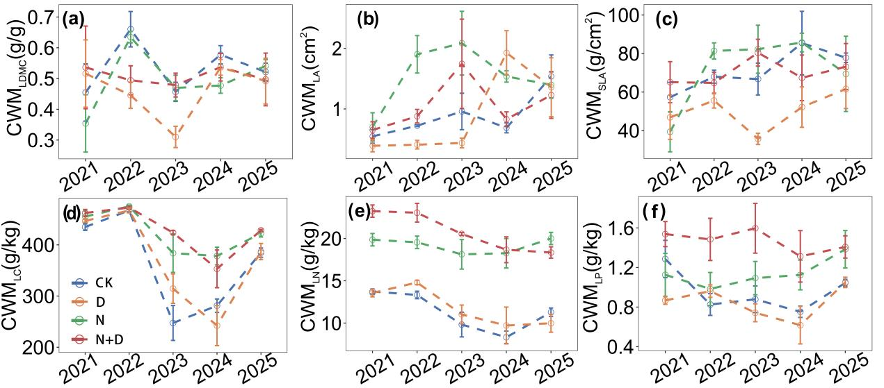
Figure S1 Changes in plant community productivity, leaf community-weighted mean morphological traits, stoichiometric characteristics, and soil nutrients over the years. The data represent the mean ± standard deviation (SD) of each indicator under different treatments. The dashed lines are obtained by segmented linear regression analyses.

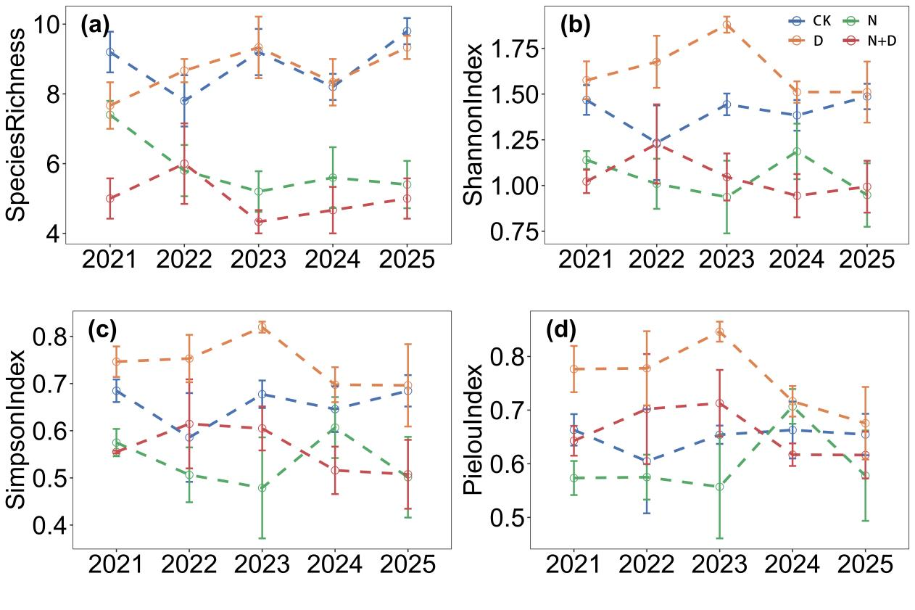
Figure S2 Changes of species diversity over the years. The data represent the mean ± standard deviation (SD) of functional diversity under different treatments. The dashed line is obtained by segmented linear regressions.
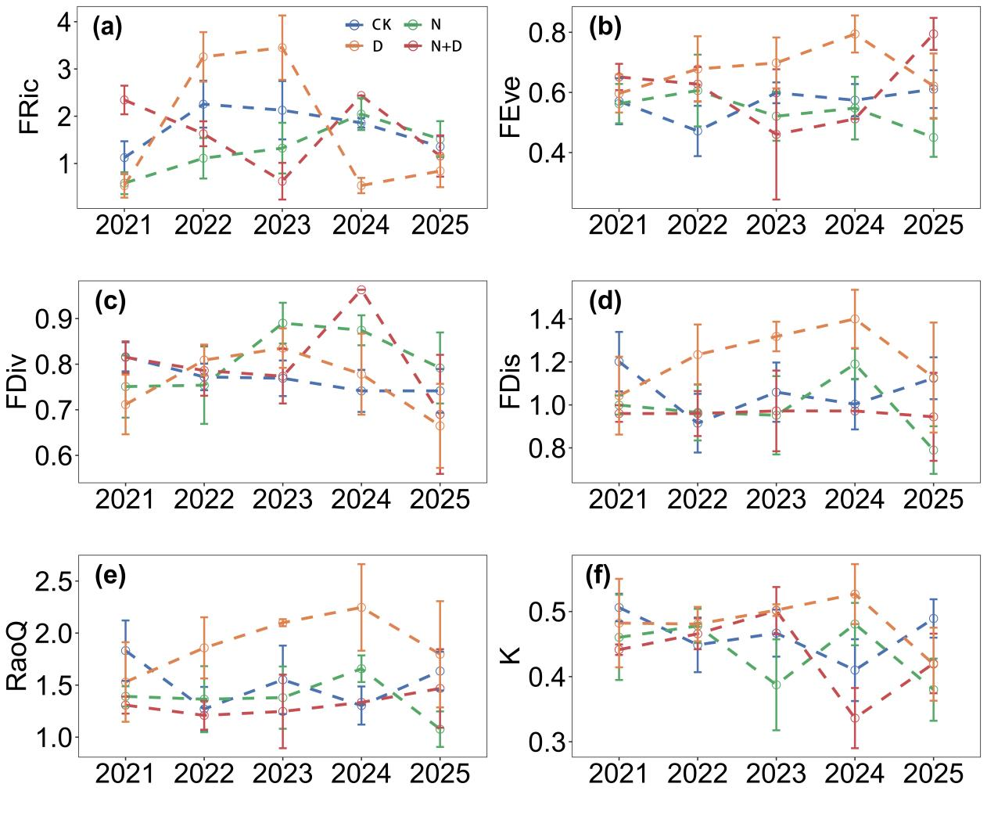
Figure S3 Changes of functional diversity over the years. The data represent the mean ± standard deviation (SD) of functional diversity under different treatments. The dashed line is obtained by segmented linear regressions.

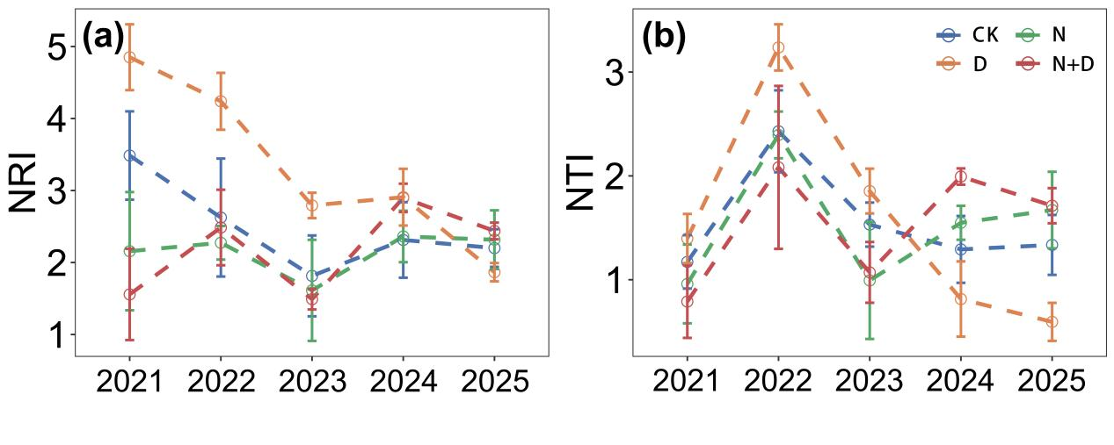
Figure S4 Changes of phylogenetic diversity over the years. The data represent the mean ± standard deviation (SD) of phylogenetic diversity under different treatments. The dashed line is obtained by segmented linear regressions.

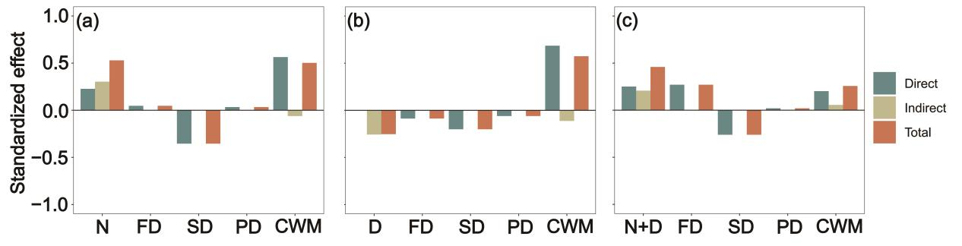
Figure S5 Standardized effects (direct, indirect, and total effects) derive from the SEM. Nitrogen addition (N), drought (D), under long-term nitrogen addition, drought treatment (N+D), functional diversity (FD), species diversity (SD), phylogenetic diversity (PD), community-weighted mean leaf morphological traits (CWM).

