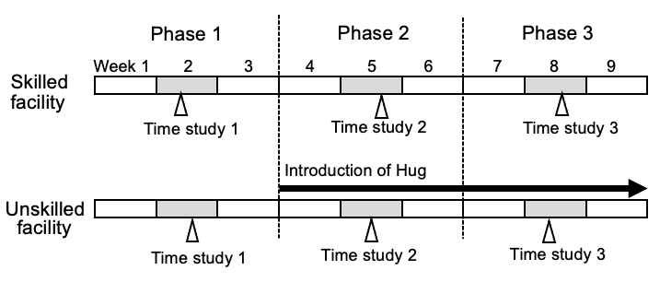

Supplementary Figure 1.
Measurement schedule of the study. The study period was set at 9 weeks (1 phase = 3 weeks; 3 phases), and the numbers of transfer and toileting assists were recorded for 1 week (in the middle of each phase, shown in gray). A time study (open triangle) was conducted by selecting a normal day during the middle week of each phase. Hug was introduced to the unskilled facilities in the second phase.

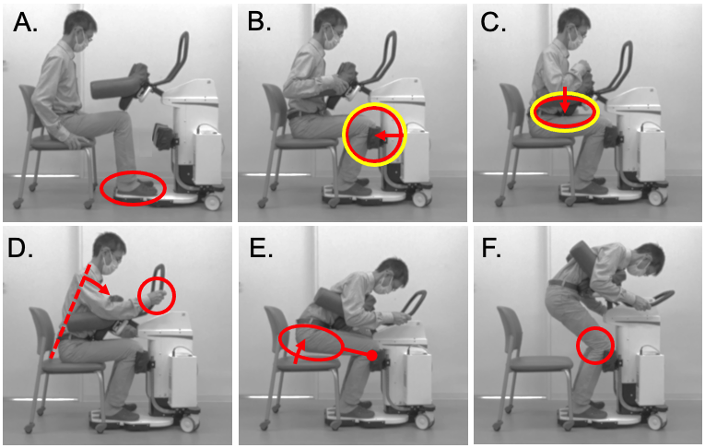

Supplementary Figure 2.
Instructions for using Hug. We have summarized the instructions in the user manual for Hug with red lines. The care recipient’s feet should be placed into the foot-shaped marks (A), Hug is moved closer to the care recipient until it touches their knees (B), and the main shaft is moved down until the thoracoabdominal support pad lightly touches their thighs (C). The care recipient should then grab the bar handle and bend forward before the caregiver starts the transfer (D). By pressing the “Stand up” button, the care recipient is hugged by the two arms of Hug (E) and stands up as the main shaft is raised further (F), while ensuring that their knees remain slightly bent and do not straighten. For these steps, we propose that the yellow circles in B and C are the two most important points to consider when using Hug. To then sit down on a wheelchair or toilet seat, pressing the “Sit down” button reverses the process.

Supplementary Table 1. Criteria for determining the daily life independence level (bedridden level) of an older adult with disability
Grade J | Has some sort of disability, but is almost independent in daily life and can get out of home alone
(Independent living) | 1. Goes out using transport facilities
 | 2. Goes out to neighbors
Grade A | Almost independent for indoor daily life, but cannot go outside without assistance
(Requires assistance to leave home) | 1. Goes out with assistance, and stays away from bed for most of the daytime
(Requires assistance to leave home) | 2. Does not go out so much, but gets in and out of bed in daytime
Grade B | Requires some sort of care for indoor daily life, and stays in bed for most of the time, but can maintain a sitting position
(Nearly bedridden) | 1. Eats and visits the toilet away from the bed by getting in a wheelchair
 | 2. Requires care to get in a wheelchair
Grade C | Stays in bed all of the time, and requires care for toileting, eating, and changing clothes
(Completely bedridden) | 1. Able to roll over by themself
 | 2. Unable to roll over by themself

Supplementary Table 2. Criteria for determining the daily life independence level of an older adult with dementia
Grade |  | Assessment criteria | Examples of symptoms and behaviors that may be observed
I |  | Has some sort of dementia, but is almost independent in daily life for domestic and social activities
II |  | Symptoms, behavior, or difficulty in communication that interfere with their daily life are observed to some degree, but can live independently if someone looks after them
 | IIa | The condition described in II is observed outside the home | Frequently getting lost and/or making mistakes in things they used to be able to do such as shopping, paperwork, managing finances, etc.
 | IIb | The condition described in II is also observed at home | Inability to manage medications and/or to stay at home alone due to difficulties in answering the phone, dealing with visitors, etc.
III |  | Symptoms, behavior, or difficulty in communication that interfere with their daily life are observed once in a while, and requires care
 | IIIa | The conditions described in III are observed mainly during the day | Has difficulty and/or taking time to change clothes, eat, defecate, and/or urinate. Repeatedly putting things in their mouth, picking up things, wandering, becoming incontinent, shouting or screaming, mismanagement of fire, uncleanliness, sexually abnormal behavior, etc.
 | IIIb | The conditions described in III are observed mainly at night | Same as level IIIa
IV |  | Symptoms, behavior, or difficulty in communication that interfere with their daily life are observed frequently, and requires constant care | Same as level III
M |  | Significant psychotic manifestations, problem behavior, or severe physical diseases are observed, and requires specialized medical care | Persistent psychiatric symptoms such as delirium, delusions, agitation, or self-harm or harming others and problematic behavior caused by psychiatric symptoms

