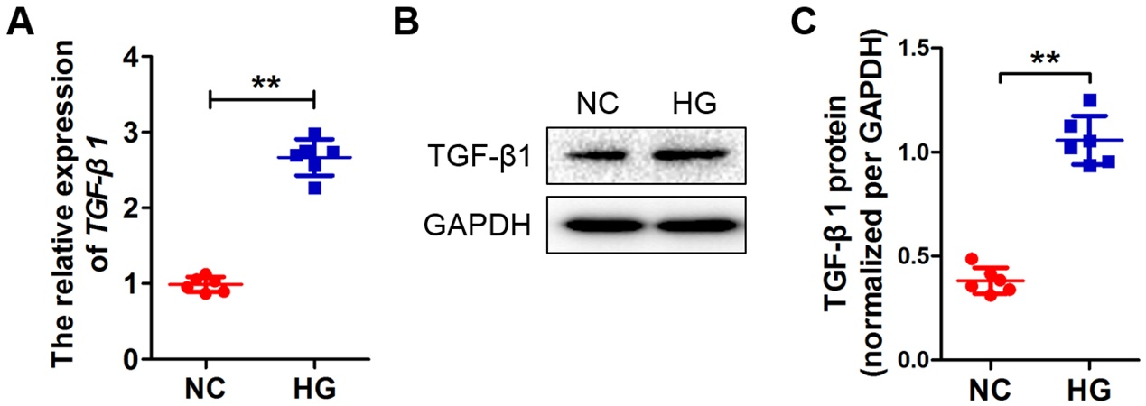
Supplemental Figure 1. The mRNA (A) and protein (B and C) expressions of TGF-β1 under HG condition. All data were mean ± SD, (n = 6); *p < 0.05, **p < 0.01.

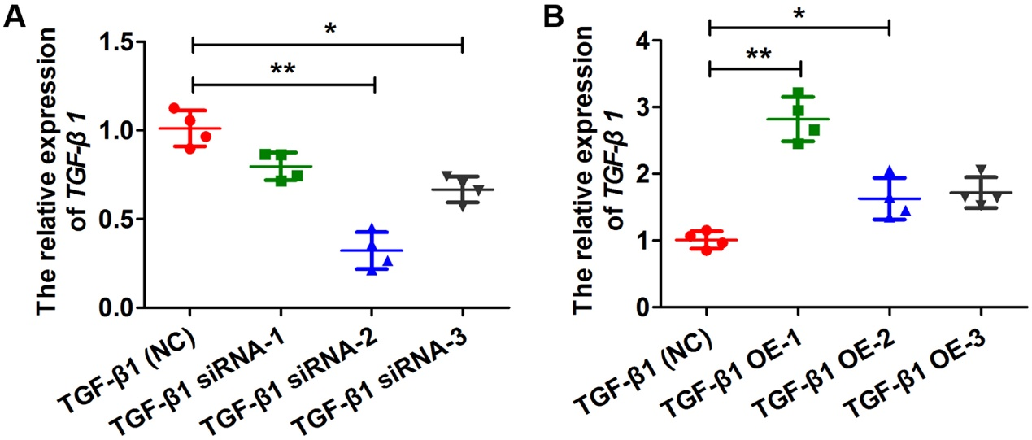
Supplemental Figure 2. The mRNA expression of TGF-β1 in the siRNA-mediated TGF-β1 silencing (A) and overexpression (B) podocytes. All data were mean ± SD, (n = 6); * p < 0.05, ** p < 0.01.

