Extended Data
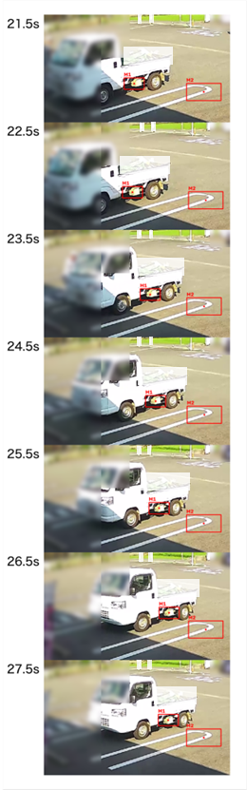

Extended Data Fig. 1. Snapshot of car motion. Snapshots taken every 16 frames, showing the motion of the car. The red rectangles labelled M1 and M2 indicate the markers used to derive the ground displacement. Portions of the images have been altered to protect personal information and privacy.

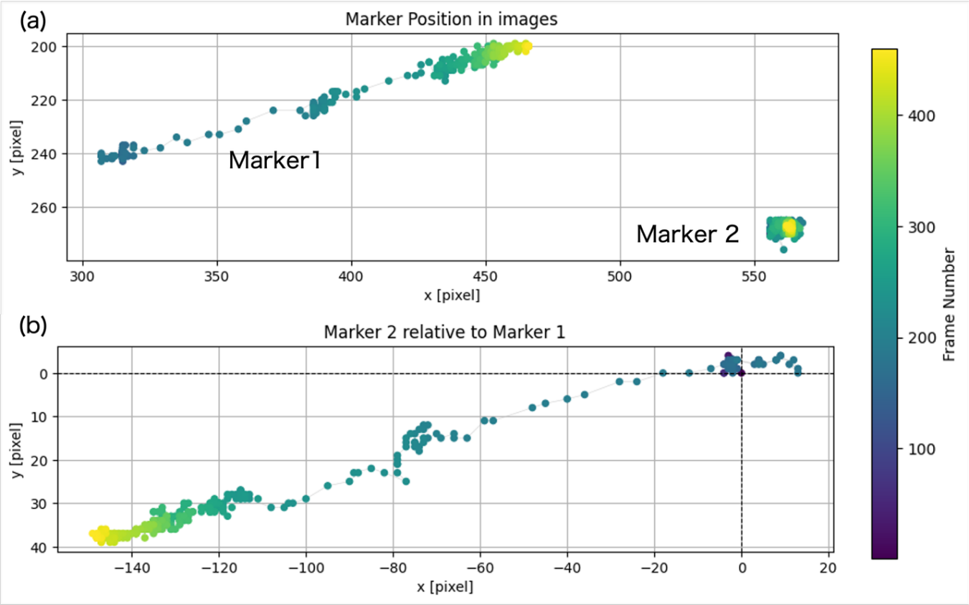Extended Data Fig. 2. The process until obtaining the car motion. (a) Tracking results in the 2D image coordinates. Markers 1 and 2 are placed on the car and on the ground white line, respectively (see Fig. 1e and Extended Data Fig. 1). Marker colour indicates the frame number. See also Supplementary Video 1. (b) The pixel-based motion of Marker 2 relative to Marker 1, which represents the displacement of the ground.

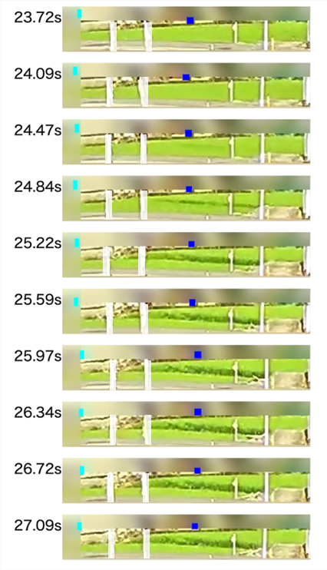

Extended Data Fig. 3. Snapshots of fault motion in cultivated area. Snapshots taken every 6 frames, showing when the fault appears. The cyan and blue rectangles indicate the position of markers used to estimate the fault slip. Portions of the images have been altered to protect personal information and privacy.

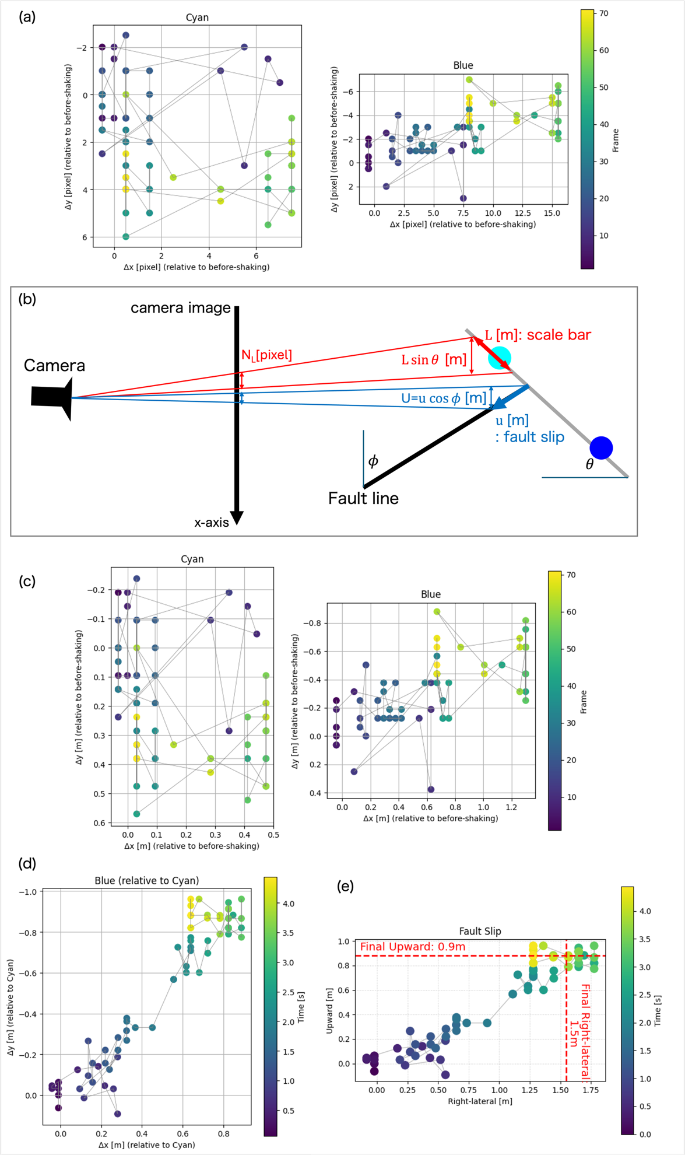

Extended Data Fig. 4. The process until obtaining the fault slip time series in Fig. 2c. (a) The tracking results with colours corresponding to frame numbers. Two tracking markers (cyan and blue; see Fig. 2a) are placed across the fault. The plotted points are relative to their positions before shaking. (b) Illustrative map view for pixel-meter conversion. (c) The length-scale-converted plot of (a). (d) The motion of the blue marker relative to the cyan marker, representing the fault slip. The frame-to-time conversion is based on a frame rate of 16 fps. (e) The plot obtained by converting (d) into upward (unchanged) and right-lateral (divided by cosφ) components. The final displacement is shown by the red dashed lines. The values shown here are identical to those in Fig. 2c, which instead plots time against the right-lateral and upward components separately.

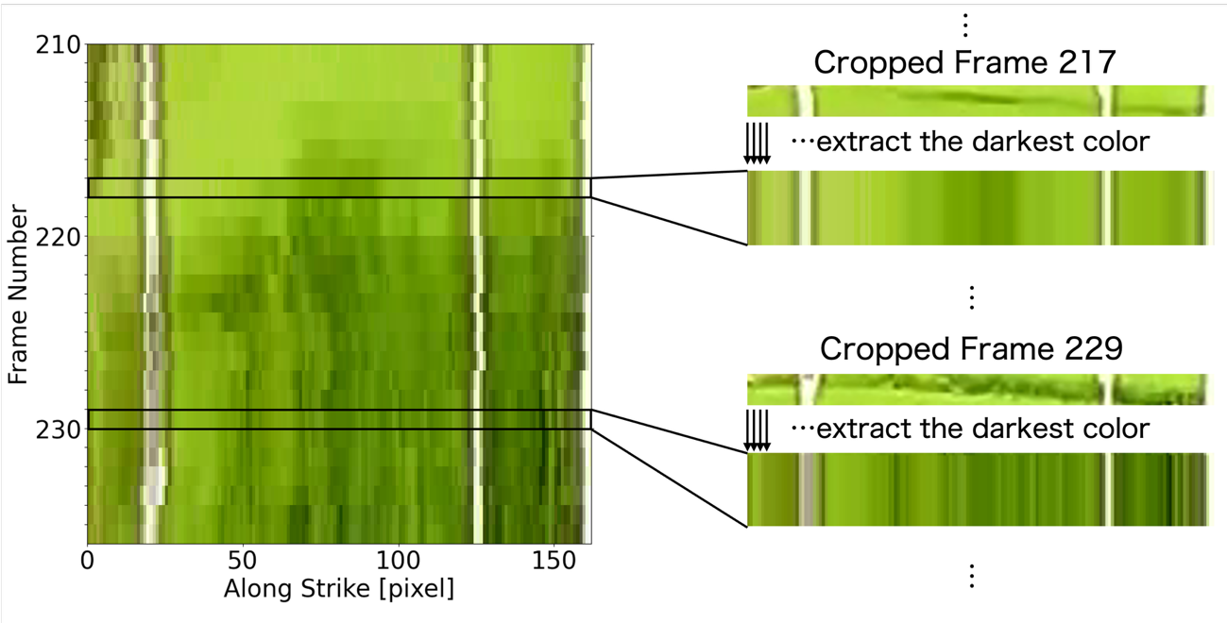 Extended Data Fig. 5. Process to obtain Fig. 2e. For each frame, the image is cropped to 22 (height) × 162 (width) pixels, with the crop region dynamically determined from the marker positions (Fig. 2a) so that the fault remains within the frame throughout the sequence. As illustrated on the right panels, within each cropped frame, the darkest pixel (i.e., the pixel with the lowest brightness, V value in HSV) is extracted from each column, producing a single 1 × 162-pixel line. Stacking these lines for all frames, in order of frame number, produces the left panel (Fig. 2e). Since the darker pixels primarily correspond to shadows cast by the uplifted fault scarp, the onset of darkening indicates the onset of uplift, i.e., the initiation of fault slip and rupture.

