Thermally Adaptive Interfacial Polymer Network Enables Space-Compatible Perovskite Solar Cells
Ran Wang¹, Liangliang Deng², Zhijie Hu¹, Xiaoguo Li², Hongzhou Zhao¹, Dawei Zhao³, Dan Li¹, Ligang Xu⁴, Qiang Guo¹, Tianyi Liu¹, Siqi Huang¹, Jiao Wang¹, Yingguo Yang⁵, Anran Yu^{1*}, Yiqiang Zhan^{1,6*}

¹The State Key Laboratory of Photovoltaic Science and Technology, College of Future Information Technology, Fudan University, Shanghai 200438, China
²Jiangyin Jinghao New Energy Technology Co., Ltd. Jiangyin, China
³Department of Materials, University of Manchester, Oxford Road, Manchester, M13 9PL, UK
⁴State Key Laboratory of Catalysis, Dalian National Laboratory for Clean Energy, Dalian Institute of Chemical Physics, Chinese Academy of Sciences, Dalian 116023, China
⁵School of Microelectronics, Fudan University, Shanghai 200433, China
⁶Institute of Optoelectronics, Fudan University, Shanghai 200438, China

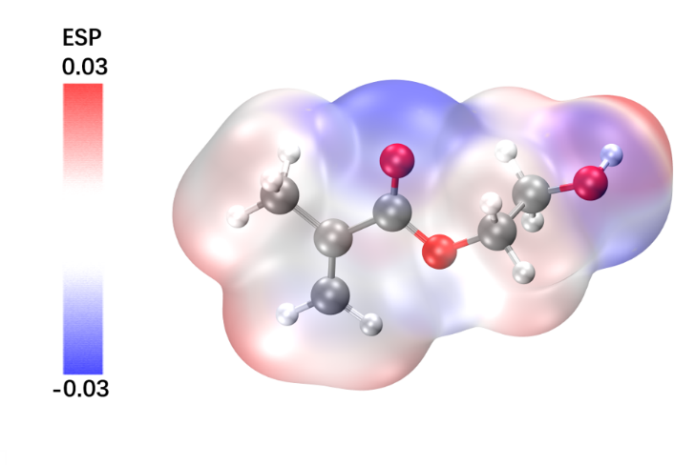
Supplementary Figure 1 ESP of P2HM molecules.

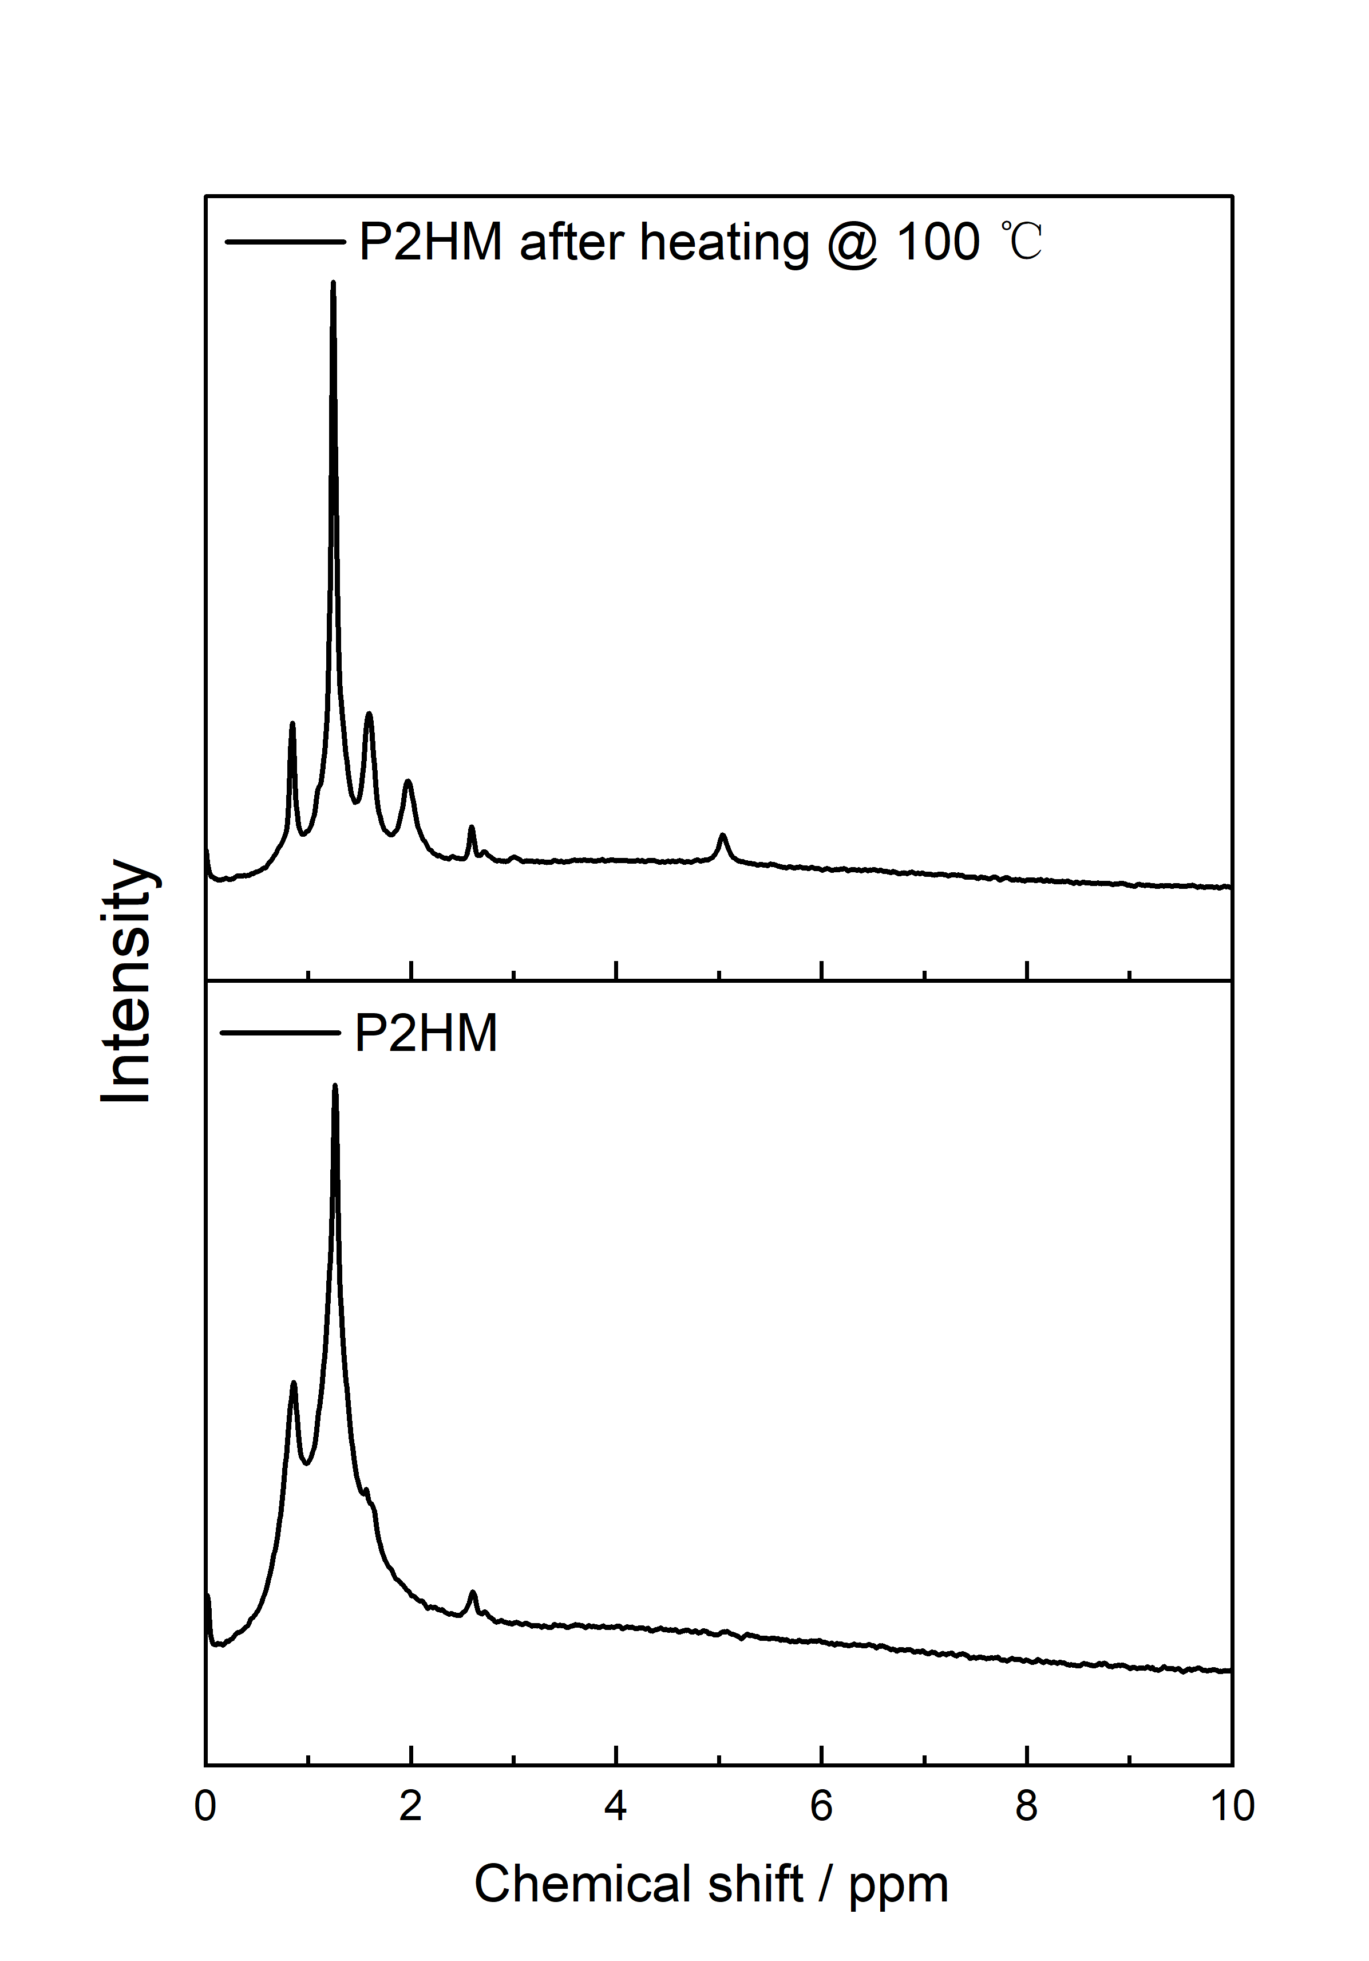
Supplementary Figure 2 SS ¹H NMR spectra of P2HM powder and P2HM after heating.

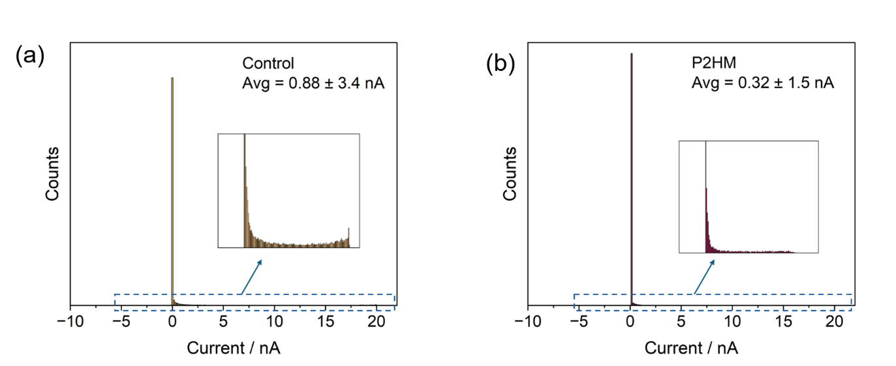
Supplementary Figure 3 Statistical current distribution of Control and P2HM-treated films extraceted from Figure 1d, e.

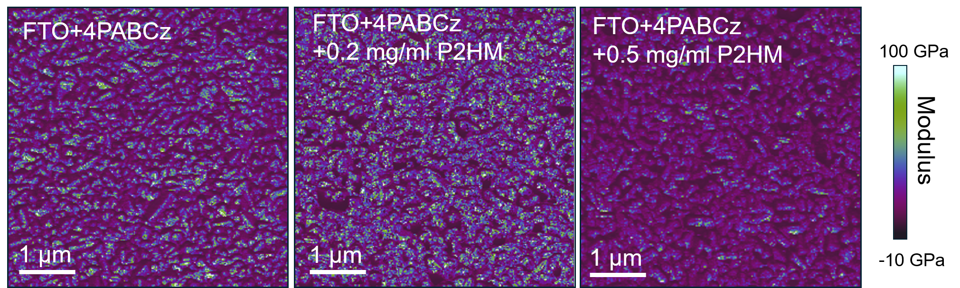
Supplementary Figure 4 PFQNM images of the FTO/4PABCz, FTO/4PABCz/0.2 mg/mL P2HM and 0.5 mg/mL P2HM films.

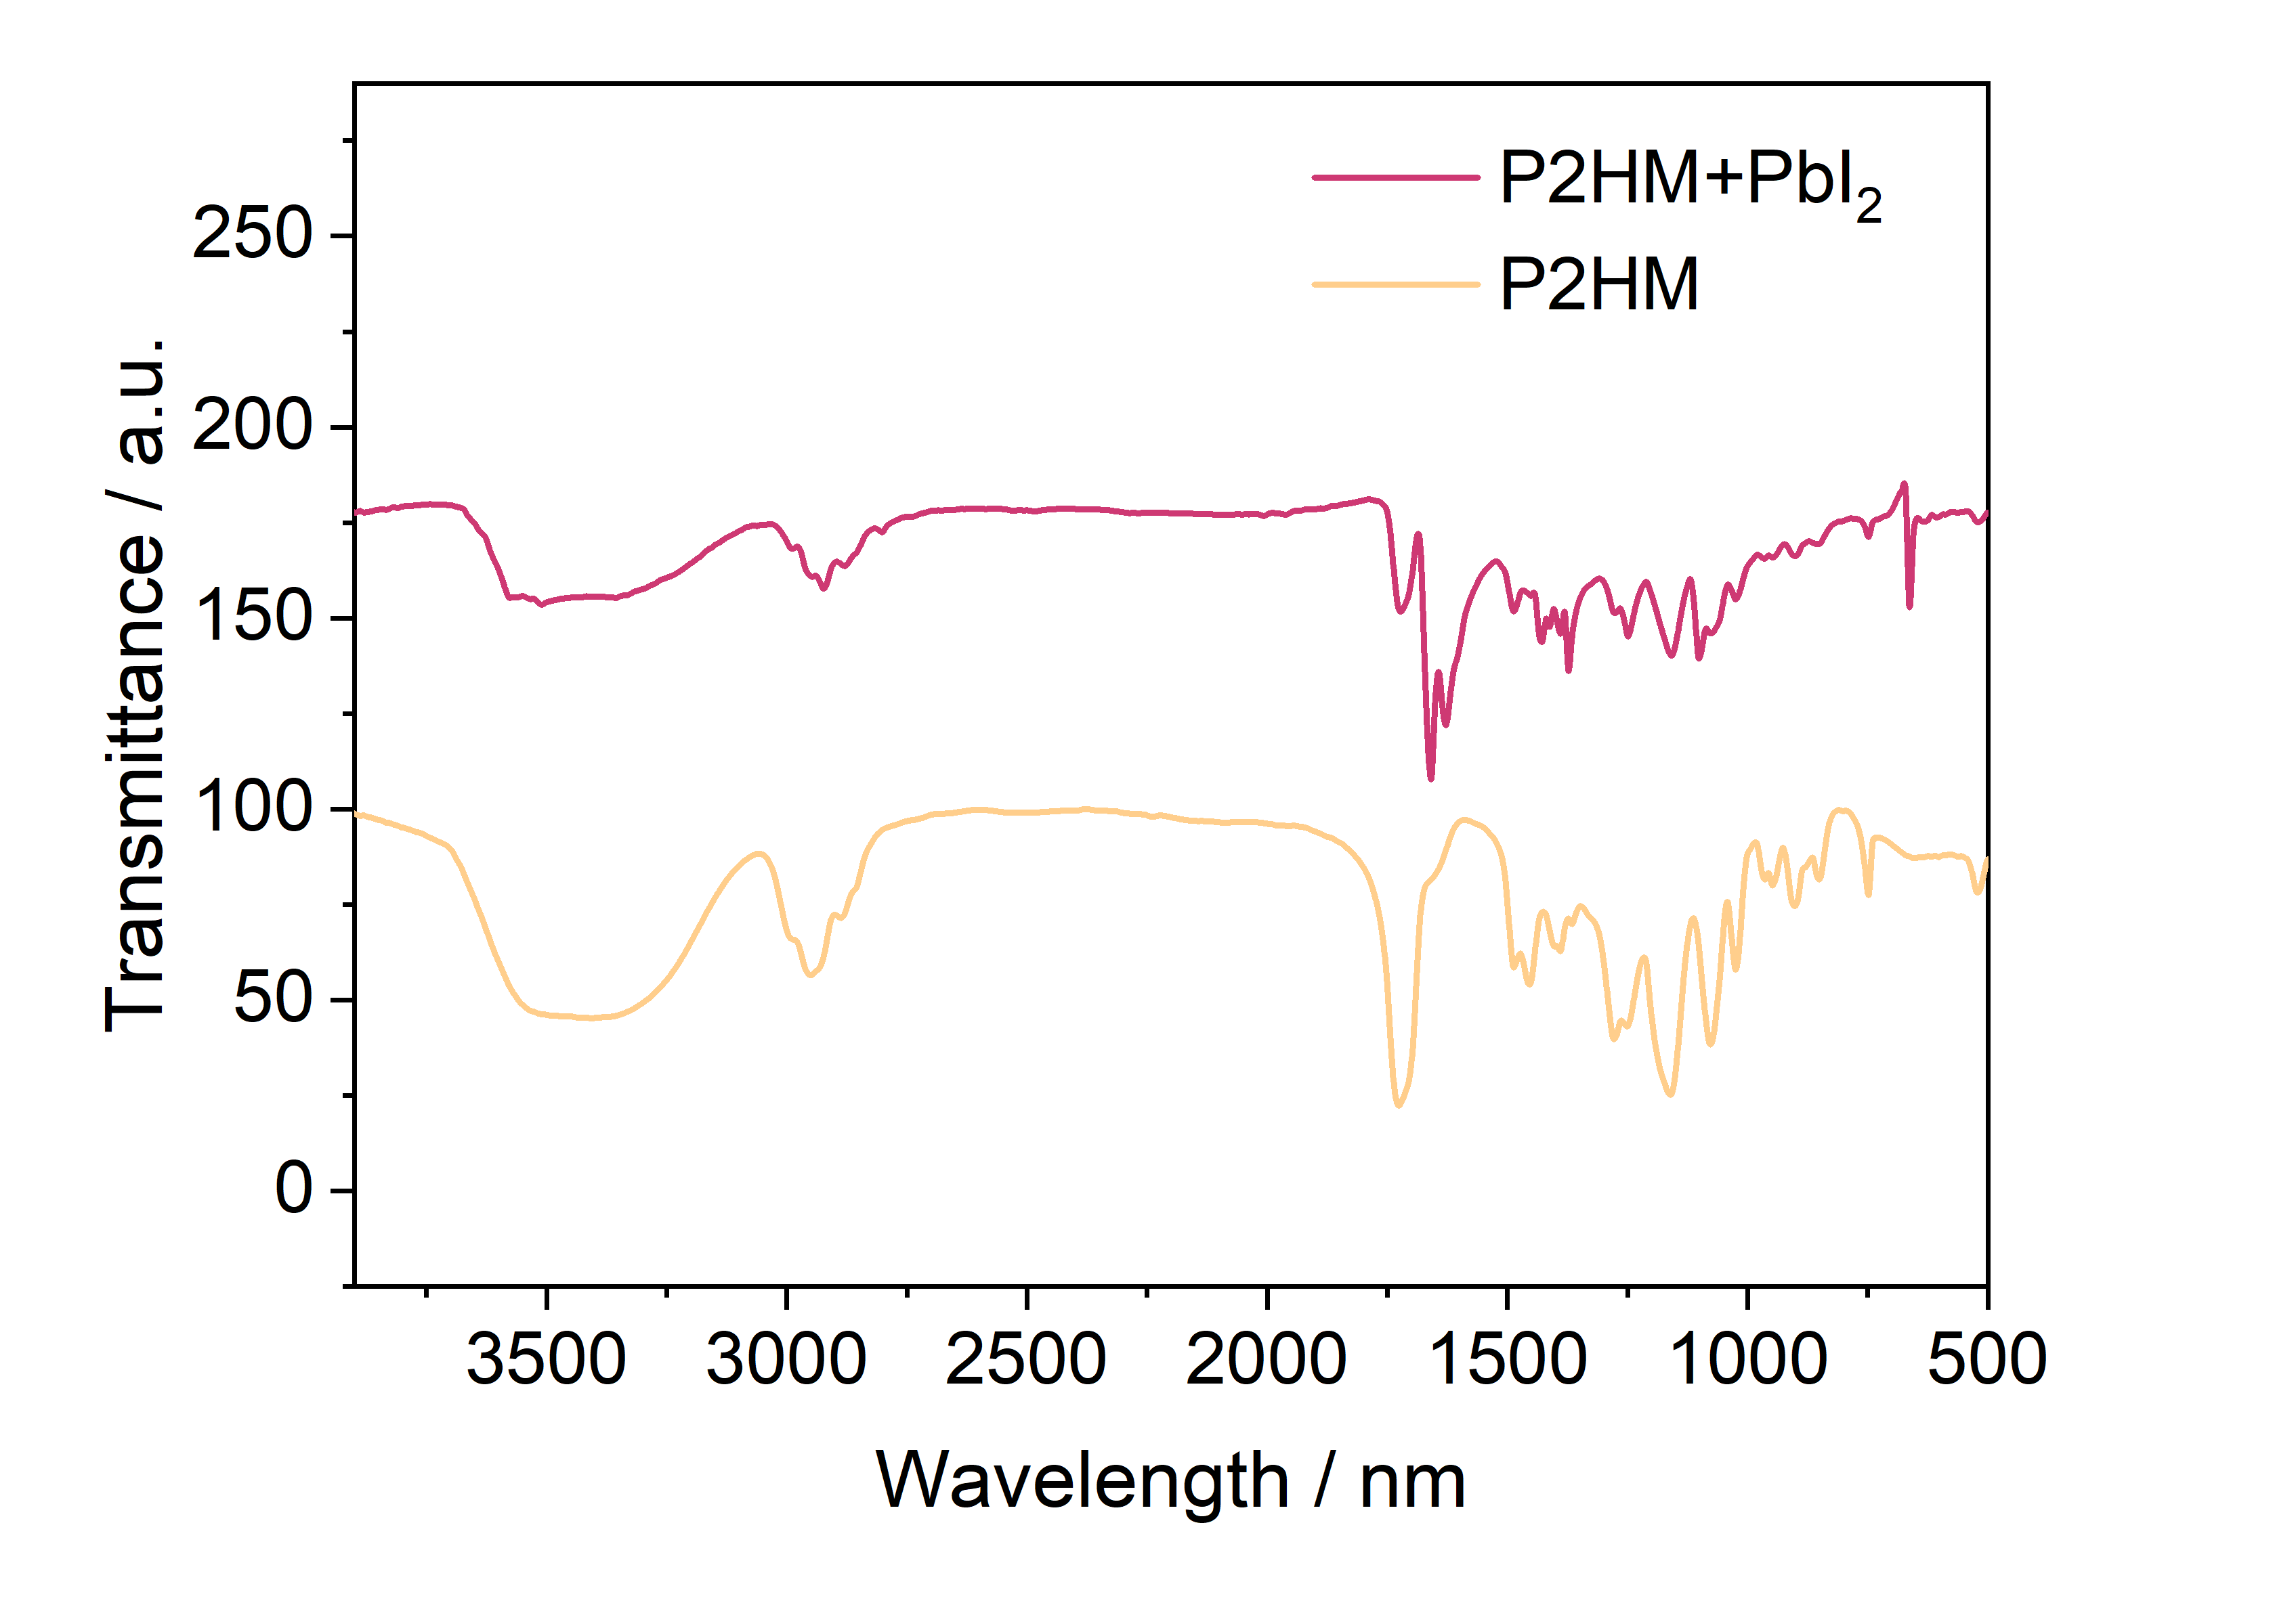
Supplementary Figure 5 FTIR full spectra of P2HM and P2HM/PbI₂ mixture.

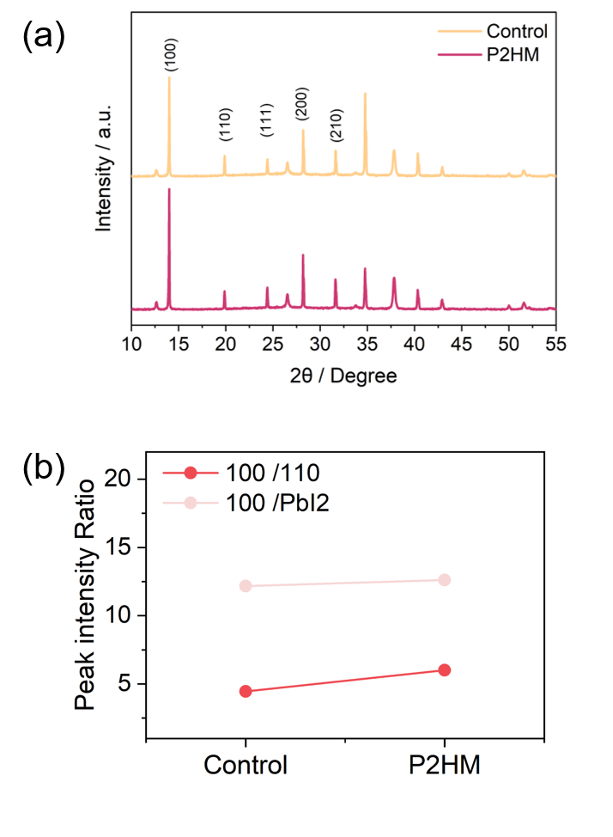
Supplementary Figure 6 (a) XRD patterns of perovskite films with and without P2HM treatment. (b) Intesntiy ratio of (100)/(110) and (100)/(PbI₂) peaks extracted from the XRD spectra.

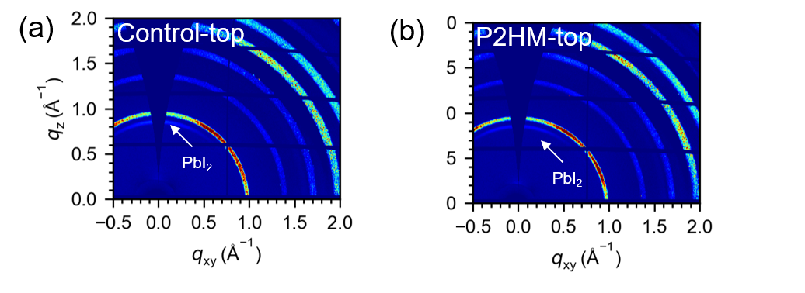
Supplementary Figure 7 GIWAX patterns of the perovskite film (top side) before and after treament at a grazing incidence angle of 0.2°.

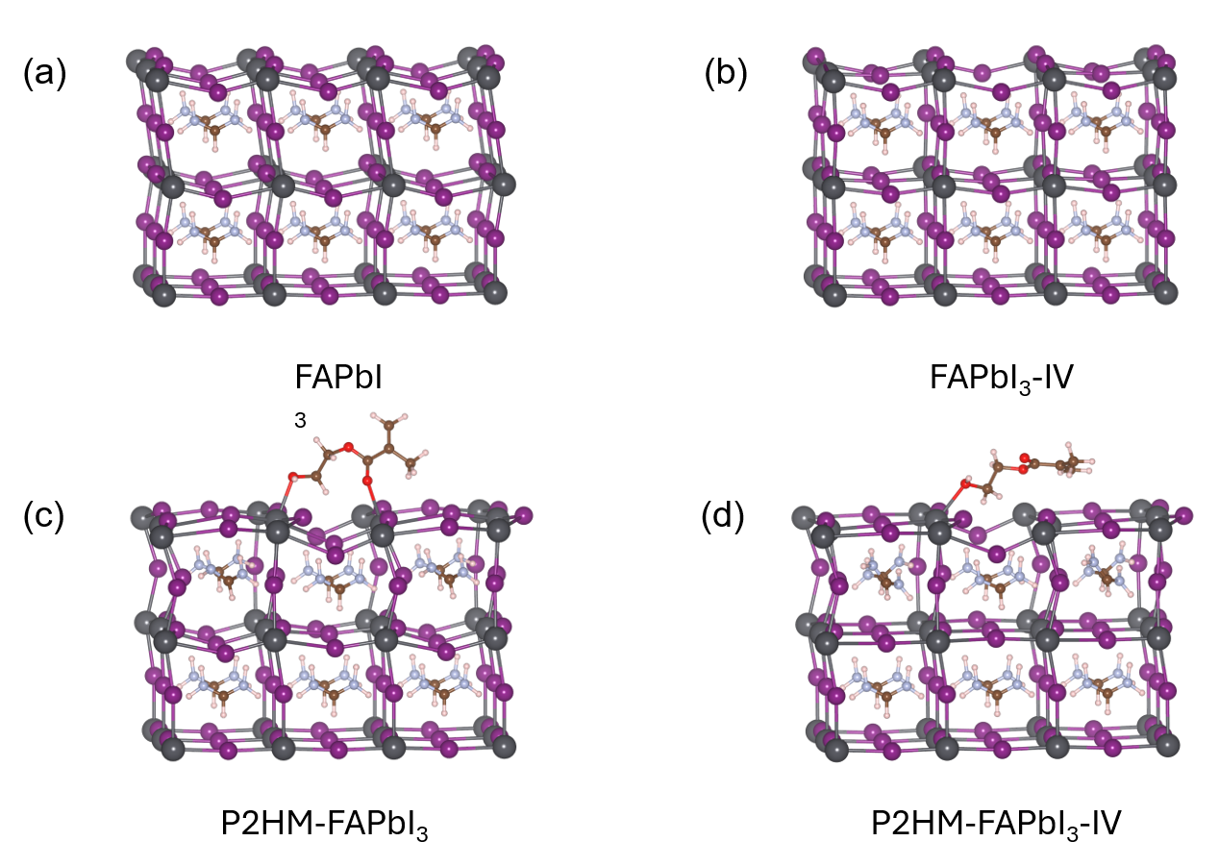Supplementary Figure 8 (a) The perovskite slab, (b) with an V_{I}, (c) P2HM adsorbed on the perovskite slab, (d) adsorbed on the perovskite slab with an V_{I}.

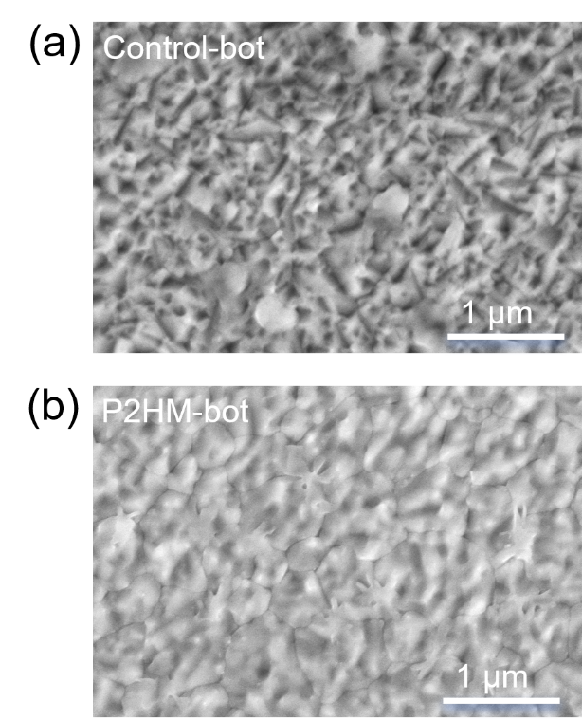
Supplementary Figure 9 SEM images of buried Control and P2HM-treated perovskite films.

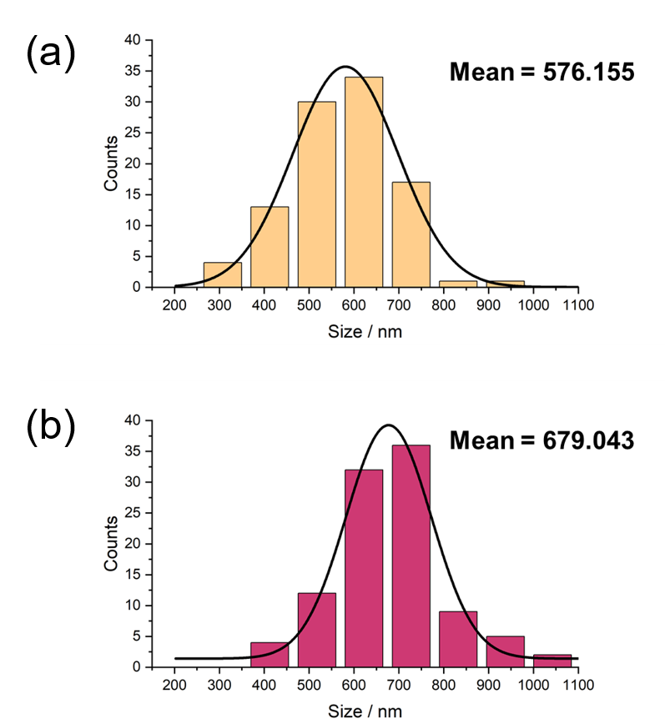
Supplementary Figure 10 SEM grain size distribution of the control and treated films.

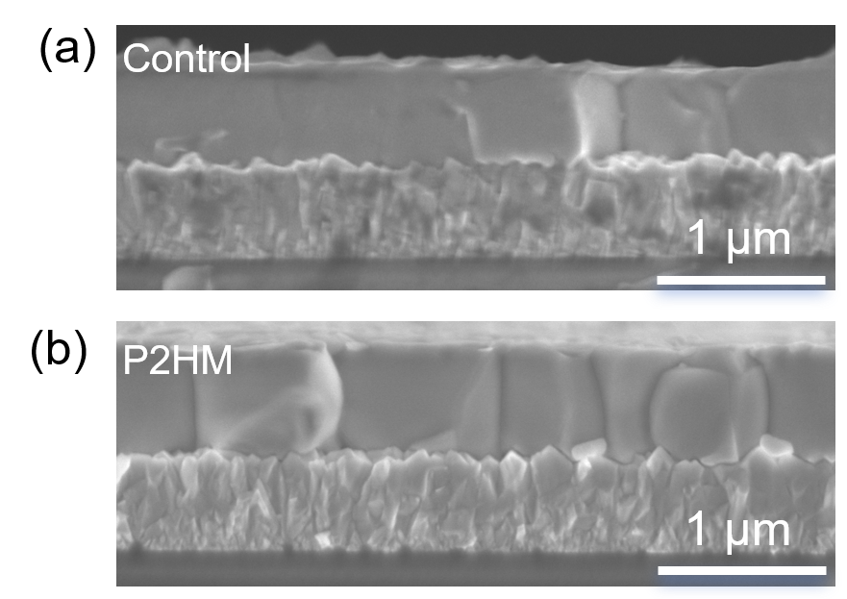
Supplementary Figure 11 Cross-sectional SEM images of Control and P2HM-treated films.

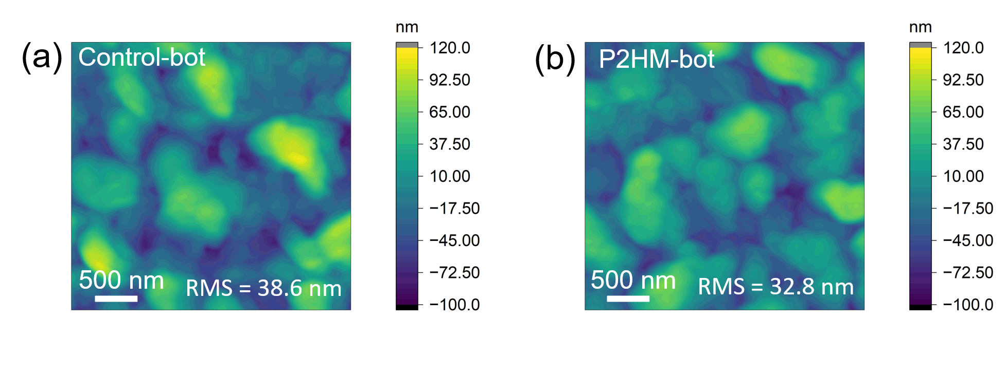
Supplementary Figure 12 AFM images of buried surface of control and treated perovskite films.
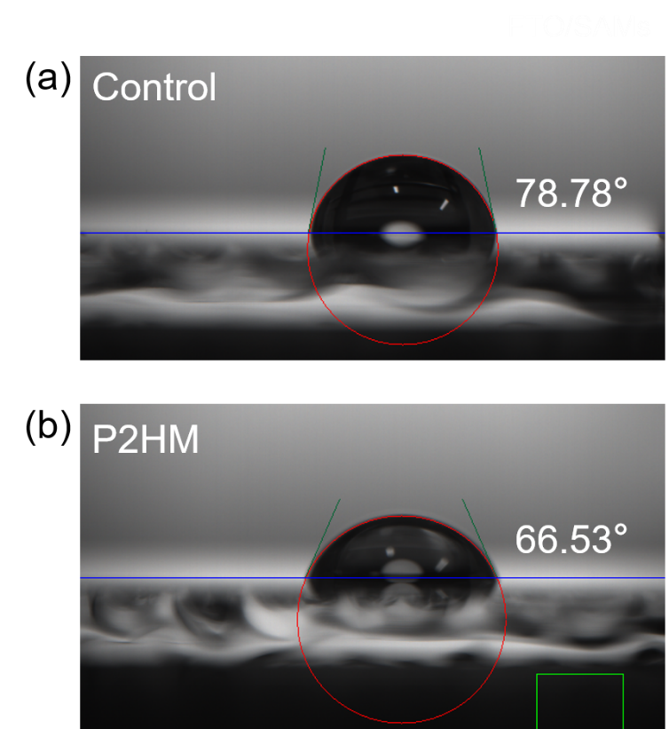
Supplementary Figure 13 Contact angles of FTO/4PABCz, FTO/4PABCz/P2HM thin films.

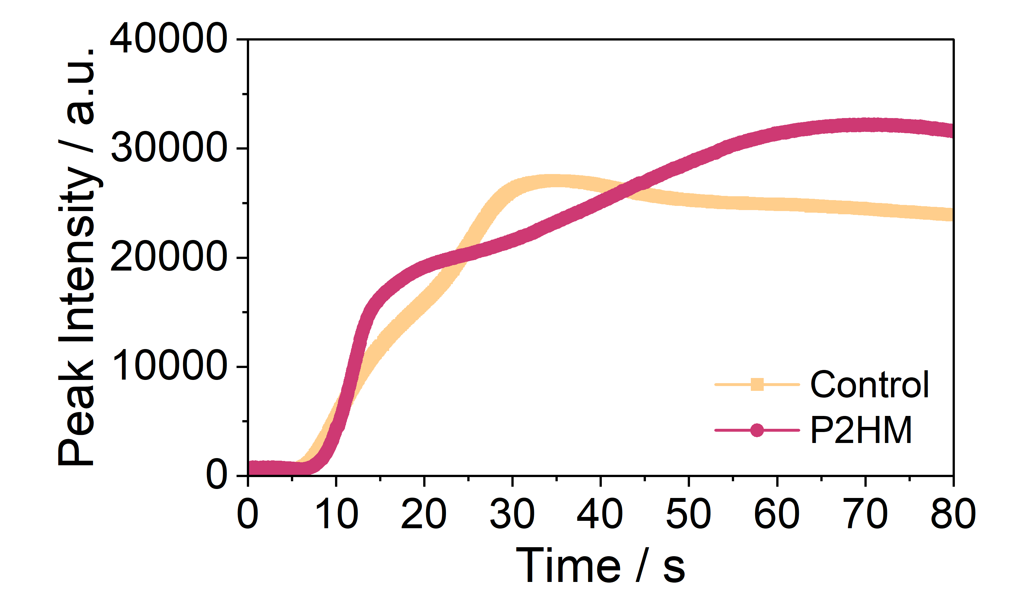
Supplementary Figure 14 Peak information plots obtained from in-situ PL measurements for peak intensity correspond to Figure 2i, j.

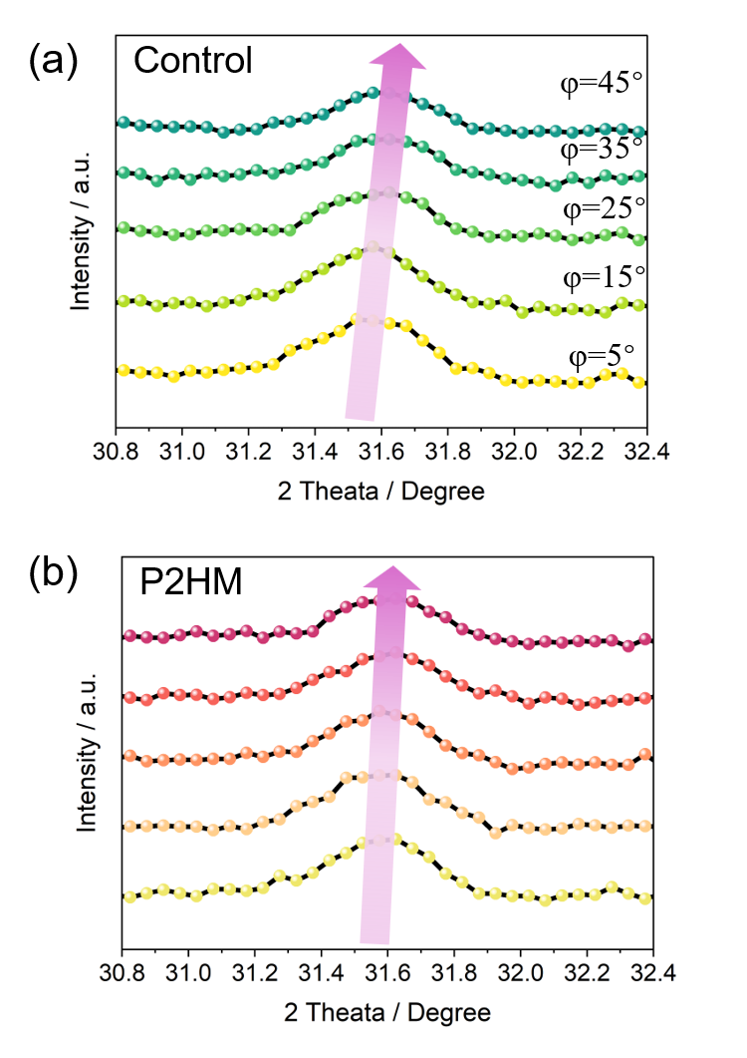
Supplementary Figure 15 GIXRD patterns at different Ψ angles (from 5° to 45°) of the (a) Control and (b) P2HM-treated films.

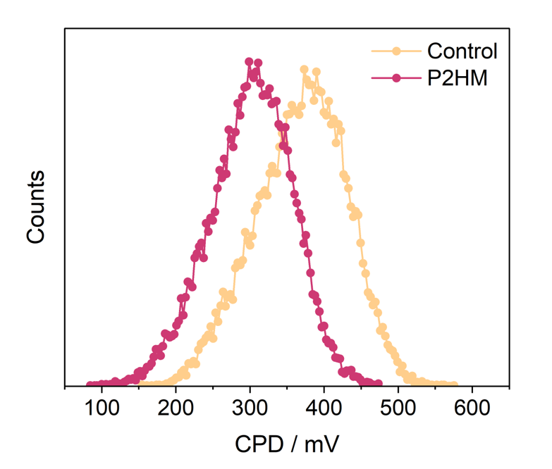
Supplementary Figure 16 The corresponding CPD potential distributions obtained from Figure 3a, b.

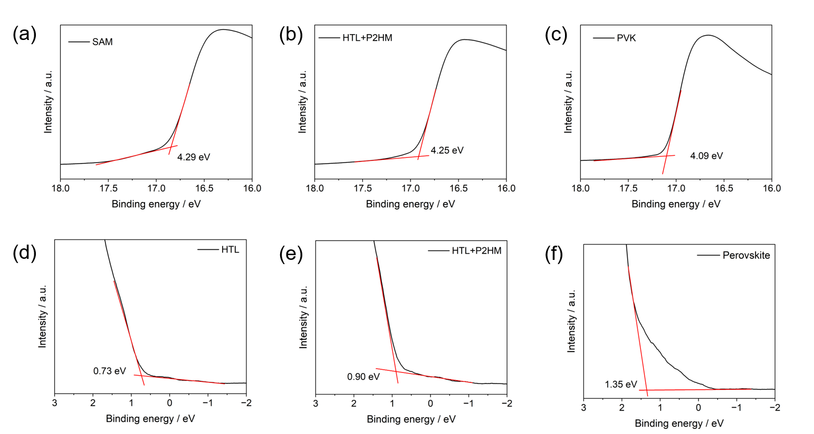
Supplementary Figure 17 UPS of the (a, d) FTO/4PABCz, (b, e) FTO/4PABCz/P2HM and (e, f) FTO/4PABCz/P2HM/Perovskite thin films.

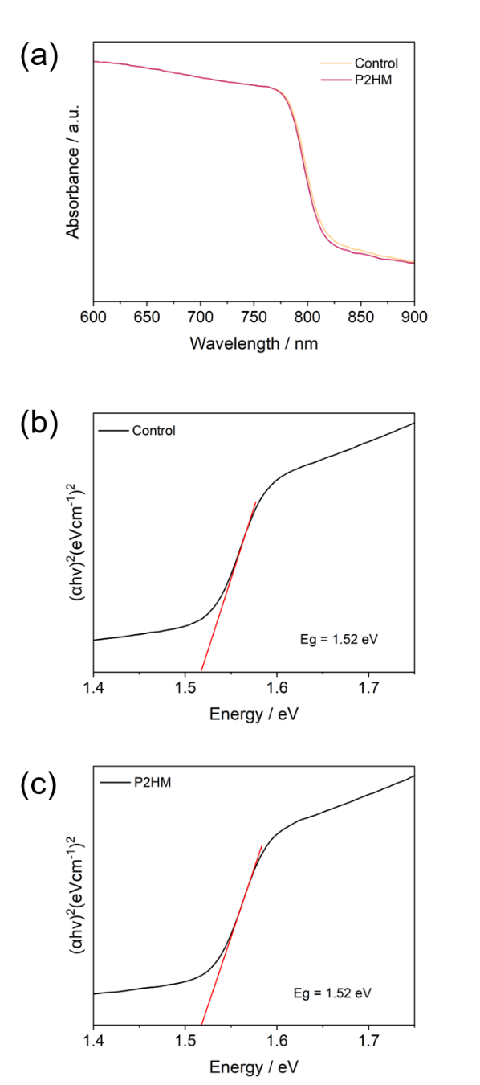
Supplementary Figure 18 (a) UV-vis spectra of perovskite films before or after modifications and (b, c) the corresponding calculated Tauc plots.

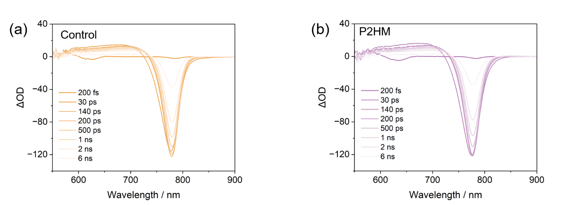
Supplementary Figure 19 (a) TA spectras of FTO/4PABCz/perovskite and (b) FTO/4PABCz/P2HM/Perovskite films.

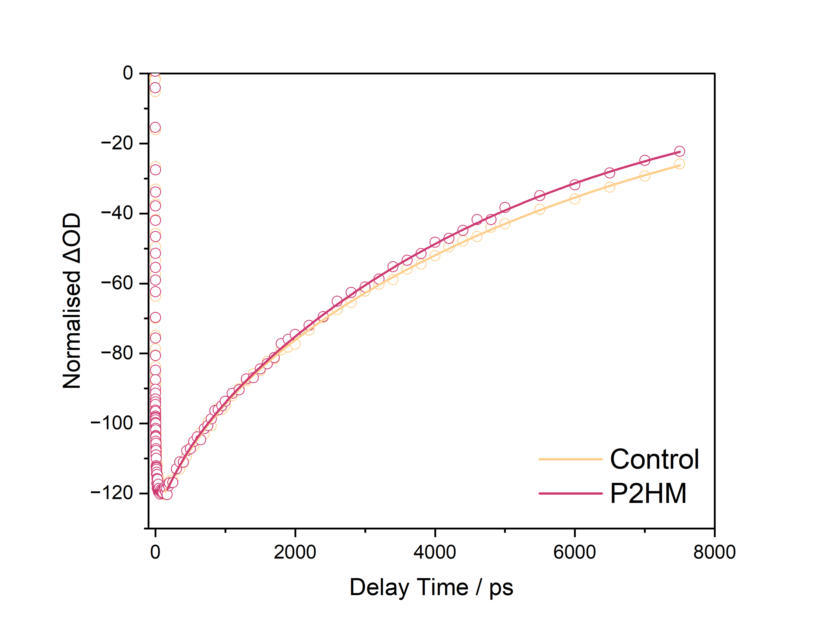
Supplementary Figure 20 Normalized TA kinetics probed at 776 nm.

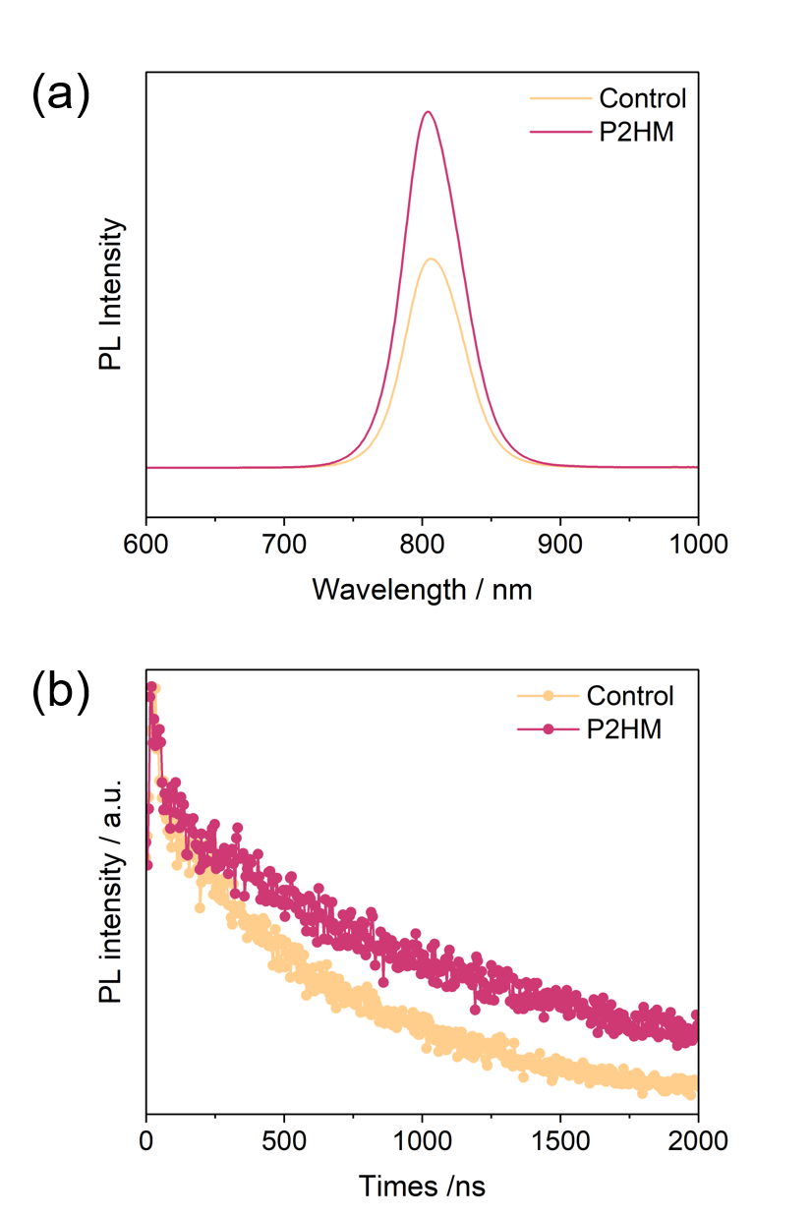
Supplementary Figure 21 PL (a) and TRPL (b) spectra of different perovskite films.

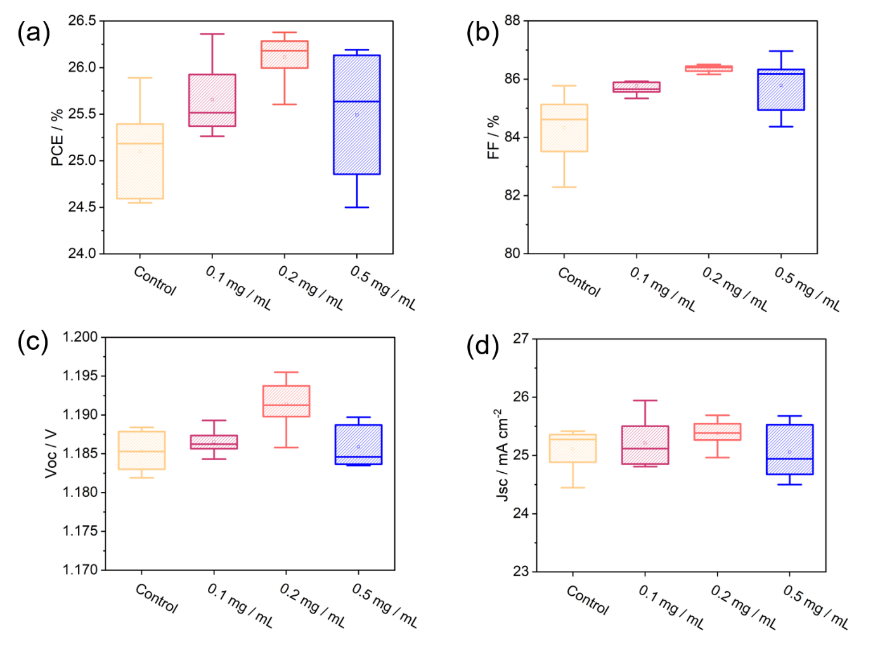
Supplementary Figure 22 Statistical box plots of V_{OC}, FF, J_{SC}, and PCE for P2HM-treated devices with various concetrations in EtOH.

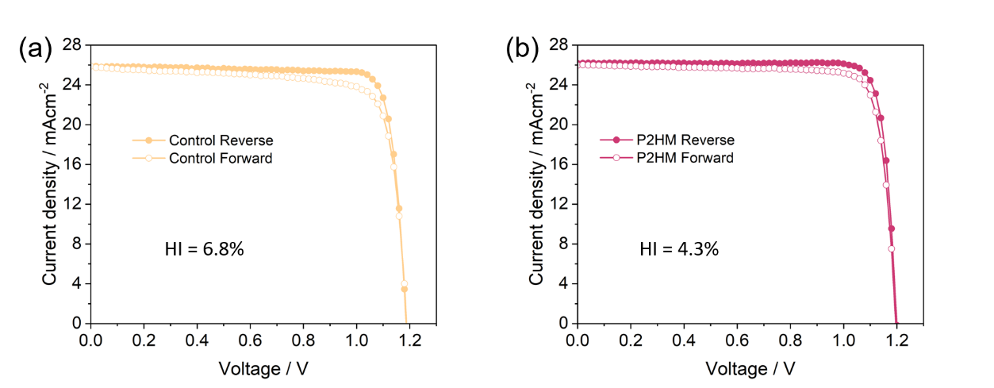
Supplementary Figure 23 J–V curves of the best-performing devices measured under fowford and reverse scan direction.
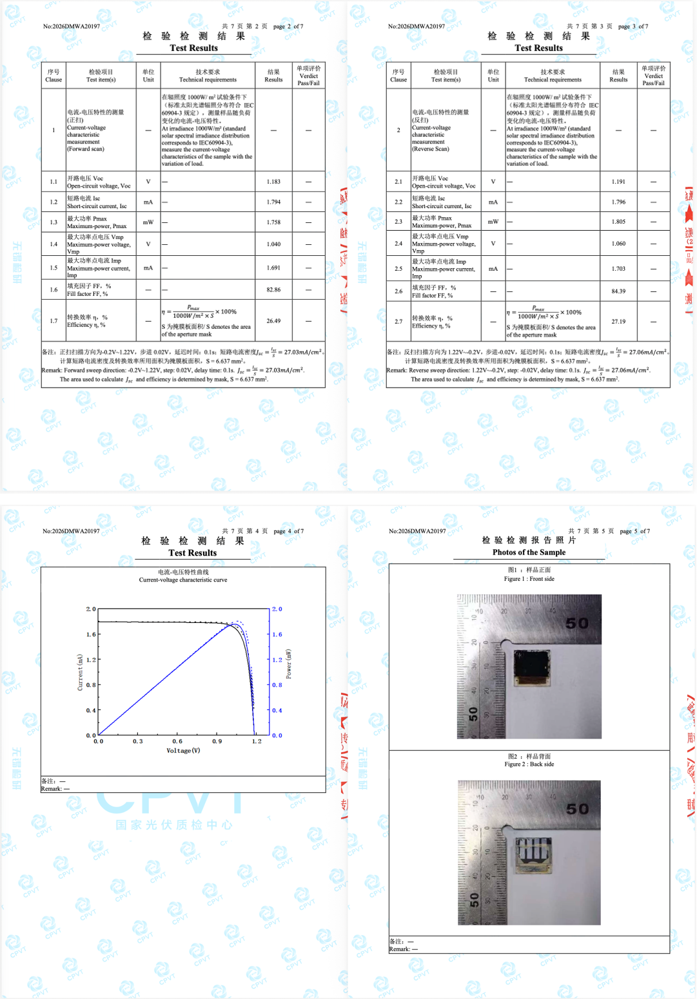
Supplementary Figure 24 Certified report on the performance of small-area P2HM-treated PSCs from the Wuxi Institute of Inspection, Testing and Certification, National Center of Inspection on Solar Photovoltaic Prodcuts Quality.

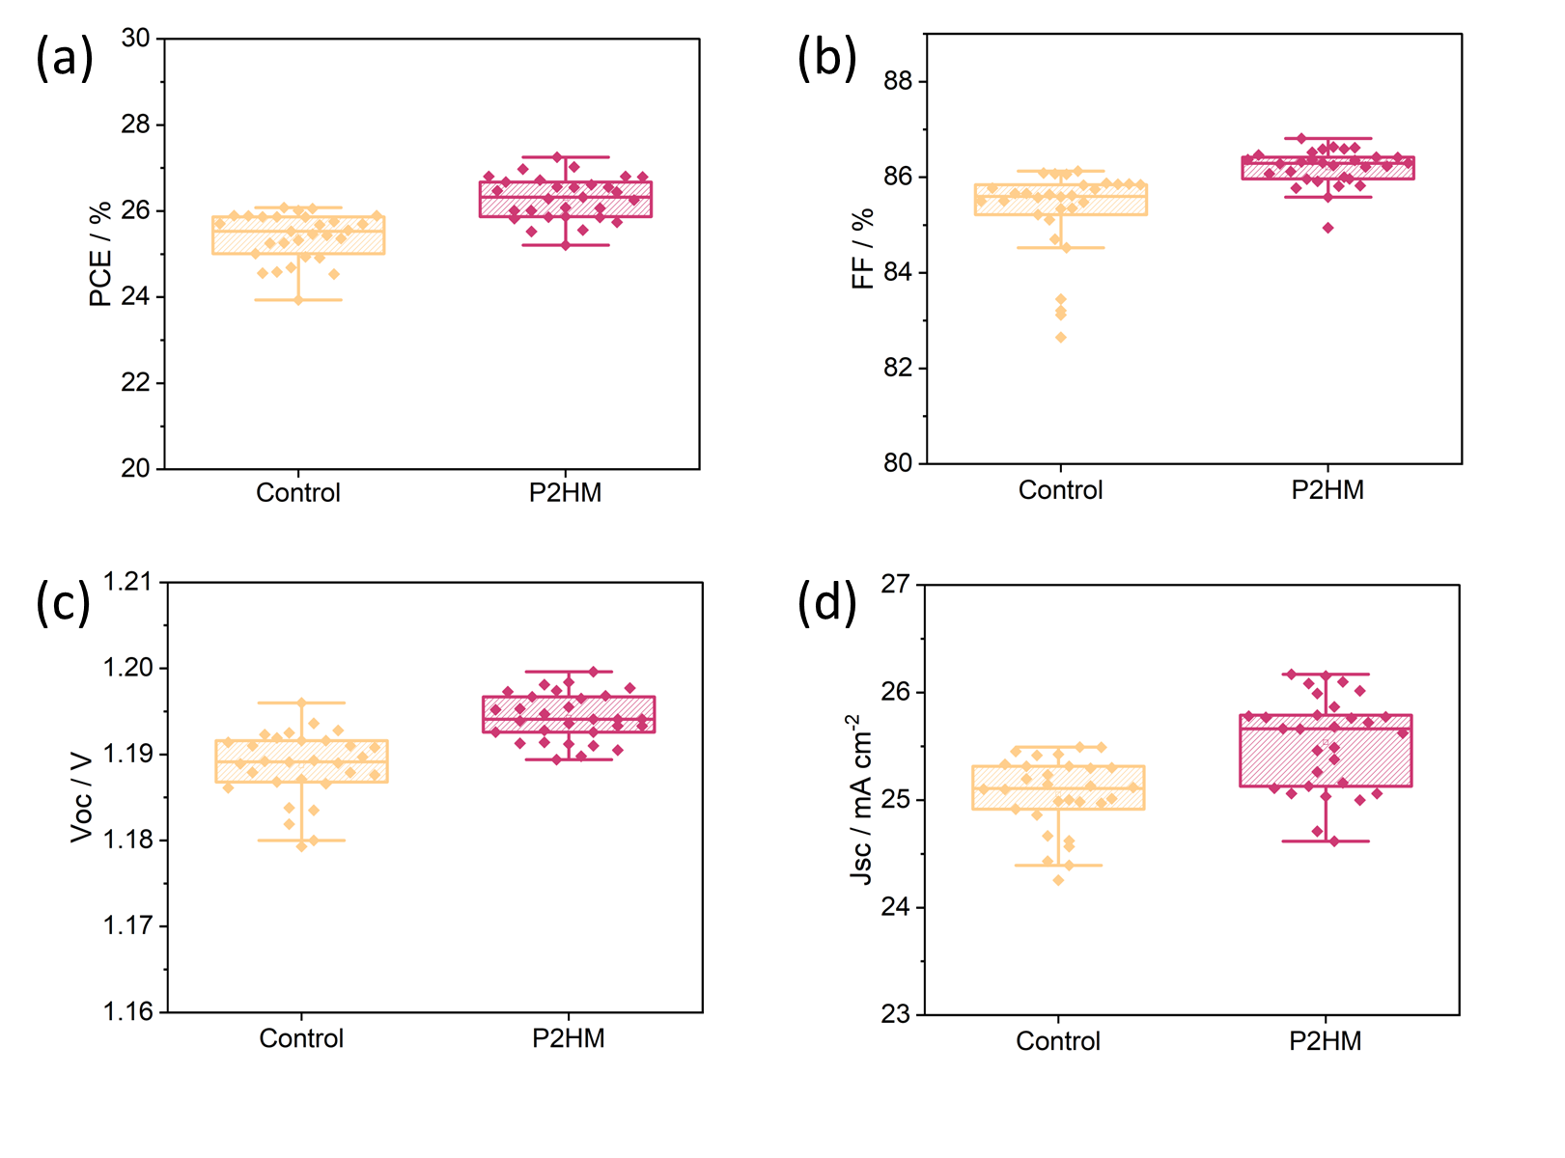
Supplementary Figure 25 Statistic results of (a) PCE, (b) FF, (c) V_{oc} and (d) J_{sc}, of perovskite devices without and with P2HM treatment collected from 24 individual devices.

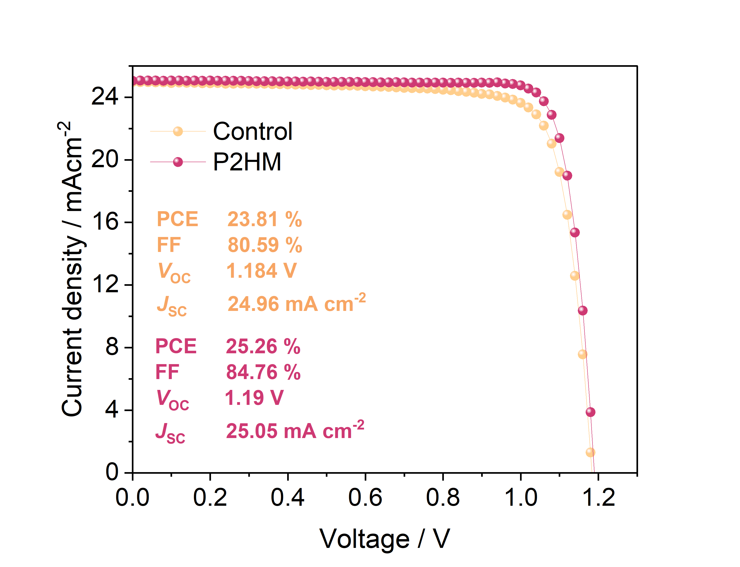
Supplementary Figure 26 The J-V curves of the small-area flexible devices.

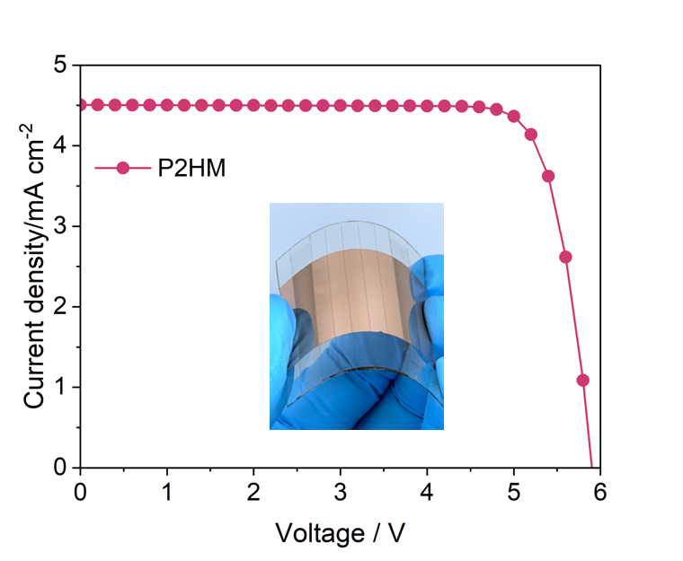
Supplementary Figure 27 The J-V curves of the modulus flexible devices.

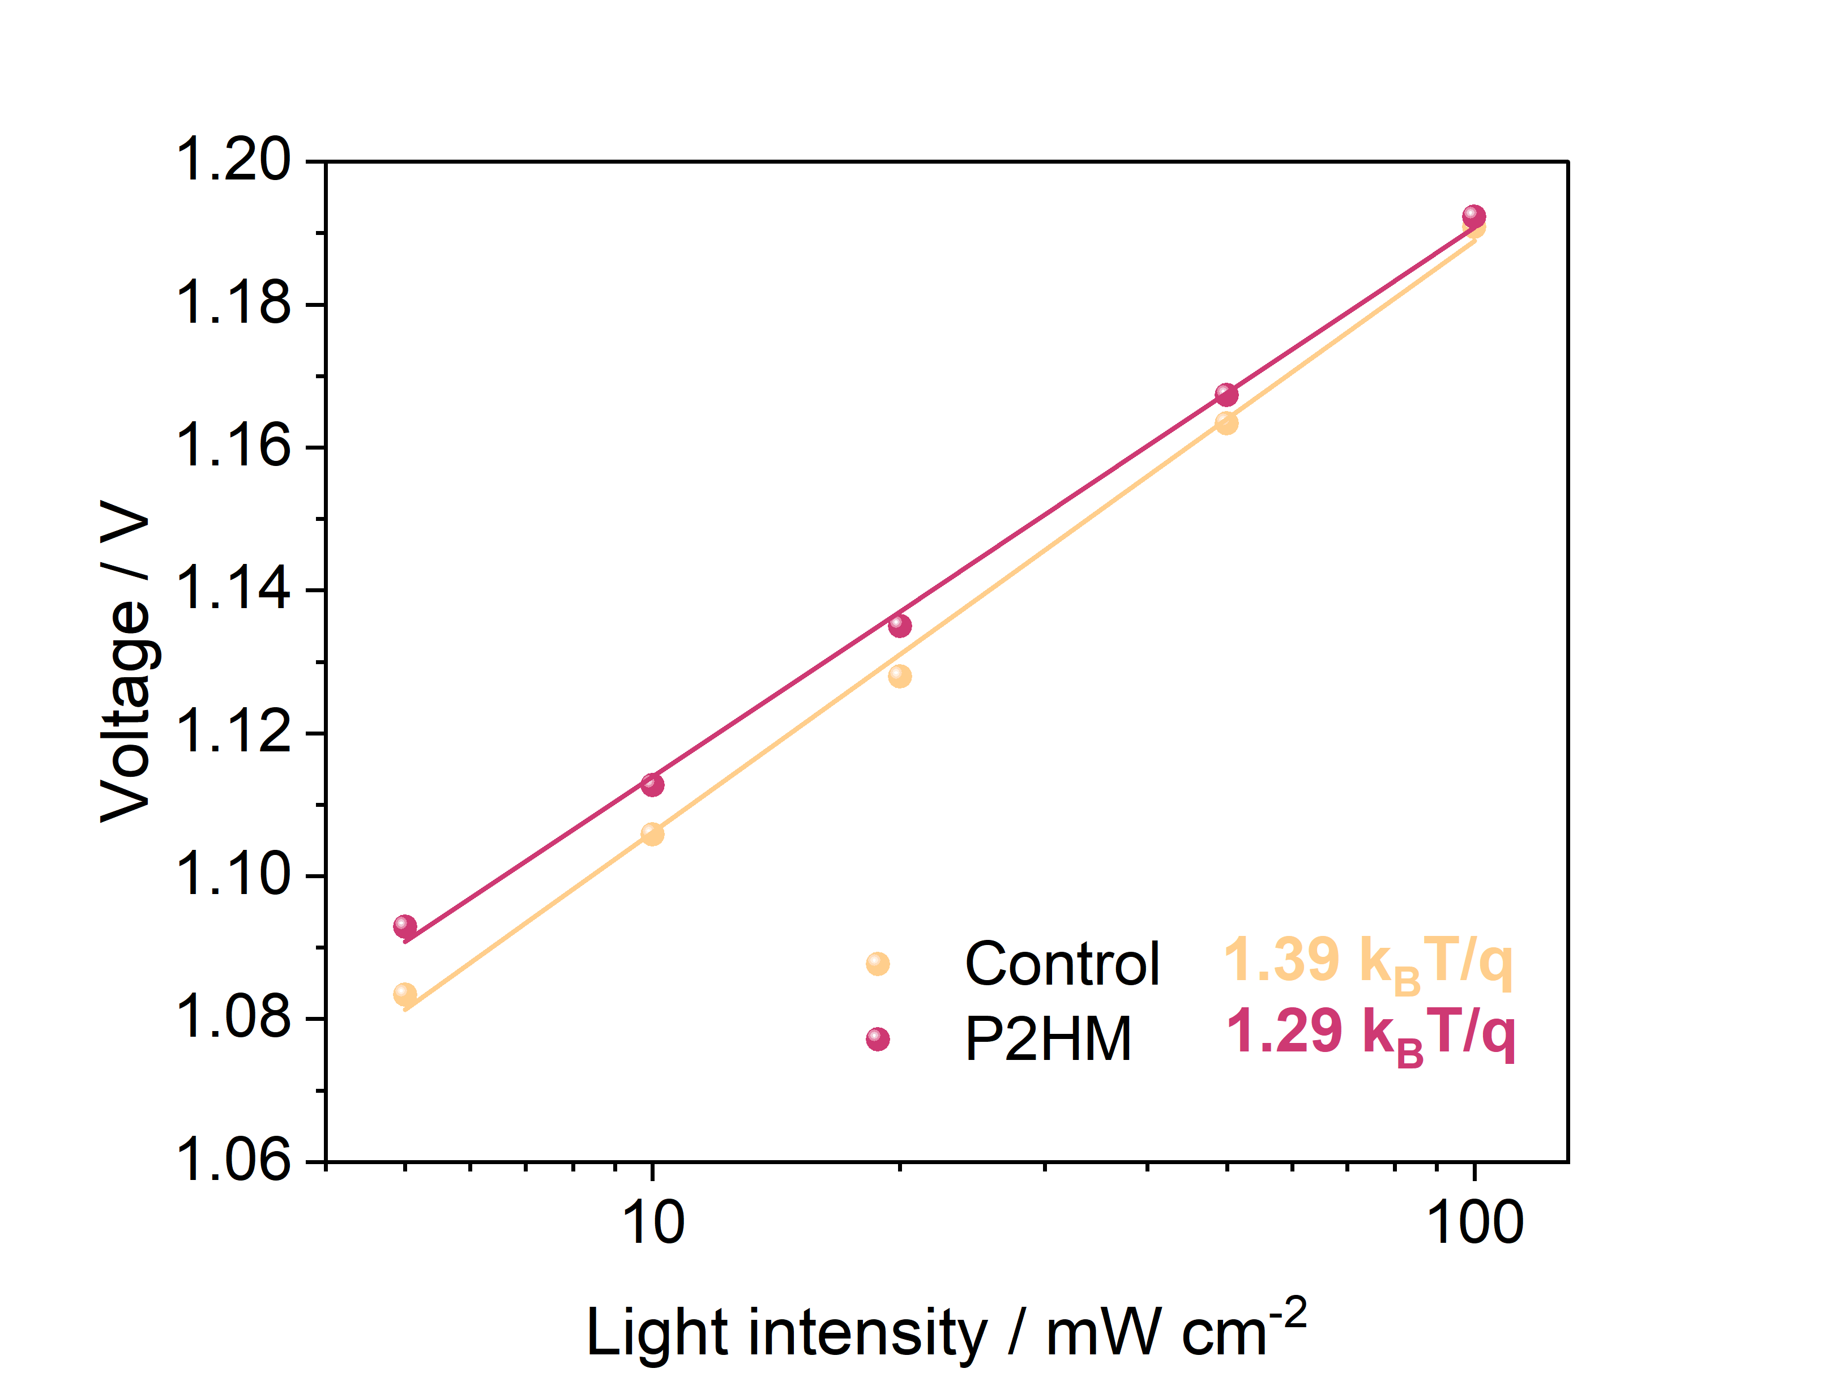
Supplementary Figure 28 V_{OC} versus light intensity plots.

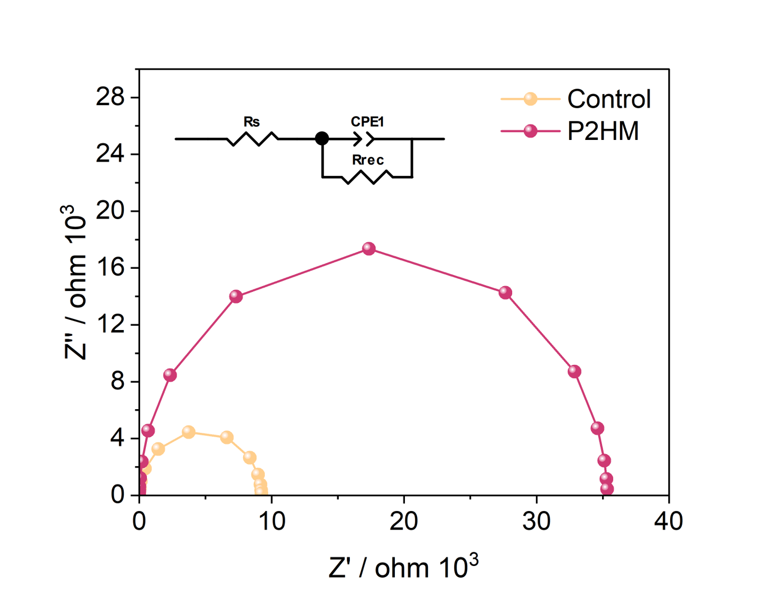
Supplementary Figure 29 EIS curves of control and trested devices.

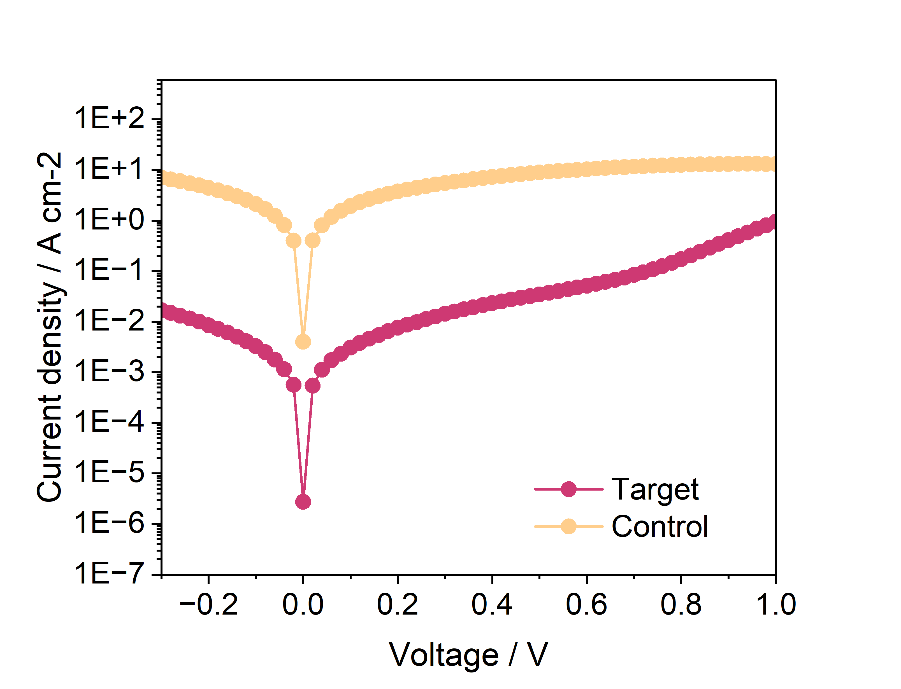
Supplementary Figure 30 Dark-current measurements of control and trested devices.

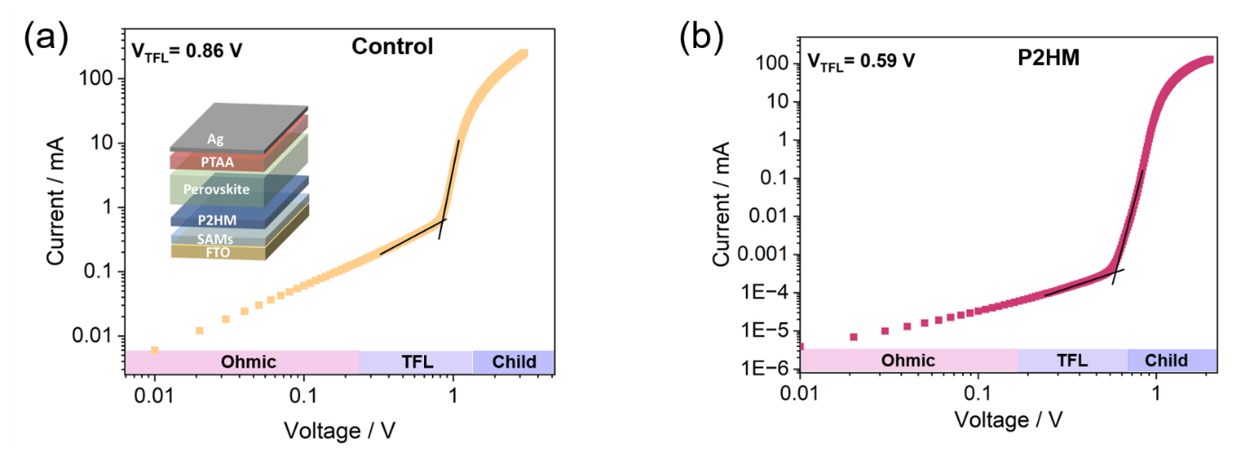
Supplementary Figure 31 SCLC results for the hole-only devices with a structure of FTO/4PABCz/perovskite/PTAA/Ag.

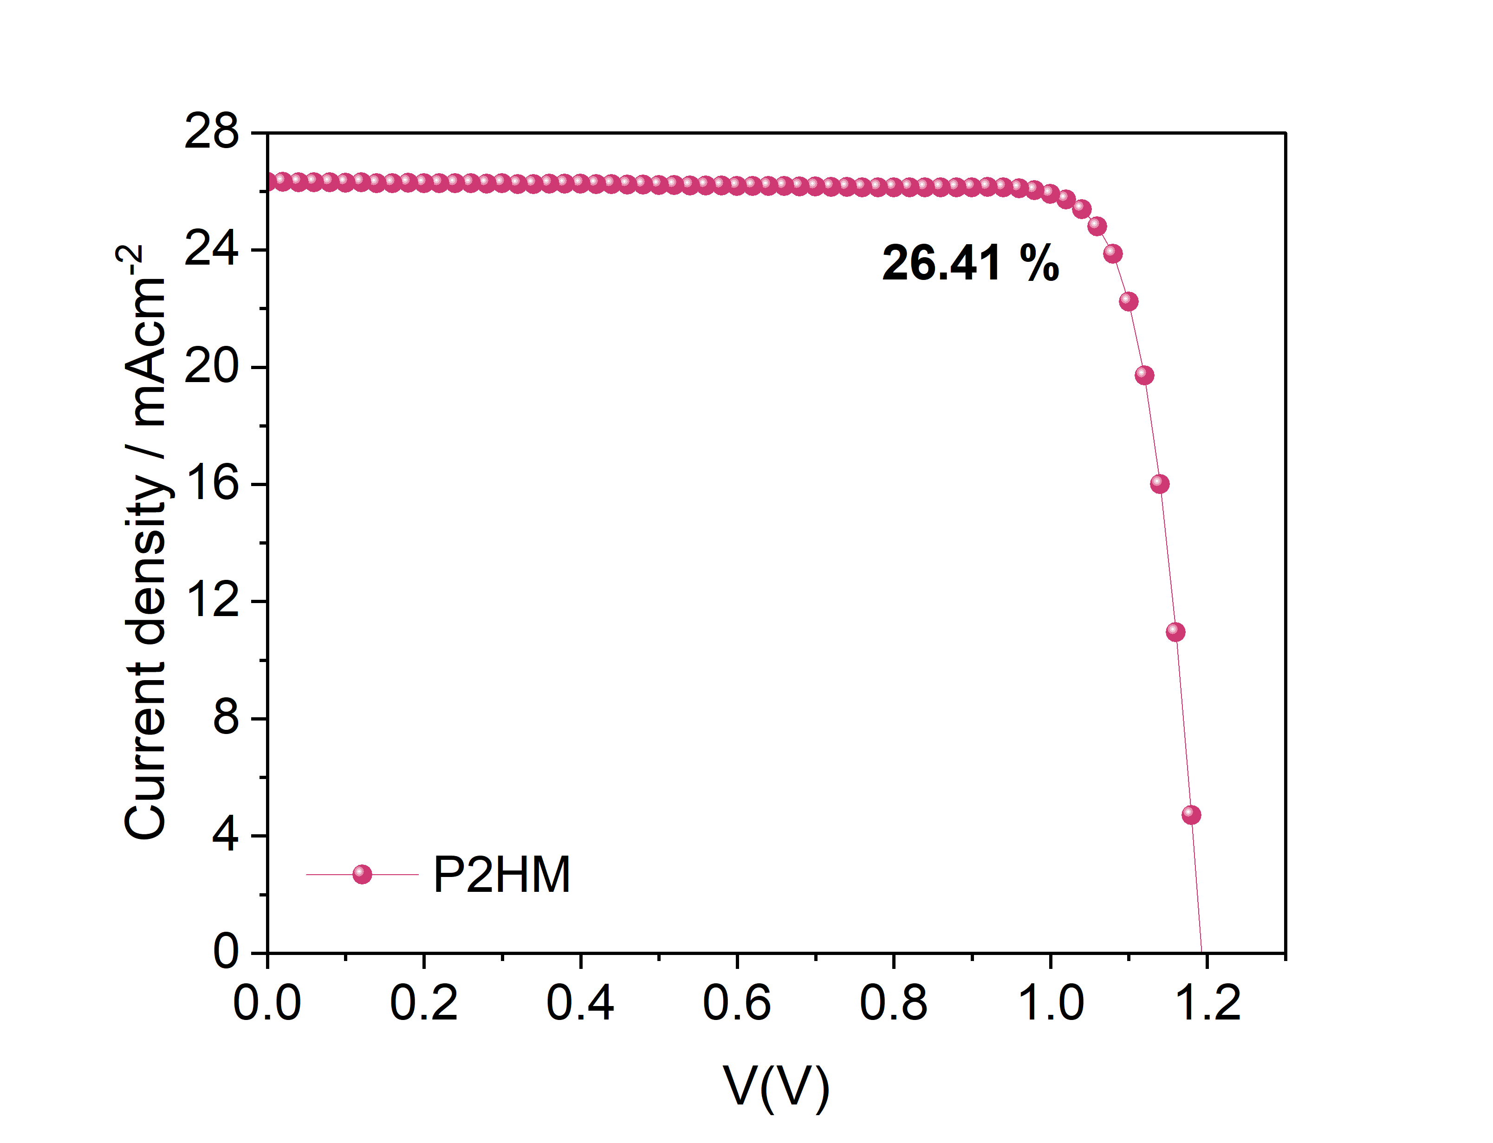
Supplementary Figure 32 The J-V curves of the devices with replaced SnOx and Au.

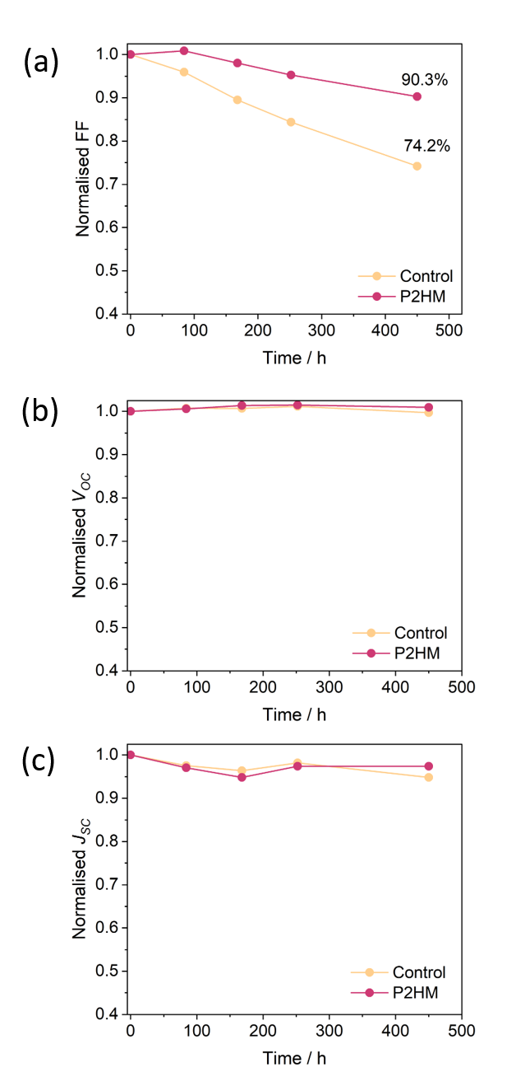
Supplementary Figure 33 FF, V_{OC} and J_{SC} change during thermal stability at 100°C.

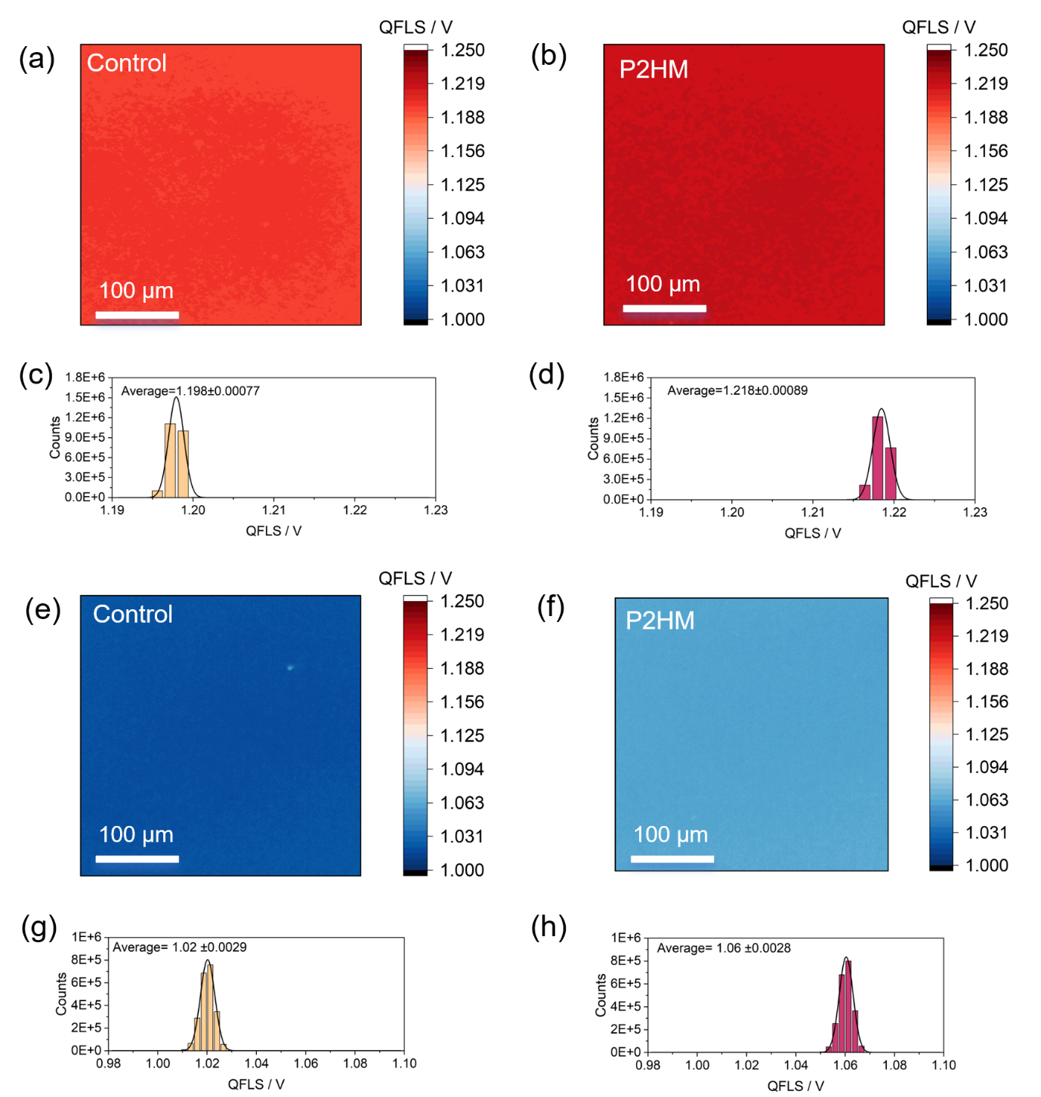
Supplementary Figure 34 QFLS mapping and QFLS value distribution of (a, c) Control (b, d) P2HM-treated perovskite films and QFLS mapping after 400 h aging at 100 °C (e-h).

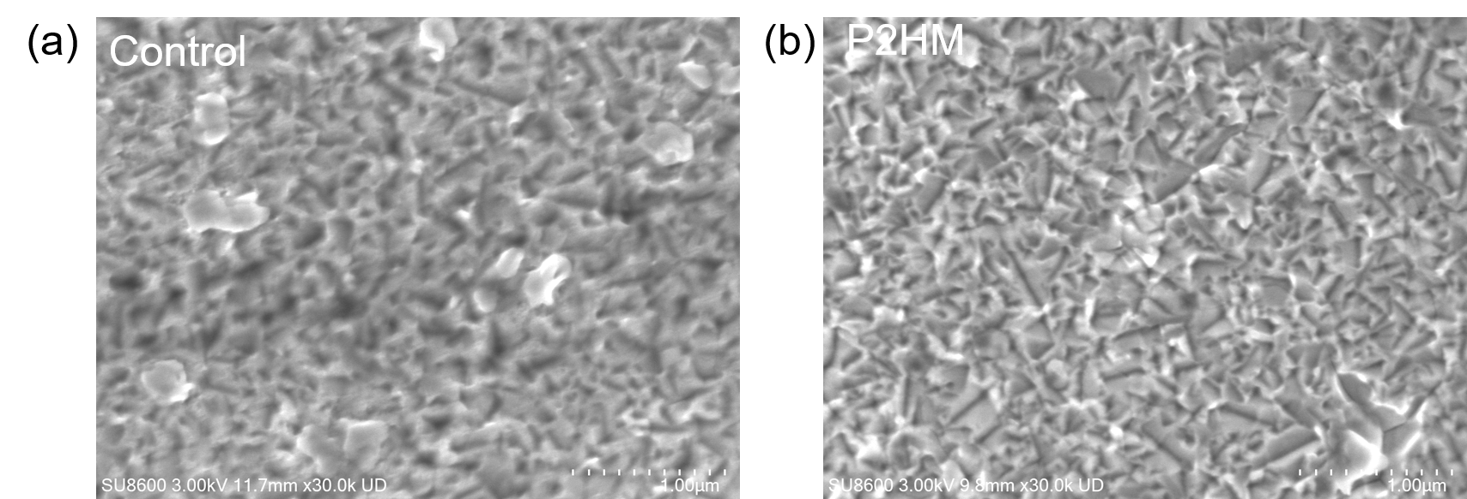
Supplementary Figure 35 SEM images of buried Control and P2HM-treated perovskite films after 400 h aging at 100 °C.

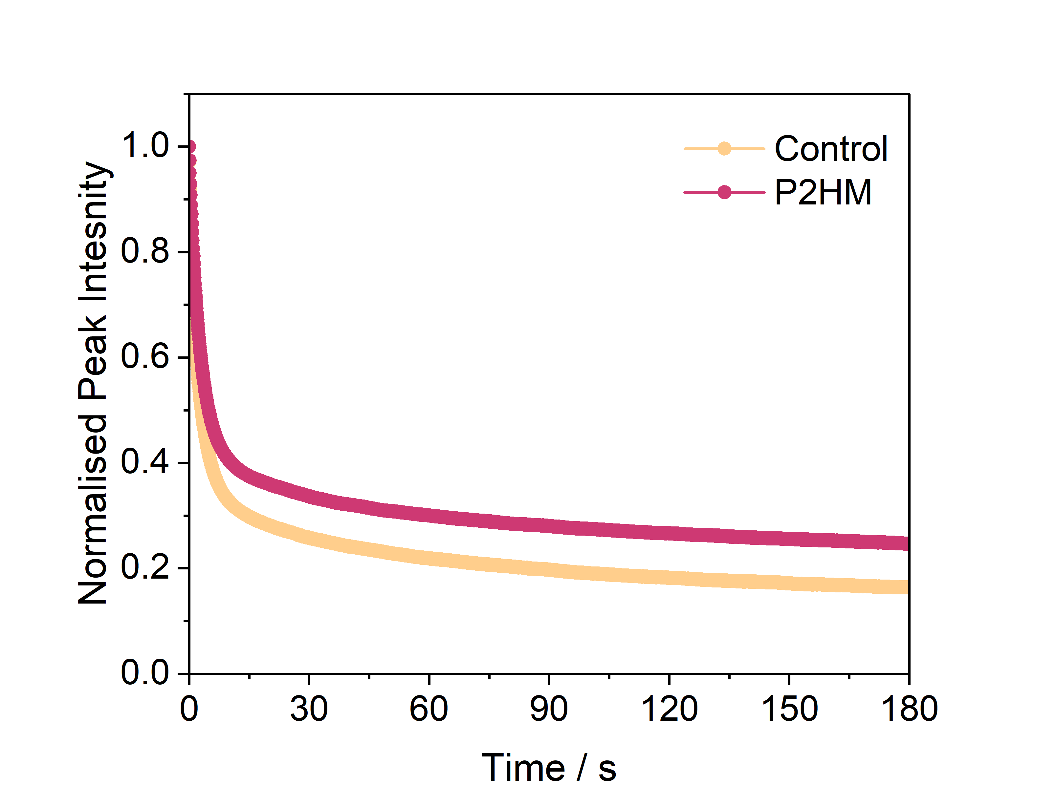
Supplementary Figure 36 PL intensity evolution during the 100 ℃ aging process.

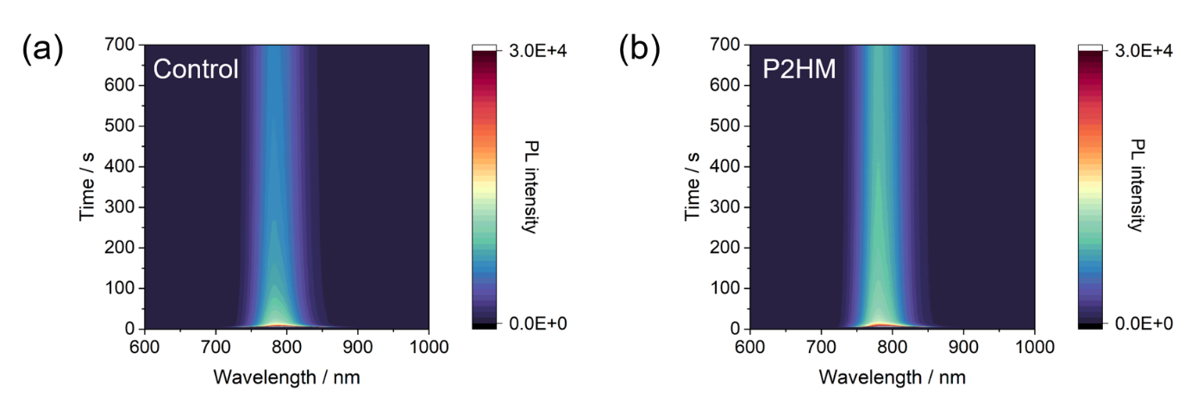
Supplementary Figure 37 In-situ PL spectra of the (a) control and (b) P2HM-treated films during the 85°C aging process.

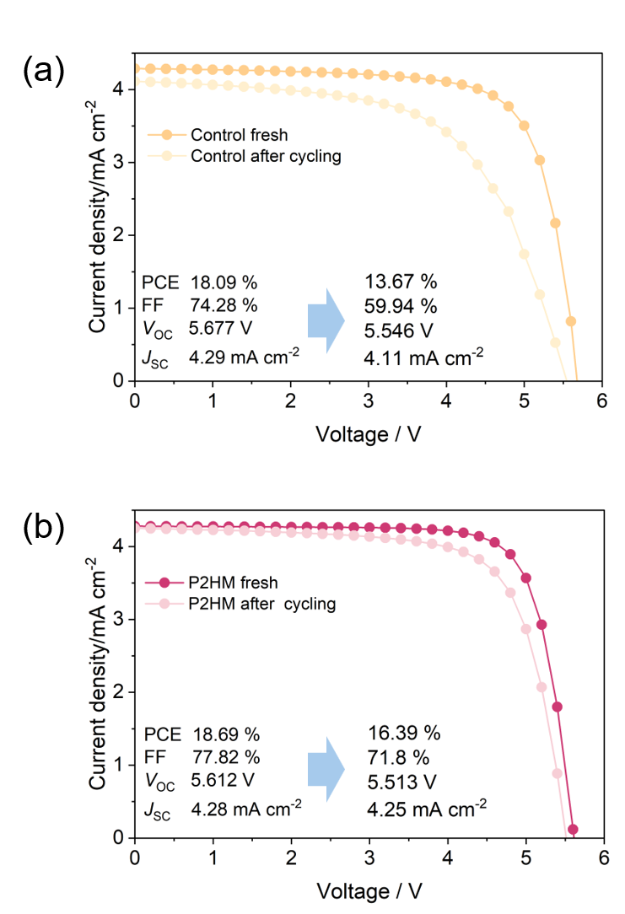
Supplementary Figure 38 The PCE change of control (b) and treated film (c) after thermal cycling.

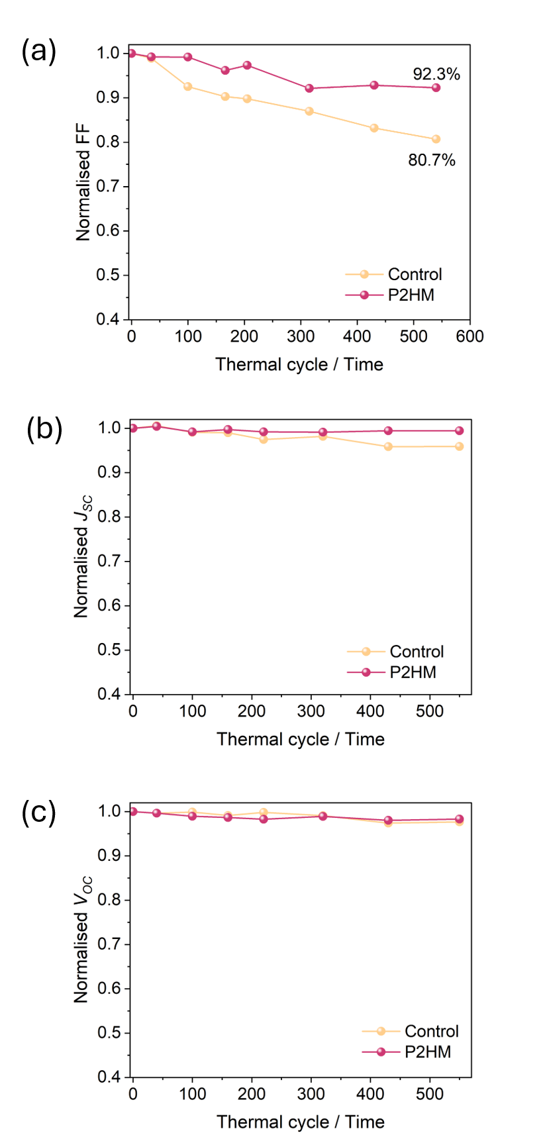
Supplementary Figure 39 FF, V_{OC} and J_{SC} change during TC stability.

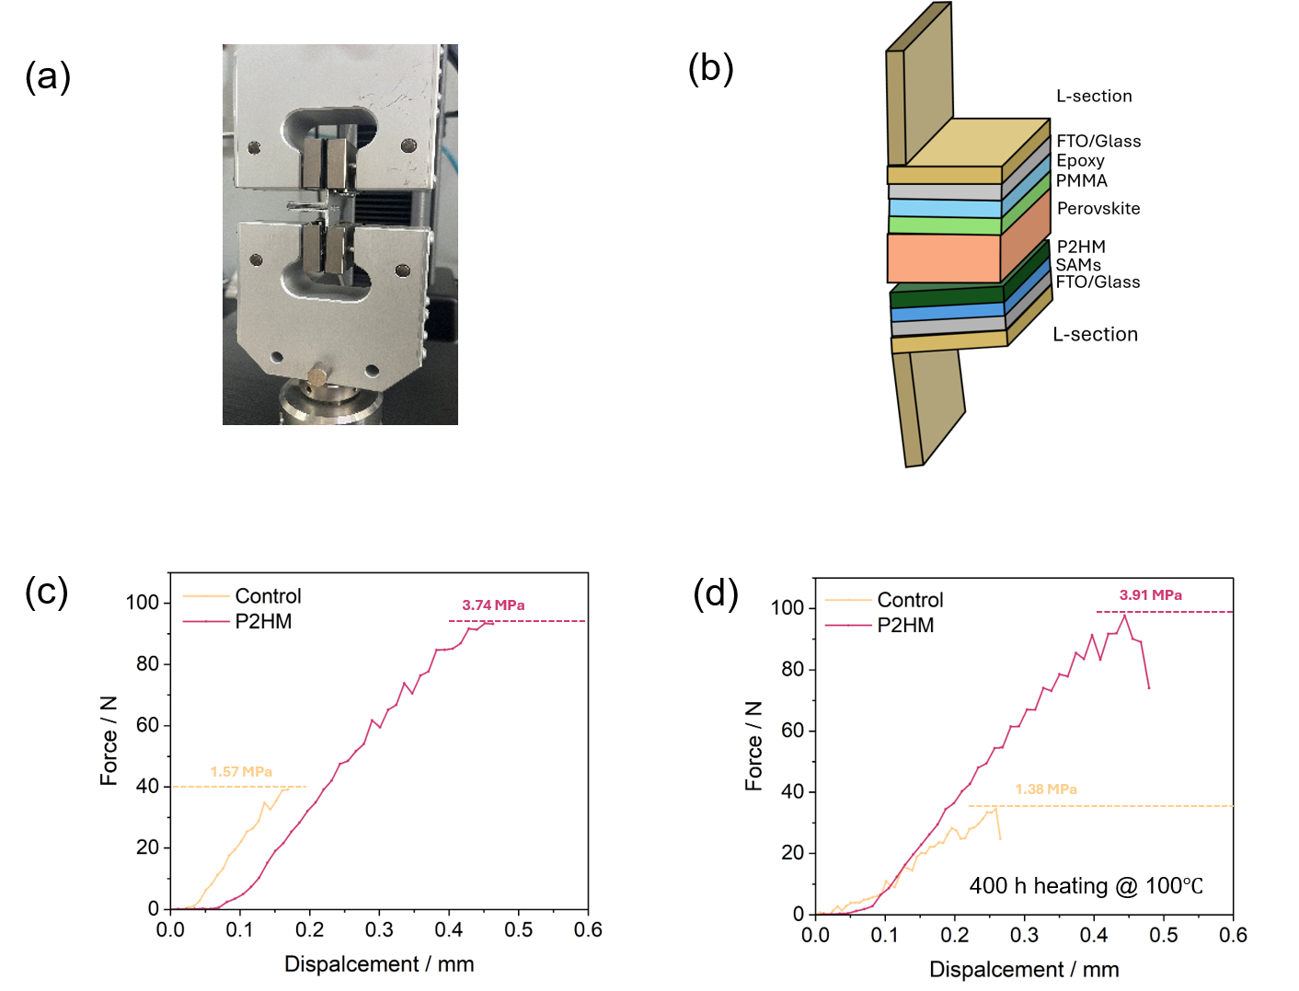
Supplementary Figure 40 (a) Photo captured and (b) schematic illustration of the sandwich double-cantilever beam (DCB) specimen for toughness testing. (c) Maximum adhesion strength results and (d) after 400 h aging.

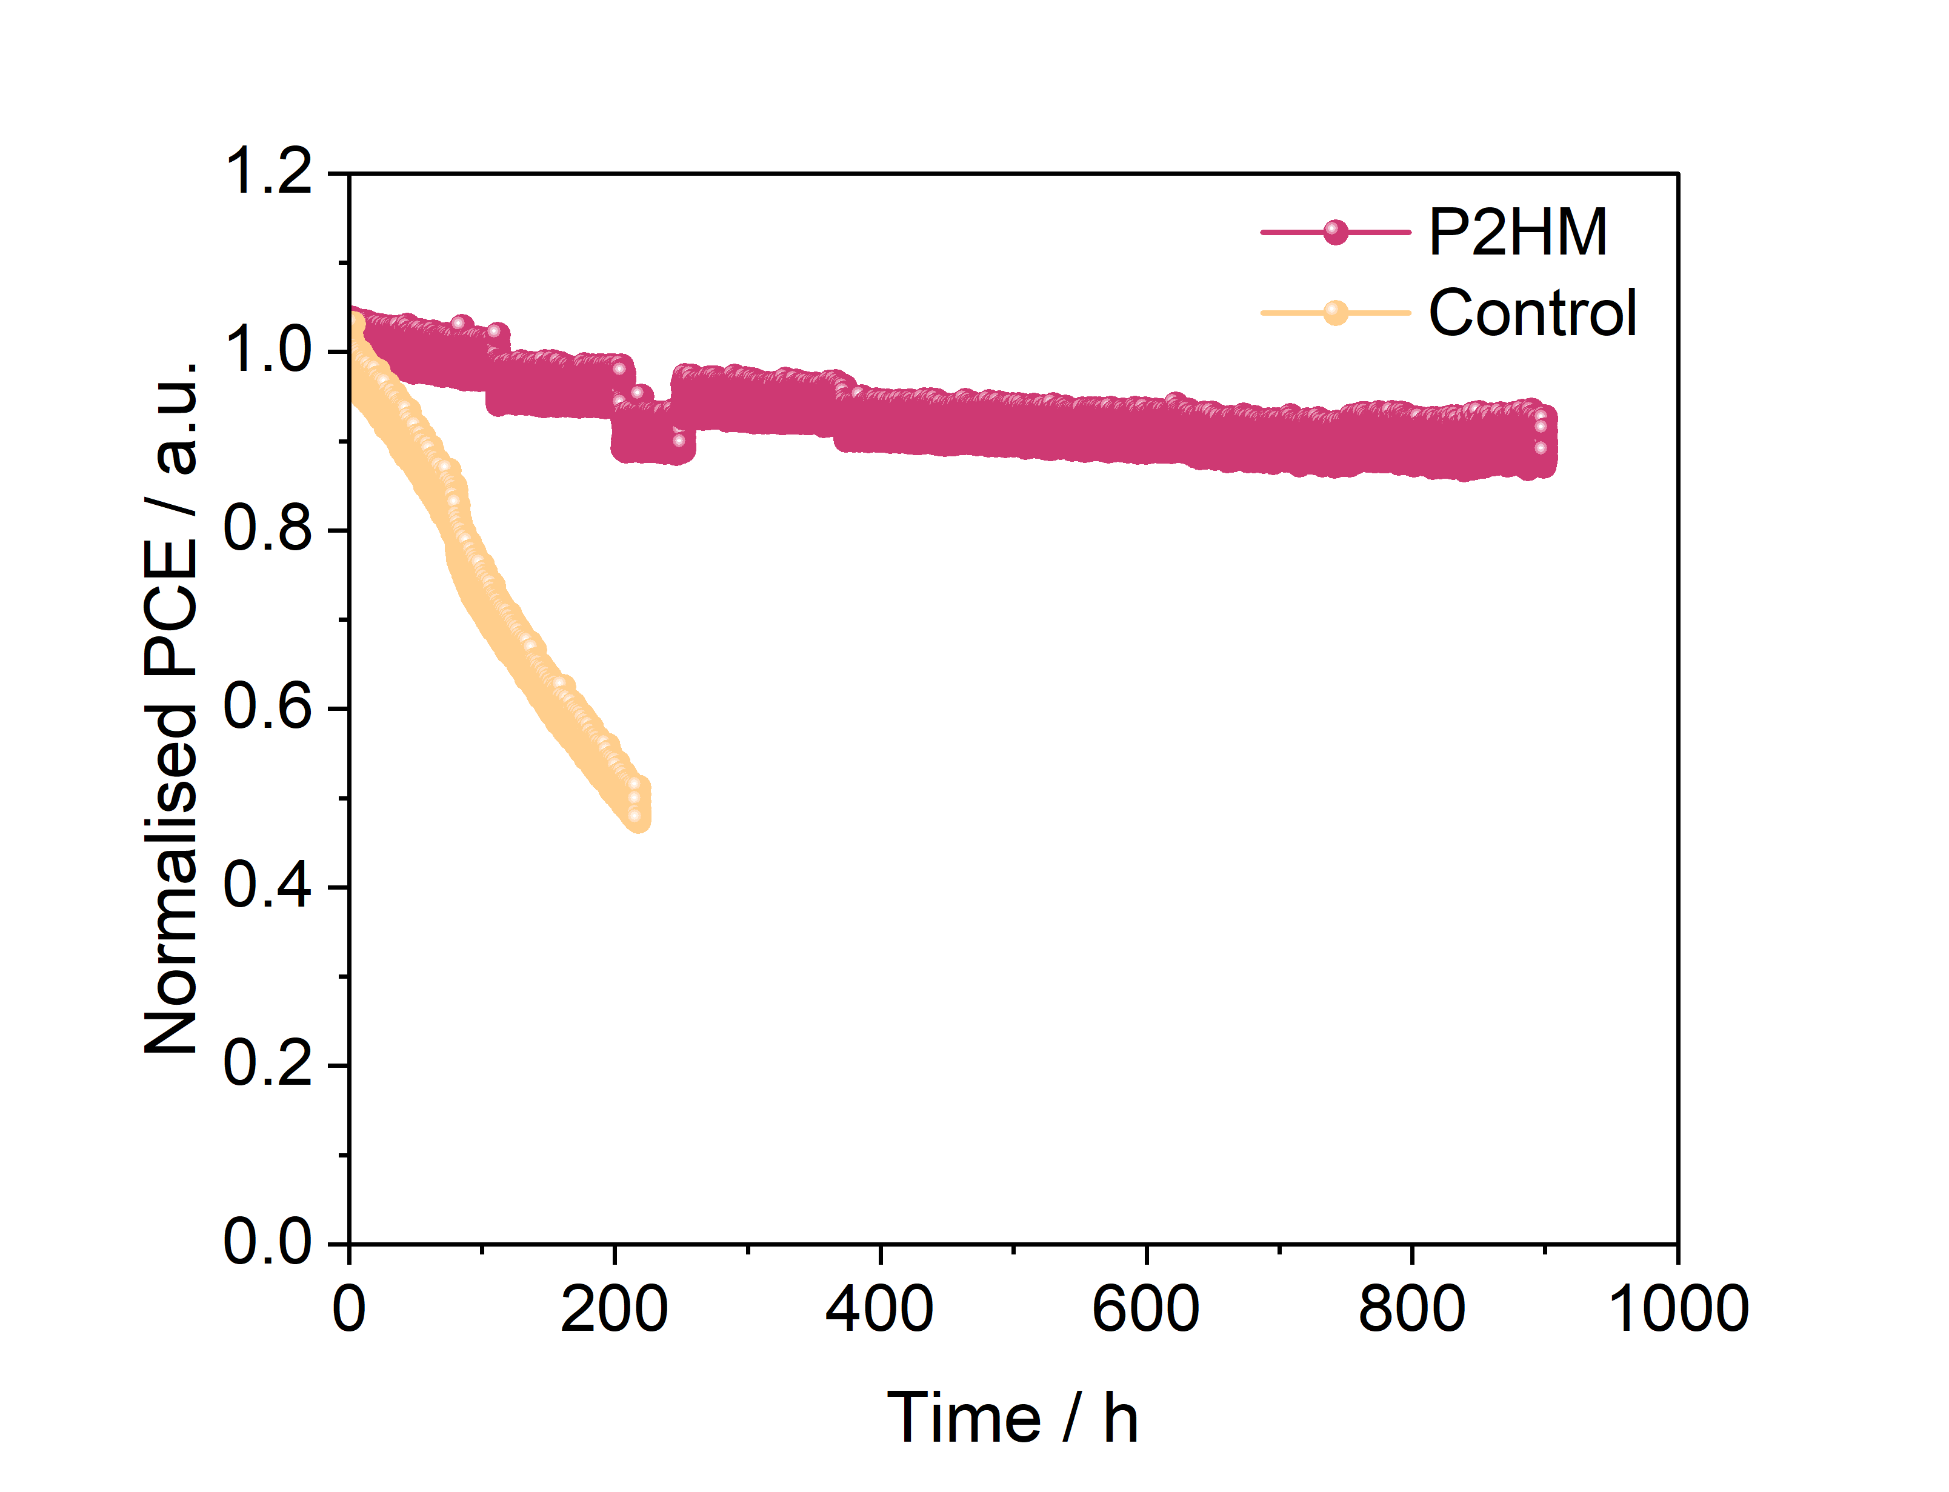
Supplementary Figure 41 Operational stability of unencapsulated devices with MPPT under continuous one-sun illumination in a nitrogen atmosphere.

Table S1 Fitted results of TA curves of the control and P2HM-treated films probed at 776 nm.
Device | A₁ | τ₁ (ps) | A₂ | τ₂ (ps) | τ_{avg}
Control | -18.46 | 781.08 | -112.72 | 5990.84 | 5398.8
P2HM | -11.73 | 410.32 | -117.11 | 4766.25 | 4562.9

Table S2 Fitted results of TRPL curves of the control and P2HM-treated films.
Device | A₁ | τ₁ (ns) | A₂ | τ₂ (ns) | τ_{avg}
Control | 89.78 | 166.48 | 333.44 | 816.83 | 694.5
P2HM | 84.93 | 217.37 | 329.55 | 1561.11 | 1312.7

Table S3 Element ratio change after thermal aging extracted from XPS results.
 | Pb₀ (Fresh) / % | Pb₀ (Age) / % | Increase rate / %
Control | 5.78 | 10.78 | 86.5
P2HM | 4.45 | 4.99 | 12.1

