Supplementary Materials
Molecule encoding methods
Extended-connectivity fingerprints (ECFPs)
ECFPs [1] are circular topological fingerprints that represent molecular structures as a variable-length binary vector. Generated using the Morgan algorithm, ECFPs iteratively encode atomic environments and their connections, capturing detailed molecular features, including stereochemistry. ECFPs are highly flexible and are widely used in structure-activity relationship modeling, virtual screening, and compound library analysis. Their detailed nature makes them computationally intensive, and their high dimensionality can sometimes lead to overfitting in predictive models.

Functional-connectivity fingerprints (FCFPs)
FCFPs [1] are like ECFPs but specifically focus on encoding functional groups within molecules. Like ECFPs, FCFPs are generated using a circular topological approach, creating a variable-length binary vector that highlights functional group environments. This focus on functional groups enhances their utility in modeling biochemical activity and predicting molecular interactions. FCFPs share the advantages of ECFPs in terms of flexibility and detailed feature capture, but they also share similar computational demands and potential problems for high dimensionality.

The international chemical identifier (InChI)
The international chemical identifier (InChI) [2] is a textual encoding system designed to provide a unique and standardized identifier for chemical substances. Generated by a specific algorithm, InChI encodes molecular structures into a text string that uniquely represents the substance. InChI is primarily used for the unique identification and retrieval of chemical substances in databases, ensuring consistency and interoperability across different platforms. However, InChI is unsuitable for similarity searching or structure-activity relationship modeling since it is not represented as binary or integer vectors that encode the presence or absence of certain structural features.

Molecular ACCess System Keys (MACCS Keys)
MACCS Keys [3] are a type of fixed-length fingerprint commonly used in cheminformatics. They consist of a binary vector, typically 167 bits long, where each bit represents the presence or absence of predefined substructures within a molecule. MACCS Keys are valued for their simplicity and speed in computing, making them ideal for similarity searching and clustering in chemical databases. However, their effectiveness is limited by the predefined set of substructures, which may not capture all relevant features for specific applications.

The PubChem fingerprint
The PubChem fingerprint is a fixed-length binary vector, consisting of 881 bits, used to represent molecular structures based on predefined substructural features. Each bit in the PubChem fingerprint indicates the presence or absence of a specific substructure, as defined by the PubChem project. These fingerprints are used for similarity searching, clustering, and virtual screening within the PubChem database. The standardized nature of PubChem fingerprints ensures consistency in chemical informatics applications, although their utility is limited by the predefined set of substructures they encompass.

The RDKit fingerprint
RDKit fingerprint is a widely used tool in cheminformatics for representing molecular structures as fixed-length bit vectors, typically 1024 bits. These fingerprints capture the presence or absence of various substructures within a molecule, allowing for efficient comparison and similarity searching. Generated using the open-source RDKit library, these fingerprints are customizable in terms of size and substructure definitions, making them versatile for different applications. They are known for their speed and ease of integration with other tools, although they can suffer from information loss due to hash collisions and may not capture all molecular features with high specificity. Despite these limitations, RDKit fingerprints are a robust choice for many large-scale virtual screening and molecular analysis tasks.

SMILES arbitrary target specification (SMARTS)
SMILES arbitrary target specification (SMARTS) is an extension of the SMILES [4] notation, designed for defining molecular substructure patterns and queries. It is a highly flexible and expressive language that allows chemists to specify complex substructures and perform substructure searching within chemical databases. SMARTS is invaluable for tasks requiring precise pattern matching and molecular query definitions. However, constructing accurate SMARTS queries requires expert knowledge, and SMARTS is not typically used for generating fingerprints or for similarity searching.

In Table S2, we selected Aspirin as our sample molecule due to its three characteristics, which are shown below. These characteristics could help us understand the variations among the seven molecule embedding methods.
- Structural Diversity: The combination of aromatic and aliphatic structures, along with functional groups like the acetyl and carboxylic acid groups, allows us to see how different encoding methods capture various aspects of the molecule.
- Common Usage: Aspirin is a well-known and widely studied molecule, making it easy to reference and understand the encoded representations.
- Functional Groups: The presence of functional groups like acetyl and carboxylic acid groups will highlight how methods like FCFPs and SMARTS handle functional group identification and matching.
Five major steps of workflow
Our experimental workflow consisted of five major steps: (1) data preprocessing and fingerprint standardization, (2) input format processing, (3) data resampling and splitting, (4) model training, and (5) performance evaluating (Figures 2-3). First, in the data preprocessing stage, molecular data were standardized and prepared to ensure consistency across datasets. Different molecular encoding methods were then generated or precomputed as required before being used as model inputs. Meanwhile, data cleaning and standardization were performed to ensure consistency and quality across datasets. Second, in the input format processing stage, we examined whether the original molecular encoding methods should be used directly or transformed before model training. This step included checking for missing values and, when appropriate, applying imputation-based approach, Feature Net (FN) [5-7], to refine the input format. Third, the datasets were split into training and testing sets, and five-fold cross-validation was used for model selection. Moreover, class imbalanced issue has been taken into account when dealing with classification datasets under data preprocessing. Fourth, in the model training stage, two different neural network-based architectures were used for molecular property prediction (Figures 1a-b). The first architecture was Multi-Layer Perceptron (MLP), which served as a strong and simple baseline for evaluating molecular encoding methods across datasets. The second architecture incorporated Transformer encoder layers before the MLP (MLP+TL), allowing the model to capture interactions among fingerprint features and potentially learn richer structural dependencies. Fifth, model performance was assessed using task-specific evaluation metrics. For classification tasks, we used Area Under the Receiver Operating Characteristic Curve (AUC-ROC), F1 score, Accuracy, Precision, and Recall capturing different aspects of predictive quality, especially under imbalanced conditions. For the solubility prediction task, which is formulated as a regression problem with continuous numerical outputs, we used Root Mean Squared Error (RMSE), Mean Squared Error (MSE), Mean Absolute Error (MAE), and Coefficient of Determination (R²).

Training and Testing
For model development, the dataset was first divided into a training-validation set and an internal test set at a ratio of 8:2. Within the training-validation set, five-fold cross-validation was performed to determine the optimal hyperparameters. After hyperparameter selection, the data were again split into training and validation subsets at a ratio of 8:2 for final model training. Early stopping was applied during training to prevent overfitting and improve generalization by terminating training when the validation performance no longer improved, thereby also reducing computational cost. For subsequent molecular-level prediction and interpretation, we used the optimal hyperparameters obtained from five-fold cross-validation. The target molecule to be interpreted was treated as the single test sample, while the remaining molecules were split into training and validation sets at a ratio of 8:2 for model training with early stopping. To evaluate model performance, different metrics were adopted for classification and regression tasks. For classification tasks, the area under the receiver operating characteristic curve (AUC-ROC) was adopted as the primary metric in five-fold cross-validation. Unlike the F1 score, AUC-ROC is threshold-independent and therefore provided a more comprehensive assessment of model performance across different decision boundaries. Owing to this property, it has been widely applied in biological and biomedical data analysis. In contrast, for the solubility prediction task, which was formulated as a regression problem on a continuous numerical dataset, RMSE was used as the principal evaluation metric because it is commonly employed in the literature and enables direct comparison with previous studies [8]. For BBBP external validation, since B3DB [9] contained molecules originating from BBBP, we first removed all molecules in B3DB that shared the same CID or InChI [2] with molecules in BBBP. We further observed that some molecules in B3DB still had the same compound names as those in BBBP. To avoid potential data leakage, these molecules were removed from B3DB as well. After this filtering process, the final size of B3DB was 4,368 molecules. In addition, after standardizing the molecules in the A+P datasets, which served as the external dataset for ESOL, we checked whether any molecules had the same SMILES strings as those in ESOL. If duplicated SMILES were identified, the corresponding molecules were removed from A+P. The remaining molecules from A+P were then combined to form the external dataset. After that, the combined size of A+P owned 1362 molecules. To assess whether the external dataset had a distribution comparable to that of the training dataset, visualization was performed (Figure S9a-b).

Hyperparameter analysis
We implemented two models: MLP and MLP+TL, following the workflow detailed in Figure 2 and Figure 3. For both models, critical hyperparameters—including the number of hidden layers, normalization techniques, dropout rates, optimizer, activation function, and loss functions—were optimized through hyperparameter tuning, with Adam [10] chosen as the optimizer, ReLU [11] chosen as the activation function of transformer encoder layer, and LeakyReLU [12] chosen as the activation function of MLP. (Supplementary 2 Tables S24-31)
The first hidden layer dimension was constrained to values close to the fingerprint dimension to prevent an abrupt expansion of feature dimensionality in the early stage of representation learning. For instance, MACCS keys dimension is 167, the candidate values of the first hidden layer dimension were set to 128, 256, and 512. We observed that certain models tended to achieve better performance when the hyperparameter values were within a specific range. For MLP model, the optimal range of batch_size, was 32 to 8. Meanwhile, MLP+TL performed best with larger batch_size 64, however, if out-of-memory (OOM) error was encountered, the batch size was adjusted downward to fit the available GPU memory. The learning rate for the MLP model ranged from 1e-5 to 1e-2, whereas that for MLP+TL ranged from 1e-7 to 1e-5. Transformer_dim is 1 to 4 times larger than dimension of the first hidden layer. Specifically, we found that single head has higher performance, which may be attributed to the binary representation of fingerprint. In contrast to natural language sequences, binary-encoded strings have a simpler structure and lower semantic complexity. The model depth (num_layer) could not be reduced excessively, since an overly shallow architecture caused the model to depend heavily on MLP. Based on our experiments, at least two layers were required. We also explored several training strategies, including learning rate warm-up [13] and alternative activation functions such as GELU [14], but these modifications did not yield noticeable performance improvements. For learning rate scheduling, we adopted cosine annealing [15], which performed better than a scheduler reducing the learning rate by a factor of 10 once learning stagnates. This may be attributed to the fluctuating learning curves observed during training, for which cosine annealing provided a more stable adjustment of the learning rate.
The Transformer encoder-based model first restored the original hidden_dim and dropout_rates settings inherited from MLP. Hyperparameter tuning was then conducted using a two-stage, pruning-aware strategy designed to reduce computational cost while preserving a systematic search procedure.
In the first stage, all candidate values of num_layers were evaluated while the remaining hyperparameters were fixed at their baseline values (transformer_dim = first hidden dimension, batch_size = 64, learning_rate=1e-5, weight_decay=1e-2). The value of num_layers that produced the best performance, defined as the highest AUC for classification tasks or the lowest RMSE for regression tasks, was selected for the second stage.
In the second stage, depth was fixed at its selected value, and the remaining hyperparameters (batch_size, num_heads, transformer_dim, learning_rate, weight_decay) were optimized sequentially. For each hyperparameter, candidate values were tested in a predefined order while all other parameters were kept at their current best settings. A greedy coordinate-wise update strategy was used, such that the best-performing value from each sweep was retained before moving to the next hyperparameter. To further improve efficiency, an intra-sweep pruning rule was applied: once performance deteriorated relative to the previous successful trial, the remaining candidate values in that sweep were skipped. This strategy enabled progressive refinement of the model configuration at a substantially lower cost than exhaustive grid search. Moreover, the resume mechanism ensured that previously evaluated combinations were not repeatedly executed.

Local Interpretation of BBBP Predictions Using LIME
Local Interpretable Model-Agnostic Explanations (LIME) was employed to interpret the predictions generated by the trained MLP+TL model. The trained model was treated as a black-box predictor, and local perturbations were introduced to the molecular fingerprint of each selected compound. By observing the resulting changes in the model-predicted probability, LIME estimated the contribution of individual fingerprint bits to the prediction for that specific molecule.
It is important to note that LIME provides a local explanation for an individual compound rather than a global rule governing the behavior of the entire model. Moreover, an influential fingerprint feature does not necessarily correspond to an activated bit. Both the presence and absence of a molecular substructure may contribute substantially to a prediction. Accordingly, the sign of the LIME weight indicates whether a feature supports or opposes the BBBP-positive prediction, whereas the bit value indicates whether the corresponding contribution arises from the presence or absence of the substructure.
For example, for oxirane, MACCS bit 40 (S-O) had a bit value of 0 and a LIME weight of +0.041 (Supplementary 2 Table S37). This result indicates that the absence of S-O locally increased the model’s predicted probability of BBBP positivity. Thus, the contribution of a fingerprint feature should be interpreted jointly according to its LIME weight and observed bit value: a positive weight supports the BBBP-positive prediction, whereas a negative weight opposes it; meanwhile, a bit value of 1 indicates that the corresponding substructure is present, whereas a bit value of 0 indicates that its absence contributes to the prediction.

Interpretation of MACCS Bit 139 in the External B3DB Validation Set
The BBBP-trained MLP+TL model was evaluated using the external B3DB validation set (Supplementary 2 Table S37, 39). Among the selected top-k B3DB compounds, MACCS bit 139 (OH), exhibited a consistent direction of contribution. Specifically, the absence of the OH feature supported BBBP-positive predictions, whereas its presence opposed BBBP-positive predictions (Supplementary 2 Table S38).
These results suggest that, for the examined external validation compounds, the BBBP-trained MLP+TL model regarded OH substructures as negative evidence for blood–brain barrier penetration. A possible chemical interpretation is that the presence of hydroxyl groups may increase molecular polarity and hydrogen-bonding capacity, thereby reducing passive diffusion across the blood–brain barrier. Nevertheless, because LIME explanations are molecule-specific and depend on the local neighborhood generated through fingerprint perturbation, this observation should not be interpreted as a universal relationship applicable to all compounds.
The direction of the LIME contribution associated with MACCS bit 139 was also consistent with the previously observed attention-weight patterns for heroin and morphine. Compared with heroin, morphine contains an additional free hydroxyl group and generally exhibits lower blood–brain barrier permeability. Taken together, the LIME and attention-based analyses indicate that the trained model may have learned to associate exposed hydroxyl-containing structural features with reduced BBB penetration, at least within the local chemical environments represented by these compounds.
Table
Table S1. Introduction of nine datasets including training sets and external validation sets.
Dataset | BACE [16] | BBBP [17] | ClinTox [18] | ToxCast [67] | MUTAG [19] | SIDER [20] | ESOL [21] | B3DB [9] | A+P [9]
Size | 1513 | 2050 | 1483 | 8597 | 188 | 1427 | 1128 | 7807 | 3321
Y-label | active vs. inactive | penetration of the BBB | toxic and non-toxic | Various biological assay results | mutagenic vs. non-mutagenic | Side effects | log solubility values in mol/L | penetration of the BBB | log solubility values in mol/L
Problem type | Binary classification | Binary classification | Binary classification | Multi-label classification | Binary classification | Multi-label classification | Regression | Binary classification | Binary classification
A+P: AQUA and PHYS dataset

Table S2. Comparison of fingerprints.
Characteristic | ECFPs [1] | FCFPs [1] | InChI [2] | MACCS Keys [3] | PubChem | RDKit | SMARTS
Type | Circular | Circular | String-based | Structure-based | Structure-based | Structure-based | String-based
Length | typically 1024 or 2048bits | typically 1024 or 2048bits | Variable | 167 bits | 881 bits | typically 1024 bits | Variable
Generation | Morgan algorithm | Functional groups | Textual encoding | Binary vector | Binary vector | Binary vector | Pattern definitions
Advantages | Detailed, Stereochemistry | functional groups-based | Stansardized, unique, Human-readable | Simple, fast | Comprehensive and standardized | Speed, customization, compatibility, availability | Flexible, expressive
Limitation | Computationally intensive | Reduced general applicability | Not for similarity searching | Predefined set | Predefined set | Informaiton loss, bias of substructure, interpretability | Expert knowledge needed
Example  (Aspirin) | [0, 0, 0, 0, 0, 0, 0, 0, 0, 0, 0, 0…0,0,0]  Size:2048 bits  Radius:2 | [1, 1, 1, 0, 1, 0, 0…,1, 0, 0, 0, 0, 0, 0, 0]  Size:2048 bits  Radius:2 | InChI=1S/C9H8O4/c1-6(10)13-8-5-3-2-4-7(8)9(11)12/h2-5H,1H3, (H,11,12) | [0, 0, 0, 0…,1, 0, 1, 1, 1, 1, 0]  Type: MACCSKeyBits  Size: 167 | [0, 0, 0, 0, 0…, 0, 0, 0, 0, 0]  Size:881bits | [0,0,0,0,0…,0,0,0] | [#6]-[#6](=[#8])-[#8]-[#6]1:[#6]:[#6]:[#6]:[#6]:[#6]:1-[#6](=[#8])-[#8]

Figure
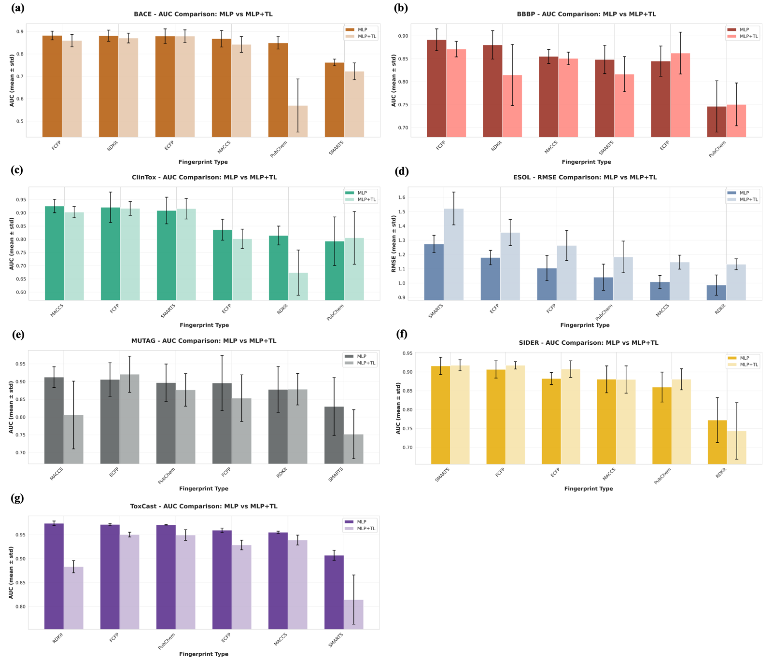
Figure S1. Bar plots of five-fold cross-validaiton results of AUC scores showing the ranking of fingerprint methods based on the performance of the MLP and MLP+TL models across different datasets: (a) BACE, (b) BBBP, (c) ClinTox, (d) ESOL, (e) MUTAG, (f) SIDER, (g) ToxCast.
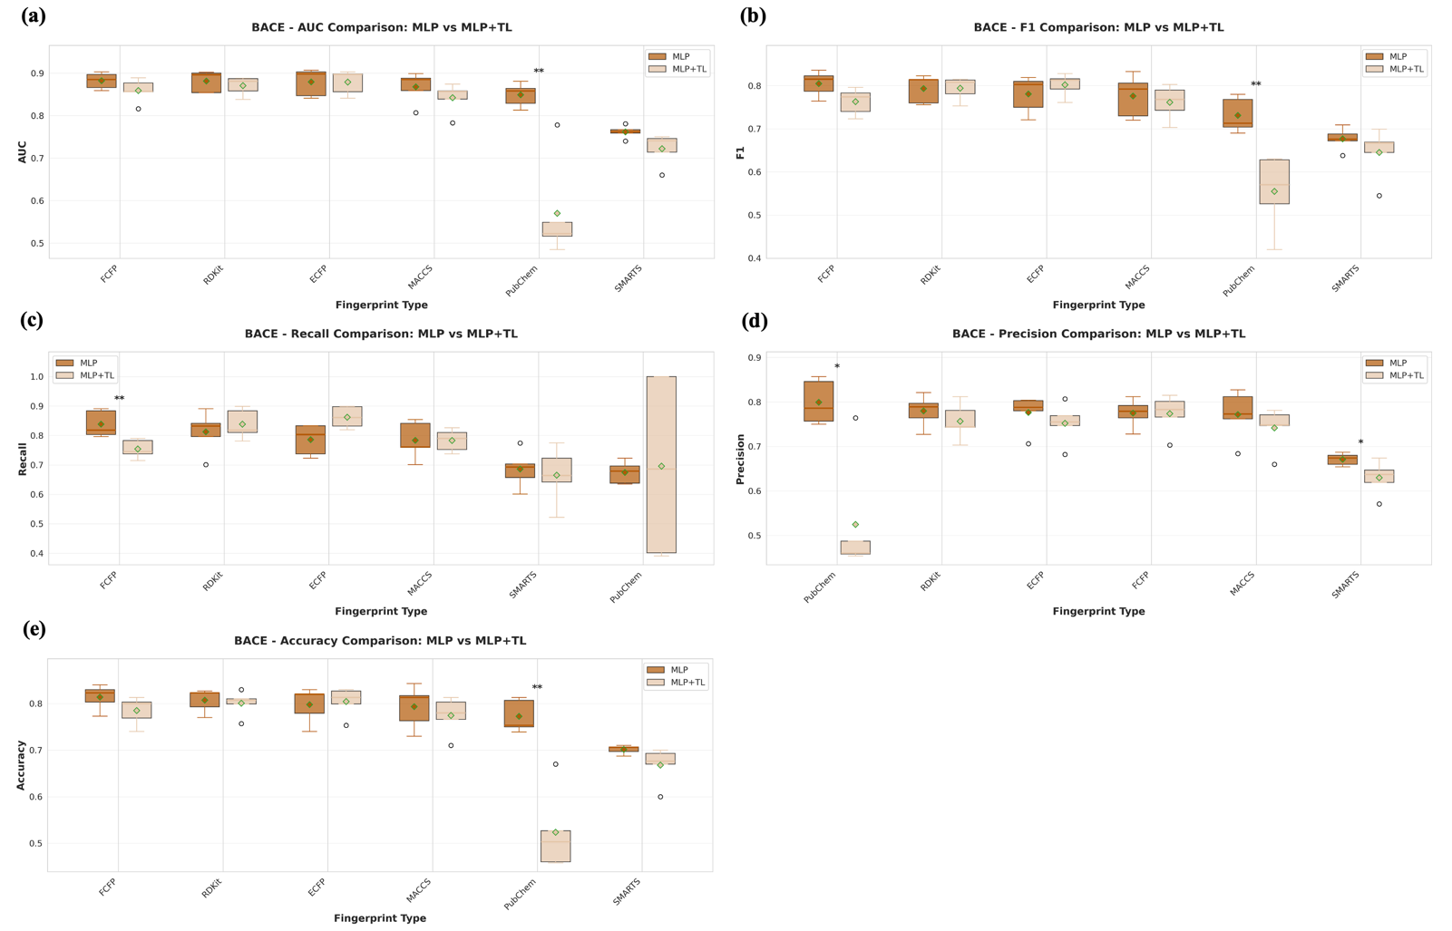
Figure S2. The performance comparison of MLP and MLP+TL model on BACE dataset. We use Wilcoxon rank-sum test to indicate the difference between two models. Across five metrics, significant differences were observed for PubChem-based models in (a) AUC, (b) F1, (d) Precision (e) Accuracy. In contrast, significant differences were only observed for FCFP-based model in (c) Recall. Asterisks (*) indicate statistically significant differences (p-value < 0.05).

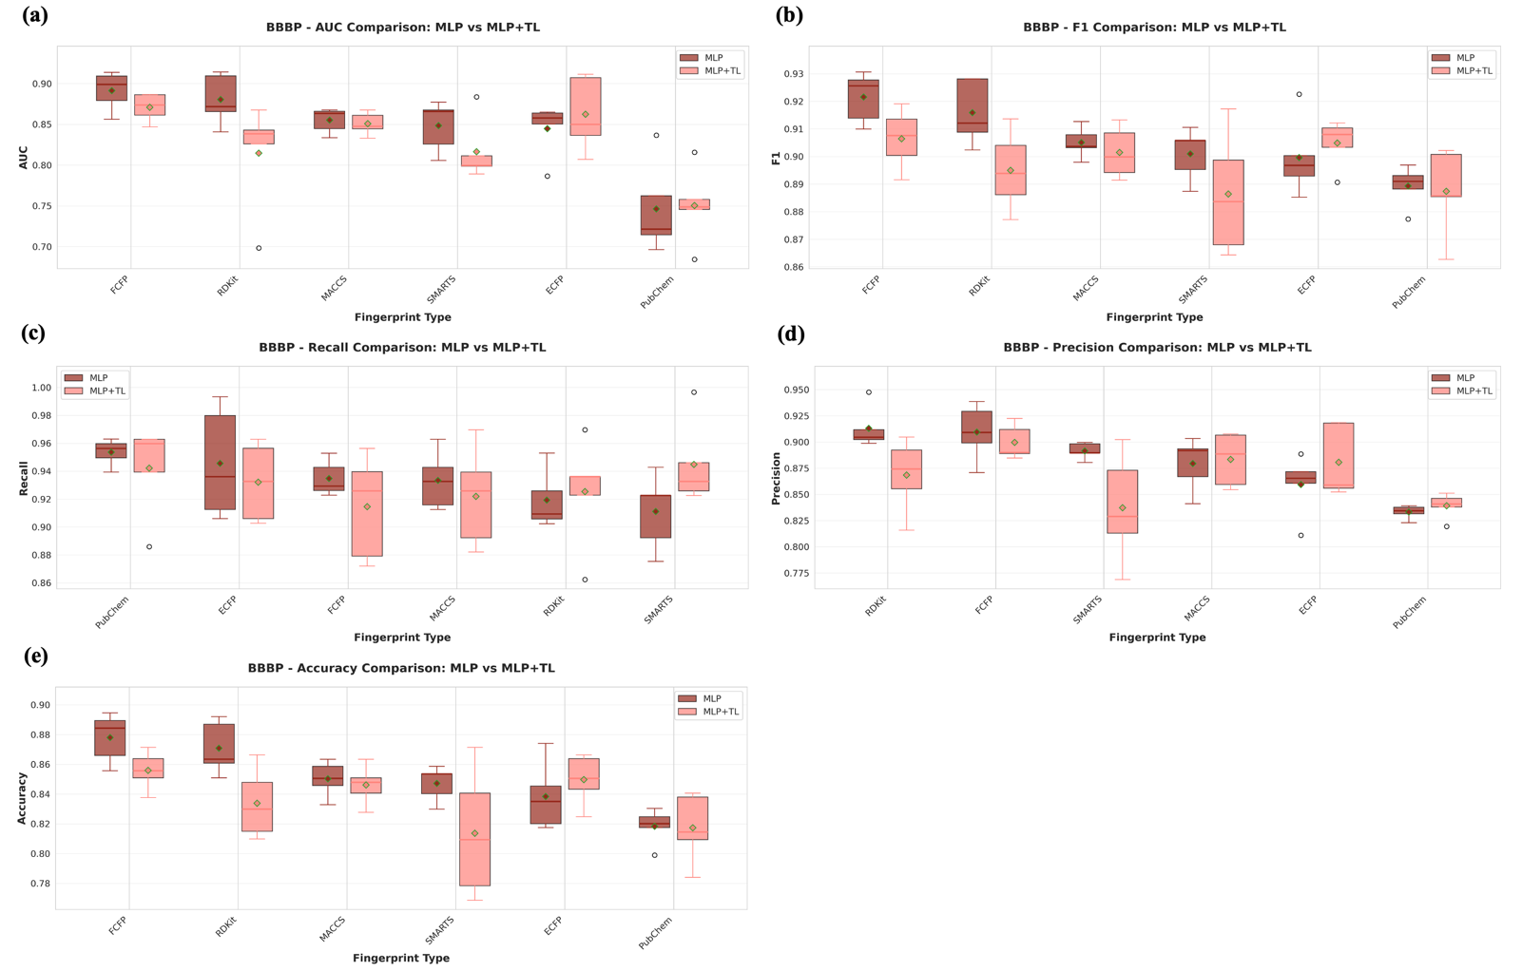Figure S3. Comparison of performance between MLP and MLP+TL model on BACE dataset. Differences between the two models were assessed using the Wilcoxon rank-sum test. Across five metrics, (a) AUC, (b) F1, (c) Recall, (d) Precision, and (e) Accuracy, no significant differences were found. Asterisks (*) indicate statistically significant differences (p < 0.05).

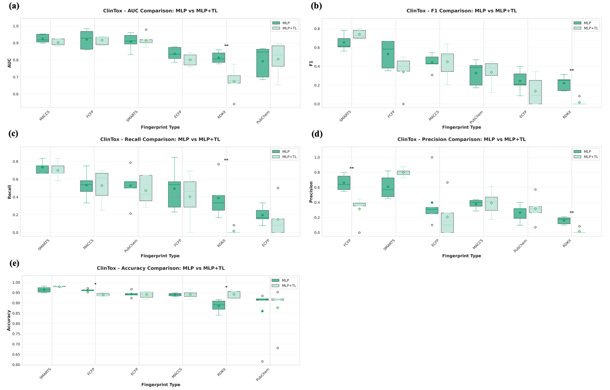
Figure S4. Comparison of performance between MLP and MLP+TL model on ClinTox dataset. Differences between the two models were assessed using the Wilcoxon rank-sum test. Among the five metrics, significant differences were observed for RDKit-based models in (a) AUC, (b) F1-score, and (c) Recall. In contrast, significant differences were observed for both FCFP- and RDKit-based models in (d) Precision and (e) Accuracy. Asterisks (*) indicate statistically significant differences (p < 0.05).
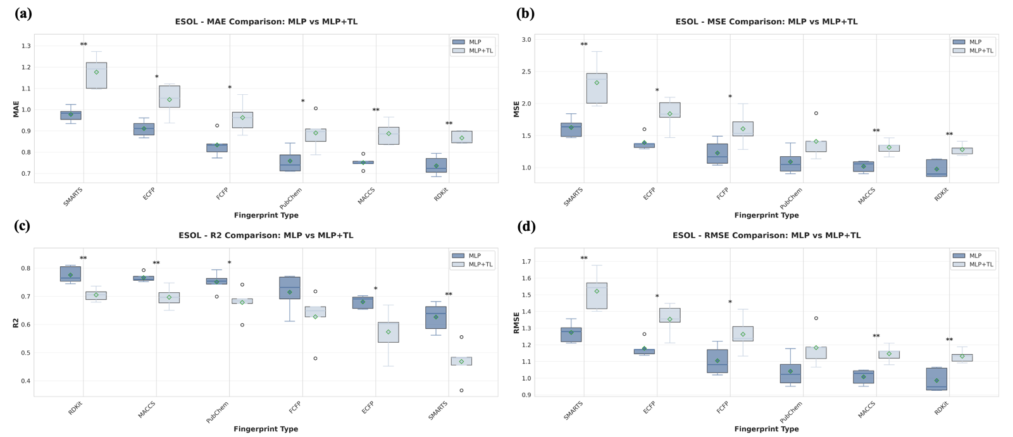
Figure S5.Comparison of performance between MLP and MLP+TL model on ESOL dataset. Differences between the two models were assessed using the Wilcoxon rank-sum test. Among the five metrics, significant differences were not observed for PubChem-based models in (b) MSE and (d) RMSE. In contrast, significant differences were not observed for FCFP-based models in (c) $R^{2}$. All fingerprints show significant difference in (a) MAE. Asterisks (*) indicate statistically significant differences (p < 0.05).
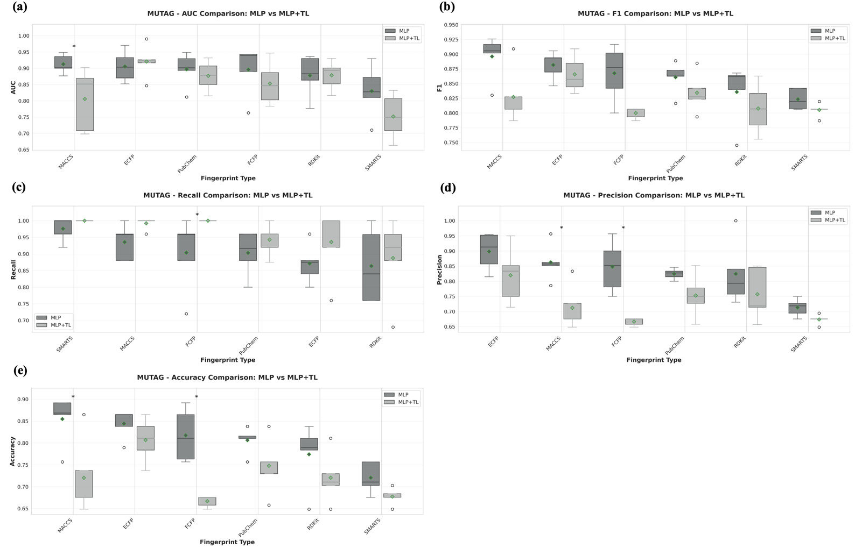
Figure S6.Comparison of performance between MLP and MLP+TL model on MUTAG dataset. Differences between the two models were assessed using the Wilcoxon rank-sum test. Among the five metrics, significant differences were observed for MACCS-based models in (a) AUC and (e) Accuracy. In contrast, significant differences were observed for FCFP-based models in (c) Recall and (e) Precision. Asterisks (*) indicate statistically significant differences (p < 0.05).
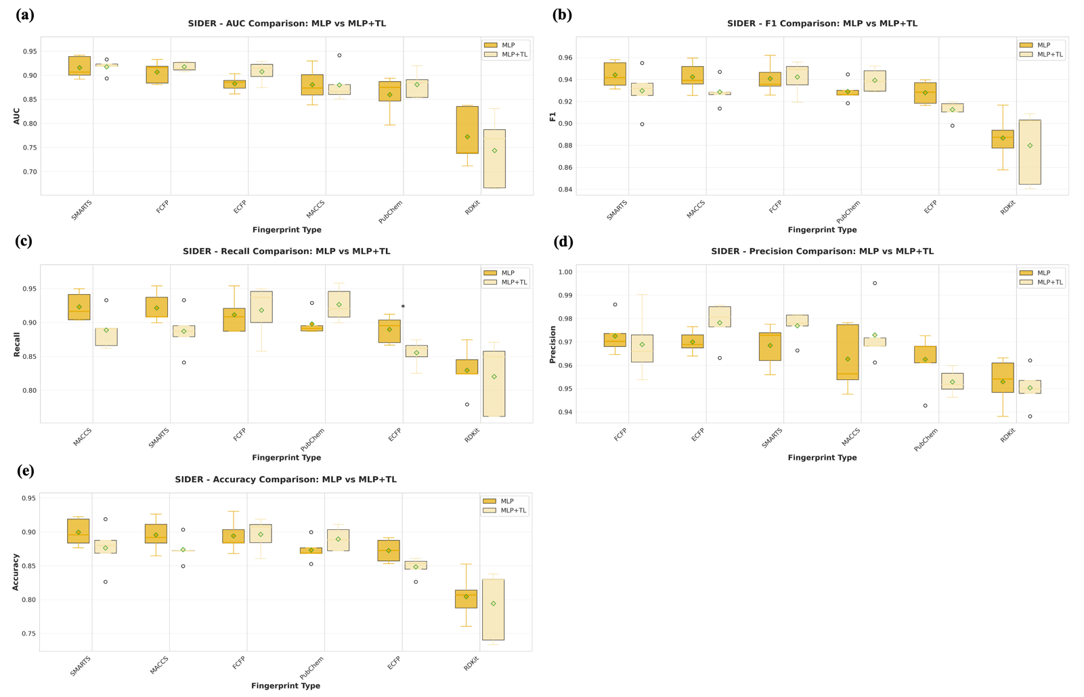
Figure S7. Comparison of performance between MLP and MLP+TL model on SIDER dataset. Differences between the two models were assessed using the Wilcoxon rank-sum test. Among the five metrics, significant differences were observed for ECFP-based models in (d) Recall. Asterisks (*) indicate statistically significant differences (p < 0.05).
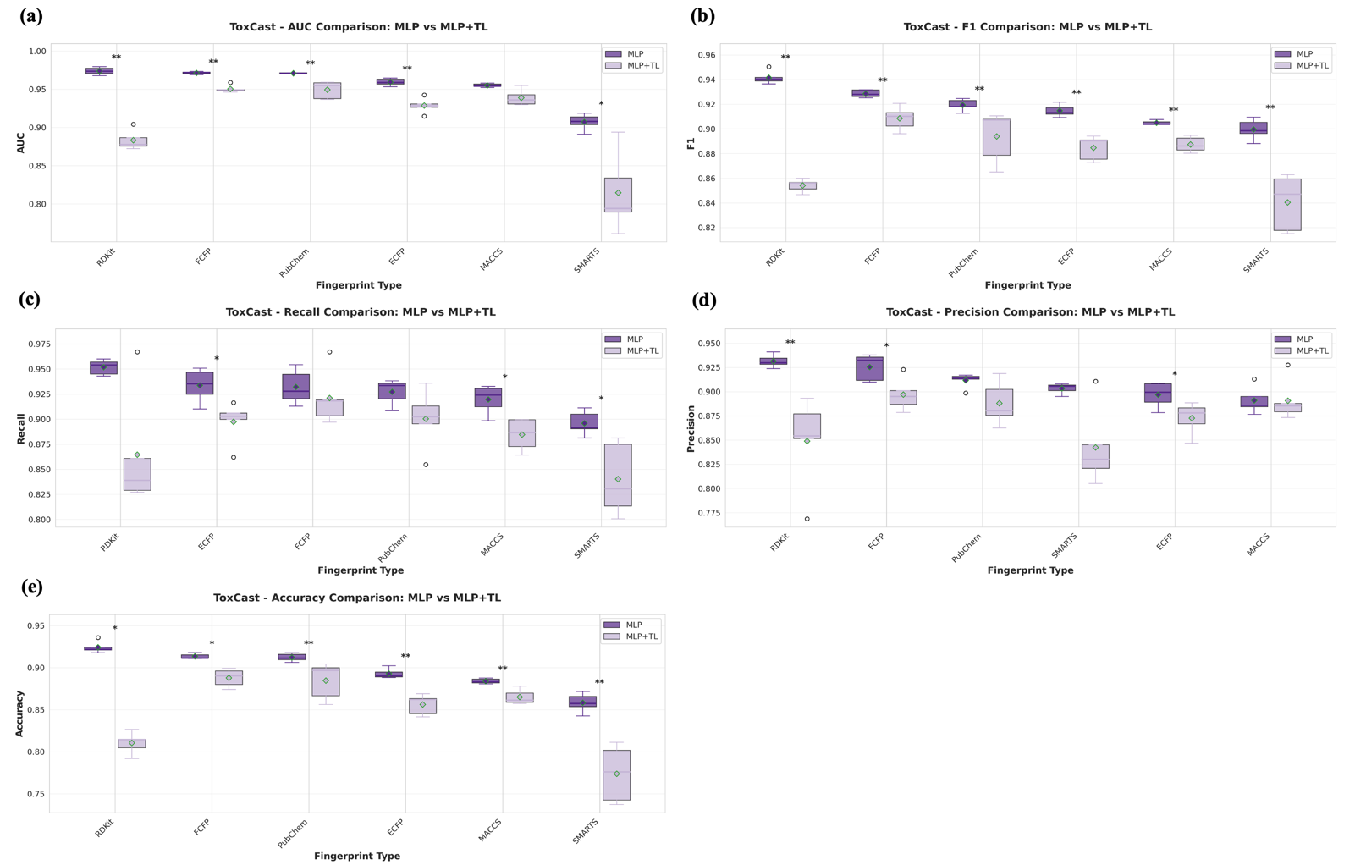
Figure S8. Comparison of performance between MLP and MLP+TL model on ToxCast dataset. Differences between the two models were assessed using the Wilcoxon rank-sum test. Among the five metrics, significant differences were observed for all fingerprint-based models in (b) F1-score and (e) Accuracy. In contrast, significant differences were observed for MACCS-based models in (a) AUC. For (c) Recall, significant differences were observed for ECFP-, MACCS-, and SMARTS-based models, whereas for (d) Precision, significant differences were observed for RDKit-, FCFP-, and ECFP-based models. Asterisks (*) indicate statistically significant differences (p < 0.05).

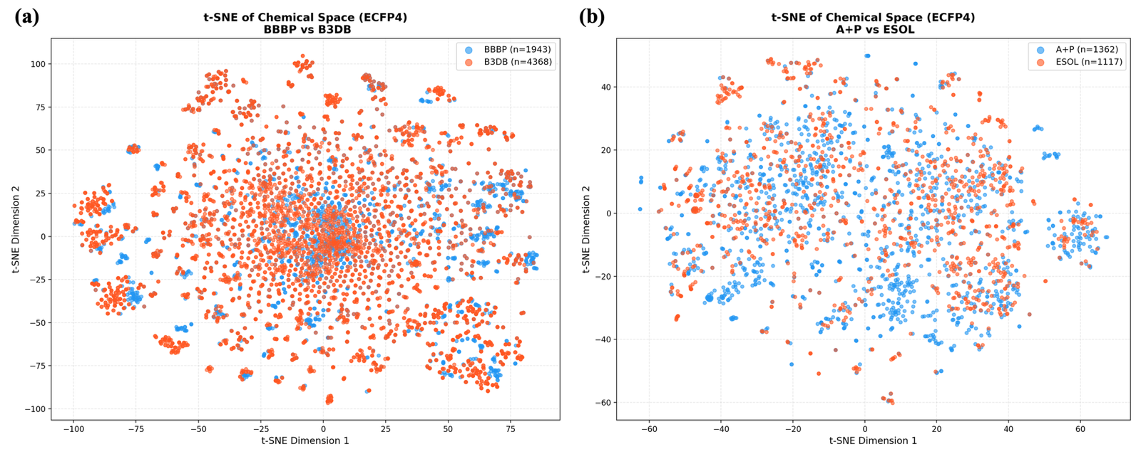
Figure S9. (a) t-SNE distribution of BBBP and B3DB based on ECFP4. Most molecules in the external datasets (B3DB) were located within the distribution range of the corresponding training datasets (BBBP). (b) t-SNE distribution of ESOL, AQUA and PHYS (A+P) based on ECFP4. In the ESOL panel, several blue points representing A+P were clearly positioned outside the main distribution of the training data.
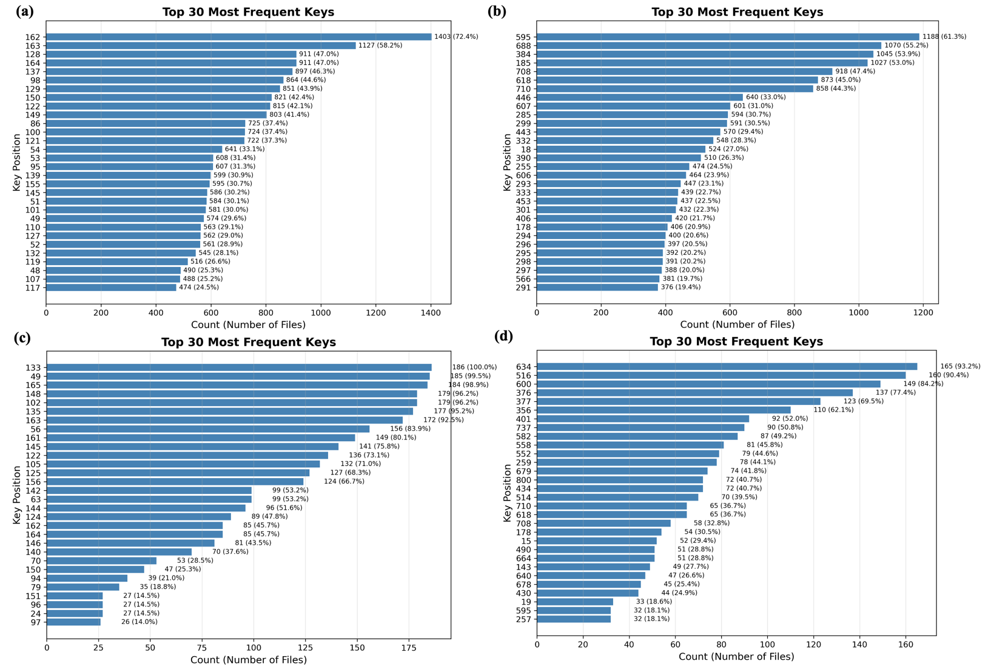
Figure S10. (a) Top 30 MACCS keys in BBBP. (b) Top 30 PubChem keys in BBBP. (c) Top 30 MACCS keys in MUTAG. (d) Top 30 PubChem keys in MUTAG. The y-axis shows the structural features corresponding to predefined fingerprint keys, whereas the x-axis indicates the number of times each key was selected among the top 20 most important features across molecules in the dataset. The percentage next to each bar denotes the proportion of molecules in which the corresponding structure appeared in the top 20 ranked features.

Reference
1. Rogers, D. and M. Hahn, Extended-connectivity fingerprints. Journal of chemical information and modeling, 2010. 50(5): p. 742-754.
2. Heller, S.R., et al., InChI, the IUPAC international chemical identifier. Journal of cheminformatics, 2015. 7(1): p. 23.
3. Durant, J.L., et al., Reoptimization of MDL keys for use in drug discovery. Journal of chemical information and computer sciences, 2002. 42(6): p. 1273-1280.
4. Weininger, D., SMILES, a chemical language and information system. 1. Introduction to methodology and encoding rules. Journal of chemical information and computer sciences, 1988. 28(1): p. 31-36.
5. Varnek, A., et al., Inductive transfer of knowledge: application of multi-task learning and feature net approaches to model tissue-air partition coefficients. Journal of chemical information and modeling, 2009. 49(1): p. 133-144.
6. Davis, I.L. and A. Stentz. Sensor fusion for autonomous outdoor navigation using neural networks. in Proceedings 1995 IEEE/RSJ International Conference on Intelligent Robots and Systems. Human Robot Interaction and Cooperative Robots. 1995. IEEE.
7. Walter, M., et al., Analysis of the benefits of imputation models over traditional QSAR models for toxicity prediction. Journal of Cheminformatics, 2022. 14(1): p. 32.
8. Meng, J., et al., Boosting the predictive performance with aqueous solubility dataset curation. Scientific Data, 2022. 9(1): p. 71.
9. Meng, F., et al., A curated diverse molecular database of blood-brain barrier permeability with chemical descriptors. Scientific Data, 2021. 8(1): p. 289.
10. Kingma, D.P. and J. Ba, Adam: A method for stochastic optimization. arXiv preprint arXiv:1412.6980, 2014.
11. Glorot, X., A. Bordes, and Y. Bengio. Deep sparse rectifier neural networks. in Proceedings of the fourteenth international conference on artificial intelligence and statistics. 2011. JMLR Workshop and Conference Proceedings.
12. Maas, A.L., A.Y. Hannun, and A.Y. Ng. Rectifier nonlinearities improve neural network acoustic models. in Proc. icml. 2013. Atlanta, GA.
13. Vaswani, A., et al., Attention is all you need. Advances in neural information processing systems, 2017. 30.
14. Hendrycks, D. and K. Gimpel, Gaussian error linear units (gelus). arXiv preprint arXiv:1606.08415, 2016.
15. Loshchilov, I. and F. Hutter, Sgdr: Stochastic gradient descent with warm restarts. arXiv preprint arXiv:1608.03983, 2016.
16. Subramanian, G., et al., Computational modeling of β-secretase 1 (BACE-1) inhibitors using ligand based approaches. Journal of chemical information and modeling, 2016. 56(10): p. 1936-1949.
17. Martins, I.F., et al., A Bayesian approach to in silico blood-brain barrier penetration modeling. Journal of chemical information and modeling, 2012. 52(6): p. 1686-1697.
18. Krewski, D., et al., Toxicity testing in the 21st century: a vision and a strategy. Journal of Toxicology and Environmental Health, Part B, 2010. 13(2-4): p. 51-138.
19. Debnath, A.K., et al., Structure-activity relationship of mutagenic aromatic and heteroaromatic nitro compounds. correlation with molecular orbital energies and hydrophobicity. Journal of medicinal chemistry, 1991. 34(2): p. 786-797.
20. Kuhn, M., et al., The SIDER database of drugs and side effects. Nucleic acids research, 2016. 44(D1): p. D1075-D1079.
21. Delaney, J.S., ESOL: estimating aqueous solubility directly from molecular structure. Journal of chemical information and computer sciences, 2004. 44(3): p. 1000-1005.

