Supplementary information for
Exceeding 500 Gbps thin film lithium niobate microring modulator and its applications
Y. Jiang,^{1†} P. Zhang,^{1†} S. Meng,^{1†} X. Ma,^{1†} H. Peng,¹ J. Liang,¹ X. Zhou,¹ M. Yuan,¹ H. Xiao,¹ M. X. Low,^{2,3} A. Dubey,^{2,3} T. G. Nguyen,^{2,3} G. Ren,^{2,3} A. Mitchell,^{2,3} and Y. Tian^{1,4*}

¹ School of Physical Science and Technology, Lanzhou University, Lanzhou 730000, China
² Integrated Photonics and Applications Centre (InPAC), School of Engineering, RMIT University, Melbourne, VIC 3001, Australia
³ ARC Centre of Excellence in Optical Microcombs for Breakthrough Science (COMBS), School of Engineering, RMIT University, Melbourne, VIC 3001, Australia
⁴ School of Mathematics and Physics, North China Electric Power University, Beijing 102206, China
† These authors contributed equally
* Corresponding author. Email: tianyh@lzu.edu.cn

This supplementary information file includes:
Supplementary Note 1 - Design of high-speed electrodes based on silicon nitride loaded LNOI platform.
Supplementary Note 2 - Design of Euler circle bent waveguide based on silicon nitride loaded LNOI platform.

Supplementary Note 1 - Design of high-speed electrodes based on silicon nitride loaded LNOI platform.
To boost modulation efficiency, capacitance-loaded traveling-wave electrodes are integrated into the microring modulator, with the electrodes fabricated from 300-nm-thick gold. Supplementary Figures 1a-c illustrate three distinct electrode configurations: ground-signal-ground (GSG) electrodes with a dummy waveguide, GSG electrodes without a dummy waveguide, and conventional ground-signal (GS) electrodes. We performed systematic simulations to characterize the effective refractive index, characteristic impedance, and electrical-electrical (EE) bandwidth for each structure, with the corresponding results plotted in Supplementary Figures 1d–f.
As revealed by the simulation data, the GS electrode exhibits a characteristic impedance of ~31.6 Ω, corresponding to a 36.8% impedance mismatch relative to the 50 Ω standard. Moreover, the inherently asymmetric electromagnetic field distribution of the GS structure aggravates high-frequency signal radiation, resulting in a bandwidth inferior to that of GSG counterparts even when a 31.6 Ω on-chip load is implemented. The GSG electrode with a dummy waveguide demonstrates lower electrical loss than the conventional GSG design, which is primarily attributed to its fully symmetric geometry that effectively suppresses parasitic effects including crosstalk and modal dispersion. Consequently, the GSG electrode with a dummy waveguide is adopted for the final modulator implementation.
In this work, the designed traveling-wave electrodes achieve a characteristic impedance of approximately 43 Ω, corresponding to an impedance mismatch rate of 14% when interfaced with a standard 50 Ω off-chip load. According to the formula, the reflectance Γ is about 0.075 which is small enough to be negligible, where Z_{L} is the impedance of the load, and Z₀ is the characteristic impedance of the fabricated electrodes.
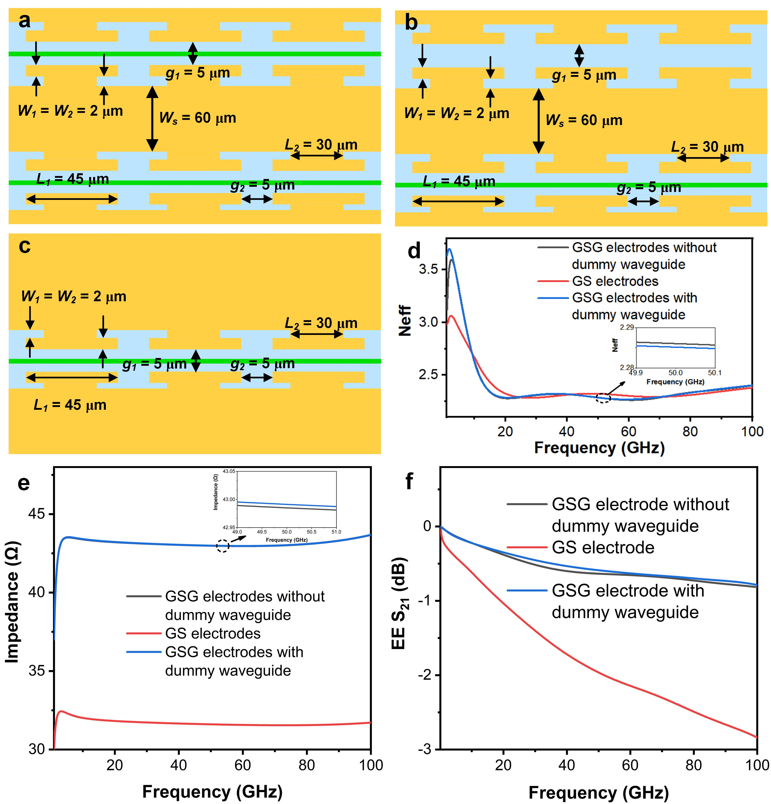
Supplementary Figure 1. The simulated results of the electrodes. a-c. Top view of the GSG electrodes with dummy waveguide, GSG electrodes without dummy waveguide, and GS electrodes. d Simulated refractive index of electrodes as a function of frequency. e Simulated impedance of electrodes as a function of frequency. f Simulated S21 responses of electrodes.
Supplementary Note 2 - Design of Euler circle bent waveguide based on silicon nitride loaded LNOI platform.
In this work, we design the high-speed microring modulator based on silicon nitride loaded lithium niobate on insulator (Si₃N₄-LNOI) platform. The TE₀ mode profile of the SiN-LNOI waveguide reveals that approximately 60% of the optical power is tightly confined within the thin-film lithium niobate layer, a feature that underpins the device’s strong electro-optic modulation efficiency but inherently imposes a larger minimum bending radius compared to conventional directly etched LNOI waveguides. To address this integration bottleneck, we implement a Euler bent architecture to minimize the footprint of curved waveguide segments in the heterogeneous microring¹, enabling a substantial enhancement in device integration density. Through systematic 3D finite difference time domain (3D-FDTD) simulations, we have optimized the Euler bent waveguides in which the maximum radius (R_{max}) and the minimum radius (R_{min}) are designed to be 100 μm and 64 μm, respectively. Figure 3a shows the simulated transmission spectra of Euler ring, which has the transmission loss lower than 0.03 dB for 100 nm wide wavelength range centred at 1550 nm. Figure 3b shows the field distribution in Euler bent waveguide, from which we can see the field is confined in the hybrid waveguide.
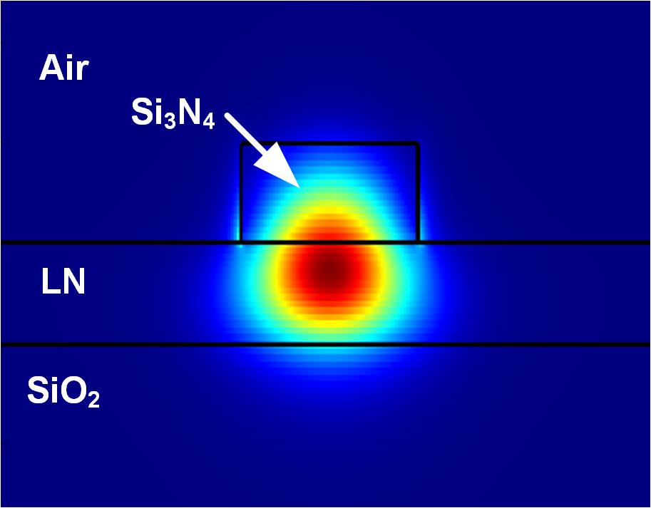
Supplementary Figure 2. Mode field distribution of the TE₀ mode in a Si₃N₄-LNOI hybrid waveguide.
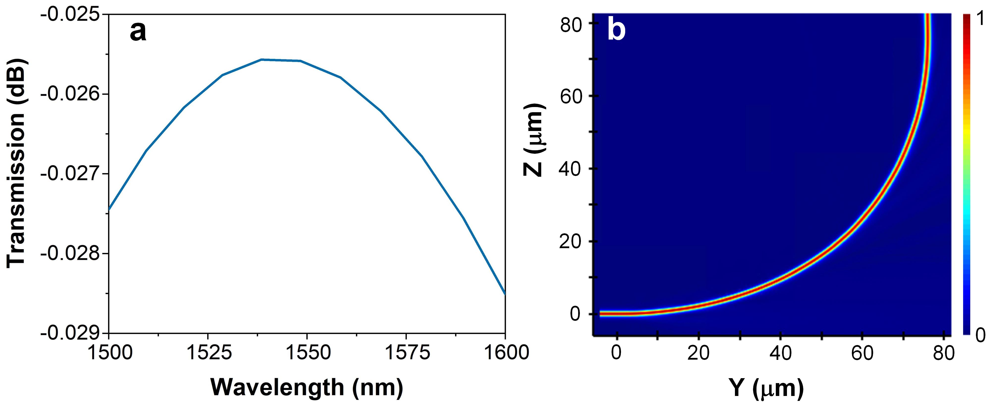
Supplementary Figure 3. The simulated result of the Euler bent waveguide. a Simulated transmission spectra of Euler ring. b Simulated field distribution in Euler bent waveguide.

Reference
1. Tan, J. et al. Arbitrary access to optical carriers in silicon photonic mode/wavelength hybrid division multiplexing circuits. Opt. Lett. 47, 3531-3534 (2022).

