Supplementary Material
Supplementary Table S1. Complete Architecture Specification
Layer-by-layer specification of the model (PhysioTransformer). All reported results correspond to this exact architecture and checkpoint.
Layer | Component | Specification
a | Sport embedding | Embedding(n_sports = 5, dim = 16); concatenated to input → ℝ^{T×30}
b | Input projection | Linear(30, 128); d_model = 128
c | Positional encoding | Fixed sinusoidal encoding
d | Transformer encoder | 4 layers; 8 attention heads; feedforward dim = 1024; dropout = 0.15; GELU activation; batch-first
e | Representation head | Linear(128,128) → LayerNorm → GELU → Linear(128,64) → GELU
f | Attention pooling | Learned query MLP over valid time steps; softmax weights; global vector h_global ∈ ℝ⁶⁴
g | Lactate curve head | Linear(64,64) → GELU → Linear(64,1); applied per time step
h | LT estimation head | Linear(64,64) → LayerNorm → GELU → Linear(64,10); soft-argmax over 10 ordinal bins spanning [0.40, 1.00]×HR_max
i | Training loss | ℒ = ℒ_curve (masked MSE) + 0.5×ℒ_LT (Smooth L1)

Supplementary Table S2. Feature Engineering Details
All 14 input features extracted per test stage. Features 1–9: dynamic (recomputed each stage). Features 10–14: static (same value appended at every stage).
# | Feature | Formula | Notes
1 | HR reserve | (HR−HR_rest)/(HR_max−HR_rest) | Normalised cardiac demand
2 | Normalised power | Power / sport max | Run/22 W/kg; Cycle/450 W; Row/500 W; Kayak/300 W
3 | HR slope | ∇HR_norm | 1st difference
4 | HR acceleration | ∇²HR_norm | 2nd difference
5 | HR moving avg. | 3-stage centred mean | Smooths transient noise
6 | HR rolling SD | SD of 3-stage window | HR stability
7 | VO₂ proxy | HR_reserve × power_norm | Aerobic demand proxy
8 | Cumulative fatigue | cumsum(HR_reserve)/N | Monotone index
9 | Normalised time | linspace(0,1,N) | Stage position
10–14 | Anthropometric (static) | height/200; weight/120; BMI/40; sex (binary); age/80 | Same at every stage

Supplementary Table S3. Training Hyperparameters
Parameter | Value
Optimiser | AdamW
Initial learning rate | 3×10⁻⁴
OneCycleLR peak learning rate | 1×10⁻³
Weight decay | 1×10⁻⁴
Training epochs | 51
Batch size | 32
Checkpoint criterion | Minimum validation LT MAE (not training loss)
Random seeds | PyTorch 42; NumPy 42 (fixed before every training run)
Software | Python 3.11; PyTorch 2.0.1; scikit-learn 1.4.0; scipy 1.12.0; pingouin 0.5.4

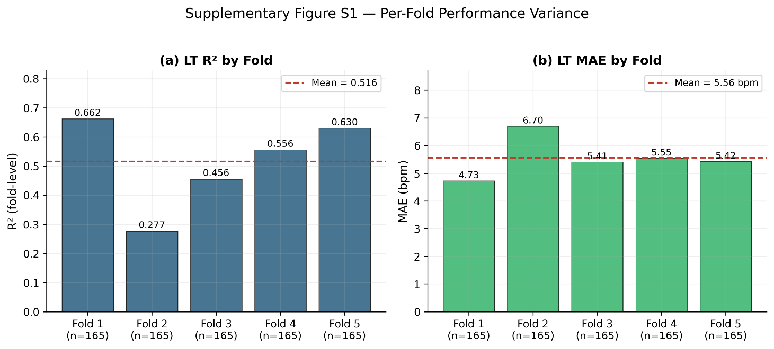

Supplementary Figure S1. Per-fold performance variance across 5-fold cross-validation. (a) LT R² by fold; (b) LT MAE by fold. Error bars show standard deviation across folds. The narrow variation in MAE and R² across folds supports the stability of the model and the cross-validation procedure.

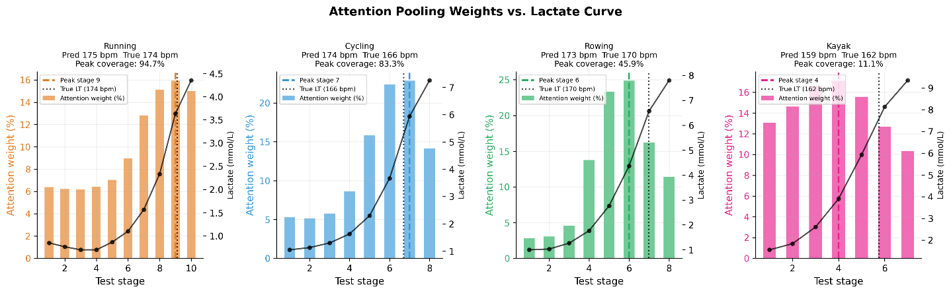
Supplementary Figure S2. Attention pooling weights across test stages, aligned with blood lactate curves for each sport. Peak coverage (attention weight maximum within ±2 stages of true LT): running 94.7%, cycling 83.3%, rowing 45.9%, kayak 11.1%.

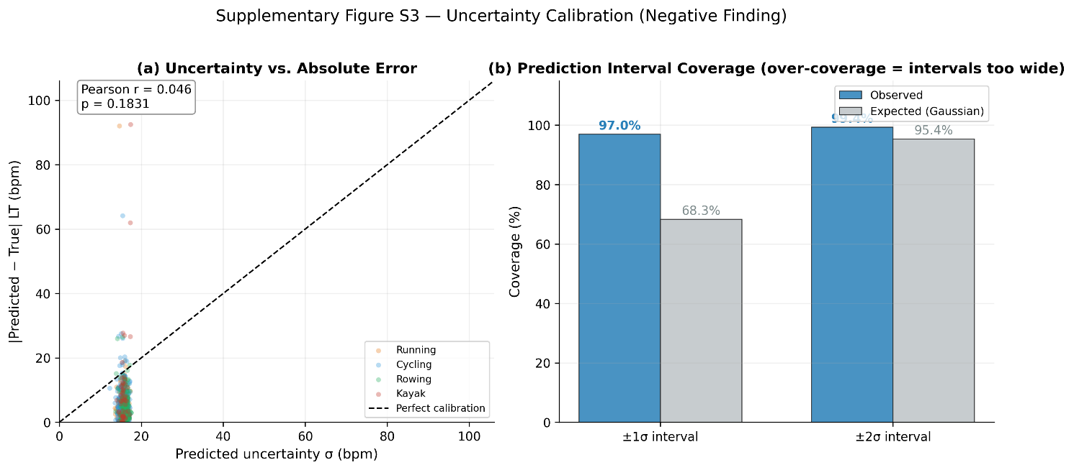

Supplementary Figure S3. Uncertainty calibration analysis. (a) Predicted uncertainty (σ) vs. absolute error (Pearson r = 0.046, p = .183). (b) Prediction interval coverage showing severe over-coverage (observed ±1σ = 97.0% vs. expected 68.3%). This analysis motivated the exclusion of the uncertainty head from the final model; deep ensemble methods are recommended for future work.

