Supplementary Information
Competitive Displacement Fluorescence Biosensor Based on Aptamer-Peptide Conjugates for Simultaneous Detection of Pb²⁺ and Cd²⁺ in Rice
Liling Haoª, Jiaqi Hanª, Jiahao Shaª, Xu Jinª, Kaimin Pengª, Fei Xuª*
a: School of Health Science and Engineering, Shanghai Engineering Research Center for Food Rapid Detection, University of Shanghai for Science and Technology, Shanghai, 200093, China.
*E-mail of the corresponding author: xufei8135@126.com (Fei Xu)

Table S1. Oligonucleotide and short peptide sequences used in this study.
Items | Sequence
Pb APC-apt-Cy3 | Cy3-GGGAGGGTGGGT-Azide(N₃) GGG
Pb APC-pep | Alkyne- KVSATDADDD
Cd APC-apt-Cy5 | Cy5-C-Azide(N₃) GACGGGTTCACAGTCCGTTG
Cd APC-pep | Alkyne- QGCICKGASDKCSCCA
Strand A | SH-TATCACCAGGCAGTTGACAGTGTAGCAAGCTGTAA  TAGATGCGAGGGTCCAATAC
Strand B | SH-TCAACTGCCTGGTGATAAAACGACACTACGTGGGA  ATCTACTATGGCGGCTCTTC
Strand C | SH-TTCAGACTTAGGAATGTGCTTCCCACGTAGTGTCG  TTTGTATTGGACCCTCGCAT
Strand D-Pb | CCACCCTCCCTTTTTTTTTTACATTCCTAAGTCTGAAACATTACAGCTTGCTACACGAGAAGAGCCGCCATAGTA
Strand D-Cd | GTCAAGCAACTTTTTTTTTTACATTCCTAAGTCTGAAACATTACAGCTTGCTACACGAGAAGAGCCGCCATAGTA

S1. Supplementary experimental procedures
S1.1. Preparation of Fe₃O₄/Au magnetic nanocomposites
Gold nanoparticles (AuNPs) were synthesized using a citrate reduction method with slight modifications [1]. Briefly, 100 mL of HAuCl₄ solution (1 mmol/L) was brought to reflux in a 250 mL round-bottom flask under continuous stirring. Trisodium citrate solution (10 mL, 38.8 mmol/L) was rapidly added, and the reaction mixture was refluxed for 15 min. The color changed from pale yellow to dark gray and finally to wine red. The AuNPs suspension was allowed to cool naturally to room temperature and stored at 4 ℃.
Fe₃O₄ nanoparticles were prepared using a citrate-assisted solvothermal method adapted from Deng et al. (2005) [2]. FeCl₃·6H₂O (1.28 g), trisodium citrate (0.09 g), sodium acetate (3.36 g), and ethylene glycol (40 mL) were mixed and ultrasonicated until homogeneous. The solution was transferred to a 100 mL Teflon-lined stainless-steel autoclave and heated at 200 ℃ for 16 h. After natural cooling, the black precipitate was collected magnetically and washed three times each with deionized water and absolute ethanol. The purified Fe₃O₄ nanoparticles were dried overnight at 60 ℃.
Surface amination and AuNPs immobilization were performed according to a previously reported procedure with modifications [3]. Fe₃O₄ nanoparticles (20 mg) were dispersed in a mixture of absolute ethanol (30 mL) and deionized water (2 mL). Ammonium hydroxide solution (2 mL, 25%, w/w) and 3-aminopropyltrimethoxysilane (APTMS, 200 μL) were added, and the suspension was sonicated at room temperature for 8 h. The resulting amine-functionalized Fe₃O₄ nanoparticles (Fe₃O₄-NH₂) were collected magnetically, washed four times with ethanol and deionized water, and redispersed in 10 mL of deionized water. Subsequently, 1 mL of the Fe₃O₄-NH₂ suspension was mixed with 10 mL of the AuNP suspension and gently stirred at room temperature for 15 min. The Fe₃O₄/Au nanocomposites were collected by magnetic separation for 2 min, washed three times with deionized water to remove unbound AuNPs, redispersed in 1 mL of deionized water, and stored at 4 ℃.

S1.2. Fluorescamine assay
Changes in accessible surface amino groups were evaluated using a fluorescamine assay. Fe₃O₄, Fe₃O₄-NH₂, and Fe₃O₄/Au nanocomposites were adjusted to identical mass concentrations and reacted with fluorescamine under identical conditions. Fluorescence emission spectra were recorded from 440 to 550 nm.

S1.3. Native PAGE characterization of TDNs assembly
The TDNs were prepared from strands A, B, and C and either strand D-Pb or D-Cd, as described in the main manuscript. Individual component strands and stepwise assembly mixtures were analyzed by native polyacrylamide gel electrophoresis. Samples were separated on a 10% polyacrylamide gel in 1× TBE buffer at 120 V for 1 h. The gel was stained with SYBR Gold in the dark for 30 min and imaged using a gel documentation system.

S1.4. Native PAGE characterization of APC formation
The Pb APCs and Cd APCs were prepared through Cu(I)-catalyzed azide-alkyne cycloaddition, as described in the main manuscript. The unconjugated Pb aptamer, Pb APC, unconjugated Cd aptamer, and Cd APC were analyzed on a 12% native polyacrylamide gel in 1× TBE buffer at 120 V for 40 min. The gel was stained with SYBR Gold in the dark for 30 min and imaged using a gel documentation system.

S2. Supplementary results
S2.1. Fluorescamine characterization of Fe₃O₄/Au
Amine-functionalized Fe₃O₄ nanoparticles (Fe₃O₄-NH₂) exhibited the strongest fluorescamine response, supporting the successful introduction of accessible primary amino groups (Fig. S1). Following AuNPs immobilization, the fluorescence intensity decreased markedly, consistent with partial occupation or masking of surface amino groups by the deposited AuNPs. Together with the TEM observations presented in the main text, these results supported the successful surface modification of the Fe₃O₄/Au nanocomposites.
Fig. S1. Fluorescamine assay for verifying the formation of Fe₃O₄/Au.

S2.2. Native PAGE characterization of TDNs assembly
The electrophoretic mobility decreased progressively upon stepwise addition of the component DNA strands (Fig. S2). The fully assembled four-strand product exhibited the lowest mobility and formed a distinct band, supporting the successful assembly of the TDNs.
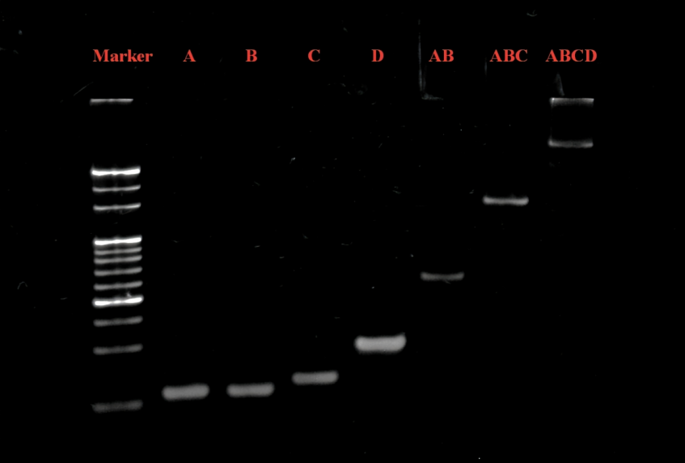
Fig. S2. Native polyacrylamide gel electrophoresis of the stepwise assembly of the TDNs.

S2.3. Native PAGE characterization of APC formation
Both Pb APCs and Cd APCs migrated more slowly than their corresponding unconjugated aptamers (Fig. S3). The observed mobility shifts were consistent with an increase in apparent molecular size following peptide conjugation and supported the formation of the APC products through the click reaction.
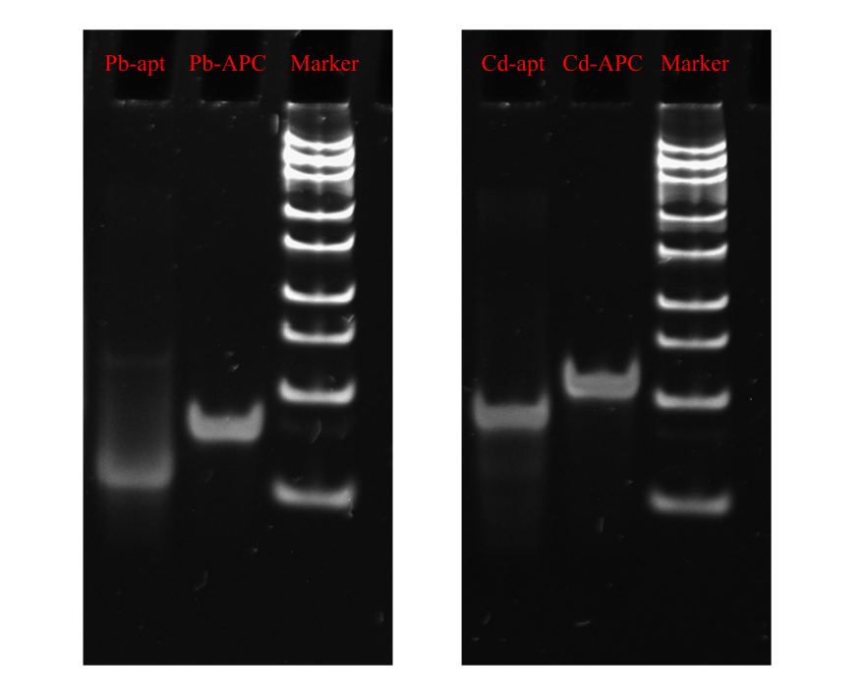
Fig. S3. Native polyacrylamide gel electrophoresis of the unconjugated aptamers and corresponding APC products.

S2.4. Optimization of sensing conditions
The density of TDNs on the Fe₃O₄/Au surface directly influences the probe loading capacity. The effect of assembly time was evaluated over a range of 4 to 20 h (Fig. S4a). The fluorescence response progressively increased with incubation time up to 16 h, reflecting a gradual increase in the surface coverage of TDNs. Extending the immobilization beyond 16 h produced a negligible further increase in signal, indicating surface saturation. Consequently, 16 h was selected for TDN anchoring.
The kinetics of APC hybridization on the immobilized TDNs were subsequently investigated over 1 to 5 h. As illustrated in Fig. S4b, the fluorescence signal increased within the first 2 h, indicating efficient duplex formation between the aptamer domains and the TDN capture strands. The signal plateaued thereafter, indicating that interfacial hybridization had approached completion. An incubation time of 2 h was therefore adopted for APC assembly.
To balance the fluorescence responses of Cy3 and Cy5 for the simultaneous determination of Pb²⁺ and Cd²⁺, the volume ratio of the Cy3-containing supernatant to the Cy5-containing supernatant after magnetic separation was optimized. Because the two fluorophores have different quantum yields, Cy3/Cy5 supernatant volume ratios from 1:10 to 1:50 were investigated. As shown in Fig. S4c, a ratio of 1:30 yielded balanced baseline signals and comparable fluorescence responses, facilitating the simultaneous quantification of Pb²⁺ and Cd²⁺. Accordingly, a 1:30 volume ratio was maintained in subsequent sensing experiments.
Fig. S4. Optimization of sensing conditions. Effects of (a) TDNs immobilization time, (b) APC incubation time, and (c) the Cy3/Cy5 supernatant volume ratio after magnetic separation on the fluorescence response of the sensor.

References
[1] Turkevich J, Stevenson PC, Hillier J (1951) A study of the nucleation and growth processes in the synthesis of colloidal gold. Discuss Faraday Soc 11:55-75. https://doi.org/10.1039/DF9511100055
[2] Deng H, Li X, Peng Q, Wang X, Chen J, Li Y (2005) Monodisperse magnetic single-crystal ferrite microspheres. Angew Chem Int Ed 44:2782-2785. https://doi.org/10.1002/anie.200462551
[3] Beiranvand S, Azadbakht A (2017) Electrochemical switching with a DNA aptamer-based electrochemical sensor. Mater Sci Eng C 76:925-933. https://doi.org/10.1016/j.msec.2017.03.028

