Supporting Information

Water-Dispersible Gold-Decorated Conjugated Polymer Nanoparticles as Selective In-Solution SERS Substrates for Enhanced Detection of Aromatic Pollutants
Huijun Mao*, and Mark T. McDermott
Department of Chemistry, University of Alberta, Alberta, Canada, T6G 2G2.
E-mail: 15505318077@163.com.
Table of Contents
Figure S 1. TEM image of 30 nm gold-decorated PFP at 1880 MR with over 1 min exposed to electron beam. 3
Figure S 2. Size of 30 nm gold and gold-decorated PFP by dynamic light scattering (DLS), (a) 30 nm gold; (b) 1880 MR. 3
Figure S 3. Raman spectrum of solid pyrene. 4
Figure S 4. Raman spectrum of solid PFP. 4
Figure S 5. Raman spectrum of blank solution of 30 nm gold-decorated PFP in water and DMF: Water. 5
Figure S 6. Size of gold-decorated PFP by dynamic light scattering (DLS), (a) 1200 MR, (b) 1880 MR, (c) 9400. 6
Table S 1. Gold nanoparticle concentrations. 7
Table S 2. Major band assignments listed for the SERS spectra of pyrene. 7
Table S 3. Major band assignments listed for the SERS spectra of methimazole. 8
Reference 8

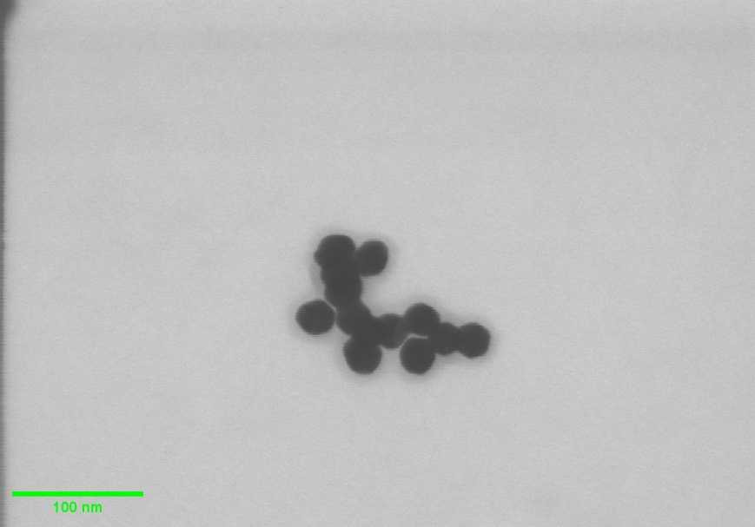

Figure S 1. TEM image of 30 nm gold-decorated PFP at 1880 MR with over 1 min exposed to electron beam.

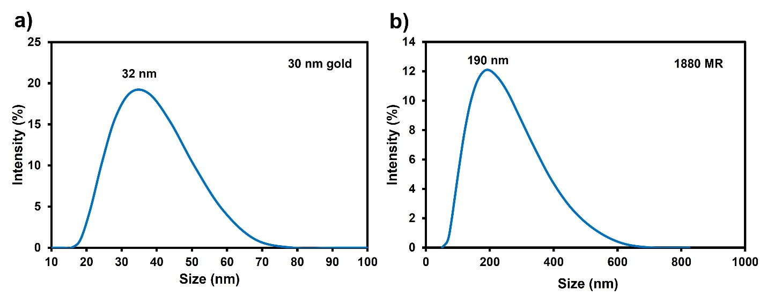

Figure S 2. Size of 30 nm gold and gold-decorated PFP by dynamic light scattering (DLS), (a) 30 nm gold; (b) 1880 MR.
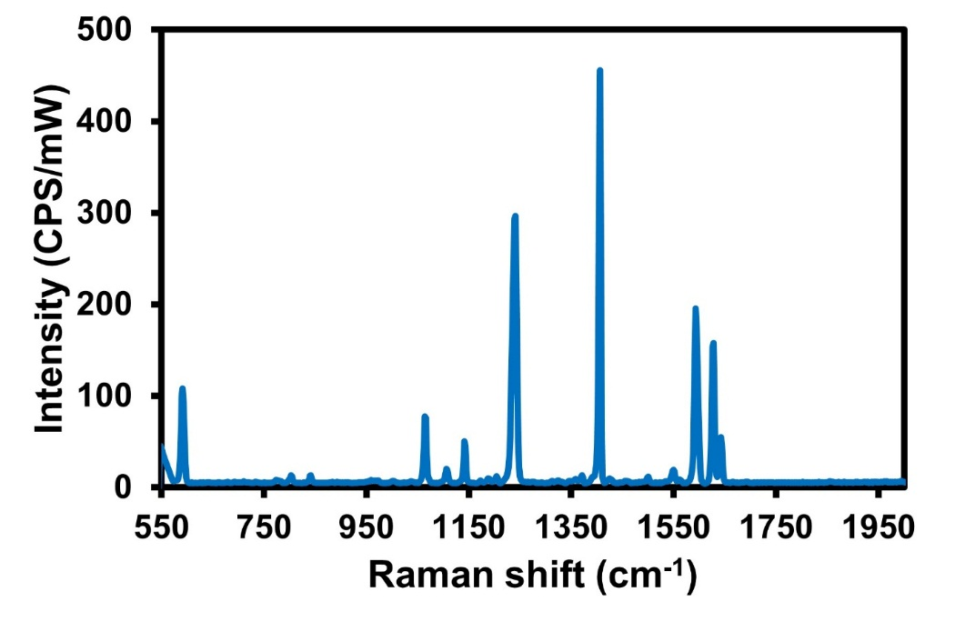

Figure S 3. Raman spectrum of solid pyrene.

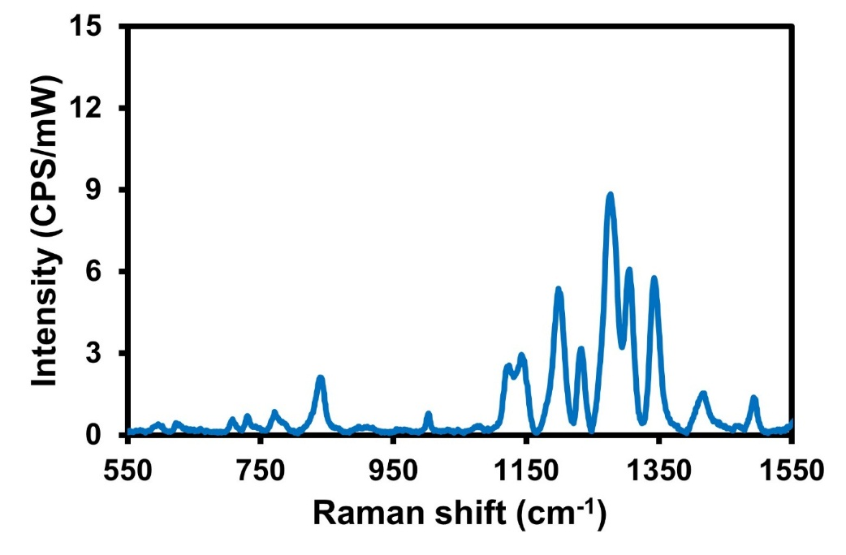

Figure S 4. Raman spectrum of solid PFP.
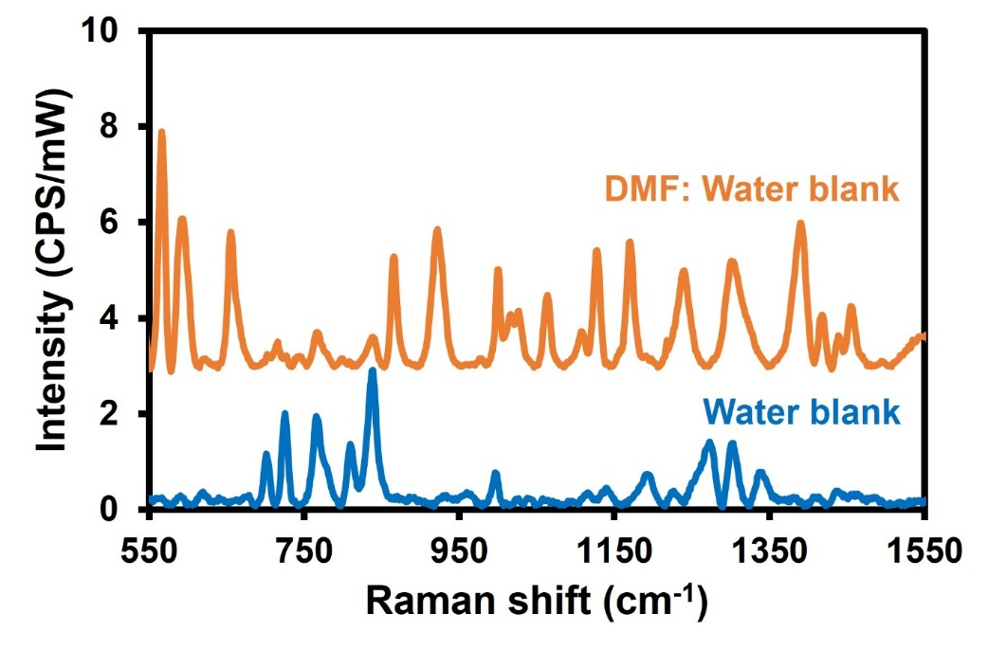

Figure S 5. Raman spectrum of blank solution of 30 nm gold-decorated PFP in water and DMF: Water.
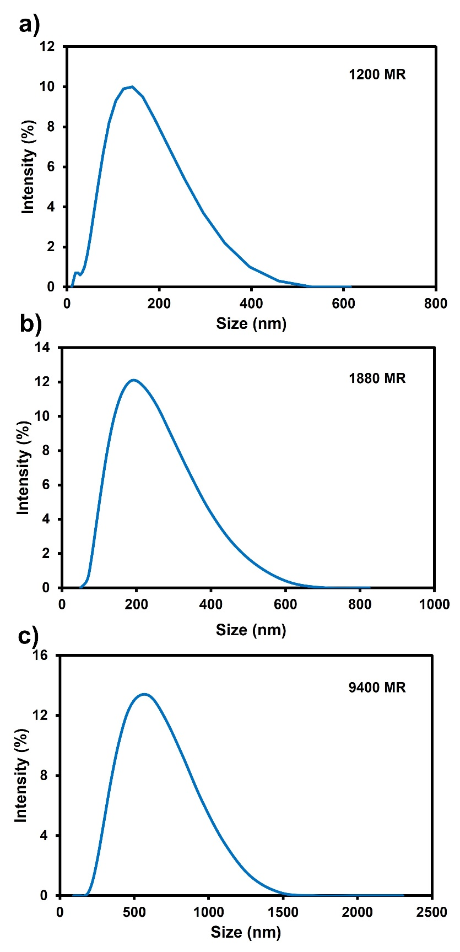

Figure S 6. Size of gold-decorated PFP by dynamic light scattering (DLS), (a) 1200 MR, (b) 1880 MR, (c) 9400.

Table S 1. Gold nanoparticle concentrations.
Gold nanoparticle size (nm) | Concentration (M)
20 | 1.16 × 10⁻⁹
30 | 3.32 × 10⁻¹⁰
60 | 4.32 × 10⁻¹¹
100 | 9.30 × 10⁻¹²

Table S 2. Major band assignments listed for the SERS spectra of pyrene.
Band position (cm⁻¹) | Assignment^{1,2}
590 | Ring deformation
1231 | C-H in-plane bending
1394 | Ring stretching

Table S 3. Major band assignments listed for the SERS spectra of methimazole.
Band position (cm⁻¹) | Assignment^{3–5}
499 | S-C-N in-plane bending
616 | Ring out-of-plane bending, ring C-H and N-H out-of-plane bending
1037 | ring bending, ring C–H bending and C-S-H bending
1086 | ring C-N stretching and ring C-H bending
1145 | C-S stretching, ring C-H bending and C-N stretching
1364 | C-N stretching, ring bending and ring C-H bending

Reference
(1) Xie, Y.; Wang, X.; Han, X.; Xue, X.; Ji, W.; Qi, Z.; Liu, J.; Zhao, B.; Ozaki, Y. Sensing of Polycyclic Aromatic Hydrocarbons with Cyclodextrin Inclusion Complexes on Silver Nanoparticles by Surface-Enhanced Raman Scattering. Analyst 2010, 135 (6), 1389–1394. https://doi.org/10.1039/C0AN00076K.
(2) Carrasco, E. A.; Campos-Vallette, M.; Leyton, P.; Diaz, G.; Clavijo, R. E.; García-Ramos, J. V; Inostroza, N.; Domingo, C.; Sanchez-Cortes, S.; Koch, R. Study of the Interaction of Pollutant Nitro Polycyclic Aromatic Hydrocarbons with Different Metallic Surfaces by Surface-Enhanced Vibrational Spectroscopy (SERS and SEIR). J Phys Chem A 2003, 107 (45), 9611–9619. https://doi.org/10.1021/jp035242a.
(3) Saleh, T. A.; Al-Shalalfeh, M. M.; Onawole, A. T.; Al-Saadi, A. A. Ultra-Trace Detection of Methimazole by Surface-Enhanced Raman Spectroscopy Using Gold Substrate. Vib Spectrosc 2017, 90, 96–103. https://doi.org/https://doi.org/10.1016/j.vibspec.2017.03.009.
(4) Ma, P.; Liang, F.; Yang, Q.; Wang, D.; Sun, Y.; Wang, X.; Gao, D.; Song, D. Highly Sensitive SERS Probe for Mercury(II) Using Cyclodextrin-Protected Silver Nanoparticles Functionalized with Methimazole. Microchimica Acta 2014, 181 (9), 975–981. https://doi.org/10.1007/s00604-014-1196-7.
(5) Long, Y.; Li, H.; Wang, W.; Yang, X.; Liu, Z. Ultrasensitive Detection of Cr(VI) Using a Novel SERS Optical Fiber Probe Modified by Dual-Functional Methimazole. J Alloys Compd 2022, 910, 164916. https://doi.org/https://doi.org/10.1016/j.jallcom.2022.164916.

