Supplementary Figure S1. Propensity score distributions before and after 1:3 matching
Density plots of the estimated propensity scores in patients with (blue) and without (pink) postoperative depression, in the unadjusted (before matching, left panel) and adjusted (after 1:3 matching, right panel) samples. The close overlap of the two distributions in the adjusted sample indicates adequate common support after matching. Propensity scores were estimated by logistic regression on age, sex, and household income category.
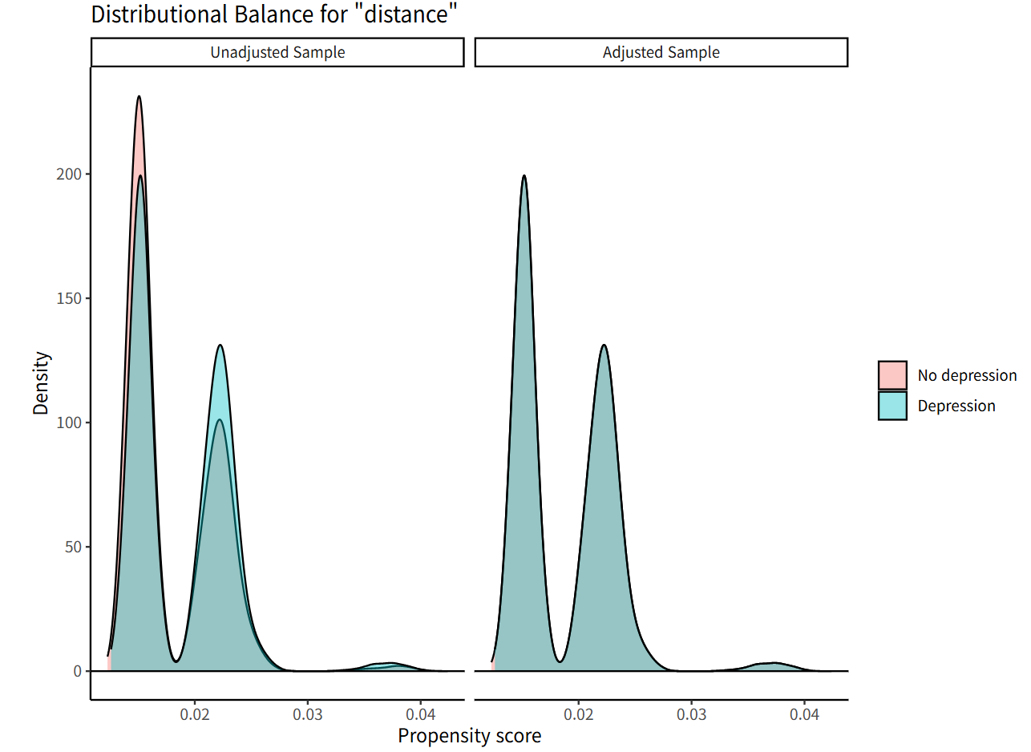

Supplementary figure S2. Dementia risk by timing of depression diagnosis and age group (sensitivity outcome, Dementia 2).
Joint effect of the timing of depression diagnosis and age group on incident dementia risk. Forest plot with the number of patients shown for each category, combined with a heat map of adjusted hazard ratios (aHRs) from inverse-probability-weighted Cox models for each combination of depression diagnosis timing (no depression, diagnosis on postoperative days 0–90, diagnosis on days 91–365) and age group (<65, ≥65 years), shown for the sensitivity outcome (Dementia 2); colour intensity represents the magnitude of the aHR. Hazard ratios were adjusted for the Model 4 covariates. Error bars indicate 95% confidence intervals; arrows denote intervals extending beyond the axis. The P for timing × age interaction was obtained from a pooled inverse-probability-weighted Cox model (P=0.003). Vertical dashed line: aHR=1.0. ***P<0.001; **P<0.01.

