Public capital and the productivity of public spending across the Italian regions

Appendix 1. The stock of public capital in monetary terms. Supplementary information
The available monetary indicators of public investment and public capital stock for the Italian regions
The classification of infrastructure has long been debated (Hansen, 1965; Aschauer, 1989; Biehl, 1991; Sturm et al., 1995; Jochimsen, 1996; Buhr, 2003). We adopt the distinction among core infrastructure - primarily oriented toward the support of directly productive activities or toward the movement of economic goods (roads, highways, airports, naval transport, sewer networks, aqueducts, networks for water distribution, gas networks, electricity networks, irrigation plant and structures dedicated to the commodities transfer) – and noncore infrastructure including schools, structures for public safety, public accommodation, plant of waste disposal, hospitals, sport structures, and so on. The same classification has been adopted by the World Development Report (World Bank, 1994) including transport, energy (power, oil, gas, coal), telecommunications, water (irrigation projects, etc.), waste disposal, among economic infrastructure, and education, health, family welfare, housing, drinking water, sanitation, all the services available to the people for self-development and professional proficiency, among social infrastructure. Our taxonomy of core and noncore infrastructure is reported in Tables 1 and 2 (main text). Note that one main asset class (Others) includes categories from both core and noncore infrastructures.
Table A1 sums up the different series of public capital in monetary terms for Italian regions (NUTS2) and provinces (NUTS3), all based on the PIM.
Table A1. The main indicators for the monetary value of the public capital stock. Italian regions and provinces
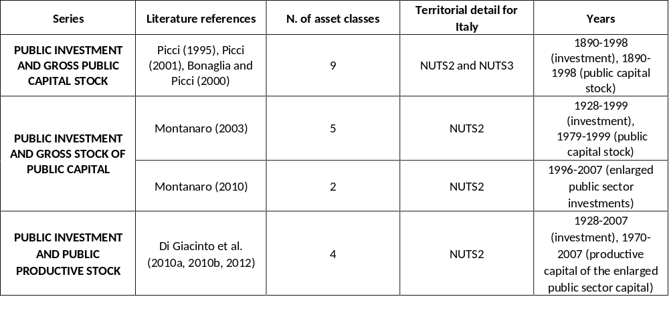
We choose to undertake the updating of the public investment series elaborated by Picci (2001), because of their finer disaggregation for nine asset classes (Roads, Rails, Ports, Buildings, Health, Water, Land, TLC, Others).

Updating the series for regional public investment
Some differences between Picci (2001) and CPT series must be tackled.
Regional data of central and local administrations expenditures are classified by CPT in 30 Functions of Government classes (COFOG) for period 1996-2019. We consider only outflows for building works (properly Beni e opere immobiliari) in the specific sectors of interest. These outflows include the costs supported for buildings, extraordinary maintenance (to fix, complete, readjust the infrastructure) and purchases of real estate assets including civil engineering infrastructure (such as roads, ports, airports, land reclamation, consolidation works, etc.). The sectoral functions are not univocally related to one or more assets from Picci (2001) series, and some assumptions, to be made explicit below, must be taken. Other differences between the Istat-based series used by Picci and the CPT series, not relevant for present purposes, are listed in CPT (2019).
To update Picci (2001) public investment series, we adopt the following steps.
1) We assume a table of correspondences among Picci asset classes and CPT sectoral functions (Table 1 in the main text);
2) We define a matching year comparing the trends of the investment series from Picci (2001) and of the CPT public investment series in the neighbourhood of the possible matching years and apply the growth rate of CPT public investments from the chosen matching year onwards to the value for the previous year from the Picci series. Based on the visual inspection of Graph A1, we update Picci series by asset class and region with CPT dynamics taking 1997 as matching year for asset classes Health, Land and Others and 1998 as matching year for Roads, Rails, Buildings, Water.

Graph A1. Public investment from Picci (2001) and CPT at 2010 prices (index; 1996=100 for Health, Land and Others, 1997=100 for Roads, Rails, Buildings, Water), 1990-2000.
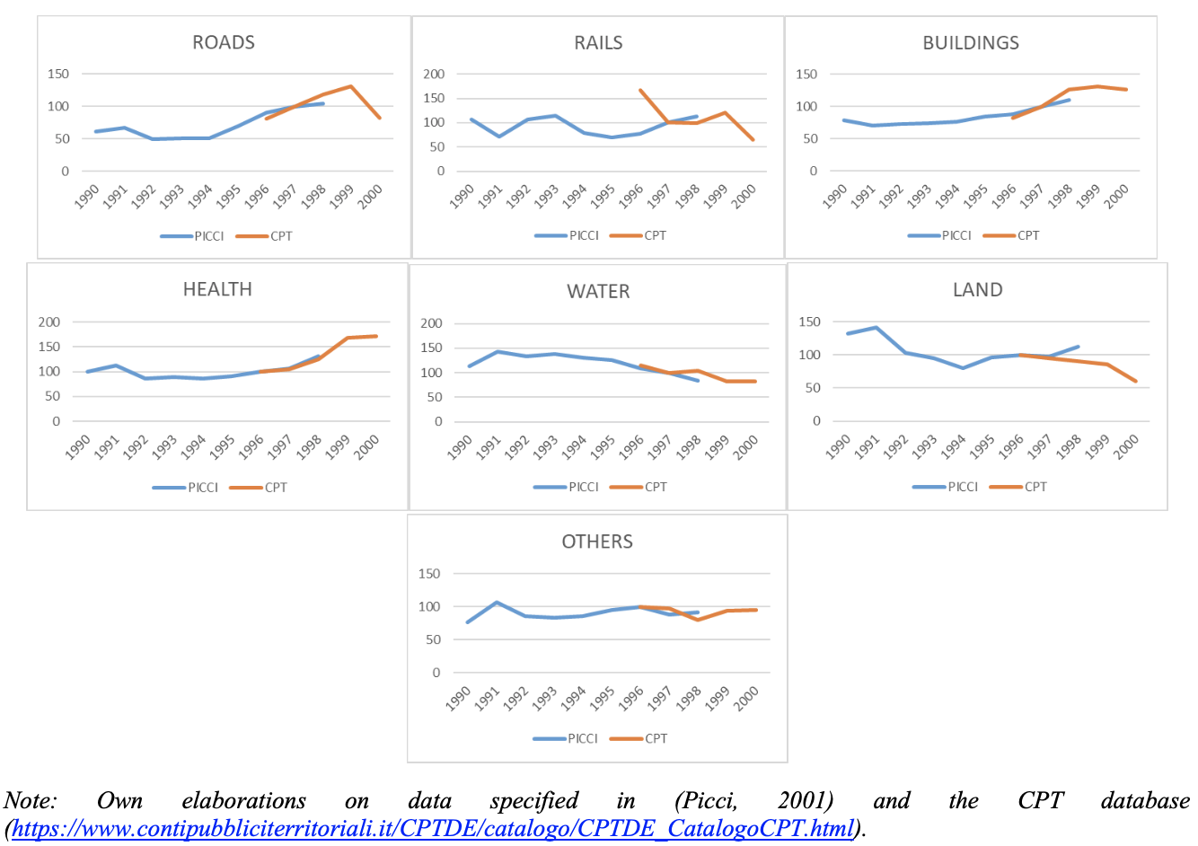

Formally, we obtain the spliced series for nominal investments ${I_N}_{r,t}^{a}$ in asset a, region r, year t, according to equation [2] of the main text;
3) Finally, we deflate the nominal investments mainly using the Istat Consumer Price Index (https://www.istat.it/it/archivio/243273) readily available from 1861 to 2019.
Graph A2 reproduces the aggregate spliced public investment series constructed from Picci (2001) and CPT data.

Graph A2. Public investment (excluding Communication infrastructure, Mln euro at 2010 prices), 1890-2019
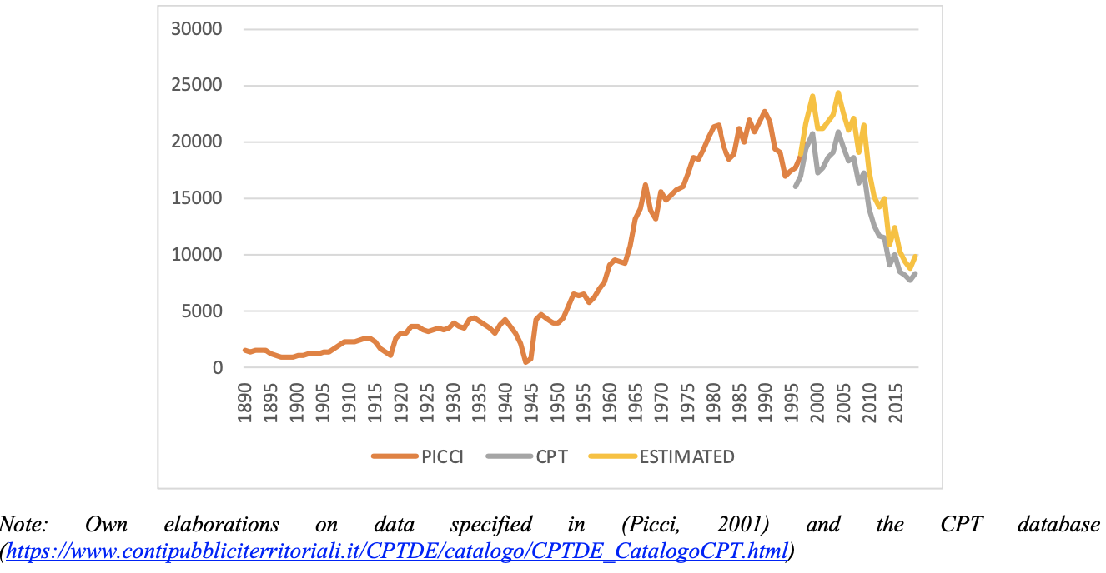

Applying the PIM to obtain regional public capital stock
We assume a geometrical pattern of depreciation following OECD (2009):
$TD=\frac{Declining balance rate}{Average service rate}$ [A1]
Under a “geometric” profile, depreciation is more pronounced during the first years of the service life. Therefore, the price-age profiles are also convex to the origin. The geometric depreciation profile is in fact used for practical reasons to approximate a combined age-price/retirement pattern (Hulten and Wyckoff, 1996). For the combined average service life/depreciation rate and retirement function, we adopt the time-invariant EUKLEMS implicit depreciation rates by asset in Transport for assets Roads and Rails, in Public administration and Education for asset Buildings, in Health and social work for asset Health, in Electricity, gas and water supply for asset Water, in Agriculture for Land, in Public administration for asset Others. Moreover, we assume the declining balance rates proposed by IVIE for Roads and airports (Roads), Railways and maritime infrastructure (Rails), Public water infrastructure (Water), Other constructions (Buildings, Health, Land, Others). The hypotheses about the depreciation pattern are summed up in Table A2.

Table A2. Hypotheses on the combined average service life/depreciation rate and retirement function
 | Declining balance rate (IVIE) ª | Depreciation rate  (EUKLEMS)^{b} | Average service life
ROADS | 1.251 | 0.028 | 45
RAILS | 1.251 | 0.028 | 45
BUILDINGS | 1.390 | 0.025 | 56
HEALTH | 1.390 | 0.027 | 51
WATER | 1.112 | 0.023 | 48
LAND | 1.390 | 0.024 | 58
OTHERS | 1.390 | 0.025 | 56
Sources: a) Perez et al. (2019); b) https://euklems.eu/

Validating the new monetary index for infrastructure
Table A3 reproduces the range (minimum and maximum) of the year-by-year correlations between Picci (2001) regional gross capital series and the estimated net capital stock by asset class for period 1890-1998 (both series taken at 2010 prices). The two series are very highly correlated considering the very long period (more than a century) and the different methodologies adopted to compute the stocks. The relatively low minimum correlation for public buildings and water equipment may be partially due to the different assumptions on the service life of the asset. Yet, this correlation generally increases in the last decades.

Table A3 Year-by-year correlation between Picci regional gross capital series (Picci, 2001) and the estimated net capital stock by asset class (1890-1998)
 | Total | Roads | Rails | Buildings | Health | Water | Land | Others
MIN | 0.92 | 0.95 | 0.87 | 0.58 | 0.97 | 0.79 | 0.94 | 0.81
MAX | 0.99 | 1.00 | 0.97 | 0.96 | 1.00 | 0.94 | 1.00 | 0.92
1970-79 (mean) | 0.99 | 0.99 | 0.90 | 0.76 | 1.00 | 0.88 | 1.00 | 0.83
1980-89 (mean) | 0.99 | 1.00 | 0.91 | 0.92 | 1.00 | 0.82 | 0.99 | 0.84
1990-98 (mean) | 0.99 | 0.99 | 0.96 | 0.92 | 0.99 | 0.91 | 1.00 | 0.83
Note: Own elaborations on data from Picci (2001) and CPT
(https://www.contipubbliciterritoriali.it/CPTDE/catalogo/CPTDE_CatalogoCPT.html)

Evidence from the new monetary index for infrastructure
Table A4 and Map A1 report the regional rankings of the new monetary indicator for 1989 and 2019. The Total index for all assets reveals a decreasing trend (in relative terms) for the Southern regions. This evolution is even more marked for Core assets. Particularly strong reductions in relative terms take place for the monetary capital in Roads and Rails of Calabria and Sicilia. On the other hand, Northern regions generally improve their ranking. Lombardia shows an enduring primacy for most asset classes and aggregations.
Table A4. The new measure of regional monetary capital stock. Regional rankings (1989, 2019)
 | Total |  | Core |  | Noncore |  | Roads |  | Rails |  | Buildings |  | Health |  | Water |  | Others
 | 1989 | 2019 | 1989 | 2019 | 1989 | 2019 | 1989 | 2019 | 1989 | 2019 | 1989 | 2019 | 1989 | 2019 | 1989 | 2019 | 1989 | 2019
PIE | 10 | 7 | 11 | 7 | 6 | 4 | 9 | 6 | 11 | 7 | 2 | 3 | 9 | 6 | 9 | 7 | 10 | 12
VDA | 20 | 20 | 20 | 20 | 20 | 20 | 20 | 19 | 20 | 20 | 19 | 19 | 20 | 20 | 20 | 20 | 18 | 18
LIG | 12 | 13 | 13 | 13 | 14 | 14 | 8 | 12 | 10 | 10 | 13 | 13 | 16 | 13 | 16 | 13 | 15 | 19
LOM | 1 | 1 | 3 | 2 | 1 | 1 | 2 | 1 | 5 | 11 | 1 | 1 | 2 | 1 | 2 | 1 | 2 | 6
TAA | 16 | 8 | 16 | 10 | 13 | 5 | 17 | 9 | 18 | 17 | 12 | 6 | 14 | 4 | 14 | 4 | 13 | 4
VEN | 9 | 5 | 10 | 5 | 8 | 7 | 10 | 2 | 9 | 5 | 3 | 5 | 7 | 5 | 7 | 6 | 20 | 20
FVG | 15 | 17 | 15 | 17 | 12 | 16 | 16 | 16 | 14 | 12 | 11 | 14 | 15 | 17 | 15 | 17 | 7 | 16
EMR | 5 | 3 | 6 | 4 | 4 | 2 | 3 | 4 | 7 | 3 | 5 | 2 | 6 | 2 | 6 | 2 | 1 | 5
TOS | 8 | 9 | 8 | 9 | 9 | 9 | 6 | 8 | 6 | 6 | 7 | 8 | 11 | 9 | 11 | 9 | 6 | 10
UMB | 19 | 18 | 19 | 19 | 18 | 18 | 18 | 18 | 17 | 18 | 17 | 18 | 19 | 18 | 19 | 18 | 17 | 17
MAR | 17 | 15 | 17 | 16 | 16 | 13 | 13 | 15 | 16 | 14 | 14 | 12 | 17 | 15 | 17 | 15 | 11 | 13
LAZ | 4 | 2 | 4 | 1 | 3 | 8 | 4 | 3 | 3 | 1 | 4 | 9 | 3 | 3 | 3 | 3 | 5 | 7
CAM | 3 | 4 | 2 | 3 | 2 | 3 | 5 | 7 | 1 | 2 | 6 | 4 | 1 | 7 | 1 | 5 | 4 | 2
ABR | 13 | 16 | 14 | 15 | 15 | 17 | 12 | 13 | 15 | 16 | 15 | 16 | 12 | 16 | 12 | 16 | 14 | 15
MOL | 18 | 19 | 18 | 18 | 19 | 19 | 19 | 20 | 12 | 15 | 20 | 20 | 18 | 19 | 18 | 19 | 19 | 14
PUG | 6 | 10 | 7 | 8 | 7 | 10 | 11 | 10 | 8 | 4 | 9 | 11 | 5 | 11 | 5 | 11 | 9 | 3
BAS | 14 | 14 | 12 | 14 | 17 | 15 | 14 | 17 | 19 | 19 | 18 | 17 | 13 | 12 | 13 | 12 | 16 | 11
CAL | 7 | 11 | 5 | 11 | 11 | 11 | 7 | 11 | 4 | 8 | 16 | 10 | 10 | 14 | 10 | 14 | 8 | 8
SIC | 2 | 6 | 1 | 6 | 5 | 6 | 1 | 5 | 2 | 9 | 8 | 7 | 4 | 8 | 4 | 8 | 3 | 1
SAR | 11 | 12 | 9 | 12 | 10 | 12 | 15 | 14 | 13 | 13 | 10 | 15 | 8 | 10 | 8 | 10 | 12 | 9
Sources: Own elaboration on Picci (2001) and CPT
(https://www.contipubbliciterritoriali.it/CPTDE/catalogo/CPTDE_CatalogoCPT.html); for the declining balance rate IVIE (Perez et al., 2019) and for the depreciation rate EUKLEMS (https://euklems.eu/).
Note: a lower figure corresponds to a higher monetary index.

Map A1. The new measure of monetary capital stock. Regional endowment rankings (1989, 2019)
1989
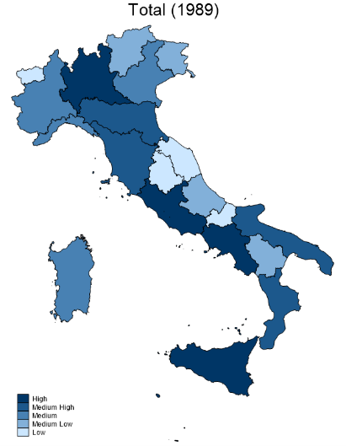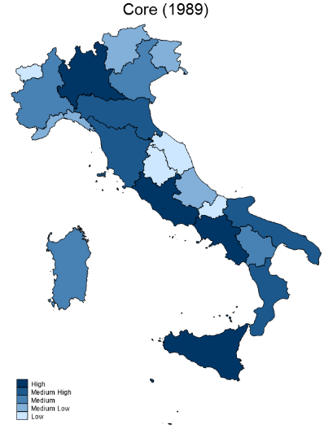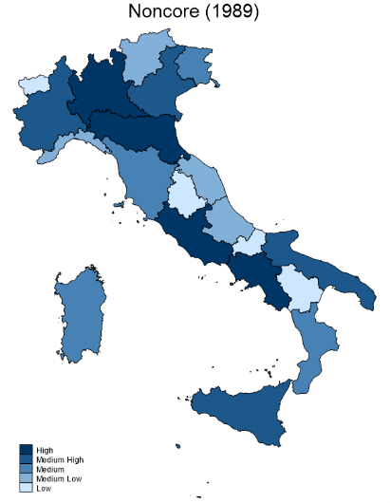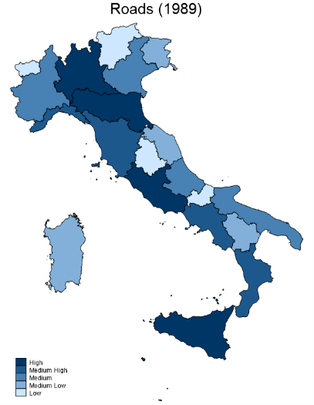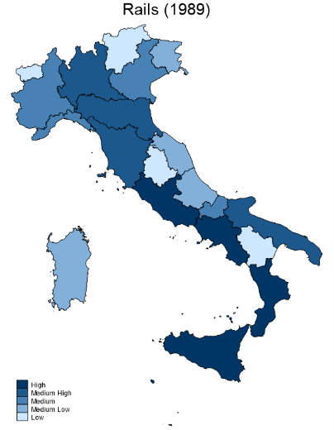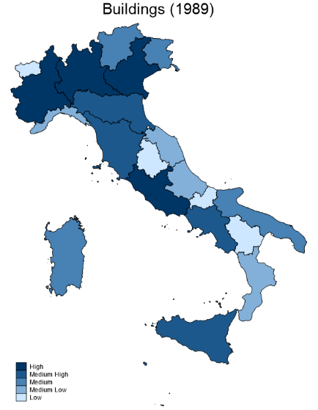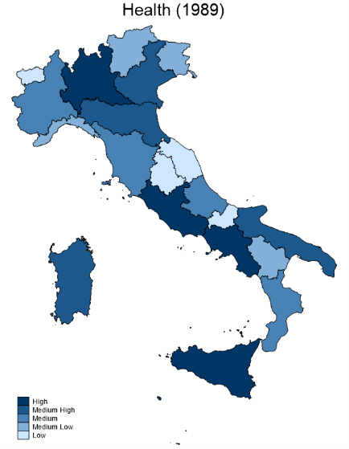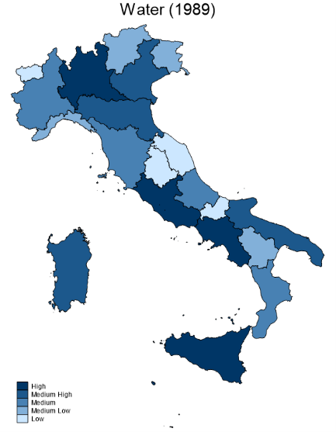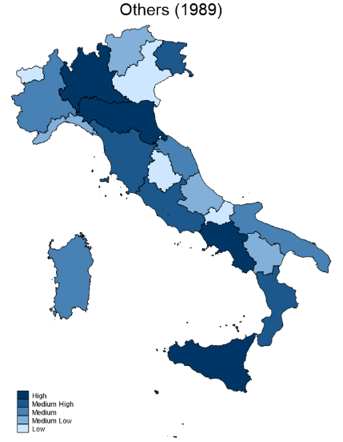
2019
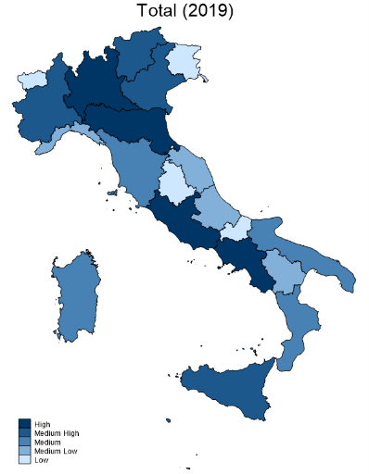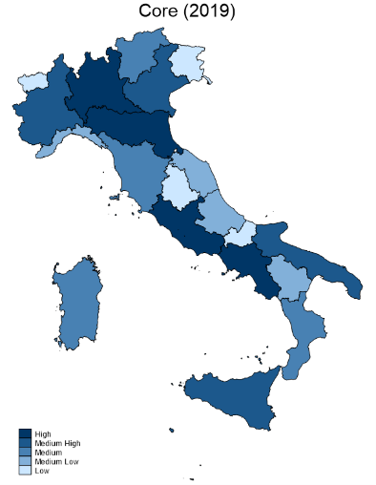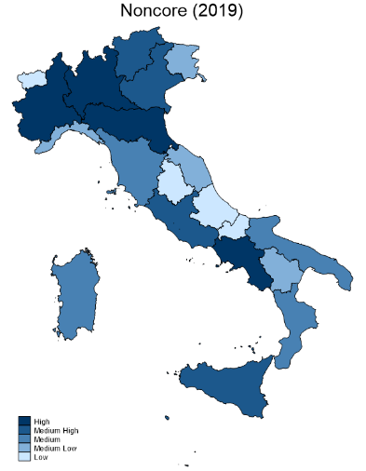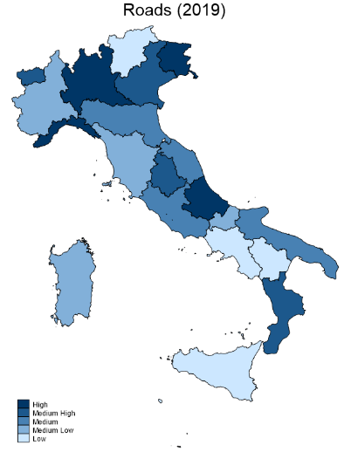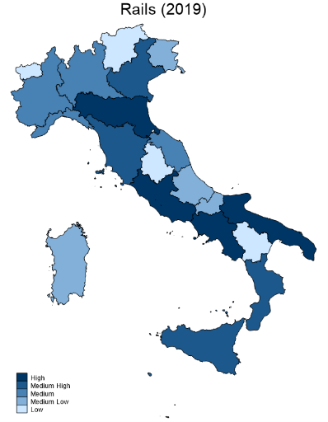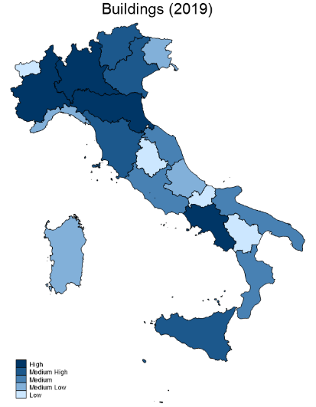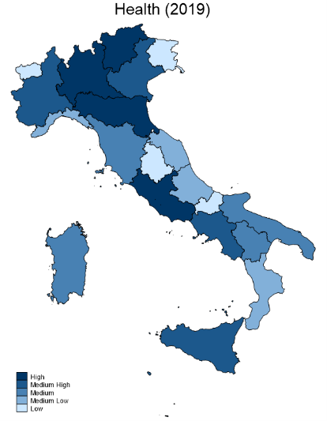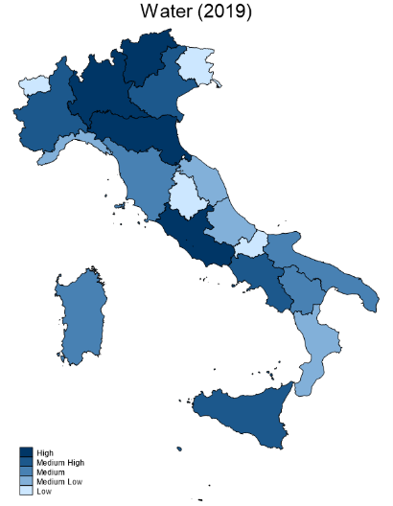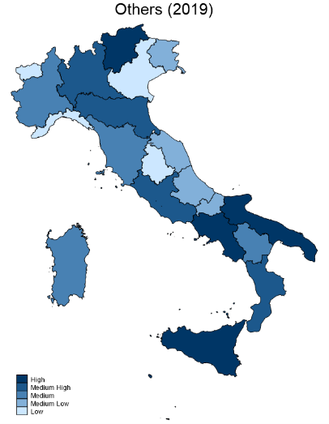
Note: Higher ranking corresponds to darker blue regions and to higher monetary capital stock.

Appendix 2. The public capital in physical terms. Supplementary information
The available physical indicators of infrastructure for the Italian regions
Infrastructure is a huge umbrella term for many factors facilitating the production of goods or services. In fact, several infrastructure classifications have been introduced by different authors. Moreover, many approaches have been adopted to measure infrastructural endowment, either in physical terms – constructing a measure of physical public infrastructure using appropriate elementary indicators, or in monetary terms – using the Perpetual Inventory Model (PIM) to cumulate fixed capital formation.
Table A5 sums up the main infrastructure indexes in physical terms still currently extant for Italian regions and provinces.
Table A5 The main infrastructure indicators in physical terms, Italian regions and provinces.
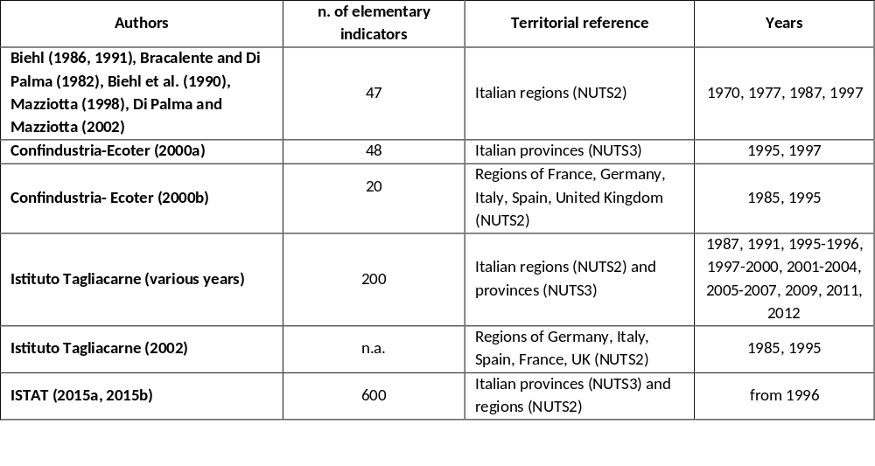
Computing the new physical infrastructure indicator
Various data sources were employed to yield long and consistent time series for our indicators (Table A2). The main sources were Eurostat – Regional statistics, for 1990-2019, and Istat – Atlante Statistico Territoriale delle Infrastrutture (ASTI) for 1996-2019. Other Istat statistics have been used from I.Stat and Istat – Indicatori territoriali delle Politiche di sviluppo. For less recent statistics the data have been sourced from Istat – Annuario statistico italiano, and Infrastructure and Transport Ministry (MIT) – Conto nazionale delle infrastrutture e dei trasporti. For some specific asset classes, more particular sources have been adopted: Terna for electricity network system, Unionpetrolifera and Economic Development Ministry (MISE) for statistics on Petroleum infrastructure, Autorità di regolazione per Energia, Reti e Ambiente (ARERA) for natural gas pipelines, Istituto Superiore per la Protezione e la Ricerca Ambientale (ISPRA) for waste infrastructure.
The green cells of Table A6 single out data coming from the primary data source (the one available for the higher number of years). A secondary data source (if available) was used to fill yellow cells. Linear interpolations between adjacent available values were finally adopted to fill the white cells.

Table A6. Primary and secondary sources by elementary infrastructure index over period 1987-2019
Elementary index | Elementary indicator description | Primary data source (green) | Secondary data source (yellow) | 1987 | 1988 | 1989 | 1990 | 1991 | 1992 | 1993 | 1994 | 1995 | 1996 | 1997 | 1998 | 1999 | 2000 | 2001 | 2002 | 2003 | 2004 | 2005 | 2006 | 2007 | 2008 | 2009 | 2010 | 2011 | 2012 | 2013 | 2014 | 2015 | 2016 | 2017 | 2018 | 2019
ROAD1 | Motorways (km) | Eurostat | Istat (1)
ROAD2 | Other roads (km) | Eurostat | Istat (1)
AIRP1 | Runways surface (m2) | Istat (1) | MIT
AIRP2 | Parking area (m2) | Istat (1) | MIT
RAIL1 | Total railway lines (km) | Eurostat
PORT1 | Lenght of docks (m) | Istat (4) | MIT
PORT2 | Total quays surface (sqm) | Istat (4) | MIT
PORT3 | Freight loaded and unloaded (thousand tonnes) | Eurostat | Istat (4)
PORT4 | Passengers embarked and disembarked (thousand) | Eurostat
WATE1 | Water delivered (thousand m3) | Istat (1)
WATE2 | Sewage treatment plants (thousand) | Istat (2)
WATE3 | Regional population served by complete wastewater treatment plants (%) | Istat (2)
ELEC1 | Lenght of electricity network system 220Kv (Km) | Istat (1) | MIT
ELEC2 | Lenght of electricity network system 380 Kv (Km) | Istat (1) | MIT
ELEC3 | Net production of electrical energy (GWh) | Istat (1) | MIT
GAS1 | Total lenght natural gas pipelines (km) | ARERA | Istat (1)
PETR1 | Total lenght petroleum pipelines (km) | MIT
PETR2 | Cumulative n. of oil wells | MISE
WAST1 | Production of urban waste (thousand tonnes) | Istat (1) | ISPRA
EDUC1 | n. of maternal classrooms | Istat (2)
EDUC2 | n. of primary classrooms | Istat (2)
EDUC3 | n. of secondary first cycle classrooms | Istat (2)
EDUC4 | n. of secondary upper cycle classrooms | Istat (2)
EDUC5 | n. of university professors and researchers | MIUR | Istat (1)
CULT1 | n. of visitors of public art institutes | Istat (1)
CULT2 | n. of tickets for theatres and concerts | Istat (1)
SOCI1 | n. of available beds in nursing and residential care facilities | Istat (2)
SOCI2 | Kindergartens (number of users) | Istat (3)
HEAL1 | n. of beds in hospitals | Eurostat | Istat (1)
HEAL2 | n. doctors | Eurostat | Istat (1)
Note: see text about the meaning of the different cell colours. (1) Istat-ASTI, (2) IstatData, (3) Istat – Indicatori territoriali delle Politiche di sviluppo (4) Istat – Annuario statistico italiano

We validate the selection of the elementary indicators by constructing asset class and aggregate indexes using the methodology of the Istituto Tagliacarne and comparing the result with the corresponding indexes from the Istituto Tagliacarne for the available years. In particular, we apply a standard procedure for constructing composite indicators of public infrastructural endowment (see, e.g., Mazziotta, 2006) to the 30 regional elementary indicators over 1987-2019, removing the methodological novelties introduced in the construction of the new index.
Generally, the elementary indicators are normalized by land area for "network" or space serving infrastructure and by population for "punctual" indicators or population serving infrastructure. To this purpose the Economic elementary categories of Transport, Energy and Water infrastructure have been related to regional area and the Social elementary categories of Education, Cultural, Social, Health and Waste infrastructure to regional population.
The normalized indicators are not yet comparable, as they are expressed in different units of measurement (km of roads per square km of land area, or number of doctors per inhabitant). One common method for this purpose is to relate, within the same infrastructural category, the yearly normalized indices of each territorial unit to the national value of the series, thus obtaining the immediate comparability between the indicators considered.
Finally, to aggregate elementary standardized indicators in intermediate and main asset classes, an averaging procedure is used. Usually, the arithmetic mean is adopted to aggregate elementary indicators within a category (hypothesis of greater fungibility) and the geometric mean to combine different main categories (hypothesis of smaller substitutability).
Table A7 reports the Pearson correlation indexes between the physical indicators of infrastructure obtained in this manner for some intermediate categories (Energy, i.e., Electricity, Gas Petrol; Education; Health; Social), as well as for Core, Noncore and Total assets, and the corresponding indicators from Istituto Tagliacarne (various years). We do not consider the Istat series as a benchmark because this source does not provide aggregate or intermediate indexes but only elementary indicators. The generally high correlation between the indicators from the two series indicates the appropriateness of the 30 elementary indicators chosen to measure public capital in physical terms.

Table A7 Correlation between the new physical indicators of infrastructure and corresponding indicators from Istituto Tagliacarne (years 1991, 1995-1996, 1997-2000, 2001-2004, 2005-2007, 2009, 2011, 2012)
 | 1991 | 1995-1996 | 1997-2000 | 2001-2004 | 2005-2007 | 2009 | 2011 | 2012
Energy |  |  | 0.82 | 0.82 | 1.00 | 0.75 | 0.76 | 0.76
Education | 0.78 |  | 0.84 | 0.84 | 0.99 | 0.86 | 0.84 | 0.87
Health | 0.88 |  | 0.88 | 0.89 | 1.00 | 0.92 | 0.92 | 0.92
Social | 0.48 |  | 0.57 | 0.60 | 1.00 | 0.56 | 0.60 | 0.59
Core |  |  |  | 0.90 | 0.99 | 0.86 | 0.89 | 0.86
Noncore |  |  |  | 0.86 | 1.00 | 0.86 | 0.84 | 0.86
Total | 0.88 | 0.78 | 0.90 | 0.87 | 0.87 | 0.88 | 0.90 | 0.90

As the outcome of this validating procedure supports our choice of elementary indicators, we proceed, by aggregating them in thirteen intermediate categories and seven main asset classes. More precisely, we consider:
- 18 elementary indicators for economic (Core) infrastructure, to be grouped in 8 intermediate categories and in 4 main asset classes (Roads (including Roads and Airports), Rails (including Rails and Ports), Water disposal, Others (Electricity, Gas, Petrol)).
- 12 elementary indicators for social (Noncore) infrastructure to be grouped in 5 intermediate categories and in 3 main asset classes (Buildings (including Education, Cultural and Social infrastructure), Health, Others (Waste)).
The main class Roads includes the intermediate assets Roads and Airports, and the main class Rails include the intermediate assets Rails and Ports, to achieve comparability with the monetary capital stocks considered in § 3.1.
The main asset class of telecommunications was not considered because of the difficulties in tracking the evolution of the sector during period 1987-2019. Biehl (1991) used such elementary categories as Telephone, Telex, Fax network. Yet, they cannot currently represent the current endowment of communication coverage increasingly related to the internet networking system.
Evidence from the new physical infrastructure indicator
Table A8 and Map A2 show the relative ranking of the new regional infrastructure indicators for 1989 and 2019, revealing some changes in this ranking by asset in the period under consideration. In fact, although the synthetic indexes report limited discrepancies in the regional ranking at the beginning and at the end of the period, more differences emerged in the regional ranking by asset. For core infrastructure, most of Northern and Central regions improve their performance in Roads and Rails endowment, while Southern regions increased in relative terms their Water infrastructure. Recall that the main asset index f_Rails is aggregating intermediate assets Rails and Ports. Hence, coastal regions such as Liguria and Sicilia may report a particularly high value for this index, while landlocked regions such as Lombardia, may have an unexpectedly low value. On the other hand, there have been relevant changes of the ranking for the Health infrastructure with more performing regions (such as Campania and Sicilia) and regions losing many positions (such as Veneto). Finally, for most regions the adoption of unweighted indexes does not entail any significant variations in regional rankings and their modifications. Campania and Emilia-Romagna provide an exception for this rule in the case of Noncore assets.
These physical indexes of infrastructure are used in § 3.3 (main text) to compute measures of public spending productivity both aggregated and by asset class.
Table A8. The new regional infrastructure index. Regional rankings (1989, 2019)
 | Total |  | Core |  | Noncore |  | Roads |  | Rails |  | Buildings |  | Health |  | Water |  | Others
 | 1989 | 2019 | 1989 | 2019 | 1989 | 2019 | 1989 | 2019 | 1989 | 2019 | 1989 | 2019 | 1989 | 2019 | 1989 | 2019 | 1989 | 2019
PIE | 4 | 3 | 2 | 3 | 7 | 7 | 4 | 5 | 4 | 12 | 6 | 5 | 7 | 7 | 2 | 1 | 3 | 5
VDA | 19 | 18 | 18 | 18 | 20 | 20 | 19 | 19 | 20 | 20 | 20 | 20 | 20 | 20 | 15 | 16 | 20 | 20
LIG | 10 | 10 | 10 | 8 | 10 | 11 | 11 | 12 | 7 | 2 | 11 | 12 | 10 | 11 | 13 | 13 | 10 | 10
LOM | 1 | 1 | 1 | 1 | 1 | 2 | 1 | 1 | 10 | 13 | 1 | 2 | 1 | 1 | 1 | 2 | 1 | 1
TAA | 16 | 16 | 16 | 16 | 16 | 15 | 16 | 16 | 16 | 17 | 16 | 14 | 16 | 16 | 14 | 9 | 16 | 16
VEN | 6 | 7 | 6 | 4 | 3 | 8 | 7 | 4 | 5 | 7 | 8 | 8 | 3 | 6 | 4 | 4 | 5 | 4
FVG | 14 | 13 | 14 | 14 | 13 | 12 | 15 | 14 | 13 | 11 | 14 | 11 | 14 | 15 | 9 | 15 | 15 | 15
EMR | 5 | 5 | 5 | 6 | 4 | 4 | 5 | 6 | 12 | 6 | 7 | 4 | 4 | 5 | 3 | 3 | 6 | 2
TOS | 7 | 6 | 9 | 7 | 6 | 3 | 8 | 7 | 2 | 3 | 4 | 3 | 6 | 8 | 8 | 7 | 8 | 8
UMB | 17 | 17 | 17 | 17 | 17 | 17 | 17 | 17 | 17 | 16 | 17 | 17 | 17 | 17 | 18 | 18 | 17 | 17
MAR | 15 | 15 | 15 | 15 | 12 | 10 | 14 | 15 | 15 | 14 | 12 | 10 | 12 | 13 | 19 | 11 | 13 | 13
LAZ | 2 | 2 | 4 | 2 | 2 | 1 | 2 | 2 | 11 | 9 | 2 | 1 | 2 | 2 | 5 | 8 | 2 | 3
CAM | 8 | 8 | 8 | 9 | 8 | 5 | 9 | 9 | 3 | 5 | 5 | 7 | 8 | 3 | 7 | 5 | 7 | 6
ABR | 13 | 14 | 13 | 13 | 15 | 16 | 12 | 13 | 14 | 15 | 15 | 16 | 13 | 14 | 10 | 6 | 14 | 12
MOL | 20 | 20 | 19 | 19 | 19 | 19 | 20 | 20 | 19 | 19 | 19 | 19 | 19 | 19 | 17 | 19 | 19 | 19
PUG | 9 | 9 | 7 | 10 | 9 | 9 | 6 | 8 | 8 | 10 | 9 | 9 | 5 | 9 | 6 | 12 | 9 | 9
BAS | 18 | 19 | 20 | 20 | 18 | 18 | 18 | 18 | 18 | 18 | 18 | 18 | 18 | 18 | 20 | 20 | 18 | 18
CAL | 11 | 12 | 11 | 11 | 11 | 14 | 10 | 10 | 6 | 4 | 10 | 15 | 11 | 12 | 16 | 17 | 11 | 11
SIC | 3 | 4 | 3 | 5 | 5 | 6 | 3 | 3 | 1 | 1 | 3 | 6 | 9 | 4 | 12 | 14 | 4 | 7
SAR | 12 | 11 | 12 | 12 | 14 | 13 | 13 | 11 | 9 | 8 | 13 | 13 | 15 | 10 | 11 | 10 | 12 | 14
Source: Own elaboration on data specified in Table A6
Note: A lower figure corresponds to a higher infrastructure index

Map A2. The new infrastructure index. Regional endowment rankings (1989, 2019)
1989
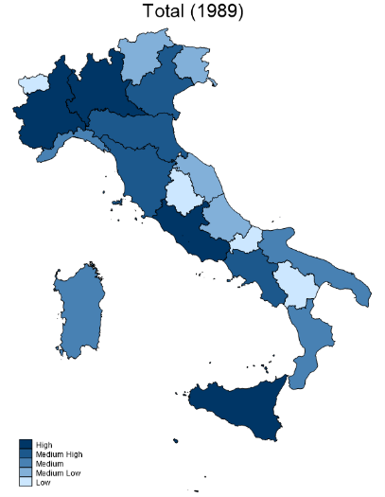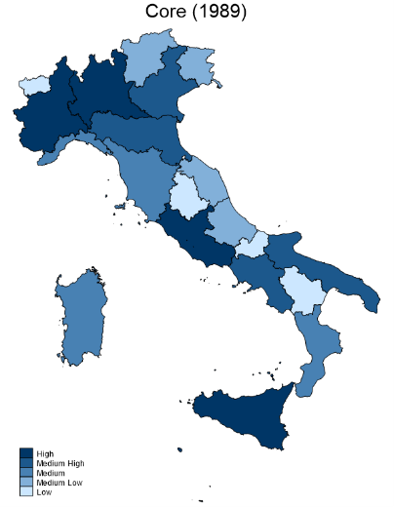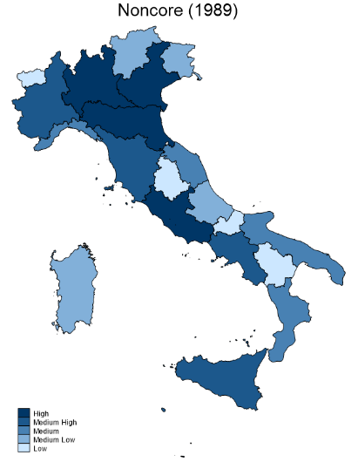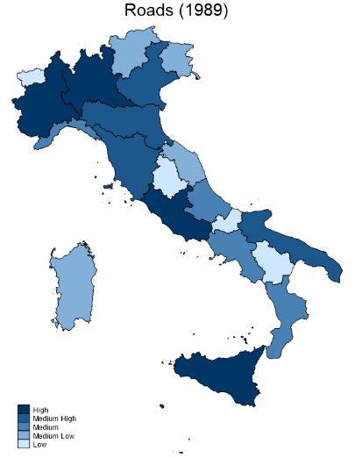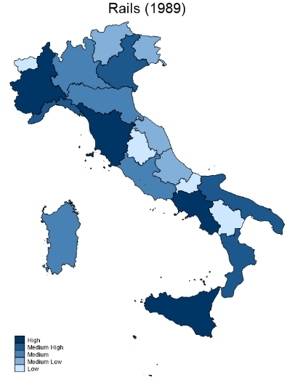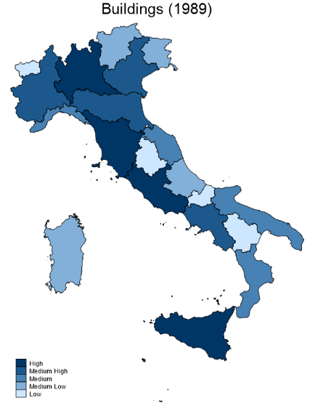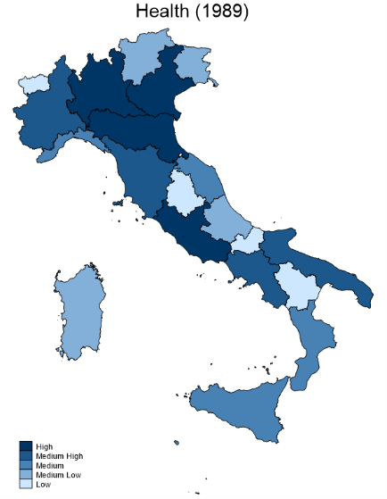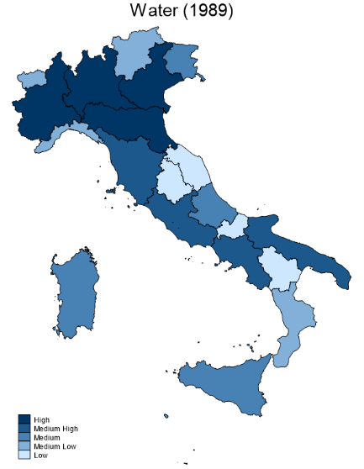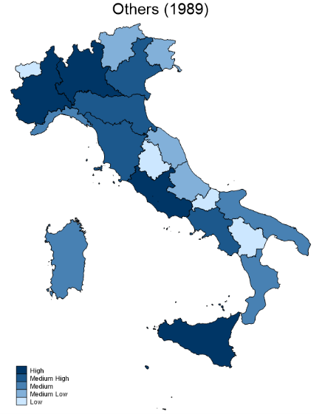

2019
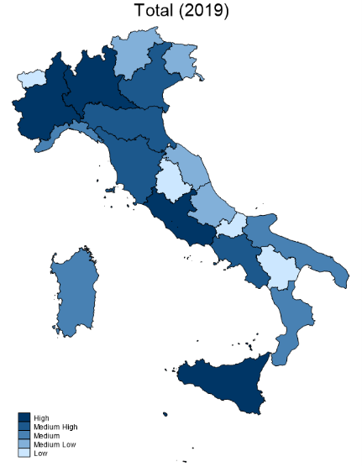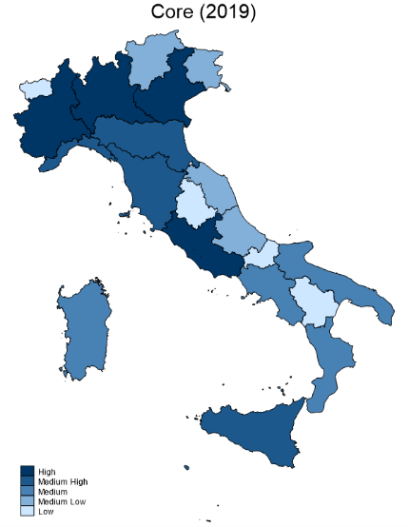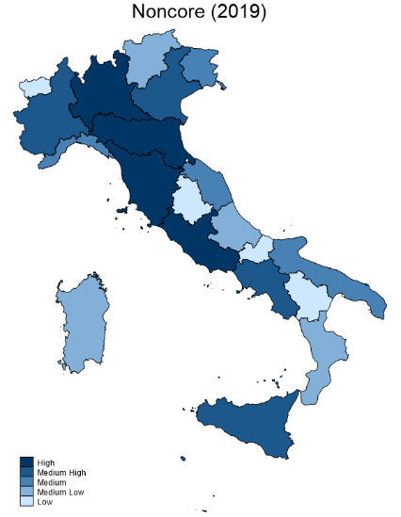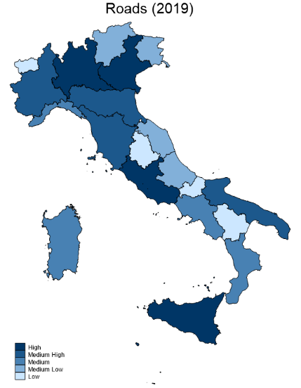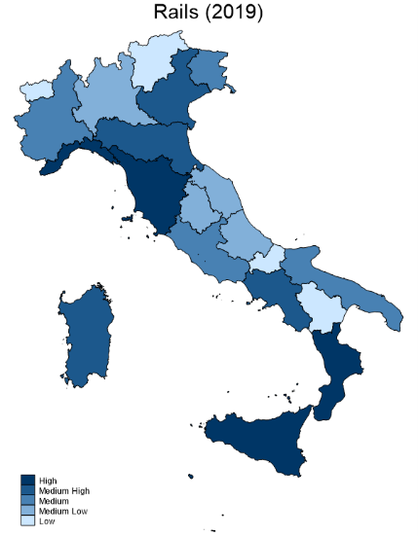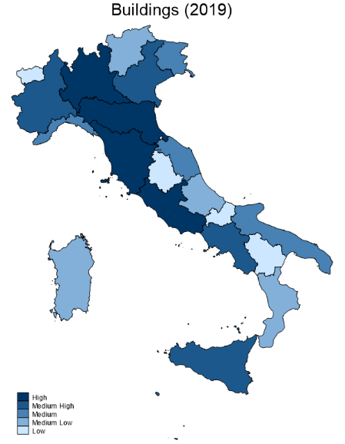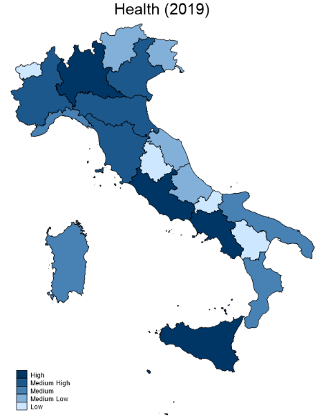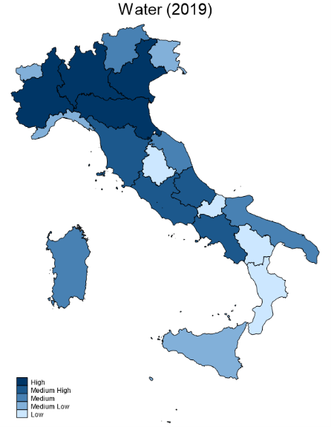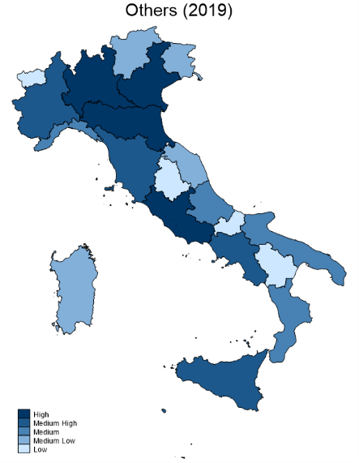
Note: Higher ranking corresponds to darker blue regions and to higher infrastructure index.

Appendix 3. The public spending productivity (PSP) index. Supplementary information
The econometric model
Since Italian regions are highly integrated, variables in one region may be influenced by variables in other regions, leading to their cross-section dependence. To assess whether this is the case, we adopt the cross-section dependence test from Pesaran (2015). The results, shown in the first column of Table A9.A, indicate that the null hypothesis of no cross-section dependence between regions is rejected for all the variables used in the construction of the public spending productivity index.

Table A9. Cross-section dependence and stationarity properties
Panel A). Variables used in the construction of the public spending productivity index
Variable | Cross-section dependence test |  | Panel unit root test
Ln f_index total | 51.099 | *** | -2.143 |  | **
Ln m_index total (c) | 32.425 | *** | -1.645
Ln f_index core | 60.35 | *** | -2.080 |  | *
Ln m_index core | 7.568 | *** | -1.003
Ln f_index noncore | 29.407 | *** | -1.837
Ln m_index nconore (c) | 74.813 | *** | -2.699 |  | ***
Ln f_index roads | 61.16 | *** | -1.969
Ln m_index roads (c) | 8.713 | *** | -0.174
Ln f_index rails | 21.702 | *** | -1.764
Ln m_index rails (c) | 7.685 | *** | -1.522
Ln f_index buildings | 51.253 | *** | -2.235 |  | **
Ln m_index buildings (c) | 73.614 | *** | -3.507 |  | ***
Ln f_index health | 69.174 | *** | -1.676
Ln m_index health | 21.216 | *** | -1.859
Ln f_index water | 13.888 | *** | -1.028
Ln m_index water | 11.587 | *** | -1.231
Ln f_index others | 67.709 | *** | -2.094 |  | *
Ln m_index others | 14.901 | *** | -2.655 |  | ***
ctr_density | -2.316 | *** | -1.159
Ln (Human capital) | 76.603 | *** | -2.895 |  | ***
Ln (Patents per capita) | 66.497 | *** | -3.944 |  | ***
Employment, Agriculture | 45.050 | *** | -2.380 |  | ***
Employment, Manufacturing | 37.840 | *** | -1.861
Panel B). Variables used in the analysis of the impact of regional policies over GDP per capita
Variable | Cross-section dependence test |  | Panel unit root test
Ln GDP | 54.093 | *** | -2.283 |  | **
Ln (Gross fixed investment/GDP) | 30.372 | *** | -2.801 |  | ***
D. Ln(population) | 41.577 | *** | -2.151 |  | **
Ln (EU Funds plus national co-financing/GDP) | 25.201 | *** | -3.647 |  | ***
Ln (Current account subsidies to firms/GDP) | 38.137 | *** | -2.338 |  | ***
Ln (Nationally financed cohesion funds/GDP) | 45.594 | *** | -2.954 |  | ***
Ln (Capital account subsidies/GDP) | 27.850 | *** | -2.862 |  | ***
Ln (Nationally financed public investments/GDP) | 21.988 | *** | -3.331 |  | ***
Ln (Current account subsidies to households/GDP) | 62.086 | *** | -2.930 |  | ***
Employment share, Manufacturing | 59.639 | *** | -2.352 |  | ***
Employment share, Construction | 34.964 | *** | -1.851
Value added share, Manufacturing | 32.060 | *** | -2.099
Value added share, Public sector | 24.972 | *** | -1.832
Ln (Unit labour cost, Services) | 25.800 | *** | -1.376
Female unemployment rate | 39.759 | *** | -1.962
Notes:
Cross-section dependence test (Pesaran, 2015): The null hypothesis assumes no cross-section dependence. Under the null hypothesis the test statistic is distributed as a N (0, 1). Hence, p-values close to zero indicate that data are correlated across panel groups. For this test, *** denotes a p-value <0.01; ** a p-value <0.05; * a p-value <0.1.
Panel unit root test (Pesaran, 2007): The null hypothesis assumes non-stationarity. Assuming that deterministic terms are represented by a constant term, critical values are -2.07 at 10% level, -2.15 at 5% level, -2.32 at 1% level. It follows that t-ratios below the critical values indicate that data are non-stationary. The criterion decision adopted for selecting the lags of the data generating process is the Portmanteau (Q) test for white noise residuals. For this test, *** denotes significance at 1% level; ** significance at 5% level; * significance at 1% level

As a consequence, inference for equation [4] in the main text is based on the consistent covariance matrix proposed by Driscoll and Kraay (1998). This matrix yields standard errors for the regression coefficients that are robust to very general forms of heteroskedasticity, serial correlation of residuals and cross-section dependence when the time dimension of the panel is large.
The dynamic specification for [4] follows from a general-to-specific search that started with once and twice lagged values for the dependent variable, and current plus once and twice lagged values for m_index and ended up in the specifications reported in Table 3 of the main text. As said above, some regional dummies were included in the regressions. This was needed to obtain residuals that were not serially correlated for Roads (possibly because Basilicata is characterised by a complex local road network), Buildings (Valle d’Aosta with morphological peculiarities of the territory and Sicilia characterised by a particularly rich cultural and artistic heritage), Water (Basilicata, Toscana and Sicilia suffering from relatively limited wastewater purification plants), Others (Piemonte, Lombardia and Veneto possibly characterised by their proximity to the Alps, and Basilicata), Core (Piemonte, Abruzzo and Basilicata), Noncore (Valle d’Aosta and Sicilia). The absence of serial correlation in the residuals is propaedeutic to the construction of a PSP index based on a correctly specified model. Indeed, the Reset misspecification test is unreliable in the presence of serially correlated residuals (Godfrey, 1988). Besides, white noise residuals imply that there is no endogeneity problem for the monetary capital, if no current values of the latter enter the estimates.
Note that equation [4] implicitly assumes the existence of a long-run relationship between the physical index of infrastructure and the monetary capital stock. If these variables are non-stationary, we can formally test for the existence of a long-run cointegrating relationship, yielding further precious information about the soundness of our econometric model. To test for non-stationarity, we apply the unit root test proposed by Pesaran (2007), that is robust to very general forms of cross-section dependence. The findings from the second column of Table A9.A indicate that the null hypothesis of non-stationarity is not rejected for most physical and monetary indicators, as well as for ctr_density and emp_man (note that some controls are time-invariant). As not all these variables are non-stationary, an appropriate test for cointegration is supplied by the bounds testing procedure proposed by Bertsatos et al. (2023), which generalizes to panel data the bounds testing procedure first developed by Pesaran et al. (2001). This procedure provides evidence about a cointegrating relationship even if not all the variables under investigation are non-stationary.
Supplementary information about the bounds testing procedure, Bertsatos et al. (2023).
The bounds testing procedure (BTP) developed by Bertsatos et al. (2023) builds upon the method proposed by Pesaran et al. (2001) to test for a long-run (cointegration) relationship between variables in an Autoregressive Distributed Lag (ARDL) model. It is particularly useful for relatively small sample sizes and when variables have different orders of integration (e.g., a mix of I(0) and I(1) series).
The BTP involves reparametrizing a panel ARDL model in an unrestricted error correction form that includes both short-run and long-run components, typically with variables in their difference and lagged level forms, then conducting a battery of tests on the significance of the long-run coefficients. The calculated F-statistics on the joint significance of the long-run coefficients are compared to two critical bounds. If they exceed the upper bound, the null hypothesis of no cointegration is rejected; if it their values are below the lower bound, the null hypothesis of no cointegration cannot be rejected and no cointegrating relationship exists. If their values fall between the bounds, the test is inconclusive, unless there is strong a priori information about the order of integration of the variables under scrutiny.
In Table 3 of the main text and A12:
the BTP F_{yx} statistic tests for the joint significance of the long-run coefficients (in lagged levels) of the variable of interest y (the dependent variable) and of all the x forcing variables (the stochastic regressors);
the BTP t_{y} statistic tests for the significance of the long-run coefficient of the variable of interest y;
the BTP F_{x} tests for the joint significance of the long-run coefficients of all the x forcing variables.
If the null hypothesis of no significance is rejected for BTP F_{yx}, BTP t_{y}, and BTP F_{x}, we find evidence that a non-degenerate cointegrating relationship exists in levels between y and the forcing variables x.
The lower and upper critical bound values for the F-statistics and the confidence interval for the t-statistic are computed through an Eviews routine provided by Bertsatos et al. (2023).
In Table 3 (main text), the critical values refer to Bertsatos et al.’s Case XI (unrestricted constant term and linear and quadratic trends).
In Table A12, the critical values refer to Bertsatos et al.’s Case III (unrestricted constant term) for column (2), to Bertsatos et al.’s Case XI (unrestricted constant term and linear and quadratic trends) for the other columns.
The relationships of the PSP index with other indicators
Table A10 shows the correlation coefficients of the mean PSP total index over 1989-2019 with the Golden-Picci corruption index (Golden and Picci, 2005). The coefficient is 0.18 rising to 0.33 if we take the mean PSP total index over the more restricted 1987-1997 period, closer to 1997 for which Golden and Picci computed their index. We can proceed further and analyse the correlation of our index with other well-known indexes of corruption, government effectiveness and quality of government, such as the Institutional Quality Indexes (Nifo and Vecchione, 2014 and 2015) and the European Quality Government Indexes (Charron et al., 2014, 2015, 2019, 2022).
Table A10. The PSP index, Golden-Picci corruption index, and other indexes. Correlations
 |  | Institutional Quality Index  (2004-2019) |  |  |  | European Quality of Government Index (2010, 2013, 2017) |  |  | PSP Total index
 |  | General |  | Corruption | Government effectiveness | General | Corruption | Quality of governement | PSP Total index
Golden-Picci corruption index (1997) |  |  | 0.76 | 0.80 | 0.44 | 0.78 | 0.73 | 0.76 | 0.18
IQI | General | 1.00 |  | 0.85 | 0.73 | 0.92 | 0.85 | 0.93 | 0.47
IQI | Corruption |  |  | 1.00 | 0.59 | 0.74 | 0.67 | 0.76 | 0.33
IQI | Government effectiveness |  |  |  | 1.00 | 0.57 | 0.59 | 0.60 | 0.50
EQI | General |  |  |  |  | 1.00 | 0.96 | 0.96 | 0.48
EQI | Corruption |  |  |  |  |  | 1.00 | 0.87 | 0.50
EQI | Quality of governement |  |  |  |  |  |  | 1.00 | 0.52
PSP Total index |  |  |  |  |  |  |  |  | 1.00
NB: For both the Institutional Quality and the European Quality of Government Indexes of Corruption, a higher value signals a lower level of corruption.
Generally speaking, the correlation among the other indexes is higher than the correlation between the PSP index and any of them (note anyway that the Institutional Quality Index of corruption is based, by construction, on the Golden-Picci index as well as on other indicators).
Indeed, the methodology adopted to construct the new index differs, even from the Golden-Picci approach, along various lines.
The data: we constructed a new updated index for infrastructure in physical terms which is highly correlated to the index of Istituto Tagliacarne, rather than using the Ecoter index of Golden and Picci (as already said, our choice was justified by the greater amenability of the Istituto Tagliacarne index to a panel setup). Moreover, we constructed a net public capital stock, instead of the gross capital used by Golden and Picci. The net public capital stock, however, is highly correlated to Picci’s series. The cost-corrected net public capital has been computed using an approach inspired by Golden and Picci with a different time-varying regional cost index.
The period: with the construction of long series for infrastructure index and net public capital, we capture the evolution of public spending productivity throughout 1989-2019.
The in-depth asset analysis: the construction of productivity index for six asset classes, excluding Telecommunication, allows an in-depth analysis by assets.
The econometric method: we rely on a dynamic panel regression based on the quantitative analysis of production, with the physical index of infrastructure as output and the monetary capital stock as input. Public spending productivity is constructed using the coefficients for the area and regional trends in that equation. This procedure is based on inference robust to very general forms of heteroskedasticity and cross-section dependence and successfully tests for the existence of a cointegrating relationship including the monetary capital stock and the physical index of infrastructure.

Appendix 4. Supplementary information variables and specification of equations [6] and [7]

Table A11 Sources and descriptive statistics of variables from Equations [6] and [7]
Description (label) | Source | Mean | SD | Min | p10 | p50 | p90 | Max
GDP per capita (y) | Prometeia | 24.906 | 1.306 | 14.243 | 16.865 | 26.955 | 35.240 | 38.115
Gross fixed investment / GDP (gfi) | Prometeia | 0.206 | 1.193 | 0.140 | 0.162 | 0.206 | 0.262 | 0.323
Population (pop) | Prometeia | 1912.350 | 2.894 | 116.650 | 428.495 | 1783.480 | 5715.900 | 10027.695
EU funding plus national co-financing / GDP (SF) | Spesa statale regionalizzata | 0.001 | 0.003 | 0.000 | 0.000 | 0.001 | 0.006 | 0.030
Current account subsidies to firms / GDP  (Nat) | Spesa statale regionalizzata | 0.005 | 0.004 | 0.000 | 0.002 | 0.004 | 0.011 | 0.027
Nationally financed cohesion funds / GDP (Nat) | Spesa statale regionalizzata | 0.002 | 0.005 | 0.000 | 0.000 | 0.002 | 0.015 | 0.066
Capital account subsidies / GDP  (Nat) | Spesa statale regionalizzata | 0.028 | 0.020 | 0.003 | 0.009 | 0.023 | 0.053 | 0.142
Nationally financed public investments / GDP (Nat) | Spesa statale regionalizzata | 0.023 | 0.022 | 0.001 | 0.009 | 0.024 | 0.065 | 0.333
Golden-Picci corruption index (q) | Golden and Picci, 2005 | 1.000 | 0.494 | 0.182 | 0.323 | 0.955 | 1.687 | 1.767
IQI General index (q) | Charron et al., 2014 | 0.568 | 0.225 | 0.130 | 0.198 | 0.617 | 0.831 | 0.881
IQI corruption index (q) | Charron et al., 2014 | 0.750 | 0.157 | 0.309 | 0.525 | 0.811 | 0.886 | 0.933
IQI government effectiveness (q) | Charron et al., 2014 | 0.345 | 0.138 | 0.096 | 0.148 | 0.389 | 0.500 | 0.570
EQI General index (q) | Nifo and Vecchione, 2014, 2015 | -0.950 | 0.625 | -1.906 | -1.764 | -0.874 | -0.003 | 0.293
EQI Corruption index (q) | Nifo and Vecchione, 2014, 2015 | -0.966 | 0.573 | -1.849 | -1.606 | -0.956 | -0.036 | 0.185
EQI Quality of government index (q) | Nifo and Vecchione, 2014, 2015 | -0.838 | 0.715 | -2.158 | -1.835 | -0.733 | 0.106 | 0.236
Public Spending Productivity Index for all assets, (q) | Own elaboration | 0.386 | 0.035 | 0.324 | 0.345 | 0.382 | 0.441 | 0.444
Public Spending Productivity Index for core assets, (q) | Own elaboration | 2.157 | 0.083 | 1.980 | 2.059 | 2.153 | 2.272 | 2.284
Public Spending Productivity Index for noncore assets, (q) | Own elaboration | 0.509 | 0.080 | 0.361 | 0.394 | 0.526 | 0.613 | 0.681
Current account subsidies to households/GDP | Spesa statale regionalizzata | 0.007 | 0.006 | 0.001 | 0.002 | 0.005 | 0.016 | 0.034
Manufacturing sector (value added) share | Prometeia | 0.19 | 0.06 | 0.07 | 0.10 | 0.19 | 0.26 | 0.34
Manufacturing sector (employment) share | Prometeia | 0.18 | 0.07 | 0.07 | 0.09 | 0.17 | 0.27 | 0.32
Construction sector (employment) share | Prometeia | 0.07 | 0.01 | 0.05 | 0.06 | 0.07 | 0.09 | 0.12
Public sector (value added) share | Prometeia | 0.20 | 0.05 | 0.10 | 0.13 | 0.19 | 0.28 | 0.33
Unit labour cost, services | Prometeia | 59.64 | 6.18 | 46.37 | 51.67 | 60.93 | 67.60 | 71.80
Female unemployment rate | Istat | 12.65 | 6.67 | 2.59 | 5.43 | 11.20 | 22.69 | 34.21
Human capital | Own elaboration on Istat | 11.59 | 0.93 | 9.41 | 10.24 | 11.70 | 12.72 | 13.64
Patents per capita | OECD, Istat | 0.037 | 0.034 | 0.000 | 0.004 | 0.027 | 0.088 | 0.156
Employment, Agriculture (000’s) | Prometeia | 51.63 | 41.41 | 2.00 | 11.00 | 42.15 | 121.50 | 197.48
Employment, Manufacturing (000’s) | Prometeia | 232.98 | 256.37 | 5.61 | 24.10 | 131.75 | 533.90 | 1212.01

Further information about regional policies
European structural and national funds are both taken from the database Spesa statale regionalizzata of the General Accounting Office (Ragioneria Generale dello Stato) at the Italian Ministry of Economy and Finance, which allows us to rely for both kinds of funds on series based on the same methodology. Funds’ series relate to the amounts disbursed by the various regions. A proportion of funds (both national and from EU) are not allocated to any single region, but to multi-regional aggregates. In our analysis, we shall assume that these funds are spread across regions proportionally to the shares of regionally allocated funds.
EU funding plus national co-financing is the Rotation Fund financing the EU structural funds through EU resources, plus the Rotation Fund financing the EU structural funds through national resources. The EU structural funds are the European Social Fund (ESF), the European Regional Development Fund (ERDF), the European Agricultural Fund for Rural Development (EAFRD), the European Maritime and Fisheries Fund (EMFF) and other less important funds. The largest funds are the ERDF (57.2% of EU funds in 2010), the EAFRD (21.6%) and the ESF (16.2%).
Current subsidies to firms include unilateral current subsidies made by public administrations to market producers with the aim of influencing production or prices, and/or the remuneration of production factors, and other current transfers to firms, provided by public administrations in support of production activities and related to specific economic policies such as research and development, workplace safety, usury prevention.
The Nationally financed cohesion funds include a host of funds all broadly related to regional policy. In empirical analysis they have all been aggregated into a single item because their composition changed a considerable number of times during the period under scrutiny. The funds include: the Fondo di imprenditorialità giovanile (fund for youth entrepreneurship), the Fondo per le agevolazioni alla ricerca (fund for research incentives), the Fondo per la crescita sostenibile (fund for sustainable growth), the Contratti d’Area and Patti Territoriali (both aggregates of local development programmes) and the Fondo SACE (a fund supporting export from SMEs). The fund for sustainable growth includes the Fondo Sviluppo e Coesione (cohesion and development fund), as well as few other subsidies for underdeveloped areas still coming from old laws that are being disposed of (Law 64/1986 and Law 488/1992)
Capital expenditures include capital-account subsidies to public administrations, capital-account subsidies to firms, capital-account subsidies to households and non-profit institutions and gross fixed capital formation. In our empirical analysis we separate gross fixed capital formation (public investments) from total capital account subsidies. Public investments are the difference between acquisitions and disposals of fixed capital. Capital-account subsidies are grants made by public administrations to finance all or part of the costs of fixed capital purchases. Before 2000 all capital-account subsidies were gathered in a single account. Therefore, for estimation purposes, all kinds of subsidies were aggregated into a single variable also for the years after 2000.

Supplementary information about the variables entering the W_{rt-1} vector in equations [6] and [7]
The variables entering W_{rt-1} are selected by estimating a set of auxiliary regressions where, in turn, SF_{rt} and Nat_{jrt} depend on a wide array of potential determinants (lags of SF_{rt} and Nat_{jrt}, GDP per capita, gross fixed investment, population change, rates of unemployment, sectoral shares of employment and value added, unit labour costs, human capital, patents per capita, linear and quadratic region-specific trends). We then choose a parsimonious specification consistent with satisfactory diagnostics. Beside the use of this selection procedure in the control function approach, comparing the structure of funding rules across fund categories yields useful information about a relatively under researched topic in the literature.
The first column of Table A9.B indicates that the null hypothesis of no cross-section dependence between regions is rejected for all the variables entering the preferred estimates for the auxiliary regressions shown in Table 5 of the main text, as well as for the other variables included in [6] and [7]. Accordingly, inference for these estimates is based on the consistent covariance matrix proposed by Driscoll and Kraay (1998). The findings from the second column of Table A9.B show that the null hypothesis of non-stationarity is not rejected for some of the variables entering the preferred estimates for the auxiliary regressions. This suggests applying to the auxiliary regressions the cointegration bounds test from Bertsatos et al. (2023).
We adopt for the estimation of the auxiliary regressions a dynamic panel two-way fixed-effects method. Overall, the preferred estimates for the auxiliary regressions shown in Table A12 are satisfactory. The bounds testing procedure always rejects the null hypothesis of no cointegration, providing evidence in favour of the existence of a long-run relationship among the policy funds and their determinants. Furthermore, while the null of homoscedasticity is rejected in four cases out of five, the insignificant value for the Reset test suggests that this heteroskedasticity is not likely to affect the coefficient estimates (see on this Thursby, 1982).

Table A12. EU and National Cohesion Funds, the fund allocation mechanism (1994-2019).
Two-way fixed effect panel LS model with robust standard errors (Driscoll-Kraay consistent covariance matrix).
 | (1) | (2) | (3) | (4) | (5)
Dependent variables  Regressors | D.EU Funds plus national co-financing | D.Current account subsidies to firms | D.Nationally financed cohesion funds | D.Capital accout subsidies | D.Nationally financed public investments
EU Funds plus national co-financing (t-1) | -0.871*** |  |  | -0.043** | -0.034**
EU Funds plus national co-financing (t-2) | -0.089** |  |  | -0.078***
Current account subsidies to firms (t-1) |  | -0.671*** |  | 0.057***
Current account subsidies to firms (t-2) |  | 0.265***
Nationally financed cohesion funds (t-1) |  |  | -0.792***
Capital account subsidies (t-1) | 0.110 |  |  | -0.898***
Capital account subsidies (t-2) |  |  |  | -0.07
Nationally financed public investments (t-1) | -0.061 |  | 0.132** | 0.049 | -0.928***
GDP (t-1) |  |  | -9.034***
GDP (t-2) |  | -3.613*** | 7.543***
Gross fixed investment (t-1) | -0.602*** | 0.280**
Current account subsidies to households (t-1) | -0.209*** |  |  | -0.071
Employment share, Manufacturing (t-1) |  |  |  |  | 7.757***
Employment share, Construction (t-1) |  |  | 24.919***
Value added share, Manufacturing (t-1) |  | 5.574***
Value added share, Public sector (t-1) | 16.208**
Ln (Unit labour cost), Services (t-1) |  |  |  |  | 1.917***
Female unemployment rate (t-1) |  | 0.010**
Ln (human capital) (t-1) | 7.518 |  | -6.403*** | 12.366*** | 6.141***
Ln (patents per capita) (t-1) | 0.044*** |  |  | 0.058***
Linear and quadratic trends | YES | NO | YES | YES | YES
N | 480 | 480 | 500 | 480 | 500
Rss | 97.160 | 70.329 | 141.150 | 33.108 | 55.116
r2_a | 0.608 | 0.655 | 0.493 | 0.601 | 0.467
C-W test | 0.0801 | 0.0000 | 0.0189 | 0.0293 | 0.0153
A-B test | 0.7075 | 0.9850 | 0.3637 | 0.1550 | 0.4260
Reset test | 0.3292 | 0.4163 | 0.0631 | 0.9220 | 0.3473
BTP F_{yx} | 19.44*** | 21.86*** | 30.39*** | 50.21*** | 57.71***
BTP t_{Y} | 8.07*** | 10.10*** | 11.71*** | 9.71*** | 12.15***
BTP F_{x} | 16.55*** | 34.46*** | 23.78*** | 6.57*** | 5.55***
Note: The following variables are all taken as the natural log of their ratio over GDP:
EU Funds plus national co-financing, Current account subsidies to firms, Nationally financed cohesion funds, Capital account subsidies, Nationally financed public investments, Gross fixed investment, Current account subsidies to households.
D. is the first-difference operator. N is the number of observations, rss is the residual sum of squares, r2_a is the coefficient of determination adjusted for degrees of freedom. C-W is the Cook-Weisberg test for heteroskedasticity. A-B is the Arellano-Bond test for serial correlation present at lag one, Reset is Ramsey’s test for functional form and omitted variables (carried out including quadratic terms of fitted values).***p<0.01; ** p<0.05; * p<0.1; P-values reported for the C-W test, the A-B test and the Reset test. See Appendix 3 for information about BTP F_{yx}, BTP t_{y}, BTP F_{x}
All policy funds are related to their own past values, but none of them is characterized by a strong inertia. We find substitutability between EU funds and national public investments. EU funds are countercyclical relative to gross fixed investment, while current account subsidies to firms are procyclical relative to this variable. However, current account subsidies to firms and nationally financed cohesion funds are countercyclical vis-à-vis GDP (current account subsidies are also countercyclical relative to the female rate of unemployment). National public investments are apparently unrelated to any cyclical influence. Other variables consistently showing up in Table 13 are human capital and patents per capita (virtually always with a positive sign) and the share of the manufacturing sector (either value added or employment).
Following the suggestion of Wooldridge (2004, p. 35), we build the W_{rt-1} vectors using the predicted values from the auxiliary regressions of Table A12 and proceed to the estimation of equations [6] and [7] from the main text. We adopt for this purpose a dynamic panel two-way fixed-effects method (we test for the endogeneity of all current regressors and never reject the null hypothesis; results are available upon request) and rely on the consistent covariance matrix proposed by Driscoll and Kraay (1998) to deal with cross-section dependence and heteroskedasticity. On the other hand, there is no need to test for cointegration, since the W_{rt-1} variables are cointegrated and the null of non-stationarity is rejected for the other variables (see the second column of Table A9.B).
When EU Funds (plus national co-financing) enter equations [6] and [7] from the main text as a regressor, the W_{rt-1} vector includes the predicted values from the equation in column (1), Table A12; when Current account subsidies to firms enter equations [6] and [7], the W_{rt-1} vector also includes the predicted values from column (2), Table A12, and so on. The W_{rt-1} vector also includes the predicted values from column (3), Table A12, when Nationally financed cohesion funds enter [6] and [7], the predicted values from column (4), Table A12, when Capital account subsidies enter [6] and [7], and the predicted values from column (5), Table A12, when Nationally financed public investments enter [6] and [7].

References for supplementary material
Aschauer D. A. (1989), Is Public Expenditure Productive?, Journal of Monetary Economics, n. 23, 177-200.
Attanasio O., Picci L., Scorcu A. E. (2000). Saving, Growth, and Investment: A Macroeconomic Analysis Using a Panel of Countries. Review of Economics and Statistics, 82: 182- 211.
Bertsatos G., Sakellaris P., Tsionas M. (2023). A Panel Bounds Testing Procedure, Theoretical Economics Letters,13(7), 1765-1779.
Biehl D. (1986), The contribution of infrastructure to the regional development, Commission of the European Communities.
Biehl D. (1991). The Role of Infrastructure in Regional Development, in Infrastructure and Regional Development, R.W. Vickerman (ed.), London, Pion.
Biehl D., Bracalente B., Di Palma M., Mazziotta C. (1990). La diffusione territoriale delle infrastrutture: un’analisi per l’Europa e per l’Italia, Sipi editore, Roma.
Bracalente B., Di Palma M., Mazziotta C. (2006), Investimenti, capitale pubblico e dotazione fisica di infrastrutture nelle regioni italiane, in Federalismo, equità e sviluppo Barca, Cappiello F, Ravoni L. e Volpe M. (eds), Il Mulino, Bologna.
Bonaglia F., Picci L. (2000), Lo stock di capitale nelle regioni italiane, Working papers, n. 374, Dipartimento Scienze Economiche, Università di Bologna.
Buhr W. (2003). What is Infrastructure? Department of Economics, School of Economic Disciplines, University of Siegen, Siegen Discussion Paper n. 107- 03.
Charron N., Dijkstra L., Lapuente V. (2014). Regional governance matters: Quality of government within European Union member states. Regional Studies, 48, 68–90.
Charron N., Dijkstra L., Lapuente, V. (2015). Mapping the regional divide in Europe: A measure for assessing quality of government in 206 European regions. Social indicators research, 122(2), 315-346.
Charron N., Lapuente V., Annoni P. (2019). Measuring Quality of Government in EU Regions Across Space and Time. Papers in Regional Science.
Charron N., Lapuente V., Bauhr M., Annoni P. (2022). Change and Continuity in Quality of Government: Trends in subnational quality of government in EU member states. Investigaciones Regionales-Journal of Regional Research, 2022(53), 5-23.
Confindustria-Ecoter, (2000a). La dotazione infrastrutturale nelle province italiane, aggiornamento al 1997. Quaderni sul Mezzogiorno e le politiche territoriali, 33.
Confindustria-Ecoter, (2000b). Analisi della dotazione di infrastrutture nei principali paesi europei. Quaderni sul Mezzogiorno e le politiche territoriali, 34.
CPT (2019). Confronto tra il sistema CPT e i Conti delle Amministrazioni Pubbliche Istat. CPT Informa, 3.
Di Giacinto V., Micucci G., Montanaro P. (2010a). L’impatto macroeconomico delle infrastrutture: una rassegna della letteratura e un’analisi empirica per l’Italia, in Le infrastrutture in Italia: dotazione, programmazione, realizzazione, Banca d’Italia, Workshop.
Di Giacinto, V., Micucci G., Montanaro P. (2010b). Coordinamento della spesa pubblica e spillover spaziali delle infrastrutture di trasporto: evidenze per l’Italia, in Le infrastrutture in Italia: dotazione, programmazione, realizzazione, Banca d’Italia, Workshop.
Di Giacinto V., Micucci G., Montanaro P. (2012). Network effects of public transport infrastructure: evidence on Italian regions. Temi di discussione Working Papers, n. 869, Bank of Italy.
Di Palma M., Mazziotta C. (2002), La dotazione di capitale pubblico in Europa e in Italia: un quadro di riscontri empirici, in L'Italia nella Competizione Globale - Regole per il Mercato, Baldassarri M., Galli G., Piga G. (eds), Edizioni Il Sole 24 Ore.
Driscoll J. C., Kraay A. C. (1998), Consistent Covariance Matrix Estimation with Spatially Dependent Panel Data, Review of Economics and Statistics, 80, 549-560.
Godfrey L. G. (1988). Mis-specification tests in econometrics: The Lagrange multiplier principle and other approaches. Cambridge University Press, Cambridge.
Golden M. A., Picci L. (2005). Proposal for a measure of corruption, and tests using Italian data. Economics & Politics, 17, 37-75.
Hansen N. M. (1965), The structure and determinants of local public investment expenditures, Review of economics and statistics, n. 2, 150-162.
Hulten C.R., Wykoff F.C. (1996). Issues in the Measurement of Economic Depreciation: Introductory Remarks. Economic Inquiry 34(1): 10–23
ISTAT, (1954-1998). Opere Pubbliche, Roma.
ISTAT, (1995). Investimenti, stock di capitale e produttività dei fattori. Anni 1980-1994. Note e Relazioni, n. 2. Rome: ISTAT.
ISTAT, (1999a). Contabilità Nazionale. Tomo 1 - Conti Economici Nazionali Anni 1970-95, Roma.
ISTAT, (1999b). Contabilità Nazionale. Tomo 2 - Conti Economici Regionali Anni 1980-95, Roma.
ISTAT, (2000). Contabilità Nazionale, Roma.
ISTAT, (2001). Statistiche delle opere pubbliche Anni 1999-2000, Roma.
ISTAT, (2006). Le Infrastrutture in Italia. Un'analisi della dotazione e della funzionalità, Roma.
ISTAT, (2015a). Atlante statistico territoriale delle infrastrutture.
ISTAT, (2015b). Nota metodologica, luglio 2015.
Istituto Guglielmo Tagliacarne, (1995). La dimensione dello sviluppo infrastrutturale nelle province italiane, Reti & Territorio, Ferrovie dello Stato S.p.A.
Istituto Guglielmo Tagliacarne, (1998). La dotazione delle infrastrutture per lo sviluppo delle imprese nelle 103 province, Unioncamere, maggio.
Istituto Guglielmo Tagliacarne, (2001). La dotazione di infrastrutture nelle province italiane 1997-2000, Roma.
Istituto Guglielmo Tagliacarne, (2002). Le infrastrutture nelle province italiane tra l’inizio e la fine degli anni ’90: un confronto temporale, Roma.
Istituto Guglielmo Tagliacarne, (2006). La dotazione di infrastrutture nelle province italiane, Roma.
Jochimsen R. (1966), Theorie der Infrastruktur: Grundlagen der marktwirtschaftlichen Entwicklung, (eds), Tübingen, J.C.B. Mohr.
Mazziotta C. (1998). Definizione di aree e di indicatori per la misurazione della dotazione di infrastrutture. Parte II — La definizione degli indicatori, in Statistica e territorio. Esperienze e nuovi percorsi di ricerca per l'analisi delle economie locali, Istituto Guglielmo Tagliacarne (ed), Milan, Italy: Franco Angeli.
Mazziotta C. (2006). Infrastructure, Services and Competitiveness: The Italian case, in Atti della XLIII Riunione Scientifica della Società Italiana di Statistica, Torino, giugno 2006.
Montanaro P. (2003). Lo stock di capitale pubblico: una stima per regione e per tipologia di bene. Rivista Economica del Mezzogiorno, XVII, 423-461.
Montanaro P. (2010). La spesa per infrastrutture in Italia: dinamica recente, confronto internazionale e divari regionali, in Le infrastrutture in Italia: dotazione, programmazione, realizzazione, Workshop, Banca d’Italia.
Nifo A., Vecchione G. (2014). Do Institutions Play a Role in Skilled Migration? The Case of Italy, Regional Studies, 48 (10), 1628-1649.
Nifo A., Vecchione G. (2015). Measuring Institutional Quality in Italy. Rivista economica del Mezzogiorno, Società editrice il Mulino, issue 1-2, 157-182.
OECD, (2009). Measuring capital. OECD Publishing, Paris.
Perez F., Mas M., Martinez L. S., Jimenez E. U. (eds.), (2019). El stock de capital en Espana y sus comunidades autonomas, Documento de Trabajo, Fundacion BBVA, n. 1/2019.
Pesaran M. H. (2007). A simple panel unit root test in the presence of cross-section dependence. Journal of Applied Econometrics, 22(2), 265–312.
Pesaran M. H. (2015). Testing weak cross-sectional dependence in large panels. Econometric Reviews, 34(6-10), 1089–1117.
Pesaran M. H., Shin Y., Smith R. J. (2001). Bounds Testing Approaches to the Analysis of Level Relationships. Journal of Applied Econometrics, 16, 289-326.
Picci L. (1995). Lo stock di capitale nelle regioni italiane, Dipartimento di Scienze Economiche, Università di Bologna, Collana di Economia Applicata, 4.
Picci L. (2001). Le infrastrutture in Italia. Le differenze territoriali e l’efficienza della spesa, in L'Italia nella Competizione Globale - Regole per il Mercato, Baldassarri M., Galli G., Piga G. (eds), Edizioni Il Sole 24 Ore.
Sturm J.-E., Jacobs J., Groote P. (1995). Productivity impacts of infrastructure investment in the Netherlands 1853-1913. Research Institute SOM (Systems, Organisations and Management) Research Report, University of Groningen, 95D3.
World Bank, (1994). Infrastructure for development. World Development Report.

We exclude the sectors not covered by the infrastructure index in physical terms: Amministrazione Generale; Difesa; Sicurezza pubblica; Giustizia; Formazione; Ricerca e Sviluppo; Interventi in campo sociale (assistenza e beneficenza); Ambiente; Lavoro; Previdenza e Integrazioni Salariali; Pesca marittima e Acquicoltura; Turismo; Commercio; Industria e Artigianato; Altre opere pubbliche; Altre in campo economico; Oneri non ripartibili.
Sources and further information for these variables are provided in Table A11.
The adoption of a GMM Arellano-Bond set-up was not deemed as appropriate given the relatively low number of our cross-section units and the relatively high number of time periods in our sample (see Attanasio et al., 2000).

