Supplementary results

Article title: Circular RNA CDR1as promotes gastric cancer growth via miR-299-3p/TGIF1 axis
Journal name: Molecular Biology Reports
Author names: Rong Li, Jiajia Jiang, Junyi Wang, Jie Hou, Dongli Wang, Hui Qian, Xu Zhang, Wenrong Xu
Corresponding authors: Wenrong Xu or Xu Zhang, School of Medicine, Jiangsu University, 301 Xuefu Road, Zhenjiang, Jiangsu 212013, China. E-mail: icls@ujs.edu.cn (W. Xu) or xuzhang@ujs.edu.cn (X. Zhang).

Table S1 The sequences of gene-specific primers for RT-qPCR
Gene | Forward primer | Reverse primer
CDR1as | ACGTCTCCAGTGTGCTGA | CTTGACACAGGTGCCATC
β-actin | CTCAGGAGGAGCAATGATCT | GACCTGTACGCCAACACAGT
ABCE1 | CAGCCTTTGTTGTGGAACATGA | ATTCGTGGCCTATAGTTGTTTGGA
AP1G1 | TGCAATCCGGTCATCTTTTAGAG | AACTGTCCAAAGTGAGCAGGG
CD164 | GTGCTGTCCGCGGACAAGAAC | TGTGAACAATAGCTCTCATC
ITGAV | AAGCTGAGCTCATCGTTTCC | GCACAGGAAAGTCTTGCTAAGG
TGIF1 | GAACACAGATACAACGCCTATCC | CGTTGATGAACCAGTTACAGACC
MAPK8 | ATGGAGTACATGAGCACTGGA | GCTGGCTCTTCACTTGCATAAAG
PRPS1 | GGCTGACACTTGTGGCACAATC | GATGCGAGAAATAGCAGGACCG
PTP4A1 | TGCTGTTCATTGCGTTGCAG | CCACGCCGCTTTTGTCTTATG
TCF4 | CCACAGCTCTGACCGTCAAT | TGTTGGTGTGACTATGGCCG
VEGFA | GGGCAGAATCATCACGAAGT | TGGTGATGTTGGACTCCTCA

Table S2 The sequences of siRNAs for gene knockdown
siRNA | sense | antisense
NC | UUCUCCGAACGUGUCACGUTT | ACGUGACACGUUCGGAGAATT
CDR1as siRNA1 | UCUGCAAUAUCCAGGGUUUTT | AAACCCUGGAUAUUGCAGATT
CDR1as siRNA2 | UAUCCAGGGUUUCCGAUGGTT | CCAUCGGAAACCCUGGAUATT
TGIF1 siRNA1 | GGACAUUCCCUUGGACCUUTT | AAGGUCCAAGGGAAUGUCCTT
TGIF1 siRNA2 | GCACCGUUACAAUGCCUAUTT | AUAGGCAUUGUAACGGUGCTT

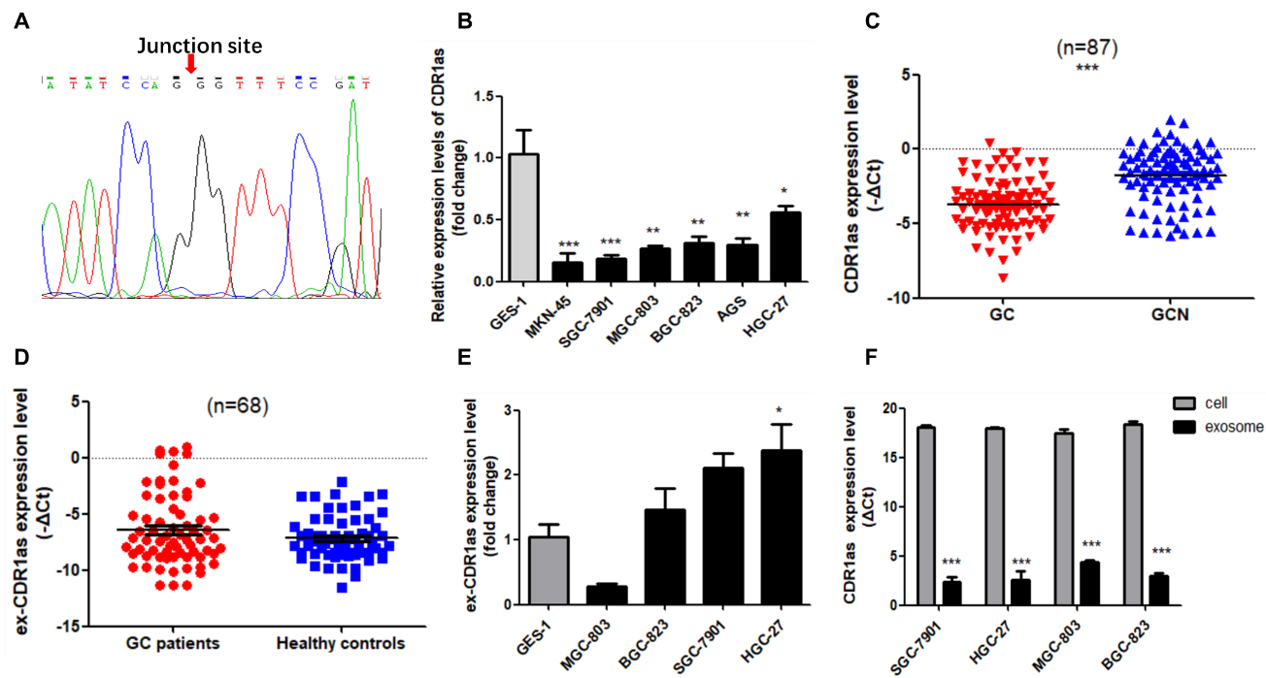
Fig. S1 The expression of CDR1as in GC tissues, cells and exosomes determined by RT-qPCR. a Sanger sequencing for RT-qPCR products of CDR1as to confirm head-to-tail splicing. b Relative expression level of CDR1as in GES-1 and GC cell lines. c Comparison of CDR1as level in GC and GCN tissues. GCN represents matched noncancerous tissues. d CDR1as level in plasma exosomes from GC patients and healthy controls. e Relative expression level of CDR1as in exosomes from GES-1 and GC cell lines. f CDR1as expression level in GC cells and its derived exosomes. (*P<0.05, **P<0.01, ***P<0.001)

Table S3 The correlation between CDR1as expression level in plasma and clinicopathological parameters of GC patients
Features | Number | Plasma-CDR1as |  | P value
 |  | High(n=37) | Low(n=26)
Age
<60 | 14 | 9 | 5 | 0.632
≧60 | 49 | 28 | 21
Gender
Male | 51 | 32 | 19 | 0.208
Female | 12 | 5 | 7
Tumor size ª
<5cm | 29 | 17 | 12 | 0.338
≧5cm | 16 | 7 | 9
Differentiation ª
Poor | 17 | 10 | 7 | 0.900
Moderate | 28 | 17 | 11
Lymphatic metastasis ^{b}
N0 | 16 | 10 | 6 | 0.570
N1 | 22 | 11 | 11
N2 | 14 | 10 | 4
N3 | 10 | 5 | 5
Distant metastasis ^{b}
Absent | 50 | 29 | 21 | 0.983
Present | 12 | 7 | 5
Vascular invasion
Absent | 56 | 35 | 21 | 0.114
Present | 7 | 2 | 5
Nerve invasion
Absent | 46 | 28 | 18 | 0.570
Present | 17 | 9 | 8
TNM stage ^{b}
I | 8 | 5 | 3 | 0.644
II | 23 | 11 | 12
III | 18 | 12 | 6
IV | 13 | 8 | 5
Invasion depth ^{b}
T1 | 5 | 3 | 2 | 0.967
T2 | 8 | 5 | 3
T3 | 24 | 13 | 11
T4 | 25 | 15 | 10
ª Missing 18 cases; ^{b} Missing 1 case

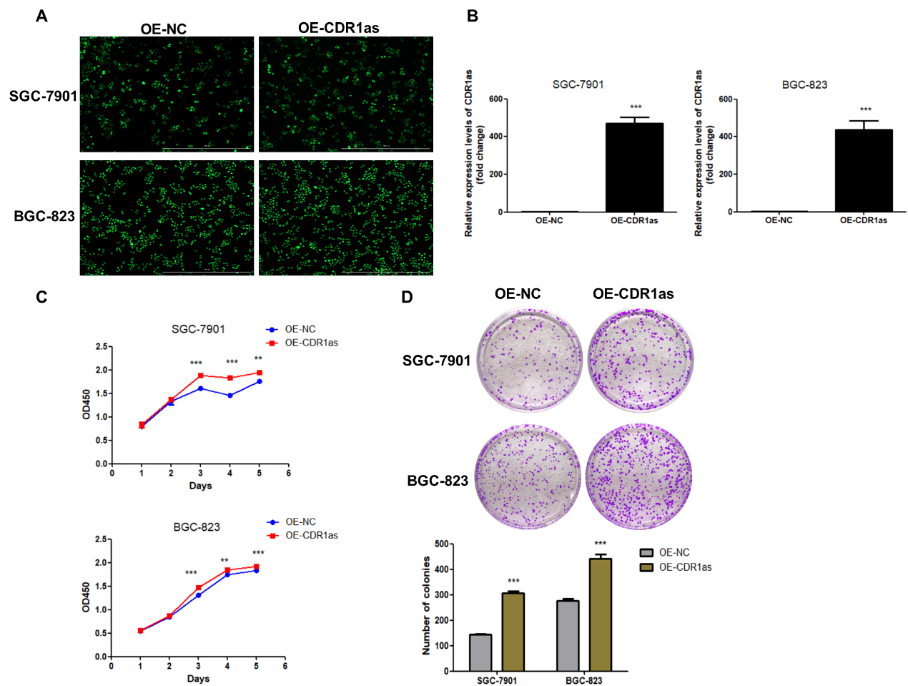
Fig. S2 CDR1as overexpression promoted GC cell proliferation. a GFP intensity in CDR1as stably overexpressing GC cells and corresponding control cells. The scale bar indicates 1000 μm. b RT-qPCR analysis of CDR1as levels in CDR1as stably overexpressing cells and control cells. c, d CCK8 and colony formation assays of SGC-7901 and BGC-823 cells after CDR1as overexpression. The right bar graph shows quantitative comparison of colony numbers. (**P<0.01, ***P<0.001)

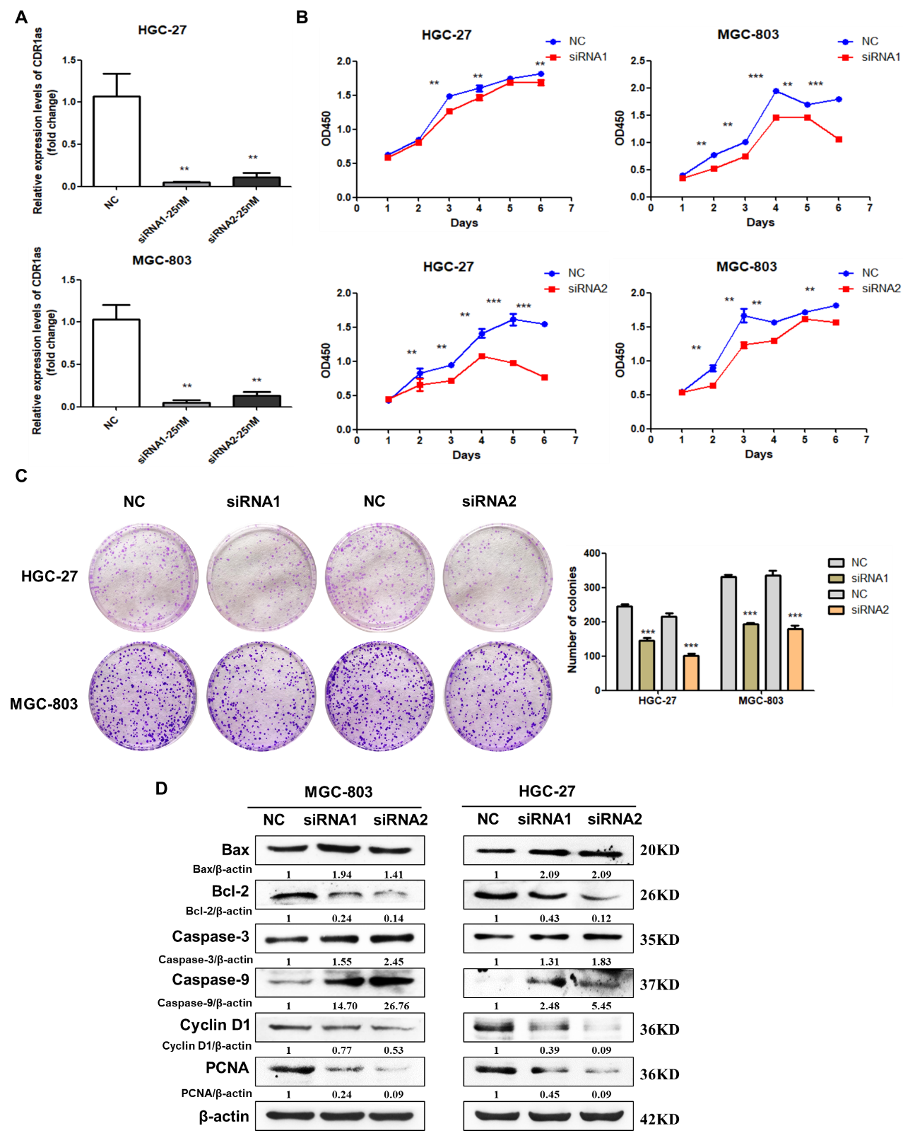
Fig. S3 CDR1as knockdown inhibited GC cell proliferation. a RT-qPCR analysis of CDR1as level in HGC-27 and MGC-803 cells transfected with NC and CDR1as siRNAs. NC represents negative control. b, c CCK8 and colony formation assays of HGC-27 and MGC-803 cells after CDR1as knockdown. d Western blot analysis of proliferation and apoptosis related protein levels. (**P<0.01, ***P<0.001)

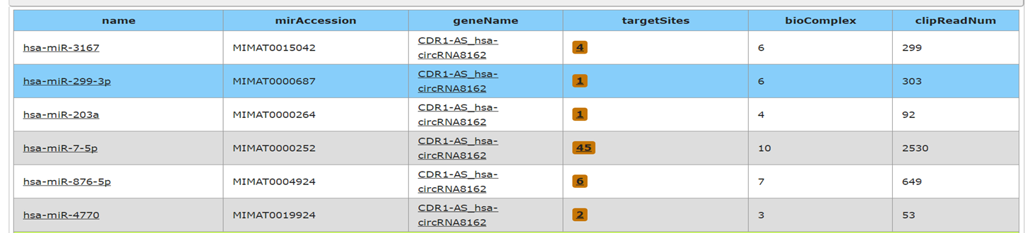
Fig. S4 Predicted miRNAs for CDR1as from starBase v2.0.

Table S4 Potential target mRNAs of miR-299-3p predicted via starBase v2.0
miRNAname | geneID | geneName | PITA | RNA22 | miRmap | microT | miRanda | PicTar | TargetScan | coincidence number
hsa-miR-299-3p | ENSG00000175582 | RAB6A | 1 | 0 | 1 | 1 | 1 | 1 | 1 | 6
hsa-miR-299-3p | ENSG00000010244 | ZNF207 | 1 | 0 | 1 | 1 | 1 | 1 | 1 | 6
hsa-miR-299-3p | ENSG00000108848 | LUC7L3 | 1 | 0 | 1 | 1 | 1 | 1 | 1 | 6
hsa-miR-299-3p | ENSG00000196628 | TCF4 | 1 | 0 | 1 | 1 | 1 | 1 | 1 | 6
hsa-miR-299-3p | ENSG00000138448 | ITGAV | 1 | 0 | 1 | 1 | 1 | 1 | 1 | 6
hsa-miR-299-3p | ENSG00000124201 | ZNFX1 | 1 | 0 | 1 | 1 | 1 | 1 | 1 | 6
hsa-miR-299-3p | ENSG00000198900 | TOP1 | 1 | 0 | 1 | 1 | 1 | 1 | 1 | 6
hsa-miR-299-3p | ENSG00000175040 | CHST2 | 1 | 0 | 1 | 1 | 1 | 1 | 1 | 6
hsa-miR-299-3p | ENSG00000087274 | ADD1 | 1 | 0 | 1 | 1 | 1 | 1 | 1 | 6
hsa-miR-299-3p | ENSG00000164163 | ABCE1 | 1 | 0 | 1 | 1 | 1 | 1 | 1 | 6
hsa-miR-299-3p | ENSG00000111962 | UST | 1 | 1 | 1 | 1 | 1 | 0 | 1 | 6
hsa-miR-299-3p | ENSG00000186591 | UBE2H | 1 | 0 | 1 | 1 | 1 | 1 | 1 | 6
hsa-miR-299-3p | ENSG00000105866 | SP4 | 1 | 0 | 1 | 1 | 1 | 1 | 1 | 6
hsa-miR-299-3p | ENSG00000082258 | CCNT2 | 1 | 0 | 1 | 1 | 1 | 1 | 1 | 6
hsa-miR-299-3p | ENSG00000107968 | MAP3K8 | 1 | 0 | 0 | 1 | 1 | 1 | 1 | 5
hsa-miR-299-3p | ENSG00000171798 | KNDC1 | 1 | 0 | 1 | 1 | 1 | 0 | 1 | 5
hsa-miR-299-3p | ENSG00000073614 | KDM5A | 1 | 0 | 1 | 1 | 1 | 0 | 1 | 5
hsa-miR-299-3p | ENSG00000051825 | MPHOSPH9 | 1 | 0 | 0 | 1 | 1 | 1 | 1 | 5
hsa-miR-299-3p | ENSG00000103647 | CORO2B | 1 | 1 | 1 | 1 | 1 | 0 | 0 | 5
hsa-miR-299-3p | ENSG00000157766 | ACAN | 1 | 1 | 1 | 0 | 1 | 0 | 1 | 5
hsa-miR-299-3p | ENSG00000069345 | DNAJA2 | 1 | 0 | 1 | 1 | 1 | 0 | 1 | 5
hsa-miR-299-3p | ENSG00000166747 | AP1G1 | 1 | 0 | 1 | 1 | 1 | 1 | 0 | 5
hsa-miR-299-3p | ENSG00000108375 | RNF43 | 1 | 0 | 1 | 0 | 1 | 1 | 1 | 5
hsa-miR-299-3p | ENSG00000177426 | TGIF1 | 1 | 0 | 1 | 1 | 1 | 0 | 1 | 5
hsa-miR-299-3p | ENSG00000136536 | 7-Mar | 1 | 0 | 1 | 1 | 1 | 0 | 1 | 5
hsa-miR-299-3p | ENSG00000116095 | PLEKHA3 | 1 | 0 | 0 | 1 | 1 | 1 | 1 | 5
hsa-miR-299-3p | ENSG00000159086 | PAXBP1 | 1 | 0 | 1 | 0 | 1 | 1 | 1 | 5
hsa-miR-299-3p | ENSG00000135535 | CD164 | 1 | 0 | 1 | 1 | 1 | 1 | 0 | 5
hsa-miR-299-3p | ENSG00000112715 | VEGFA | 1 | 0 | 1 | 0 | 1 | 1 | 1 | 5
hsa-miR-299-3p | ENSG00000112245 | PTP4A1 | 1 | 0 | 1 | 1 | 1 | 0 | 1 | 5
hsa-miR-299-3p | ENSG00000157212 | PAXIP1 | 1 | 0 | 1 | 1 | 1 | 1 | 0 | 5
hsa-miR-299-3p | ENSG00000257923 | CUX1 | 1 | 0 | 1 | 0 | 1 | 1 | 1 | 5
hsa-miR-299-3p | ENSG00000147224 | PRPS1 | 1 | 0 | 1 | 1 | 1 | 0 | 1 | 5
hsa-miR-299-3p | ENSG00000205189 | ZBTB10 | 1 | 0 | 1 | 1 | 1 | 0 | 1 | 5

