Amycolatopsis camponoti sp.nov., new tetracenomycin-producing actinomycete isolated from carpenter ant Camponotus vagus

Supplementary information

Yuliya V. Zakalyukina^{1,2}*, Iliya A. Osterman ^{1,3,4}, Jacqueline Wolf⁵, Meina Neumann-Schaal⁵, Imen Nouioui⁵ and Mikhail V. Biryukov^{1,3,6}

¹ Scientific Center of Genetics and Life Sciences, Sirius University of Science and Technology, Sochi, 354340, Russia
² Department of Soil Science, Lomonosov Moscow State University, Moscow, 119991, Russia; juline@soil.msu.ru
³ Skolkovo Institute of Science and Technology, Skolkovo, Moscow Region, 143025, Russia; osterman@yandex.ru
⁴ Department of Chemistry and A.N. Belozersky Institute of Physico-Chemical Biology, Lomonosov Moscow State University, Moscow, 119991, Russia
⁵ Department of Microorganisms, Leibniz Institute DSMZ–German Collection of Microorganisms and Cell Cultures, 38124 Braunschweig, Germany
⁶ Department of Biology, Lomonosov Moscow State University, Moscow, 119991, Russia; metrim@gmail.com

* Correspondence: juline@soil.msu.ru (Y.V.Z.); Tel.: +79175548004 (Y.V.Z)

Contents

Fig. S1 Phylogenetic of strain A₂₃^{T} and comparison with related Amycolatopsis species, 3
Table S1. Pairwise comparisons of strain A23^{T} genome vs. type-strain genomes 4
Table S2. The composition of respiratory quinones (%) of strain A₂₃^{T} and closely related A. pretoriensis DSM 44654^{T} 5
Table S3. Fatty acid content of A₂₃^{T} and closely related A. pretoriensis DMS 44654^{T} 6
Fig. S2 Spectrum of some carbohydrate utilization of A₂₃^{T} 7
Fig. S3 TLC plates of whole cell sugars of A₂₃^{T} and its closely related neighbour A. pretoriensis DMS 44654^{T}. 8
Table S4. Secondary metabolite gene clusters in Amycolatopsis A₂₃^{T} 9
Table S5. Secondary metabolite gene clusters in Amycolatopsis pretoriensis DSM 44654^{T} 10
Fig. S4 The genetic map of the macrotermycin (Mte) biosynthetic gene cluster: 11

Fig. S1 Phylogenetic of strain A₂₃^{T} and comparison with related Amycolatopsis species,
calculated from 16S rDNA sequences by using the neighbour-joining method. Asterisks indicate branches that were also obtained by maximum likelihood method. Accession numbers of the sequences are given in parentheses. Bootstrap values for n=1,000 are given at the branching points in percentages for values higher than 70. Bar, 0,01 nucleotide substitutions per site. Streptomyces albus DSM 40313^{T} was used as the outgroup
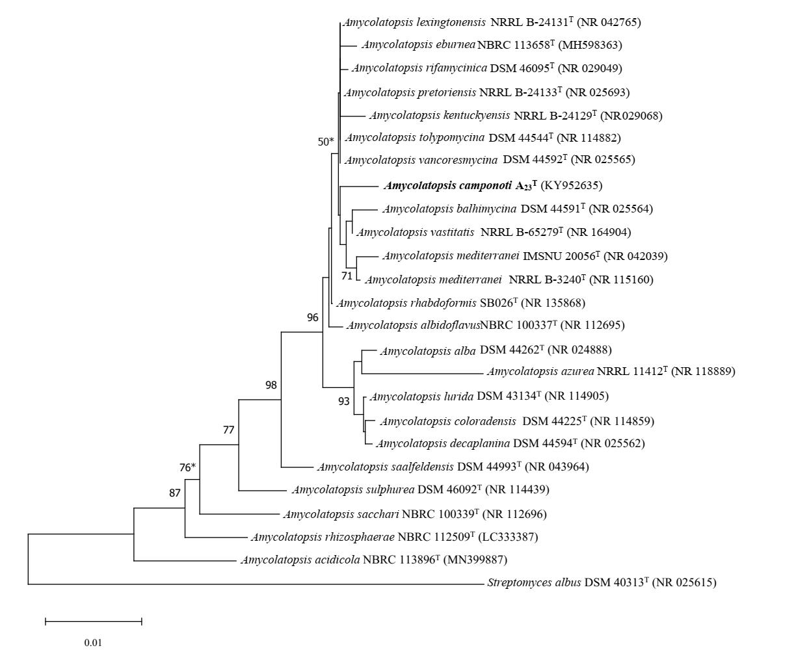

Table S1. Pairwise comparisons of strain A23^{T} genome vs. type-strain genomes

Subject strain | ANIb, % | dDDH (in %) | G+C content difference (in %)
Amycolatopsis pretoriensis DSM 44654^{T} | 88.57 | 39.5 | 0
A. lexingtonensis NRRL B-24131 ^{T} | 86.83 | 35.4 | 0.37
A. eburnea NBRC 113658 ^{T} | 85.80 | 34.7 | 0.68
A. vancoresmycina DSM 44592 ^{T} | 85.63 | 33.4 | 0.81
A. australiensis DSM 44671 ^{T} | 86.45 | 35.6 | 0.71
A. rifamycinica DSM 46095 ^{T} | 85.50 | 33.6 | 0.68
A. mediterranei NRRL B-3240 ^{T} | 85.82 | 34.1 | 0.12
A. tolypomycina DSM 44544 ^{T} | 85.43 | 33.1 | 0.51
A. kentuckyensis NRRL B-24129 ^{T} | 85.86 | 34.2 | 0.57
A. vastitatis NRRL B-65279 ^{T} | 85.52 | 34.4 | 0.32
A. balhimycina DSM 44591 ^{T} | 85.58 | 34.0 | 0.4
A. saalfeldensis DSM 44993 ^{T} | 77.98 | 23.6 | 0.13

Table S2. The composition of respiratory quinones (%) of strain A₂₃^{T} and closely related A. pretoriensis DSM 44654^{T}

Strains | MK-9(H2) | MK-9(H4) | MK-9(H6) | MK-9(H8) | MK-8(H4) | MK-10(H4)
A23^{T} | 5,2 | 83,3 | 3,5 | 1,6 | 6,4 | nd¹
DSM 44654^{T} | 9,4 | 78,4 | 4,6 | 0,1 | 6,1 | 1,4
¹ nd – not detected

Table S3. Fatty acid content of A₂₃^{T} and closely related A. pretoriensis DMS 44654^{T}
Fatty acids | A₂₃^{T} | DMS 44654^{T}
iso-C_{13:0} | 0.16 | —
anteiso-C_{13:0} | 0.13 | —
iso-C_{14:0} | 1.93 | 0.91
C_{14:0} | 0.25 | —
iso-C_{15:0} | 18.41 | 13.11
anteiso-C_{15:0} | 6.08 | 1.53
C_{15:1} cis 9 | 0.33 | —
С_{15:0} | 2.83 | 1.35
iso-C_{16:1} cis 9 | 0.29 | —
iso-C_{16:0} | 21.87 | 35.32
anteiso-C_{16:0} | 0.3 | 0.18
C_{16:1} cis 9 | 1.86 | —
iso-C_{15:0} 2OH/ C_{16:1} trans 9 | 1.11 | 3.66
anteiso-C_{15:0} 2OH | 0.42 | 0.64
C_{16:0} | 10.38 | 3.34
iso-C_{16:0} 10 Methyl | 1.21 | 0.87
C_{16:0} 10 Methyl | 1.49 | 0.56
anteiso-C_{17:1} C | 0.36 | —
iso-C_{17:0} | 3.19 | 5.61
anteiso-C_{17:0} | 11.48 | 6.07
C_{17:1} cis 9 | 2.55 | 0.8
iso-C_{16:0} 2OH | 0.88 | 6.50
C_{17:0} | 7.59 | 6.72
iso-C_{17:0} 10 Methyl | 1.75 | 7.34
C_{17:0} 10 Methyl | 0.91 | 1.95
iso-C_{18:0} | 0.13 | 1.4
C_{18:1} cis 9 | 0.17 | —
C_{18:0} | 1.12 | 1.74
minor components (less 0.1%) are not shown

Fig. S2 Spectrum of some carbohydrate utilization of A₂₃^{T}

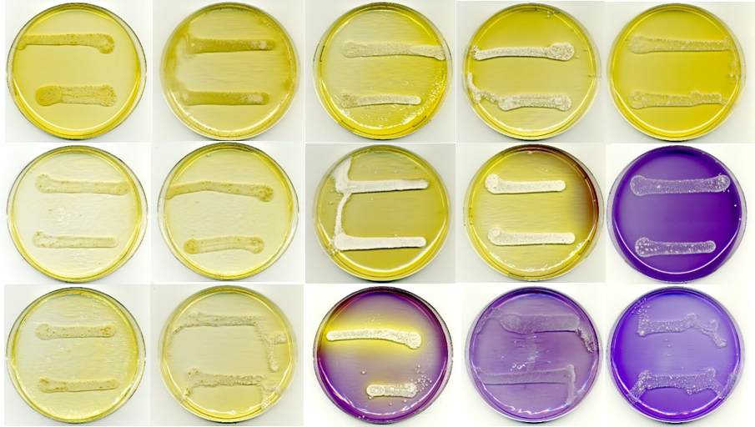

Top row, left to right: glucose, fructose, arabinose, maltose, rhamnose;
middle row, left to right: galactose, lactose, sucrose, inositol, cellulose;
bottom row: mannitol, xylose, raffinose, sorbitol, mineral base without sugar.

Fig. S3 TLC plates of whole cell sugars of A₂₃^{T} and its closely related neighbour A. pretoriensis DMS 44654^{T}.
RHA, rhamnose, GAL, galactose, RIB, ribose, ARA, arabinose, Sd, standard

Table S4. Secondary metabolite gene clusters in Amycolatopsis A₂₃^{T}

Region | Type | From (bp) | To (bp) | Products of most similar cluster | Similarity,%
1.1 | ectioin | 38,513 | 48,905 | Ectoine | 100
1.2 | NRP+Polyketide | 804,440 | 826,441 | Linkacidin C | 20
1.3 | Polyketide | 1,012,995 | 1,083,802 | Rifamorpholines A-E | 9
1.4 | Terpene | 1,750,993 | 1,770,613 | Isorenieratene | 42
1.5 | RiPP-like | 2,135,622 | 2,145,140
1.6 | Terpene | 2,562,204 | 2,582,452 | Isorenieratene | 71
1.7 | NRP | 2,798,054 | 2,907,649 | Limazepines A, C-F | 100
1.8 | Terpene | 2,973,065 | 2,994,180 | 2-methylisoborneol | 100
1.9 | RiPP-like | 3,080,354 | 3,092,141
1.10 | Polyketide | 3,147,520 | 3,193,172 | Niphimycins C-E | 9
1.11 | Polyketide | 3,323,398 | 3,367,527 | Saquayamycin A | 7
1.12 | Polyketide | 3,958,821 | 4,001,430
1.13 | Polyketide | 4,152,698 | 4,203,838
1.14 | NRP | 4,302,110 | 4,374,525 | Dechlorocuracomycin | 12
2.1 | Terpene | 137,529 | 159,595 | Geosmin | 100
2.2 | Butyrolactone | 238,046 | 341,027 | Macrotermycins | 96
2.3 | Terpene | 1,179,816 | 1,257,455 | Amycolamycins A,B | 45
2.4 | Ectoine | 1,263,567 | 1,273,938 | Kosinostatin | 6
2.5 | Polyketide | 1,523,632 | 1,598,321 | FD-594 | 26
2.6 | Polyketide | 1,615,273 | 1,781,609 | Aculeximycin | 61
2.7 | Saccharide | 1,784,450 | 1,805,529 | Fortimicin | 4
2.8 | NAPAA | 2,199,665 | 2,233,600
2.9 | NRP+Polyketide | 2,261,757 | 2,283,423 | FR-900520 | 9
2.10 | NRP | 2,889,117 | 2,915,073
2.11 | NRP | 3,000,765 | 3,052,856 | JBIR-126 | 7
2.12 | NRP | 3,076,766 | 3,127,493 | rimosamide | 21
2.13 | NRP | 3,146,009 | 3,210,324 | atratumycin | 21
2.14 | Lanthipeptide II | 3,230,071 | 3,294,048 | Friulimicins A-D | 21
2.15 | Redox-cofactor | 3,334,745 | 3,360,384
3.1 | Lanthipeptide I | 98,996 | 124,294
3.2 | Lanthipeptide III | 1,309,125 | 1,331,689 | Ery3-9 | 100
4.1 | NRP | 353,119 | 411,166 | scabechelin | 80
NRP - non-ribosomal peptide, RiPP-like - other unspecified ribosomally synthesised and post-translationally modified peptide product (RiPP) cluster, NAPAA - non-alpha poly-amino acids like e-Polylysin

Table S5. Secondary metabolite gene clusters in Amycolatopsis pretoriensis DSM 44654^{T}
Region | Type | From (bp) | To (bp) | Most similar known cluster | Similarity
1.1 | terpene | 1 | 11,224 | 2-methylisoborneol | 50
1.2 | betalactone | 14,378 | 39,530
1.3 | T1PKS | 315,426 | 360,291 | saquayamycin A | 7
1.4 | T1PKS | 872,299 | 915,225 | primycin | 5
1.5 | hglE-KS, T1PKS | 1,090,289 | 1,141,330 | meilingmycin
2.1 | LAP, thioamitides | 191,773 | 224,955
2.2 | redox-cofactor | 380,526 | 406,476
2.3 | NRPS, lanthipeptide class-II | 493,669 | 556,944 | friulimicins A-D | 21
2.4 | NRPS-like, oligosaccharide, NRPS, T2PKS, T1PKS, RiPP-like | 681,768 | 833,721 | arixanthomycins A-C | 57
2.5 | PKS-like, NRPS, NRPS-like | 853,548 | 929,386 | friulimicins A-D | 12
2.6 | PRE-containg | 1.122.831 | 1,145,083
2.7 | NAPAA | 1,175,415 | 1,209,299
3.1 | transAT-PKS, T1PKS, hgIE-KS | 133,657 | 205,822 | rifamorpholines A-E | 11
3.2 | T3PKS, Redox-cofactor | 353,742 | 440,721 | julichromes Q3-3, Q3-5 | 37
3.3 | T3PKS | 1,006,491 | 1,047,651
4.1 | Ectoine | 816,967 | 827,353 | ectoine | 100
5.1 | Lanthipeptide III | 382,776 | 405,406 | ery3-9 | 75
6.1 | indole | 356,114 | 377,097 | frankiamicin | 14
6.2 | Ectoine | 671,017 | 681,388 | kosinostatin | 6
6.3 | NRPS-like, T1PKS, PRE-containing | 687,011 | 766,413 | amycolamycins A,B | 45
7.1 | terpene | 112,485 | 133,411 | isorenieratene | 42
7.2 | RiPP-like | 566,684 | 577,484
10.1 | T1PKS, Butyrolactone | 67,142 | 171,081 | macrotermycins | 96
10.2 | terpene | 241,393 | 263,417 | geosmin | 100
11.1 | PKS-like | 258,312 | 299,421
14.1 | terpene | 14,321 | 35,256 | isorenieratene | 71
14.2 | NRPS, NRPS-like | 89,220 | 135,474 | limazepines A, C-F | 100
15.1 | NRPS | 139,148 | 211,464 | dechlorocuracomycin | 12
16.1 | NRPS | 1 | 46,518 | scabechelin | 80
18.1 | PKS-like, Lanthipeptide I | 36,396 | 79,511 | A5145 | 3

NRP - non-ribosomal peptide, RiPP-like - other unspecified ribosomally synthesised and post-translationally modified peptide product (RiPP) cluster, NAPAA - non-alpha poly-amino acids like e-Polylysin,

Fig. S4 The genetic map of the macrotermycin (Mte) biosynthetic gene cluster:
in genome of Amycolatopsis sp. M39 (Beemelmanns et al., 2017), Amycolatopsis A₂₃^{T} (B) and Amycolatopsis pretoriensis DSM 44654^{T} (C).

