Predicting Vitamin C Content in Vegetables Using Moisture and Ash Profiles: A Machine Learning Approach for Rapid Nutritional Screening.

Md. Abdul Hamid Khan^{a,b*}, Md. Mujahidul Islamª, Rubaya Hasna^{b}, Shohanur Rahman^{b}

ª Department of Chemistry, Chittagong University of Engineering and Technology, Chattogram-4349, Bangladesh
^{b}Department of Applied Chemistry and Chemical Engineering, Islamic University Bangladesh, Kushtia-7003, Bangladesh.

Corresponding Author: 24mschem114@student.cuet.ac.bd

Supplementary information
The supplementary section retains the diagnostic and model-specific graphics that would make the main article excessively dense if every panel were presented separately. It also reproduces all 350 modelling rows in seven 50-row tables and lists the selected hyperparameters for every final model.

Supplementary model diagnostics
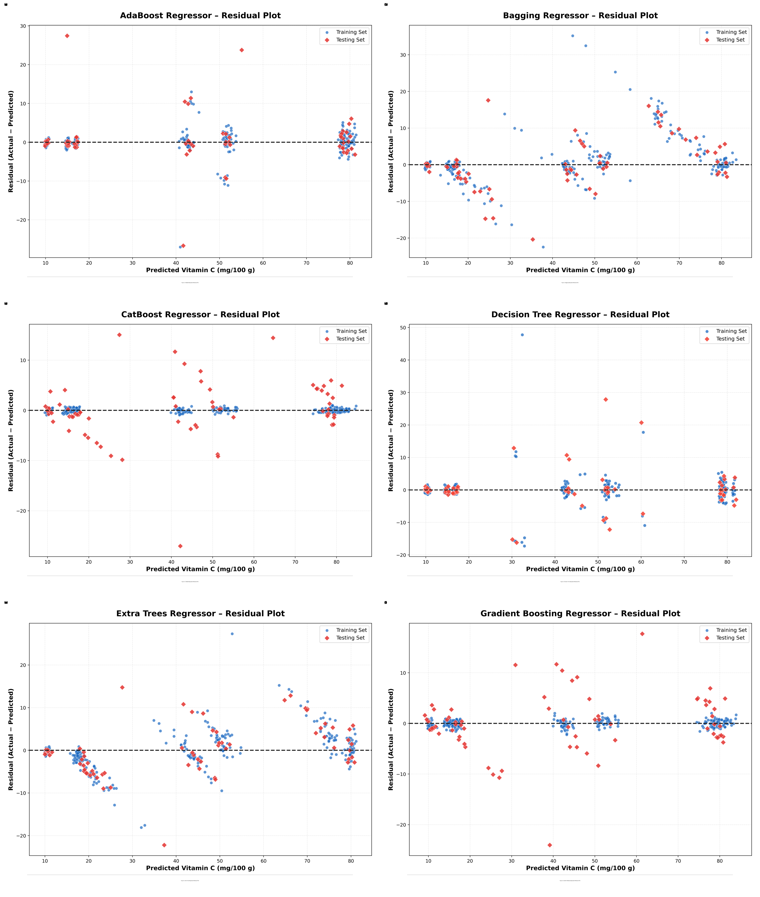
Fig. S1a. Residual plots for the first six regression models.
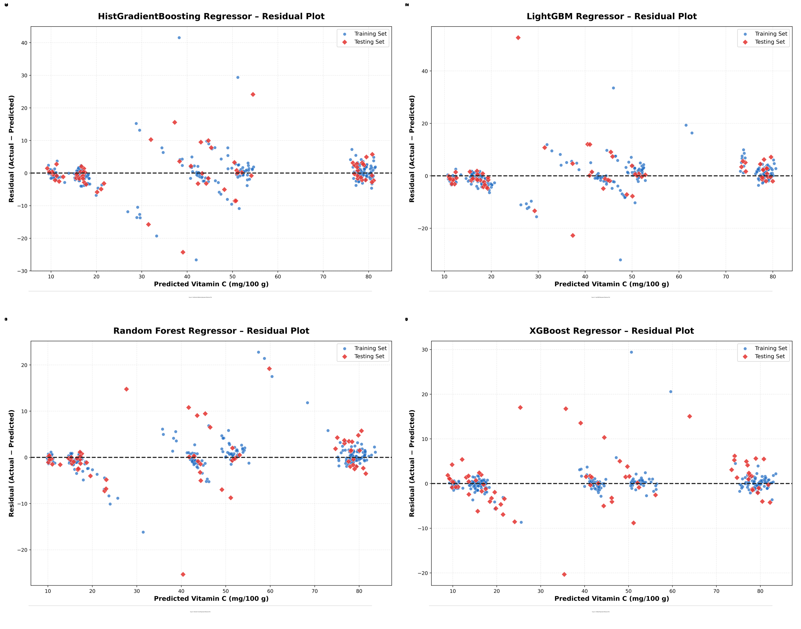
Fig. S1b. Residual plots for the remaining four regression models.
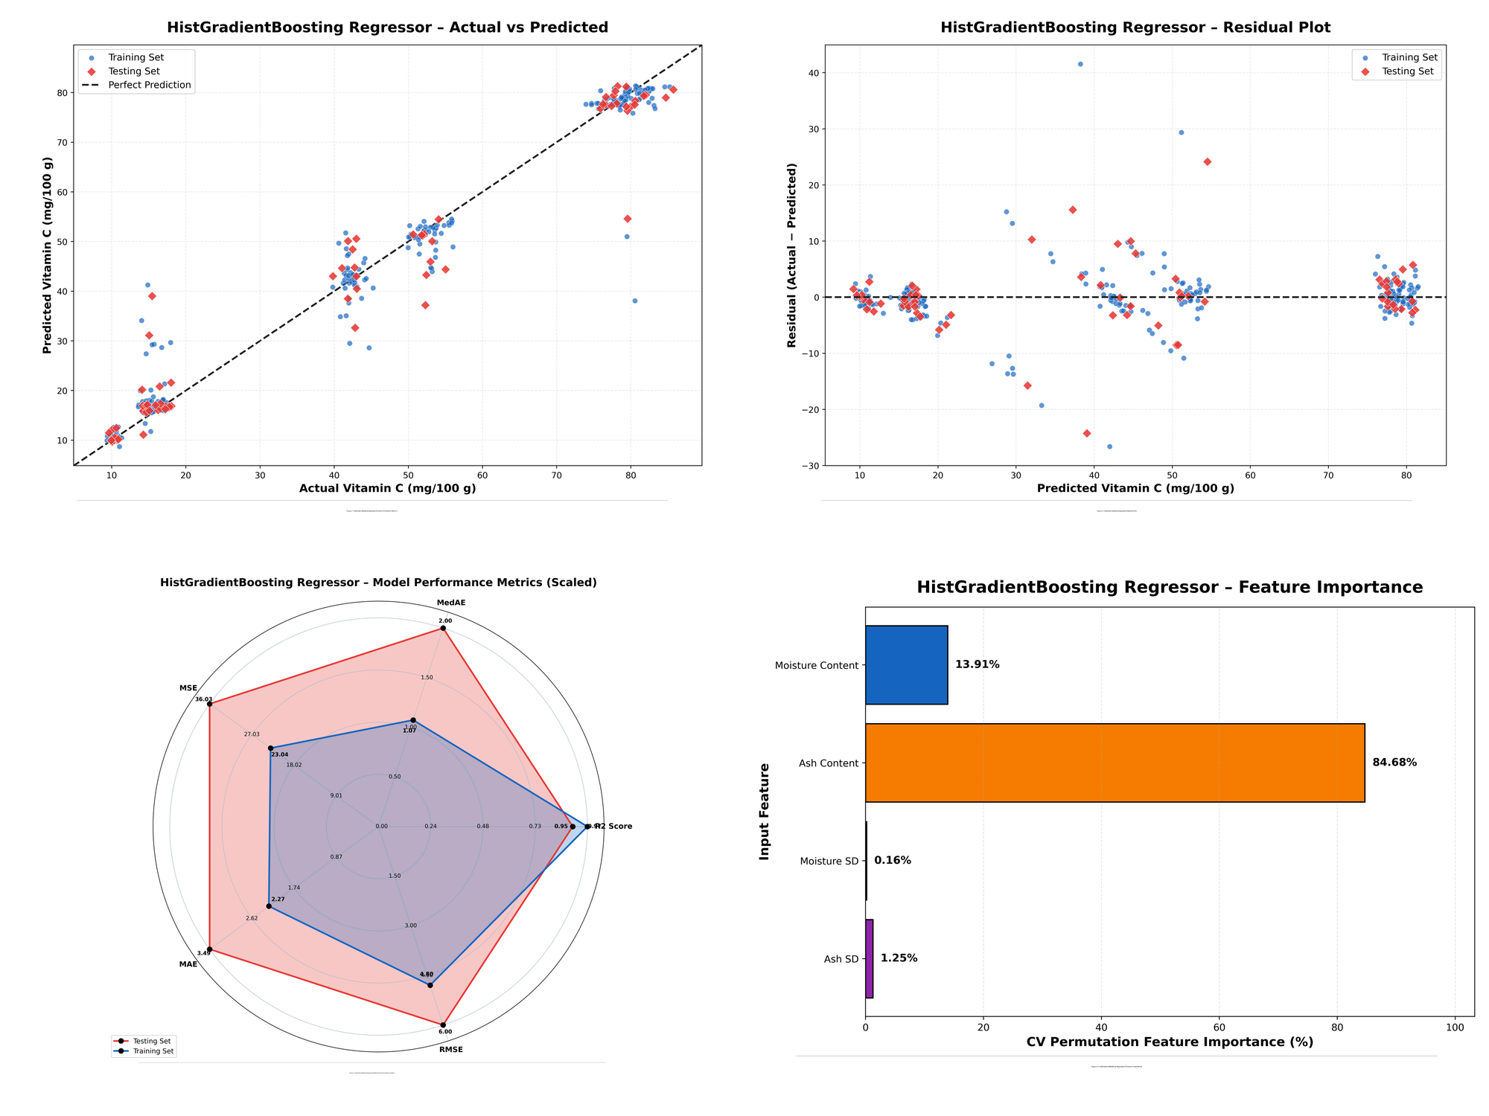
Fig. S2. HistGradientBoosting diagnostic summary: actual versus predicted, residual plot, scaled radar metrics, and model-specific feature importance.
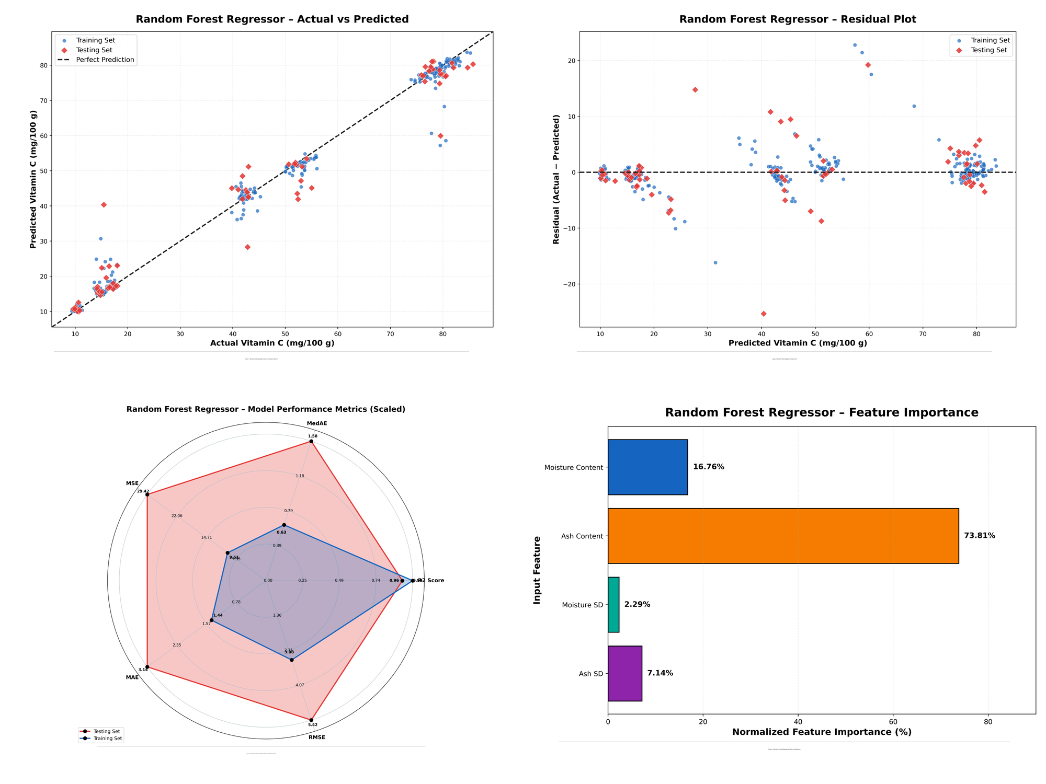
Fig. S3. Random Forest diagnostic summary: actual versus predicted, residual plot, scaled radar metrics, and model-specific feature importance.
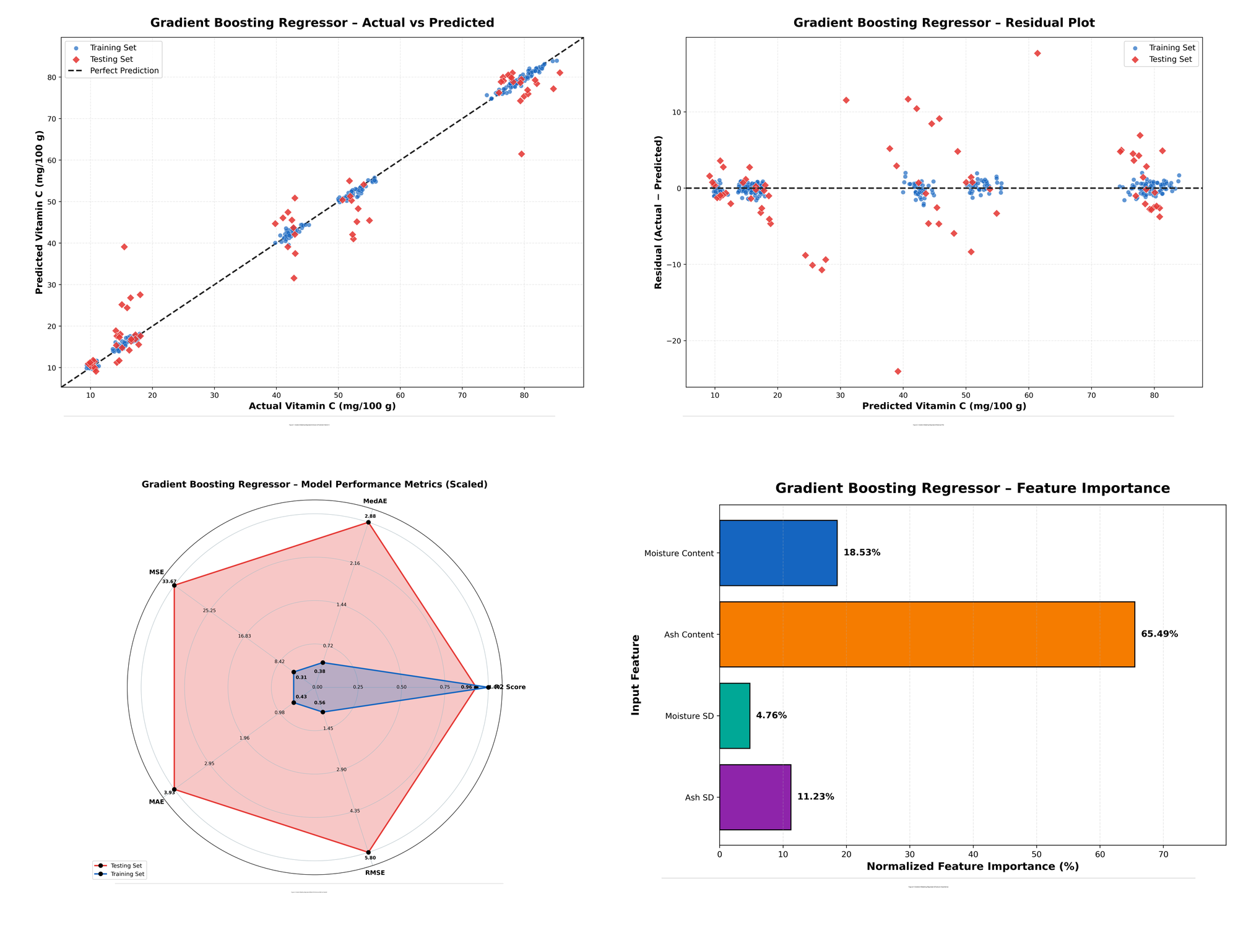
Fig. S4. Gradient Boosting diagnostic summary: actual versus predicted, residual plot, scaled radar metrics, and model-specific feature importance.
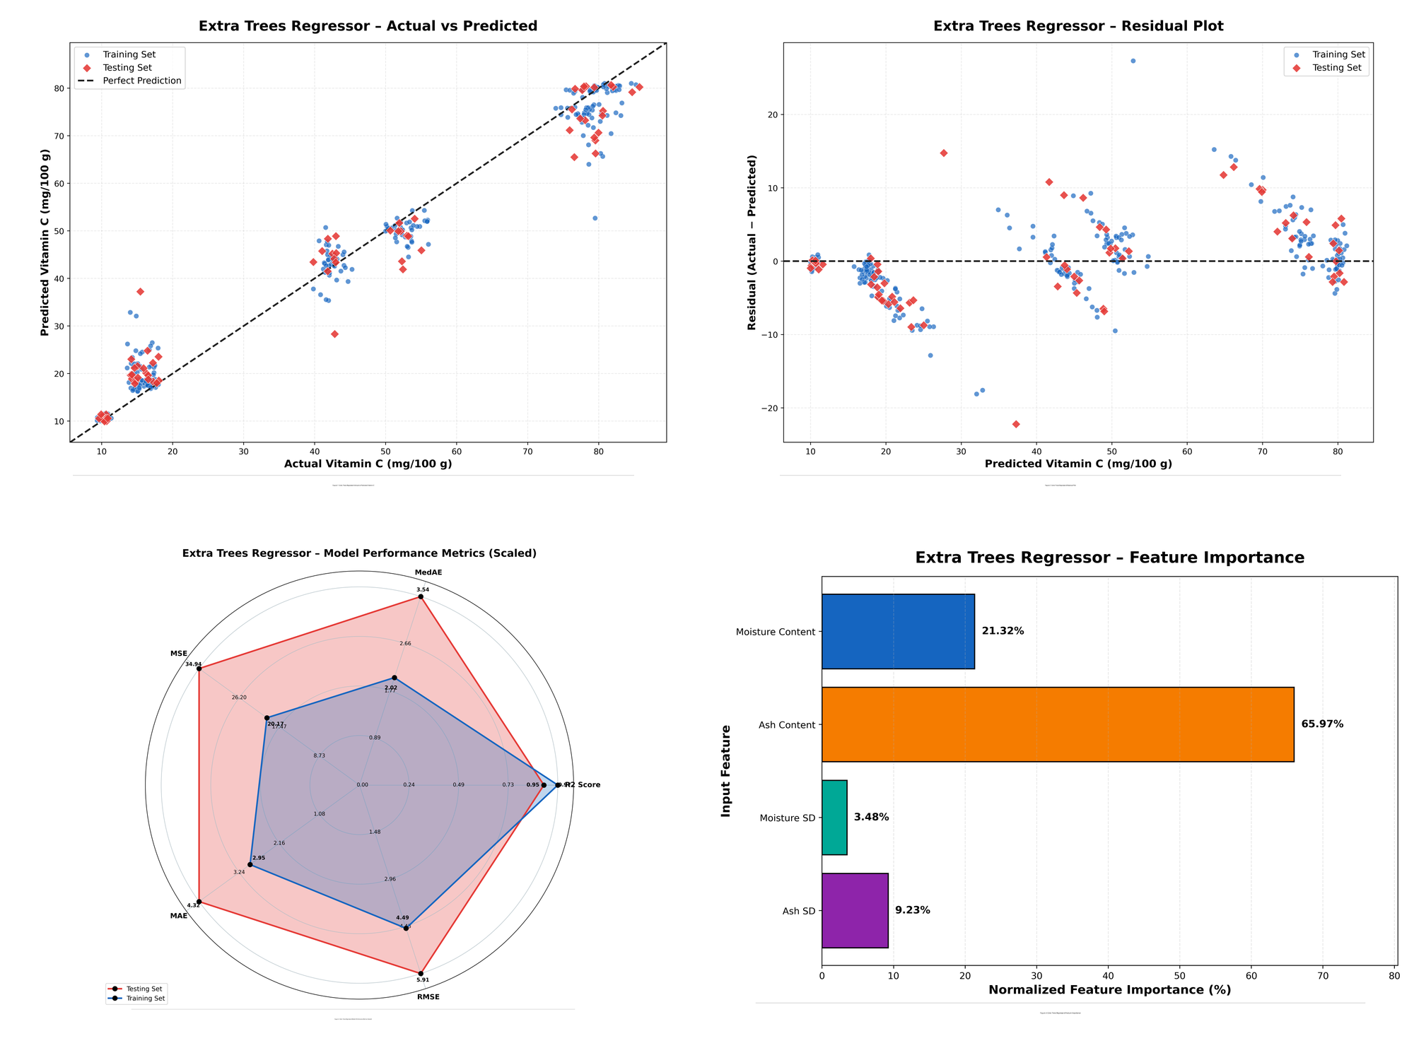
Fig. S5. Extra Trees diagnostic summary: actual versus predicted, residual plot, scaled radar metrics, and model-specific feature importance.
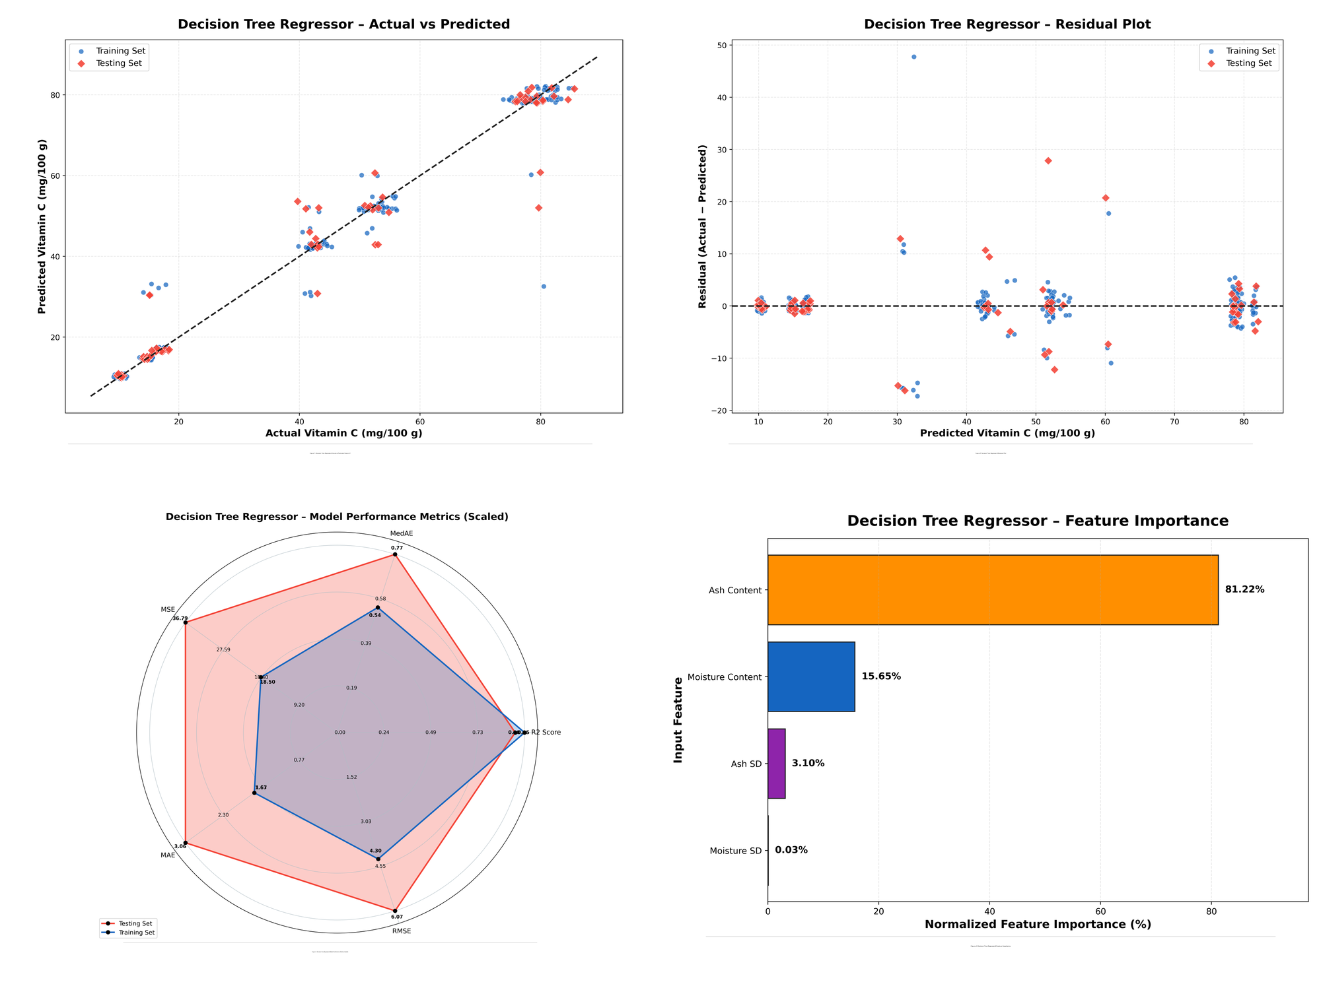
Fig. S6. Decision Tree diagnostic summary: actual versus predicted, residual plot, scaled radar metrics, and model-specific feature importance.
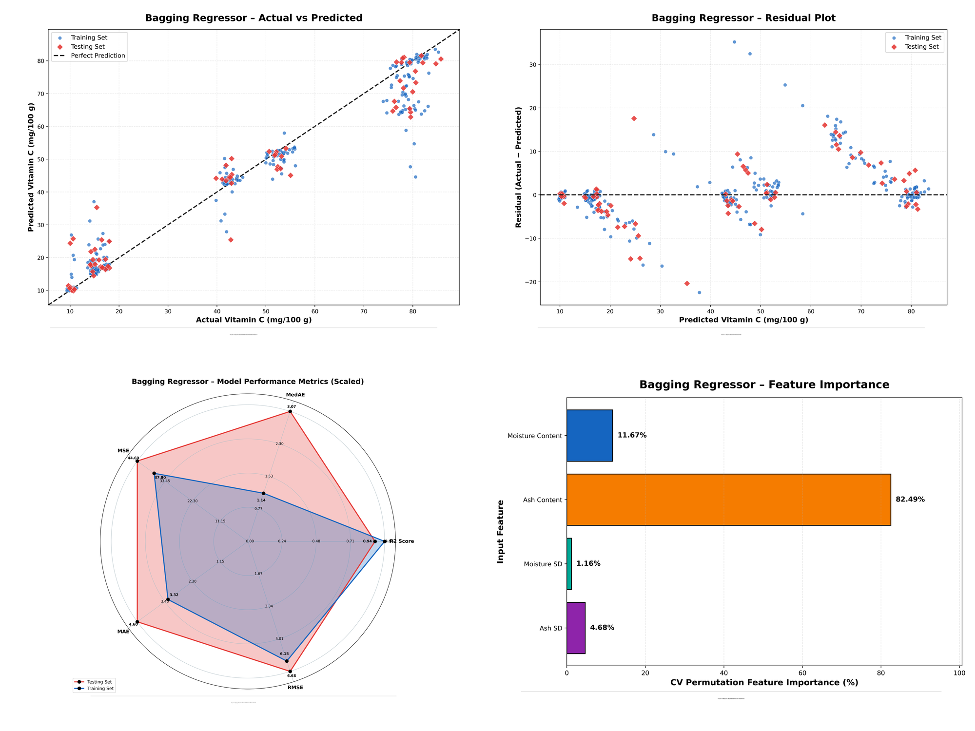
Fig. S7. Bagging diagnostic summary: actual versus predicted, residual plot, scaled radar metrics, and model-specific feature importance.
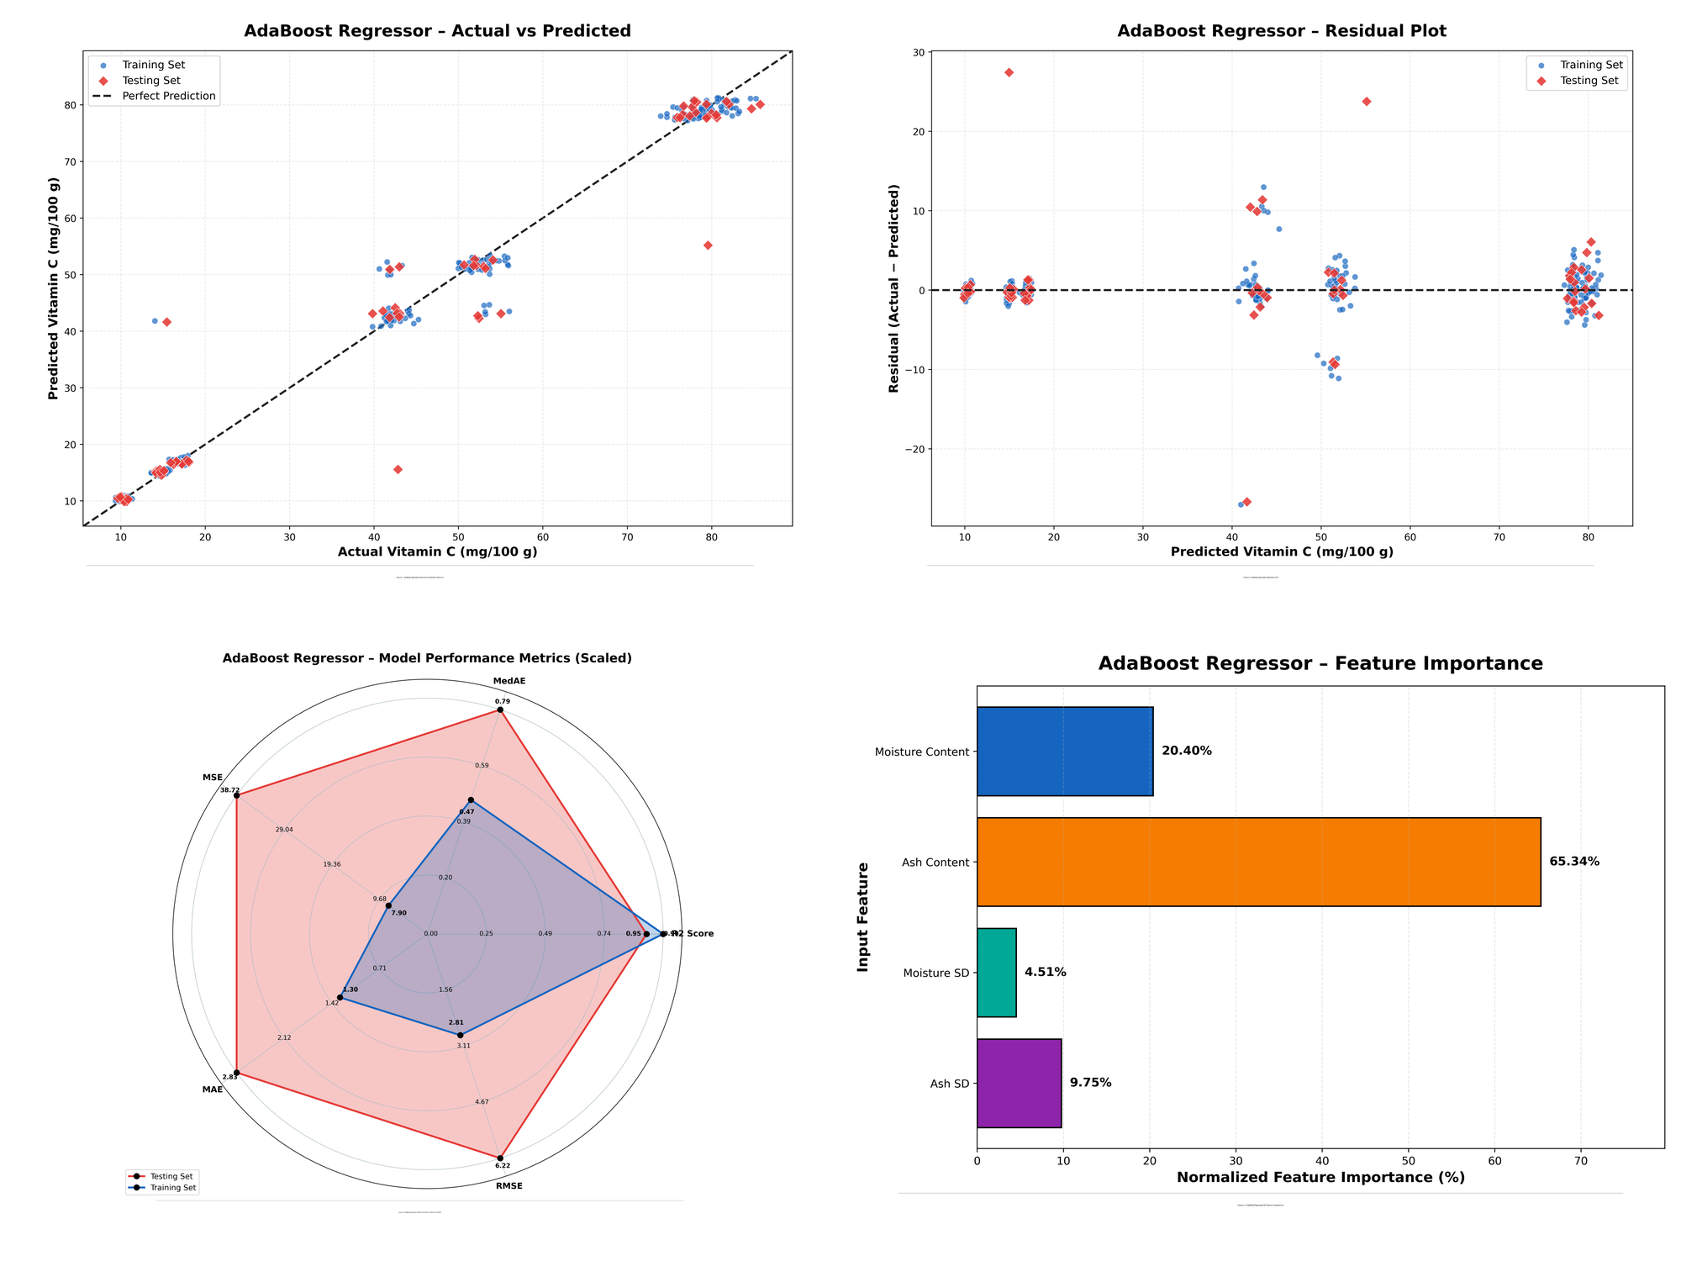
Fig. S8. AdaBoost diagnostic summary: actual versus predicted, residual plot, scaled radar metrics, and model-specific feature importance.
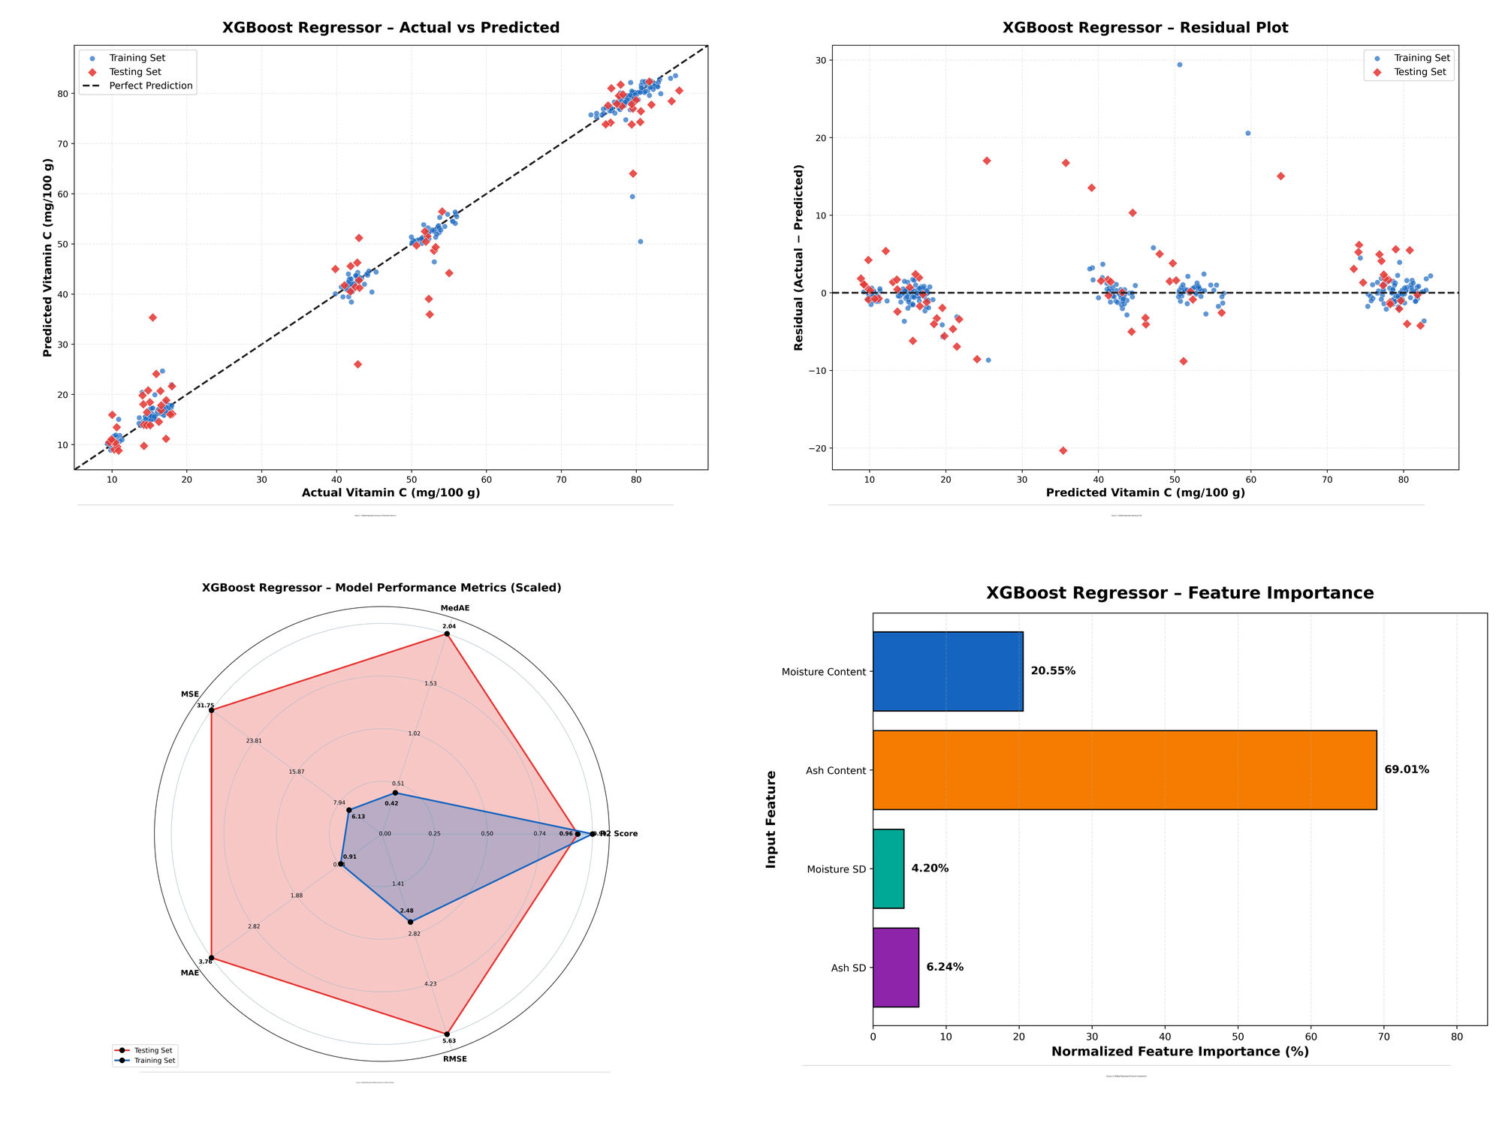
Fig. S9. XGBoost diagnostic summary: actual versus predicted, residual plot, scaled radar metrics, and model-specific feature importance.
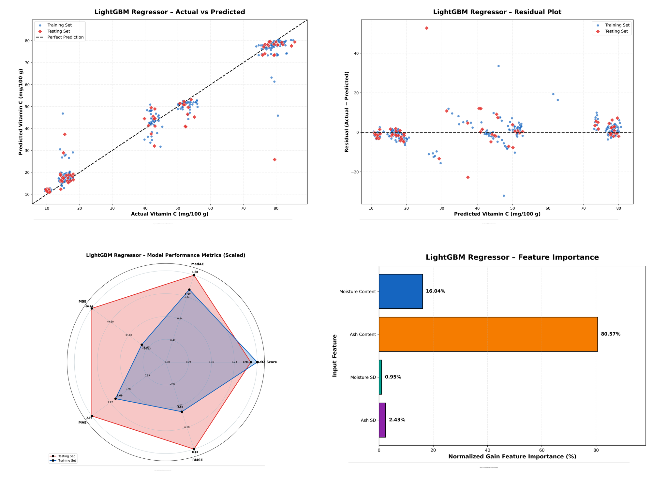
Fig. S10. LightGBM diagnostic summary: actual versus predicted, residual plot, scaled radar metrics, and model-specific feature importance.
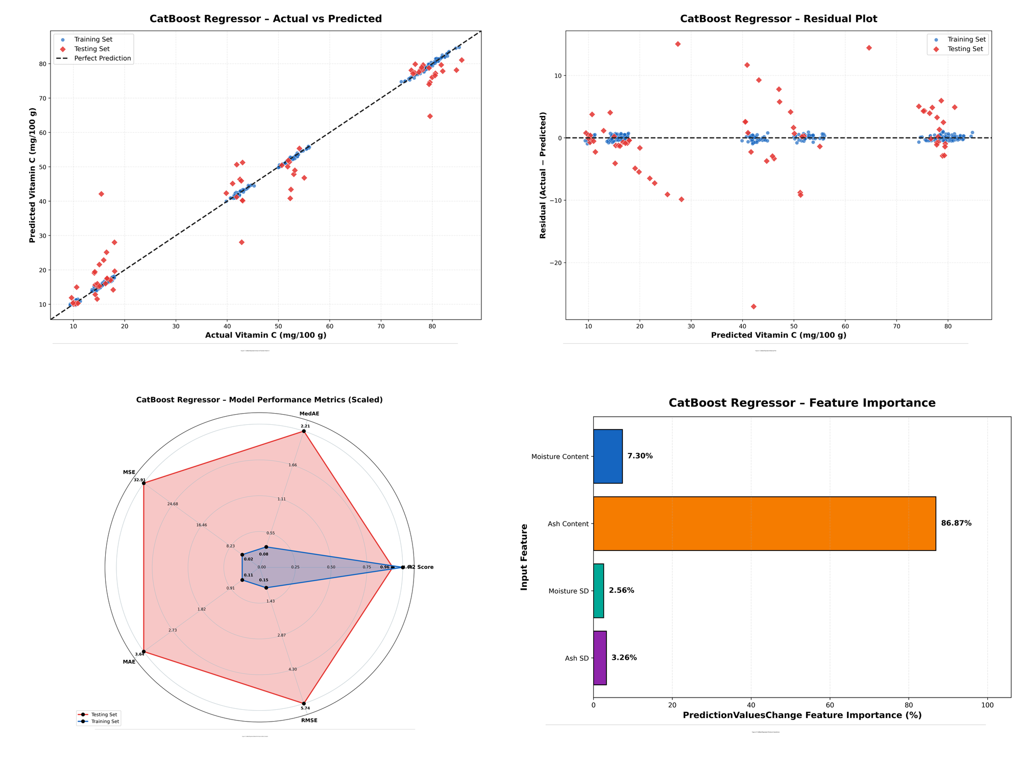
Fig. S11. CatBoost diagnostic summary: actual versus predicted, residual plot, scaled radar metrics, and model-specific feature importance.

Selected Bayesian-optimization hyperparameters
Table S2A. Selected hyperparameters for HistGradientBoosting.
Hyperparameter | Selected value
early_stopping | False
l2_regularization | 0.0783649896
learning_rate | 0.01
loss | squared_error
max_bins | 177
max_depth | 7
max_iter | 568
max_leaf_nodes | 35
min_samples_leaf | 26
n_iter_no_change | 14
tol | 1.5284e-05
validation_fraction | 0.1839048713
Table S2B. Selected hyperparameters for Random Forest.
Hyperparameter | Selected value
bootstrap | True
ccp_alpha | 0.005
criterion | squared_error
max_depth | 12
max_features | 0.8843321036
max_leaf_nodes | 180
min_impurity_decrease | 1e-12
min_samples_leaf | 1
min_samples_split | 2
n_estimators | 551
Table S2C. Selected hyperparameters for Gradient Boosting.
Hyperparameter | Selected value
ccp_alpha | 0.00492820697
learning_rate | 0.0301065326
loss | squared_error
max_depth | 6
max_features | sqrt
max_leaf_nodes | 15
min_impurity_decrease | 1e-12
min_samples_leaf | 1
min_samples_split | 16
n_estimators | 750
subsample | 0.7988962724
Table S2D. Selected hyperparameters for Extra Trees.
Hyperparameter | Selected value
bootstrap | False
ccp_alpha | 2.83825e-12
criterion | squared_error
max_depth | 10
max_features | 1
max_leaf_nodes | 30
min_impurity_decrease | 0.0001081369
min_samples_leaf | 1
min_samples_split | 4
n_estimators | 250
Table S2E. Selected hyperparameters for Decision Tree.
Hyperparameter | Selected value
ccp_alpha | 5.1403899e-05
criterion | friedman_mse
max_depth | 24
max_features | 0.7635414765
max_leaf_nodes | 20
min_impurity_decrease | 9.37668e-12
min_samples_leaf | 2
min_samples_split | 6
splitter | best
Table S2F. Selected hyperparameters for Bagging.
Hyperparameter | Selected value
bootstrap | True
bootstrap_features | False
estimator__ccp_alpha | 2.5656620e-08
estimator__criterion | absolute_error
estimator__max_depth | 7
estimator__max_features | None
estimator__max_leaf_nodes | 120
estimator__min_samples_leaf | 1
estimator__min_samples_split | 2
max_features | 1.0
max_samples | 0.7117031752
n_estimators | 93
Table S2G. Selected hyperparameters for AdaBoost.
Hyperparameter | Selected value
estimator__ccp_alpha | 5.8481709e-09
estimator__criterion | absolute_error
estimator__max_depth | 9
estimator__max_features | 1.0
estimator__max_leaf_nodes | 60
estimator__min_impurity_decrease | 1.037957e-09
estimator__min_samples_leaf | 7
estimator__min_samples_split | 9
estimator__splitter | random
learning_rate | 0.0102631653
loss | linear
n_estimators | 461
Table S2H. Selected hyperparameters for XGBoost.
Hyperparameter | Selected value
colsample_bytree | 1
gamma | 7.673687e-07
grow_policy | depthwise
learning_rate | 0.0724717606
max_delta_step | 2
max_depth | 7
min_child_weight | 4.0598792633
n_estimators | 376
reg_alpha | 1.734455e-08
reg_lambda | 0.1712318598
subsample | 0.6
Table S2I. Selected hyperparameters for LightGBM.
Hyperparameter | Selected value
colsample_bytree | 0.9954994688
learning_rate | 0.0133526936
max_bin | 110
max_depth | 6
min_child_samples | 13
min_child_weight | 0.0524820705
min_split_gain | 0.0047493931
n_estimators | 248
num_leaves | 12
reg_alpha | 0.0460851185
reg_lambda | 0.0001
subsample | 1
Table S2J. Selected hyperparameters for CatBoost.
Hyperparameter | Selected value
bagging_temperature | 2.3083852919
border_count | 206
depth | 10
iterations | 327
l2_leaf_reg | 4.0474559825
leaf_estimation_iterations | 5
learning_rate | 0.0862389340
random_strength | 10.0
rsm | 0.7287005318
score_function | L2

Complete 350-row modelling dataset
Table S1A. Complete modelling observations for Green Banana (n = 50).
Sample_ID | Vegetable_Code | Moisture_% | Moisture_SD | Ash_% | Ash_SD | Vitamin_C_mg_100g
1 | 1 | 77.73 | 0.414 | 0.579 | 0.029 | 10.47
2 | 1 | 77.99 | 0.732 | 0.715 | 0.033 | 10.64
3 | 1 | 79.41 | 0.341 | 0.599 | 0.037 | 9.84
4 | 1 | 80.97 | 0.553 | 0.731 | 0.042 | 10.8
5 | 1 | 77.31 | 0.538 | 0.593 | 0.027 | 10.38
6 | 1 | 77.34 | 0.505 | 0.647 | 0.017 | 10.25
7 | 1 | 77.34 | 0.628 | 0.707 | 0.043 | 10.11
8 | 1 | 77.53 | 0.377 | 0.576 | 0.04 | 10.94
9 | 1 | 80.56 | 0.654 | 0.725 | 0.039 | 10.27
10 | 1 | 77.98 | 0.397 | 0.668 | 0.029 | 10.75
11 | 1 | 81.22 | 0.673 | 0.765 | 0.035 | 10.93
12 | 1 | 77.37 | 0.842 | 0.779 | 0.023 | 10.2
13 | 1 | 78.62 | 0.609 | 0.632 | 0.036 | 9.86
14 | 1 | 78.94 | 0.47 | 0.715 | 0.04 | 10.13
15 | 1 | 78.09 | 0.409 | 0.658 | 0.035 | 10.28
16 | 1 | 81.1 | 0.41 | 0.64 | 0.03 | 10.52
17 | 1 | 77.41 | 0.746 | 0.625 | 0.029 | 10.29
18 | 1 | 76.9 | 0.338 | 0.697 | 0.024 | 9.84
19 | 1 | 79.25 | 0.453 | 0.681 | 0.041 | 10.58
20 | 1 | 80.49 | 0.566 | 0.624 | 0.027 | 10.19
21 | 1 | 80.81 | 0.51 | 0.581 | 0.043 | 10.55
22 | 1 | 77.63 | 0.357 | 0.684 | 0.043 | 10.53
23 | 1 | 76.56 | 0.487 | 0.618 | 0.039 | 10.1
24 | 1 | 79.31 | 0.371 | 0.72 | 0.035 | 10.22
25 | 1 | 79.31 | 0.622 | 0.656 | 0.039 | 10.51
26 | 1 | 77.48 | 0.408 | 0.622 | 0.025 | 10.99
27 | 1 | 75.79 | 0.706 | 0.749 | 0.043 | 10.43
28 | 1 | 76.69 | 0.594 | 0.719 | 0.033 | 10.18
29 | 1 | 78.67 | 0.521 | 0.695 | 0.032 | 9.82
30 | 1 | 77.14 | 0.429 | 0.705 | 0.027 | 10.82
31 | 1 | 80.17 | 0.389 | 0.698 | 0.022 | 9.97
32 | 1 | 81.22 | 0.643 | 0.611 | 0.04 | 10.85
33 | 1 | 78.45 | 0.611 | 0.656 | 0.019 | 10.93
34 | 1 | 75.45 | 0.342 | 0.647 | 0.019 | 10.56
35 | 1 | 79.86 | 0.516 | 0.65 | 0.023 | 10.08
36 | 1 | 76.44 | 0.593 | 0.657 | 0.028 | 10.1
37 | 1 | 75.6 | 0.864 | 0.717 | 0.043 | 10.1
38 | 1 | 77.01 | 0.617 | 0.778 | 0.043 | 10.23
39 | 1 | 75.31 | 0.785 | 0.6 | 0.038 | 10.52
40 | 1 | 76.97 | 0.779 | 0.694 | 0.033 | 10.95
41 | 1 | 80.2 | 0.542 | 0.641 | 0.041 | 10.35
42 | 1 | 79.77 | 0.377 | 0.651 | 0.041 | 10.39
43 | 1 | 79.19 | 0.636 | 0.659 | 0.024 | 10.27
44 | 1 | 77.62 | 0.55 | 0.624 | 0.028 | 10.22
45 | 1 | 78.33 | 0.555 | 0.701 | 0.026 | 10.63
46 | 1 | 76.47 | 0.491 | 0.771 | 0.031 | 10.18
47 | 1 | 79.44 | 0.675 | 0.678 | 0.043 | 10.07
48 | 1 | 75.52 | 0.513 | 0.704 | 0.039 | 10.13
49 | 1 | 76.82 | 0.42 | 0.707 | 0.03 | 10.29
50 | 1 | 77.33 | 0.523 | 0.605 | 0.03 | 10.31

Table S1B. Complete modelling observations for Bitter Gourd (n = 50).
Sample_ID | Vegetable_Code | Moisture_% | Moisture_SD | Ash_% | Ash_SD | Vitamin_C_mg_100g
51 | 2 | 90.87 | 0.492 | 0.853 | 0.049 | 52.02
52 | 2 | 93.6 | 0.297 | 0.85 | 0.039 | 51.9
53 | 2 | 91.87 | 0.585 | 0.81 | 0.047 | 51.98
54 | 2 | 90.77 | 0.438 | 0.916 | 0.048 | 55.36
55 | 2 | 93.84 | 0.392 | 0.815 | 0.038 | 53.66
56 | 2 | 94.07 | 0.342 | 0.874 | 0.052 | 52.21
57 | 2 | 97.19 | 0.45 | 0.847 | 0.033 | 52.85
58 | 2 | 92.22 | 0.434 | 0.813 | 0.036 | 51.57
59 | 2 | 95.21 | 0.264 | 0.786 | 0.037 | 55.69
60 | 2 | 93.77 | 0.581 | 0.855 | 0.027 | 53.61
61 | 2 | 92.0 | 0.497 | 0.772 | 0.044 | 52.91
62 | 2 | 92.99 | 0.582 | 0.873 | 0.041 | 54.65
63 | 2 | 94.04 | 0.522 | 0.715 | 0.06 | 53.26
64 | 2 | 92.99 | 0.335 | 0.881 | 0.047 | 50.53
65 | 2 | 95.21 | 0.423 | 0.949 | 0.048 | 53.54
66 | 2 | 92.29 | 0.304 | 0.779 | 0.049 | 51.18
67 | 2 | 90.36 | 0.502 | 0.7 | 0.038 | 52.95
68 | 2 | 93.08 | 0.36 | 0.76 | 0.043 | 52.44
69 | 2 | 92.85 | 0.419 | 0.767 | 0.066 | 55.54
70 | 2 | 93.98 | 0.352 | 0.805 | 0.028 | 52.73
71 | 2 | 90.45 | 0.492 | 0.828 | 0.053 | 50.05
72 | 2 | 93.31 | 0.432 | 0.84 | 0.044 | 52.59
73 | 2 | 95.78 | 0.457 | 0.712 | 0.049 | 52.03
74 | 2 | 93.1 | 0.5 | 0.766 | 0.039 | 53.39
75 | 2 | 91.79 | 0.482 | 0.931 | 0.037 | 51.75
76 | 2 | 96.84 | 0.37 | 0.805 | 0.064 | 51.04
77 | 2 | 90.67 | 0.58 | 0.846 | 0.042 | 54.81
78 | 2 | 92.33 | 0.346 | 0.81 | 0.049 | 50.11
79 | 2 | 93.63 | 0.435 | 0.7 | 0.063 | 49.76
80 | 2 | 92.54 | 0.454 | 0.864 | 0.055 | 54.45
81 | 2 | 91.34 | 0.371 | 0.839 | 0.042 | 49.94
82 | 2 | 93.63 | 0.518 | 0.906 | 0.053 | 53.58
83 | 2 | 93.65 | 0.424 | 0.864 | 0.054 | 52.65
84 | 2 | 91.87 | 0.626 | 0.765 | 0.04 | 51.61
85 | 2 | 93.5 | 0.311 | 0.732 | 0.052 | 51.29
86 | 2 | 92.45 | 0.372 | 0.87 | 0.045 | 51.13
87 | 2 | 94.23 | 0.479 | 0.883 | 0.055 | 55.55
88 | 2 | 93.25 | 0.264 | 0.754 | 0.041 | 52.54
89 | 2 | 92.49 | 0.458 | 0.7 | 0.035 | 52.41
90 | 2 | 91.5 | 0.285 | 0.897 | 0.027 | 53.0
91 | 2 | 93.46 | 0.572 | 0.879 | 0.037 | 52.59
92 | 2 | 93.37 | 0.309 | 0.866 | 0.049 | 53.67
93 | 2 | 94.31 | 0.328 | 0.901 | 0.063 | 52.3
94 | 2 | 92.34 | 0.282 | 0.8 | 0.057 | 55.95
95 | 2 | 91.83 | 0.384 | 0.822 | 0.041 | 50.57
96 | 2 | 92.97 | 0.417 | 0.848 | 0.044 | 51.98
97 | 2 | 95.73 | 0.295 | 0.843 | 0.036 | 55.13
98 | 2 | 92.16 | 0.269 | 0.901 | 0.049 | 55.33
99 | 2 | 93.06 | 0.27 | 0.781 | 0.04 | 51.66
100 | 2 | 90.38 | 0.295 | 0.82 | 0.042 | 53.4

Table S1C. Complete modelling observations for Green Bell Pepper (n = 50).
Sample_ID | Vegetable_Code | Moisture_% | Moisture_SD | Ash_% | Ash_SD | Vitamin_C_mg_100g
101 | 3 | 93.33 | 0.273 | 0.464 | 0.019 | 76.94
102 | 3 | 98.44 | 0.343 | 0.472 | 0.021 | 77.65
103 | 3 | 94.24 | 0.315 | 0.513 | 0.023 | 81.16
104 | 3 | 93.94 | 0.576 | 0.456 | 0.017 | 79.37
105 | 3 | 93.49 | 0.452 | 0.478 | 0.012 | 75.91
106 | 3 | 93.62 | 0.362 | 0.45 | 0.032 | 80.22
107 | 3 | 91.96 | 0.385 | 0.467 | 0.018 | 77.47
108 | 3 | 95.37 | 0.37 | 0.554 | 0.027 | 78.98
109 | 3 | 93.14 | 0.421 | 0.446 | 0.022 | 77.37
110 | 3 | 94.18 | 0.302 | 0.505 | 0.02 | 76.98
111 | 3 | 94.46 | 0.382 | 0.496 | 0.021 | 78.04
112 | 3 | 93.87 | 0.307 | 0.47 | 0.012 | 79.36
113 | 3 | 92.48 | 0.303 | 0.482 | 0.023 | 79.3
114 | 3 | 94.56 | 0.353 | 0.436 | 0.016 | 77.21
115 | 3 | 94.54 | 0.388 | 0.532 | 0.02 | 81.97
116 | 3 | 93.76 | 0.37 | 0.473 | 0.012 | 80.13
117 | 3 | 96.21 | 0.558 | 0.418 | 0.027 | 80.32
118 | 3 | 91.9 | 0.479 | 0.463 | 0.021 | 79.55
119 | 3 | 93.36 | 0.5 | 0.487 | 0.014 | 75.76
120 | 3 | 94.13 | 0.214 | 0.482 | 0.031 | 76.76
121 | 3 | 95.98 | 0.308 | 0.407 | 0.03 | 80.89
122 | 3 | 91.68 | 0.276 | 0.437 | 0.02 | 78.45
123 | 3 | 97.22 | 0.373 | 0.443 | 0.015 | 78.52
124 | 3 | 91.91 | 0.414 | 0.429 | 0.032 | 78.23
125 | 3 | 95.14 | 0.232 | 0.437 | 0.023 | 79.31
126 | 3 | 93.23 | 0.576 | 0.491 | 0.021 | 79.94
127 | 3 | 96.78 | 0.259 | 0.471 | 0.02 | 77.86
128 | 3 | 96.52 | 0.273 | 0.515 | 0.021 | 78.53
129 | 3 | 93.79 | 0.518 | 0.432 | 0.022 | 76.62
130 | 3 | 93.36 | 0.309 | 0.471 | 0.02 | 75.8
131 | 3 | 91.7 | 0.351 | 0.544 | 0.024 | 78.5
132 | 3 | 92.84 | 0.328 | 0.437 | 0.019 | 80.57
133 | 3 | 96.11 | 0.373 | 0.46 | 0.023 | 78.48
134 | 3 | 91.59 | 0.219 | 0.413 | 0.018 | 77.8
135 | 3 | 92.04 | 0.31 | 0.468 | 0.02 | 74.26
136 | 3 | 95.39 | 0.497 | 0.49 | 0.017 | 83.37
137 | 3 | 95.16 | 0.29 | 0.482 | 0.016 | 78.25
138 | 3 | 98.49 | 0.482 | 0.483 | 0.02 | 83.19
139 | 3 | 93.33 | 0.392 | 0.444 | 0.017 | 74.35
140 | 3 | 93.75 | 0.422 | 0.454 | 0.023 | 80.4
141 | 3 | 93.78 | 0.477 | 0.442 | 0.021 | 78.65
142 | 3 | 96.56 | 0.425 | 0.469 | 0.016 | 74.7
143 | 3 | 96.41 | 0.346 | 0.469 | 0.026 | 78.35
144 | 3 | 97.65 | 0.382 | 0.465 | 0.012 | 80.66
145 | 3 | 92.77 | 0.342 | 0.448 | 0.022 | 82.31
146 | 3 | 95.35 | 0.288 | 0.466 | 0.026 | 77.92
147 | 3 | 95.22 | 0.274 | 0.437 | 0.018 | 75.49
148 | 3 | 96.81 | 0.337 | 0.478 | 0.028 | 78.22
149 | 3 | 95.43 | 0.398 | 0.517 | 0.022 | 79.31
150 | 3 | 98.02 | 0.354 | 0.496 | 0.021 | 77.95

Table S1D. Complete modelling observations for Broccoli (n = 50).
Sample_ID | Vegetable_Code | Moisture_% | Moisture_SD | Ash_% | Ash_SD | Vitamin_C_mg_100g
151 | 4 | 88.76 | 0.504 | 1.185 | 0.082 | 79.8
152 | 4 | 91.38 | 0.443 | 1.132 | 0.082 | 79.71
153 | 4 | 89.55 | 0.714 | 1.143 | 0.034 | 81.15
154 | 4 | 91.02 | 0.342 | 1.17 | 0.055 | 77.94
155 | 4 | 91.01 | 0.567 | 1.195 | 0.056 | 77.93
156 | 4 | 88.42 | 0.628 | 0.981 | 0.074 | 79.74
157 | 4 | 91.75 | 0.558 | 1.218 | 0.046 | 81.96
158 | 4 | 90.27 | 0.516 | 1.116 | 0.05 | 79.3
159 | 4 | 91.52 | 0.502 | 1.019 | 0.046 | 78.01
160 | 4 | 88.79 | 0.418 | 1.084 | 0.043 | 78.91
161 | 4 | 88.31 | 0.559 | 1.014 | 0.079 | 79.49
162 | 4 | 90.33 | 0.394 | 1.067 | 0.055 | 79.53
163 | 4 | 89.0 | 0.428 | 0.976 | 0.053 | 79.91
164 | 4 | 90.1 | 0.378 | 1.109 | 0.044 | 76.86
165 | 4 | 90.01 | 0.363 | 1.293 | 0.077 | 81.48
166 | 4 | 88.74 | 0.541 | 1.094 | 0.057 | 79.16
167 | 4 | 88.42 | 0.449 | 1.144 | 0.061 | 85.33
168 | 4 | 90.88 | 0.604 | 1.107 | 0.052 | 84.75
169 | 4 | 88.81 | 0.469 | 1.034 | 0.062 | 80.01
170 | 4 | 92.84 | 0.394 | 1.018 | 0.079 | 82.07
171 | 4 | 87.75 | 0.55 | 0.957 | 0.038 | 80.0
172 | 4 | 87.39 | 0.433 | 1.044 | 0.051 | 77.8
173 | 4 | 88.37 | 0.413 | 1.042 | 0.033 | 83.12
174 | 4 | 90.61 | 0.468 | 1.195 | 0.082 | 77.82
175 | 4 | 93.07 | 0.321 | 1.117 | 0.045 | 78.67
176 | 4 | 89.23 | 0.548 | 1.116 | 0.039 | 77.91
177 | 4 | 91.7 | 0.519 | 1.209 | 0.072 | 82.65
178 | 4 | 88.9 | 0.444 | 1.047 | 0.028 | 76.08
179 | 4 | 90.29 | 0.483 | 1.09 | 0.057 | 75.84
180 | 4 | 91.1 | 0.714 | 1.052 | 0.062 | 82.45
181 | 4 | 87.15 | 0.577 | 1.128 | 0.052 | 75.54
182 | 4 | 92.72 | 0.483 | 1.249 | 0.071 | 84.45
183 | 4 | 90.56 | 0.426 | 1.088 | 0.052 | 78.95
184 | 4 | 88.19 | 0.386 | 1.101 | 0.048 | 79.17
185 | 4 | 89.34 | 0.666 | 1.189 | 0.034 | 81.06
186 | 4 | 93.21 | 0.589 | 1.103 | 0.042 | 82.06
187 | 4 | 89.49 | 0.452 | 1.084 | 0.067 | 79.67
188 | 4 | 87.35 | 0.414 | 1.201 | 0.082 | 80.74
189 | 4 | 86.82 | 0.377 | 1.2 | 0.057 | 82.83
190 | 4 | 90.82 | 0.703 | 1.144 | 0.057 | 79.65
191 | 4 | 88.06 | 0.546 | 1.115 | 0.043 | 82.27
192 | 4 | 87.71 | 0.39 | 1.276 | 0.061 | 81.06
193 | 4 | 90.13 | 0.423 | 1.185 | 0.063 | 84.9
194 | 4 | 89.97 | 0.483 | 1.047 | 0.043 | 76.79
195 | 4 | 91.16 | 0.636 | 1.161 | 0.078 | 80.96
196 | 4 | 89.3 | 0.475 | 1.263 | 0.067 | 82.48
197 | 4 | 92.24 | 0.581 | 1.088 | 0.055 | 82.09
198 | 4 | 88.59 | 0.339 | 1.023 | 0.041 | 81.06
199 | 4 | 88.84 | 0.458 | 1.134 | 0.045 | 81.02
200 | 4 | 90.73 | 0.44 | 1.307 | 0.042 | 81.9

Table S1E. Complete modelling observations for Turnip (n = 50).
Sample_ID | Vegetable_Code | Moisture_% | Moisture_SD | Ash_% | Ash_SD | Vitamin_C_mg_100g
201 | 5 | 92.5 | 0.408 | 0.764 | 0.034 | 43.95
202 | 5 | 94.57 | 0.373 | 0.785 | 0.023 | 42.8
203 | 5 | 95.58 | 0.452 | 0.906 | 0.036 | 43.36
204 | 5 | 95.41 | 0.393 | 0.726 | 0.04 | 42.11
205 | 5 | 97.34 | 0.345 | 0.683 | 0.037 | 44.99
206 | 5 | 93.99 | 0.353 | 0.771 | 0.024 | 40.93
207 | 5 | 92.47 | 0.599 | 0.77 | 0.039 | 41.58
208 | 5 | 93.95 | 0.476 | 0.802 | 0.022 | 40.22
209 | 5 | 93.86 | 0.484 | 0.795 | 0.038 | 41.95
210 | 5 | 93.34 | 0.398 | 0.845 | 0.038 | 43.43
211 | 5 | 95.01 | 0.35 | 0.836 | 0.033 | 41.67
212 | 5 | 93.49 | 0.37 | 0.898 | 0.05 | 42.03
213 | 5 | 95.8 | 0.315 | 0.894 | 0.03 | 43.01
214 | 5 | 95.33 | 0.396 | 0.764 | 0.034 | 42.8
215 | 5 | 97.95 | 0.403 | 0.707 | 0.026 | 43.18
216 | 5 | 94.99 | 0.434 | 0.744 | 0.028 | 43.33
217 | 5 | 91.52 | 0.513 | 0.822 | 0.031 | 41.76
218 | 5 | 94.92 | 0.425 | 0.853 | 0.037 | 42.39
219 | 5 | 94.5 | 0.259 | 0.76 | 0.026 | 41.29
220 | 5 | 94.54 | 0.574 | 0.784 | 0.027 | 41.34
221 | 5 | 90.93 | 0.476 | 0.745 | 0.035 | 42.21
222 | 5 | 95.52 | 0.461 | 0.76 | 0.037 | 42.21
223 | 5 | 93.05 | 0.438 | 0.705 | 0.028 | 41.55
224 | 5 | 95.61 | 0.375 | 0.797 | 0.028 | 42.31
225 | 5 | 96.99 | 0.298 | 0.73 | 0.031 | 41.44
226 | 5 | 91.64 | 0.497 | 0.784 | 0.031 | 42.99
227 | 5 | 96.51 | 0.312 | 0.728 | 0.047 | 42.9
228 | 5 | 94.65 | 0.254 | 0.831 | 0.03 | 41.92
229 | 5 | 94.19 | 0.376 | 0.768 | 0.031 | 44.38
230 | 5 | 95.69 | 0.599 | 0.808 | 0.035 | 41.11
231 | 5 | 93.25 | 0.412 | 0.798 | 0.031 | 42.62
232 | 5 | 95.15 | 0.282 | 0.677 | 0.044 | 41.8
233 | 5 | 94.12 | 0.409 | 0.757 | 0.026 | 44.27
234 | 5 | 95.12 | 0.523 | 0.74 | 0.02 | 40.13
235 | 5 | 95.72 | 0.444 | 0.777 | 0.027 | 43.86
236 | 5 | 95.61 | 0.26 | 0.787 | 0.025 | 41.81
237 | 5 | 95.35 | 0.355 | 0.764 | 0.028 | 42.88
238 | 5 | 94.34 | 0.405 | 0.846 | 0.042 | 42.1
239 | 5 | 94.36 | 0.314 | 0.847 | 0.034 | 42.14
240 | 5 | 93.14 | 0.559 | 0.809 | 0.025 | 43.03
241 | 5 | 95.15 | 0.35 | 0.739 | 0.038 | 41.19
242 | 5 | 98.43 | 0.404 | 0.758 | 0.029 | 44.85
243 | 5 | 97.1 | 0.387 | 0.774 | 0.033 | 41.66
244 | 5 | 90.93 | 0.599 | 0.774 | 0.044 | 40.75
245 | 5 | 93.58 | 0.365 | 0.816 | 0.033 | 44.17
246 | 5 | 94.11 | 0.313 | 0.778 | 0.018 | 41.82
247 | 5 | 94.4 | 0.309 | 0.806 | 0.027 | 41.79
248 | 5 | 95.24 | 0.584 | 0.701 | 0.03 | 40.75
249 | 5 | 92.67 | 0.38 | 0.782 | 0.029 | 42.64
250 | 5 | 91.13 | 0.268 | 0.826 | 0.025 | 43.03

Table S1F. Complete modelling observations for Ash Gourd (n = 50).
Sample_ID | Vegetable_Code | Moisture_% | Moisture_SD | Ash_% | Ash_SD | Vitamin_C_mg_100g
251 | 6 | 94.33 | 0.359 | 0.654 | 0.013 | 15.72
252 | 6 | 98.61 | 0.393 | 0.631 | 0.016 | 14.32
253 | 6 | 95.19 | 0.318 | 0.574 | 0.019 | 15.17
254 | 6 | 95.56 | 0.235 | 0.71 | 0.03 | 15.15
255 | 6 | 94.6 | 0.293 | 0.637 | 0.023 | 14.31
256 | 6 | 93.95 | 0.376 | 0.674 | 0.018 | 15.1
257 | 6 | 94.61 | 0.298 | 0.617 | 0.016 | 15.47
258 | 6 | 98.73 | 0.222 | 0.679 | 0.018 | 15.04
259 | 6 | 98.17 | 0.274 | 0.604 | 0.017 | 15.15
260 | 6 | 92.68 | 0.351 | 0.635 | 0.013 | 14.51
261 | 6 | 96.24 | 0.2 | 0.699 | 0.02 | 14.18
262 | 6 | 97.48 | 0.381 | 0.64 | 0.02 | 15.22
263 | 6 | 95.88 | 0.249 | 0.632 | 0.022 | 14.38
264 | 6 | 91.91 | 0.374 | 0.568 | 0.018 | 14.49
265 | 6 | 94.88 | 0.347 | 0.627 | 0.027 | 15.56
266 | 6 | 96.37 | 0.346 | 0.647 | 0.018 | 15.35
267 | 6 | 96.79 | 0.251 | 0.66 | 0.021 | 14.99
268 | 6 | 96.13 | 0.463 | 0.645 | 0.019 | 14.45
269 | 6 | 94.63 | 0.467 | 0.563 | 0.02 | 14.08
270 | 6 | 93.52 | 0.307 | 0.733 | 0.031 | 15.71
271 | 6 | 95.73 | 0.365 | 0.679 | 0.02 | 14.84
272 | 6 | 95.28 | 0.403 | 0.647 | 0.019 | 14.97
273 | 6 | 96.92 | 0.337 | 0.614 | 0.025 | 14.76
274 | 6 | 96.19 | 0.308 | 0.711 | 0.02 | 14.69
275 | 6 | 95.88 | 0.327 | 0.7 | 0.025 | 14.5
276 | 6 | 96.76 | 0.276 | 0.624 | 0.019 | 14.67
277 | 6 | 96.05 | 0.329 | 0.671 | 0.025 | 14.82
278 | 6 | 97.97 | 0.375 | 0.633 | 0.014 | 14.97
279 | 6 | 95.74 | 0.45 | 0.678 | 0.024 | 13.96
280 | 6 | 96.72 | 0.237 | 0.664 | 0.029 | 15.82
281 | 6 | 96.04 | 0.398 | 0.739 | 0.031 | 14.17
282 | 6 | 95.97 | 0.398 | 0.618 | 0.029 | 14.91
283 | 6 | 92.57 | 0.357 | 0.6 | 0.028 | 15.13
284 | 6 | 94.92 | 0.348 | 0.609 | 0.031 | 14.23
285 | 6 | 95.84 | 0.452 | 0.555 | 0.028 | 14.51
286 | 6 | 93.74 | 0.231 | 0.62 | 0.019 | 14.39
287 | 6 | 95.65 | 0.455 | 0.595 | 0.028 | 14.72
288 | 6 | 93.18 | 0.373 | 0.622 | 0.018 | 15.39
289 | 6 | 92.04 | 0.392 | 0.623 | 0.014 | 15.04
290 | 6 | 92.37 | 0.358 | 0.667 | 0.018 | 15.33
291 | 6 | 95.13 | 0.235 | 0.651 | 0.017 | 15.01
292 | 6 | 98.73 | 0.281 | 0.613 | 0.013 | 15.14
293 | 6 | 94.16 | 0.44 | 0.585 | 0.031 | 14.99
294 | 6 | 97.01 | 0.315 | 0.633 | 0.017 | 14.6
295 | 6 | 93.49 | 0.288 | 0.573 | 0.024 | 14.5
296 | 6 | 95.57 | 0.295 | 0.618 | 0.016 | 15.42
297 | 6 | 92.11 | 0.38 | 0.64 | 0.019 | 13.95
298 | 6 | 95.73 | 0.299 | 0.697 | 0.026 | 14.07
299 | 6 | 97.1 | 0.325 | 0.695 | 0.018 | 13.97
300 | 6 | 96.54 | 0.332 | 0.636 | 0.013 | 14.57

Table S1G. Complete modelling observations for Tomato (n = 50).
Sample_ID | Vegetable_Code | Moisture_% | Moisture_SD | Ash_% | Ash_SD | Vitamin_C_mg_100g
301 | 7 | 92.65 | 0.464 | 0.319 | 0.018 | 17.1
302 | 7 | 93.21 | 0.419 | 0.4 | 0.027 | 16.58
303 | 7 | 93.0 | 0.408 | 0.382 | 0.027 | 17.04
304 | 7 | 94.47 | 0.348 | 0.385 | 0.021 | 17.22
305 | 7 | 90.84 | 0.371 | 0.357 | 0.018 | 16.74
306 | 7 | 93.87 | 0.515 | 0.409 | 0.031 | 17.71
307 | 7 | 91.65 | 0.557 | 0.3 | 0.019 | 17.5
308 | 7 | 92.08 | 0.398 | 0.328 | 0.02 | 16.68
309 | 7 | 95.42 | 0.436 | 0.337 | 0.016 | 16.16
310 | 7 | 90.35 | 0.424 | 0.361 | 0.023 | 17.72
311 | 7 | 96.9 | 0.447 | 0.309 | 0.018 | 17.77
312 | 7 | 92.9 | 0.443 | 0.342 | 0.018 | 16.07
313 | 7 | 93.39 | 0.535 | 0.327 | 0.021 | 17.68
314 | 7 | 95.08 | 0.482 | 0.381 | 0.028 | 17.48
315 | 7 | 94.08 | 0.455 | 0.366 | 0.018 | 16.3
316 | 7 | 93.21 | 0.496 | 0.335 | 0.018 | 17.46
317 | 7 | 91.57 | 0.422 | 0.366 | 0.022 | 17.34
318 | 7 | 92.77 | 0.32 | 0.311 | 0.031 | 16.9
319 | 7 | 92.77 | 0.302 | 0.299 | 0.024 | 15.97
320 | 7 | 94.26 | 0.346 | 0.332 | 0.03 | 16.56
321 | 7 | 93.46 | 0.353 | 0.343 | 0.021 | 17.01
322 | 7 | 94.18 | 0.561 | 0.352 | 0.022 | 17.82
323 | 7 | 93.85 | 0.349 | 0.385 | 0.019 | 16.77
324 | 7 | 97.14 | 0.505 | 0.355 | 0.016 | 16.58
325 | 7 | 92.0 | 0.381 | 0.324 | 0.027 | 16.02
326 | 7 | 93.82 | 0.425 | 0.322 | 0.027 | 16.89
327 | 7 | 90.49 | 0.354 | 0.343 | 0.014 | 17.48
328 | 7 | 90.7 | 0.319 | 0.317 | 0.022 | 16.91
329 | 7 | 94.34 | 0.416 | 0.359 | 0.023 | 15.97
330 | 7 | 93.72 | 0.354 | 0.355 | 0.022 | 16.79
331 | 7 | 92.06 | 0.551 | 0.401 | 0.031 | 17.53
332 | 7 | 94.38 | 0.649 | 0.32 | 0.031 | 17.32
333 | 7 | 93.22 | 0.438 | 0.346 | 0.014 | 16.52
334 | 7 | 90.9 | 0.616 | 0.376 | 0.022 | 16.36
335 | 7 | 91.56 | 0.649 | 0.342 | 0.016 | 16.02
336 | 7 | 94.31 | 0.591 | 0.347 | 0.024 | 16.65
337 | 7 | 92.56 | 0.343 | 0.338 | 0.027 | 17.01
338 | 7 | 91.91 | 0.413 | 0.385 | 0.016 | 16.92
339 | 7 | 91.7 | 0.279 | 0.359 | 0.029 | 16.65
340 | 7 | 91.77 | 0.465 | 0.378 | 0.031 | 16.37
341 | 7 | 94.6 | 0.535 | 0.408 | 0.017 | 15.97
342 | 7 | 91.61 | 0.484 | 0.341 | 0.025 | 16.97
343 | 7 | 93.71 | 0.392 | 0.342 | 0.014 | 16.63
344 | 7 | 92.27 | 0.494 | 0.358 | 0.021 | 16.61
345 | 7 | 94.23 | 0.622 | 0.305 | 0.025 | 17.03
346 | 7 | 91.05 | 0.451 | 0.313 | 0.018 | 17.56
347 | 7 | 96.35 | 0.537 | 0.386 | 0.031 | 16.93
348 | 7 | 92.39 | 0.475 | 0.409 | 0.025 | 16.52
349 | 7 | 90.4 | 0.523 | 0.345 | 0.017 | 16.74
350 | 7 | 90.42 | 0.625 | 0.358 | 0.021 | 16.97

