Appendix – Table 1 - Major Recent Cardiovascular Disease Epidemiology Studies In India

Study Name | Study Design  (Year ) | Sample Size | Principal Findings | Limitations
PURE study | Cohort Study ( 2014) | 24 000 from India | The CVD event rate in predominantly Indian population( low- and middle-income region) is 6.43 / 1000 person – years of follow up in comparison with 3.99 per 1000 person – years of follow -up in high income countries. | Under – Reporting of CVD events, resulting from poor access to hospital and diagnostic facilities in India.
The MUMBAI COHORT STUDY | Cohort Study (2011) | 148173 | Inverse association of CVD mortality and education in men. | Cause of death ascertainment from death registry that doesn’t provide robust data.
PROLIFE | Cohort Study (2011) | 161942 | 40 Percent deaths are attributed to CVD. | Located in small region in 1 state.
APRHI | Analysis of cause of death in 1-year period. | 180162 | 32 percent mortality from CVD. | Located in a single region.
APCAPS ( Ongoing) | Intergenerational cohort of children and parents (2014) | 10213 | Expected to provide data on transgenerational influences of other environmental and genetic factors on chronic diseases in rural India. | Located in a single region. High attrition rate.
CARRS Surveillance study | Two repeat cross-sectional surveys and follow up of all participants (2012) | 9000 | Expected to provide secular trends and risk factor progression of CVD. | Limited to Delhi and Chennai.
SOLAN Surveillance study | Repeat Cross sectional survey (ongoing) | 40000 | Expected to provide secular trends in risk factors | Limited to Solan district in Himachal Pradesh.
ICMR INDIAB ( PHASE 1) | Multi stage cluster sampling design (2014) | 16607 | Regional variations in prevalence of CVD risk factors. | Data from only 3 states are currently available.
JAIPUR Heart watch | 5 repeat cross- sectional surveys in an urban city in India ( 2003) | 1992-1994: 712  1991-2001: 558  2002-2003: 374  2004-2005: 887  2009-2010: 530 | Liner increase in CVD Risk factors. | Limited to 1 urban city. Response rate varied from 55% to 75%.
India Heart Watch ( ongoing) | Cross sectional survey in 15 cities in India (2012) | Plan to recruit 7500 participants | Identification of regional differences in risk factors. | No follow up.
ICMR Urban rural survey. | Repeat cross sectional surveys in urban and rural areas of the national capital region( 2013) | ≈6000 | Prevalence of CHD increased from 10.19%( 95%CI,9.11-11.27) to 13.91%( 95%CI, 12.41 -15.41). Rate of increase in risk factor levels was higher in rural area in comparison with urban area. | Survey conducted only at 2 time points.
NFHS 3 | Cross sectional representative sample. Multi stage cluster sampling in states of India (2013) | 156316 | Relatively low prevalence of diabetes mellitus | Self-reported prevalence estimates.
CREATE | ACS registry (2008) | 20937 | Higher rates of STEMI in Indians( 60%) in comparison with western data. | Only 30 day follow up is available. Data is essentially from tertiary care centers.
KERALA  ACS Registry | ACS registry (2013) | 25748 | Suboptimal treatment is associated with incidence of major cardiovascular events. | Only in-hospital, mortality data were captured.
INSPIRE (Ongoing: CTRI/2013/10/004108) | Stroke registry (2015) | 11000 | Expected to provide information on etiology, clinical practice patterns of acute care, clinical outcomes, and secondary prevention practices. | Data are essentially from tertiary care centers in urban

Appendix – Table 2 – Maastricht UMC – Validation Cohort Data

Appendix Figure 1 | Correlation Coefficient Results

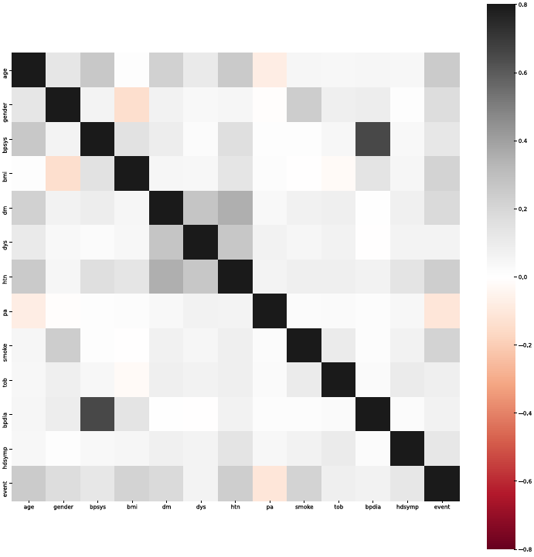

Appendix Figure 2 | Propensity Matching details – Model 31599 Cohort

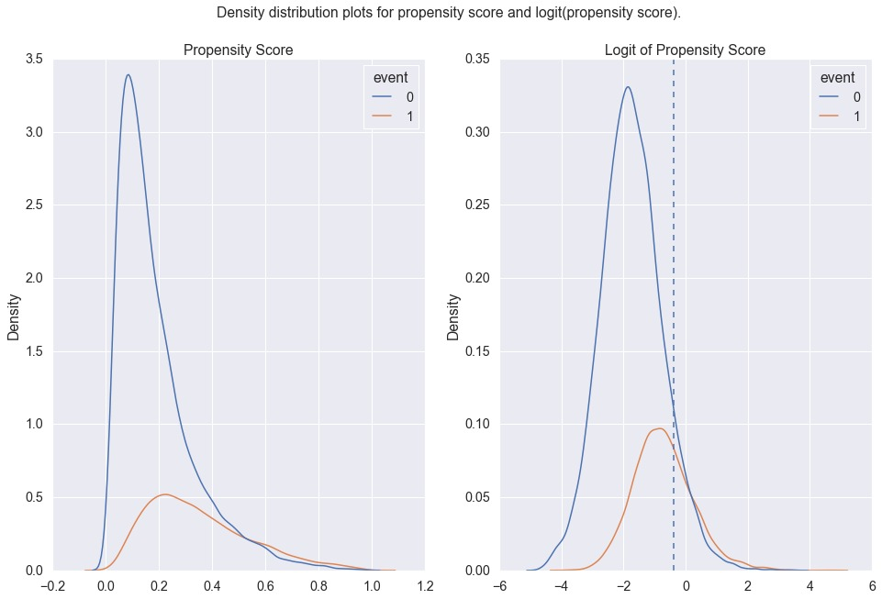

Appendix Figure 3 | Comparison of the AUC at Maastricht University Medical Centre
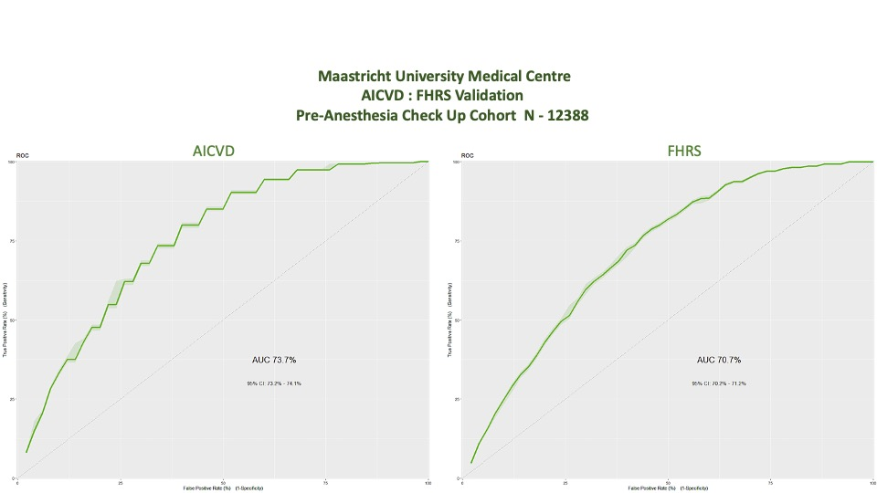

Appendix | 1

Definition of Cardiac Event (Based on ICD 10 and relevant Procedural Codes) –
    - Primary -
      - Death –
        - Any cause of death
        - Cardiovascular Death – Death due to Cardiovascular Disease / Causes
      - Clinical Condition (ICD 10 - I20 to I25) –
        - Angina pectoris
        - Acute myocardial infarction
        - Subsequent ST elevation (STEMI) and non-ST elevation (NSTEMI) myocardial infarction
        - Other acute ischemic heart diseases
        - Chronic ischemic heart disease
    - Secondary
      - Stroke & PVD or other Vascular Events
      - New Onset Angina

Appendix | 2

Inclusion Criteria
- Individuals aged above18 years
- Individuals who have voluntary undertaken Health Check at Apollo Hospitals with appropriate consent related to the use of data
- Individuals presenting for Routine Health Check

Exclusion Criteria - Individuals with
- Any acute illness coming to hospitals like
  - Life Threatening Conditions,
  - Altered physiological criteria (Triage 1 & 2 of Canadian Triage Acuity Scale),
  - Respiratory Distress (moderate to severe),
  - Trauma,
  - Pregnancy or post-partum period,
  - Circulatory shock,
  - Coma,
  - Altered Level of Consciousness,
  - Fever – Sepsis or immuno-compromised patients, and
  - Any form of Poisoning.
- Previously treated Coronary Artery Disease with revascularization (PTCA / CABG)
- Inappropriate Data with missing fields or errors

Appendix | 3

Description and Definition of Key Clinical Terms
- Diabetes Mellitus - The American Diabetes Association (ADA) defines Diabetes Mellitus as follows:
- A fasting plasma glucose (FPG) ≥126 mg/dl. Fasting is defined as no caloric intake for at least 8 hr.
- Symptoms of hyperglycaemia and a casual (random) plasma glucose ≥200 mg/dl. Classic symptoms of hyperglycaemia include polyuria, polydipsia, and unexplained weight loss. (At the time of diagnosis as a diabetic, B cell function is at 25% to 30%.)
- An oral glucose tolerance test (OGTT) with a plasma glucose ≥200 mg/dl 2 hr after a 75 g (100 g for pregnant women) glucose load.
- A haemoglobin A1c (HbA1c) value ≥6.5%.

Source - David Domenichini M.D. : Ferri's Clinical Advisor 2019, 424-433.e2

In context of the study, data collection method and overall clarity, please follow –
- Patient with no history of diabetes and previous record of normal FPG / OGTT / HbA1c – Select NO
- Patient with history of diabetes and a current record of HbA1c <7.5% - Select Controlled (this is irrespective of patient under / not under medication / treatment)
- Patient with history of diabetes and a current record of HbA1c ≥7.5% - Select Uncontrolled (this is irrespective of patient under / not under medication / treatment)

Source –
    - ACP Guideline 2018
    - ICSI and VA/DoD recommend ranges of HbA1c targets, with ICSI recommending targets of <7% to <8% based on patient factors, and VA/DoD recommending 3 different tiers of target ranges.

- Hypertension
Normal blood pressure (BP) in adults can be defined as systolic BP <120 mm Hg and diastolic BP <80 mm Hg.
Prehypertension is defined as systolic BP between 120 and 139 mm Hg or diastolic between 80 and 89 mm Hg.
Hypertension can be divided into
Stage 1: systolic BP from 140 to 159 mm Hg or diastolic BP from 90 to 99 mm Hg and
Stage 2: systolic BP ≥160 mm Hg or diastolic BP ≥100 mm Hg.

Source : Tania B. Babar M.D. : Ferri's Clinical Advisor 2019, 729-735.e5

- Body Mass Index
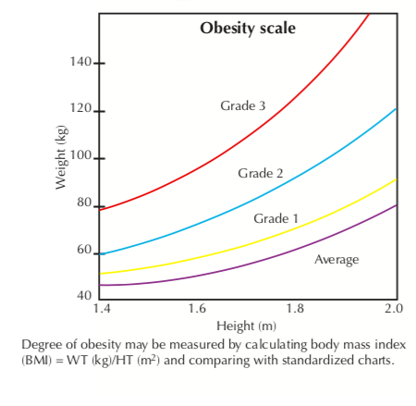
Figure 11 – Body Mass Index Definition
Source : Centers for Disease Control and Prevention: Overweight and obesity. Available at: http://www.cdc.gov/nccdphp/dnpa/obesity/.

- Symptoms and History of Heart Disease
Symptoms
- Chest pain or chest discomfort
- Dyspnoea or shortness of breath
- Swelling of legs (Peripheral Edema)
- Palpitations and / or Syncope
- Others

History (As per NYHA)
- Underlying Aetiology – Congenital, Hypertensive, Ischemic or Inflammatory
- Anatomic abnormalities – Heart Chambers; Hypertrophy or Dilated or both; Valvular disease – stenosis or regurgitation
- Physiological – Arrhythmia, Congestive Heart Failure, Coronary Artery Disease etc
- Functional Disability – NYHA Class I – IV
- Family History of Sudden Cardiac Death

Source : Joseph Loscalzo M.D. : Harrison’s Principles of Internal Medicine 20th Edition : The Criteria Committee of New York Heart Association

- Dyslipidaemia

Total Cholesterol - > 200 mg/dl
LDL Cholesterol - > 130 mg/dl
Non HDL Cholesterol - > 144 mg/dl
Apo B - >110 mg /dl
Triglycerides > 130 mg/dl
HDL - < 35 mg/dl
Total Cholesterol / HDL ratio - 4.0

Cut points to define elevated TC, LDL-C, apo B, non–HDL-C, and TG and low HDL-C and apo A-I are found in Table. Dyslipidemia is present if one or more of these lipid, lipoprotein, or apolipoprotein factors are abnormal.

Source : National Cholesterol Education Program (NCEP) Expert Panel on Cholesterol Levels. Preventive Cardiology: Companion to Braunwald's Heart Disease

Appendix | 4 - Mathematical Details

Input to the model is normalized risk factors (between 0 and 1), where each neuron represents each risk factor. This is followed by 4 layers of deep neural network of sizes 100, 70 40 and 25 respectively.

RL1=FC₁₀₀(Input)∈ ℝ¹⁰⁰ (1)
RL2=FC₇₀(RL1)∈ ℝ⁷⁰ (2)
RL3=FC₄₀(RL2)∈ ℝ⁴⁰ (3)
RL4=FC₂₅(RL3)∈ ℝ²⁵ (4)
As the next step, a regression layer was added, where job of this layer was to find survival days (number of days before cardiac event).
CoxLayer=FC₁(RL4)∈ ℝ¹ (5)
We tried multiple approaches for regression loss calculation, including Root Mean Square Error loss as well as Maximum Likelihood loss, but the better accuracy numbers were achieved by using negative log partial likelihood and derivation based on that as suggested by [22]. The equations for the same suggested by them are as follow:
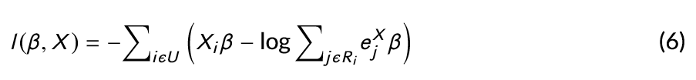

Gradients for backpropagation were calculated using the following equation:
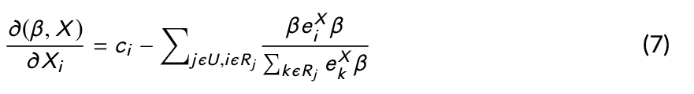
Where $X_{i}$ are inputs to the output layer from $RL4$ (equation 4), β are co-efficients for Cox parameters (described as fully connected layer in equation 5), U is set of uncensored samples, $R_{i}$ is the set of “at-risk samples” where follow-up time $Y_{j}$ > $Y_{i}$. One of the issue with current deep survival networks was to not utilize censored data in the model. To utilize right censored data properly, we added a classification layer parallel to Cox-Regression layer and calculated Binary loss via binary cross entropy loss.
ClassificationLayer = FC₂(RL4)∈ ℝ (8)
CrossEntropyLoss = −(y log(p) + (1 − y) log(1 − p)) (9)
One the major challenge is to merge classification and regression loss. As regression loss would be numerical value (difference between number of days between actual and predicted days) while binary classification loss would be between 0 and 1. One of the ways to handle this by adding static weight score to both the loss, but it was observed that regression loss decreases drastically compared to classification loss after first few iterations, so assigning pre-decided weights to both the loss terms was not very helpful. Changing the weights dynamically after every iteration would mean changing the error space and would mean that the model may not converge. To solve this problem, different approaches based on Michel et al.’s [20] A-Mixture model as well as Kendal et al.’s [16] uncertainty based multi-task loss model were tried. But both of these models are based on Bayesian deep learning methodology and requires learning two additional noise parameters for regression and classification loss. These additional parameters increase/decrease inversely in proportion to their respective regression and classification loss. Based on multiple experiments we observed that similar objective can be achieved if both regression and classification loss are in same ranges. Hence, finally, we added max scaling based loss, where regression loss is scaled down between 0 and 1 and average of Regression and Classification loss is used for further processing

Appendix | 5 - Clinical Algorithm - AICVD

Patient appropriate for SCREENING or with symptoms
21 Clinical Parameters (API)
Patient Parameters  Age  Gender  Height  Weight  BMI | Medical History  Hypertension  Diabetes mellitus  Dyslipidemia  History of Heart Disease  Family History of Heart Disease | Lifestyle  Diet  Alcohol  Smoking  Tobacco  Physical Activity | Heart Health Attributes  Heart Symptom  Heart Rate  Systolic BP  Diastolic BP  Pulse Rhythm  Respiration Rate

Generate Cardiac Risk Score

Referral : None
<1 of Optimum Score |  | 1- 1.5 of Optimum Score |  | >1.5 of Optimum Score
Minimal Risk |  | Moderate Risk |  | High Risk
Lab Investigation  Complete Blood Count, Fasting Blood Sugar, Lipid Profile, Urea & Creatinine | Referral : Cardiologist (Routine) | Lab Investigation  Complete Blood Count, Fasting and Post Prandial Blood Sugar, Lipid Profile, Urea & Creatinine + Other Tests as deemed fit (e.g. HBA1C)  Homocysteine Levels  Lipoprotein a  Neutrophil / Lymphocyte Ratio |  | Lab Investigation  Complete Blood Count, Fasting and Post Prandial Blood Sugar, Lipid Profile, Urea & Creatinine + Other Tests as deemed fit (e.g. HBA1C)  Homocysteine Levels  Lipoprotein a  Neutrophil / Lymphocyte Ratio  hsCRP
Diagnostics & Imaging  ECG, Chest X-ray  2D Echocardiography |  | Diagnostics & Imaging  ECG, Chest X-ray,  2D Echocardiography  Dobutamine Stress Echo  TMT |  | Diagnostics & Imaging  ECG, Chest X-ray,  2D Echocardiography,  Dobutamine Stress Echo  TMT  ADVANCED Tests -  Cardiac CT or Coronary Angiography  Thallium Stress Test
Medication  TREAT primary conditions like Diabetes or Hypertension and / or Dyslipidemia |  | Medication  TREAT primary conditions like Diabetes and / or Hypertension and / or Dyslipidemia  Medical Treatment (Prevention) of Coronary Artery Disease |  | Medication  Referral : Cardiologist (Urgent)  TREAT primary conditions like Diabetes and / or Hypertension and / or Dyslipidemia  Intervention or Medical Treatment of Coronary Artery Disease
EDUCATE on lifestyle management and Smoking or Tobacco Use Cessation  REPEAT TESTING every year for:  – All adults age ≥45 OR  – Adults of any age if Diabetes, Hypertension, Dyslipidemia or Smoking persists as risk factors |  | EDUCATE on lifestyle management and Smoking or Tobacco Use Cessation  REPEAT VISIT every 6 months or earlier for:  Adults of any age if Diabetes, Hypertension, Dyslipidemia or Smoking persists as risk factors  Symptoms of Coronary Artery Disease  Any other Surgical or Other Procedural Intervention |  | EDUCATE on lifestyle management and Smoking or Tobacco Use Cessation  REPEAT VISIT every 3 months or earlier for:  Symptoms of Coronary Artery Disease  Any other Surgical or Other Procedural Intervention  Adults of any age if Diabetes, Hypertension, Dyslipidemia or Smoking persists as risk factors

Appendix | 6 – TRIPOD Checklist
Section/Topic | Item |  | Checklist Item | Page
Title and abstract
Title | 1 | D;V | Identify the study as developing and/or validating a multivariable prediction model, the target population, and the outcome to be predicted. | 1
Abstract | 2 | D;V | Provide a summary of objectives, study design, setting, participants, sample size, predictors, outcome, statistical analysis, results, and conclusions. | 3
Introduction
Background and objectives | 3a | D;V | Explain the medical context (including whether diagnostic or prognostic) and rationale for developing or validating the multivariable prediction model, including references to existing models. | 4
Background and objectives | 3b | D;V | Specify the objectives, including whether the study describes the development or validation of the model or both. | 5
Methods
Source of data | 4a | D;V | Describe the study design or source of data (e.g., randomized trial, cohort, or registry data), separately for the development and validation data sets, if applicable. | 5
Source of data | 4b | D;V | Specify the key study dates, including start of accrual; end of accrual; and, if applicable, end of follow-up. | 5
Participants | 5a | D;V | Specify key elements of the study setting (e.g., primary care, secondary care, general population) including number and location of centres. | 5
Participants | 5b | D;V | Describe eligibility criteria for participants. | 5  (App 2)
Participants | 5c | D;V | Give details of treatments received, if relevant. | n/a
Outcome | 6a | D;V | Clearly define the outcome that is predicted by the prediction model, including how and when assessed. | 5
Outcome | 6b | D;V | Report any actions to blind assessment of the outcome to be predicted. | None
Predictors | 7a | D;V | Clearly define all predictors used in developing the multivariable prediction model, including how and when they were measured. | 5-6
Predictors | 7b | D;V | Report any actions to blind assessment of predictors for the outcome and other predictors. | 6
Sample size | 8 | D;V | Explain how the study size was arrived at. | 6
Missing data | 9 | D;V | Describe how missing data were handled (e.g., complete-case analysis, single imputation, multiple imputation) with details of any imputation method. | 6
Statistical analysis methods | 10a | D | Describe how predictors were handled in the analyses. | 7
Statistical analysis methods | 10b | D | Specify type of model, all model-building procedures (including any predictor selection), and method for internal validation. | 7
Statistical analysis methods | 10c | V | For validation, describe how the predictions were calculated. | 9
Statistical analysis methods | 10d | D;V | Specify all measures used to assess model performance and, if relevant, to compare multiple models. | 8
Statistical analysis methods | 10e | V | Describe any model updating (e.g., recalibration) arising from the validation, if done. | n/a
Risk groups | 11 | D;V | Provide details on how risk groups were created, if done. | 9
Development vs. validation | 12 | V | For validation, identify any differences from the development data in setting, eligibility criteria, outcome, and predictors. | n/a
Results
Participants | 13a | D;V | Describe the flow of participants through the study, including the number of participants with and without the outcome and, if applicable, a summary of the follow-up time. A diagram may be helpful. | 11
Participants | 13b | D;V | Describe the characteristics of the participants (basic demographics, clinical features, available predictors), including the number of participants with missing data for predictors and outcome. | 12
Participants | 13c | V | For validation, show a comparison with the development data of the distribution of important variables (demographics, predictors and outcome). | 13
Model development | 14a | D | Specify the number of participants and outcome events in each analysis. | 13
Model development | 14b | D | If done, report the unadjusted association between each candidate predictor and outcome. | Table 2 (15)
Model specification | 15a | D | Present the full prediction model to allow predictions for individuals (i.e., all regression coefficients, and model intercept or baseline survival at a given time point). | 13 (Table 3)
Model specification | 15b | D | Explain how to use the prediction model. | 13
Model performance | 16 | D;V | Report performance measures (with CIs) for the prediction model. | 11  (Fig 4)
Model-updating | 17 | V | If done, report the results from any model updating (i.e., model specification, model performance). | n/a
Discussion
Limitations | 18 | D;V | Discuss any limitations of the study (such as nonrepresentative sample, few events per predictor, missing data). | 16
Interpretation | 19a | V | For validation, discuss the results with reference to performance in the development data, and any other validation data. | 15
Interpretation | 19b | D;V | Give an overall interpretation of the results, considering objectives, limitations, results from similar studies, and other relevant evidence. | 14-16
Implications | 20 | D;V | Discuss the potential clinical use of the model and implications for future research. | 16
Other information
Supplementary information | 21 | D;V | Provide information about the availability of supplementary resources, such as study protocol, Web calculator, and data sets. | 14
Funding | 22 | D;V | Give the source of funding and the role of the funders for the present study. | 17

Appendix | 7 – List of Clinical Factors in Apollo Health Check (Lab & Diagnostic Factors Not Included)
- Chief Complaints
- Present Known illness of
  - Diabetes mellitus,
  - Hypertension,
  - Coronary Artery Disease
  - Heart disease,
  - Asthma
  - Thyroid disease
  - Dyslipidemia
  - Chronic Kidney Disease
  - Chronic Liver Disease
  - Cancer Survivor
- Systemic Review
  - Cardiovascular system :
  - Respiratory system : -
  - Oral and dental : -
  - Gastrointestinal system :
  - Genitourinary system :
  - Gynaec history :
  - Central nervous system :
  - Eyes :
  - ENT : -
  - Musculoskeletal system :
  - Spine and joints
  - Skin : - Sensitive to sanitizers.
  - Head and Neck
  - Oral and Dental
- General symptoms :
- Present medications :
- Past medical history
- Vaccination history
- Surgical history
- Personal history
  - Marital status
  - No. of children
- Diet
- Alcohol - does not consume alcohol
- Smoking - No
- Chews tobacco - No
- Physical activity
- Family history
  - Father
  - Mother
  - Siblings

- General Examination
- Build
- Height (in cms)
- Weight (in Kgs)
- BMI
- Pallor
- Oedema
- Heart rate
- Pulse Rhythm – Normal
- B.P. Sitting
    - Systolic(mm of Hg) - 134
    - Diastolic(mm of Hg) - 86
- Heart sounds - S1S2+
- Respiratory system
- Abdomen
  - Appearance - Soft
  - Organomegaly - No
  - Tenderness - No
  - Physical Examination
- Central nervous system
- Eyes
- Skin
- Musculo Skeletal System
- Gynaecology findings
  - Breast examination
  - P/A -
  - P/V -
  - S/E
  - Pap smear - Taken
  - Review - with reports
- Psychological History
- Socio-economic History

Appendix 8 | Informed Consent Form (Prospective Use)
INFORMED CONSENT DOCUMENT
Patient Information sheet and Informed Consent Form

PART A: STUDY PARTICIPANT INFORMATION SHEET
STUDY TITLE: A Multicentre Prospective Observational Study on Cardiovascular Risk Factors to build a Standardized Predictive Risk Score for Indian Population
INSTRUCTIONS:
Please read and understand the information given below. While reading the document and during the course of the study, you are free to ask any study related question. Your question will be answered and required study related clarification will also be provided. LAR (Legally Acceptable Representative. A signed Xerox copy of this document will be provided to you.
- Introduction: You are being invited to take part in the research study which is done as a part of identifying risk factors for Cardiovascular Diseases in Indian Population. The details of the study are described below for your understanding. If you have any queries/clarifications feel free to ask me.
- Background:
Overview: Cardiovascular diseases account for 30% deaths in India. There is a need to conduct a study project on patient data to determine, & interpret risk factors associated with Cardiovascular Diseases(CVDs) in Indian Population.
Goal: The goal of the study is to determine relevant Risk Factors associated with Cardiac Disease, develop CVD risk score prediction model and integrate this in Healthcare Organizations’ Electronic Medical Record
Methodology: The retrospective data analysis arm of the study included 31,599 participants aged between 18 to 91 between year from 2010 to 2017 from Apollo Hospitals. A multi-step risk factors selection process was used to build the prediction model. The model was built with clinical and life style related risk factors including Hypertension, Diabetes, Blood Pressure, BMI, Diet, Physical Activity, Smoking and Tobacco preferences.
Inferences: Study was consistent with International Studies on higher significance for risk factors like Diabetes, Hypertension, Diastolic Blood Pressure & Chewing Tobacco on Indian Population.
Conclusion: This is the first Electronic Medical Record Integrated Heart Risk related project and risk model on Indian population using retrospective & prospective data which can be helpful in better prevention of Cardiovascular diseases. The tool also integrates a Clinical Decision Support System following the Risk Score generation which would provide appropriate online guideline to the physician to stratify the modifiable risk and take a proper approach for further management.
1. The Purpose of the study
To determine a Standardized Risk Score for Indian Population
2. Who can take part in the study?
Any individual
- Aged between 18-79 years
- Willing to provide informed consent and comply with study procedure
- Presenting for Routine Health Check (Asymptomatic)
- Presenting with Cardiovascular, Respiratory, General Weakness, Abnormal Lab Values or Imaging Tests (Symptomatic)
3. Duration of Your participation
You will be followed up for a period of 5 years.
4. Total No. of study participants:
The total number of study participants are 6100
5. Possible benefits of taking part in this study:
- Understand the different Cardiovascular Risk Factors
- Determine your current and prospective scores (during follow up and / or annual visits)
- Determine your modifiable risk factors and how this can be reduced through therapeutic intervention and lifestyle management
6. Possible disadvantage or risks of taking part in this study:
- Long term – 5 years follow up
- Annual or repeat visits for Health Check or Outpatient Consultation
7. Study procedure:
During the visit for the Health Check Up or Outpatient Consultation, your Investigator (doctor) shall review the following information –
- Age: Your Age in years.
- Gender: Your Gender - Male/Female.
- Systolic Blood Pressure: The blood pressure when the heart is contracting. It is specifically the maximum arterial pressure during contraction of the left ventricle of the heart.
- Diastolic Blood Pressure: The diastolic pressure is specifically the minimum arterial pressure during relaxation and dilatation of the ventricles of the heart when the ventricles fill with blood.
- BMI: Body mass Index, calculated based on Height and Weight. (Weight in Kgs)/(Height in Mtr)^2
- Diet: To determine, if you eat Vegetarian, Non Vegetarian, Mixed (both vegetarian and non vegetarian).
- Alcohol: To determine, if you are currently drinking Alcohol or in past or do not drink.
- Smoking: To determine, if you are smoking currently or in past or do not smoke..
- Tobacco: To determine, if you are chewing tobacco currently or in past or do not chew.
- Physical Activity: To determine, if you are Physically Active in following categories: Mild, Moderate, Active, Not active.
- FH of Heart Disease: To determine, if your parents or siblings had cardiovascular disease or not.
- History of Heart Disease: To determine, if you had a heart disease previously or not.
- Hypertension Medication: To determine, if you are taking medication for hypertension or not.
- Diabetes : To determine, if you have controlled, uncontrol or no diabetes.
- Dyslipidaemia: Dyslipidemia, defined as elevated total or low-density lipoprotein (LDL) cholesterol levels, or low levels of high-density lipoprotein (HDL) cholesterol. Currently capture if a person has dyslipidemia or not.
- Heart Rate: Number of Heart Beats per minute.
- Heart Rhythm: Heart Rhythm if it is Regularly Regular, Regularly Irregular, Irregularly Regular or Irregularly Irregular.
- Rate of Respiration: Number of Breaths per Minute.
- Chronic Heart Symptom: If you have recurring Heart Disease related symptom like: Chest Pain, Breathlessness etc.
- Weight: Your Weight in Kg.
- Height: Your Height in cm.

8. Collection of data:
Your data shall be collected in a standardized electronic format
9. Confidentiality of data :
Confidentiality
The organization and the Investigator shall maintain the confidentiality of data, especially with respect to the information about the patient or any other individual sharing their health information, which would otherwise be known only to the physician or care givers. The data shall be secured & stored in the Electronic and Manual Medical Records.
Data Content
Your data shall include the demographic & registration details, clinical data – personal & family history, assessment details, treatment and medication details, investigations like lab diagnosis, diagnostic imaging and other invasive procedures.
Source of Data
The source of your data shall include the previous records, results of the assessment and diagnostic & treatment procedures. The source may be from the organization, yourself, your family & friends (e.g. next of kin) and other external sources like lab, diagnostic or treatment facilities. The data are generated and shared with the organization during the processes of registration, consultation and ongoing treatment at the different locations in the organization.
Data sharing for research purposes
The organization and the Investigator shall use your data, following anonymization and de – identification of the individual for retrospective and prospective study purposes.
Conformation to Laws & Regulation
The organization and the Investigator shall conform to the national laws and internal guidelines on collection, security & storage and sharing of the data – Indian Council of Medical Research & Drug Controller General of India guidelines, General Data Protection Regulation 2016 (European Union), World Health Organization and Food and Drug Administration (United States). The Institutional Ethics Committee of respective research sites, where data are used and analyzed for research purpose, are accredited by National Accreditation Board for Hospitals and Healthcare Providers (India).
Data Sharing with other Organizations
Data Sharing with other Organizations - The organization and the Investigator shall not share data with other organizations unless required under law and following appropriate contract to institutions, where the data isn’t stored in facilities or servers outside the country abiding by the national laws. All data are appropriately encrypted meeting necessary specification and shared with anonymity
Withdrawal of Consent for Sharing Data
You may choose to withdraw your consent to share your data for research purposes which would be respected by the Organization and the Investigator
10. Signing of the consent form and keeping a copy of the Patient Information Sheet:
On agreeing to participate in the study, you may sign the consent form with your legally accepted representative. The investigators shall provide a copy of Patient Information in Informed Consent Form to Study Subjects and Versions of the Informed Consent Form
11. What will happen to the results of the research/trial study?
The results of the study shall be published and shall be available for public use as Standardized Cardiovascular Risk Score for Indian Population. You will not be identified in any report/publication.
12. Who is organizing the study? Are there any compensation for participation?
The observational study is organized by Microsoft and Apollo Hospitals. There are no financial compensation for participation, travel, laboratory, diagnostic tests or disease management
As this study is an observational, prospective data collection study, there are no allocated compensation. You would have to pay for the visit to the investigator, including your tests and investigations, travel to the hospital or clinic, any further medication or intervention required for your treatment.
13. Who has reviewed the study?
The Institutional Ethics Committee has reviewed and approved the study
14 Contact for further information.
Name of the Principal Investigator
Telephone Numbers
Address
Name of the Member Secretary of Ethics Committee and address with telephone numbers

15. Questions:

Part B: CONSENT TO ACT AS A PARTICIPANT IN THE STUDY
Study Title:
Name of Patient |  | Patient Initials
Age (years) |  | Screening No.
(Participant initials / signature / left thumb impression)
- I confirm that I have read and understood the information sheet for the above observation study and have had the opportunity to ask questions

- I understand that my participation in this study is voluntary and that I am free to withdraw at any time without my medical care or legal rights being affected and without giving any reason

- I understand that the ethics committee and the regulatory authorities will not need my permission to look at my health records both in respect of the current study and any further research that may be conducted in relation to it, even if I withdraw from the study. I agree to this access. However, I understand that my identity will not be revealed in any information released to third parties or Published.

- I understand that my identity will not be disclosed in any information released to any third parties or published.

- I agree not to restrict the use of any data or results resulting from this research study provided such a use is only for scientific purpose(s)

- I agree to take part in the above data study.

Signature of Participant Date
(If the participant is illiterate then left thumb impression)

Signature of Legally Accepted Representative Relation to participant
(LAR)

Signature of Witness Date
(If LAR is illiterate please provide witness signature)

Name of Investigator / Designee Signature Date

