SUPPLEMENTARY INFORMATION
Journal of Materials Science: Materials in Electronics
Ag/Al₂O₃/ITO memristor for honeybee-inspired associative learning, behavioral emulation, and conductance-constrained flower classification
Haoyu Li^{a , §}, Jie Lu^{a, §}, Junxiu Zhouª, Yun Wenª, Junyu Wangª, Xinyu Caoª, Weitian Xuª, Qiuyun Chen^{b}, Yegang Luª, Ran Jiang^{a,} *
ª School of Integrated Circuits, Ningbo University, Ningbo 315211, China
^{b} Qingdao Tailao Technology Co., Ltd, Qingdao 266101, China
§ Haoyu Li and Jie Lu contributed equally to this work.
* Corresponding author: jiangran@nbu.edu.cn
S1 Electrical measurement and HRS fitting procedure
During the dc measurements, voltage was applied to the Ag top electrode, while the ITO bottom electrode was grounded. Each complete voltage sweep followed the sequence 0 → +1.5 → 0 → −1.5 → 0 V. The preset compliance current was active during the positive-bias SET process. For Figs. 2(d)–2(f), ten consecutive switching cycles were measured under each compliance-current condition, although only the positive-bias portions are displayed. For the HRS conduction analysis, only data from the positive-going branch before the SET transition were used. The Schottky representation was constructed by plotting ln(I) against V¹/² over 0.10–0.50 V, with I expressed in amperes. The SCLC representation was obtained by plotting I against V² over 0.60–0.90 V. The corresponding linear fits yielded R² values of 0.9976 and 0.9966, respectively.

S2 Surface topography of the Al₂O₃ switching layer
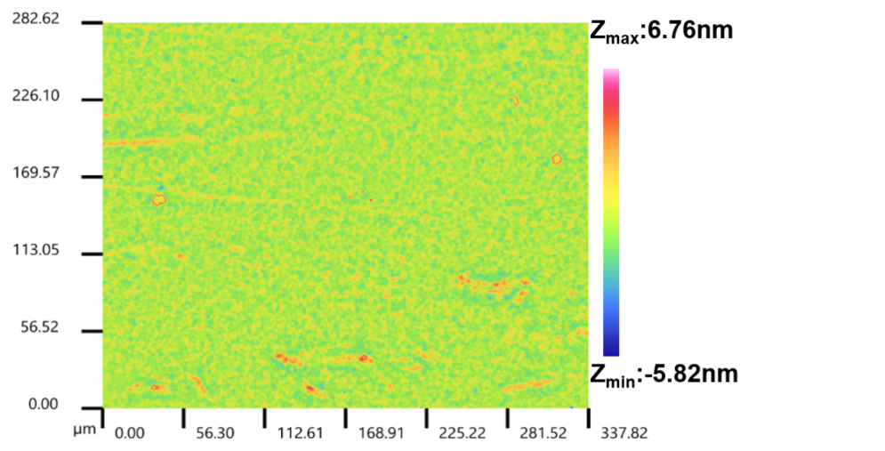
Fig. S1 White-light-interferometric surface-height map of the Al₂O₃ switching layer
The surface topography of the Al₂O₃ switching layer was examined by white-light interferometry. The scanned area of 337.82 × 282.62 μm² showed a largely uniform height distribution, with limited local variation, as shown in Fig. S1. The areal arithmetic mean roughness (Sa) was approximately 0.5 nm, indicating a smooth Al₂O₃ surface over the measured area.
S3 Additional honeybee-inspired behavioral responses
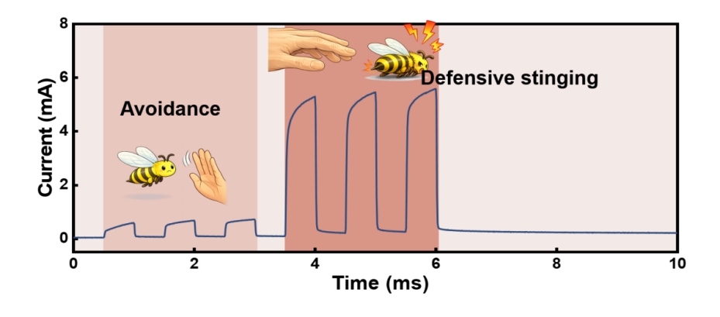
Fig. S2 Electrical representation of honeybee avoidance and defensive-stinging responses induced by 0.4 and 0.8 V pulses, respectively; the pulse interval was 0.5 ms
A constant read voltage of 0.1 V was maintained throughout the measurement. Three 0.4 V pulses with a width of 0.5 ms produced peak currents of approximately 0.60–0.72 mA, which were mapped to honeybee avoidance. Under the same timing conditions, three 0.8 V pulses generated substantially higher peak currents of approximately 5.30–5.59 mA, corresponding to defensive stinging. The amplitude-dependent current responses distinguish the two behavioral states.
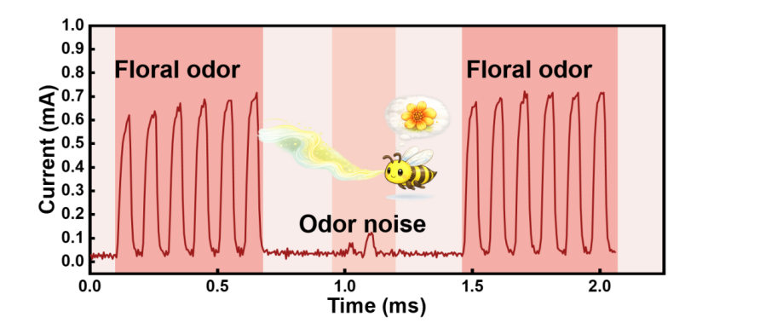
Fig. S3 Current response of the Ag/Al₂O₃/ITO device to electrical pulse sequences encoding floral odor and odor noise
To represent the discrimination between a floral odor and odor noise, the floral-odor input was encoded by six 0.8 V pulses with a pulse width and interval of 0.5 ms. A read voltage of 0.1 V was applied between consecutive pulses. As shown in Fig. S3, the first floral-odor sequence produced pronounced current responses, with peak values increasing from approximately 0.70 to 0.94 mA. The intervening odor-noise input, represented by lower voltages of 0.15–0.30 V, generated only weak current fluctuations below approximately 0.16 mA. Large periodic responses reappeared when the 0.8 V floral-odor sequence was applied again, reaching peak currents of approximately 0.91–0.99 mA. The contrast between these current levels provides an electrical representation of the two encoded olfactory states.
S4 Pulse protocol for Pavlovian conditioning
For the Pavlovian-conditioning experiment presented in Figs. 4(a)–4(d), floral odor and nectar reward were electrically encoded as the conditioned stimulus (CS) and unconditioned stimulus (US), respectively. The CS was represented by 0.4 V pulses, whereas the US was represented by 0.6 V pulses. When applied separately, each stimulus sequence contained ten pulses with a pulse width of 2 ms and an interpulse gap of 1 ms. During conditioning, ten CS–US pairs were delivered. In each pair, a 0.4 V CS pulse was applied first, followed by a 0.6 V US pulse with an onset-to-onset delay of 2 ms; both pulses had a width of 2 ms. Consecutive CS–US pairs were separated by 1 ms. After conditioning, the device response was tested using the same 0.4 V CS sequence. A peak current above 7.5 mA was taken to indicate an electrical response.
S5 CNN dataset and conductance-state mapping
Fig. S4 Fifty effective conductance states derived from measured resistance states of the Ag/Al₂O₃/ITO memristor and used for fully connected-layer weight mapping
The flower-classification task used the flower_photos dataset [1], which contains 3670 images from five categories: daisy, dandelion, rose, sunflower, and tulip. The images were divided by class-stratified random sampling into training, validation, and test subsets at a ratio of 70:15:15, corresponding to 2569, 551, and 550 images, respectively. A fixed random seed of 2026 was used for the dataset partition. The validation subset was used for model selection, whereas the held-out test subset was used only for the final comparison between the floating-point and conductance-mapped inference results.
For device-constrained weight mapping, 50 resistance states extracted from the experimentally measured LTP/LTD characteristics of the Ag/Al₂O₃/ITO memristor were converted into effective conductance states according to
$$\begin{aligned}G_{k}=\frac{1}{R_{k}+R_{s}},\#(S1)\end{aligned}$$
where $R_{k}$ is the $k$th measured resistance state and $R_{s}=10 Ω$ is the series resistance included in the mapping model. The resulting conductance values were arranged in ascending order and used as the available states for mapping the fully connected-layer weights.
References
- TensorFlow Datasets, TF Flowers. https://www.tensorflow.org/datasets/catalog/tf_flowers. Accessed 4 August 2026

