Supplementary Material

Fluorinated magnetic covalent organic framework-enhanced laser desorption/ionization mass spectrometry and imaging for determination of perfluoroalkyl ether carboxylic acids

Yanfang Zhaoª, Jun Wang^{b}, Rabah Boukherroub^{c}, Ke Jiaª, Sabine Szunerits^{c}, Lu Liuª, Xiangrong Chenª, Xiangfeng Chen*^{,a}

ªKey Laboratory for Applied Technology of Sophisticated Analytical Instruments of Shandong Province, Shandong Analysis and Test Centre, Qilu University of Technology (Shandong Academy of Sciences), Jinan, Shandong, 250014, PR China.
^{b}Key Laboratory of Supervising Technology for Meat and Meat Products, Shandong Institute for Food and Drug Control, Jinan, Shandong, 250101, China
^{c}Univ. Lille, CNRS, Univ. Polytechnique Hauts-de-France, UMR 8520, IEMN, F-59000 Lille, France

Address correspondence to:
Prof. X. F. Chen, qlgdchenxf@126.com
Contents

Fig. S1. FTIR spectra of Fe₃O₄, F-COF and Fe₃O₄@F-COF.
Fig. S2. Ultraviolet-visible spectra of Fe₃O₄, F-COF and Fe₃O₄@F-COF.
Table S1. Main peaks and LODs (S/N=3) of PFECAs obtained using Fe₃O₄@F-COF as an adsorbent and matrix in blank spring water samples.
Table S2. Main peaks and LODs (S/N=3) of PFECAs obtained using Fe₃O₄@F-COF as an adsorbent and matrix in blank human serum samples.
Table S3. Results of the recoveries of PFECAs in real samples.

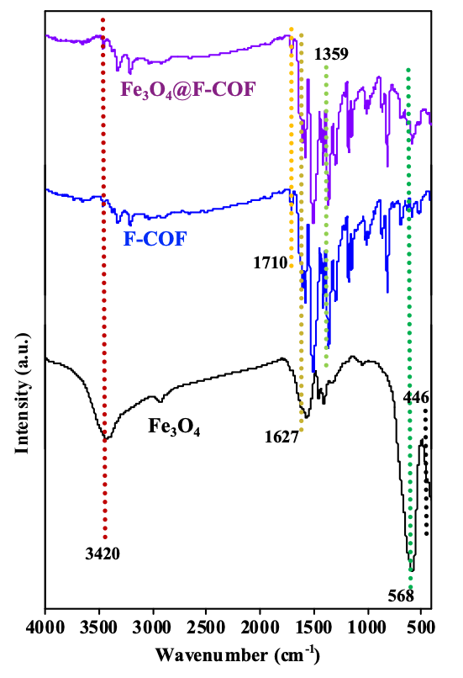
Fig. S1. FTIR spectra of Fe₃O₄, F-COF and Fe₃O₄@F-COF.

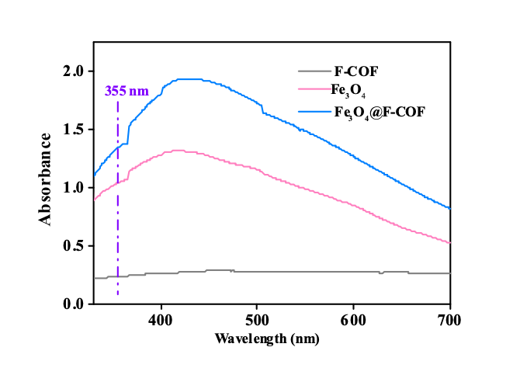
Fig. S2. Ultraviolet-visible spectra of Fe₃O₄, F-COF and Fe₃O₄@F-COF.

Table S1. Main peaks and LODs (S/N=3) of PFECAs obtained using Fe₃O₄@F-COF as an adsorbent and matrix in blank spring water samples.
Analyte | m/z | LOD  (ng/L) | LOQ  (ng/L) | Linear range  (ng/L) | Shot-to-shot RSD (%) | Sample-to-sample RSD (%)
GenX | 329.08 | 0.10 | 0.35 | 0.50–500 | 4.22 | 5.46
EEA | 345.05 | 0.075 | 0.25 | 0.30–500 | 7.26 | 10.2
ADONA | 377.07 | 0.15 | 0.45 | 0.50–500 | 9.48 | 6.65

Table S2. Main peaks and LODs (S/N = 3) of PFECAs obtained using Fe₃O₄@F-COF as an adsorbent and matrix in blank human serum samples.
Analyte | m/z | LOD  (ng/L) | LOQ  (ng/L) | Linear range  (ng/L) | Shot-to-shot RSD (%) | Sample-to-sample RSD (%)
GenX | 329.08 | 0.15 | 0.50 | 0.75–500 | 8.65 | 10.2
EEA | 345.05 | 0.10 | 0.25 | 0.50–500 | 6.44 | 8.54
ADONA | 377.07 | 0.20 | 0.75 | 1.00–500 | 6.18 | 7.23

Table S3. Results of the recoveries of PFECAs in real samples.
Analyte  Samples | GenX | EEA | ADONA
Spring water  Detection (μg/L)  Recoveryª (%)  Recovery^{b} (%)  Recovery^{c} (%)  Human serum  Detection (μg/L)  Recoveryª (%)  Recovery^{b} (%)  Recovery^{c} (%) | N.D.  90.12±4.37  96.32±5.73  83.28±1.45  N.D.  107.3±4.32  84.76±1.34  96.31±4.43 | N.D.  101.3±3.86  87.34±3.09  90.29±5.44  N.D.  83.65±1.66  114.4±4.32  105.4±4.38 | N.D.  109.4±4.54  101.7±4.87  92.36±3.76  N.D.  83.43±2.33  89.76±3.16  107.6±4.86
Spiked levels: (a) 5 ng/L; (b) 50 ng/L; (c) 250 ng/L; N.D.: not detected.

