Supplement
Supplemental Table 1: International Classification of Diseases—Clinical Modification (ICD-CM) and procedure codes used to define the metabolic syndrome and clinical outcome in the study cohort 2
Supplemental Table 2: Standardized incidence ratio by potential explanatory factors for ischemic stroke 6
Supplemental Table 3: Standardized incidence for coronary heart disease at different follow up years stratified by men and women 7
Supplemental Table 4: Standardized incidence for ischemic stroke at different follow up years stratified by men and women (A) age younger than 65 years old and older than 65 (B) 8

Supplement Figure 1: The selection of study population among thyroid cancer patients in National Taiwan Cancer Registry Database cohort from 2011 to 2016 10
Supplement Figure 2: Standardized incidence for coronary heart disease straited by men and women 11
Supplement Figure 3: Standardized incidence for coronary heart disease at different follow up years 12
Supplement Figure 4: Standardized incidence for coronary heart disease at different follow up years stratified by men and women 13
Supplement Figure 5: Standardized incidence for ischemic stroke straited by men and women 15
Supplement Figure 6: Standardized incidence for ischemic stroke at different follow up years 16
Supplement Figure 7: Standardized incidence for ischemic stroke at different follow up years stratified by men and women (A) age younger than 65 years old and older than 65 (B) 17

Supplemental Table 1: International Classification of Diseases—Clinical Modification (ICD-CM) and procedure codes used to define the metabolic syndrome and clinical outcome in the study cohort
Diagnosis | Definition | ICD-9 code | ICD-10 code | Procedure code
Coronary heart disease | Either discharge diagnosis of ICD-9 or ICD-10 or procedure code | 410 | I21.01, I21.02, I21.09, I21.11, I21.19, I22.0, I22.1 | revascularization PCI (33076B, 33077B, 33078B)  CABG(68023B, 68024B, 68025B)  N26002, N26003
Coronary heart disease |  | 411 | I20.0, I24.0, I24.1, I24.8, I24.9
Coronary heart disease |  | 414.00 | I25.10, I25.750, I25.751, I25.758, I25.759, I25.760, I25.761, I25. 768, I25.769, I25. 811, I25.812
Coronary heart disease |  | 414.01 | I25.10, I25.110, I25.111, I25.118, I25.119, I25.750, I25.751, I25.758, I25.759, I25. 811
Coronary heart disease |  | 414.02 | I25.710, I25.711, I25.718, I25.719, I25.812,
Coronary heart disease |  | 414.03 | I25.730, I25.731, I25.738, I25.739
 |  | 414.04 | I25.720, I25.721, I25.728, I25.729
 |  | 414.05 | I25.700, I25.701, I25.708, I25.709, I25.730, I25.731, I25.738, I25.739, I25.760, I25.761, I25.768, I25.769, I25.790, I25.791, I25.798, I25.799, I25.810, I25.812
 |  | v45.81 | Z95.1
 |  | v45.82 | Z95.5, Z98.61, Z95.8,

Supplement Table 1. (Continued)
Diagnosis | Definition | ICD-9 | ICD-10 | Procedure
Ischemic Stroke | discharge diagnosis of ICD-9 or ICD-10 | 433 | 165.1,I63.02, I63.12, I65.21, I63.22, I65.1, I65.23, I65.29 , I63.031, I63.032, I63.039, I63.131, I63.132, I63.139, I63.231, I63.232, I63.239, I65.01, I65.02, I65.03, , I65.09, I63.011, I63.012, I63.019, I65.22, I63.111, I63.112, I63.119, I63.211, I63.212, I63.219, I65.8, 163.09, I63.19, I63.59, I65.9, I63.00, 163.10, I63.20, I63.29
Ischemic Stroke | discharge diagnosis of ICD-9 or ICD-10 | 434 | I66.01, I66.02, I66.03, I66.09, I66.11, I66.12, I66.13, I66.19, I66.21, I66.22, I66.23, I66.29, I66.3, I63.30, I63.311, I63.312, I63.319, I63.321, I63.322, I63.329, I63.331, I63.332, I63.339, I63.341, I63.342, I63.349, I63.39, I63.6, I66.01, I66.02, I66.03, I66.09, I66.11, I66.12, I66.13, I66.19, I66.21, I66.22, I66.23, I66.29, I66.3, I66.9, I66.40, I66.411, I66.412, I66.419, I66.421, I66.422, I66.429, I66.431, I66.432, I66.439, I66.441, I66.442, I66.449, I66.49, I66.01, I66.02, I66.03, I66.09, I66.11, I66.12, I66.13, I66.19, I66.21, I66.22, I66.23, I66.29, I66.3, I66.8, I66.9, I63.50, I63.511, I63.512, I63.519, I63.521, I63.522, I63.529, I63.531, I63.532, I63.539, I63.541, I63.542, I63.549, I63.59, I63.8, I63.9
Ischemic Stroke | discharge diagnosis of ICD-9 or ICD-10 | 435 | G45.0,G45.8,G45.1,G45.2,G46.0, G46.1, G46.2, G45.9, I67.841, I67.848
Ischemic Stroke | discharge diagnosis of ICD-9 or ICD-10 | 436 | I67.89
Ischemic Stroke | discharge diagnosis of ICD-9 or ICD-10 | 4371 | I67.81, I67.82, I67.89
Ischemic Stroke | discharge diagnosis of ICD-9 or ICD-10 | 4379 | I67.9

Supplement Table 1. (Continued)
Diagnosis | Definition | ICD-9 code | ICD-10 code | Procedure code
Atrial fibrillation | ≥2 Outpatient department or ≥1 discharge diagnosis of ICD-9 or ICD-10 | 427.31 | i48.0, i48.1, i48.2, i48.9
CABG, Coronary artery bypass graft; PCI, Percutaneous coronary intervention

Supplemental Table 2: Standardized incidence ratio by potential explanatory factors for ischemic stroke
Subgroup | Incidence events | SIR | 95% CI
 |  |  | Lower | Upper
All | 30 | 0.74 | 0.47 | 1
Age at diagnosis
< 65 | 17 | 0.89 | 0.47 | 1.32
≧ 65 | 13 | 0.6 | 0.27 | 0.92
Sex
Men | 10 | 0.72 | 0.27 | 1.17
Men: 20~39 | 0 | . | . | .
Men: 40~64 | 3 | 0.35 | 0 | 0.75
Men: ≧ 65 | 7 | 1.08 | 0.28 | 1.89
Women | 20 | 0.74 | 0.42 | 1.07
Women: 20~39 | 1 | 1.66 | 0 | 4.9
Women: 40~64 | 13 | 0.98 | 0.45 | 1.51
Women: ≧ 65 | 6 | 0.38 | 0.08 | 0.69
Follow-up (years)
1 | 7 | 0.6 | 0.15 | 1.04
2 | 15 | 0.66 | 0.32 | 0.99
3 | 20 | 0.63 | 0.35 | 0.9
4 | 26 | 0.69 | 0.42 | 0.95
5 | 30 | 0.74 | 0.47 | 1

Supplemental Table 3: Standardized incidence for coronary heart disease at different follow up years stratified by men and women
 | Men |  |  |  | Women
Follow-up (years) | Incidence events | SIR | 95% CI |  | Incidence events | SIR | 95% CI
 |  |  | Lower | Upper |  |  | Lower | Upper
1 | 9 | 1.8 | 0.63 | 2.98 | 18 | 2.21 | 1.19 | 3.23
2 | 15 | 1.53 | 0.76 | 2.3 | 27 | 1.73 | 1.08 | 2.38
3 | 20 | 1.47 | 0.82 | 2.11 | 33 | 1.52 | 1 | 2.03
4 | 27 | 1.68 | 1.05 | 2.31 | 40 | 1.56 | 1.07 | 2.04
5 | 28 | 1.63 | 1.03 | 2.24 | 42 | 1.53 | 1.06 | 1.99

Supplemental Table 4: Standardized incidence for ischemic stroke at different follow up years stratified by men and women (A) age younger than 65 years old and older than 65 (B)
A)
 | Men |  |  |  | Women
Follow-up (years) | Incidence events | SIR | 95% CI |  | Incidence events | SIR | 95% CI
 |  |  | Lower | Upper |  |  | Lower | Upper
1 | ≦5 | 0.49 | 0 | 1.17 | ≦5 | 0.65 | 0.08 | 1.23
2 | 6 | 0.76 | 0.15 | 1.37 | 9 | 0.6 | 0.21 | 1
3 | 8 | 0.73 | 0.22 | 1.23 | 12 | 0.57 | 0.25 | 0.9
4 | 10 | 0.77 | 0.29 | 1.25 | 16 | 0.64 | 0.33 | 0.96
5 | 10 | 0.72 | 0.27 | 1.17 | 20 | 0.74 | 0.42 | 1.07

(B)
 | Age < 65 years old |  |  |  |  | Age >= 65 years old
Follow-up (years) | Incidence events |  | SIR | 95% CI |  | Incidence events | SIR | 95% CI
 |  |  |  | Lower | Upper |  |  | Lower | Upper
1 | ≦5 |  | 0.59 | 0 | 1.26 | ≦5 | 0.6 | 0.01 | 1.19
2 | 7 |  | 0.69 | 0.18 | 1.2 | 8 | 0.63 | 0.19 | 1.07
3 | 11 |  | 0.75 | 0.31 | 1.2 | 9 | 0.52 | 0.18 | 0.86
4 | 15 |  | 0.86 | 0.42 | 1.29 | 11 | 0.54 | 0.22 | 0.86
5 | 17 |  | 0.89 | 0.47 | 1.32 | 13 | 0.6 | 0.27 | 0.92

Supplement Figure
Supplement Figure 1: The selection of study population among thyroid cancer patients in National Taiwan Cancer Registry Database cohort from 2011 to 2016

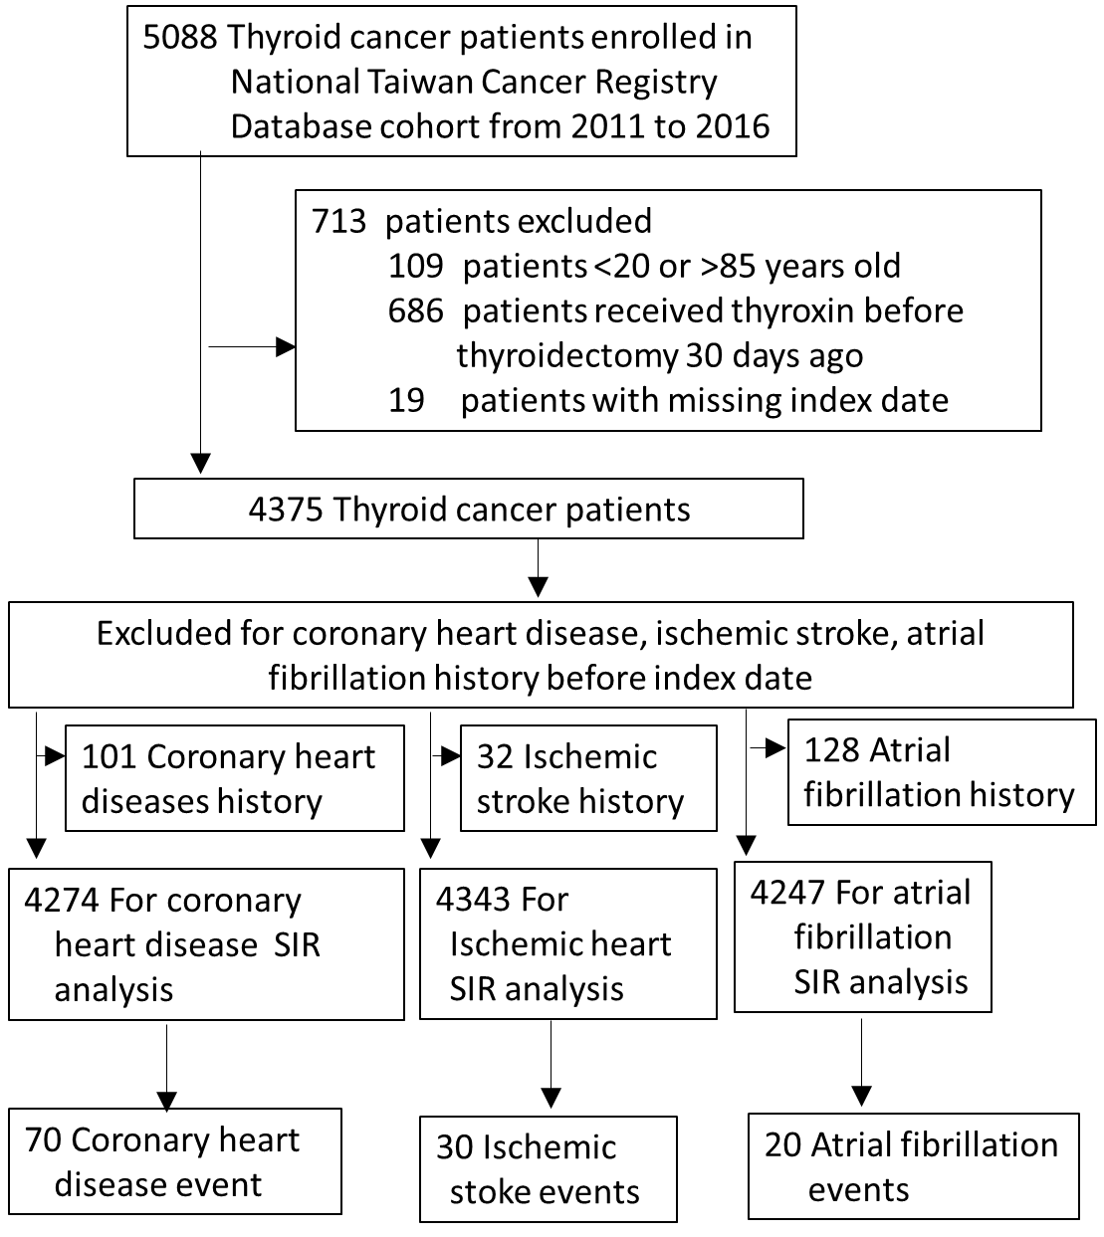
Abbreviations: SIR, standardized incidence ratios;

Supplement Figure 2: Standardized incidence for coronary heart disease straited by men and women
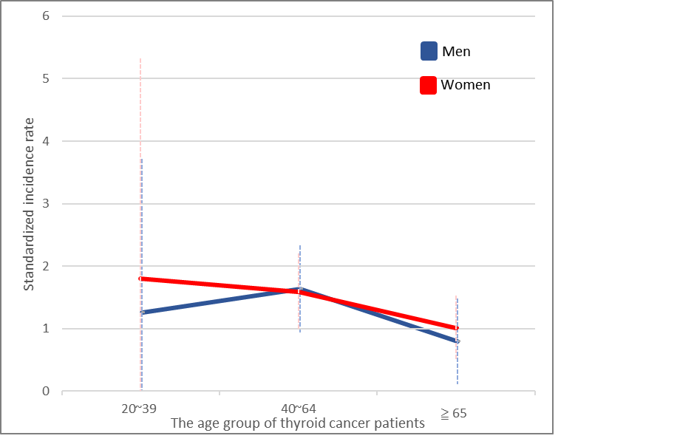

Supplement Figure 3: Standardized incidence for coronary heart disease at different follow up years
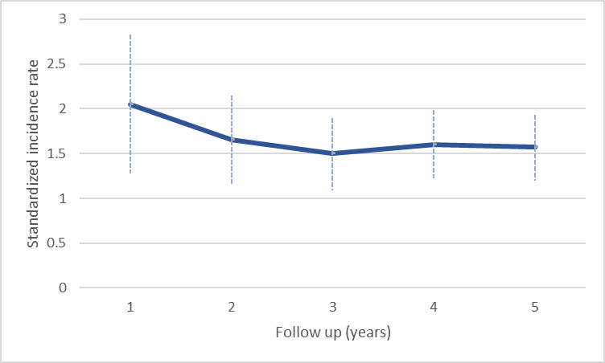)
Supplement Figure 4: Standardized incidence for coronary heart disease at different follow up years stratified by men and women
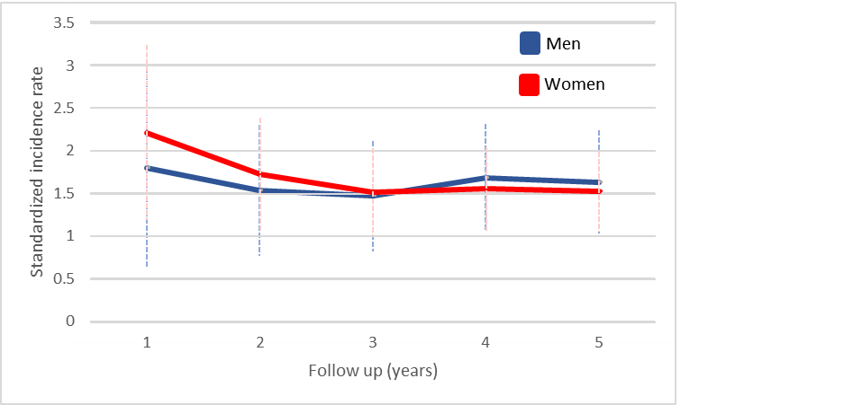

Supplement Figure 5: Standardized incidence for ischemic stroke straited by men and women
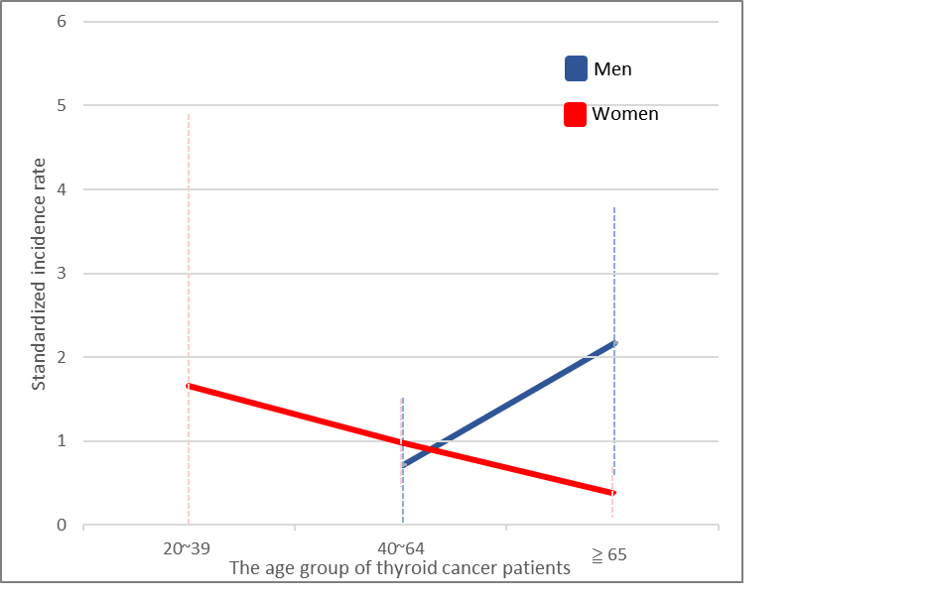
Supplement Figure 6: Standardized incidence for ischemic stroke at different follow up years
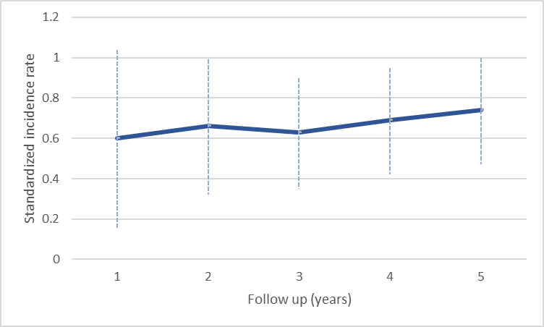
Supplement Figure 7: Standardized incidence for ischemic stroke at different follow up years stratified by men and women (A) age younger than 65 years old and older than 65 (B)
(A)
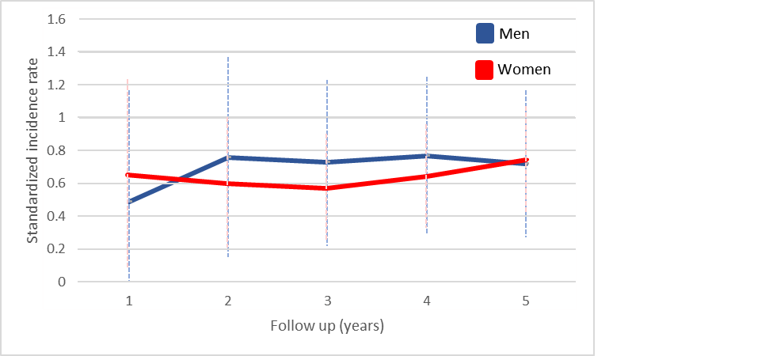
(B)
