- Supplementary materials -
Validation of Image-Derived Input Function for Non-Invasive Kinetic Modeling of [¹⁸F]-Fluorodeprenyl-D2 in Neurological Diseases

Lukas Frontzkowski¹, Nicolai Franzmeier¹, Letizia Vogler², Thomas Saller³, Simon Lindner², Marianthi Zeinaki², Benjamin Kugelmann², Artem Zatcepin^{2,4,5}, Gloria Mueller², Alexander Jäck⁶, Ilias Masouris⁶, Boris-Stephan Rauchmann^{5,7,8,9}, Sowmitha Raju², Nathalie Albert², Lisa Tagnin², David Vállez García¹⁰, Gemma Salvadó¹⁰, Gérard Nisal Bischof^{11,12}, Lena Kaiser², Robert Perneczky^{5,8,9,13,14}, Günter Höglinger^{5,6,8}, Johannes Levin^{5,6,8}, Sybille Ziegler^{2,4}, Adrian Jun Zounek^{2*}, Matthias Brendel^{2,5,8*}
¹Institute for Stroke and Dementia (ISD), LMU University Hospital, LMU Medizin, Ludwig-Maximilians-Universität München, Munich, Germany
²Department of Nuclear Medicine, LMU University Hospital, LMU Medizin, Ludwig-Maximilians-Universität München, Munich, Germany
³Department of Anaesthesiology, LMU University Hospital, LMU Medizin, Ludwig-Maximilians-Universität München, Munich, Germany
⁴Department of Nuclear Medicine, Hannover Medical School (MHH), Hannover, Germany
⁵German Center for Neurodegenerative Diseases (DZNE), Munich, Germany
⁶Department of Neurology, LMU University Hospital, LMU Medizin, Ludwig-Maximilians-Universität München, Munich, Germany
⁷Institute of Neuroradiology, LMU University Hospital, LMU Medizin, Ludwig-Maximilians-Universität München, Munich, Germany
⁸Munich Cluster for Systems Neurology (SyNergy), Munich, Germany
⁹Department of Psychiatry and Psychotherapy, LMU Hospital, LMU Munich, 81377 Munich, Germany
¹⁰Barcelonaβeta Brain Research Center, Pasqual Maragall Foundation, Barcelona, Spain
¹¹Department of Nuclear Medicine, University Hospital Cologne, Cologne, Germany
¹²Life Molecular Imaging GmbH, a Lantheus Company, Berlin, Germany
¹³Ageing Epidemiology (AGE) Research Unit, School of Public Health, Imperial College, London, UK
¹⁴International Registry for Alzheimer´s Disease and Other Dementias (InRAD) Foundation, Deventer, Netherlands

Corresponding Author
Dr. med. Lukas Frontzkowski
Institute for Stroke and Dementia (ISD), University Hospital, LMU Munich
Marchioninistr. 15, 81377 Munich, Germany
lukas.frontzkowski@med.uni-muenchen.de
* shared senior author

Keywords: [¹⁸F]F-DED · MAO-B · image-derived input function · IDIF · Patlak graphical analysis · PET quantification
Word count: -
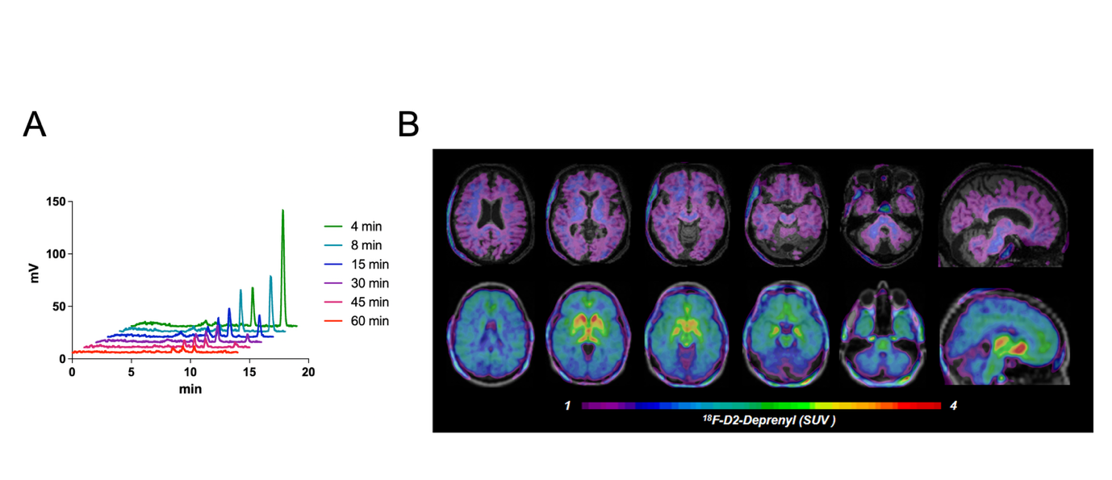
Supplementary Figure 1
Supplementary Figure 1 (A) High-performance liquid chromatography (HPLC) radio-chromatograms of arterial plasma from a representative subject, acquired at six sampling times after [¹⁸F]F-DED injection (4-60 min; colour-coded), with HPLC retention time on the x-axis. The intact parent tracer (right peak) elutes at the latest retention time, while three more polar (hydrophilic), presumably non-brain-penetrant radiometabolites are present until 60 min p.i.. (B) 30-60 min standardized-uptake-value (SUV) normalized [¹⁸F]F-DED images show no specific binding pattern in a patient with Parkinson’s disease treated with Rasaglinie (MAOB blocker) in the upper row, whereas a specific MAOB binding pattern (highest signal in the caudate nucleus, lowest signal in the cerebellum) is present in a Patient with Parkinson’s disease not receiving any MAOB related treatment. Together with the radiometabolite analysis (A), lacking of a specific binding pattern under MAOB blockade indicates no relevant brain uptake of radiometabolites, in line with their polar profile.

Supplementary Figure 2
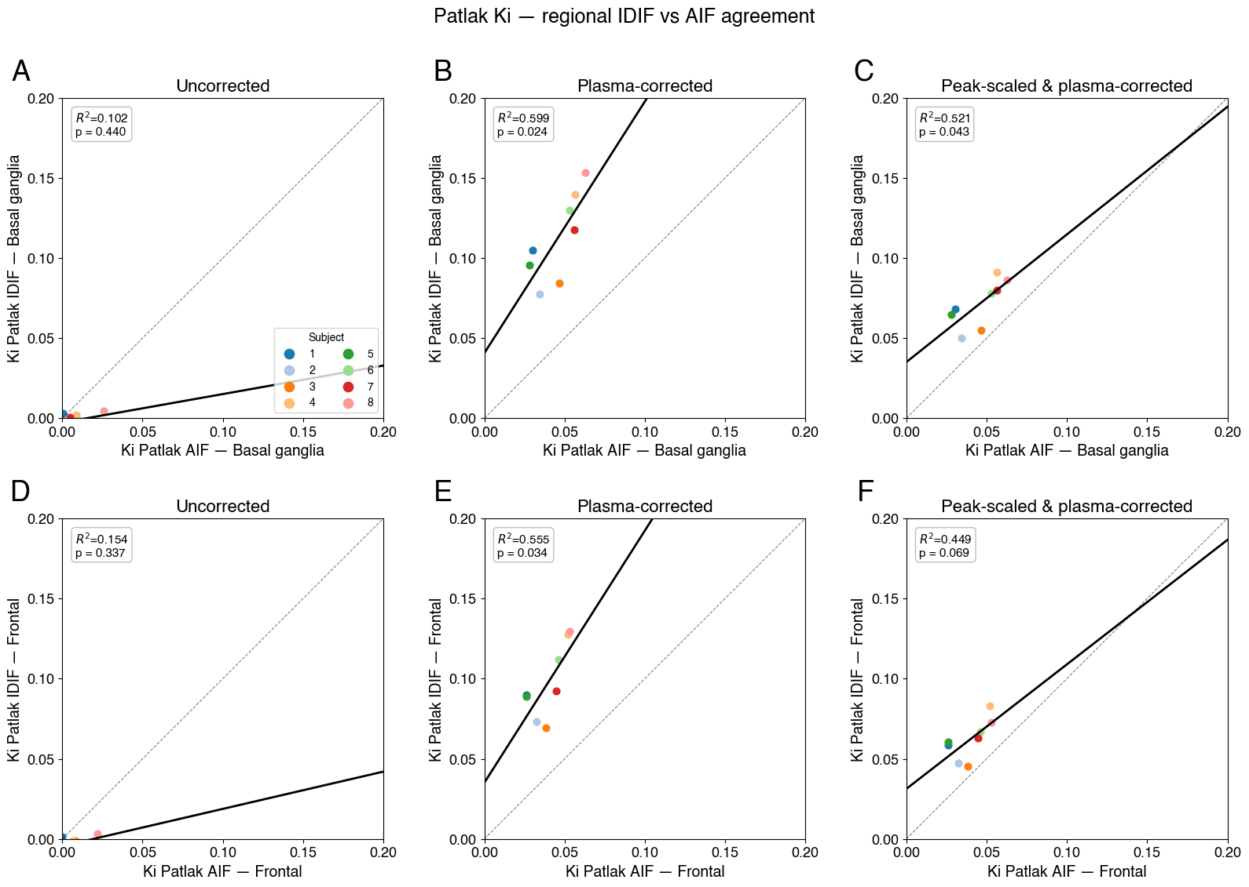
Supplementary Figure 2: Region-level agreement between IDIF- and AIF-derived net influx constant (Ki) estimated by Patlak modeling. Each panel plots the regional Ki obtained from the IDIF (y-axis) against the AIF reference (x-axis); each point is one subject and colours denote the eight subjects. Rows correspond to the two regions - basal ganglia (top, A-C) and frontal cortex (bottom, D-F) - and columns to the three input conditions: uncorrected (A, D), plasma- and metabolite-corrected (B, E), and peak-scaled plus plasma-corrected (C, F). For the uncorrected condition the IDIF and AIF are both unprocessed (raw), whereas the plasma-corrected and peak-scaled conditions use the plasma- and metabolite-corrected AIF as reference. The solid black line is the linear regression across subjects and the dashed line the line of identity; the coefficient of determination (R²) and regression p-value are inset in each panel.

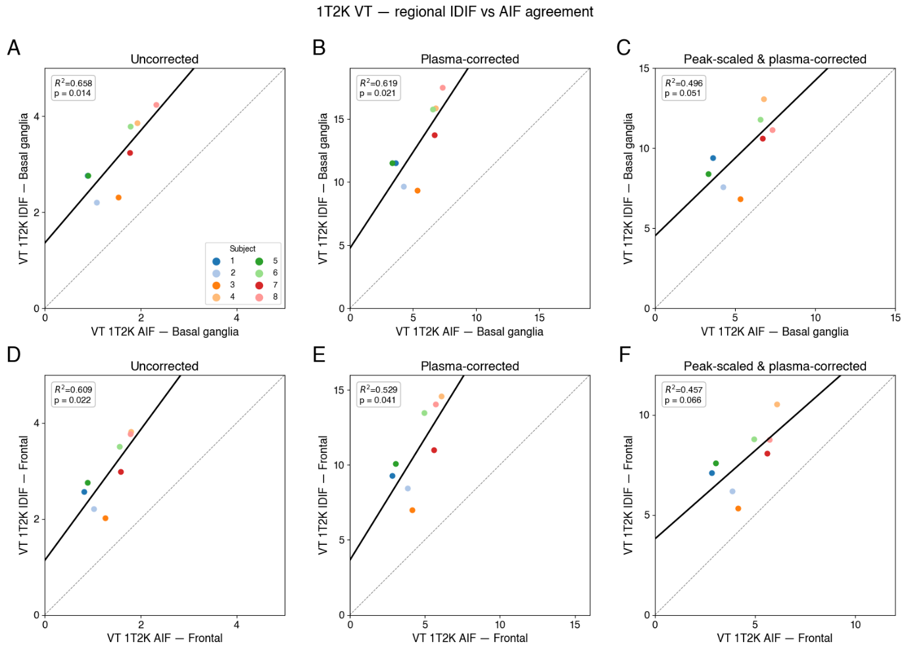
Supplementary Figure 3

Supplementary Figure 3: Region-level agreement between IDIF- and AIF-derived total distribution volume (VT) estimated by 1T2K modeling. Each panel plots the regional VT obtained from the IDIF (y-axis) against the AIF reference (x-axis); each point is one subject and colours denote the eight subjects. Rows correspond to the two regions - basal ganglia (top, A-C) and frontal cortex (bottom, D-F) - and columns to the three input conditions: uncorrected (A, D), plasma- and metabolite-corrected (B, E), and peak-scaled plus plasma-corrected (C, F). For the uncorrected condition the IDIF and AIF are both unprocessed (raw), whereas the plasma-corrected and peak-scaled conditions use the plasma- and metabolite-corrected AIF as reference. The solid black line is the linear regression across subjects and the dashed line the line of identity; the coefficient of determination (R²) and regression p-value are inset in each panel.

