SUPPLEMENTARY INFORMATION
Supplementary Table 1: SMILES notation of hydroxyethylamine derivatives and their anti-Alzheimer’s activities
ID | Molecular Structures (SMILES) | IC₅₀ (µM) | pIC₅₀
1 | C1CCC2=NC3=CC=CC=C3C(=C2C1)N | 0.015 | 7.8239
2 | COC1=C(C=C2C(=C1)CC(C2=O)CC3CCN(CC3)CC4=CC=CC=C4)OC | 1.83 | 5.7375
3 | C1=CC=C(C=C1)C[C@@H]([C@H](CNCC2=CC=CC=C2)O)NC(=O)CC(C3=CC=CC=C3)C4=CC=CC=C4 | 2.94 | 5.5317
4 | C[C@@H](C1=CC=CC=C1)NC[C@H]([C@H](CC2=CC=CC=C2)NCC(C3=CC=CC=C3)C4=CC=CC=C4)O | 0.95 | 6.0223
5 | C1=CC=C(C=C1)C[C@@H]([C@@H](CNCC2=CC=CC=C2)O)NCCC(C3=CC=CC=C3)C4=CC=CC=C4 | 1.54 | 5.8125
6 | CC(C)(C)C1=CC=C(C=C1)CNC[C@@H]([C@H](CC2=CC=CC=C2)NC(=O)C(C3=CC=CC=C3)C4=CC=CC=C4)O | 3.44 | 5.4634
7 | CC(C)C1=CC=CC(=C1)CNC[C@H]([C@H](CC2=CC=CC=C2)NC(=O)C(C3=CC=CC=C3)C4=CC=CC=C4)O | 0.5 | 6.3010
8 | CC(C)C1=CC=CC(=C1)CNC[C@H]([C@H](CC2=CC=CC=C2)NCCC(C3=CC=CC=C3)C4=CC=CC=C4)O | 1.84 | 5.7352
9 | C1CC1CNC[C@H]([C@H](CC2=CC=CC=C2)NC(=O)C(C3=CC=CC=C3)C4=CC=CC=C4)O | 3.21 | 5.4935
10 | C1=CC=C(C=C1)C[C@@H]([C@H](CNCC2=CC(=CC=C2)C(F)(F)F)O)NC(=O)C(C3=CC=CC=C3)C4=CC=CC=C4 | 0.39 | 6.4089
11 | CC(C)(C)CNC[C@H]([C@H](CC1=CC=CC=C1)NC(=O)CC(C2=CC=CC=C2)C3=CC=CC=C3)O | 2.77 | 5.5575
12 | CC(C)(C)NC[C@@H]([C@H](CC1=CC=CC=C1)NC(=O)C(C2=CC=CC=C2)C3=CC=CC=C3)O | 0.84 | 6.0757
13 | CC(C)(C)C1=CC=CC(=C1)CNC[C@H]([C@H](CC2=CC=CC=C2)NC(=O)CC(C3=CC=CC=C3)C4=CC=CC=C4)O | 0.45 | 6.3468
14 | C[C@@H](C1=CC=CC=C1)NC[C@H]([C@H](CC2=CC=CC=C2)NC(=O)C(C3=CC=CC=C3)C4=CC=CC=C4)O | 1.82 | 5.7399
15 | CC(C)(C)C1=CC=CC(=C1)CNCC(CNCCC(C2=CC=CC=C2)C3=CC=CC=C3)O | 2.92 | 5.5346
16 | CC(C)(C)C1=CC=C(C=C1)CNC[C@H]([C@H](CC2=CC=CC=C2)NC(=O)CC(C3=CC=CC=C3)C4=CC=CC=C4)O | 0.17 | 6.7696
17 | C1=CC=C(C=C1)C[C@@H]([C@@H](CNCC2=CC=CC=C2)O)NCC(C3=CC=CC=C3)C4=CC=CC=C4 | 0.95 | 6.0223
18 | CC(C)(C)CNC[C@H]([C@H](CC1=CC=CC=C1)NC(=O)C(C2=CC=CC=C2)C3=CC=CC=C3)O | 0.1 | 7.0000
19 | COC1=CC=CC=C1CNC[C@@H]([C@H](CC2=CC=CC=C2)NC(=O)CC(C3=CC=CC=C3)C4=CC=CC=C4)O | 0.33 | 6.4815
20 | C1=CC=C(C=C1)C[C@@H]([C@H](CNCC2=CC=CC=C2)O)NC(=O)C(C3=CC=CC=C3)C4=CC=CC=C4 | 0.23 | 6.6383
21 | CC(C)C1=CC=CC(=C1)CNC[C@@H]([C@H](CC2=CC=CC=C2)NC(=O)C(C3=CC=CC=C3)C4=CC=CC=C4)O | 0.2 | 6.6990
22 | COC1=CC=CC(=C1)CNC[C@H]([C@H](CC2=CC=CC=C2)NC(=O)C(C3=CC=CC=C3)C4=CC=CC=C4)O | 1.55 | 5.8097
23 | CC(C)(C)NC[C@@H]([C@H](CC1=CC=CC=C1)NCCC(C2=CC=CC=C2)C3=CC=CC=C3)O | 0.19 | 6.7212
24 | C[C@@H](C1=CC=CC=C1)NC[C@H]([C@H](CC2=CC=CC=C2)NCCC(C3=CC=CC=C3)C4=CC=CC=C4)O | 0.98 | 6.0088
25 | COC1=CC=CC=C1CNC[C@@H]([C@H](CC2=CC=CC=C2)NCC(C3=CC=CC=C3)C4=CC=CC=C4)O | 0.32 | 6.4949
26 | CC(C)(C)CNC[C@H]([C@H](CC1=CC=CC=C1)NCC(C2=CC=CC=C2)C3=CC=CC=C3)O | 0.59 | 6.2291
27 | COC1=CC=CC(=C1)CNC[C@H]([C@H](CC2=CC=CC=C2)NCCC(C3=CC=CC=C3)C4=CC=CC=C4)O | 2.04 | 5.6904
28 | COC1=CC=CC=C1CNC[C@@H]([C@H](CC2=CC=CC=C2)NC(=O)C(C3=CC=CC=C3)C4=CC=CC=C4)O | 0.11 | 6.9586
29 | C1=CC=C(C=C1)C[C@@H]([C@H](CNCC2=CC=CC=C2)O)NCCC(C3=CC=CC=C3)C4=CC=CC=C4 | 0.65 | 6.1871
30 | C1=CC=C(C=C1)C[C@@H]([C@@H](CNCC2=CC=CC=C2)O)NC(=O)CC(C3=CC=CC=C3)C4=CC=CC=C4 | 1.38 | 5.8601
31 | C1CC1CNC[C@H]([C@H](CC2=CC=CC=C2)NC(=O)CC(C3=CC=CC=C3)C4=CC=CC=C4)O | 3.23 | 5.4908
32 | C[C@@H](C1=CC=CC=C1)NC[C@H]([C@H](CC2=CC=CC=C2)NC(=O)CC(C3=CC=CC=C3)C4=CC=CC=C4)O | 8.86 | 5.0526
33 | CC(C)(C1=CC=CC=C1)NC[C@H]([C@H](CC2=CC=CC=C2)NC(=O)CC(C3=CC=CC=C3)C4=CC=CC=C4)O | 3.23 | 5.4908
34 | COC1=CC=CC=C1CNC[C@@H]([C@H](CC2=CC=CC=C2)NCCC(C3=CC=CC=C3)C4=CC=CC=C4)O | 1.01 | 5.9957
35 | C1=CC=C(C=C1)C[C@@H]([C@@H](CNCC2=CC=CC=C2)O)NC(=O)C(C3=CC=CC=C3)C4=CC=CC=C4 | 1.51 | 5.8210
36 | CC(C)C1=CC=CC(=C1)CNC[C@H]([C@H](CC2=CC=CC=C2)NC(=O)CC(C3=CC=CC=C3)C4=CC=CC=C4)O | 0.65 | 6.1871
37 | CC(C)(C1=CC=CC=C1)NC[C@H]([C@H](CC2=CC=CC=C2)NCCC(C3=CC=CC=C3)C4=CC=CC=C4)O | 1.6 | 5.7959
38 | CC(C)(C)C1=CC=CC(=C1)CNC[C@H]([C@H](CC2=CC=CC=C2)NC(=O)C(C3=CC=CC=C3)C4=CC=CC=C4)O | 0.06 | 7.2218
39 | COC1=CC=CC(=C1)CNC[C@H]([C@H](CC2=CC=CC=C2)NC(=O)CC(C3=CC=CC=C3)C4=CC=CC=C4)O | 1.28 | 5.8928

Supplementary Table 2: SMILES notation of designed analogs of template compound 10 from hydroxyethylamine derivatives
S/N | Ligands
Template Ligand 10 | C1=CC=C(C=C1)C[C@@H]([C@H](CNCC2=CC(=CC=C2)C(F)(F)F)O)NC(=O)C(C3=CC=CC=C3)C4=CC=CC=C4
1 | C1=CC=C(C=C1)C[C@@H]([C@H](CNCC2=CC(=CC=C2)C(F)(F)F)O)NC(=O)C(C3=CC=NC=C3)C4=CC=NC=C4
2 | C1=CC=C(C=C1)C[C@@H]([C@H](CNCC2=CC(=CC=C2)C(F)(F)F)O)NC(=O)CC3=CC=CC=C3
3 | C1=CC=C(C=C1)C[C@@H]([C@H](CNCC2=CC(=CC=C2)C(F)(F)F)O)NC(=O)C(C3=CC=CC=C3)N4CCOCC4
4 | C1=CC=C(C=C1)C[C@@H]([C@H](CNCC2=CC(=CC=C2)C#N)O)NC(=O)C(C3=CC=CC=C3)C4=CC=NC=C4
5 | C1=CC=C(C=C1)C[C@@H]([C@H](CNCC2=CC(=CC=C2)C(F)(F)F)O)NC(=O)C3CCCO3
6 | C1=CC=C(C=C1)C[C@@H]([C@H](CNCC2=CC(=CC=C2)C#N)O)NC(=O)C(C3=CC=CC=C3)N4CCOCC4
7 | C1=CC=C(C=C1)C[C@@H]([C@H](CNCC2=CC(=CC=C2)C(F)(F)F)O)NC(=O)C3=CNC4=CC=CC=C34
8 | C1=CC=C(C=C1)C[C@@H]([C@H](CNCC2=CC(=CC=C2)F)O)NC(=O)C(C3=CC=NC=C3)C4=CC=NC=C4
9 | C1=CC=C(C=C1)C[C@@H]([C@H](CNCC2=CC=CC=C2)O)NC(=O)CC3=CC=CC=C3
10 | C1=CC=C(C=C1)C[C@@H]([C@H](CN1CCOCC1)O)NC(=O)C(C3=CC=CC=C3)C4=CC=CC=C4

Supplementary Table 3
Key hydrogen bond occupancies (>2.0%) across the 200 ns MD trajectories
Compound | Donor Atom | Acceptor Atom | Occupancy (%) | Interaction Type
Donepezil | VAL111-Side | UNL1-Side | 6.50% | Sidechain–Sidechain
 | UNL1-Main | TRP386-Side | 19.85% | Backbone–Sidechain
 | UNL1-Side | TRP386-Side | 2.70% | Sidechain–Sidechain
 | THR412-Side | UNL1-Side | 15.70% | Sidechain–Sidechain
 | VAL111-Main | UNL1-Side | 2.50% | Sidechain–Backbone
B2 | UNL1-Side | ASP114-Side | 118.60% | Sidechain–Sidechain
 | PHE390-Side | UNL1-Side | 4.25% | Sidechain–Sidechain
 | CYS118-Side | UNL1-Side | 2.75% | Sidechain–Sidechain
B5 | UNL1-Side | ASP114-Side | 23.30% | Sidechain–Sidechain
 | CYS118-Side | UNL1-Side | 8.75% | Sidechain–Sidechain
 | UNL1-Side | THR412-Side | 2.70% | Sidechain–Sidechain
Template L10 | UNL1-Side | TYR416-Side | 4.60% | Sidechain–Sidechain
 | UNL1-Side | ASP114-Side | 78.55% | Sidechain–Sidechain
 | CYS118-Side | UNL1-Side | 3.80% | Sidechain–Sidechain
 | PHE390-Side | UNL1-Side | 3.60% | Sidechain–Sidechain
 | PHE198-Side | UNL1-Side | 2.20% | Sidechain–Sidechain
 | UNL1-Side | TRP386-Side | 2.65% | Sidechain–Sidechain
 | TYR416-Side | UNL1-Side | 2.70% | Sidechain–Sidechain

Supplementary Table 3

Variance captured by the first two principal components (PC1 and PC2) for each protein–ligand complex
Complex | PC1 variance (%) | PC2 variance (%) | Total subspace variance captured (%)
Donepezil | 69.97 | 12.66 | 82.63
B2 | 57.18 | 18.73 | 75.91
B5 | 78.09 | 9.19 | 87.28
Template ligand 10 | 69.55 | 10.63 | 80.18

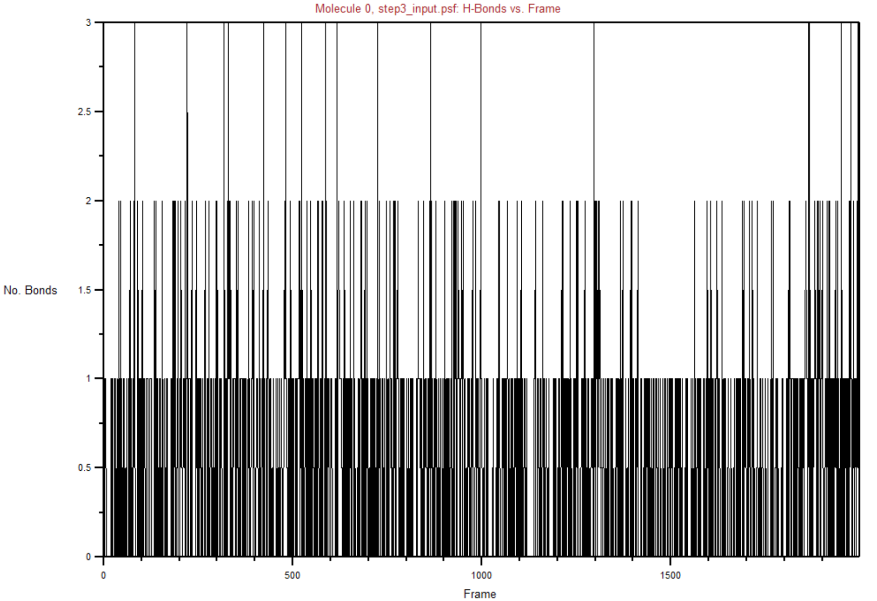
Donepezil
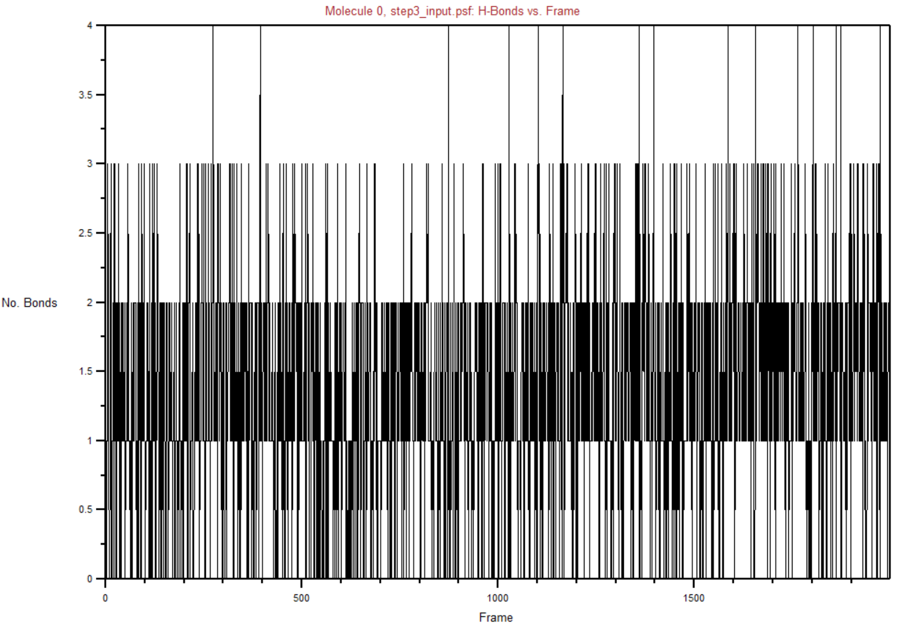
B2
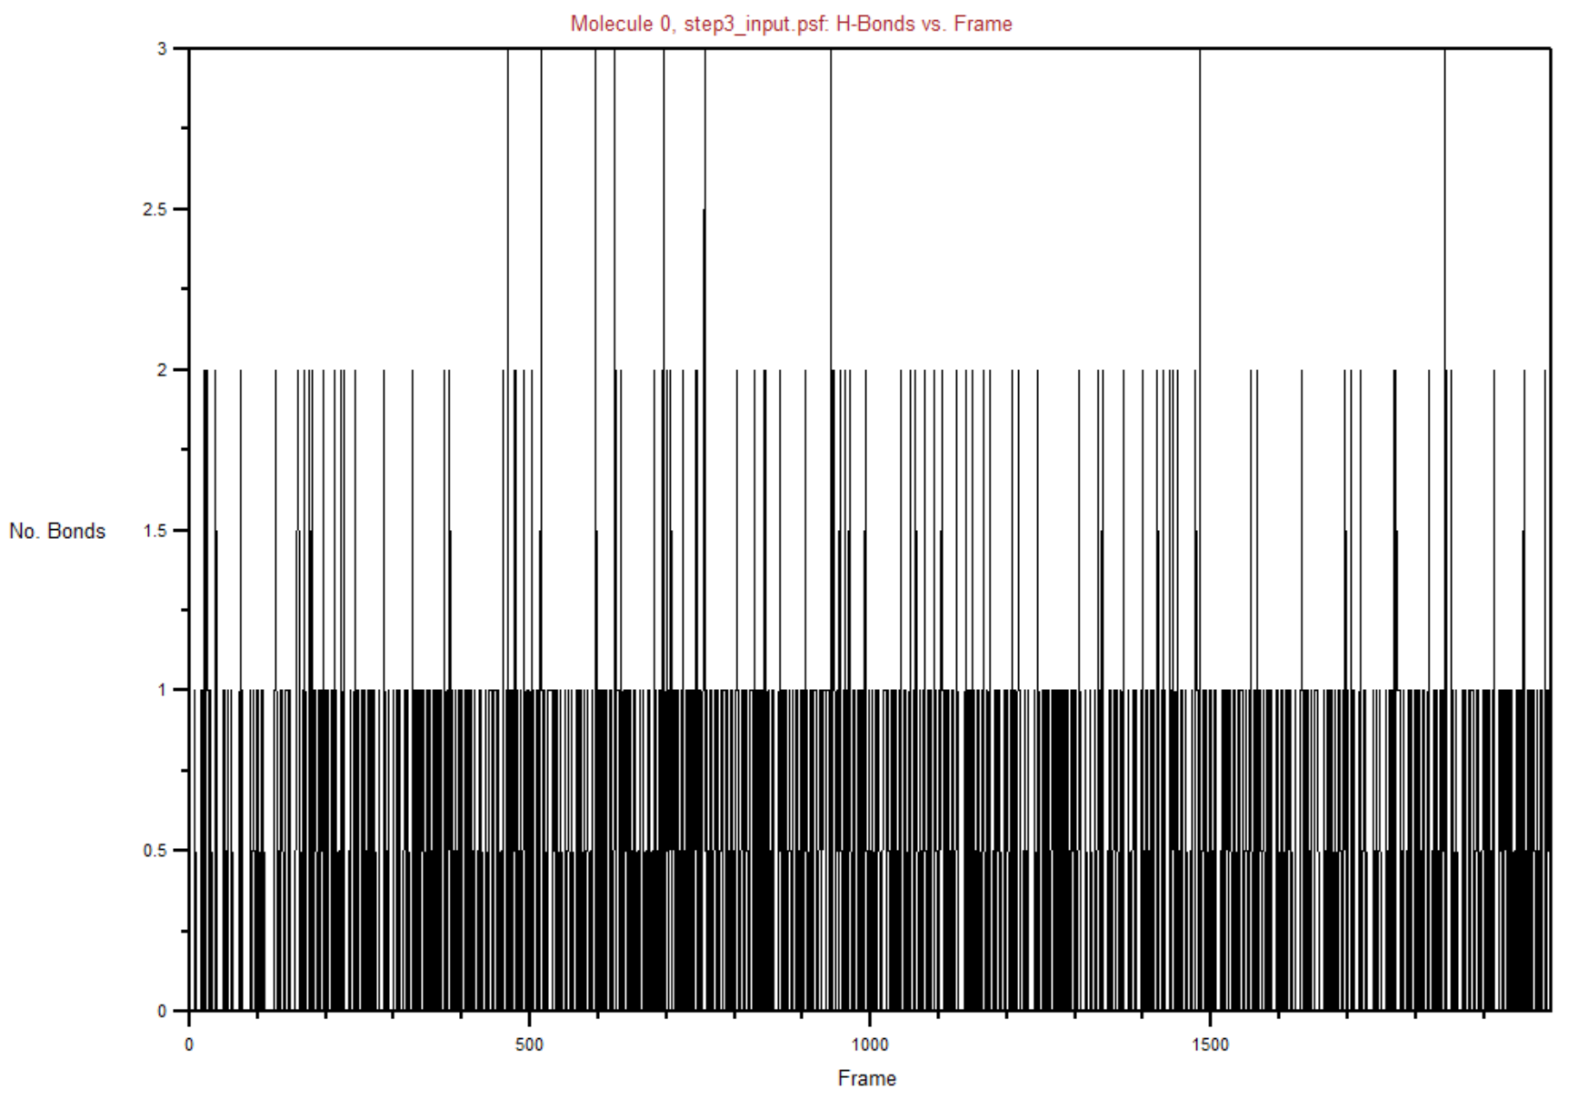
B5
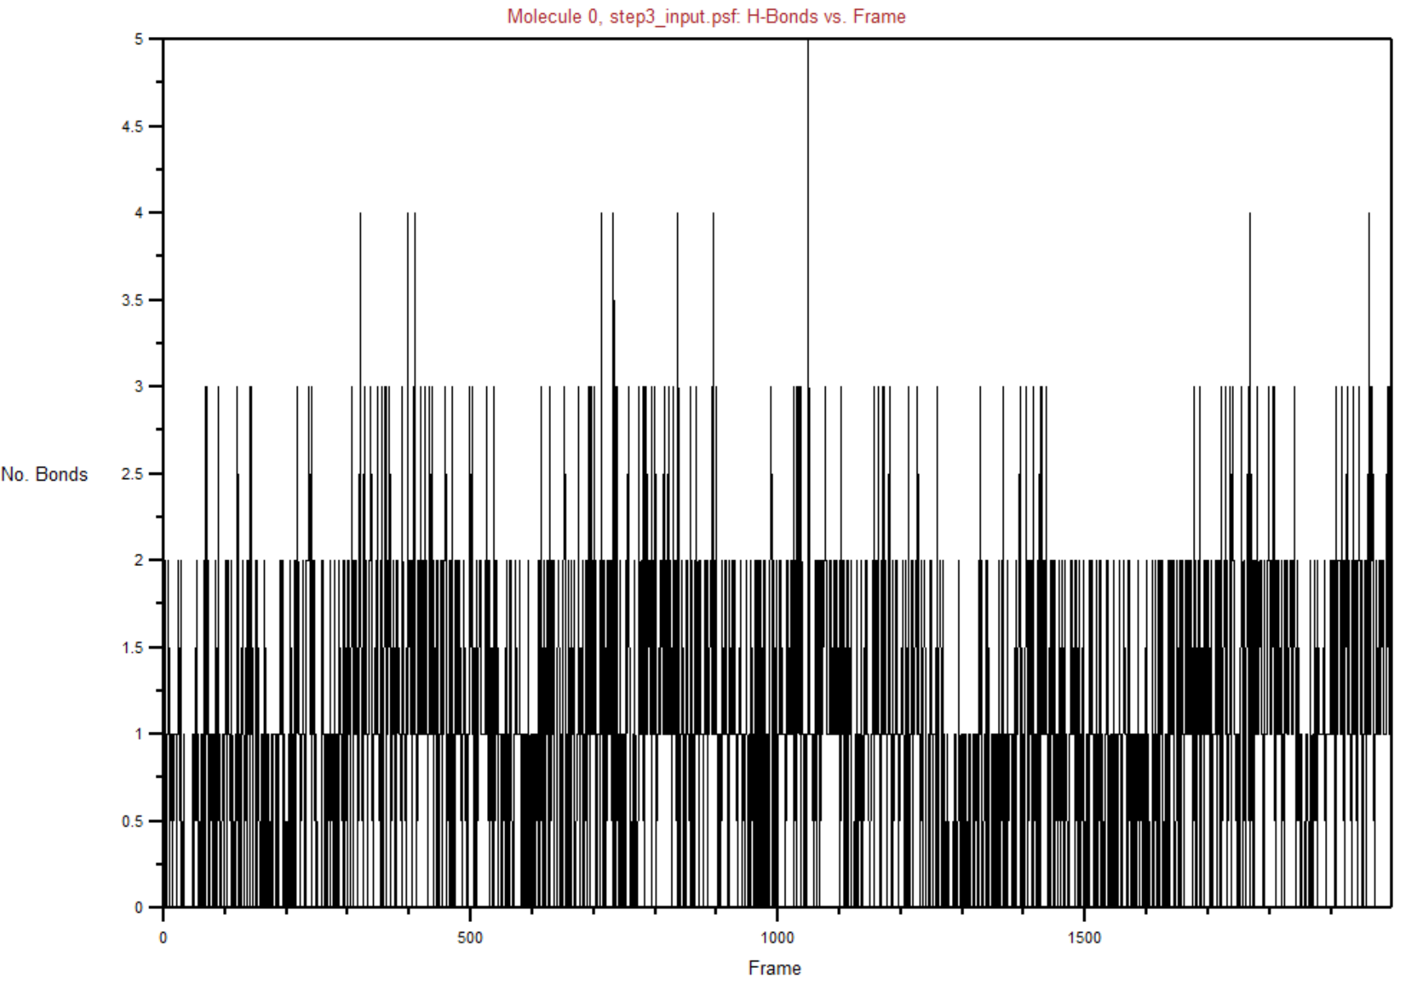
Template ligand 10
Figure S1. Time evolution plots (Number of bond versus the frame) for Donepezil, B2, B5 and Template ligand 10
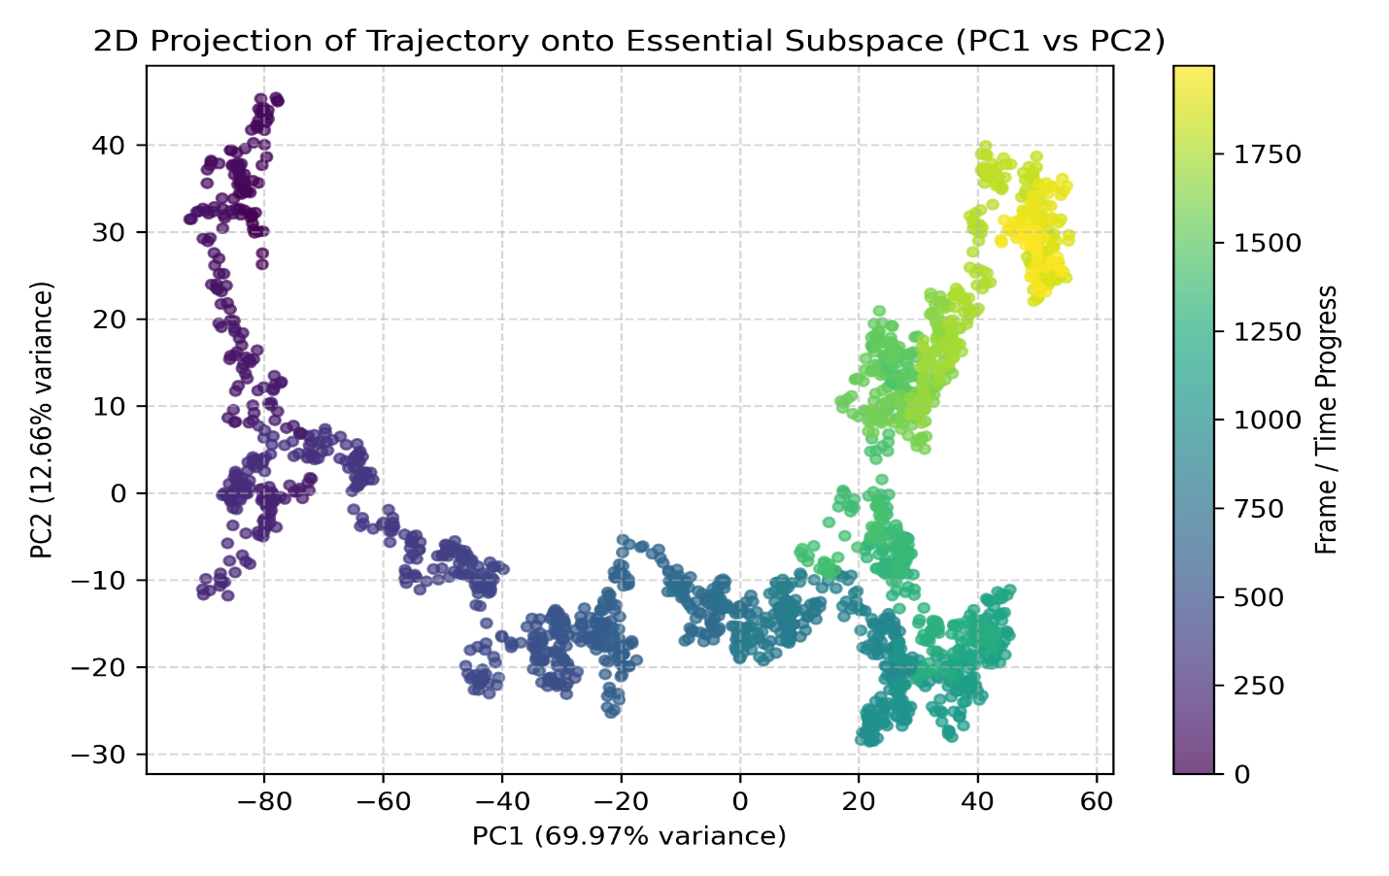
Figure S2a. PCA for Donepezil
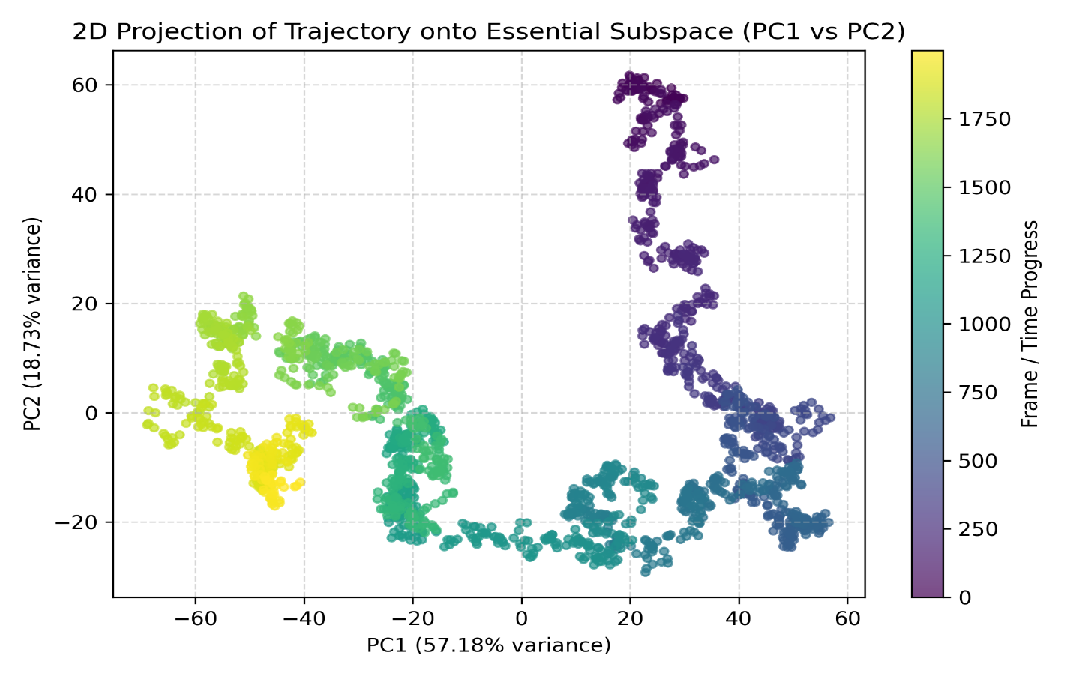
Figure S2b. PCA for B2
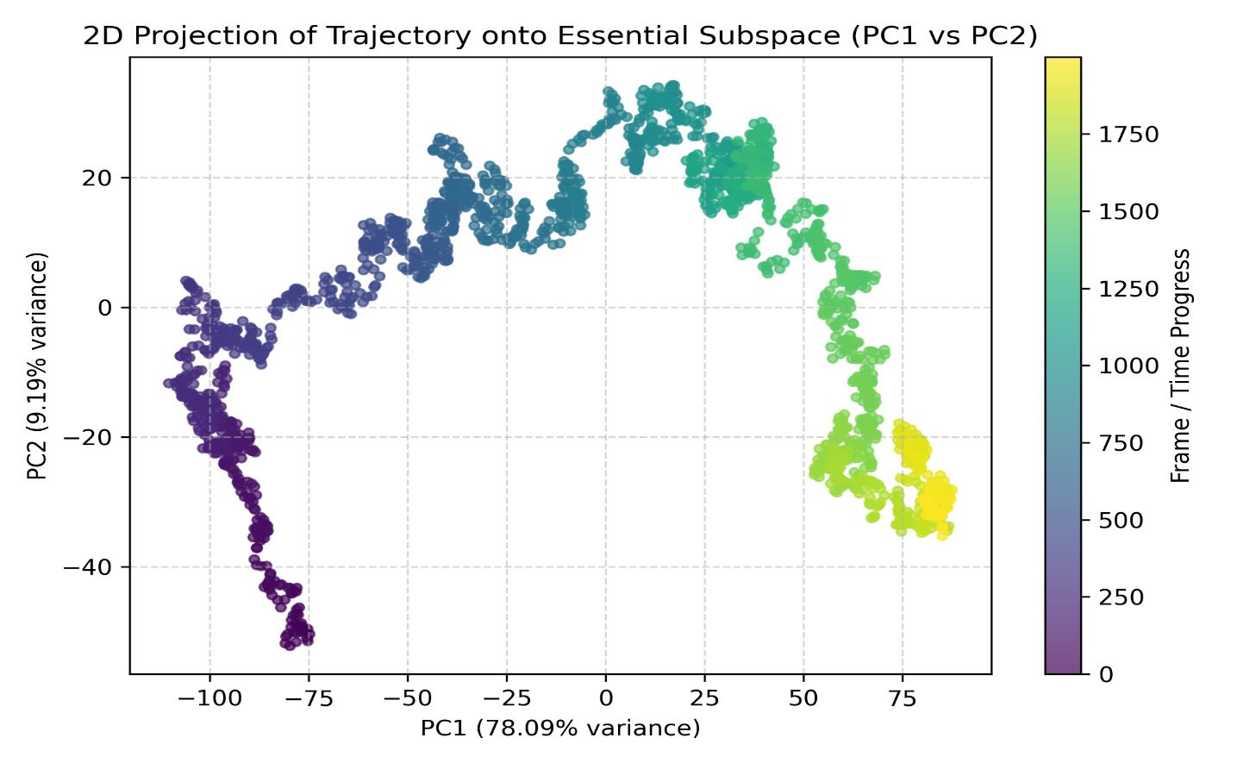 Figure S2c. PCA for B5
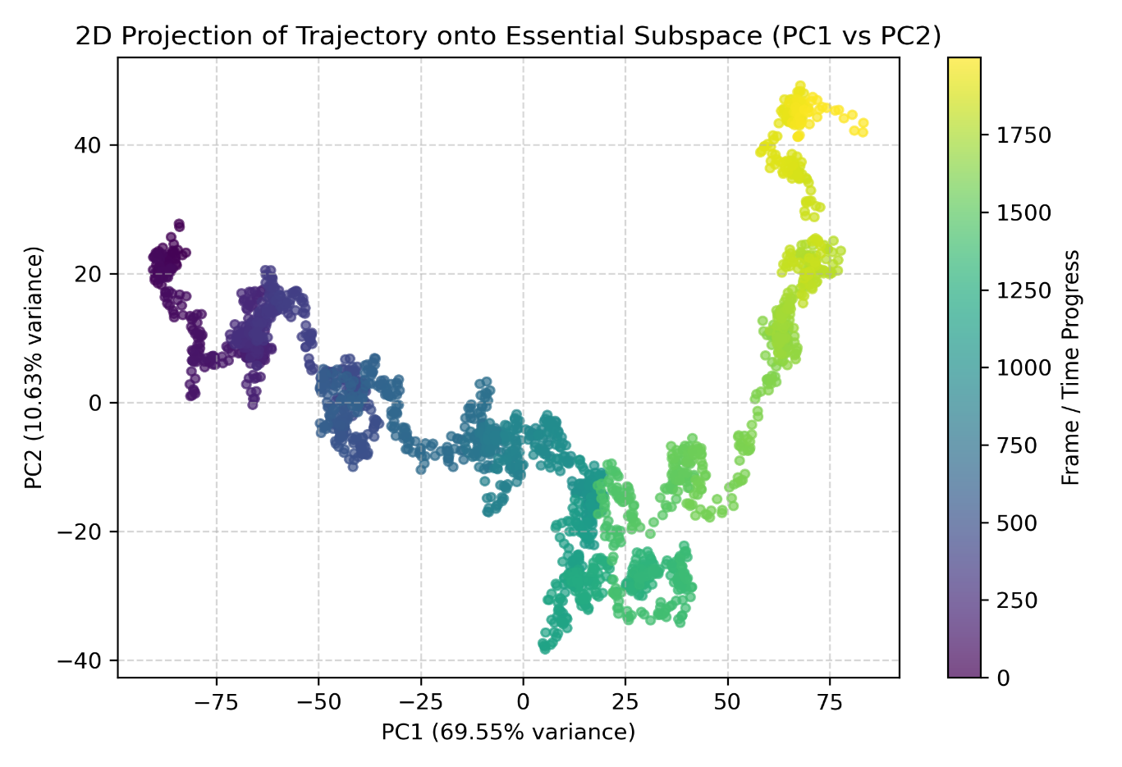
Figure S2d. PCA for Template Ligand 10
Figure S2 (a – d). Individual two-dimensional (2D) principal component analysis (PC₁ vs PC₂) phase-space projections

