Supporting Information
Highly stable organic photothermal agent based on near-infrared-II fluorophores for tumor treatment
Yunjian Xu¹, Shiqi Wang¹, Zhenjiang Chen¹, Rui Hu¹, Shaoqiang Li¹, Yihua Zhao¹, Liwei Liu¹* and Junle Qu¹
¹Key Laboratory of Optoelectronic Devices and Systems of Guangdong Province & Ministry of Education, College of Physics and Optoelectronic Engineering Shenzhen University, Shenzhen, Guangdong Province, 518060, P. R. China
E-mail: liulw@szu.edu.cn
The manuscript was coauthored by Yunjian Xu (mssn789@szu.edu.cn), Shiqi Wang (2432680983@qq.com), Zhenjiang Chen (127773259@qq.com), Rui Hu (47266743@qq.com), Shaoqiang Li (724566821@qq.com), Yihua Zhao (294596461@qq.com), Liwei Liu (Corresponding author, E-mail: liulw@szu.edu.cn) and Junle Qu (jlqu@szu.edu.cn).
Contents
Part I. Synthesis and characterization of intermediate products
Part II. Supplemental Fig.s
Part III. Supplemental references

Part I. Synthesis and characterization of intermediate products
Synthesis.
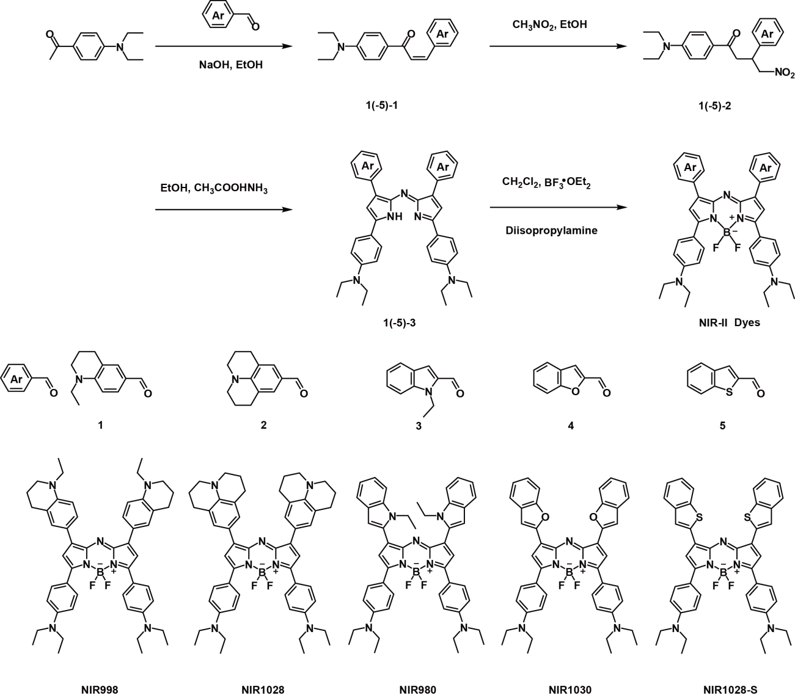
Scheme S1. Synthetic routs and chemical structures of NIR-II dyes, respectively.
Synthesis of 1-1. 1 (1.89 g, 10 mmol) and p-diethylaminoacetophenone (1.91, 10 mmol) was dissolved in EtOH (15 mL), then NaOH solution (1.00 g in 2 mL H₂O) was then dropped. After reaction at 25 ºC for 36 h, 10 mL deionized water was add and the solution was stirred for another 2 h. The final orange solid product was obtained by filtration and desiccation yellow (3.30 g, 91%). ¹H NMR (400 MHz, CDCl₃) δ(ppm) = 7.98 (d, J = 7.6 Hz, 2H), 7.72 (d, J = 15.6 Hz, 1H), 7.38 – 7.26 (m, 3H), 6.65 (d, J = 7.6 Hz, 2H), 6.56 (d, J = 8.4 Hz, 1H), 3.44 – 3.34 (m, 6H), 3.31 (t, J = 4.4 Hz, 2H), 2.76 (t, J = 6.4 Hz, 2H), 1.94 (t, J = 5.2 Hz, 2H), 1.22 – 1.13 (m, 9H). ¹³C NMR (100 MHz, CDCl₃) δ(ppm) = 187.75, 150.74, 146.82, 143.51, 130.79, 129.15, 128.82, 126.07, 122.47, 122.19, 116.12, 110.25, 110.00, 48.54, 45.35, 44.49, 28.12, 21.91, 12.56, 11.03.
Synthesis of 2-1. 2 (2.01 g, 10 mmol) and p-diethylaminoacetophenone (1.91, 10 mmol) was dissolved in EtOH (15 mL), then NaOH solution (1.00 g in 2 mL H₂O) was then dropped. After reaction at 25 ºC for 36 h, 10 mL deionized water was add and the solution was stirred for another 2 h. The final orange solid product was obtained by filtration and desiccation yellow (3.75 g, 92%). ¹H NMR (400 MHz, CDCl₃) δ(ppm) = 7.99 (d, J = 6.8 Hz, 2H), 7.68 (d, J = 15.2 Hz, 1H), 7.33 (d, J = 15.2 Hz, 1H), 7.10 (s, 2H), 6.66 (d, J = 8.0 Hz, 2H), 3.43 (q, J = 5.2 Hz , 4H), 3.23 (t, J = 5.2 Hz, 4H), 2.76 (t, J = 6.4 Hz, 4H), 2.00 – 1.93 (m, 4H), 1.21 (t, J = 6.4 Hz, 6H). ¹³C NMR (100 MHz, CDCl₃) δ(ppm) = 187.80, 150.72, 144.68, 143.72, 130.81, 127.72, 126.19, 122.36, 121.00, 116.05, 110.26, 49.95, 44.52, 27.71, 21.68, 12.58.
Synthesis of 3-1. 3 (1.73 g, 10 mmol) and p-diethylaminoacetophenone (1.91, 10 mmol) was dissolved in EtOH (15 mL), then NaOH solution (1.00 g in 2 mL H₂O) was then dropped. After reaction at 25 ºC for 36 h, 10 mL deionized water was add and the solution was stirred for another 2 h. The final orange solid product was obtained by filtration and desiccation yellow (3.26 g, 94%). ¹H NMR (400 MHz, CDCl₃) δ(ppm) = 8.04 (d, J = 7.6 Hz, 2H), 7.94 (d, J = 14.8 Hz, 1H), 7.72 (d, J = 15.2 Hz, 1H), 7.65 (d, J = 7.6 Hz, 1H), 7.36 (d, J = 8.0 Hz, 1H), 7.27 (t, J =6.8 Hz, 1H), 7.15 – 7.11 (m, 2H), 6.71 (d, J = 8.0 Hz, 2H), 4.37 (q, J = 6.8 Hz, 2H), 3.47 (q, J = 6.8 Hz, 4H), 1.43 (t, J = 6.8 Hz, 3H), 1.24 (t, J = 6.8 Hz, 6H). ¹³C NMR (100 MHz, CDCl₃) δ(ppm) = 186.54, 151.24, 137.95, 135.49, 131.09, 129.99, 127.79, 125.29, 123.19, 122.49, 121.31, 120.28, 110.41, 109.57, 102.66, 44.58, 38.02, 15.74, 12.55.
Synthesis of 4-1. 4 (1.46 g, 10 mmol) and p-diethylaminoacetophenone (1.91, 10 mmol) was dissolved in EtOH (15 mL), then NaOH solution (1.00 g in 2 mL H₂O) was then dropped. After reaction at 25 ºC for 36 h, 10 mL deionized water was add and the solution was stirred for another 2 h. The final orange solid product was obtained by filtration and desiccation yellow (2.97 g, 93%). ¹H NMR (400 MHz, CDCl₃) δ(ppm) = 8.04 (d, J = 6.4 Hz, 2H), 7.77 (dd, J = 15.2, 2.4 Hz, 1H), 7.66 (dd, J = 15.6, 3.2 Hz, 1H), 7.59 (d, J = 7.6 Hz, 1H), 7.51 (d, J = 8.0 Hz, 1H), 7.38 – 7.33 (m, 1H), 7.26 – 7.22 (m, 1H), 6.96 (d, J = 1.2 Hz, 1H), 6.68 (d, J = 7.2 Hz, 2H), 3.44 (q, J = 6.4 Hz, 4H), 1.22 (t, J = 5.2 Hz, 6H). ¹³C NMR (100 MHz, CDCl₃) δ(ppm) = 186.47, 155.40, 153.73, 151.34, 131.28, 128.71, 126.17, 125.14, 123.22, 122.54, 121.63, 111.25, 111.07, 110.40, 44.58, 12.54.
Synthesis of 5-1. 5 (1.62 g, 10 mmol) and p-diethylaminoacetophenone (1.91, 10 mmol) was dissolved in EtOH (15 mL), then NaOH solution (1.00 g in 2 mL H₂O) was then dropped. After reaction at 25 ºC for 36 h, 10 mL deionized water was add and the solution was stirred for another 2 h. The final orange solid product was obtained by filtration and desiccation yellow (3.22 g, 96%). ¹H NMR (500 MHz, CDCl₃) δ(ppm) = 8.15 (d, J = 15.5, 1H), 8.12 – 8.06 (m, 2H), 7.91 – 7.89 (m, 1H), 7.88 – 7.82 (m, 1H), 7.54 (d, J = 15.5 Hz, 1H), 7.49 – 7.41 (m, 2H), 7.36 (s, 1H), 6.80 – 6.76 (m, 2H), 3.55 (q, J = 14.5, 4H), 1.33 (t, J = 7.0 Hz, 6H). ¹³C NMR (125 MHz, CDCl₃) δ(ppm) = 186.61, 151.46, 141.17, 139.97, 135.31, 131.28, 128.66, 126.08, 125.25, 124.86, 124.37, 123.74, 122.50, 110.55, 44.69, 12.64.
Synthesis of 1-2. 1-1 (1.81 g, 5 mmol) was added into the mixture of nitromethane (8 mL), diethylamine (10 mL) and ethanol (10 mL). The mixture reacted under reflux (80 ºC) for 72 h. The low boiling point solvent was removed by vacuum pressure. The final product as gray solid (1.86 g, 88%) was obtained via column chromatography (Ethyl acetate: petroleum ether = 1:5). ¹H NMR (400 MHz, CDCl₃) δ(ppm) = 7.82 (d, J = 8.8 Hz, 2H), 6.92 (d, J = 8.0 Hz, 1H), 6.81 (s, 1H), 6.60 (d, J = 8.8 Hz, 2H), 6.50 (d, J = 8.4 Hz, 1H), 4.78 (dd, J = 12.4, 6.4 Hz, 1H), 4.59 (dd, J = 11.2, 8.4 Hz, 1H), 4.05 – 3.98 (m, 1H), 3.41 (q, J = 7.2 Hz, 4H), 3.32 – 3.17 (m, 6H), 2.70 (t, J = 6.0 Hz, 2H), 1.95 – 1.89 (m, 2H), 1.19 (t, J = 6.8 Hz, 6H), 1.10 (t, J = 7.2 Hz, 3H). ¹³C NMR (100 MHz, CDCl₃) δ(ppm) = 195.05, 151.33, 144.42, 130.66, 128.19, 125.92, 123.85, 122.61, 110.59, 110.17, 80.19, 48.27, 45.30, 44.54, 41.11, 39.01, 28.17, 22.15, 12.49, 10.90.
Synthesis of 2-2. 2-1 (1.87 g, 5 mmol) was added into the mixture of nitromethane (8 mL), diethylamine (10 mL) and ethanol (10 mL). The mixture reacted under reflux (80 ºC) for 72 h. The low boiling point solvent was removed by vacuum pressure. The final product as gray solid (1.83 g, 84%) was obtained via column chromatography (Ethyl acetate: petroleum ether = 1:5). ¹H NMR (400 MHz, CDCl₃) δ(ppm) = 7.82 (d, J = 9.2 Hz, 2H), 6.66 (s, 2H), 6.61 (d, J = 8.8 Hz, 2H), 4.77 (dd, J = 12.4, 6.4 Hz, 1H), 4.57 (dd, J = 11.6, 9.2 Hz, 1H), 4.02 – 3.90 (m, 1H), 3.42 (q, J = 6.8 Hz, 4H), 3.31 – 3.15 (m, 2H), 3.09 (t, J = 4.2 Hz, 4H), 2.71 (t, J = 6.4 Hz, 4H), 1.90 – 1.89 (m, 4H), 1.20 (t, J = 7.6 Hz, 6H). ¹³C NMR (100 MHz, CDCl₃) δ(ppm) = 195.05, 151.31, 142.31, 130.64, 126.42, 125.81, 123.83, 121.71, 110.15, 80.11, 49.90, 44.53, 41.15, 39.03, 27.64, 21.98, 12.49.
Synthesis of 3-2. 3-1 (1.73 g, 5 mmol) was added into the mixture of nitromethane (8 mL), diethylamine (10 mL) and ethanol (10 mL). The mixture reacted under reflux (80 ºC) for 72 h. The low boiling point solvent was removed by vacuum pressure. The final product as gray solid (1.81 g, 89%) was obtained via column chromatography (Ethyl acetate: petroleum ether = 1:5). ¹H NMR (400 MHz, CDCl₃) δ(ppm) = 7.82 (d, J = 8.8 Hz, 2H), 7.54 (d, J = 8.0 Hz, 1H), 7.33 (d, J = 8.4 Hz, 1H), 7.22 – 7.18 (m, 1H), 7.08 (t, J = 7.6 Hz, 1H), 6.61 (d, J = 7.2 Hz, 2H), 6.38 (s, 1H), 4.86 (dd, J = 12.8, 7.2 Hz, 1H), 4.71 (dd, J = 12.4, 8.0 Hz, 1H), 4.60 – 4.49 (m, 1H), 4.30 (q, J = 6.8 Hz, 2H), 3.46 – 3.27 (m, 6H), 1.44 (t, J = 6.8 Hz, 3H), 1.20 (t, J = 6.8 Hz, 6H). ¹³C NMR (100 MHz, CDCl₃) δ(ppm) = 193.75, 151.56, 138.36, 136.22, 130.61, 127.78, 123.33, 121.51, 120.33, 119.63, 110.22, 109.46, 98.67, 78.49, 44.55, 41.01, 37.96, 30.86, 15.42, 12.44.
Synthesis of 4-2. 4-1 (1.60 g, 5 mmol) was added into the mixture of nitromethane (8 mL), diethylamine (10 mL) and ethanol (10 mL). The mixture reacted under reflux (80 ºC) for 72 h. The low boiling point solvent was removed by vacuum pressure. The final product as gray solid (1.54 g, 81%) was obtained via column chromatography (Ethyl acetate: petroleum ether = 1:5). ¹H NMR (400 MHz, CDCl₃) δ(ppm) = 7.85 (d, J = 7.6 Hz, 2H), 7.48 (d, J = 7.6 Hz, 1H), 7.42 (d, J = 8.0 Hz, 1H), 7.26 – 7.17 (m, 2H), 6.64 – 6.59 (m, 3H), 4.94 – 4.82 (m, 2H), 4.50 – 4.44 (m, 1H), 3.53 – 3.36 (m, 6H), 1.20 (t, J = 6.4 Hz, 6H). ¹³C NMR (100 MHz, CDCl₃) δ(ppm) = 193.57, 155.51, 154.75, 130.68, 128.18, 124.12, 122.87, 120.97, 111.22, 110.68, 104.09, 44.67, 37.90, 33.87, 12.44.
Synthesis of 5-2. 5-1 (1.68 g, 5 mmol) was added into the mixture of nitromethane (8 mL), diethylamine (10 mL) and ethanol (10 mL). The mixture reacted under reflux (80 ºC) for 72 h. The low boiling point solvent was removed by vacuum pressure. The final product as gray solid (1.57 g, 85%) was obtained via column chromatography (Ethyl acetate: petroleum ether = 1:5). ¹H NMR (500 MHz, CDCl₃) δ(ppm) = 7.84 (d, J = 8.5 Hz, 2H), 7.76 (d, J = 7.5 Hz, 1H), 7.68 (d, J = 7.5 Hz, 1H), 7.34 – 7.28 (m, 2H), 7.19 (s, 1H), 6.62 (d, J = 9.0 Hz, 2H), 4.92 (dd, J = 12.5, 5.5 Hz, 1H), 4.77 (dd, J = 12.5, 8.5 Hz, 1H), 4.65 – 4.56 (m, 1H), 3.53 – 3.35 (m, 6H), 1.20 (t, J = 7.0 Hz, 6H). ¹³C NMR (125 MHz, CDCl₃) δ(ppm) = 193.54, 143.43, 139.51, 139.08, 130.75, 124.40, 123.51, 122.26, 110.37, 79.57, 44.62, 41.02, 35.91, 12.46.
Synthesis of 1-3. 1-2 (1.27 g, 3 mmol) and ammonium acetate (3.00 g, 40 mmol) reacted in n-butanol (50 mL) under reflux (120 ºC) for 48 h. The solvent was removed under vacuum pressure and the solid residue was filtered and washed with cool ethanol (3×20 mL). 1-3 was applied directly for following synthesis.
Synthesis of 2-3. 2-2 (1.31 g, 3 mmol) and ammonium acetate (3.00 g, 40 mmol) reacted in n-butanol (50 mL) under reflux (120 ºC) for 48 h. The solvent was removed under vacuum pressure and the solid residue was filtered and washed with cool ethanol (3×20 mL). 2-3 was applied directly for following synthesis.
Synthesis of 3-3. 3-2 (1.22 g, 3 mmol) and ammonium acetate (3.00 g, 40 mmol) reacted in n-butanol (50 mL) under reflux (120 ºC) for 48 h. The solvent was removed under vacuum pressure and the solid residue was filtered and washed with cool ethanol (3×20 mL). 3-3 was applied directly for following synthesis.
Synthesis of 4-3. 4-2 (1.14g, 3 mmol) and ammonium acetate (3.00 g, 40 mmol) reacted in n-butanol (50 mL) under reflux (120 ºC) for 48 h. The solvent was removed under vacuum pressure and the solid residue was filtered and washed with cool ethanol (3×20 mL). 4-3 was applied directly for following synthesis.
Synthesis of 5-3. 5-2 (1.19 g, 3 mmol) and ammonium acetate (3.00 g, 40 mmol) reacted in n-butanol (50 mL) under reflux (120 ºC) for 48 h. The solvent was removed under vacuum pressure and the solid residue was filtered and washed with cool ethanol (3×20 mL). 5-3 was applied directly for following synthesis.

Part II. Supplemental Fig.s
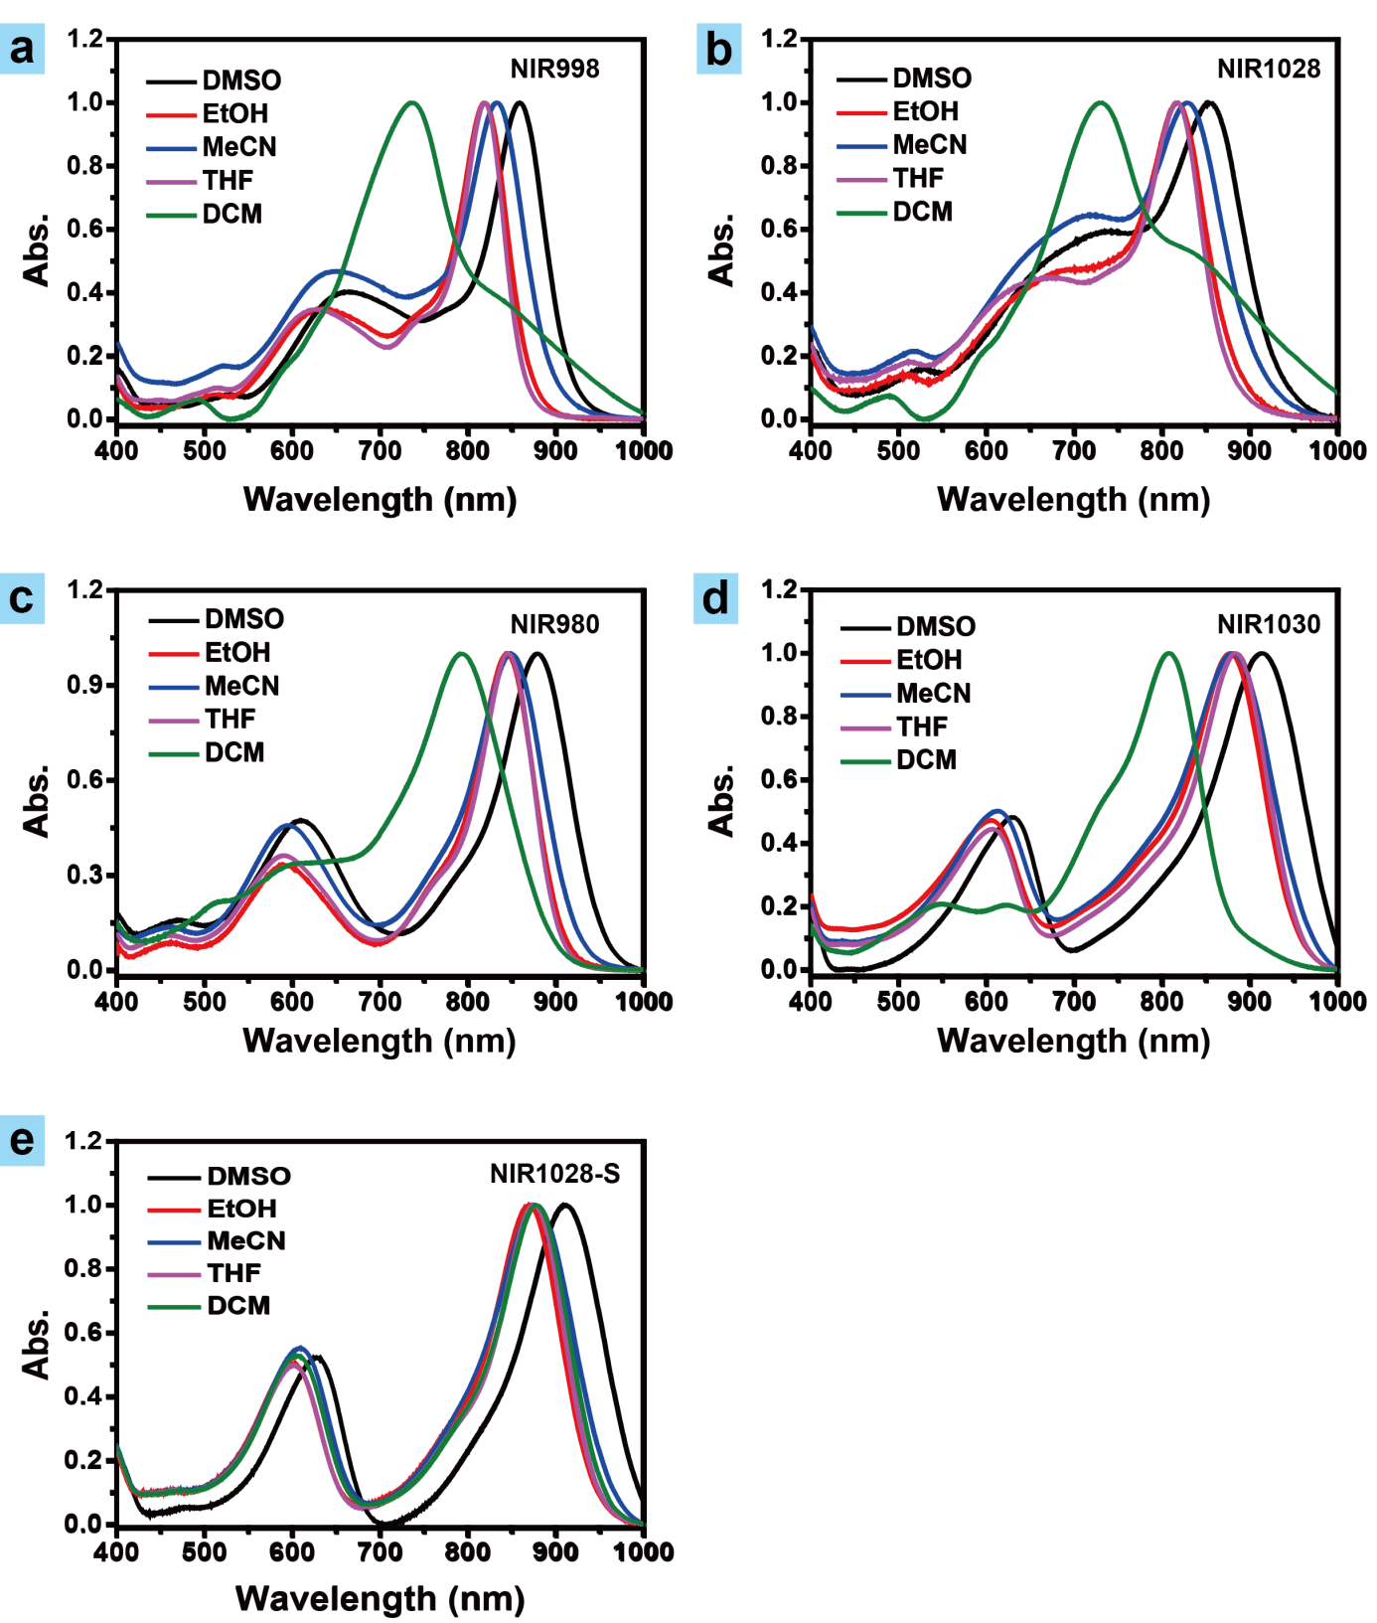
Fig. S1. UV−vis absorption spectra of (a) NIR998, (b) NIR1028, (c) NIR980, (d) NIR1030 and (e) NIR1028-S in different solvents, respectively. The absorption have been normalized.
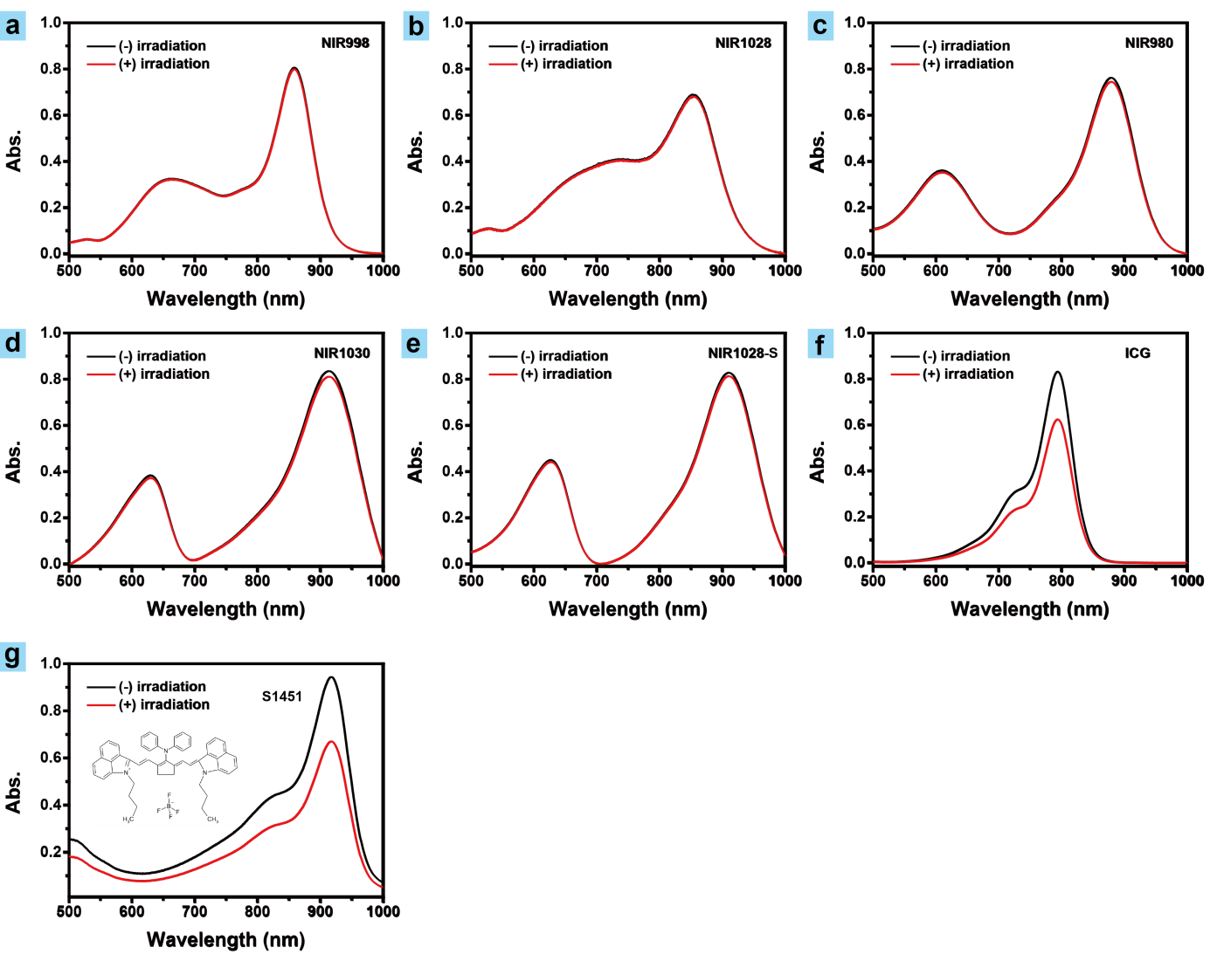
Fig. S2. Absorption spectra of NIR-II dyes and commercial dyes (ICG and S1451) in DMSO before and after irradiation of 808 nm at 0.2 W cm⁻² for 10 min, respectively.
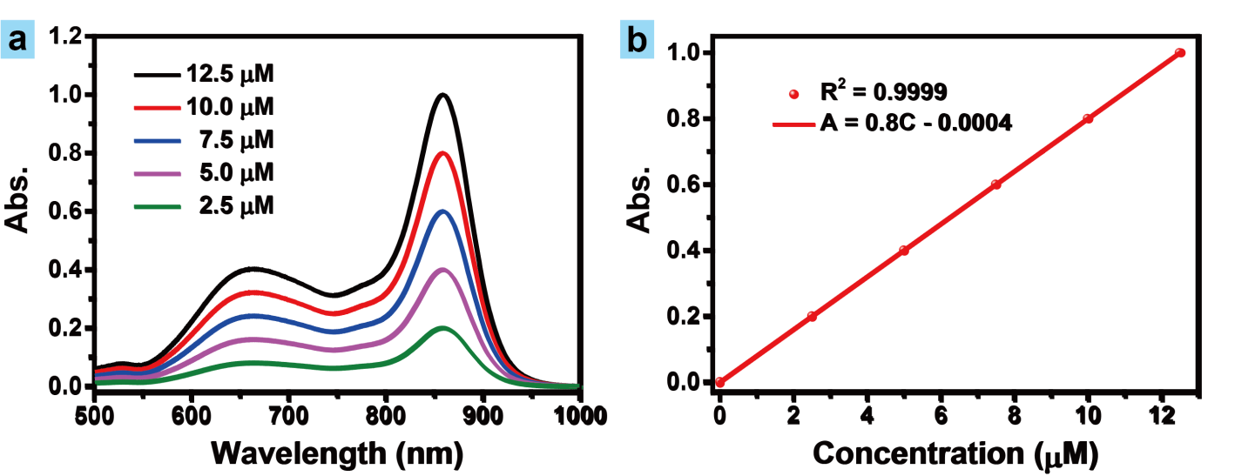
Fig. S3. (a) UV–vis absorption spectra and (b) the absorption at 859 nm of NIR998 with various concentrations in DMSO, respectively.
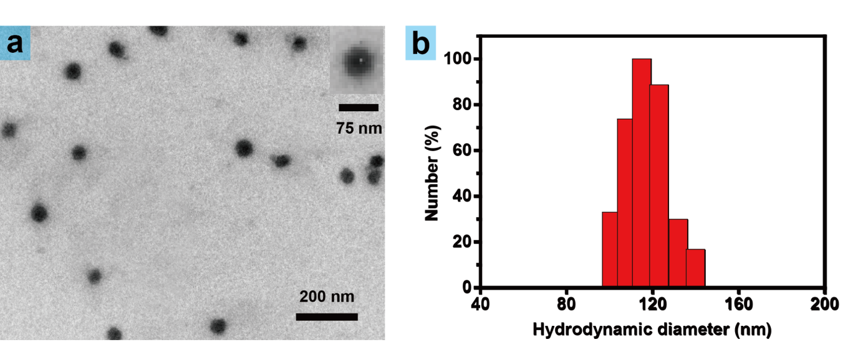
Fig. S4. (a) The transmission electron microscopy photos and (b) dynamic light scattering results of NIR998 (10⁻⁵ M) in PBS (pH = 7.4).
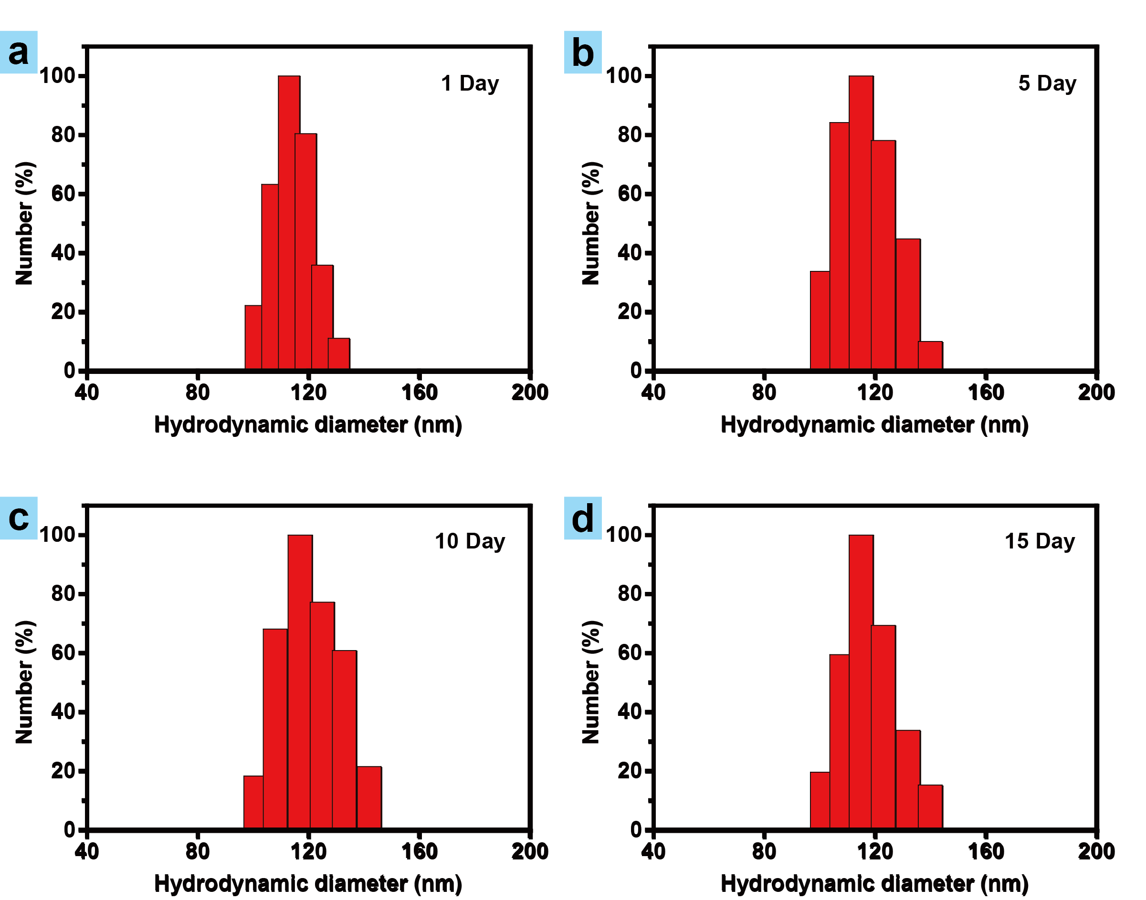
Fig. S5. (a), (b), (c), (d) are dynamic light scattering results of NIR998 (10⁻⁵ M) in PBS (pH = 7.4) during half a month, respectively.
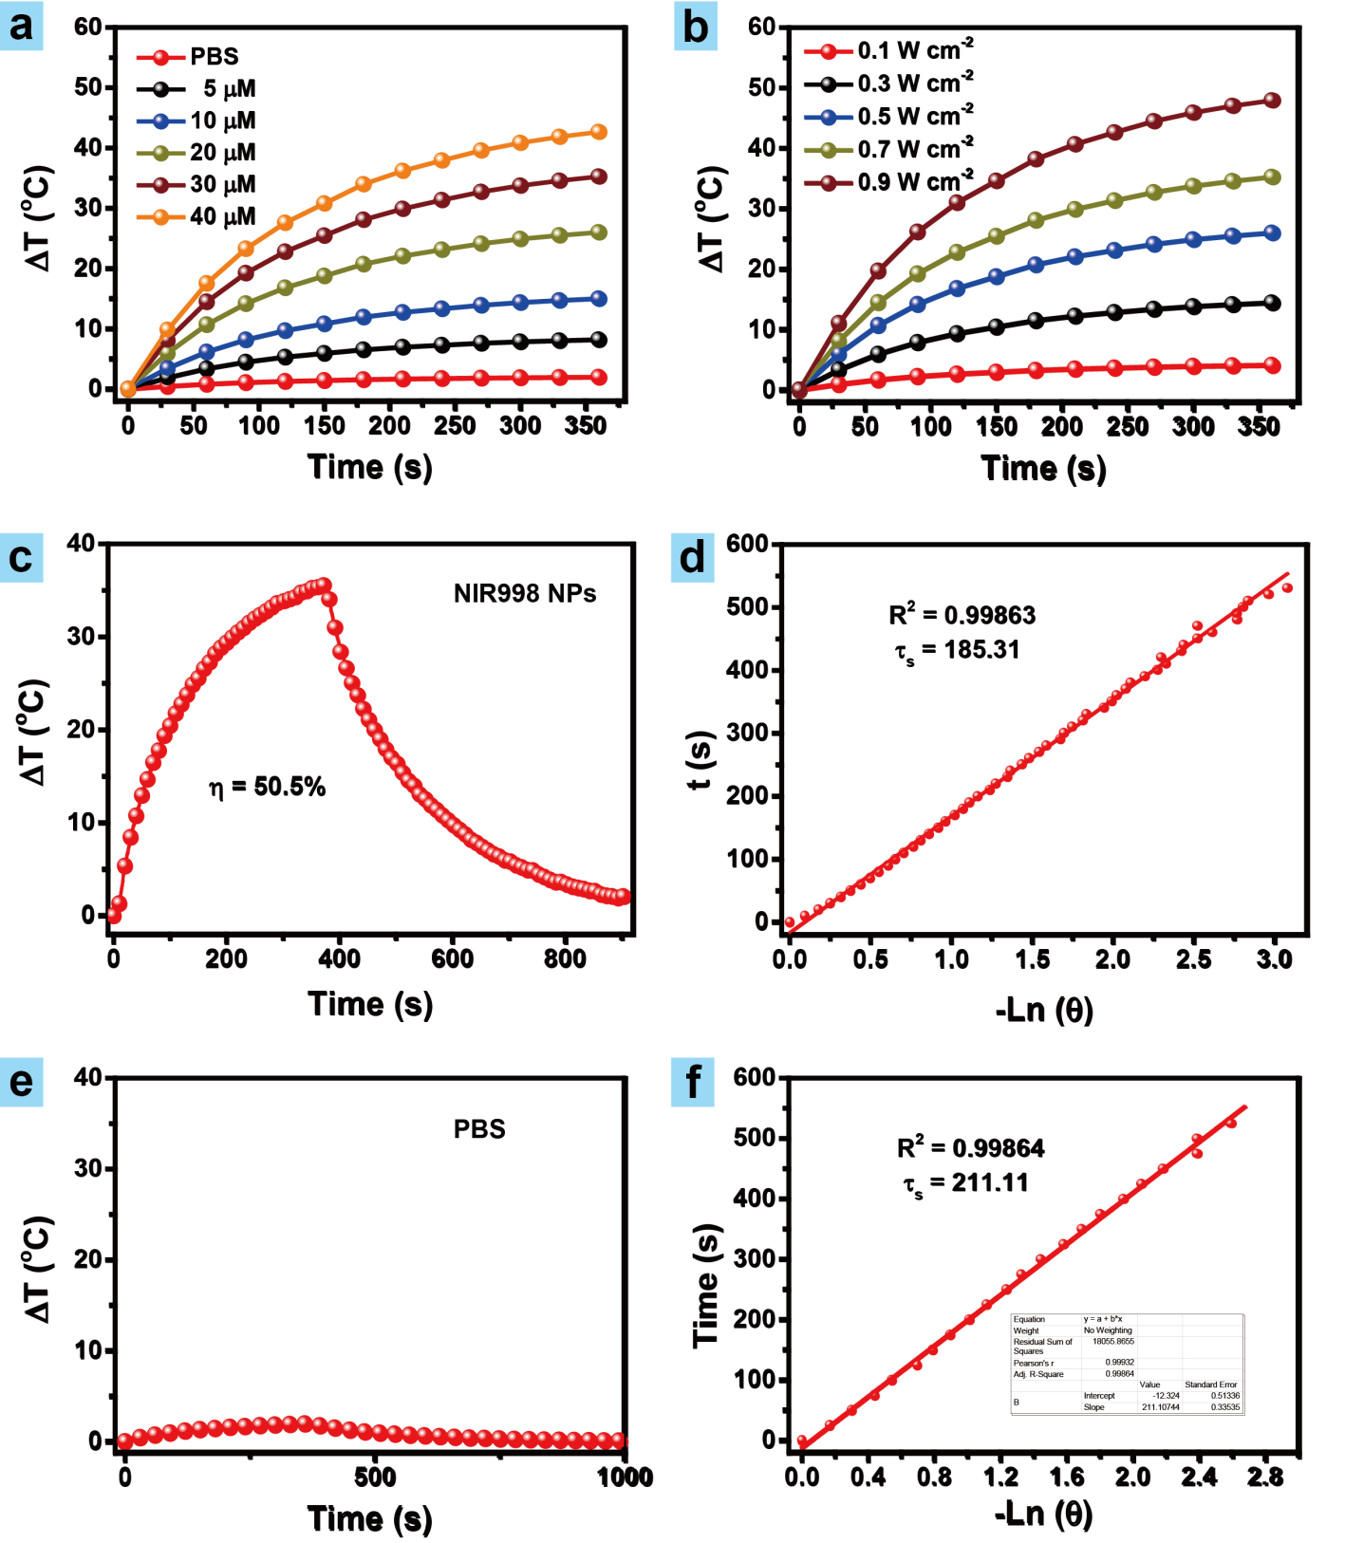
Fig. S6. (a) Concentrations (808 nm, 6 min) and (b) light power dependent (20 μM) temperature rise of NIR998 NPs in PBS (pH = 7.4) in different time, respectively. (c) and (e) are temperature change of NIR998 NPs (20 μM) solutions and PBS (pH = 7.4) under irradiation (808 nm, 0.5 W cm⁻²), respectively. After the temperature reached to plateau, light irradiation was stopped. (d) and (f) are time constants of NIR998 NPs (20 μM) solutions and PBS (pH = 7.4) for acquiring photothermal conversion of NIR998 NPs, respectively.
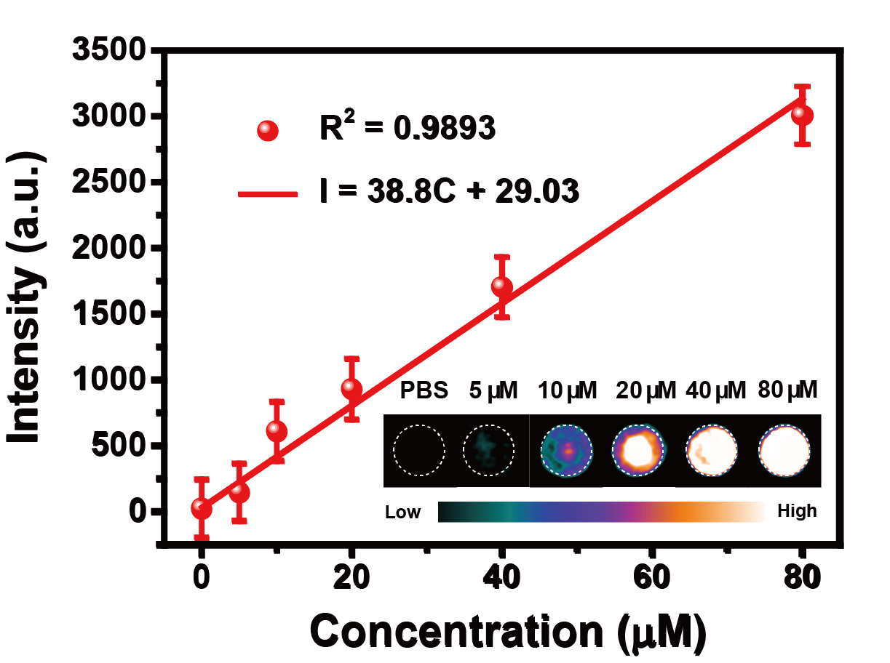
Fig. S7. Photoacoustic intensity of NIR998 NPs with various concentrations in PBS (pH = 7.4). Inset: photoacoustic intensity images of NIR998 NPs with various concentrations in PBS (pH = 7.4) (λ_{Ex} = 808 nm).
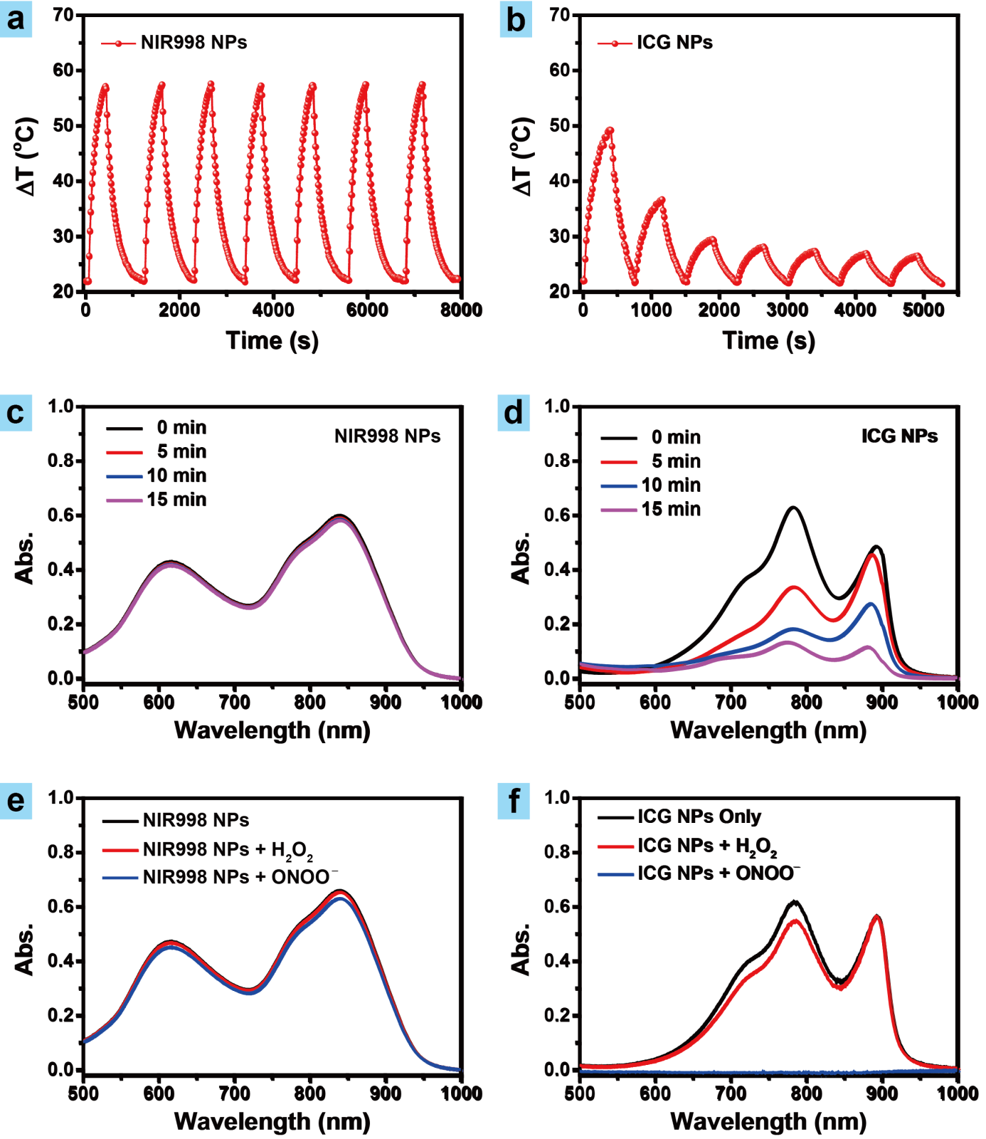
Fig. S8. (a) and (b) are photothermal circulation stability of NIR998 NPs (20 μM) and ICG NPs (20 μM) in PBS (pH = 7.4) under irradiation (808 nm, 0.5 W cm⁻²), respectively. The solutions of samples was irradiated until its temperature reached to plateau. The irradition then stopped. When its temperature decrease to ambient temperature, we then repeated above process for seven times. (c) and (d) are absorption spectra of NIR998 NPs (20 μM) and ICG NPs (20 μM) in PBS (pH = 7.4) with the absence or presence of H₂O₂ (200 μM) or ONOO⁻ (200 μM), respectively.
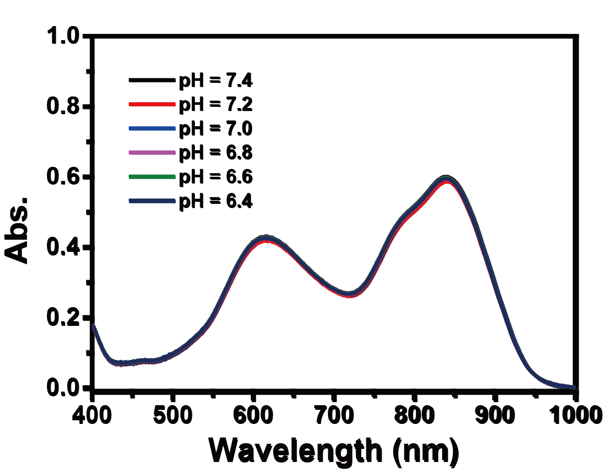
Fig. S9. Absorption spectra of NIR998 NPs (20 μM) in PBS (pH = 7.4) with various pH (6.4 – 7.4), respectively.
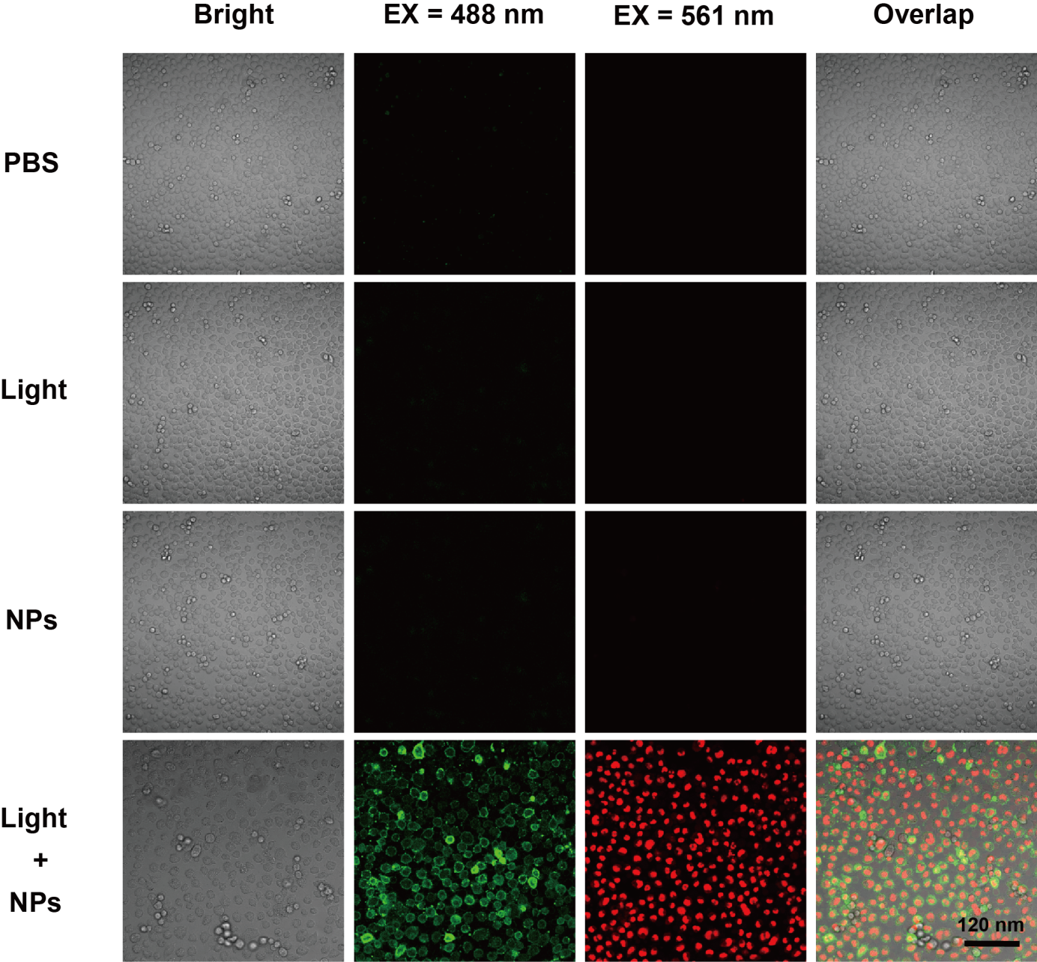
Fig. S10. Confocal fluorescence images of SKOV3 cells treated with NIR998 NPs (20 μM) plus light irradiation (808 nm, 0.5 W cm⁻², 6 min), NIR998 NPs only, light irradiation only or PBS only, respectively. Dead cells and apoptotic cells were distinguished by propidium iodide (PI) and Annexin V-FITC, respectively.
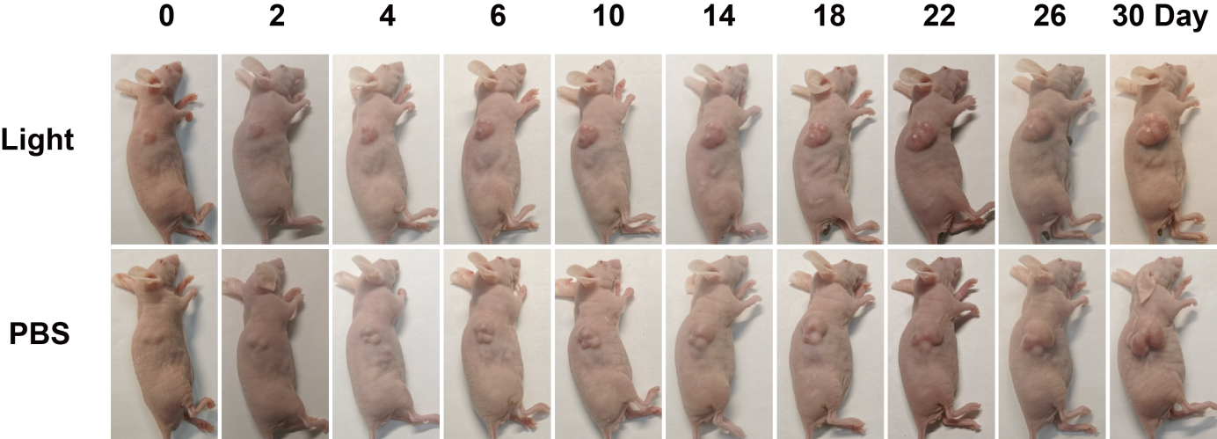
Fig. S11. Representative images of mice with SKOV3 tumor under different treatments during tumors therapy, respectively.
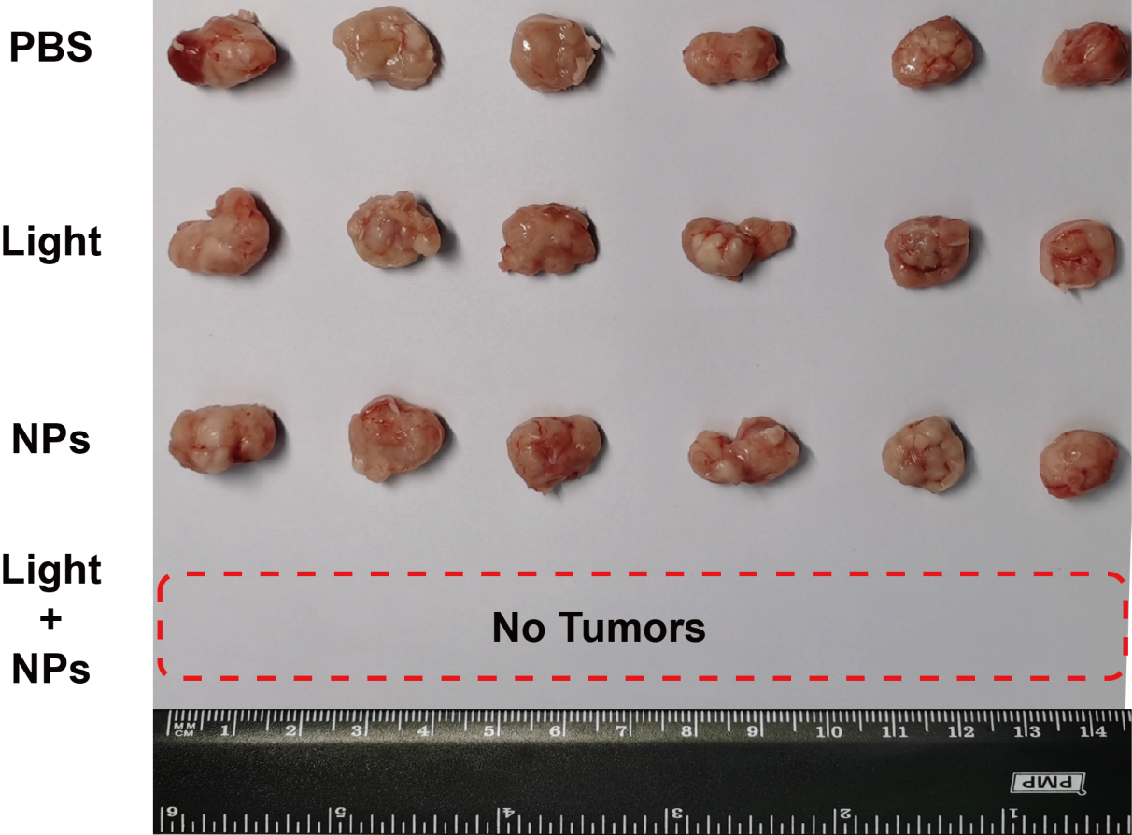
Fig. S12. SKOV3 tumors of mice with different treatments after 30 days tumor therapy, respectively.
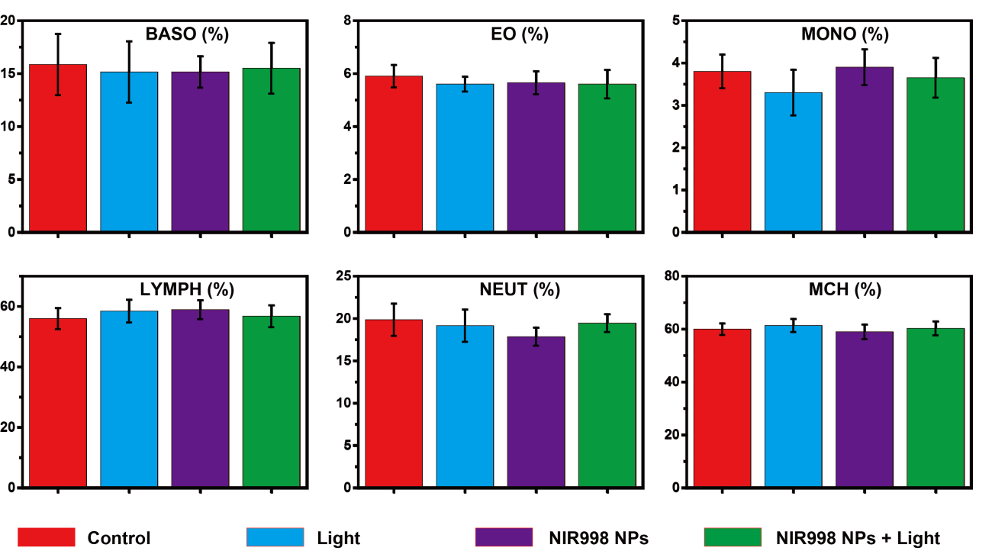
Fig. S13. Blood test parameters in terms of basophils (BASO), eosnophilshaem (EO), monocyte (MONO), lymphocyte (LYMPH), neutrophile (NEUT) and mean corpuscular hemoglobinregulation (MCH) of SKOV3 tumor mice treated with NIR998 NPs plus light irradiation, NIR998 NPs, light irradiation after 30 days treatments, respectively. Healthy mice act as control.
Part III. Characterization
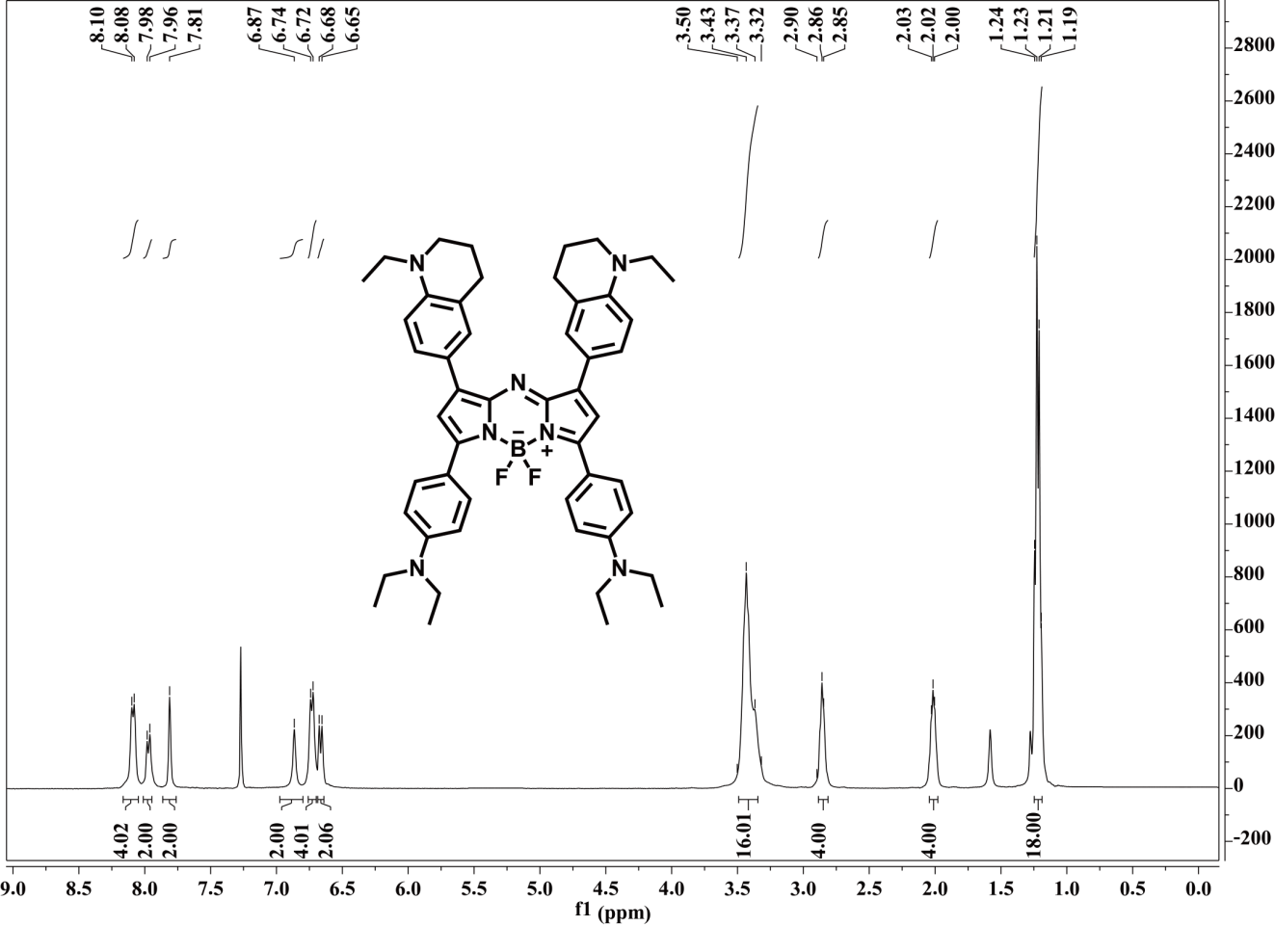
Fig. S14. ¹H-NMR spectrum of NIR998.
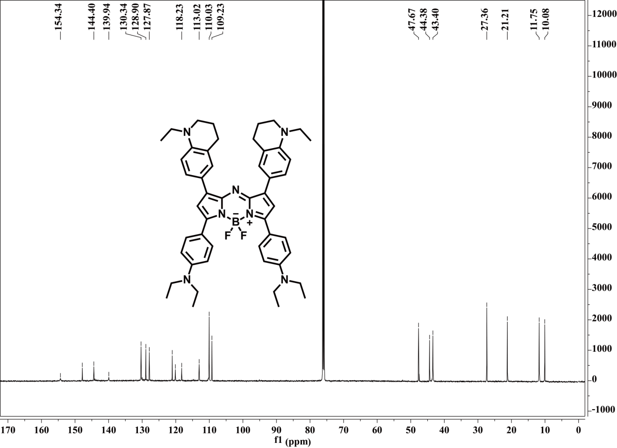
Fig. S15. ¹³C-NMR spectrum of NIR998.
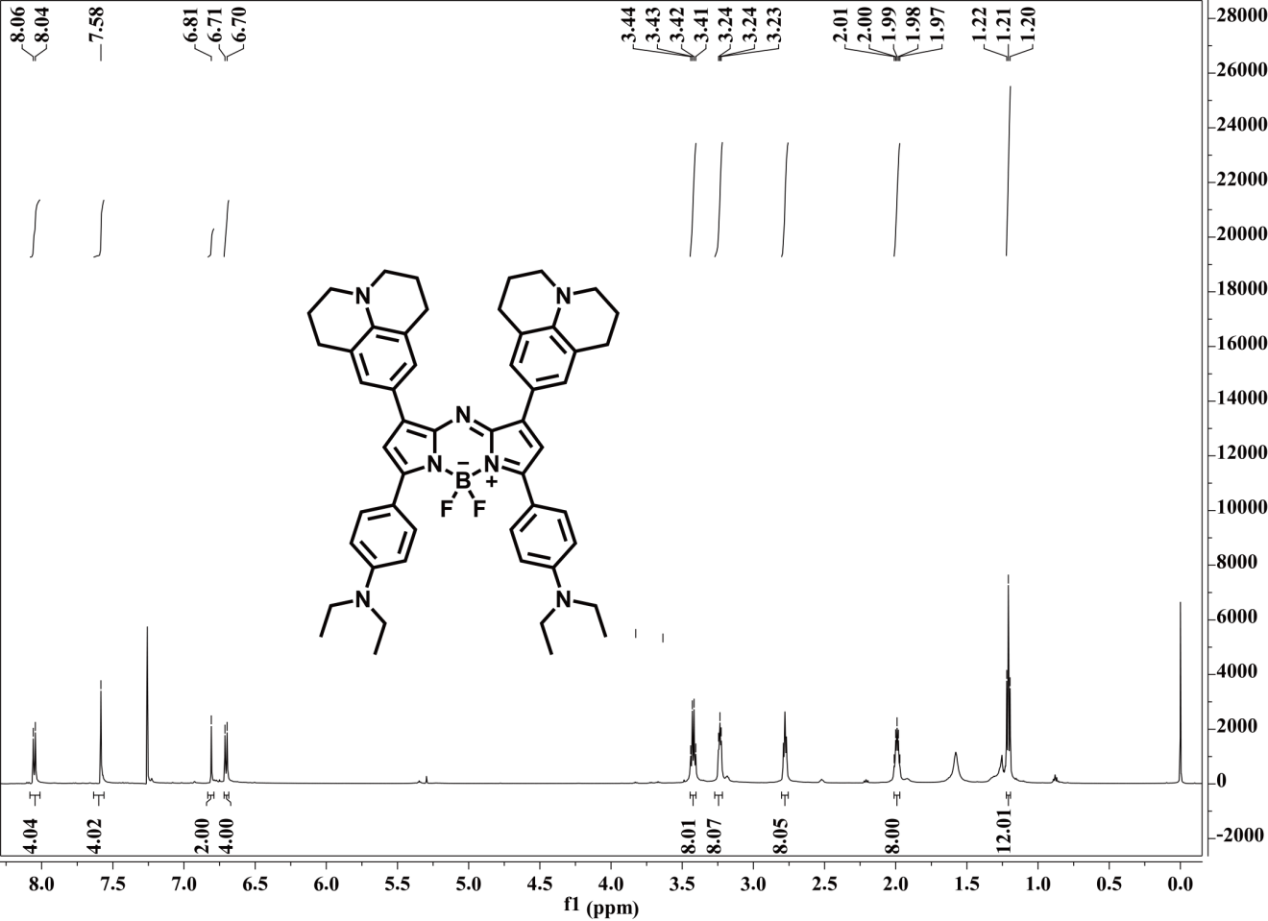
Fig. S16. ¹H-NMR spectrum of NIR1028.
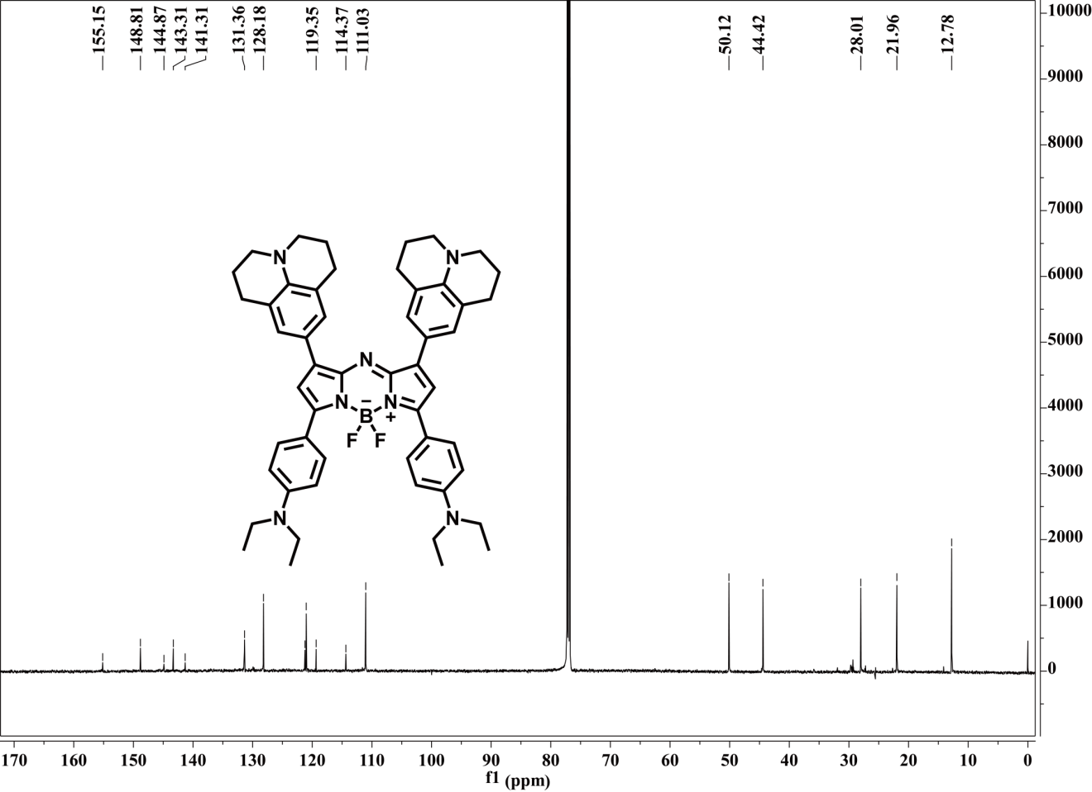
Fig. S17. ¹³C-NMR spectrum of NIR1028.
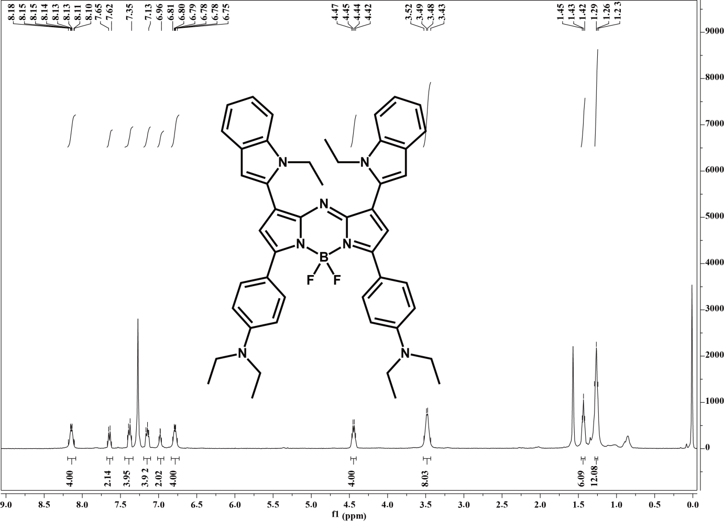
Fig. S18. ¹H-NMR spectrum of NIR980.
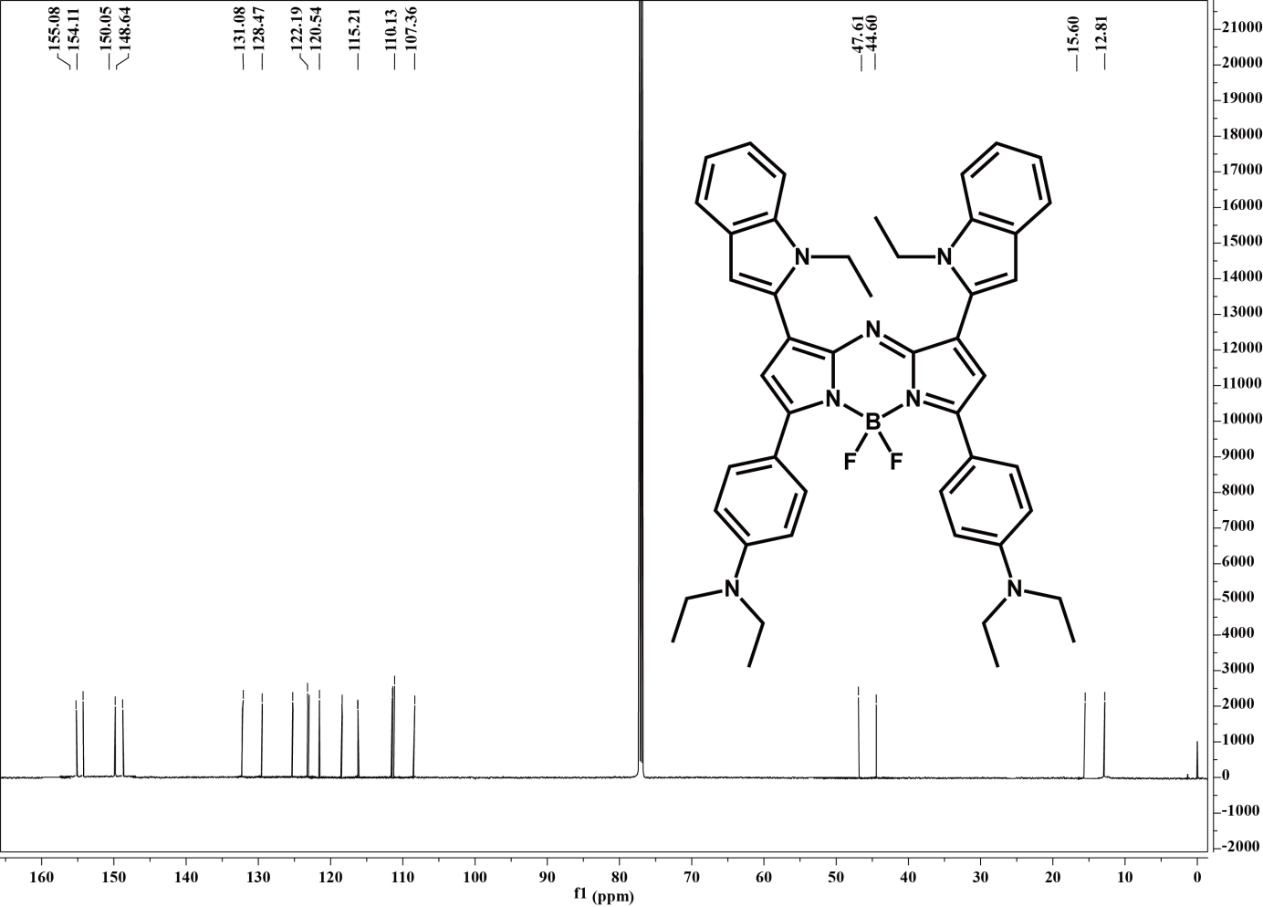
Fig. S19. ¹³C-NMR spectrum of NIR980.
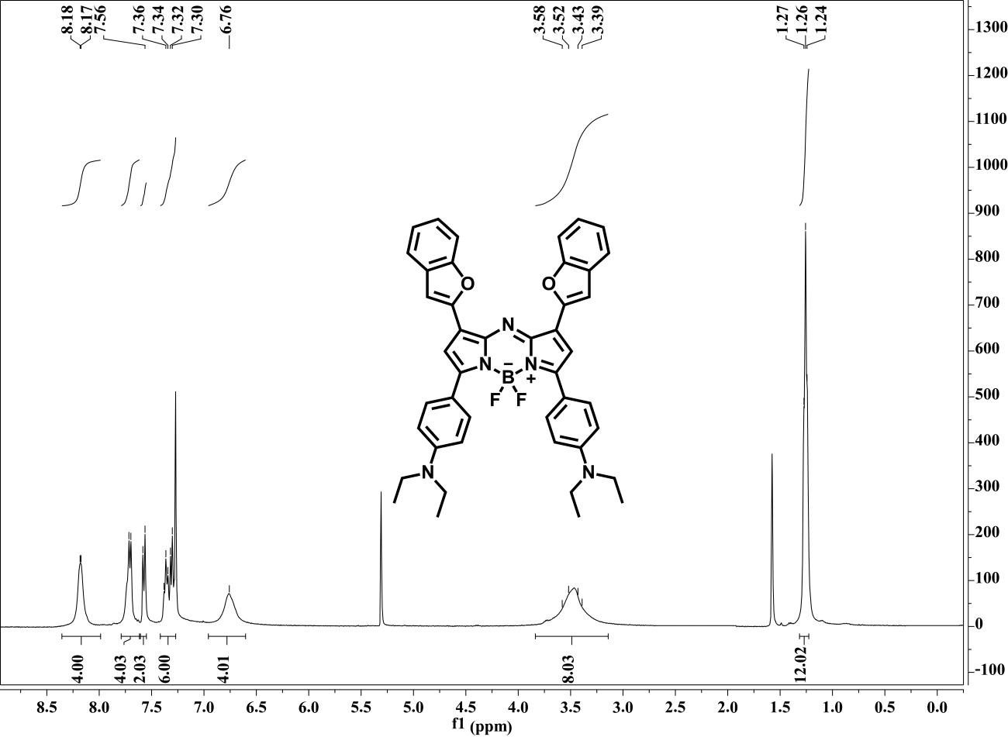
Fig. S20. ¹H-NMR spectrum of NIR1030.
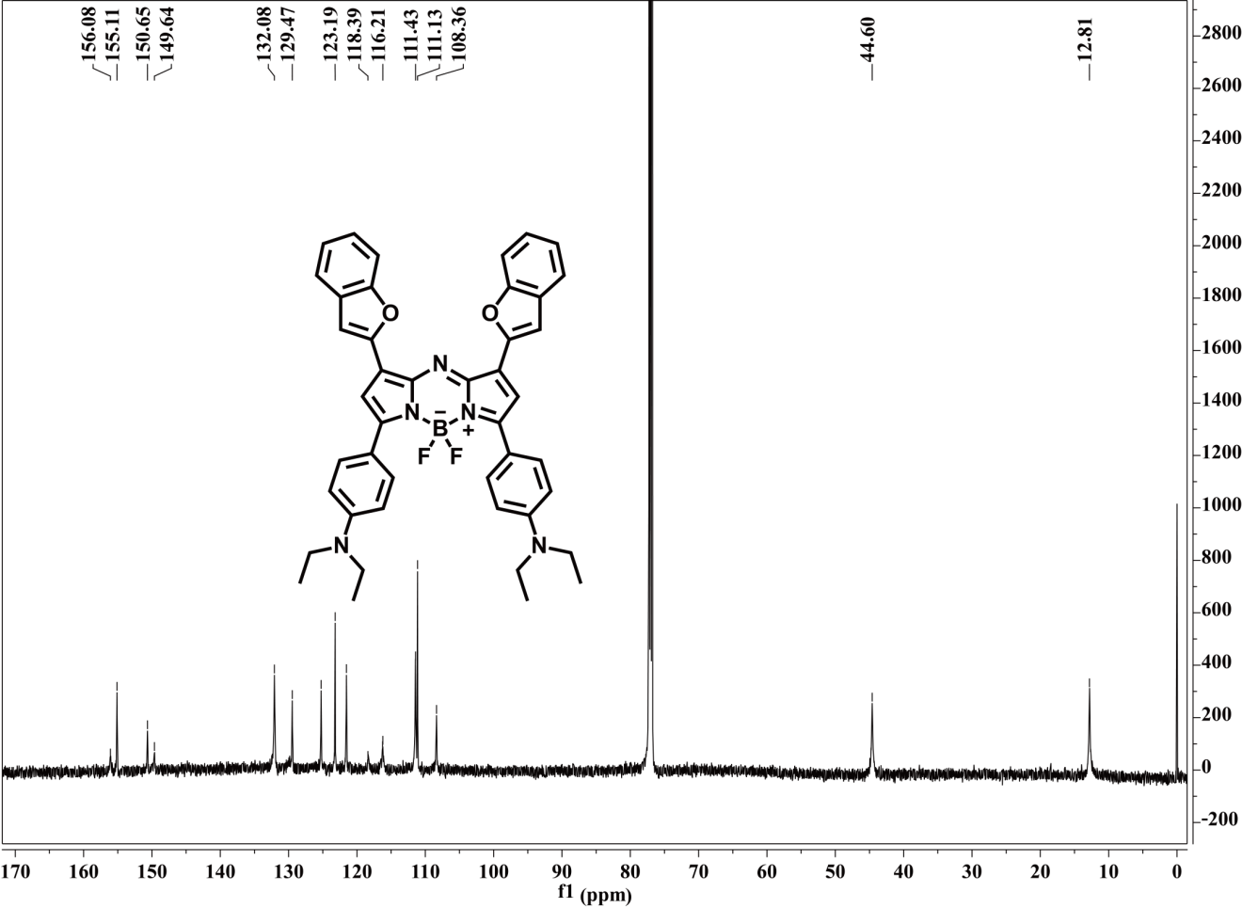
Fig. S21. ¹³C-NMR spectrum of NIR1030.
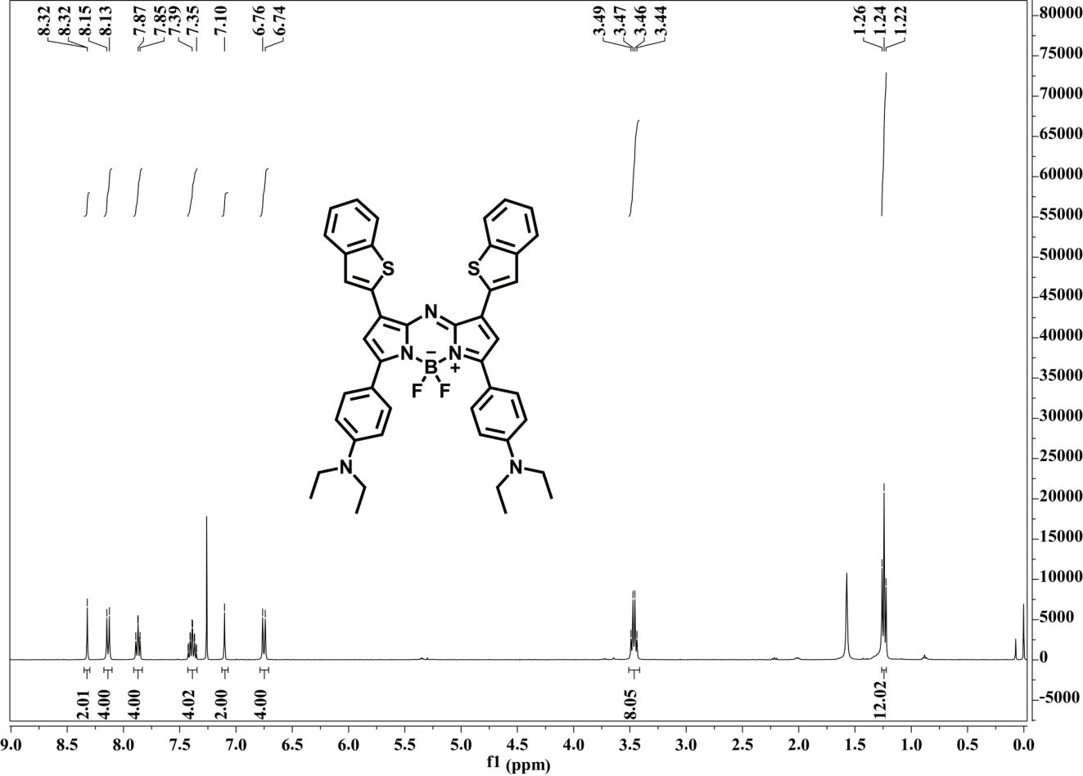
Fig. S22. ¹H-NMR spectrum of NIR1028-S.

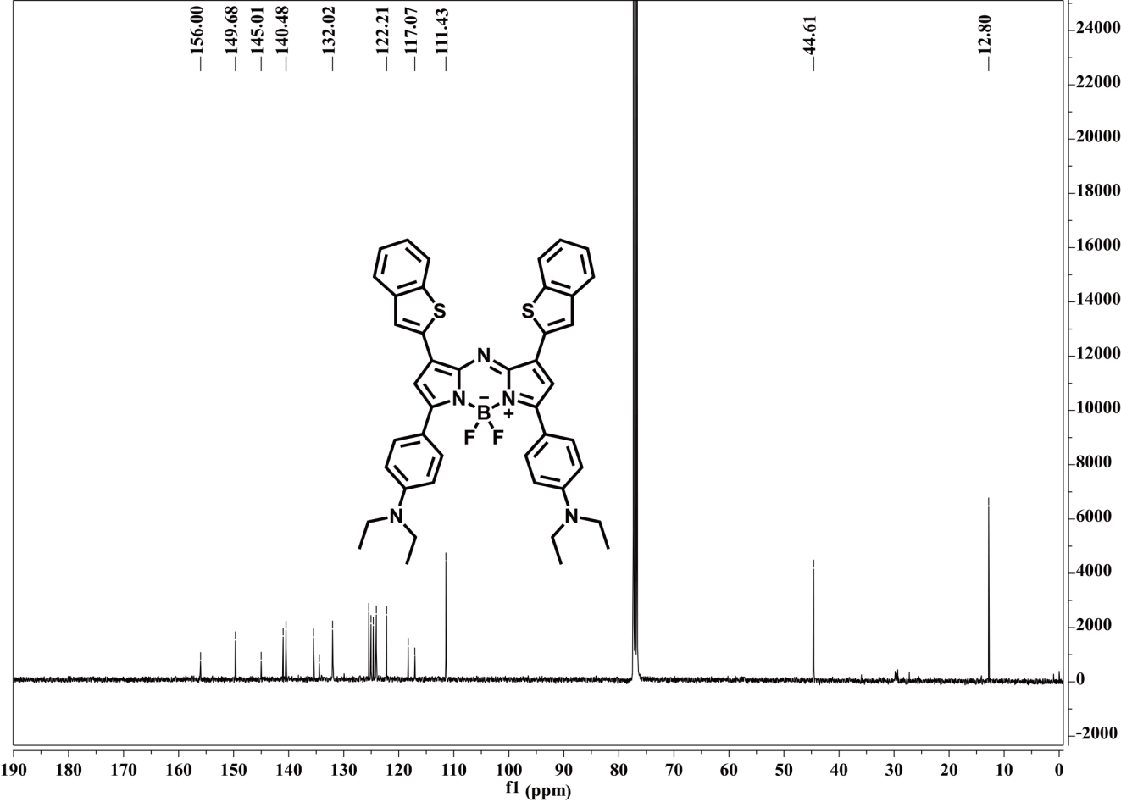
Fig. S23. ¹³C-NMR spectrum of NIR1028-S.
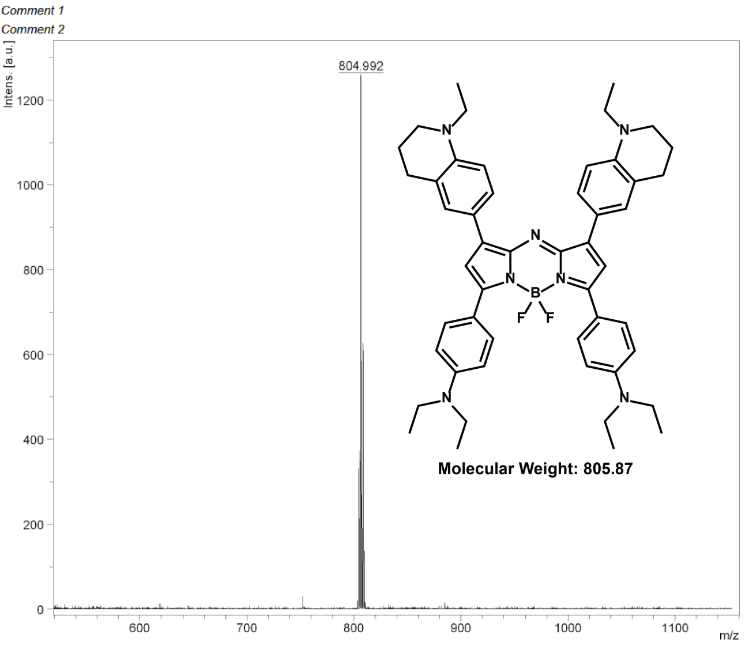
Fig. S24. MALDI-TOF-MS spectrum of NIR998.

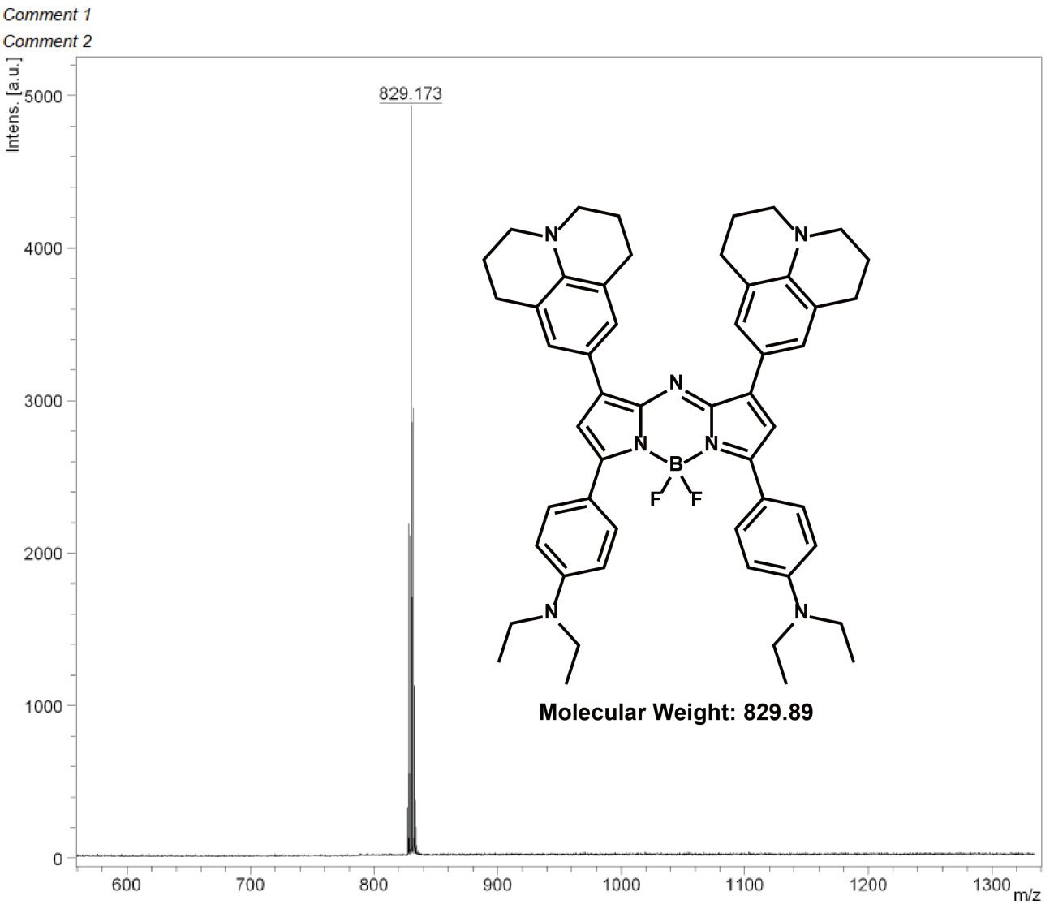
Fig. S25. MALDI-TOF-MS spectrum of NIR1028.
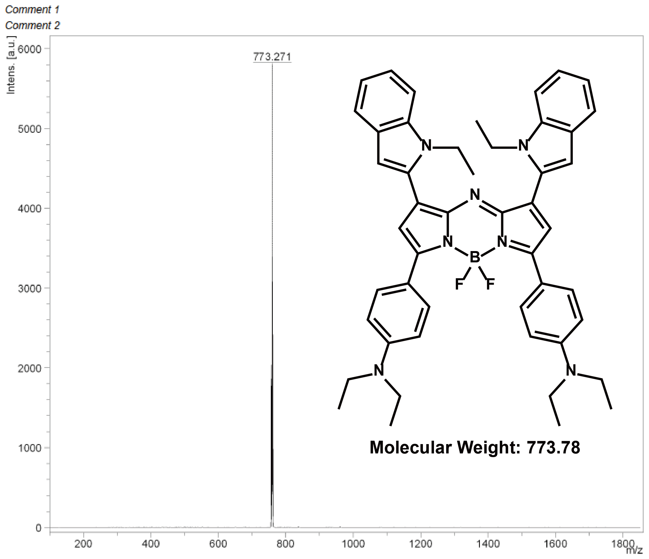
Fig. S26. MALDI-TOF-MS spectrum of NIR980.
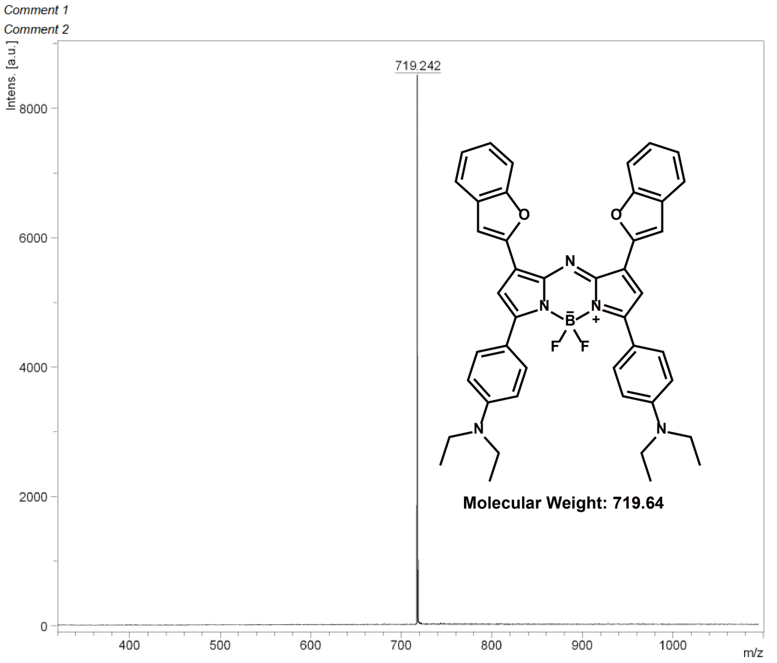
Fig. S27. MALDI-TOF-MS spectrum of NIR1030.
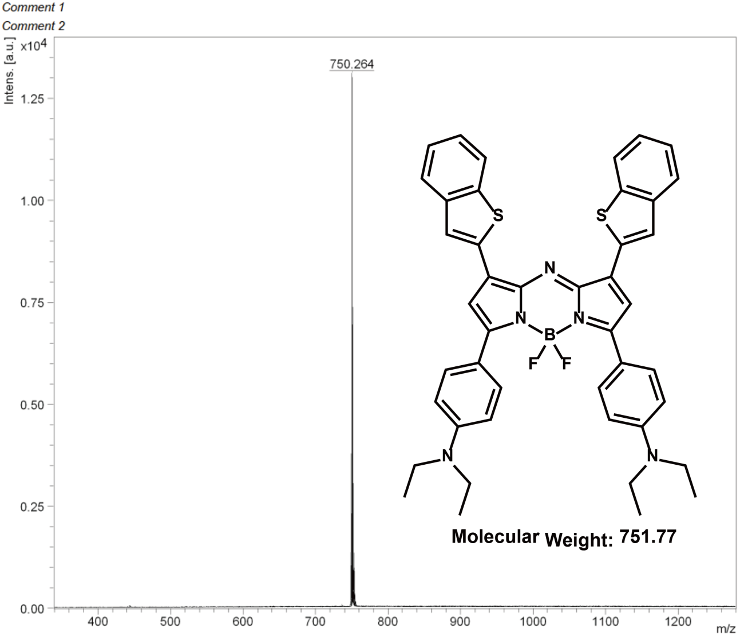
Fig. S28. MALDI-TOF-MS spectrum of NIR1028-S.

Part III. 3. Supplemental References
[1] G. Y. Pan, H. R. Jia, Y. X. Zhu, R. H. Wang, F. G. Wu, Z. Chen, ACS Biomater. Sci. Eng. 2017, 3, 3596.
[2] W. Lv, Z. Zhang, K. Y. Zhang, H. R. Yang, S. J. Liu, A. Q. Xu, S. Guo, Q. Zhao, W. Huang, Angew. Chem. Int. Ed. 2016, 55, 9947.

