SUPPLEMENTARY INFORMATION

Cloning and characterization of three GFP-like proteins identified in the transcriptome of the sea anemone Anthopleura dowii Verrill, 1869

Paul Gaytán¹*, Paola Linares-Flores¹, Abigail Roldán-Salgado, Edith Bernabé-Pérez, Jorge Arturo Yáñez¹, Gloria Saab-Rincón¹, and Claudia Rodríguez-Almazán²

¹Instituto de Biotecnología, Universidad Nacional Autónoma de México, Cuernavaca, Morelos, CP 62210, México.
²Instituto de Ciencias Aplicadas y Tecnología, Universidad Nacional Autónoma de México, Ciudad de México, CP 04510, México.

*Corresponding author: paul.gaytan@ibt.unam.mx

Fig. 1S Putative fluorescent proteins found in the transcriptome of the anemone Anthopleura dowii Verril, 1869, and their designed genes. The proteins were initially labeled as adFP1, adFP2 and adFP3. After revealing their color and fluorescent properties they were renamed as adYFP, adCP and adGFP, respectively.

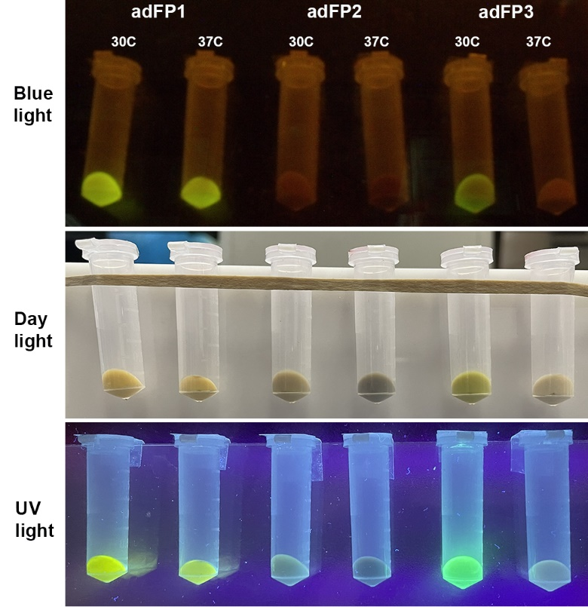

Fig. 2S Pellets of cultures grown at 30 °C and 37 °C expressing adFP1, adFP2 and adFP3, later renamed as adYFP, adCP and adGFP, respectively. Photographs under three different conditions.

Fig. 3S Analysis of the pure proteins adYFP, adCP and adGFP by size exclusion chromatography. The tetrameric protein DsRed, the dimeric rrGFP protein from renilla reniformis, and the monomeric protein EGFP were used as standards of the oligomerization level. Analyses were performed on a HiPrep 16/60 sephacryl S-200 HR from cytiva, using a buffer composed of Tris 25 mM, 100 mM NaCl, pH 7, at a flowrate of 1 mL/min and detection at 280 nm. An FPLC AKTA pure was used to perform the analyses.
Table 1S. Oligonucleotides used for assembly of the synthetic gene adFP1 (adYFP). The outermost primers are PrFw1 and PrRv12, which contain the restriction sites NdeI (catatg) and BamHI (ggatcc), respectively.

Primers | SEQUENCE 5’3’
PrFw1 | CACAGGAAACAGCATATGAGCGGCTCTATTAAAGATAAGATGCATGTGAAAGTTTTTA
PrFw2 | TGGAAGGCAGCGTGAACTATCATGCGTTTAAATGCACCGCGGAAGGCGAGGGTAACCC
PrFw3 | GTATGAAGGTGTTCACAGCATGAAAATTAAGGTGACCGAAGGCGGTCCGCTGCCATTT
PrFw4 | GCGTTCGATATTCTGGCCCTCTGCTTCTCTTATGGCCAGAAAGTGTTCATTAAGTATC
PrFw5 | CGAAGGAAATCCCGGATTTTTTCAAACAGAGCTTCCCGGAAGGCTATACCTGGGAACG
PrFw6 | CGTGACCACGTATGAAGATGGCGGTGTGCTGAGCGTGACCCAGGATACCTCTCTGCAG
PrFw7 | GGCGATTGCCTGATTTGCAACGTGAAAGCGATTGGCACCAACTTTCCGCCAAACGGCC
PrFw8 | CGGTGATGAAAAAGAAAACCTGCGGCTGGGAACCGAGCACCGAAATTGTGTATCCGCA
PrFw9 | GGAAGGCGGTCTGATTGCGCAGGATACCATGGCGCTGAAACTTGTGGGCGGTGGCCAT
PrFw10 | CTGCTTTGCTTTCTGAAAACCACGTTTCGCAGCAAAAAGAAACGCATTACCCTGCCGG
PrFw11 | AATGCCATTTTCACGATTATCGCCTGGAAACCATTAAAGAAAGCGATAACGGCAACAC
PrFw12 | CATTGATCAGTATGAAGGCACCGTGGCGCGCTATAGCTACCTGCCGAGCAAACTGGGC
PrRv1 | AAACGCATGATAGTTCACGCTGCCTTCCATAAAAACTTTCACATGCATCTTATCTTTA
PrRv2 | TAATTTTCATGCTGTGAACACCTTCATACGGGTTACCCTCGCCTTCCGCGGTGCATTT
PrRv3 | GAGAAGCAGAGGGCCAGAATATCGAACGCAAATGGCAGCGGACCGCCTTCGGTCACCT
PrRv4 | CTGTTTGAAAAAATCCGGGATTTCCTTCGGATACTTAATGAACACTTTCTGGCCATAA
PrRv5 | GCACACCGCCATCTTCATACGTGGTCACGCGTTCCCAGGTATAGCCTTCCGGGAAGCT
PrRv6 | GCTTTCACGTTGCAAATCAGGCAATCGCCCTGCAGAGAGGTATCCTGGGTCACGCTCA
PrRv7 | CCAGCCGCAGGTTTTCTTTTTCATCACCGGGCCGTTTGGCGGAAAGTTGGTGCCAATC
PrRv8 | TGGTATCCTGCGCAATCAGACCGCCTTCCTGCGGATACACAATTTCGGTGCTCGGTTC
PrRv9 | CGAAACGTGGTTTTCAGAAAGCAAAGCAGATGGCCACCGCCCACAAGTTTCAGCGCCA
PrRv10 | TTCCAGGCGATAATCGTGAAAATGGCATTCCGGCAGGGTAATGCGTTTCTTTTTGCTG
PrRv11 | GCGCCACGGTGCCTTCATACTGATCAATGGTGTTGCCGTTATCGCTTTCTTTAATGGT
PrRv12 | caccatGTGATGGGATCCACCGCTATGGTTGCCCAGTTTGCTCGGCAGGTAGCTATAGC

Table 2S. Oligonucleotides used for assembly of the synthetic gene adFP2 (adCP). The outermost primers are PrFw4 and PrRv-4, which contain the restriction sites NdeI (catatg) and BamHI (ggatcc), respectively.

Primers | SEQUENCE 5’3’
PrFw1 | AGGCTTTACCTGGGAACGCACCCAGATTTTTGAAGATGGCGGCTTTCTGACCATTTTTCAGGATACCAGCATGCAGGGCGATTGCTTTATTTTTAAAGTGAAAGTGATTG
PrRv-1 | GCCATCGCGCGGATACAGCATTTCCACGCACGGTTCCCAGCCCGCGGTTTTTTTCTGCATCACCGGGCCGTTCGCCGGAAAGTTGGTGCCAATCACTTTCACTTTAAAAA
PrFw2 | ATTCTGGCGCCGTGCGCGATGTATGGCAGCAAAACCTTTATTAAACATGTGAGCGGCATTCCGGATTATTTTAAAGAAAGCTTTCCGGAAGGCTTTACCTGGGAACGCAC
PrRv-2 | TTGCGGCTGCGATAGGTGGTGCGCAGATGGCAGGTCAGATGGTTGCCATCGGTGCATTTCAGCGCCATCAGGCTTTCGCCGCACAGCACGCCATCGCGCGGATACAGCAT
PrFw3 | AAGGCGAAGGCGAAGGCAAACCGTTTGAAGGCAACCAGGTGGAAAAAATTCGCGTGACCGAAGGCGGCCCGCTGCCGTTTGCGTATGATATTCTGGCGCCGTGCGCGATG
PrRv-3 | CATACAGCATGCCCGGTTCCGCTTCTTTCAGCATTTCAATGCGATGATCGCCAAAATGAAATTCCGGCATTTTCTGCGCGTTCGCCGCTTTGCGGCTGCGATAGGTGGTG
PrFw4 | GCGCGCATCATATGGCGAGCCTGGTGAAAAAAACCATGCGCATTAAAATGACCATGGAAGGCACCGTGAACGGCCATCATTTTAAATGCGAAGGCGAAGGCGAAGGCAAA
PrRv-4 | CGTATGGGATCCGCCGCTATGATGGCCCAGTTTGCTCGGCGCCGCTTCGCAATAGCGCGCCACCGCGCTTTCATACTGTTCATACAGCATGCCCGGTTCCG

Table 3S. Oligonucleotides used for assembly of the synthetic gene adFP3 (adGFP). The outermost primers are PrFw1 and PrRv12, which contain the restriction sites NdeI (catatg) and BamHI (ggatcc), respectively.

Primers | SEQUENCE 5’3’
PrFw1 | AGGAAACAGCATATGTATTCTAGCATTAAAGAAAATATGCGCACCAAGCTGTTTATGG
PrFw2 | AGGGCTCGGTTAACTACCATGCCTTCAAATGTGTCGCGGAAGGTGAGGGCAAGCCGTA
PrFw3 | TGAAGGTACGCAGGGCATCACCATTCGCGTTACGGAGGGTGGCCCATTACCGTTTGCC
PrFw4 | TTCGATATCCTGGCGCAAGCATTTCAGTACGGTGTCAAAGTGTTCACCAAGTATCCAA
PrFw5 | AAGAAATTCCGGACTTTTTCAAGCAATCTTTTCCAGAGGGCTTCAAATGGGAACGTGT
PrFw6 | TATGACGTACGAGGATGGTGGCGTGTTGAGCGTCTCTCAGGACACCAGCTTACAAGAT
PrFw7 | GGTTGTATCATTTGCAATATCAAGGTTATTGGCACGAACTTCCCGGCGAATGGTCCAG
PrFw8 | TGATGCAGAAAAAGACCTGTGGCTGGGAACCGTCTACGGAGATGGTTATCCCACGCGA
PrFw9 | GGTGGCCTGTTGGTGCGTGATACCGCGGCCCTGAAATTGAACGGTGGCGGTCACCTGA
PrFw10 | CGTGCAATTTGGAAACCACGTATAAGAGCAAACGCAAGGTTAATTTACCGGAGGCGC
PrFw11 | TTTTCACCATTTGCGTGTCGAACGCCTGAAAGAGTCTGACAACGGCAATACCATTGAT
PrFw12 | CAACACGAAAGCATCGTTGCCTGTTACTCTCAGGTGCCAAGCAAGTTGGGTCATAACT
PrRv1 | ATTTGAAGGCATGGTAGTTAACCGAGCCCTCCATAAACAGCTTGGTGCGCATATTTTC
PrRv2 | ACGCGAATGGTGATGCCCTGCGTACCTTCATACGGCTTGCCCTCACCTTCCGCGACAC
PrRv3 | GTACTGAAATGCTTGCGCCAGGATATCGAAGGCAAACGGTAATGGGCCACCCTCCGTA
PrRv4 | AAGATTGCTTGAAAAAGTCCGGAATTTCTTTTGGATACTTGGTGAACACTTTGACACC
PrRv5 | CTCAACACGCCACCATCCTCGTACGTCATAACACGTTCCCATTTGAAGCCCTCTGGAA
PrRv6 | AATAACCTTGATATTGCAAATGATACAACCATCTTGTAAGCTGGTGTCCTGAGAGACG
PrRv7 | GTTCCCAGCCACAGGTCTTTTTCTGCATCACTGGACCATTCGCCGGGAAGTTCGTGCC
PrRv8 | GCCGCGGTATCACGCACCAACAGGCCACCGTCGCGTGGGATAACCATCTCCGTAGACG
PrRv9 | GCTCTTATACGTGGTTTCCAAATTGCACGTCAGGTGACCGCCACCGTTCAATTTCAGG
PrRv10 | TCAGGCGTTCGACACGCAAATGGTGAAAATGCGCCTCCGGTAAATTAACCTTGCGTTT
PrRv11 | GAGTAACAGGCAACGATGCTTTCGTGTTGATCAATGGTATTGCCGTTGTCAGACTCTT
PrRv12 | GTGATGGGATCCACCGCTGCTACCGCCAGAGTTATGACCCAACTTGCTTGGCACCTGA

