Supplementary Materials
Burden, Temporal Trends, and Projections of Hodgkin Lymphoma in South Asia, 1990–2040: A Systematic Analysis of the Global Burden of Disease Study 2023

Contents
Supplementary Table S1. Joinpoint regression segments (annual percentage changes).
Supplementary Table S2. ARIMA model specifications and residual diagnostics.
Supplementary Table S3. Out-of-sample forecast validation (training 1990–2016, test 2017–2023).
Supplementary Table S4. Projected crude rates at milestone years (2025–2040).
Supplementary Figures S1–S4. Forecast trajectories to 2040 by measure.
Supplementary Table S5. Sex-specific age-standardized rates and male-to-female ratios (2023).
Supplementary Figure S5. Age-specific incidence and mortality, South Asia (2023).

Supplementary Table S1. Joinpoint regression segments (annual percentage changes, APCs) reported in the main analysis
Segment-specific APCs identified by joinpoint regression of age-standardized rates. Values are as described in the Results. NS = not statistically significant (P ≥ 0.05); all other segments were significant at P < 0.05.
Measure | Country/Region | Segment (years) | Segment APC (%)
ASIR | India | 1998–2018 | −2.00
ASIR | India | 2018–2021 | +2.66 (NS)
ASIR | India | 2021–2023 | −5.64
ASIR | Pakistan | 2018–2021 | +1.36 (NS)
ASIR | Pakistan | 2021–2023 | −7.32
ASPR | Pakistan | 1994–2021 | +0.63
ASPR | Bhutan | 2018–2023 | +2.13
ASPR | India | 2016–2023 | +1.46
ASPR | South Asia | 2016–2023 | +1.33
ASPR | Bangladesh | 2021–2023 | +7.74
ASDR | Bangladesh | 1990–2010 | −3.01
ASDR | Bangladesh | 2010–2014 | −4.77
ASDR | Bangladesh | 2014–2019 | −0.80
ASDR | Bangladesh | 2019–2023 | −5.06
ASDR | India | 1998–2018 | −2.75
ASDR | India | 2018–2021 | +0.26 (NS)
ASDR | India | 2021–2023 | −6.26
ASDR | Pakistan | 2021–2023 | −8.06
ASR-DALYs | India | 1990–1998 | −1.50
ASR-DALYs | India | 1998–2011 | −2.63
ASR-DALYs | India | 2011–2018 | −3.76
ASR-DALYs | Bangladesh | 2009–2014 | −4.55
ASR-DALYs | Bangladesh | 2014–2019 | −0.87
ASR-DALYs | Bangladesh | 2019–2023 | −3.83
Note: This table lists the joinpoint segments explicitly reported in the Results narrative. The complete joinpoint output—every breakpoint and segment APC with 95% confidence intervals for all four measures across South Asia and each country—is available from the corresponding author on request. Full-period average annual percentage changes (AAPCs) are reported in Table 1 of the main manuscript. ASIR, age-standardized incidence rate; ASPR, prevalence rate; ASDR, death rate; ASR-DALYs, DALY rate.

Supplementary Table S2. ARIMA model specifications and residual diagnostics (final models, fitted to crude rates 1990–2023)
Final ARIMA models selected by corrected Akaike Information Criterion (AICc). All 24 models passed the Ljung–Box test (P > 0.05), indicating residuals consistent with white noise.
Measure | Jurisdiction | ARIMA order | AICc | In-sample MAPE (%) | Ljung–Box p | Residuals
Deaths | Bangladesh | ARIMA(0,2,1) | -204.84 | 1.48 | 0.460 | White noise
Deaths | Bhutan | ARIMA(0,1,0) | -212.59 | 1.36 | 0.698 | White noise
Deaths | India | ARIMA(0,1,0) | -211.57 | 1.62 | 0.635 | White noise
Deaths | Nepal | ARIMA(0,2,3) | -236.21 | 0.83 | 0.962 | White noise
Deaths | Pakistan | ARIMA(2,2,0) | -167.75 | 1.08 | 0.879 | White noise
Deaths | South Asia | ARIMA(0,1,0) | -218.83 | 1.27 | 0.635 | White noise
Incidence | Bangladesh | ARIMA(0,2,1) | -192.28 | 1.25 | 0.703 | White noise
Incidence | Bhutan | ARIMA(0,1,0) | -188.66 | 1.39 | 0.836 | White noise
Incidence | India | ARIMA(0,1,0) | -180.56 | 1.64 | 0.925 | White noise
Incidence | Nepal | ARIMA(2,2,0) | -212.74 | 0.98 | 0.735 | White noise
Incidence | Pakistan | ARIMA(2,1,1) | -151.52 | 1.20 | 0.994 | White noise
Incidence | South Asia | ARIMA(0,1,0) | -187.56 | 1.28 | 0.923 | White noise
Prevalence | Bangladesh | ARIMA(0,2,1) | -64.01 | 1.92 | 0.916 | White noise
Prevalence | Bhutan | ARIMA(1,0,0) | -117.88 | 1.42 | 0.930 | White noise
Prevalence | India | ARIMA(0,1,2) | -156.29 | 0.91 | 0.868 | White noise
Prevalence | Nepal | ARIMA(0,2,1) | -122.65 | 1.37 | 0.851 | White noise
Prevalence | Pakistan | ARIMA(2,1,0) | -78.56 | 1.08 | 0.962 | White noise
Prevalence | South Asia | ARIMA(3,0,0) | -157.53 | 0.68 | 0.979 | White noise
DALYs | Bangladesh | ARIMA(0,2,1) | 31.94 | 1.31 | 0.678 | White noise
DALYs | Bhutan | ARIMA(0,1,3) | 60.37 | 1.43 | 0.998 | White noise
DALYs | India | ARIMA(0,1,0) | 46.44 | 1.76 | 0.740 | White noise
DALYs | Nepal | ARIMA(2,2,0) | 23.91 | 1.14 | 0.542 | White noise
DALYs | Pakistan | ARIMA(0,2,4) | 92.29 | 1.24 | 0.983 | White noise
DALYs | South Asia | ARIMA(0,1,0) | 40.72 | 1.30 | 0.823 | White noise
AICc, corrected Akaike Information Criterion; MAPE, mean absolute percentage error.

Supplementary Table S3. Out-of-sample forecast validation (training 1990–2016; test 2017–2023)
Models were re-fitted on 1990–2016 and evaluated on the held-out 2017–2023 period. 95% PI coverage is the proportion of held-out observations falling within the 95% prediction interval (nominal target ≈ 95%); low values indicate intervals that are too narrow.
Measure | Jurisdiction | Training order | RMSE | MAE | MAPE (%) | 95% PI coverage (%)
Deaths | Bangladesh | ARIMA(0,1,1) | 0.0460 | 0.0440 | 11.48 | 0.0 *
Deaths | Bhutan | ARIMA(0,1,0) | 0.0233 | 0.0203 | 6.00 | 100.0
Deaths | India | ARIMA(0,1,2) | 0.0253 | 0.0199 | 6.27 | 85.7
Deaths | Nepal | ARIMA(0,2,0) | 0.0153 | 0.0119 | 3.55 | 100.0
Deaths | Pakistan | ARIMA(0,2,0) | 0.0396 | 0.0320 | 3.93 | 100.0
Deaths | South Asia | ARIMA(0,1,2) | 0.0217 | 0.0171 | 4.44 | 85.7
Incidence | Bangladesh | ARIMA(0,2,1) | 0.0219 | 0.0207 | 3.31 | 100.0
Incidence | Bhutan | ARIMA(0,1,0) | 0.0342 | 0.0294 | 5.46 | 100.0
Incidence | India | ARIMA(0,1,2) | 0.0439 | 0.0334 | 7.02 | 71.4 *
Incidence | Nepal | ARIMA(0,2,0) | 0.0164 | 0.0132 | 2.67 | 100.0
Incidence | Pakistan | ARIMA(0,2,0) | 0.0541 | 0.0421 | 3.53 | 100.0
Incidence | South Asia | ARIMA(0,1,2) | 0.0398 | 0.0308 | 5.35 | 57.1 *
Prevalence | Bangladesh | ARIMA(1,2,0) | 0.2493 | 0.2005 | 8.54 | 85.7
Prevalence | Bhutan | ARIMA(0,1,0) | 0.1125 | 0.0888 | 4.82 | 85.7
Prevalence | India | ARIMA(0,1,2) | 0.0871 | 0.0689 | 4.34 | 71.4 *
Prevalence | Nepal | ARIMA(0,2,0) | 0.1101 | 0.1030 | 6.79 | 57.1 *
Prevalence | Pakistan | ARIMA(0,1,1) | 0.1482 | 0.1185 | 3.14 | 71.4 *
Prevalence | South Asia | ARIMA(3,1,0) | 0.0892 | 0.0717 | 3.70 | 28.6 *
DALYs | Bangladesh | ARIMA(0,2,1) | 0.9099 | 0.8685 | 5.13 | 100.0
DALYs | Bhutan | ARIMA(0,1,0) | 1.0007 | 0.8449 | 5.40 | 100.0
DALYs | India | ARIMA(0,1,2) | 1.2340 | 0.9453 | 7.05 | 85.7
DALYs | Nepal | ARIMA(0,2,0) | 0.8000 | 0.6459 | 4.13 | 100.0
DALYs | Pakistan | ARIMA(0,2,0) | 1.9017 | 1.4965 | 3.72 | 100.0
DALYs | South Asia | ARIMA(3,1,0) | 0.9890 | 0.6779 | 3.91 | 85.7
* Interval coverage below the nominal 95% level. Poor coverage was concentrated in prevalence and regional incidence/prevalence series, indicating that prediction intervals for those measures are likely too narrow and long-range projections should be interpreted with caution. RMSE, root mean square error; MAE, mean absolute error; PI, prediction interval.

Supplementary Table S4. Projected crude rates per 100,000 at milestone years (mean; 95% prediction interval)
Forecasts from final ARIMA models re-fitted on the full 1990–2023 series. Values are crude rates per 100,000 population and are not directly comparable to the age-standardized rates in the main text.
Deaths
Jurisdiction | 2025 | 2030 | 2035 | 2040
South Asia | 0.32 (0.30–0.35) | 0.27 (0.23–0.31) | 0.22 (0.16–0.27) | 0.16 (0.10–0.23)
Bangladesh | 0.30 (0.28–0.33) | 0.22 (0.14–0.31) | 0.14 (0.00–0.30) | 0.06 (0.00–0.29)
Bhutan | 0.30 (0.28–0.33) | 0.25 (0.20–0.30) | 0.20 (0.14–0.27) | 0.16 (0.08–0.23)
India | 0.27 (0.24–0.29) | 0.21 (0.17–0.26) | 0.16 (0.10–0.23) | 0.11 (0.04–0.19)
Nepal | 0.29 (0.27–0.31) | 0.20 (0.08–0.31) | 0.11 (0.00–0.39) | 0.02 (0.00–0.51)
Pakistan | 0.72 (0.65–0.79) | 0.51 (0.27–0.75) | 0.35 (0.00–0.83) | 0.19 (0.00–0.96)
Incidence
Jurisdiction | 2025 | 2030 | 2035 | 2040
South Asia | 0.52 (0.48–0.55) | 0.47 (0.40–0.54) | 0.43 (0.34–0.52) | 0.38 (0.27–0.49)
Bangladesh | 0.58 (0.55–0.62) | 0.54 (0.43–0.65) | 0.50 (0.30–0.70) | 0.46 (0.16–0.77)
Bhutan | 0.51 (0.47–0.55) | 0.47 (0.40–0.54) | 0.43 (0.35–0.52) | 0.40 (0.29–0.50)
India | 0.42 (0.38–0.46) | 0.37 (0.30–0.45) | 0.33 (0.23–0.43) | 0.28 (0.16–0.40)
Nepal | 0.47 (0.44–0.50) | 0.43 (0.31–0.54) | 0.39 (0.17–0.62) | 0.35 (0.00–0.72)
Pakistan | 1.21 (1.13–1.29) | 1.16 (1.04–1.29) | 1.15 (1.00–1.30) | 1.15 (0.97–1.33)
Prevalence
Jurisdiction | 2025 | 2030 | 2035 | 2040
South Asia | 1.92 (1.87–1.98) | 1.85 (1.74–1.95) | 1.84 (1.73–1.95) | 1.85 (1.74–1.97)
Bangladesh | 2.63 (2.39–2.87) | 2.78 (2.20–3.36) | 2.93 (1.99–3.87) | 3.09 (1.75–4.42)
Bhutan | 1.83 (1.73–1.93) | 1.78 (1.66–1.91) | 1.77 (1.64–1.90) | 1.76 (1.63–1.89)
India | 1.56 (1.49–1.63) | 1.56 (1.35–1.76) | 1.56 (1.27–1.84) | 1.56 (1.22–1.90)
Nepal | 1.51 (1.41–1.62) | 1.49 (1.16–1.82) | 1.47 (0.86–2.08) | 1.45 (0.51–2.39)
Pakistan | 3.90 (3.70–4.09) | 3.92 (3.65–4.19) | 4.01 (3.68–4.34) | 4.13 (3.75–4.51)
DALYs
Jurisdiction | 2025 | 2030 | 2035 | 2040
South Asia | 14.41 (13.23–15.59) | 11.98 (9.78–14.19) | 9.56 (6.67–12.45) | 7.13 (3.69–10.58)
Bangladesh | 14.05 (12.84–15.27) | 11.12 (7.12–15.13) | 8.19 (0.63–15.76) | 5.26 (0.00–17.05)
Bhutan | 14.65 (13.23–16.08) | 12.23 (8.84–15.61) | 10.18 (5.45–14.92) | 8.14 (2.36–13.92)
India | 10.89 (9.60–12.18) | 8.46 (6.05–10.87) | 6.03 (2.88–9.18) | 3.60 (0.00–7.36)
Nepal | 14.37 (13.05–15.69) | 12.00 (7.22–16.78) | 10.04 (0.39–19.69) | 7.92 (0.00–23.50)
Pakistan | 37.61 (34.23–41.00) | 31.66 (23.81–39.50) | 25.62 (9.38–41.85) | 19.58 (0.00–46.69)

Supplementary Figures S1–S4. Forecast trajectories of Hodgkin lymphoma crude rates to 2040
Supplementary Figure S1. ARIMA forecasts of the crude death rate of Hodgkin lymphoma per 100,000 population, South Asia and constituent countries, with 95% prediction intervals, 2024–2040.
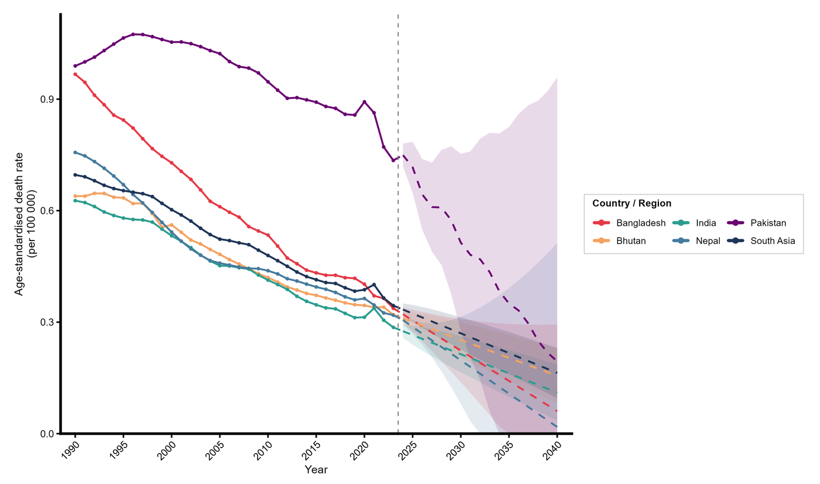
Supplementary Figure S2. ARIMA forecasts of the crude incidence rate of Hodgkin lymphoma per 100,000 population, South Asia and constituent countries, with 95% prediction intervals, 2024–2040.
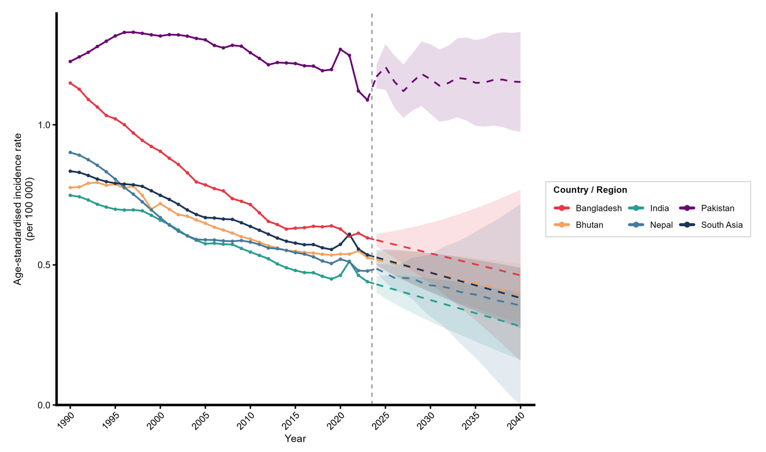
Supplementary Figure S3. ARIMA forecasts of the crude prevalence rate of Hodgkin lymphoma per 100,000 population, South Asia and constituent countries, with 95% prediction intervals, 2024–2040.
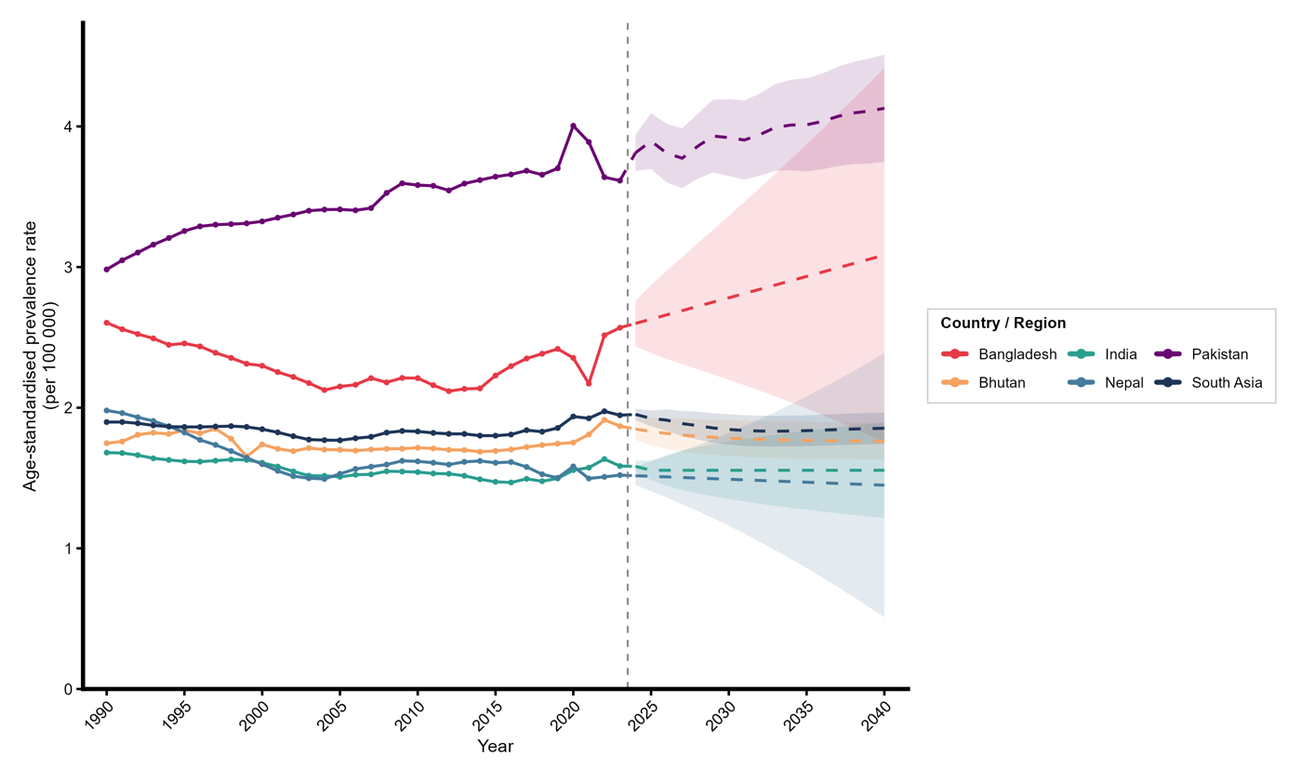
Supplementary Figure S4. ARIMA forecasts of the crude DALY rate of Hodgkin lymphoma per 100,000 population, South Asia and constituent countries, with 95% prediction intervals, 2024–2040.
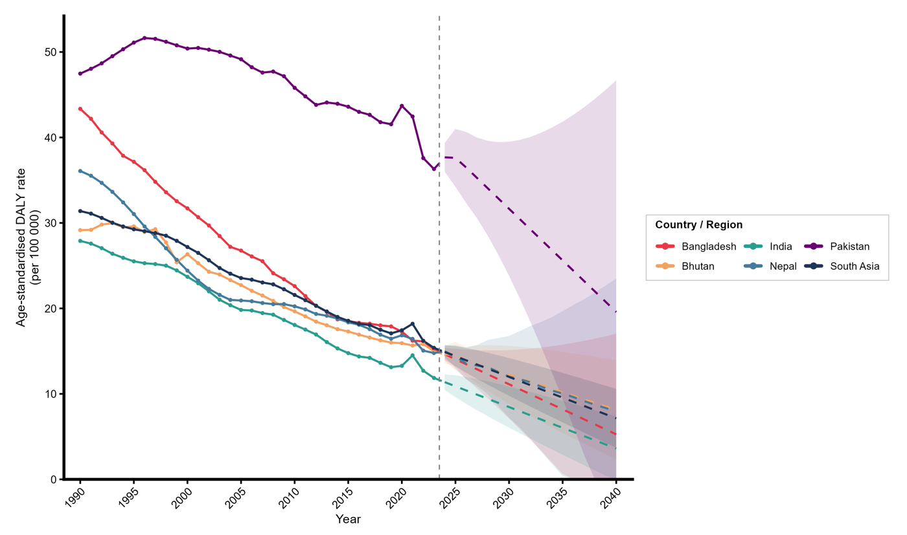

Supplementary Table S5. Sex-specific age-standardized rates and male-to-female ratios, 2023
Age-standardized rates per 100,000 population by sex in 2023. M:F = male-to-female rate ratio. ASIR, incidence; ASPR, prevalence; ASDR, death; ASR-DALYs, DALY rate.
ASIR
Jurisdiction | Male | Female | M:F ratio
South Asia | 0.69 | 0.38 | 1.79
Bangladesh | 0.72 | 0.46 | 1.55
Bhutan | 0.69 | 0.36 | 1.93
India | 0.58 | 0.31 | 1.88
Nepal | 0.60 | 0.36 | 1.67
Pakistan | 1.35 | 0.80 | 1.67
ASPR
Jurisdiction | Male | Female | M:F ratio
South Asia | 2.38 | 1.49 | 1.59
Bangladesh | 2.96 | 2.15 | 1.37
Bhutan | 2.40 | 1.30 | 1.84
India | 1.98 | 1.17 | 1.69
Nepal | 1.85 | 1.20 | 1.55
Pakistan | 4.28 | 2.89 | 1.48
ASDR
Jurisdiction | Male | Female | M:F ratio
South Asia | 0.46 | 0.23 | 2.00
Bangladesh | 0.43 | 0.24 | 1.83
Bhutan | 0.43 | 0.20 | 2.13
India | 0.39 | 0.19 | 2.08
Nepal | 0.42 | 0.23 | 1.84
Pakistan | 0.94 | 0.51 | 1.86
ASR-DALYs
Jurisdiction | Male | Female | M:F ratio
South Asia | 19.91 | 10.73 | 1.86
Bangladesh | 18.86 | 11.36 | 1.66
Bhutan | 19.92 | 9.71 | 2.05
India | 15.70 | 7.97 | 1.97
Nepal | 18.79 | 10.90 | 1.72
Pakistan | 45.10 | 26.71 | 1.69

Supplementary Figure S5. Age-specific incidence and mortality, South Asia, 2023
Supplementary Figure S5. Age-specific Hodgkin lymphoma incidence and mortality rates per 100,000 population, South Asia, 2023, showing the characteristic bimodal incidence distribution (young-adult and older-adult peaks) and the concentration of mortality among older adults.
