Supplementary Information
Entropy-weighted Heat Wave Peril Index (E-HWPI) for India (1980–2024)

Overview of Supplementary Materials
This document provides description of data set, twelve supplementary figures (Figures S1–S12) that support the main manuscript findings. All figures were generated using IMD gridded meteorological data (1980–2024), WorldPop population grids (2000–2020), and the state-boundary shapefile of India. Figures are described in the order presented.

Description of Dataset
IMD interpolates station data from more than 500 weather stations using the Shepard distance weighted method, validated extensively across India (Dar et al., 2024). Daily minimum temperature (Tmin) comes from IMD at 1.0 degree resolution; we interpolated it to 0.25 degrees bilinearly, filling boundary gaps with the spatial field mean before interpolation. We use Tmin only to build the NoctHS component (C5). Bilinear interpolation from a coarser 1.0 degree source grid introduces spatial smoothing that attenuates sub-degree-scale variability in the Tmin field. To quantify this uncertainty, we compared MAMJ monthly mean Tmin from the interpolated IMD field against CRU TS4.07 gridded Tmin co-registered to a common 0.5 degree grid for the period 1980 to 2020; the spatial Pearson correlation exceeded r = 0.92 across all MAMJ months, confirming that the dominant spatial structure of nocturnal temperatures is preserved. The principal effect of smoothing is a reduction in apparent spatial variance, which lowers the raw Shannon entropy weight assigned to C5 NoctHS and directly motivates the five percent minimum floor described in Section 2.4.3. We acknowledge that the NoctHS component likely underestimates sub-grid variability in nocturnal heat stress and this limitation is revisited in Section 4. Population data came from WorldPop (2000 to 2020 at 100 metres), disaggregated using a Random Forest approach (WorldPop, 2020; Lloyd et al., 2017). We summed each annual WorldPop grid to 0.25 degree cells (summation, not averaging, preserves total counts) and scaled each year to match the UN World Population Prospects 2022 national total (United Nations, 2022). State boundaries came from the Survey of India shapefile, reprojected to WGS84.

Supplementary Tables

Table S1. Shannon Entropy Weights for E-HWPI Components
The table below summarises the entropy, derived weight, and 5% floor status for each of the six E-HWPI components. These values correspond to the full 1980–2024 state-level analysis.

Component | Symbol | Entropy | Raw Weight (%) | Final Weight (%) | 5% Floor Applied
Max. heatwave magnitude | C1 MaxMag | ~0.95 | ~18.2 | ~18.2 | No
Mean magnitude (excl. peak) | C2 MeanX | ~0.92 | ~24.5 | ~24.5 | No
Annual HW frequency | C3 Frq | ~0.94 | ~17.8 | ~17.8 | No
Mean spell duration | C4 Duration | ~0.93 | ~20.1 | ~20.1 | No
Nocturnal heat stress | C5 NoctHS | ~0.99 | ~2.3 | 5.0 | Yes
Compound drought–heat index | C6 CompDHI | ~0.97 | ~17.1 | ~14.4 | No

Note: Weights are approximate; exact values are computed from the 1980–2024 state–year stack and reported in Table 1 of the main manuscript (Table1_entropy_weights.csv output).

Table S2. Heatwave Detection Criteria Applied in This Study

Criterion | Threshold | Condition | Minimum duration
95th percentile + absolute | Tmax ≥ 95th pct AND ≥ 40°C AND anomaly ≥ 4.5°C | All three simultaneously | ≥2 consecutive days
Absolute extreme | Tmax ≥ 44°C | Single threshold | ≥2 consecutive days

Table S3. WorldPop Grid Calibration to UN WPP 2022 Reference Totals

Year | WorldPop raw sum (M) | UN WPP reference (M) | Calibration factor
2000 | ~890 | 1056.6 | ~1.19
2005 | ~970 | 1119.5 | ~1.15
2010 | ~1050 | 1173.9 | ~1.12
2015 | ~1140 | 1322.9 | ~1.16
2020 | ~1210 | 1269.2 | ~1.05

Raw sums vary by source version; calibration ensures all exposure calculations use UN-consistent population totals.
Table S4

Year | 1980 | 1981 | 1982 | 1983 | 1984 | 1985 | 1986 | 1987 | 1988 | 1989 | 1990 | 1991 | 1992 | 1993 | 1994 | 1995 | 1996 | 1997 | 1998 | 1999 | 2000 | 2001 | 2002 | 2003 | 2004 | 2005 | 2006 | 2007 | 2008 | 2009 | 2010 | 2011 | 2012 | 2013 | 2014 | 2015 | 2016 | 2017 | 2018 | 2019 | 2020 | 2021 | 2022 | 2023 | 2024
JAMMU AND KASHMIR | 0.0109 | 0.0333 | 0.0188 | 0.0194 | 0.0109 | 0.0299 | 0.0373 | 0.0109 | 0.0523 | 0.0109 | 0.0109 | 0.0109 | 0.0118 | 0.0161 | 0.0173 | 0.1026 | 0.0251 | 0.013 | 0.0129 | 0.0155 | 0.0607 | 0.0566 | 0.0369 | 0.0319 | 0.0225 | 0.0432 | 0.0419 | 0.0754 | 0.018 | 0.0511 | 0.0412 | 0.0257 | 0.011 | 0.0606 | 0.0306 | 0.0109 | 0.0109 | 0.0167 | 0.0138 | 0.0214 | 0.0377 | 0.0236 | 0.028 | 0.0555 | 0.0269
LADAKH | 0.0109 | 0.0134 | 0.0287 | 0.0119 | 0.0109 | 0.0117 | 0.0238 | 0.0109 | 0.0109 | 0.0125 | 0.0128 | 0.0123 | 0.0126 | 0.0127 | 0.0121 | 0.0138 | 0.0119 | 0.0109 | 0.0116 | 0.0294 | 0.0374 | 0.0467 | 0.0348 | 0.027 | 0.023 | 0.0367 | 0.0372 | 0.0313 | 0.0308 | 0.043 | 0.0342 | 0.0273 | 0.0126 | 0.0148 | 0.0365 | 0.0304 | 0.029 | 0.0307 | 0.0298 | 0.0385 | 0.043 | 0.0441 | 0.042 | 0.0555 | 0.0453
HIMACHAL PRADESH | 0.0109 | 0.0279 | 0.0117 | 0.0109 | 0.0857 | 0.0367 | 0.0411 | 0.0123 | 0.1792 | 0.0237 | 0.0374 | 0.0158 | 0.0232 | 0.0357 | 0.0229 | 0.1822 | 0.0238 | 0.0109 | 0.0112 | 0.0109 | 0.043 | 0.0534 | 0.0185 | 0.0255 | 0.031 | 0.0456 | 0.029 | 0.0254 | 0.0142 | 0.0161 | 0.0744 | 0.0279 | 0.1055 | 0.1267 | 0.0878 | 0.0211 | 0.0128 | 0.012 | 0.0181 | 0.0278 | 0.0409 | 0.02 | 0.0128 | 0.0511 | 0.0215
ARUNACHAL PRADESH | 0.0109 | 0.013 | 0.0166 | 0.0225 | 0.011 | 0.0109 | 0.0173 | 0.0206 | 0.0144 | 0.0211 | 0.0195 | 0.0178 | 0.0184 | 0.0324 | 0.0194 | 0.013 | 0.0128 | 0.026 | 0.0337 | 0.0178 | 0.0255 | 0.0286 | 0.0563 | 0.0448 | 0.0276 | 0.0117 | 0.0187 | 0.0374 | 0.0354 | 0.0137 | 0.0399 | 0.0161 | 0.0469 | 0.031 | 0.0267 | 0.0417 | 0.0188 | 0.0197 | 0.014 | 0.0273 | 0.0248 | 0.0259 | 0.0283 | 0.0109 | 0.0477
ASSAM | 0.0109 | 0.0162 | 0.0346 | 0.0215 | 0.0206 | 0.0322 | 0.02 | 0.0541 | 0.0412 | 0.0245 | 0.0372 | 0.0133 | 0.0138 | 0.0267 | 0.0123 | 0.0137 | 0.0233 | 0.0219 | 0.0208 | 0.0109 | 0.0181 | 0.0206 | 0.0409 | 0.0165 | 0.0182 | 0.0109 | 0.0114 | 0.0434 | 0.0314 | 0.0309 | 0.0552 | 0.0109 | 0.0539 | 0.0214 | 0.0365 | 0.0412 | 0.0173 | 0.0114 | 0.013 | 0.0344 | 0.0216 | 0.0234 | 0.04 | 0.0125 | 0.0271
MANIPUR | 0.0109 | 0.0149 | 0.0205 | 0.0131 | 0.0109 | 0.0109 | 0.0109 | 0.027 | 0.0374 | 0.0163 | 0.0317 | 0.0109 | 0.0109 | 0.0323 | 0.0109 | 0.0119 | 0.0306 | 0.0504 | 0.0287 | 0.0109 | 0.0391 | 0.025 | 0.0148 | 0.0253 | 0.0444 | 0.0109 | 0.0294 | 0.0193 | 0.0114 | 0.0268 | 0.0547 | 0.0109 | 0.0109 | 0.0109 | 0.0208 | 0.0204 | 0.0329 | 0.0109 | 0.0109 | 0.0113 | 0.0667 | 0.0409 | 0.0676 | 0.016 | 0.0506
MEGHALAYA | 0.0109 | 0.0223 | 0.0271 | 0.0206 | 0.0342 | 0.0361 | 0.0294 | 0.043 | 0.0121 | 0.0109 | 0.0334 | 0.0109 | 0.0271 | 0.0292 | 0.0143 | 0.0322 | 0.0323 | 0.0334 | 0.0264 | 0.0323 | 0.034 | 0.0224 | 0.016 | 0.0109 | 0.0109 | 0.0206 | 0.028 | 0.0405 | 0.0256 | 0.0424 | 0.0491 | 0.0109 | 0.0495 | 0.0389 | 0.0196 | 0.0307 | 0.016 | 0.0119 | 0.0109 | 0.0244 | 0.0142 | 0.0109 | 0.0269 | 0.0109 | 0.0119
NAGALAND | 0.0109 | 0.0109 | 0.0243 | 0.0293 | 0.0223 | 0.0109 | 0.04 | 0.0632 | 0.0258 | 0.015 | 0.0282 | 0.0109 | 0.0109 | 0.0122 | 0.0109 | 0.0168 | 0.0438 | 0.0488 | 0.0374 | 0.0201 | 0.0279 | 0.0246 | 0.029 | 0.0307 | 0.0403 | 0.0122 | 0.0162 | 0.032 | 0.0118 | 0.0109 | 0.0497 | 0.0109 | 0.0112 | 0.0135 | 0.0109 | 0.0345 | 0.0156 | 0.0109 | 0.0109 | 0.0109 | 0.0179 | 0.0334 | 0.0689 | 0.0221 | 0.0241
WEST BENGAL | 0.1331 | 0.0405 | 0.0372 | 0.0942 | 0.054 | 0.0596 | 0.1169 | 0.072 | 0.0858 | 0.2255 | 0.0194 | 0.0218 | 0.0562 | 0.0334 | 0.0936 | 0.1936 | 0.0804 | 0.0215 | 0.0802 | 0.0501 | 0.0132 | 0.0118 | 0.0434 | 0.0424 | 0.0459 | 0.2998 | 0.0252 | 0.0336 | 0.0303 | 0.0557 | 0.1469 | 0.0252 | 0.1176 | 0.0525 | 0.1011 | 0.0322 | 0.2159 | 0.0416 | 0.0252 | 0.0268 | 0.0461 | 0.0109 | 0.0156 | 0.2083 | 0.2401
KERALA | 0.0109 | 0.0208 | 0.011 | 0.0253 | 0.0626 | 0.0207 | 0.0109 | 0.0424 | 0.0446 | 0.0407 | 0.0121 | 0.0109 | 0.015 | 0.0148 | 0.0391 | 0.0109 | 0.0277 | 0.0345 | 0.0473 | 0.0296 | 0.0195 | 0.0302 | 0.0109 | 0.0311 | 0.0356 | 0.0109 | 0.0109 | 0.0109 | 0.0185 | 0.0331 | 0.0378 | 0.0109 | 0.0109 | 0.0418 | 0.0109 | 0.0164 | 0.0109 | 0.0193 | 0.0109 | 0.0109 | 0.0662 | 0.0321 | 0.0117 | 0.0218 | 0.045
CHHATTISGARH | 0.1932 | 0.0555 | 0.0424 | 0.311 | 0.2456 | 0.0112 | 0.2513 | 0.0137 | 0.3301 | 0.0906 | 0.0165 | 0.0524 | 0.0708 | 0.1572 | 0.1418 | 0.3758 | 0.0939 | 0.0322 | 0.379 | 0.2054 | 0.0551 | 0.0367 | 0.1224 | 0.4522 | 0.0307 | 0.4115 | 0.0172 | 0.1133 | 0.018 | 0.4062 | 0.4441 | 0.0553 | 0.3949 | 0.1585 | 0.1989 | 0.2663 | 0.0536 | 0.0864 | 0.0253 | 0.3135 | 0.0312 | 0.0119 | 0.1903 | 0.0577 | 0.1178
ODISHA | 0.1408 | 0.0268 | 0.0181 | 0.2512 | 0.1174 | 0.0206 | 0.1106 | 0.0139 | 0.1327 | 0.0174 | 0.0124 | 0.0109 | 0.0392 | 0.0524 | 0.0455 | 0.0566 | 0.0189 | 0.028 | 0.2574 | 0.0384 | 0.0337 | 0.0228 | 0.1235 | 0.3268 | 0.0716 | 0.4738 | 0.0274 | 0.0691 | 0.0184 | 0.195 | 0.0931 | 0.0355 | 0.3226 | 0.0813 | 0.1002 | 0.1375 | 0.0799 | 0.0379 | 0.0232 | 0.0227 | 0.0296 | 0.0109 | 0.0225 | 0.2721 | 0.0659
GUJARAT | 0.0109 | 0.0236 | 0.0268 | 0.0279 | 0.0182 | 0.0251 | 0.0574 | 0.0395 | 0.131 | 0.037 | 0.0195 | 0.2796 | 0.0841 | 0.0961 | 0.0706 | 0.1734 | 0.0717 | 0.0146 | 0.0223 | 0.0189 | 0.0124 | 0.029 | 0.0641 | 0.0124 | 0.1074 | 0.0714 | 0.0119 | 0.0186 | 0.0215 | 0.1062 | 0.2258 | 0.1011 | 0.0331 | 0.0357 | 0.1025 | 0.0447 | 0.1688 | 0.2515 | 0.0343 | 0.2499 | 0.0217 | 0.0133 | 0.014 | 0.028 | 0.0109
HARYANA | 0.1105 | 0.21 | 0.0172 | 0.0109 | 0.375 | 0.157 | 0.0382 | 0.3195 | 0.456 | 0.1242 | 0.0432 | 0.0283 | 0.2379 | 0.3918 | 0.4494 | 0.4502 | 0.1311 | 0.0337 | 0.234 | 0.0743 | 0.0363 | 0.1555 | 0.0668 | 0.2787 | 0.1202 | 0.2617 | 0.0735 | 0.2099 | 0.0113 | 0.3494 | 0.5021 | 0.0486 | 0.2293 | 0.2825 | 0.2632 | 0.0205 | 0.1359 | 0.3231 | 0.2478 | 0.4467 | 0.238 | 0.0109 | 0.419 | 0.0139 | 0.4807
PUNJAB | 0.0899 | 0.15 | 0.0259 | 0.0171 | 0.3924 | 0.2792 | 0.204 | 0.1769 | 0.4661 | 0.0317 | 0.0346 | 0.0478 | 0.0602 | 0.3996 | 0.4386 | 0.3992 | 0.0301 | 0.0109 | 0.2478 | 0.0206 | 0.0352 | 0.2285 | 0.2438 | 0.2625 | 0.0753 | 0.2585 | 0.0192 | 0.2132 | 0.0468 | 0.298 | 0.562 | 0.0471 | 0.4485 | 0.2885 | 0.2469 | 0.0264 | 0.0544 | 0.2161 | 0.1847 | 0.4266 | 0.2042 | 0.0109 | 0.4297 | 0.043 | 0.124
UTTAR PRADESH | 0.2843 | 0.1632 | 0.0244 | 0.0733 | 0.2386 | 0.149 | 0.2065 | 0.383 | 0.2965 | 0.0717 | 0.0374 | 0.0448 | 0.2165 | 0.2464 | 0.332 | 0.4024 | 0.1708 | 0.0262 | 0.3485 | 0.2464 | 0.0309 | 0.0676 | 0.1164 | 0.2715 | 0.0945 | 0.3901 | 0.0623 | 0.2386 | 0.0469 | 0.2855 | 0.4536 | 0.0918 | 0.4089 | 0.1415 | 0.2584 | 0.2845 | 0.1652 | 0.2413 | 0.1227 | 0.3561 | 0.1636 | 0.0137 | 0.2648 | 0.066 | 0.4739
KARNATAKA | 0.0109 | 0.019 | 0.0202 | 0.0414 | 0.0224 | 0.0404 | 0.0298 | 0.0173 | 0.0422 | 0.0363 | 0.0372 | 0.0212 | 0.0113 | 0.0251 | 0.0401 | 0.0778 | 0.0387 | 0.0278 | 0.095 | 0.0368 | 0.0204 | 0.0324 | 0.0415 | 0.077 | 0.051 | 0.0142 | 0.0258 | 0.0137 | 0.0143 | 0.0144 | 0.0274 | 0.019 | 0.0186 | 0.0326 | 0.0147 | 0.0193 | 0.0147 | 0.0191 | 0.0224 | 0.0117 | 0.0297 | 0.0144 | 0.0166 | 0.013 | 0.033
ANDHRA PRADESH | 0.1188 | 0.025 | 0.0708 | 0.1872 | 0.1022 | 0.0441 | 0.0868 | 0.0366 | 0.0535 | 0.0264 | 0.0274 | 0.036 | 0.0131 | 0.0458 | 0.0794 | 0.1479 | 0.0474 | 0.1049 | 0.2694 | 0.0283 | 0.0266 | 0.0511 | 0.0797 | 0.3064 | 0.0371 | 0.0951 | 0.0282 | 0.0153 | 0.018 | 0.0145 | 0.1049 | 0.0146 | 0.1758 | 0.1155 | 0.0388 | 0.1176 | 0.0938 | 0.0116 | 0.0193 | 0.0309 | 0.0423 | 0.0161 | 0.0197 | 0.0787 | 0.0348
BIHAR | 0.3203 | 0.1308 | 0.0998 | 0.2799 | 0.2036 | 0.0755 | 0.1579 | 0.1183 | 0.0268 | 0.2153 | 0.0199 | 0.0234 | 0.2223 | 0.0347 | 0.0599 | 0.4462 | 0.0512 | 0.0223 | 0.2335 | 0.1728 | 0.0132 | 0.0109 | 0.0136 | 0.2114 | 0.034 | 0.4396 | 0.0474 | 0.1479 | 0.0255 | 0.1123 | 0.2647 | 0.0383 | 0.3462 | 0.0399 | 0.0739 | 0.2749 | 0.3909 | 0.0634 | 0.0256 | 0.2251 | 0.0352 | 0.0109 | 0.0109 | 0.4653 | 0.36
JHARKHAND | 0.4282 | 0.0537 | 0.0669 | 0.246 | 0.2328 | 0.0823 | 0.2092 | 0.1549 | 0.2565 | 0.156 | 0.0219 | 0.0192 | 0.0969 | 0.0671 | 0.1079 | 0.176 | 0.1599 | 0.02 | 0.3448 | 0.2167 | 0.022 | 0.0271 | 0.0337 | 0.2829 | 0.0464 | 0.568 | 0.0257 | 0.1137 | 0.0297 | 0.2917 | 0.4309 | 0.0479 | 0.4019 | 0.0447 | 0.1005 | 0.3048 | 0.3736 | 0.0626 | 0.0281 | 0.1126 | 0.0354 | 0.0134 | 0.0343 | 0.3004 | 0.3809
MADHYA PRADESH | 0.0936 | 0.1472 | 0.0243 | 0.1146 | 0.1394 | 0.1239 | 0.0864 | 0.1177 | 0.3145 | 0.2283 | 0.0151 | 0.195 | 0.245 | 0.327 | 0.3017 | 0.3219 | 0.2417 | 0.0507 | 0.3033 | 0.1071 | 0.0304 | 0.1065 | 0.1866 | 0.2718 | 0.1536 | 0.1819 | 0.0737 | 0.1322 | 0.0382 | 0.2548 | 0.4252 | 0.0896 | 0.1605 | 0.1828 | 0.3014 | 0.211 | 0.2036 | 0.1513 | 0.1491 | 0.4618 | 0.1535 | 0.0128 | 0.2657 | 0.0374 | 0.1738
MAHARASHTRA | 0.0489 | 0.0404 | 0.0252 | 0.1346 | 0.0883 | 0.0528 | 0.0637 | 0.0284 | 0.1726 | 0.1128 | 0.0157 | 0.101 | 0.0818 | 0.0877 | 0.0928 | 0.2045 | 0.085 | 0.062 | 0.2047 | 0.0513 | 0.0518 | 0.0732 | 0.0785 | 0.1532 | 0.029 | 0.0974 | 0.0267 | 0.0177 | 0.0144 | 0.1014 | 0.1641 | 0.0252 | 0.0866 | 0.1119 | 0.0861 | 0.1311 | 0.0652 | 0.0691 | 0.0806 | 0.244 | 0.0916 | 0.0125 | 0.0638 | 0.0326 | 0.0325
RAJASTHAN | 0.1422 | 0.2416 | 0.036 | 0.0181 | 0.1795 | 0.1712 | 0.1494 | 0.1398 | 0.3912 | 0.2395 | 0.0338 | 0.2192 | 0.3243 | 0.2904 | 0.351 | 0.3429 | 0.1639 | 0.0183 | 0.246 | 0.1077 | 0.0285 | 0.2149 | 0.2225 | 0.1923 | 0.083 | 0.1297 | 0.1858 | 0.1072 | 0.0192 | 0.3044 | 0.4669 | 0.2604 | 0.1397 | 0.2297 | 0.3281 | 0.1125 | 0.4068 | 0.2747 | 0.2446 | 0.3659 | 0.187 | 0.0133 | 0.3233 | 0.0328 | 0.3271
TAMIL NADU | 0.0281 | 0.0259 | 0.0231 | 0.0335 | 0.0256 | 0.0189 | 0.0295 | 0.0276 | 0.0301 | 0.0161 | 0.0265 | 0.0258 | 0.0211 | 0.0315 | 0.0321 | 0.028 | 0.0135 | 0.0144 | 0.0271 | 0.0353 | 0.0239 | 0.0251 | 0.0169 | 0.068 | 0.0535 | 0.0419 | 0.0133 | 0.0176 | 0.0254 | 0.0109 | 0.0144 | 0.0187 | 0.0119 | 0.0109 | 0.0237 | 0.0181 | 0.0267 | 0.0265 | 0.0195 | 0.0205 | 0.0441 | 0.0301 | 0.0184 | 0.0165 | 0.0128
TELANGANA | 0.1366 | 0.0394 | 0.0338 | 0.2958 | 0.207 | 0.0442 | 0.0888 | 0.0346 | 0.2542 | 0.0935 | 0.0135 | 0.0708 | 0.013 | 0.097 | 0.1055 | 0.337 | 0.0827 | 0.0756 | 0.3706 | 0.0863 | 0.093 | 0.0843 | 0.0735 | 0.3461 | 0.0376 | 0.0908 | 0.0289 | 0.0258 | 0.032 | 0.0682 | 0.2615 | 0.0326 | 0.2171 | 0.1889 | 0.081 | 0.1956 | 0.1235 | 0.0867 | 0.0402 | 0.1271 | 0.103 | 0.0116 | 0.0256 | 0.0172 | 0.0247
UTTARAKHAND | 0.0109 | 0.0234 | 0.0185 | 0.0109 | 0.0109 | 0.0229 | 0.0316 | 0.0109 | 0.0259 | 0.0144 | 0.039 | 0.0109 | 0.0281 | 0.0264 | 0.0109 | 0.0347 | 0.0375 | 0.0184 | 0.0151 | 0.0156 | 0.0461 | 0.0109 | 0.0109 | 0.019 | 0.0154 | 0.0405 | 0.0462 | 0.0258 | 0.0206 | 0.0109 | 0.0601 | 0.0439 | 0.0109 | 0.0633 | 0.0109 | 0.0307 | 0.0133 | 0.0312 | 0.0222 | 0.0147 | 0.0406 | 0.0206 | 0.0109 | 0.0551 | 0.2083

Table S5
Year | E-HWPI | HWPI_orig | Anomaly | Pop_exposure_all_India
1980 | 0.0923 | 0.1069 | 0.0071 | 1.47E+08
1981 | 0.0611 | 0.0598 | -0.024 | 89894348
1982 | 0.0309 | 0.0123 | -0.0542 | 35174478
1983 | 0.0893 | 0.0921 | 0.0042 | 1.1E+08
1984 | 0.1124 | 0.1085 | 0.0272 | 1.41E+08
1985 | 0.0607 | 0.0443 | -0.0245 | 83296394
1986 | 0.0826 | 0.0727 | -0.0025 | 1.15E+08
1987 | 0.0765 | 0.072 | -0.0086 | 1.3E+08
1988 | 0.1494 | 0.1568 | 0.0642 | 1.82E+08
1989 | 0.0735 | 0.0654 | -0.0116 | 1.06E+08
1990 | 0.0252 | 0.0008 | -0.0599 | 25505079
1991 | 0.0508 | 0.0419 | -0.0343 | 67698318
1992 | 0.0756 | 0.0733 | -0.0096 | 1.24E+08
1993 | 0.1008 | 0.0896 | 0.0157 | 1.33E+08
1994 | 0.112 | 0.117 | 0.0269 | 1.62E+08
1995 | 0.1756 | 0.18 | 0.0904 | 2.49E+08
1996 | 0.0673 | 0.0533 | -0.0179 | 97136474
1997 | 0.032 | 0.0083 | -0.0532 | 32548054
1998 | 0.1503 | 0.1544 | 0.0652 | 2.11E+08
1999 | 0.065 | 0.0483 | -0.0202 | 1.06E+08
2000 | 0.0338 | 0.0082 | -0.0514 | 29488808
2001 | 0.0576 | 0.0424 | -0.0276 | 62750250
2002 | 0.0691 | 0.0639 | -0.0161 | 88075529
2003 | 0.1469 | 0.1574 | 0.0617 | 1.95E+08
2004 | 0.0515 | 0.028 | -0.0336 | 66805691
2005 | 0.1565 | 0.1757 | 0.0713 | 2.4E+08
2006 | 0.037 | 0.015 | -0.0482 | 49578854
2007 | 0.0703 | 0.0639 | -0.0148 | 1.09E+08
2008 | 0.0241 | 0.0041 | -0.061 | 30373178
2009 | 0.1211 | 0.1367 | 0.0359 | 1.75E+08
2010 | 0.1955 | 0.2114 | 0.1104 | 2.94E+08
2011 | 0.0441 | 0.0197 | -0.0411 | 69296912
2012 | 0.1476 | 0.1572 | 0.0624 | 2.36E+08
2013 | 0.0931 | 0.0678 | 0.0079 | 1.2E+08
2014 | 0.1004 | 0.1046 | 0.0153 | 1.65E+08
2015 | 0.0952 | 0.0856 | 0.01 | 1.9E+08
2016 | 0.1058 | 0.1171 | 0.0206 | 1.91E+08
2017 | 0.0822 | 0.0805 | -0.0029 | 1.41E+08
2018 | 0.0556 | 0.0482 | -0.0295 | 90648394
2019 | 0.1409 | 0.1538 | 0.0558 | 2.52E+08
2020 | 0.0704 | 0.0426 | -0.0148 | 1.1E+08
2021 | 0.0189 | 0 | -0.0662 | 17268593
2022 | 0.095 | 0.0979 | 0.0099 | 1.51E+08
2023 | 0.0767 | 0.0633 | -0.0084 | 1.28E+08
2024 | 0.1308 | 0.1355 | 0.0457 | 2.57E+08

Table S6

Rank | State_UT | Priority_tier | Risk_zone | Risk_label | Mean_EHWPI | Std_EHWPI | Max_EHWPI | Year_of_max_EHWPI | Decadal_change_2010s_minus_1980s | MK_tau | MK_p_value | Significant_trend_p005 | Sens_slope_per_yr | C1_MaxMag_mean | C2_MeanX_mean | C3_Frq_mean | C4_Duration_mean | C5_NoctHS_mean | C6_CompDHI_mean
1 | DADRA & NAGAR HAVELI & DAMAN & DIU | Tier 1 â€” Immediate priority | No data |  |  |  |  |  |  |  | No
2 | MIZORAM | Tier 1 â€” Immediate priority | No data |  |  |  |  |  |  |  | No
3 | SIKKIM | Tier 1 â€” Immediate priority | No data |  |  |  |  |  |  |  | No
4 | LAKSHADWEEP | Tier 1 â€” Immediate priority | No data |  |  |  |  |  |  |  | No
5 | ANDAMAN & NICOBAR | Tier 1 â€” Immediate priority | No data |  |  |  |  |  |  |  | No
6 | CHANDIGARH | Tier 1 â€” Immediate priority | No data |  |  |  |  |  |  |  | No
7 | DELHI | Tier 1 â€” Immediate priority | No data |  |  |  |  |  |  |  | No
8 | HARYANA | Tier 1 â€” Immediate priority | 5 | Extreme | 0.2026 | 0.1555 | 0.5021 | 2010 | 0.0749 | 0.1101 | 0.2907 | No | 0.001774 | 0.3585 | 0.1624 | 0.1667 | 0.1182 | 0.4139 | 0.1456
9 | UTTAR PRADESH | Tier 1 â€” Immediate priority | 5 | Extreme | 0.2016 | 0.1299 | 0.4739 | 2024 | 0.0585 | 0.0929 | 0.3734 | No | 0.001478 | 0.3498 | 0.1599 | 0.1767 | 0.1285 | 0.3709 | 0.1394
10 | PUNJAB | Tier 1 â€” Immediate priority | 5 | Extreme | 0.1892 | 0.1573 | 0.562 | 2010 | 0.0511 | 0.0556 | 0.5973 | No | 0.000664 | 0.3518 | 0.143 | 0.1481 | 0.104 | 0.4041 | 0.1462
11 | GOA | Tier 2 â€” High priority | No data |  |  |  |  |  |  |  | No
12 | PUDUCHERRY | Tier 2 â€” High priority | No data |  |  |  |  |  |  |  | No
13 | RAJASTHAN | Tier 2 â€” High priority | 5 | Extreme | 0.2001 | 0.1194 | 0.4669 | 2010 | 0.0891 | 0.1152 | 0.269 | No | 0.001854 | 0.3184 | 0.1646 | 0.1845 | 0.127 | 0.4172 | 0.1351
14 | MADHYA PRADESH | Tier 2 â€” High priority | 5 | Extreme | 0.1757 | 0.1068 | 0.4618 | 2019 | 0.0709 | 0.0747 | 0.4752 | No | 0.000948 | 0.3095 | 0.1127 | 0.1547 | 0.1136 | 0.3843 | 0.1484
15 | JHARKHAND | Tier 2 â€” High priority | 4 | High | 0.1607 | 0.1441 | 0.568 | 2005 | 0.0046 | -0.0061 | 0.961 | No | -0.00017 | 0.2863 | 0.1407 | 0.119 | 0.0721 | 0.3425 | 0.1444
16 | CHHATTISGARH | Tier 2 â€” High priority | 4 | High | 0.1586 | 0.1402 | 0.4522 | 2003 | 0.0185 | 0.0101 | 0.9298 | No | 5.00E-05 | 0.3052 | 0.1045 | 0.1133 | 0.0863 | 0.3834 | 0.1451
17 | BIHAR | Tier 2 â€” High priority | 4 | High | 0.1466 | 0.1368 | 0.4653 | 2023 | 0.0252 | -0.0313 | 0.7692 | No | -0.00029 | 0.245 | 0.1297 | 0.1181 | 0.0683 | 0.3095 | 0.1366
18 | TELANGANA | Tier 2 â€” High priority | 4 | High | 0.1088 | 0.0963 | 0.3706 | 1998 | -0.0104 | -0.1293 | 0.2141 | No | -0.00061 | 0.1825 | 0.0475 | 0.0848 | 0.0709 | 0.3162 | 0.1516
19 | ODISHA | Tier 2 â€” High priority | 4 | High | 0.0913 | 0.1031 | 0.4738 | 2005 | 0.0106 | 0.0475 | 0.6527 | No | 0.000199 | 0.1541 | 0.0548 | 0.0543 | 0.0393 | 0.29 | 0.1481
20 | MAHARASHTRA | Tier 2 â€” High priority | 3 | Moderate | 0.0821 | 0.0543 | 0.244 | 2019 | 0.0153 | -0.0303 | 0.7767 | No | -0.00011 | 0.1231 | 0.0341 | 0.0635 | 0.0431 | 0.2835 | 0.1469
21 | WEST BENGAL | Tier 2 â€” High priority | 3 | Moderate | 0.0773 | 0.0702 | 0.2998 | 2005 | 0.0018 | -0.0929 | 0.3734 | No | -0.00043 | 0.1219 | 0.0432 | 0.045 | 0.029 | 0.2758 | 0.1464
22 | ANDHRA PRADESH | Tier 2 â€” High priority | 3 | Moderate | 0.0697 | 0.0651 | 0.3064 | 2003 | -0.0098 | -0.1434 | 0.1678 | No | -0.00054 | 0.1218 | 0.0197 | 0.0383 | 0.0311 | 0.2726 | 0.1437
23 | GUJARAT | Tier 2 â€” High priority | 3 | Moderate | 0.0675 | 0.0715 | 0.2796 | 1991 | 0.0511 | 0.0434 | 0.6812 | No | 0.000108 | 0.116 | 0.0235 | 0.0385 | 0.0272 | 0.2629 | 0.1344
24 | HIMACHAL PRADESH | Tier 2 â€” High priority | 3 | Moderate | 0.0395 | 0.0403 | 0.1822 | 1995 | 0.0006 | 0.0525 | 0.6179 | No | 6.90E-05 | 0.0379 | 0.0126 | 0.0123 | 0.0071 | 0.2334 | 0.1381
25 | JAMMU AND KASHMIR | Tier 2 â€” High priority | 2 | Low | 0.0294 | 0.0202 | 0.1026 | 1995 | 0.0053 | 0.1687 | 0.1044 | No | 0.000228 | 0.0113 | 0.003 | 0.0031 | 0.0014 | 0.2167 | 0.1523
26 | KARNATAKA | Tier 3 â€” Monitoring | 2 | Low | 0.0289 | 0.0181 | 0.095 | 1998 | -0.0084 | -0.1838 | 0.0766 | No | -0.00023 | 0.0134 | 0 | 0.0026 | 0.0023 | 0.2173 | 0.1503
27 | LADAKH | Tier 3 â€” Monitoring | 2 | Low | 0.0255 | 0.013 | 0.0555 | 2023 | 0.0199 | 0.5354 | 0 | Yes | 0.000708 | 0 | 0 | 0 | 0 | 0.2101 | 0.155
28 | ASSAM | Tier 3 â€” Monitoring | 2 | Low | 0.0251 | 0.0126 | 0.0552 | 2010 | -0.0005 | 0.0323 | 0.7617 | No | 2.70E-05 | 0 | 0 | 0 | 0 | 0.2101 | 0.1513
29 | TAMIL NADU | Tier 3 â€” Monitoring | 1 | Negligible | 0.0249 | 0.0111 | 0.068 | 2003 | -0.0051 | -0.199 | 0.0552 | No | -0.00019 | 0.003 | 0 | 0.0009 | 0.0009 | 0.2117 | 0.1384
30 | MEGHALAYA | Tier 3 â€” Monitoring | 1 | Negligible | 0.0246 | 0.0114 | 0.0495 | 2012 | -0.003 | -0.1212 | 0.2444 | No | -0.00011 | 0 | 0 | 0 | 0 | 0.2101 | 0.1452
31 | KERALA | Tier 3 â€” Monitoring | 1 | Negligible | 0.0245 | 0.0149 | 0.0662 | 2020 | -0.0036 | -0.0394 | 0.7101 | No | 0 | 0 | 0 | 0 | 0 | 0.2101 | 0.144
32 | ARUNACHAL PRADESH | Tier 3 â€” Monitoring | 1 | Negligible | 0.0242 | 0.0113 | 0.0563 | 2002 | 0.0118 | 0.2899 | 0.0051 | Yes | 0.000326 | 0 | 0 | 0 | 0 | 0.2101 | 0.1412
33 | MANIPUR | Tier 3 â€” Monitoring | 1 | Negligible | 0.0241 | 0.0157 | 0.0676 | 2022 | 0.0105 | 0.1646 | 0.113 | No | 0.000118 | 0 | 0 | 0 | 0 | 0.2101 | 0.1402
34 | NAGALAND | Tier 3 â€” Monitoring | 1 | Negligible | 0.0238 | 0.0146 | 0.0689 | 2022 | -0.0025 | -0.002 | 0.9922 | No | 0 | 0 | 0 | 0 | 0 | 0.2101 | 0.1376
35 | TRIPURA | Tier 3 â€” Monitoring | No data |  |  |  |  |  |  |  | No
36 | UTTARAKHAND | Tier 3 â€” Monitoring | 2 | Low | 0.0289 | 0.0309 | 0.2083 | 2024 | 0.0225 | 0.1899 | 0.0674 | No | 0.000258 | 0.0066 | 0.0074 | 0.0025 | 0.0015 | 0.216 | 0.1455

Supplementary Figures

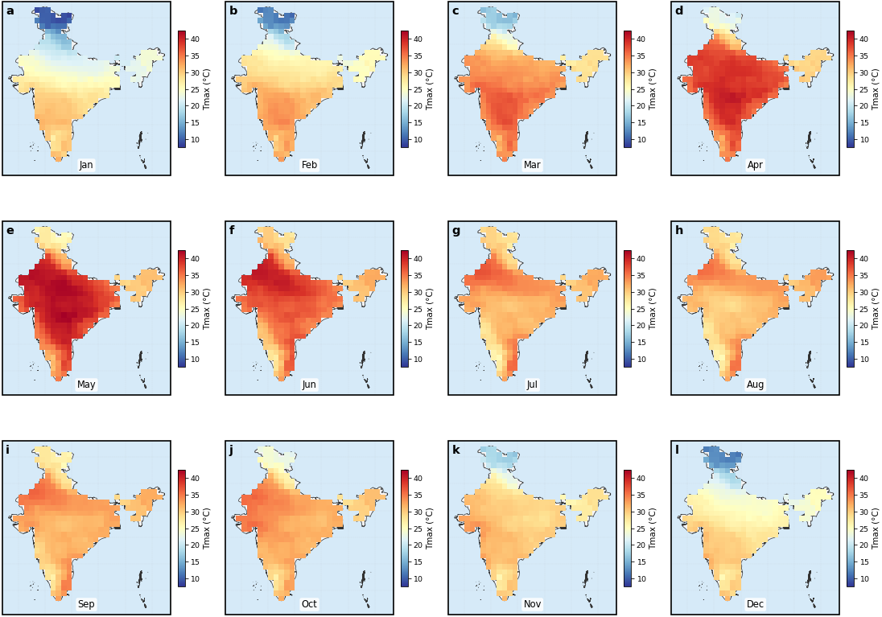

Supplementary Figure S1. Monthly Tmax Climatology (1980–2024)
Figure S1. Monthly climatological mean daily maximum temperature (Tmax, °C) for each calendar month (a–l: January–December), computed from the IMD 0.25° gridded dataset over 1980–2024. The colour scale is common across all twelve panels (blue: cool; red: hot). Pre-monsoon months (March–June) show the highest Tmax over the Thar Desert and Indo-Gangetic Plain, forming the principal window for heatwave occurrence. Monsoon months (June–September) exhibit cooling associated with cloud cover and advection of maritime air. The spatial gradients illustrate the physiographic control of temperature across India’s diverse terrain.
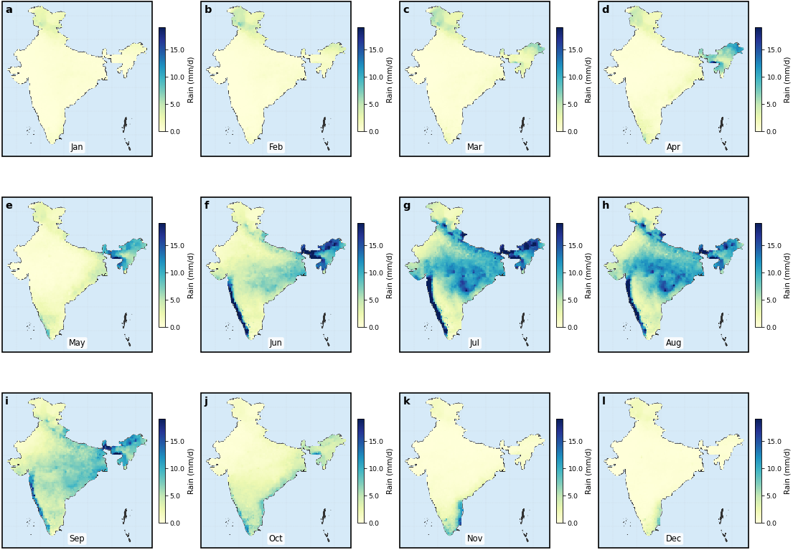

Supplementary Figure S2. Monthly Rainfall Climatology (1980–2024)
Figure S2. Monthly climatological mean daily rainfall (mm day⁻¹) for each calendar month (a–l: January–December), computed from the IMD 0.25° gridded dataset. South-west monsoon onset (June) and withdrawal (September) are clearly visible. The Western Ghats and north-east India receive the highest rainfall; Rajasthan and north-west India show persistent aridity — a key driver of high CompDHI (C6) values. Pre-monsoon rainfall deficits in March–May amplify heatwave intensity, motivating the inclusion of antecedent rainfall Z-score in E-HWPI
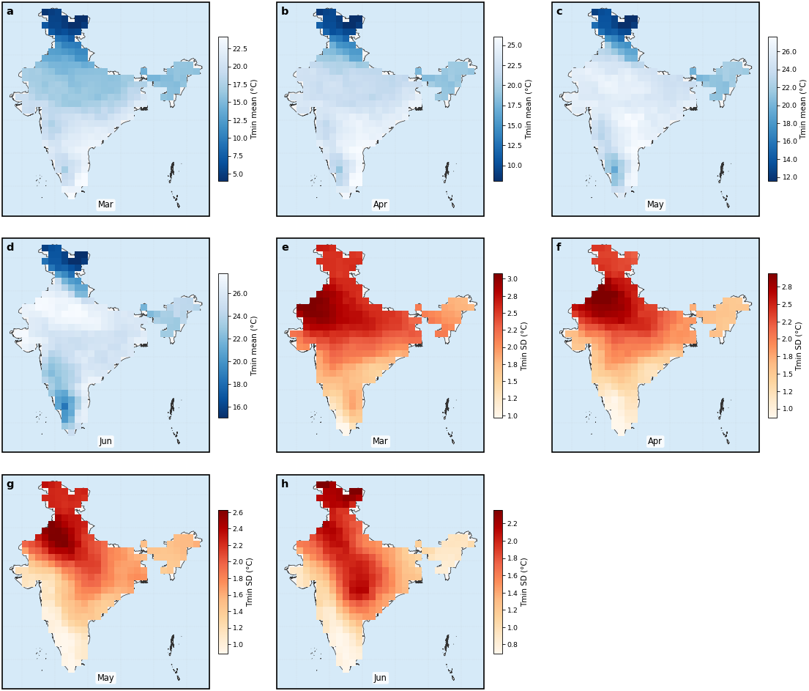

Supplementary Figure S3. MAMJ Tmin Climatology and Interannual Variability
Figure S3. Mean (a–d) and interannual standard deviation (e–h) of daily minimum temperature (Tmin, °C) for the four pre-monsoon months (March, April, May, June) over 1980–2024. Tmin is derived from the IMD 1.0° gridded product bilinearly interpolated to 0.25°. High nocturnal temperatures across the Indo-Gangetic Plain (particularly in May–June) underpin the NoctHS component (C5) of E-HWPI. Standard deviation maps (e–h) highlight regions of greatest interannual variability in night-time temperature, which translate directly to uncertainty in the nocturnal heat stress signal.
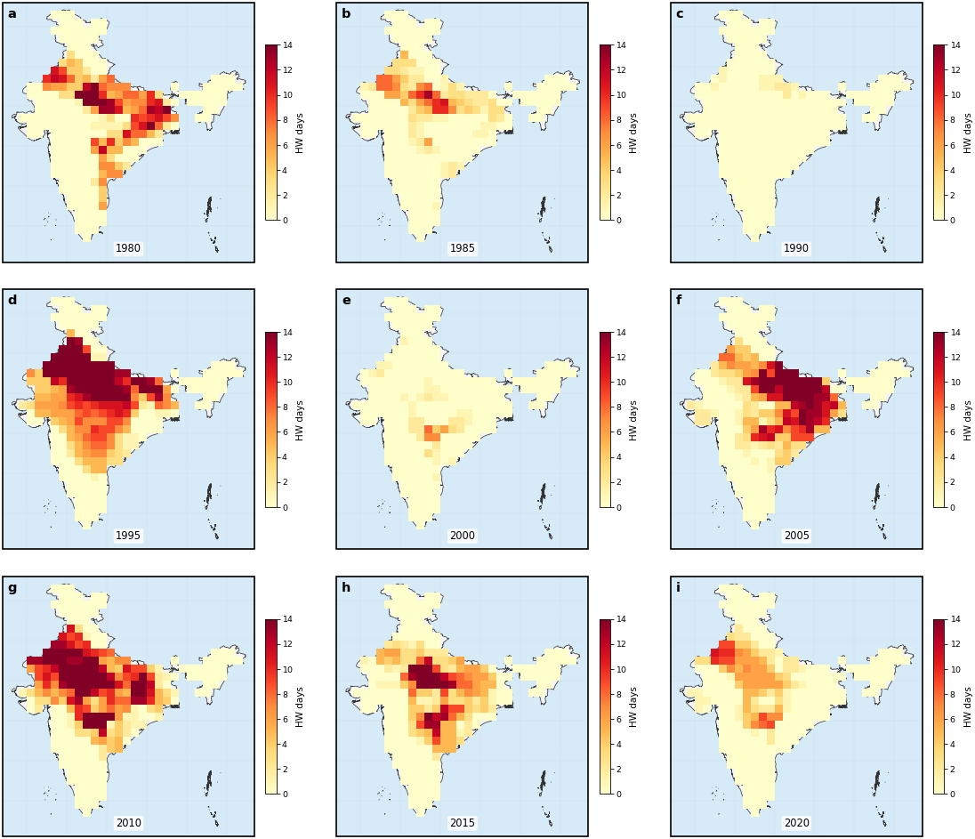

Supplementary Figure S4. Annual Heatwave-Day Maps at 5-Year Intervals
Figure S4. Total heatwave days per year for selected years at approximately 5-year intervals (a–i: 1980, 1985, 1990, 1995, 2000, 2005, 2010, 2015, 2020), computed from the IMD dual-criteria detection algorithm. The colour scale shows 0 to the 99th percentile of heatwave days. Progressive expansion of heatwave-affected area and intensification of the core heatwave region (north-central India) are visible, consistent with the positive E-HWPI trend identified in the main manuscript. The 2015 event, while severe in mortality terms, appears spatially localised to Andhra Pradesh/Telangana, explaining its absence from the top-5 domain-mean E-HWPI years.
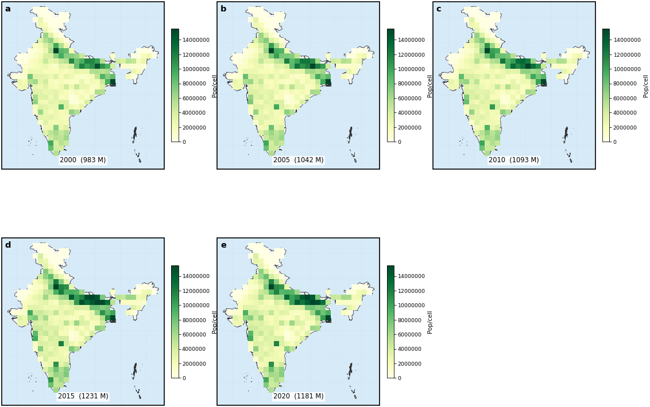

Supplementary Figure S5. Annual Population Maps (WorldPop, 2000–2020)
Figure S5. Calibrated WorldPop population density (persons per 0.25° cell) for selected years (a–e: 2000, 2005, 2010, 2015, 2020). Each grid has been scaled to match the UN WPP 2022 national total. The Ganga–Yamuna Doab and eastern Indo-Gangetic Plain show the highest population densities, which, combined with high E-HWPI values, produce the largest exposure estimates in the main manuscript (Figure 10). Total calibrated population (in millions) is annotated in each panel.
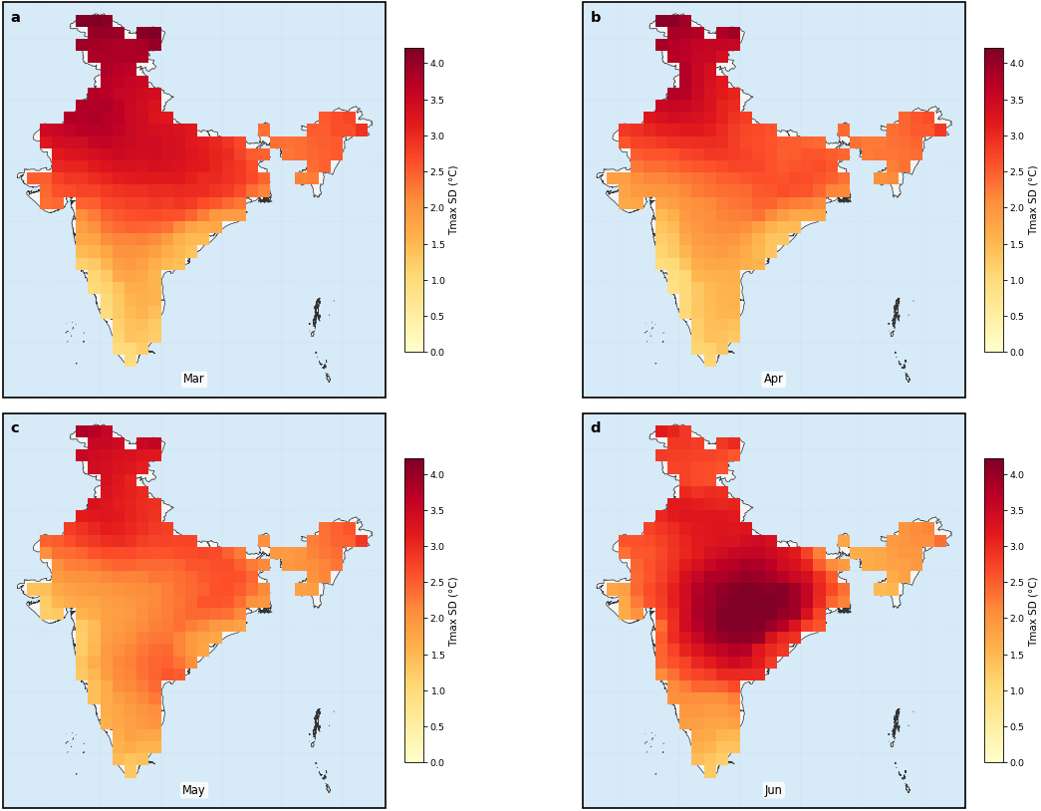

Supplementary Figure S6. MAMJ Tmax Interannual Standard Deviation
Figure S6. Interannual standard deviation of daily Tmax during MAMJ months (a–d: March, April, May, June) computed over the full 1980–2024 record. High variability in Rajasthan and Punjab (σ > 3°C) reflects the pronounced year-to-year swings between severe heatwave years and cooler pre-monsoon seasons. This variability directly controls the width of violin distributions in risk-zone plots (Figure 9c of the main manuscript) and the uncertainty range of state-level E-HWPI.
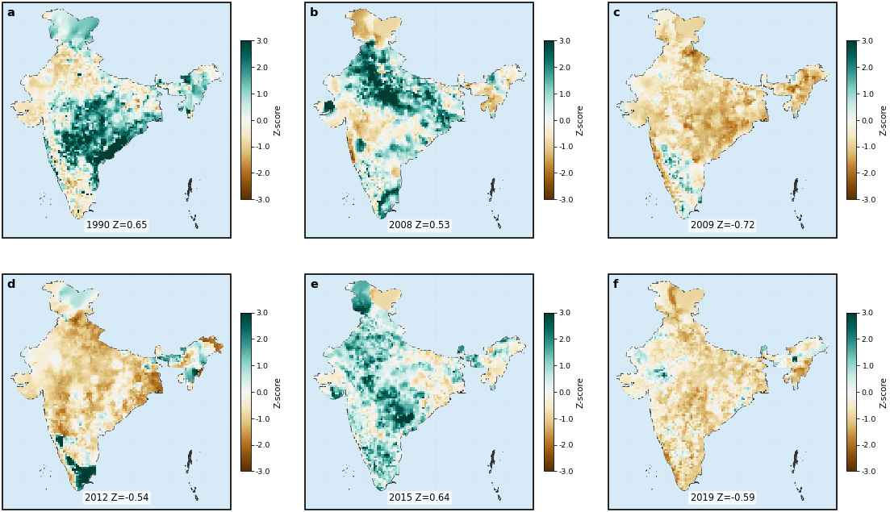

Supplementary Figure S7. Rainfall Z-Score Maps for Driest and Wettest Years
Figure S7. MAMJ rainfall Z-score maps for the three driest (a–c) and three wettest (d–f) years in the historical record, ranked by area-mean Z-score across India. Brown shading indicates below-normal rainfall (positive CompDHI contribution); green shading indicates above-normal. Dry years coincide with high E-HWPI via the C6 CompDHI pathway. The Z-score for each panel is annotated. These maps corroborate the physical basis of the compound drought–heat coupling incorporated in E-HWPI.
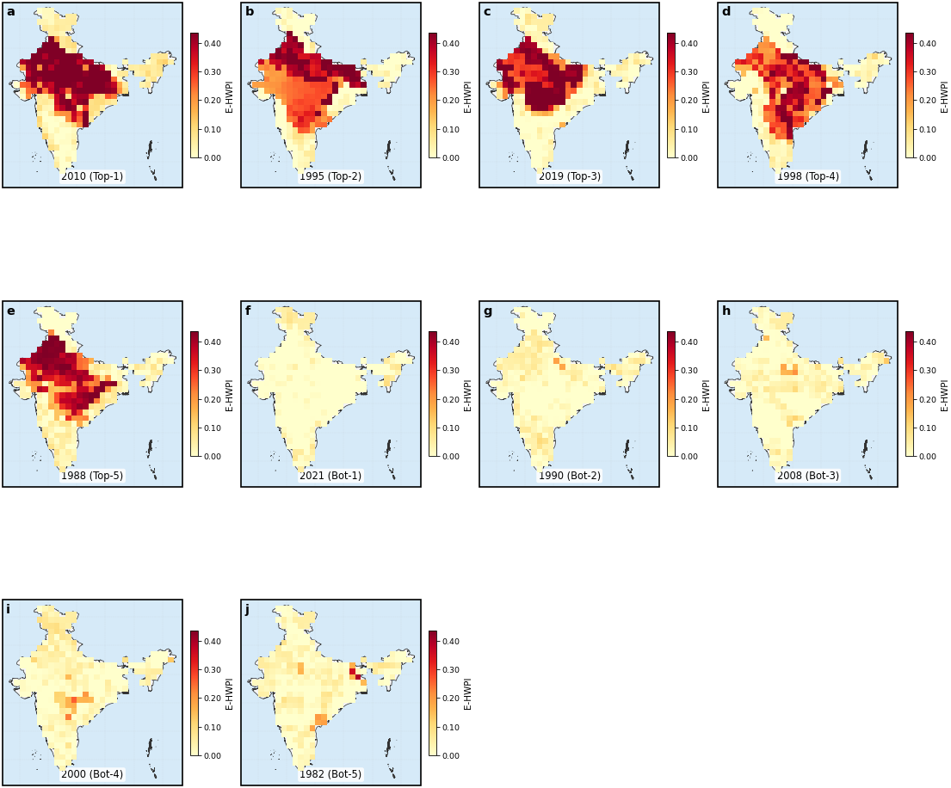

Supplementary Figure S8. Pixel-level E-HWPI Maps for Top-5 and Bottom-5 Years
Figure S8. Pixel-level E-HWPI maps (0.25° resolution) for the five highest (a–e) and five lowest (f–j) domain-mean E-HWPI years over 1980–2024, ordered by rank. Unlike the state-level choropleth maps in the main manuscript, these panels show the full intra-state spatial heterogeneity. North-central India consistently shows the highest pixel-level values in extreme years, while the south and north-east remain comparatively cool. The spatial coherence of extreme years supports the robustness of the domain-mean time series used for trend analysis.
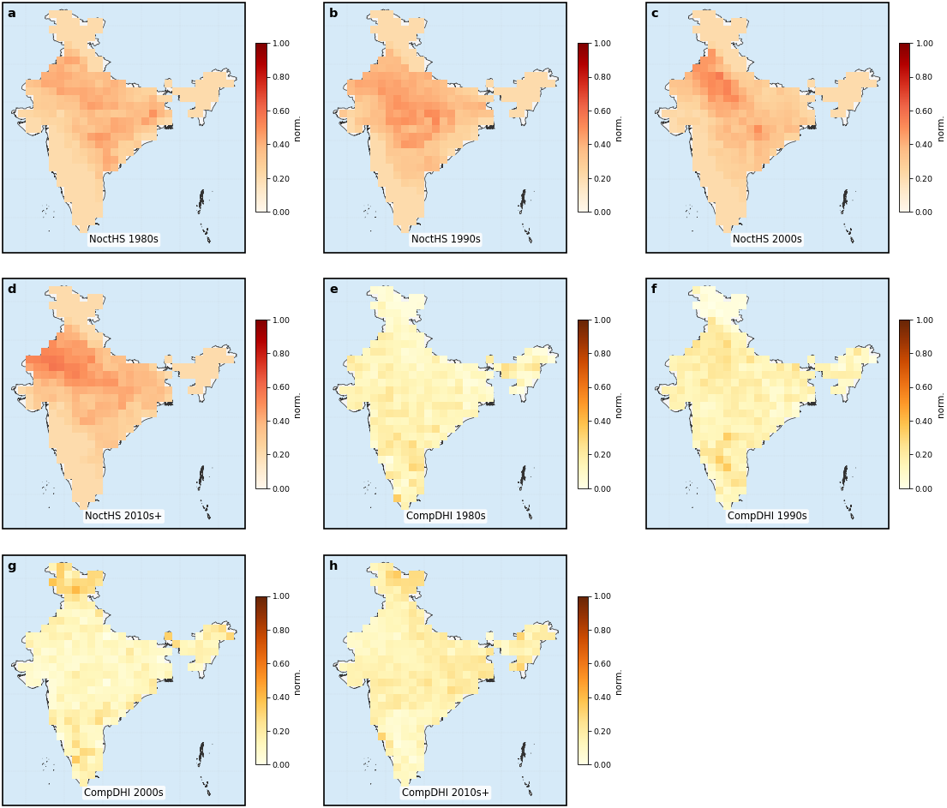

Supplementary Figure S9. Decadal Maps of Novel Components NoctHS and CompDHI
Figure S9. Normalised component values for C5 NoctHS (a–d) and C6 CompDHI (e–h) averaged over each decade (1980s, 1990s, 2000s, 2010s–2024). NoctHS shows a progressive increase across northern India, consistent with accelerating Tmin warming. CompDHI exhibits more episodic patterns linked to drought years (notably 1987, 2002, 2009, 2023). The ninth panel (i) is reserved for 2020s where data are available. These decadal averages complement Figure 12 of the main manuscript by revealing the temporal trajectory of each novel component.
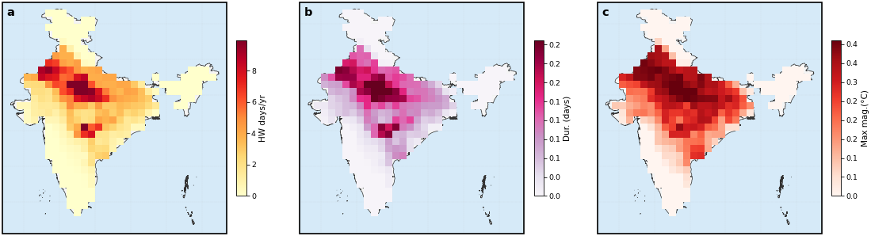

Supplementary Figure S10. Heatwave Attribute Spatial Maps
Figure S10. Spatial distribution of three key heatwave attributes averaged over 1980–2024: (a) mean annual heatwave days (C3-equivalent), (b) mean spell duration in days (C4), and (c) mean maximum magnitude in °C (C1). All three attributes peak in north-central India (Rajasthan, Uttar Pradesh, Madhya Pradesh), confirming the consistency of the component-level signals with established climatological understanding. The north-east and southern peninsula record the fewest heatwave days and shortest spells, consistent with their Negligible-Low risk-zone classification.
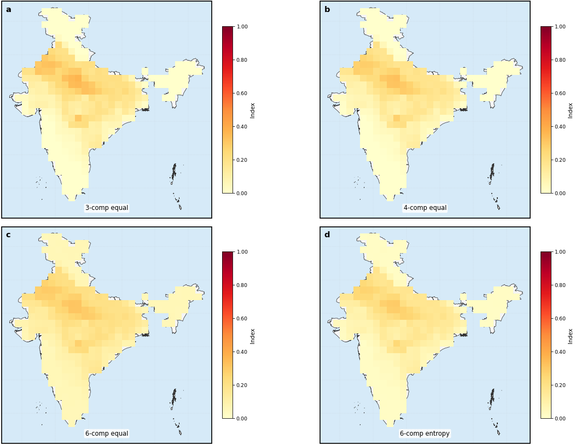

Supplementary Figure S11. Sensitivity Analysis: Alternative Weighting Schemes
Figure S11. Sensitivity of the composite index to the choice of weighting scheme. (a) Three-component equal-weight index (C1+C2+C3)/3 — equivalent to the original HWPI. (b) Four-component equal-weight index (C1+C2+C3+C4)/4. (c) Six-component equal-weight index (mean of all six normalised components). (d) Six-component E-HWPI with Shannon entropy weights (this study). Spatial patterns are broadly consistent across schemes, but E-HWPI (d) produces higher values in regions with strong NoctHS and CompDHI signals, demonstrating that the novel components add spatially discriminating information rather than noise.
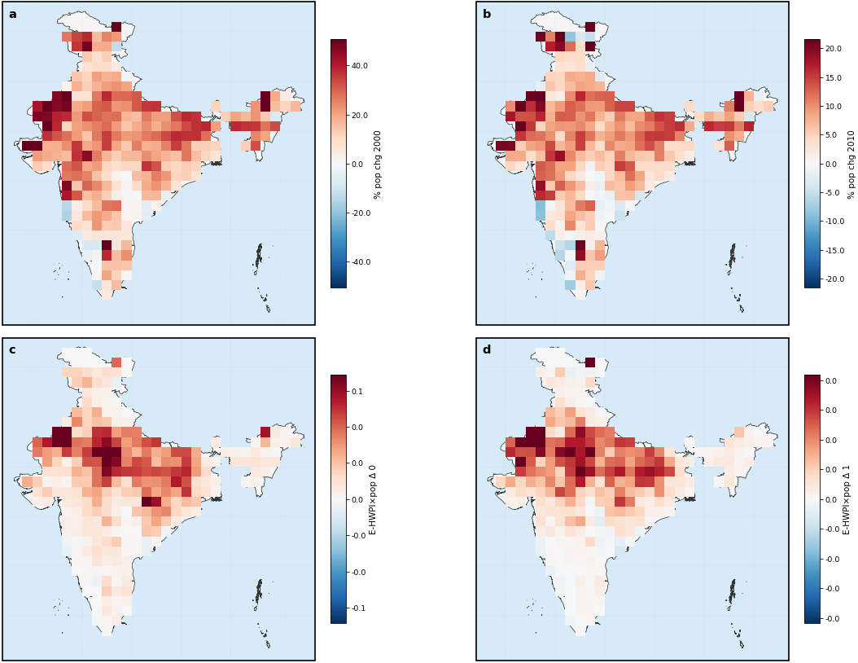

Supplementary Figure S12. Population Change and Compound Exposure (2000–2020)
Figure S12. Spatial analysis of population dynamics and their interaction with E-HWPI. (a) Percentage population change 2000–2020; (b) percentage population change 2010–2020; (c) compound exposure metric (E-HWPI × proportional population change) for 2000–2010; (d) the same metric for 2010–2020. Panels (c) and (d) use a diverging colormap centred on zero; warm colours indicate states where both E-HWPI and population increased simultaneously (compound risk amplification). Rajasthan, Uttar Pradesh, and Telangana emerge as the highest-priority states from a compound exposure perspective, reinforcing the Tier 1 classification in the main manuscript.

Supplementary Methods

SM1. Tmin Interpolation from 1° to 0.25° Resolution
Daily Tmin is provided by IMD at 1.0° × 1.0° resolution (approximately 111 km), compared with 0.25° for Tmax and rainfall. Bilinear interpolation is performed using scipy.interpolate.RegularGridInterpolator with bounds_error=False and fill_value=NaN. For each daily time step, grid cells with NaN values are filled with the spatial mean of the available field prior to interpolation to prevent edge artefacts. The interpolated Tmin field is then used exclusively for the C5 NoctHS computation; the resolution mismatch motivates the 5% entropy weight floor described in Section 2.5.

SM2. WorldPop Block-Sum Aggregation
WorldPop 100-m TIF files are read in row-strips of 300 pixels (~3 km) to limit RAM consumption to approximately 40 MB per strip. Each 100-m source pixel is assigned to the 0.25° target cell whose boundary contains its centroid. Population values are summed (not averaged) within each target cell to preserve total population counts. The resulting 0.25° grid is then multiplied by a calibration scalar to match the UN WPP 2022 national total for the corresponding year. This procedure prevents the systematic underestimate that arises when averaging is applied across cells with highly skewed population distributions (e.g., urban cores adjacent to rural hinterlands).

SM3. Shannon Entropy Weight Calculation
For component c with state–year values P_c(s,t), the normalised frequency distribution is computed as p_i = P_c(s_i, t_i) / Σ P_c, clipped to a minimum of 10⁻⁹ to avoid log(0). The Shannon entropy is E_c = −Σ p_i ln(p_i) / ln(N), where N is the number of non-NaN state–year pairs. The information divergence is d_c = 1 − E_c. The raw weight is w_c = d_c / Σ d_c. A minimum floor of 5% is then applied: any component with w_c < 0.05 is set to 0.05, and remaining weights are rescaled to ensure Σ w_c = 1. This procedure is consistent with the entropy-weighting approach of Hwang and Yoon (1981) as applied in multi-criteria decision analysis.

SM4. Mann–Kendall and Sen’s Slope
The Mann–Kendall statistic S is the sum of sign differences across all ordered pairs. The variance of S under the null hypothesis of no trend is V(S) = n(n−1)(2n+5)/18 (no ties adjustment applied, as ties in annual index values are negligible). The normalised test statistic Z = (S−1)/√V(S) for S > 0 is compared to a standard normal distribution for significance testing (α = 0.05 two-tailed). Sen’s slope is the median of all pairwise slopes (β = (x_j − x_i)/(t_j − t_i) for j > i), with 95% confidence bounds derived from the order statistics of the slope array. The Pettitt changepoint test is not reported due to a documented artefact (p = 1.0) arising from the discrete character of the annual index values combined with the relatively short record; the CUSUM permutation envelope in Figure 2d provides a non-parametric alternative.

Supplementary References
Hwang, C. L., & Yoon, K. (1981). Multiple Attribute Decision Making: Methods and Applications. Springer, Berlin.

Mann, H. B. (1945). Nonparametric tests against trend. Econometrica, 13(3), 245–259.

Sen, P. K. (1968). Estimates of the regression coefficient based on Kendall’s tau. Journal of the American Statistical Association, 63(324), 1379–1389.

Pettitt, A. N. (1979). A non-parametric approach to the change-point problem. Applied Statistics, 28(2), 126–135.

Shannon, C. E. (1948). A mathematical theory of communication. Bell System Technical Journal, 27(3), 379–423.

WorldPop (2020). India gridded population (100 m, unconstrained individual countries 2000–2020). University of Southampton. https://www.worldpop.org/

United Nations (2022). World Population Prospects 2022, Volume I: Comprehensive Tables. Department of Economic and Social Affairs, Population Division.

