Supplement

Supplemental Table 1. Train and Test Errors in pixels from DLC
Animal | Train error (pixels) | Test error  (pixels)
1 | 1.72 | 3.86
2 | 1.59 | 2.72
3 | 2.23 | 2.39
4 | 2.16 | 3.20
5 | 1.26 | 1.81

Supplemental Table 2. CORrelation and Analysis (CORA) score comparison of DLC-tracked angular velocity curves across CoR calculation methods: CoR_{head} from head anatomical points and CoR_{combined} from all five anatomical points of the head, and CoR_{device} from injury device anatomical points and CoR_{combined} from all five anatomical points of the injury device.

Animal | Injury Condition | CoR_{head} vs. CoR_{combined} |  |  | CoR_{device} vs. CoR_{combined}
Animal | Injury Condition | Point 1 (Eye) | Point 2 (Ear) | Point 3 (Snout) | Point 4  (Bite Plate Arm) | Point 5 (Strap)
1 | Moderate  Velocity | 0.99 | 0.99 | 0.99 | 0.98 | 0.98
2 | Moderate  Velocity | 0.98 | 0.98 | 0.98 | 0.97 | 0.96
Average _{Moderate} (SD) |  | 0.98 (0.01) | 0.98 (0.01) | 0.99 (0.00) | 0.97 (0.01) | 0.97 (0.01)
3 | High  Velocity | 0.98 | 0.98 | 0.99 | 0.99 | 0.99
4 | High  Velocity | 0.96 | 0.96 | -- | 0.98 | 0.97
5 | High  Velocity | 0.99 | 1.00 | 1.00 | 0.99 | 0.98
Average _{High} (SD) |  | 0.98 (0.02) | 0.98 (0.02) | 0.99 (0.01) | 0.99 (0.01) | 0.98 (0.01)
Average _{Total} (SD) |  | 0.98 (0.01) | 0.98 (0.01) | 0.99 (0.00) | 0.98 (0.01) | 0.98 (0.01)
Supplemental Table 3. Mean Absolute Error (MAE; rad/s) and CORrelation and Analysis (CORA) scores of angular velocity curves between manual tracking of injury device and transducer recording of the injury device.

Animal | Injury Condition | Manual: device vs.  Transducer
Animal | Injury Condition | MAE | CORA
1 | Moderate  Velocity | 7.10 | 0.93
2 | Moderate  Velocity | 4.83 | 0.95
Average _{Moderate} (SD) |  | 5.97 (1.61) | 0.94 (0.01)
3 | High  Velocity | 17.63 | 0.72
4 | High  Velocity | 14.98 | 0.79
5 | High  Velocity | 13.88 | 0.83
Average _{High} (SD) |  | 15.49 (1.93) | 0.78 (0.06)
Average _{Total} (SD) |  | 11.68 (5.45) | 0.84 (0.10)

Supplemental Table 4. Mean Absolute Error (MAE; rad/s) of angular acceleration curves between listed conditions.

Animal | Injury Condition | DLC: device vs.  Transducer | DLC: head vs.  DLC: device | DLC: head  vs. Transducer
1 | Moderate  Velocity | 3465.52 | 3316.36 | 2972.75
2 | Moderate  Velocity | 2093.92 | 3065.75 | 4151.34
Average _{Moderate} (SD) |  | 2779.72 (969.86) | 3191.05 (177.21) | 3562.04 (833.39)
3 | High  Velocity | 3583.03 | 5247.06 | 5728.89
4 | High  Velocity | 4269.41 | 4203.46 | 7272.32
5 | High  Velocity | 4209.47 | 6323.18 | 6834.67
Average _{High} (SD) |  | 4020.64 (380.16) | 5257.90 (1059.90) | 6611.96 (795.45)
Average _{Total} (SD) |  | 3524.27 (877.14) | 4431.16 (1360.55) | 5392.00 (1811.24)

Supplemental Table 5. CORrelation and Analysis (CORA) scores of angular acceleration curves from the three comparisons: DLC recording of injury device and transducer recording of the injury device, DLC recordings of head and injury device, and DLC recording of head and transducer recording of the injury device.

Animal | Injury Condition | DLC: device vs.  Transducer | DLC: head vs.  DLC: device | DLC: head  vs. Transducer
1 | Moderate  Velocity | 0.75 | 0.70 | 0.74
2 | Moderate  Velocity | 0.76 | 0.52 | 0.68
Average _{Moderate} (SD) |  | 0.76 (0.01) | 0.61 (0.13) | 0.71 (0.04)
3 | High  Velocity | 0.77 | 0.60 | 0.68
4 | High  Velocity | 0.85 | 0.71 | 0.62
5 | High  Velocity | 0.82 | 0.69 | 0.73
Average _{High} (SD) |  | 0.81 (0.04) | 0.67 (0.06) | 0.68 (0.06)
Average _{Total} (SD) |  | 0.79 (0.04) | 0.64 (0.08) | 0.69 (0.05)

Supplemental Figure 1. Example angular velocity and acceleration curves of a transducer recording with raw data (light green), bin smoothed filtered data (dark green), and Butterworth filtered data (royal blue) (A-B). Butterworth filtering of the velocity curve notably reduces noise in the acceleration curve.
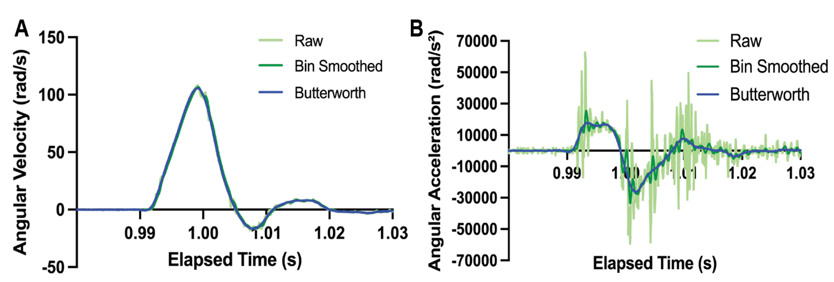

Supplemental Figure 2. Manual, automated, and transducer tracking of the device (A-B) and the head (C-D) generates velocity (A, C) and acceleration (B, D) curves. Waveforms have been peak-aligned for comparison.

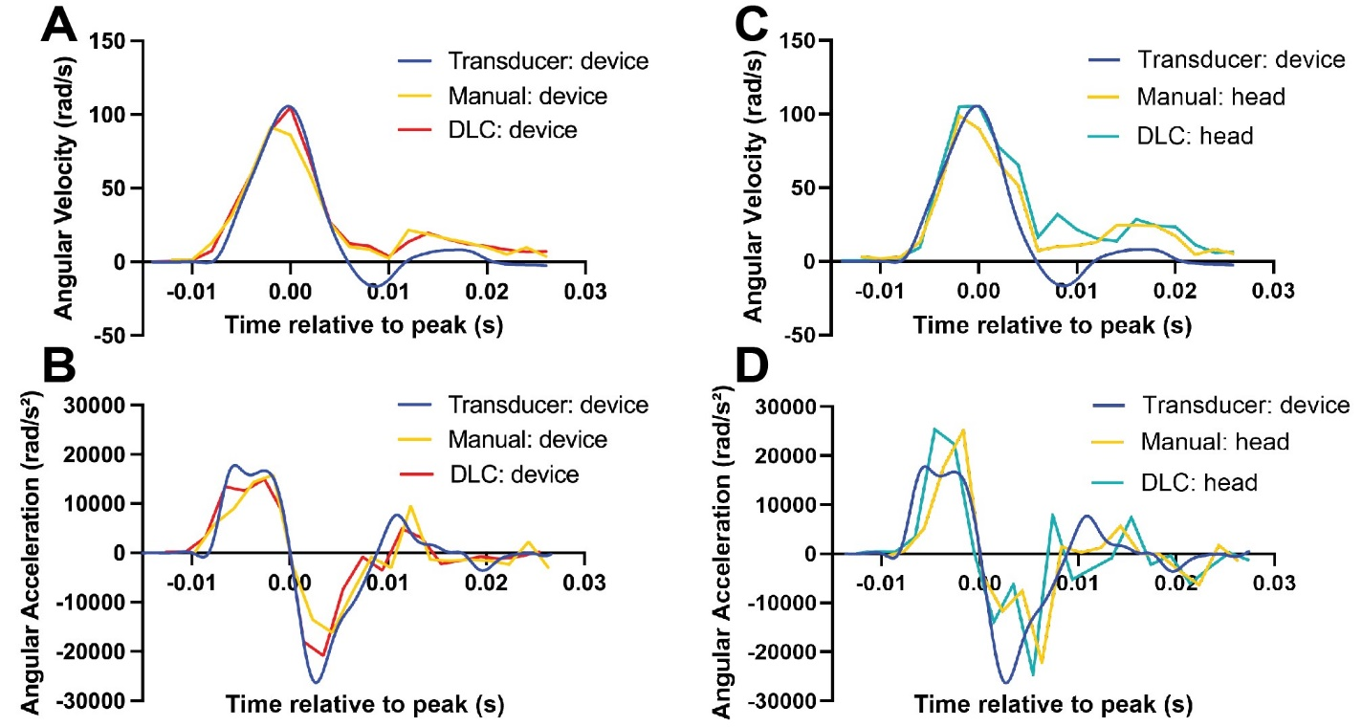

Supplemental Figure 3. Each subject’s angular velocity curves from the transducer recording, automated DLC recoding of the rotational device, and automated DLC recording of the head. Waveforms have been peak-aligned for comparison.
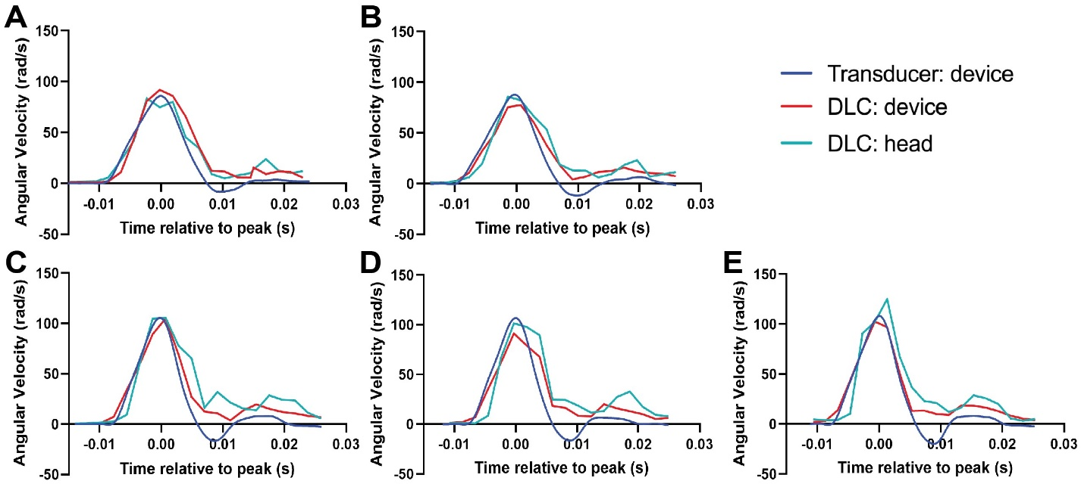
Supplemental Figure 4. Peak velocity changes for each subject between transducer recording and DLC recording of rotational device (A), between DLC recording of the rotational device and head (B), and between transducer recording and DLC recording of head (C).

