Supplementary File 1: The role of chromosome segmental mutations in eukaryotic pangenome evolution
Sisi Chen^{*,1}, Marc Krasovec², Rosalind E. Rickaby³ and Dmitry A. Filatov^{*,1}

¹Department of Biology, University of Oxford, South Parks Road, Oxford OX1 3EL, United Kingdom
²Sorbonne Université, CNRS, Laboratoire de Biodiversité et Biotechnologies Microbiennes, LBBM, 66650 Banyuls-sur-Mer, France
³Department of Earth Sciences, University of Oxford, South Parks Road, Oxford OX1 3AN, United Kingdom
*Corresponding author: E-mails: dmitry.filatov@biology.ox.ac.uk; sisi.chen@biology.ox.ac.uk

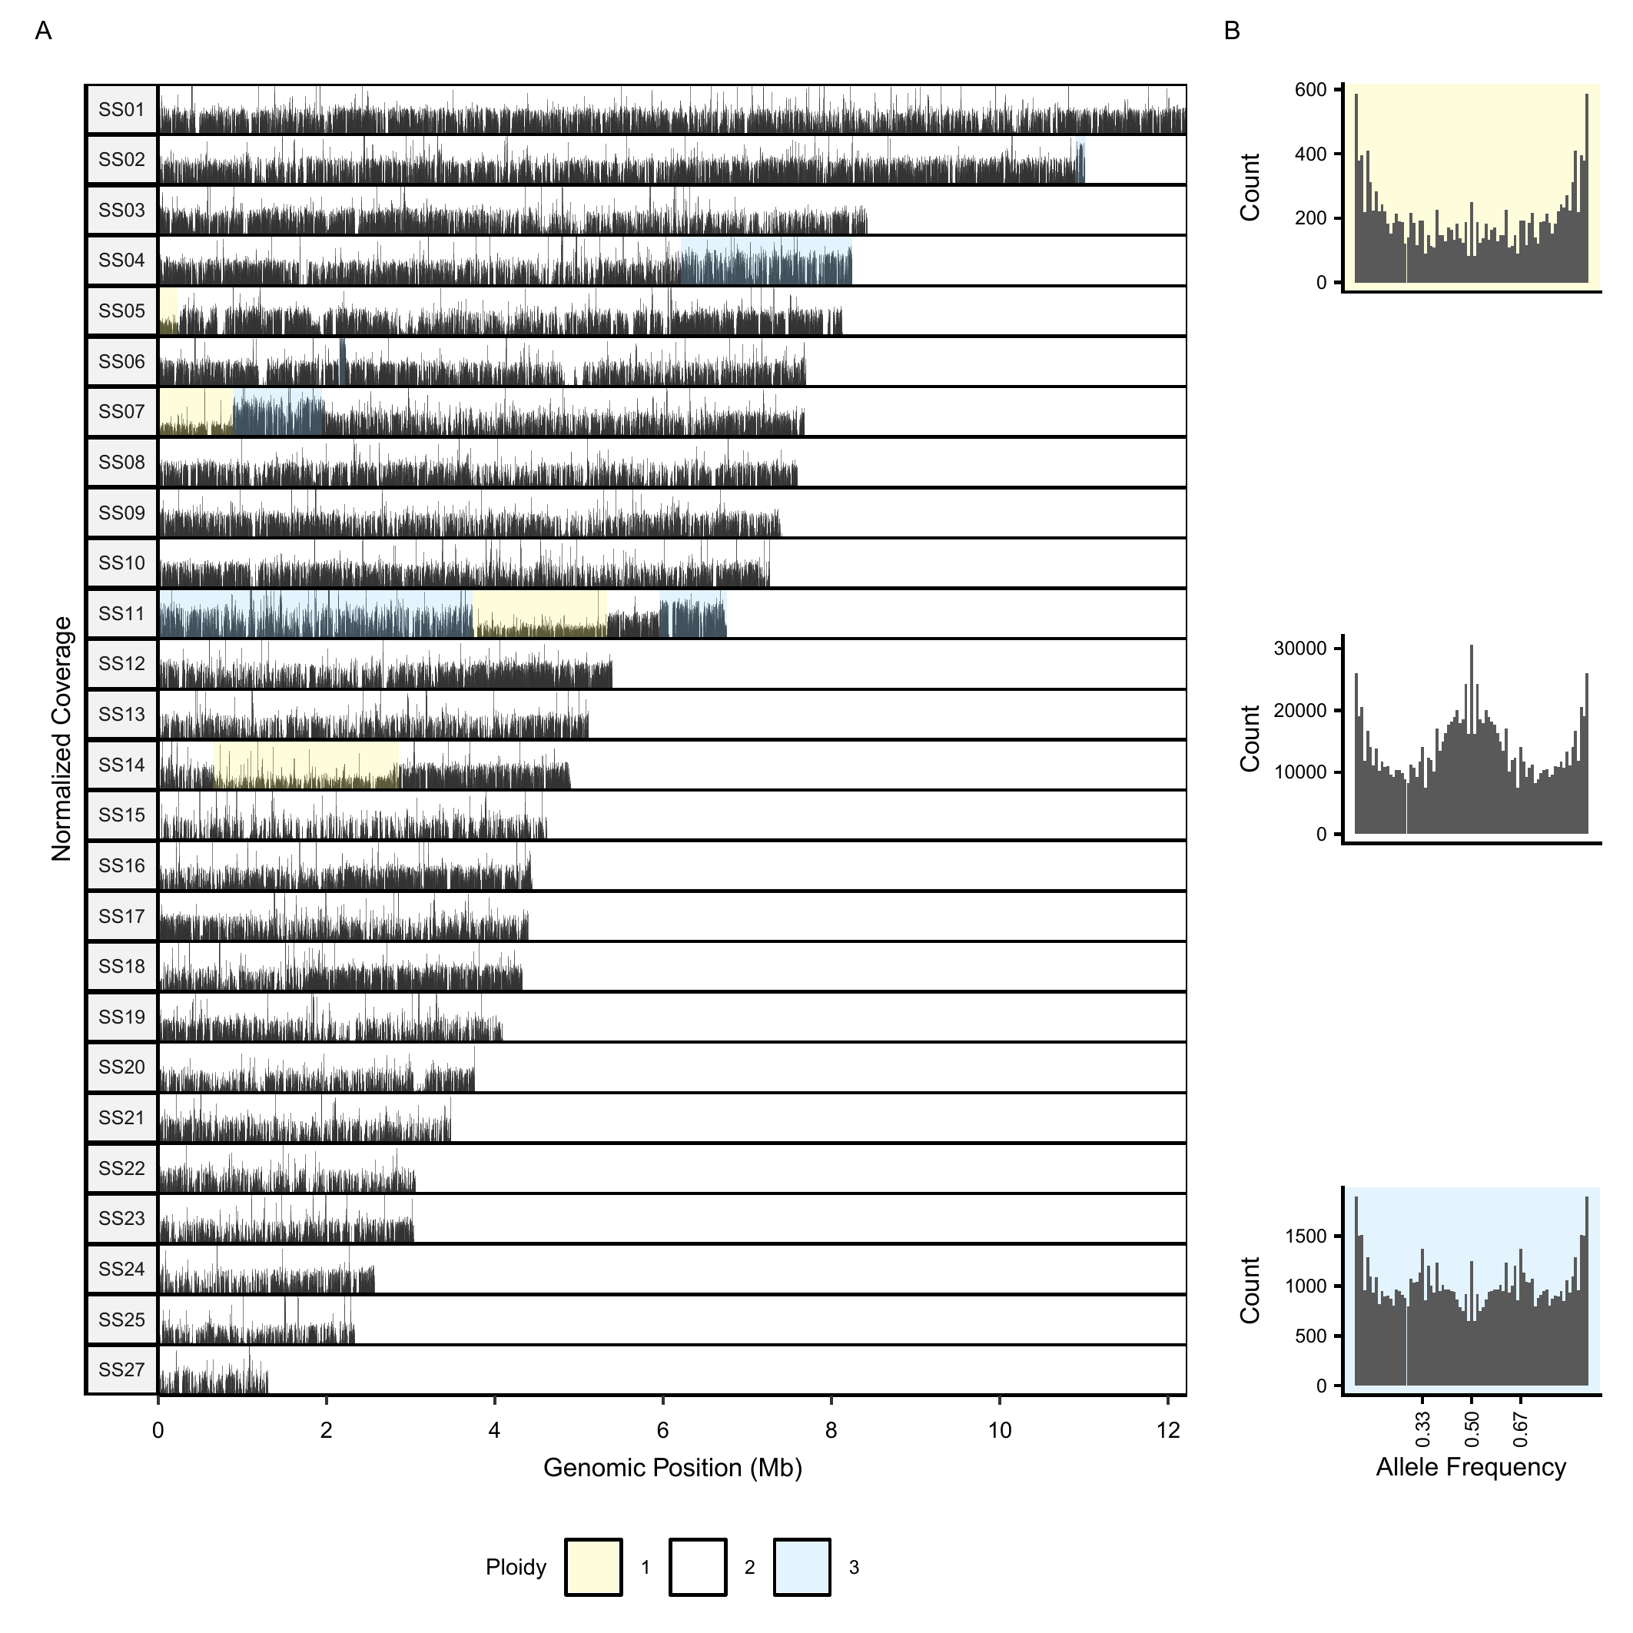
Supplementary Figure 1. Variation in ploidy across T0 genome. A. Normalized coverage plot along each chromosome, with regions of different ploidy levels indicated by coloured shading (1 for haploid, 2 for diploid, and 3 for triploid). Chromosome SS26 is not shown because it was excluded from the reference (see Methods). B. Allele frequency distributions for regions of each ploidy level; colours correspond to those used in A.

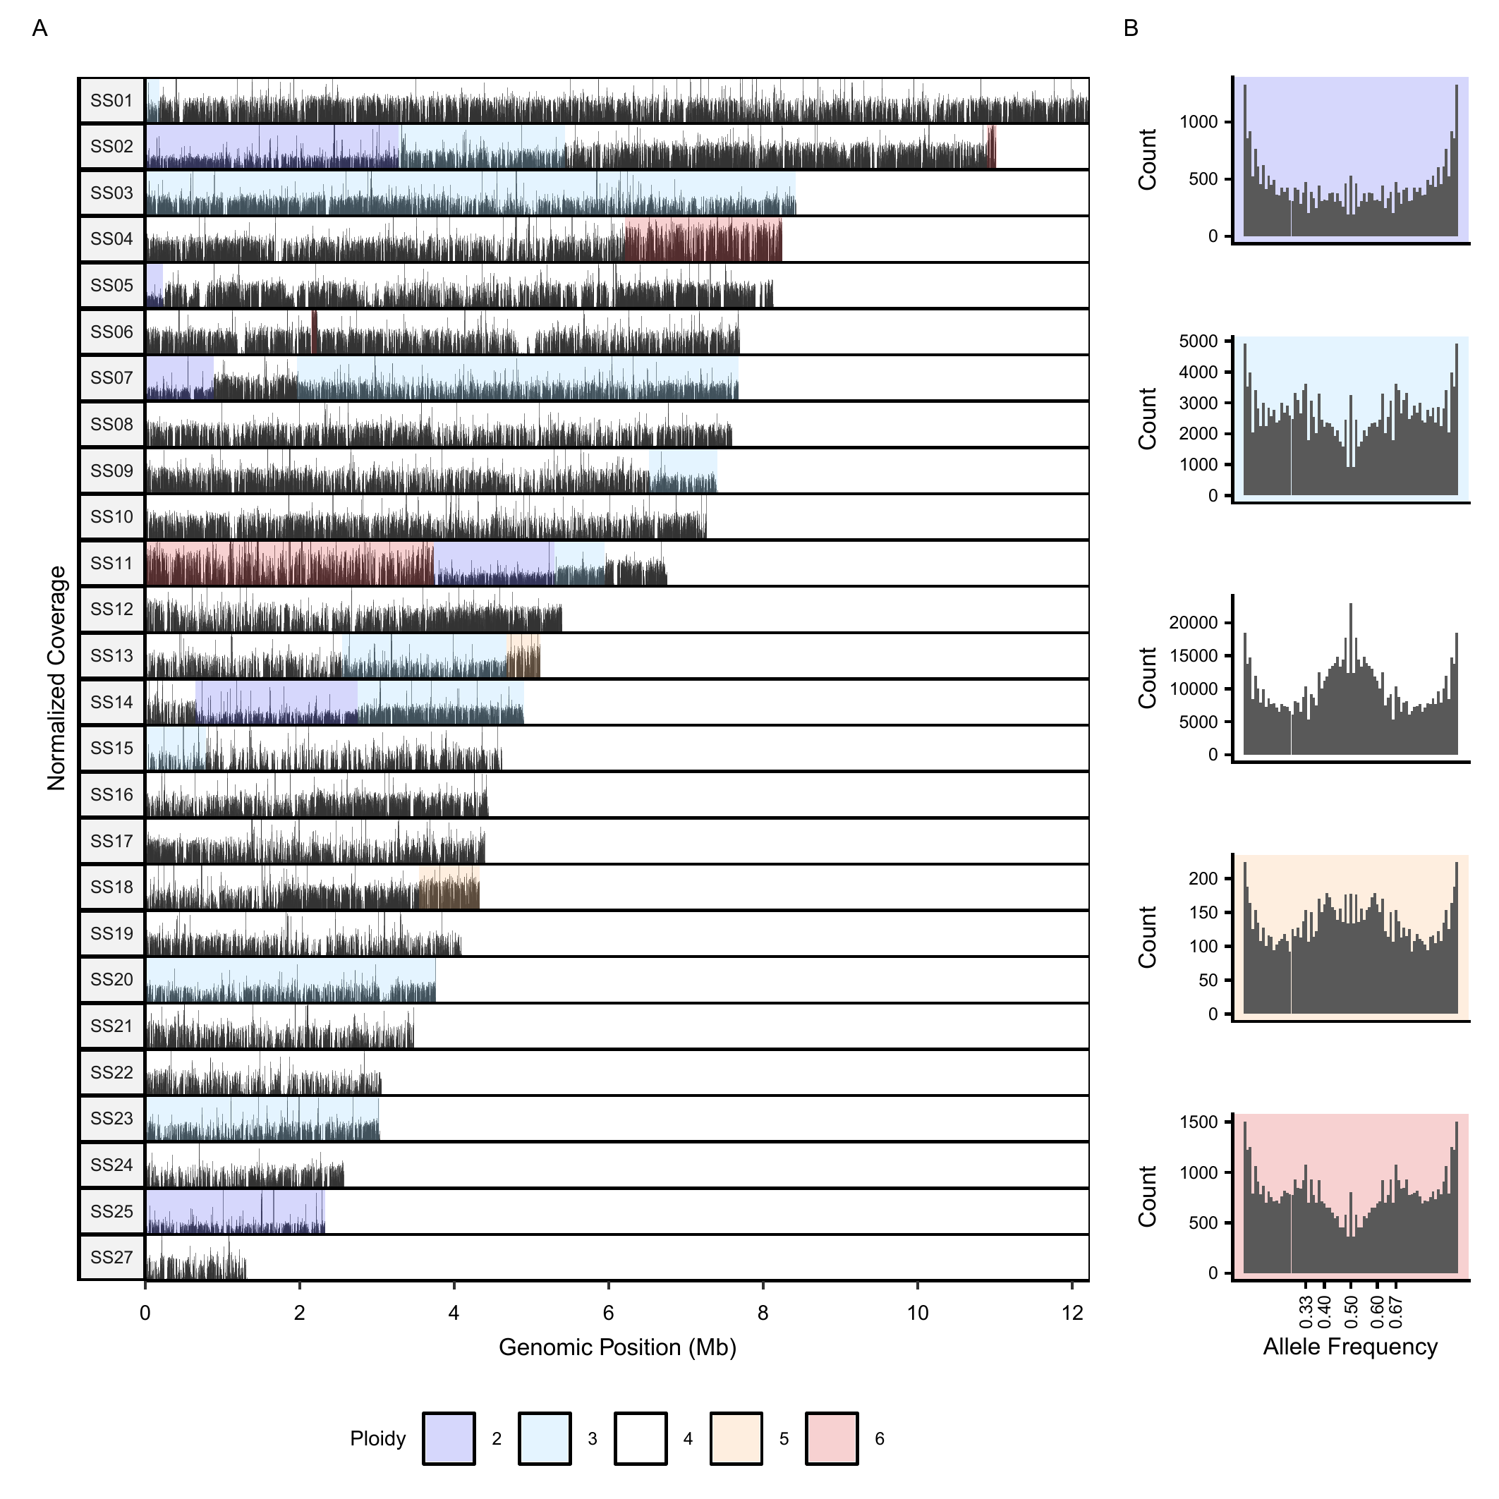
Supplementary Figure 2. Segmental mutations in the MA-X strain. A. Normalized coverage plot along each chromosome, with regions of different ploidy levels indicated by coloured shading (2 for diploid, 3 for triploid, 4 for tetraploid, and so on). B. Allele frequency distributions for regions of each ploidy level; colours correspond to those used in A. As tetraploid regions arose recently through duplication of diploid regions (for example, from AB to AABB), heterozygous sites retain an expected allele-frequency peak at 1/2, rather than producing additional peaks at 1/4 and 3/4. Diploid regions lacking a 1/2 peak are consistent with loss of one duplicated copy, leaving predominantly AA or BB genotypes.

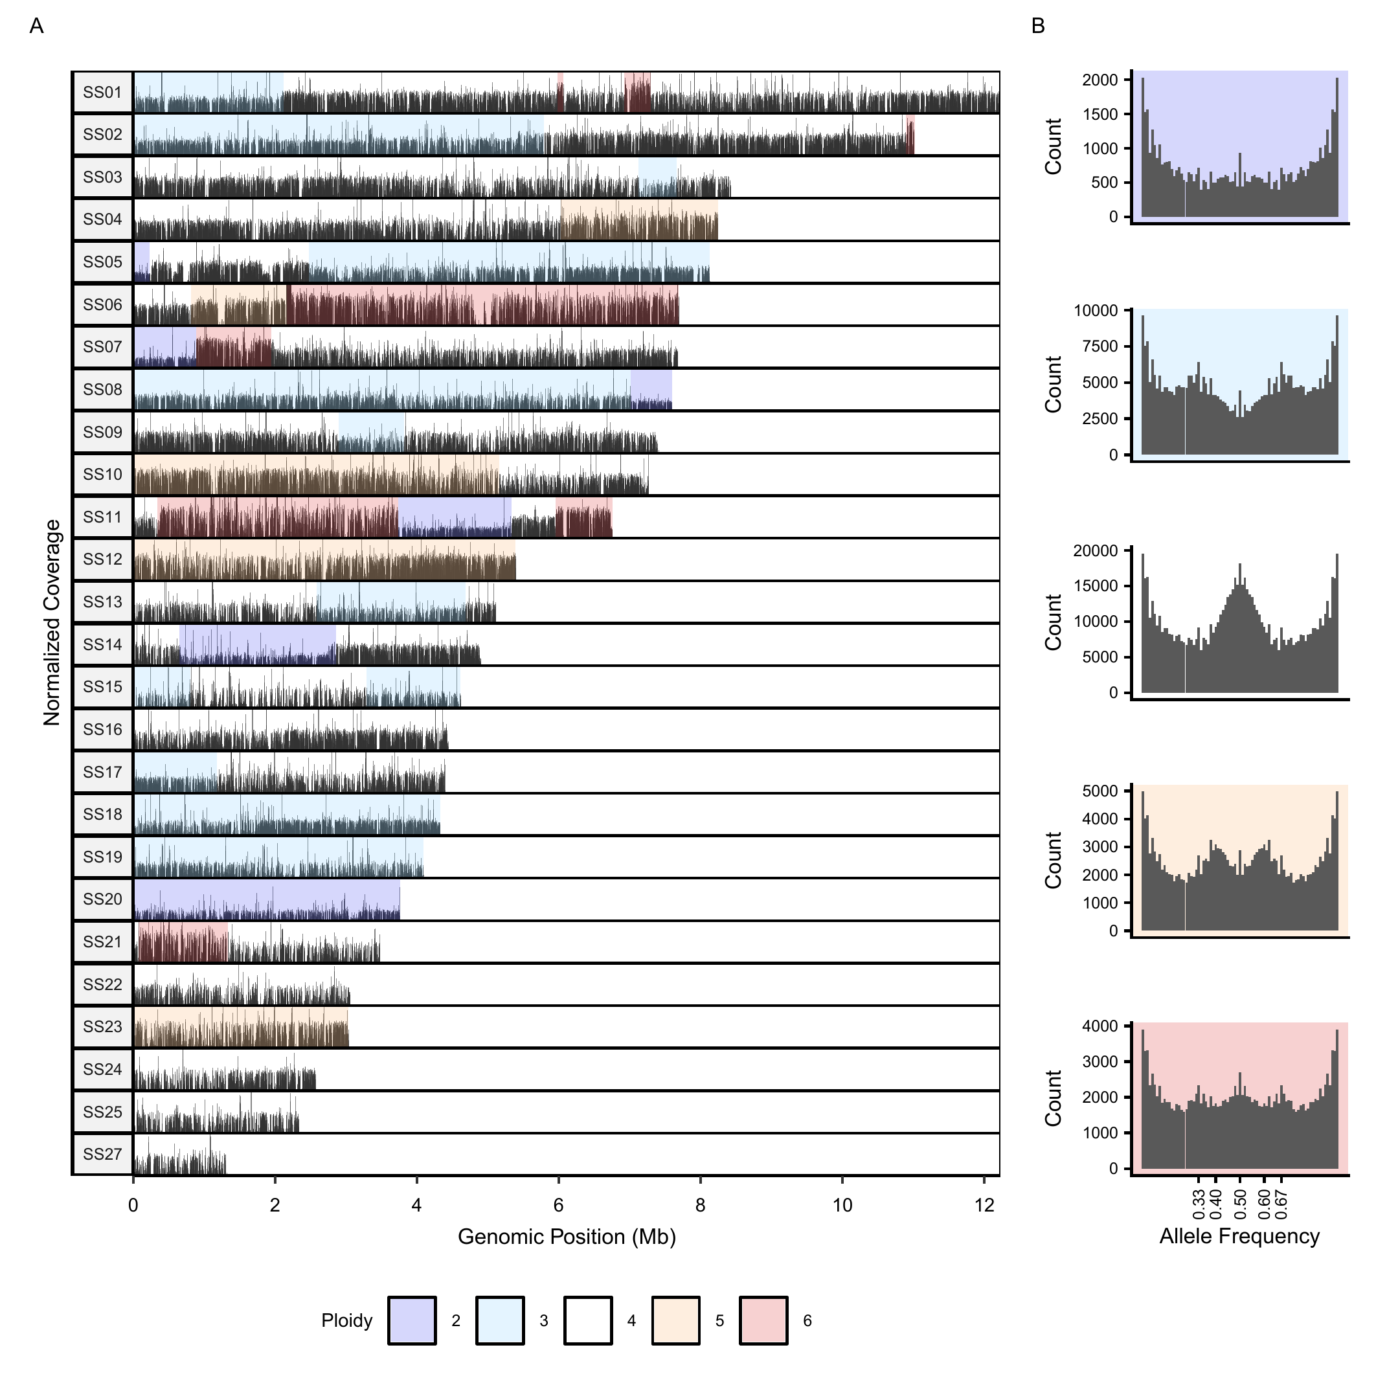
Supplementary Figure 3. Segmental mutations in the MA-S strain. A. Normalized coverage plot along each chromosome, with regions of different ploidy levels indicated by coloured shading (2 for diploid, 3 for triploid, 4 for tetraploid, and so on). B. Allele frequency distributions for regions of each ploidy level; colours correspond to those used in A. As tetraploid regions arose recently through duplication of diploid regions (for example, from AB to AABB), heterozygous sites retain an expected allele-frequency peak at 1/2, rather than producing additional peaks at 1/4 and 3/4. Diploid regions lacking a 1/2 peak are consistent with loss of one duplicated copy, leaving predominantly AA or BB genotypes.

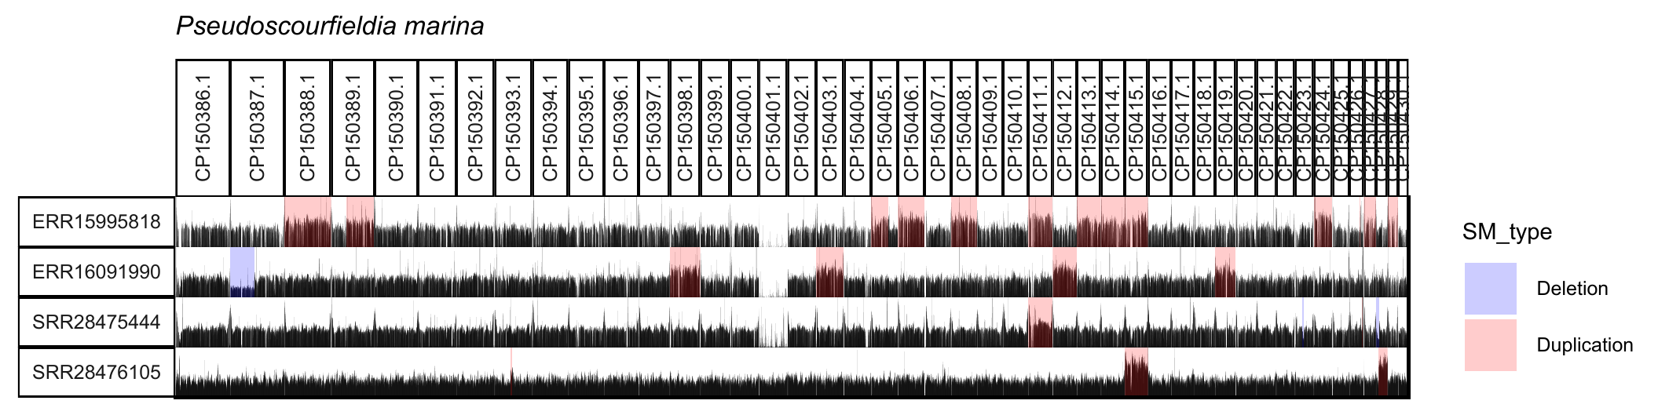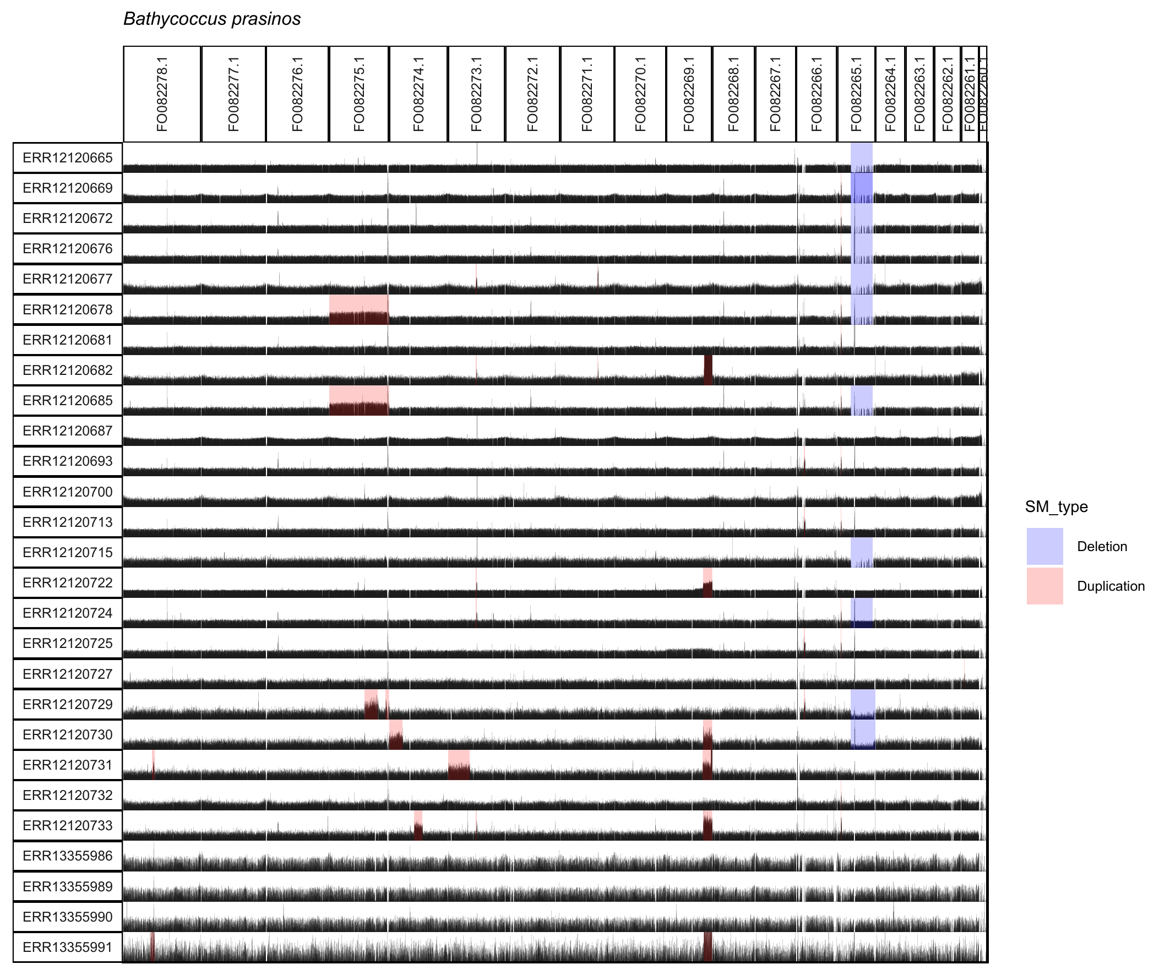
Supplementary Figure 4. Coverage profiles showing segmental mutations identified in wild population sequencing data from the plankton species Pseudoscourfieldia marina, Bathycoccus prasinos, Prymnesium parvum, Poteriospumella lacustris, Aureococcus anophagefferens, Pseudo-nitzschia multistriata, and Phaeodactylum tricornutum. The y-axis lists NCBI accessions, and the top x-axis labels chromosomes. For species lacking chromosome-level reference genomes, the 20 longest scaffolds/contigs are shown; substantial numbers of SMs remained detectable under this restriction. Segmental deletions are highlighted in blue, and segmental duplications in red.
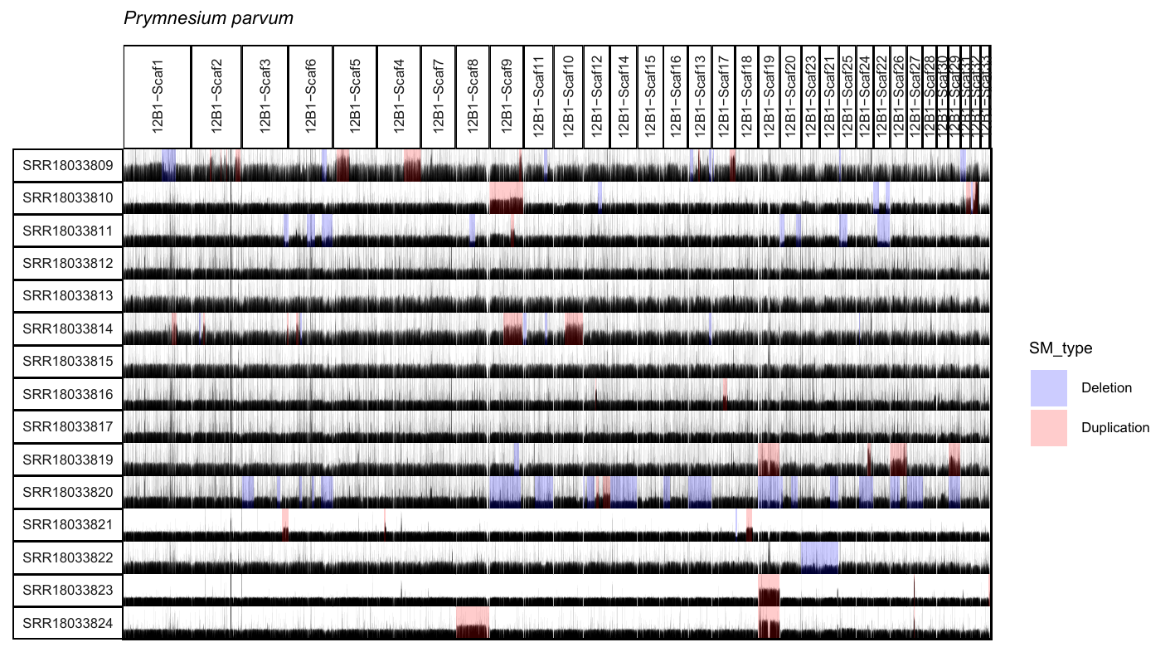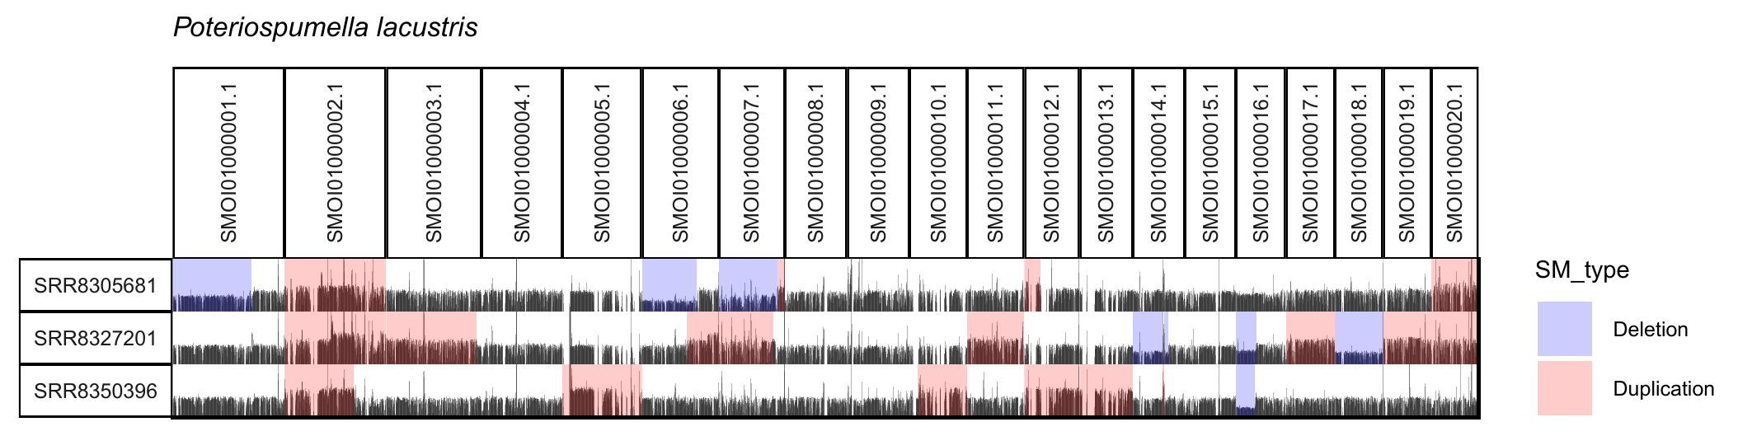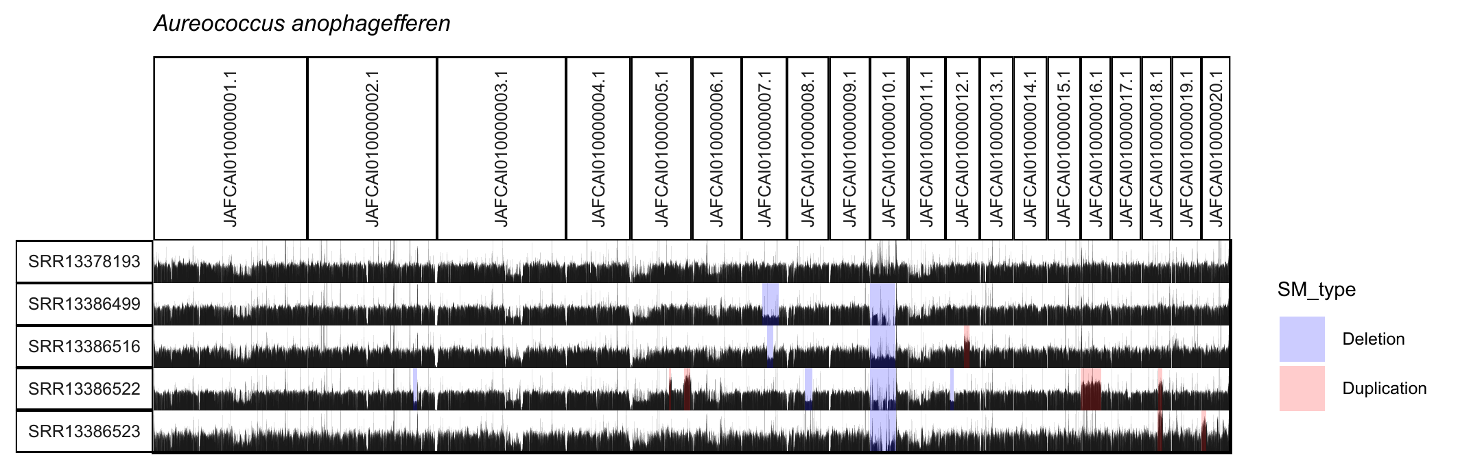 Supplementary Figure 4. Continued.
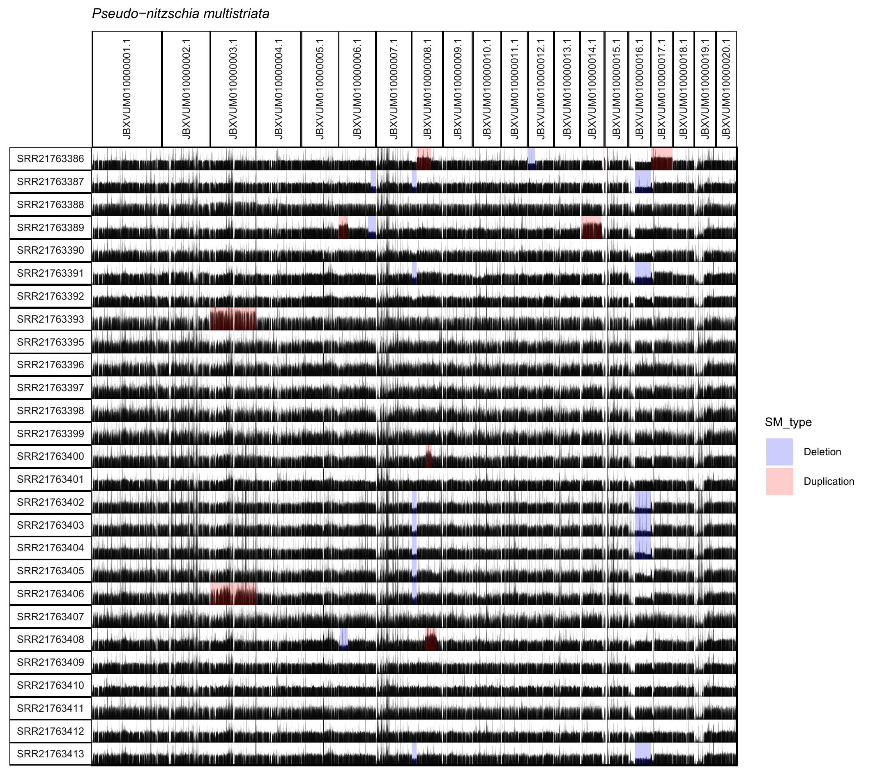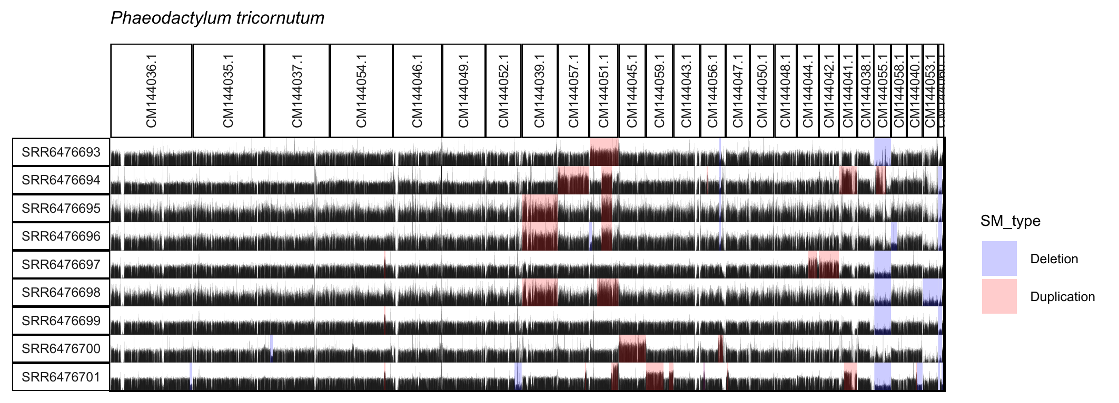
Supplementary Figure 4. Continued.

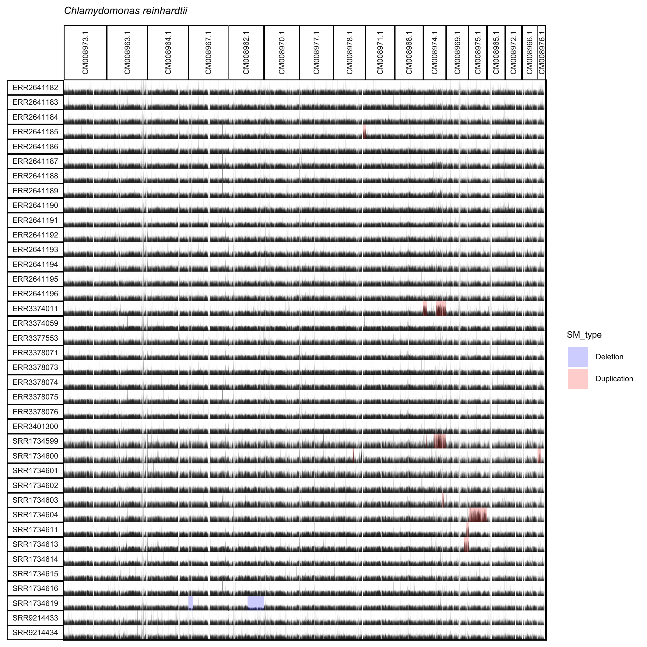Supplementary Figure 5. Coverage profiles showing segmental mutations identified in wild population sequencing data from the model species Chlamydomonas reinhardtii, Caenorhabditis elegans, Arabidopsis thaliana and Drosophila melanogaster. The top x-axis labels chromosomes carrying segmental mutations, and the y-axis lists NCBI accessions. Segmental deletions are highlighted in blue, and segmental duplications in red. Please note that, due to the large sample size (>500 individuals) in A. thaliana and C. elegans, only representative individuals carrying relatively large SMs are shown for visualization. For A. thaliana and D. melanogaster, zoomed-in views of chromosomal regions are provided for mutations that would otherwise be indiscernible at the whole-genome scale.

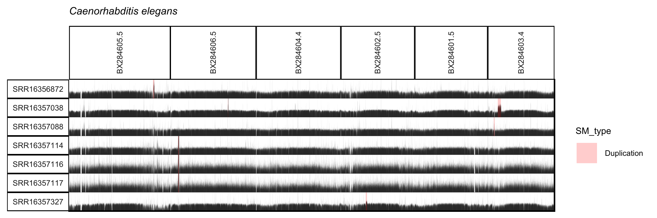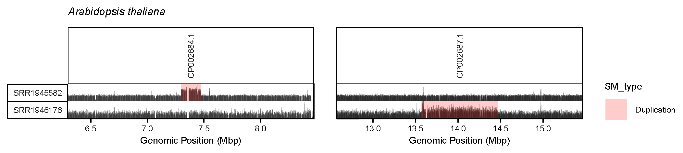
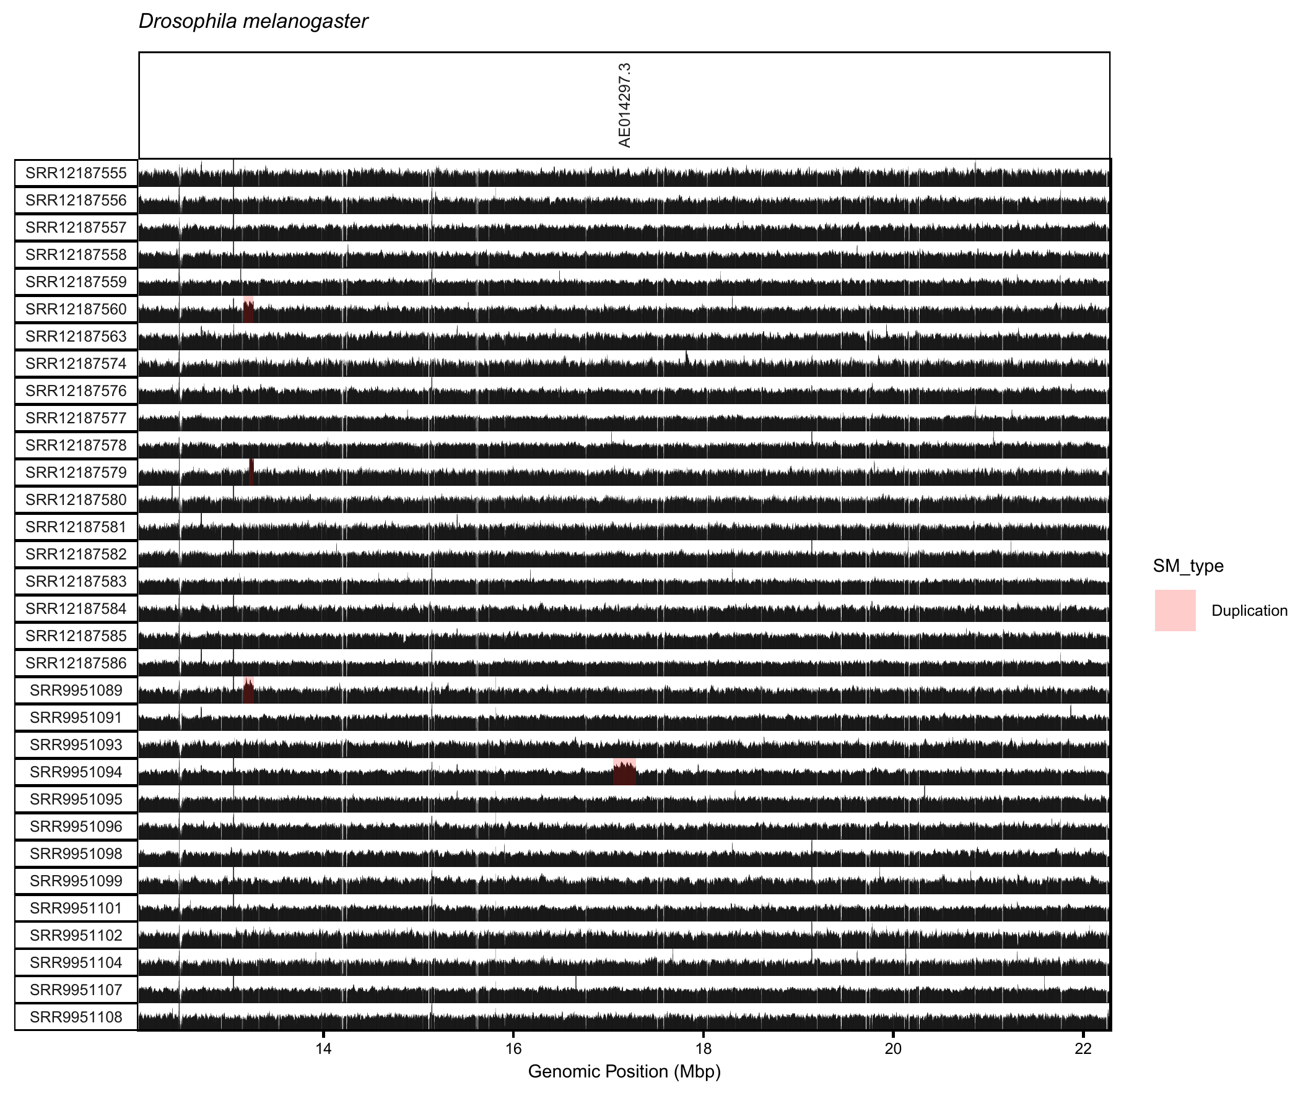
Supplementary Figure 5. Continued.
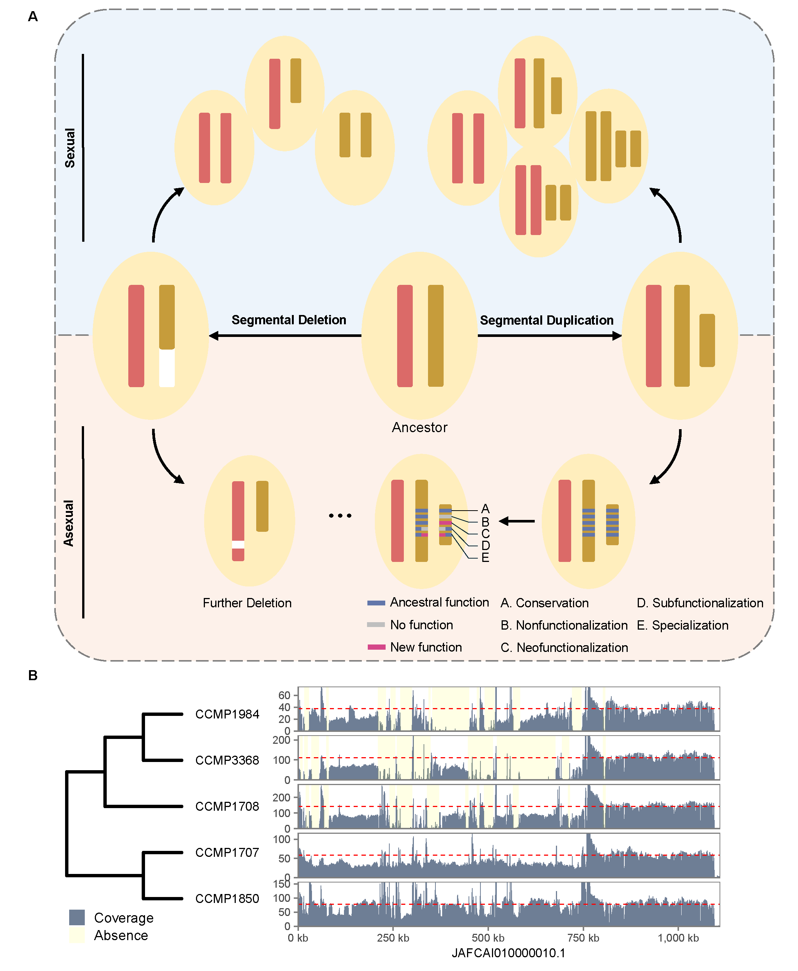 Supplementary Figure 6. Proposed mechanism for eukaryotic pangenome. A. Segmental deletion and duplication contributing to PAV. B. Examples of segmental deletion-induced PAV in A. anophagefferens, with phylogenetic tree shown on the left and coverage profile on the right (tree topology from Sibbald et al. 2025). The red line indicates the genome-wide mean coverage for each strain.

