Supplementary File 2: The role of chromosome segmental mutations in eukaryotic pangenome evolution
Sisi Chen^{*,1}, Marc Krasovec², Rosalind E. Rickaby³ and Dmitry A. Filatov^{*,1}

¹Department of Biology, University of Oxford, South Parks Road, Oxford OX1 3EL, United Kingdom
²Sorbonne Université, CNRS, Laboratoire de Biodiversité et Biotechnologies Microbiennes, LBBM, 66650 Banyuls-sur-Mer, France
³Department of Earth Sciences, University of Oxford, South Parks Road, Oxford OX1 3AN, United Kingdom
*Corresponding author: E-mails: dmitry.filatov@biology.ox.ac.uk; sisi.chen@biology.ox.ac.uk
Overlap of repetitive elements with breakpoints in the T0 line. A. Sliding-window coverage of the ancestral (T0) across a 100 kb region centred on the breakpoint. C. Enlarged view of the shaded region in A (window size, 10 kb). D. Genomic features in the region shown in C, including transposable elements (TEs) and gene annotations. Breakpoints are labelled using the format T0.[chromosome].[genomic position].
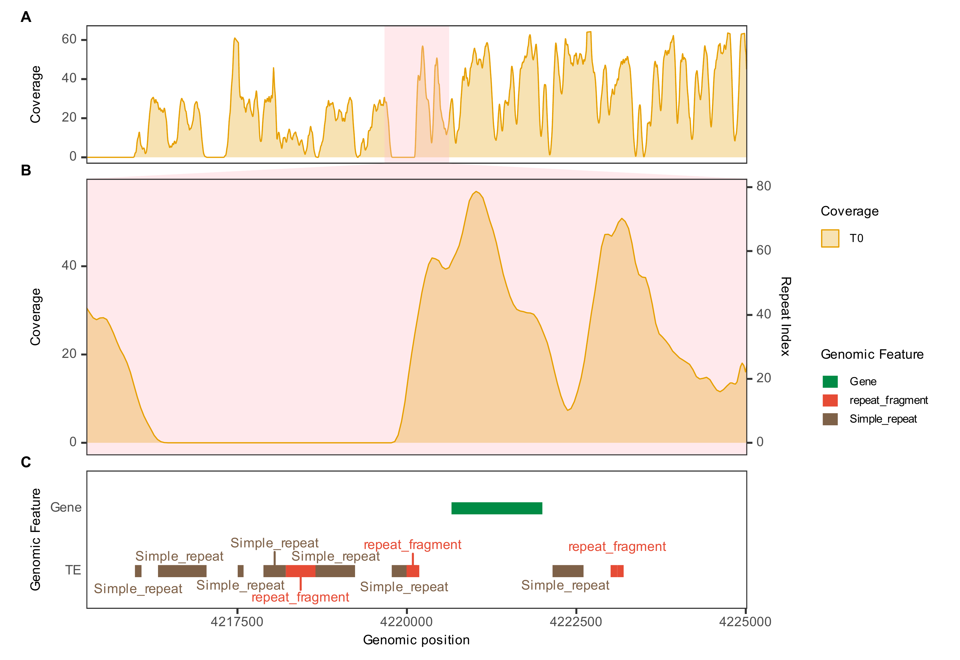
T0.SS04_RagTag.4220022
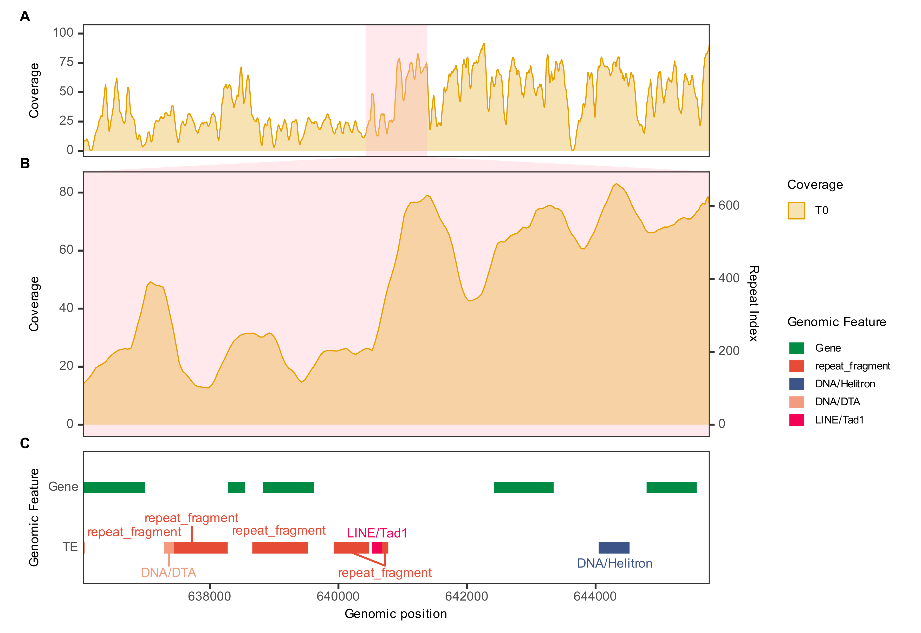
T0.SS07_RagTag.640775
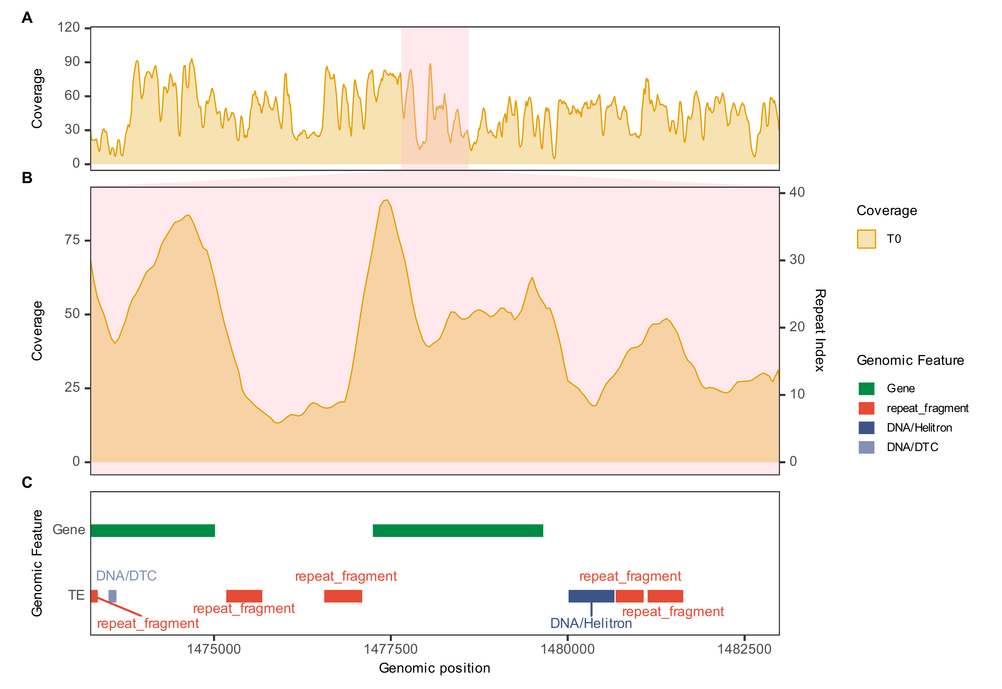
T0.SS07_RagTag.1478000
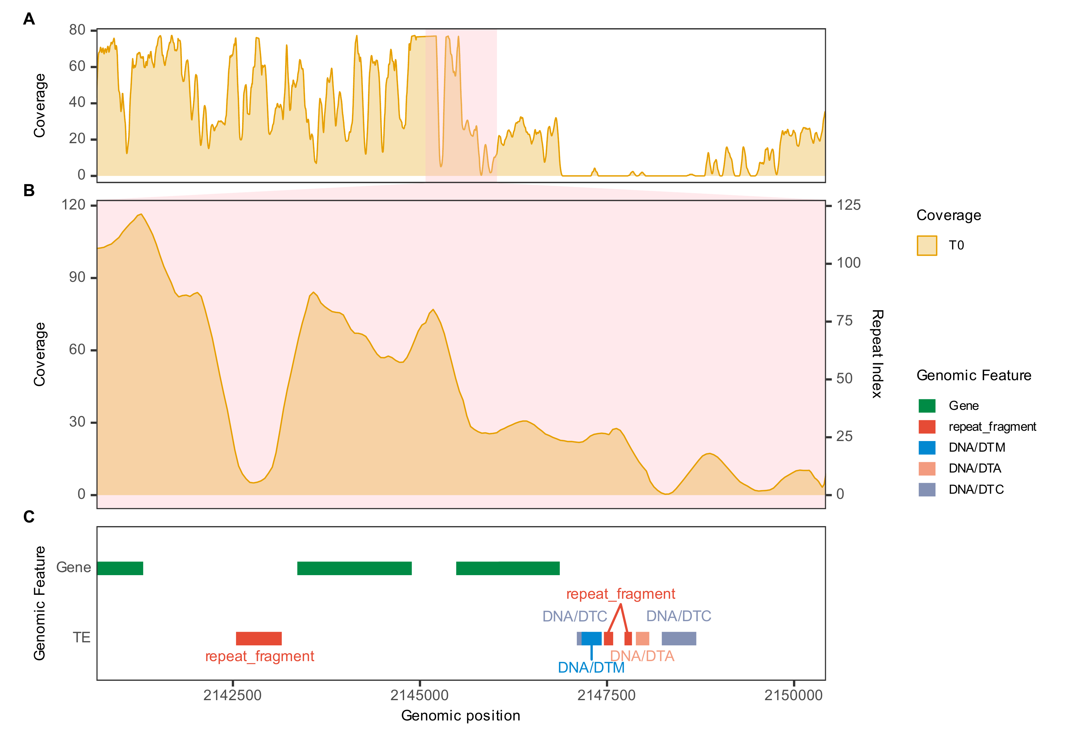
T0.SS11_RagTag.2145427
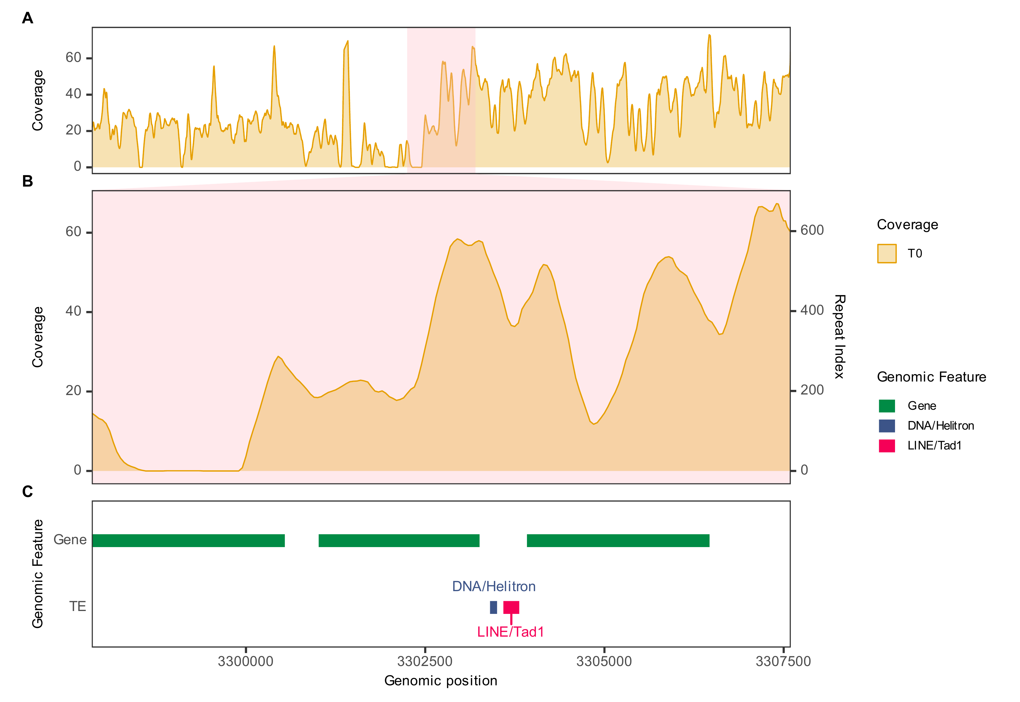
T0.SS11_RagTag.3302600
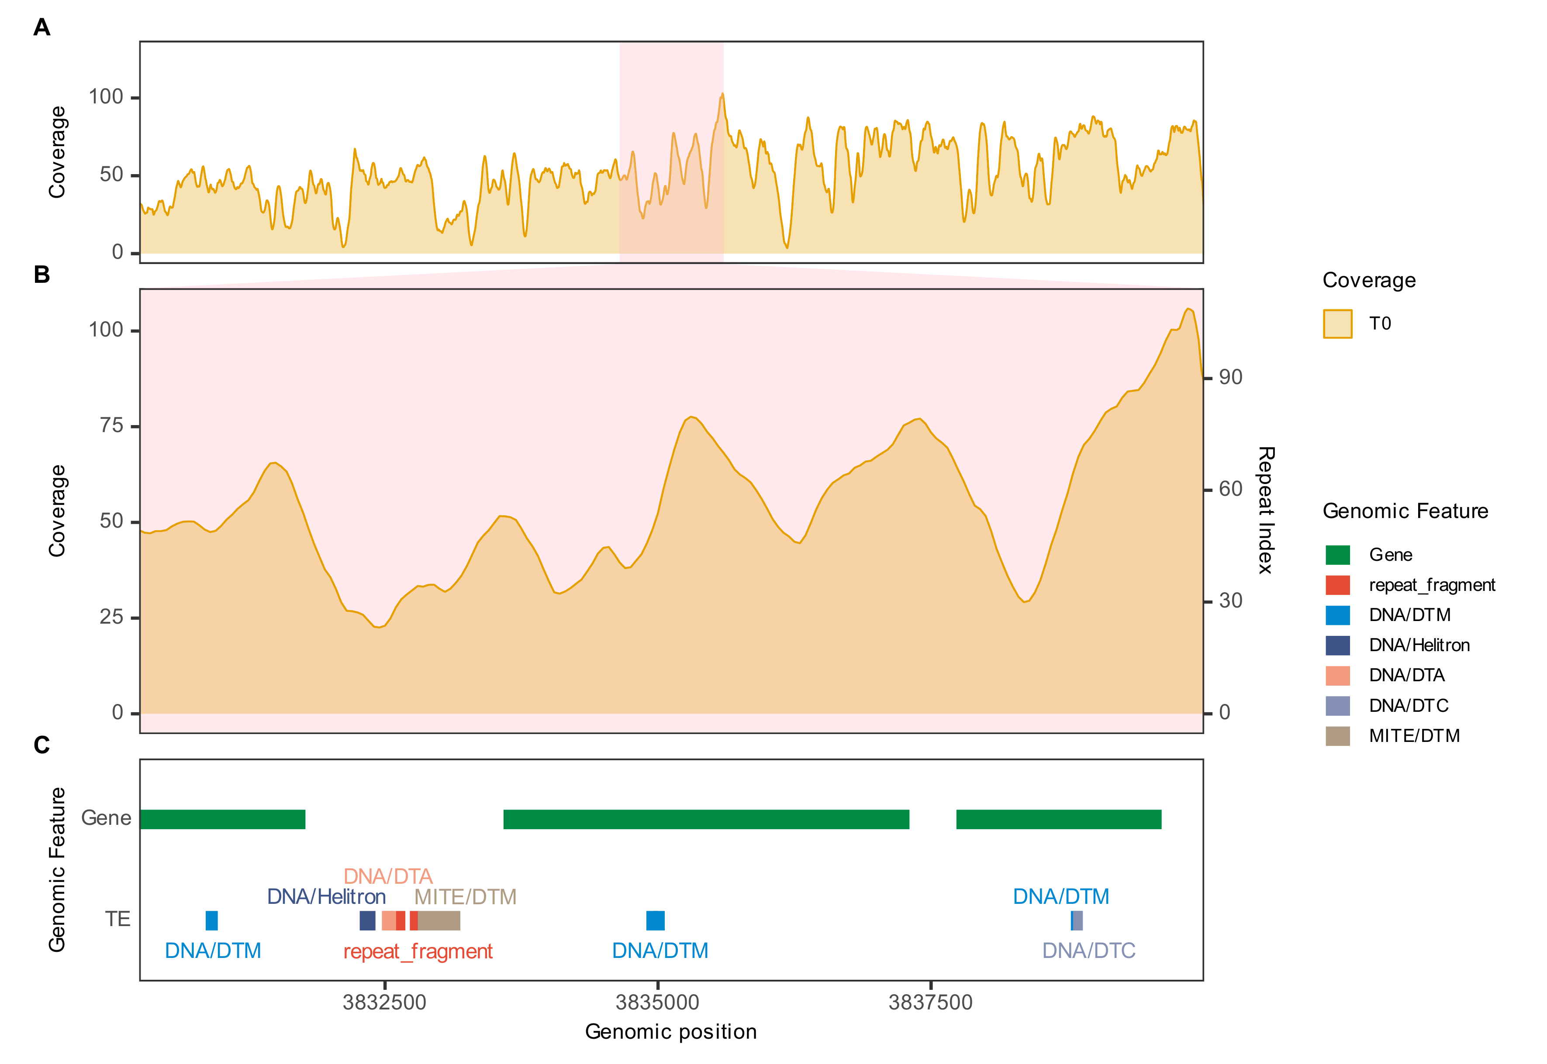
T0.SS11_RagTag.3835000
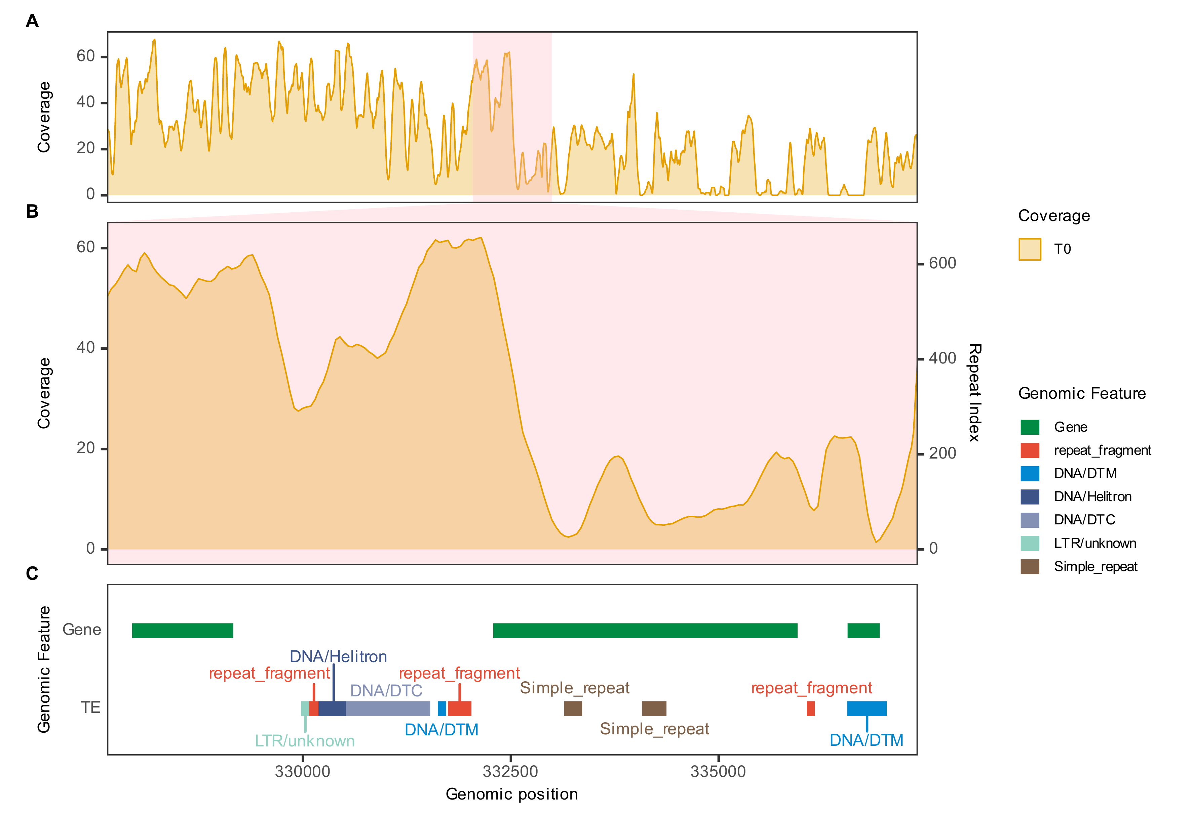
T0.SS14_RagTag.332395
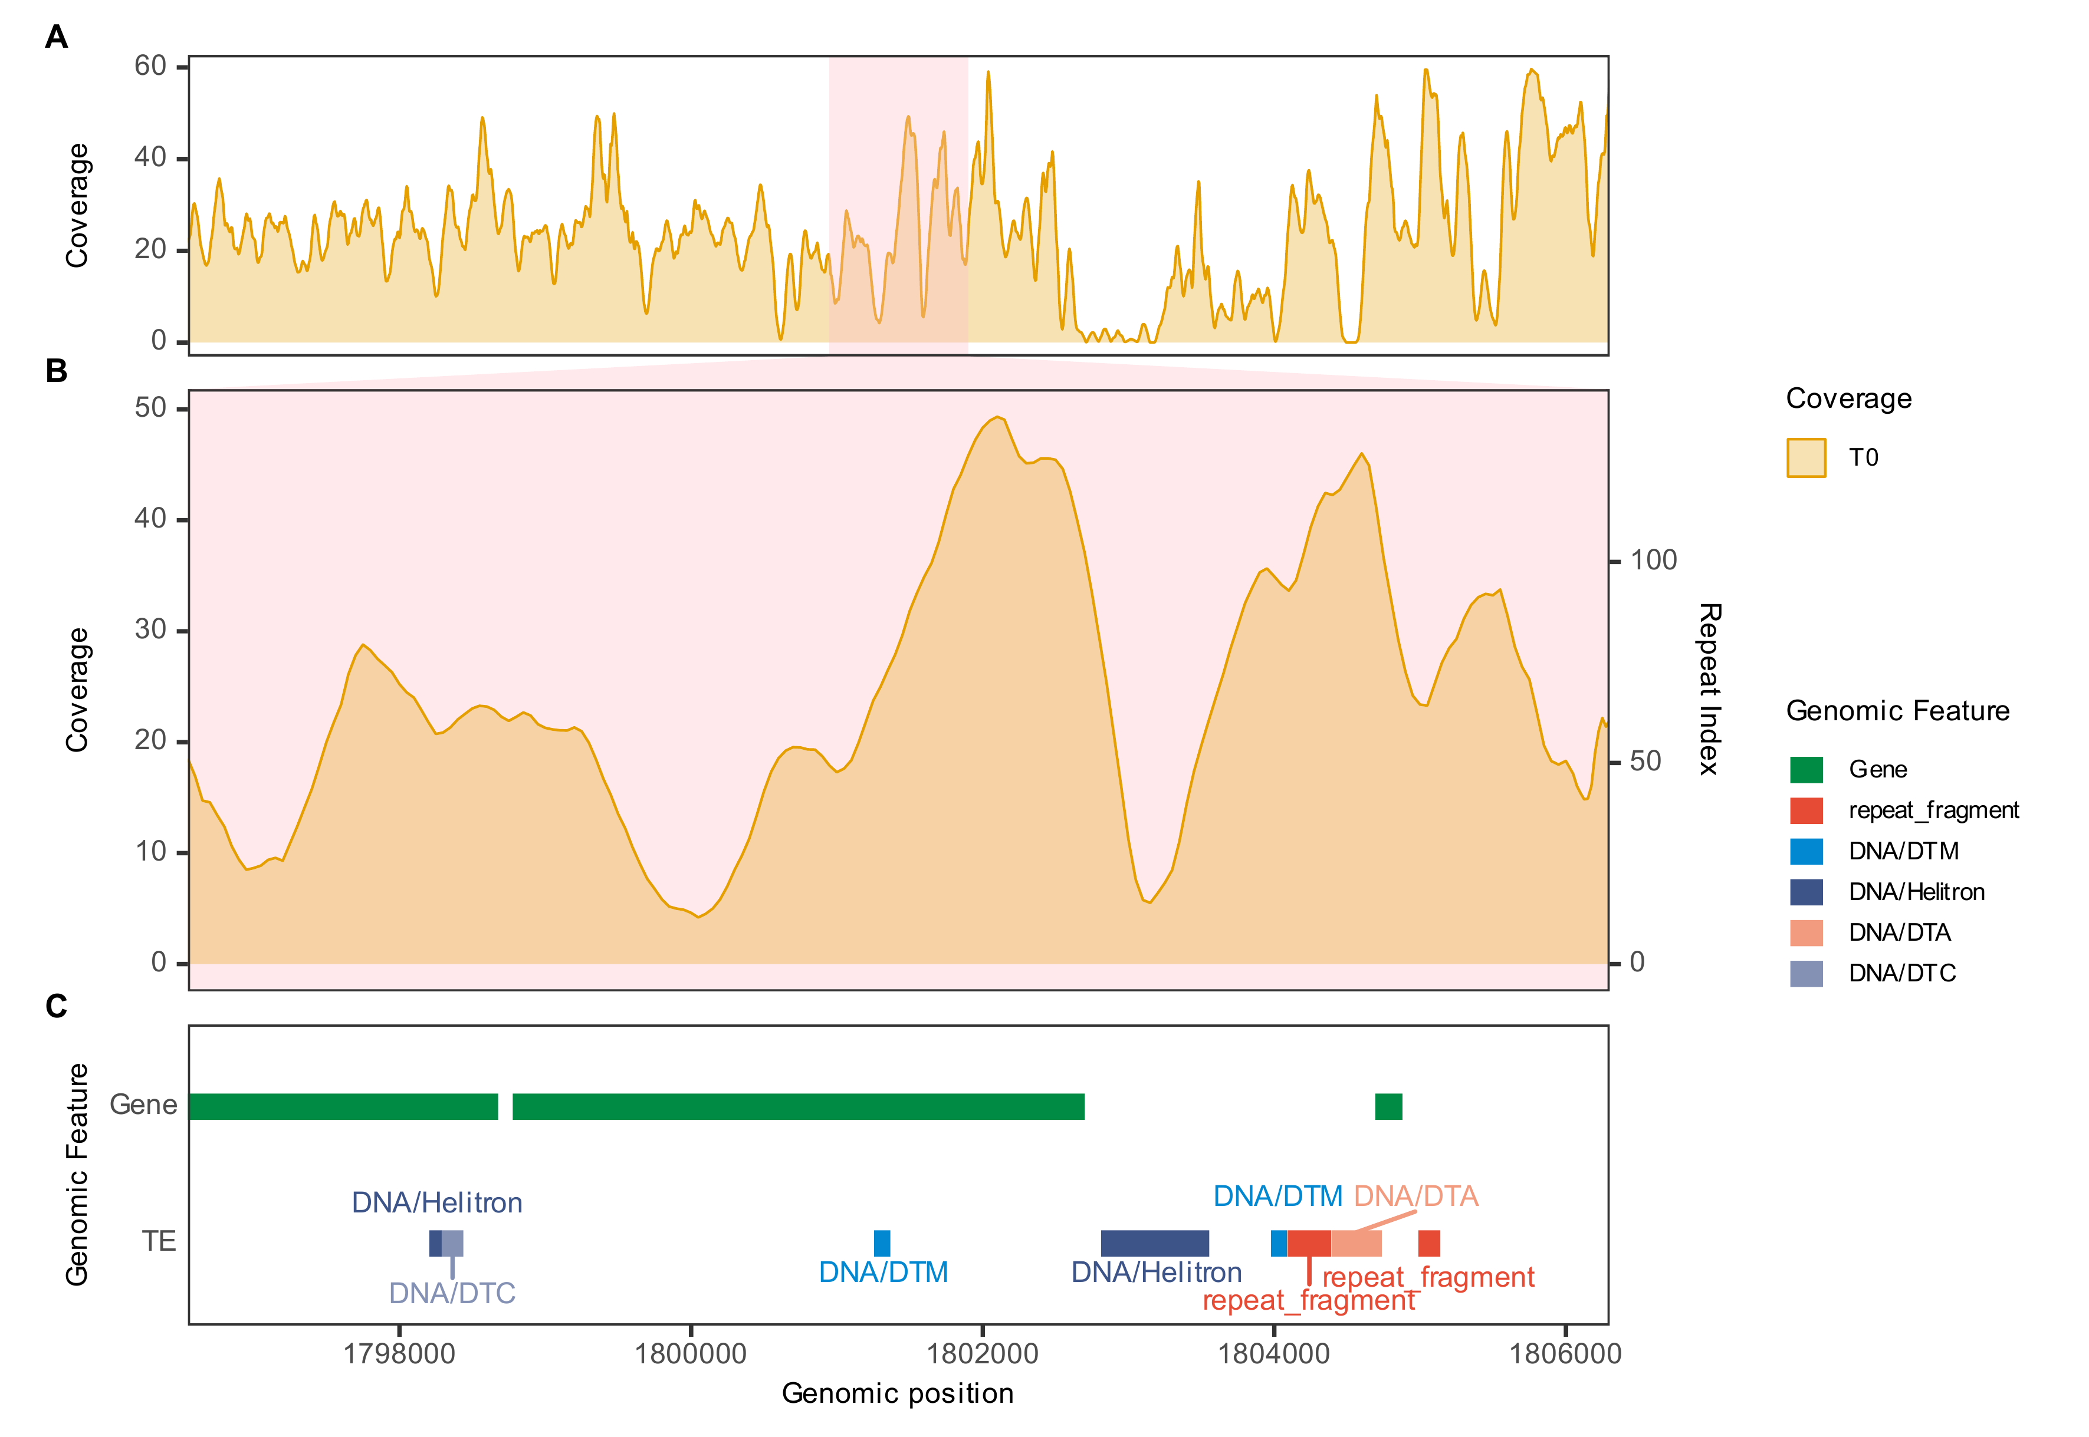
T0.SS14_RagTag.1801300

Overlap of repetitive elements with new breakpoints in MA lines. A. Sliding-window coverage of the ancestral (T0) and MA line across a 100 kb region centred on the breakpoint. B. Relative coverage across the same region as in A, comparing target MA line with the MA line H. C. Enlarged view of the shaded region in B (window size, 10 kb). D. Genomic features in the region shown in C, including transposable elements (TEs) and gene annotations. Breakpoints are labelled using the format [MA line ID].[chromosome].[genomic position].
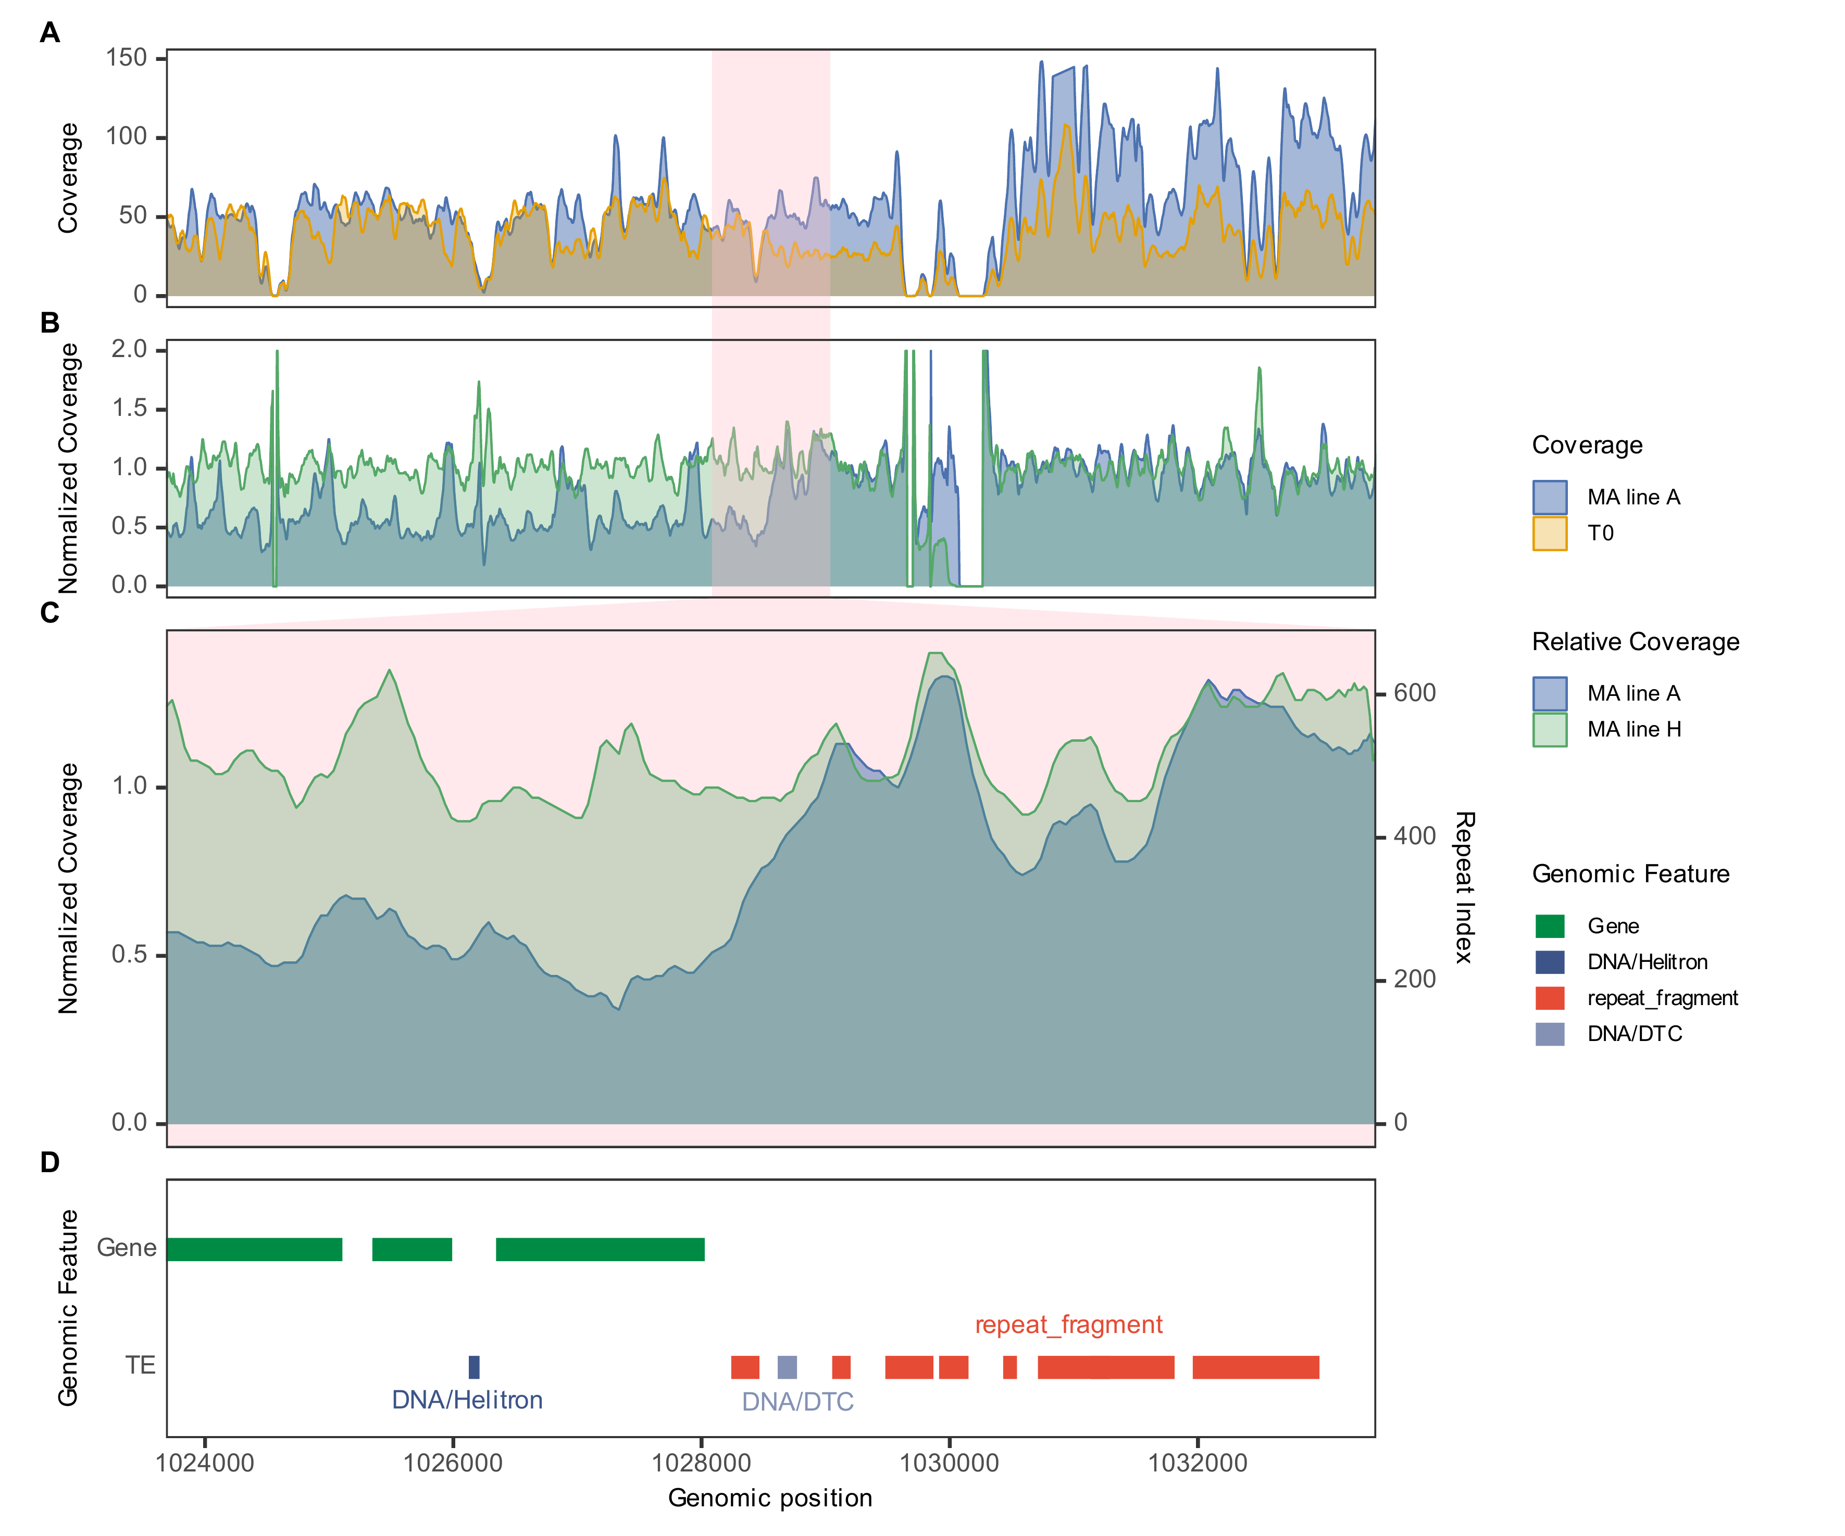
MA line A.SS03_RagTag.1028436
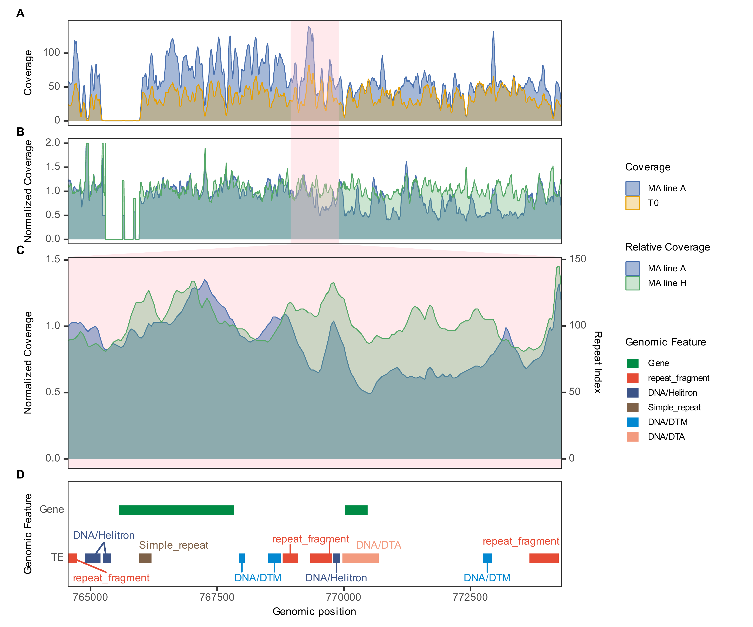
MA line A.SS15_RagTag.769301
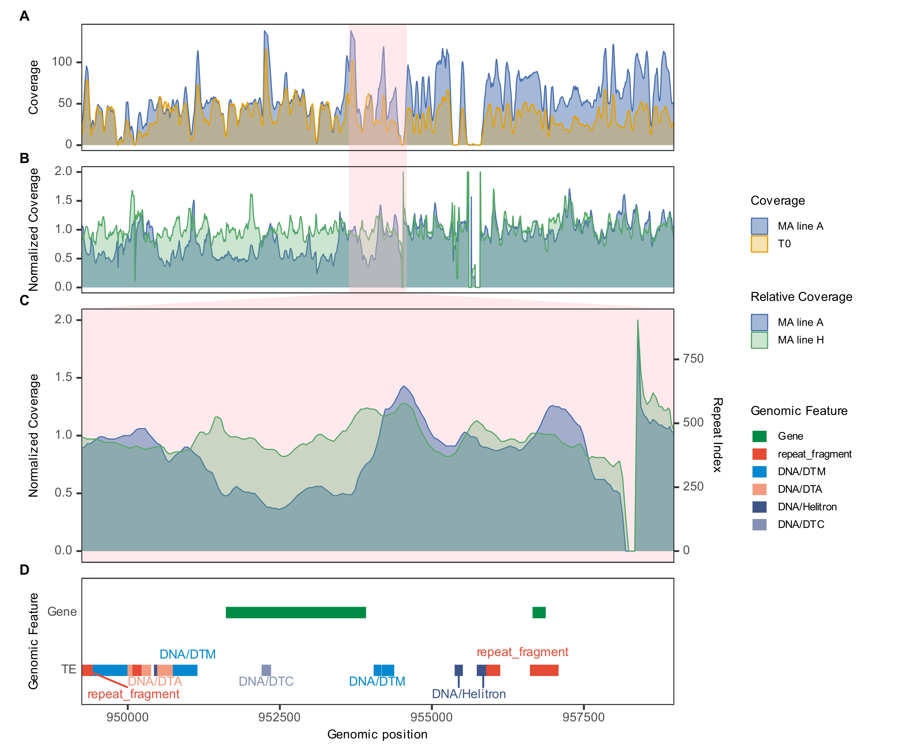
MA line A.SS15_RagTag.953987
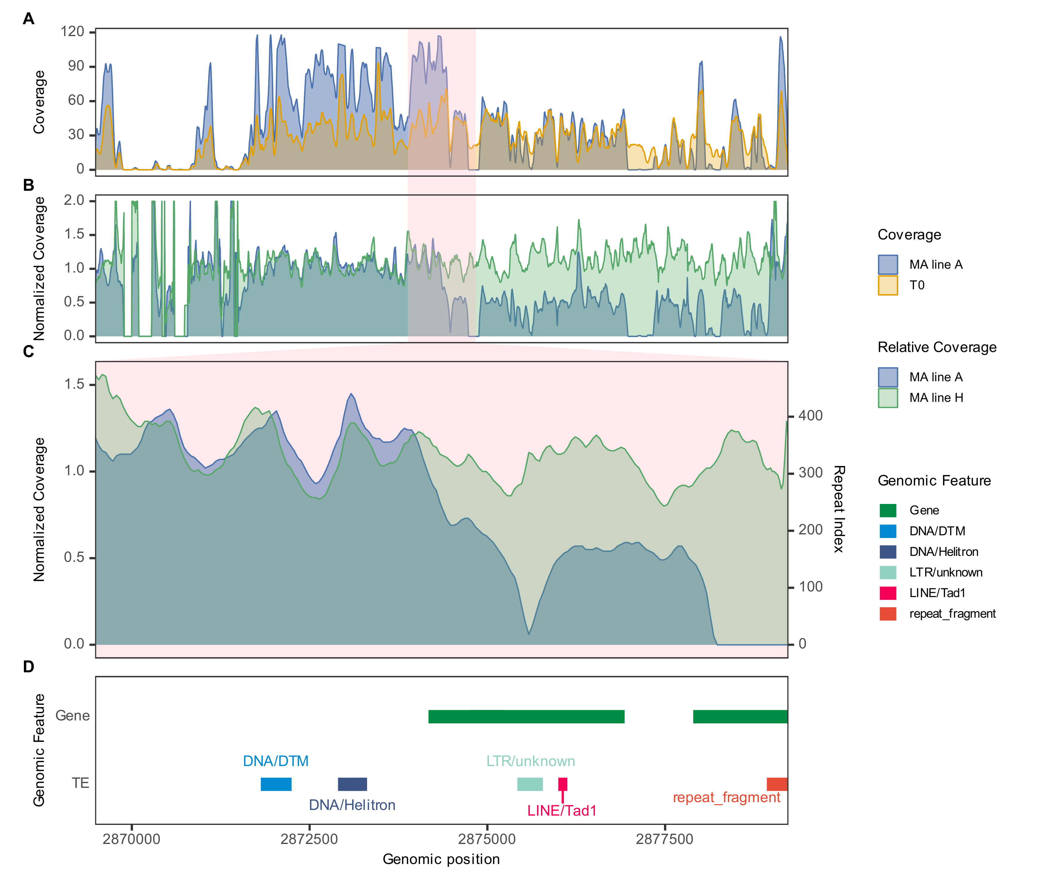
MA line A.SS17_RagTag.2874234
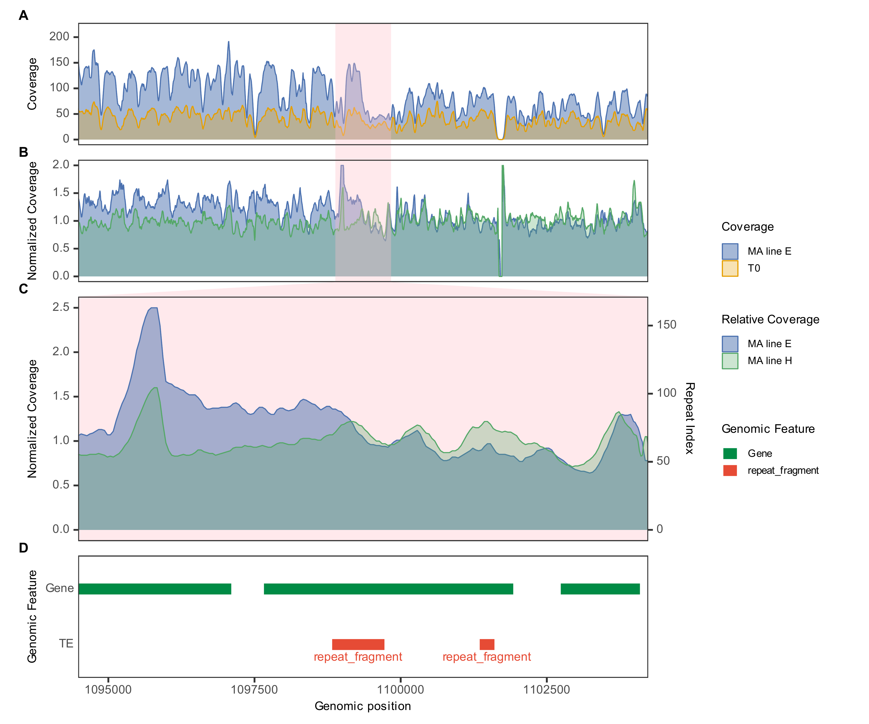
MA line E.SS05_RagTag.1099235
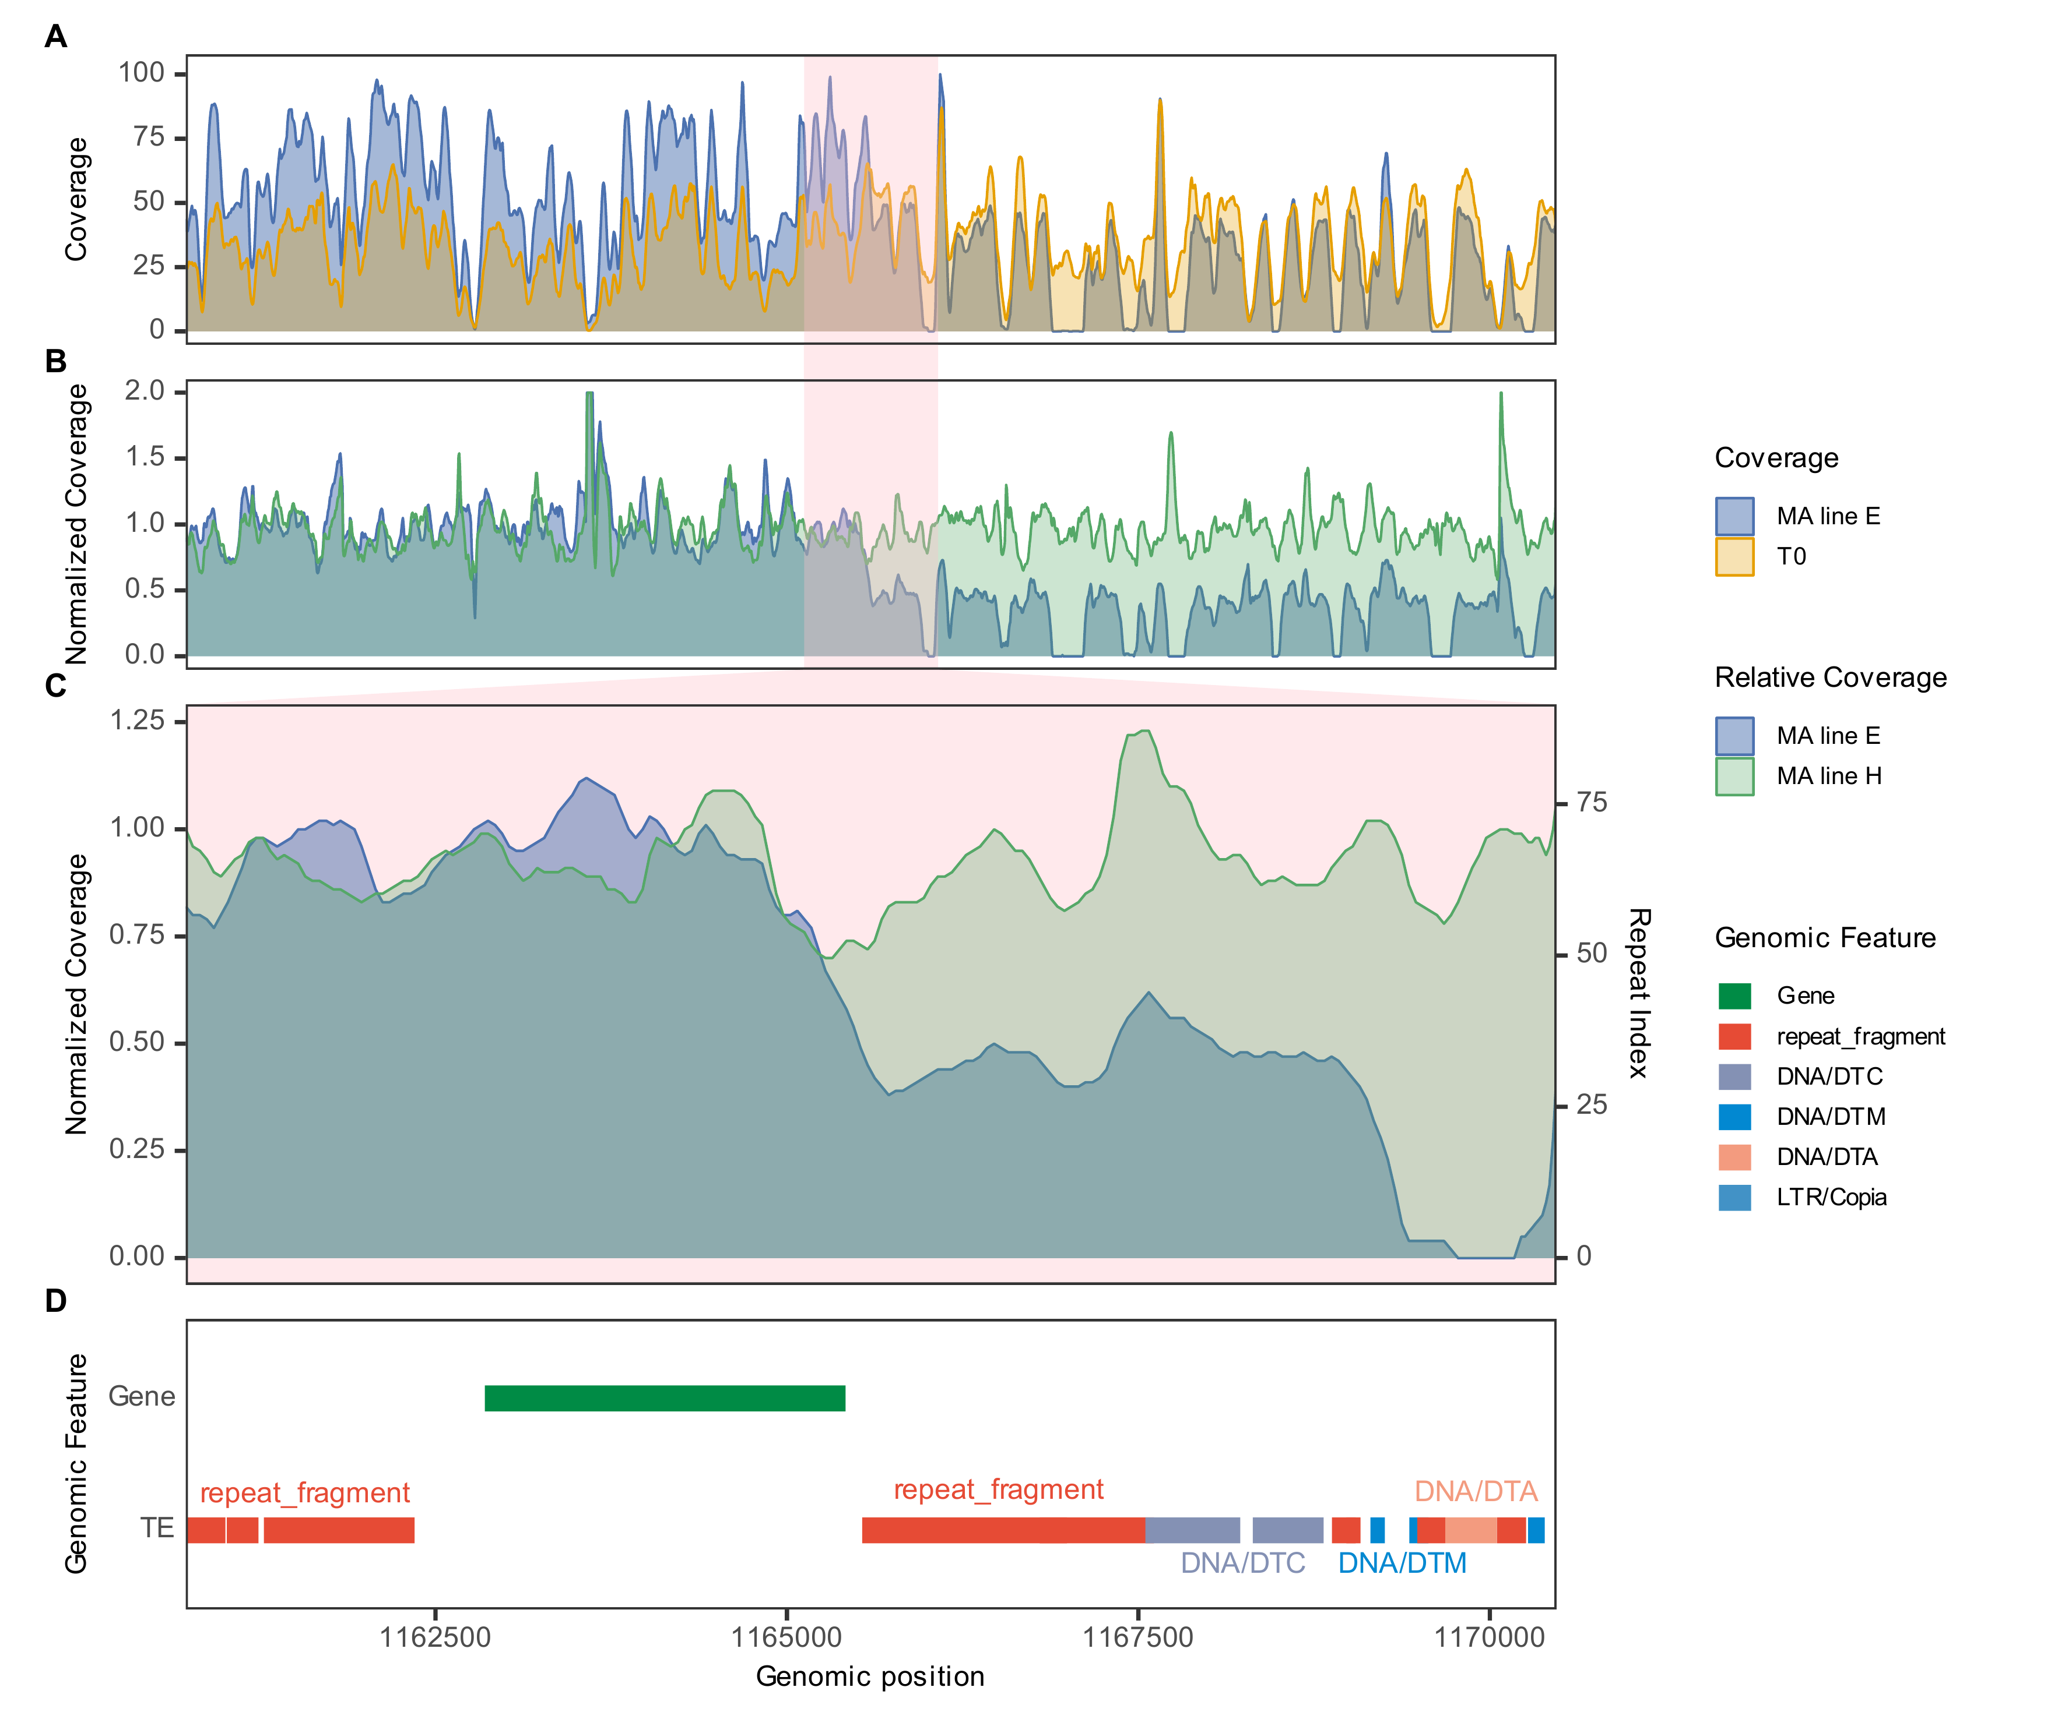
MA line E.SS12_RagTag.1165475
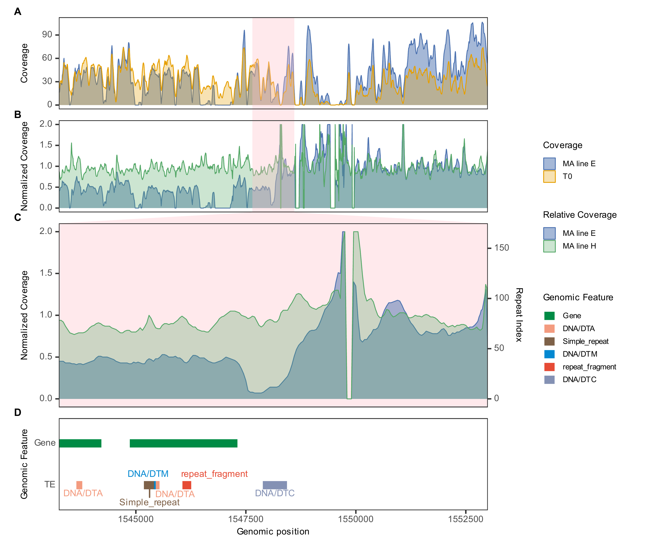
MA line E.SS12_RagTag.1548000
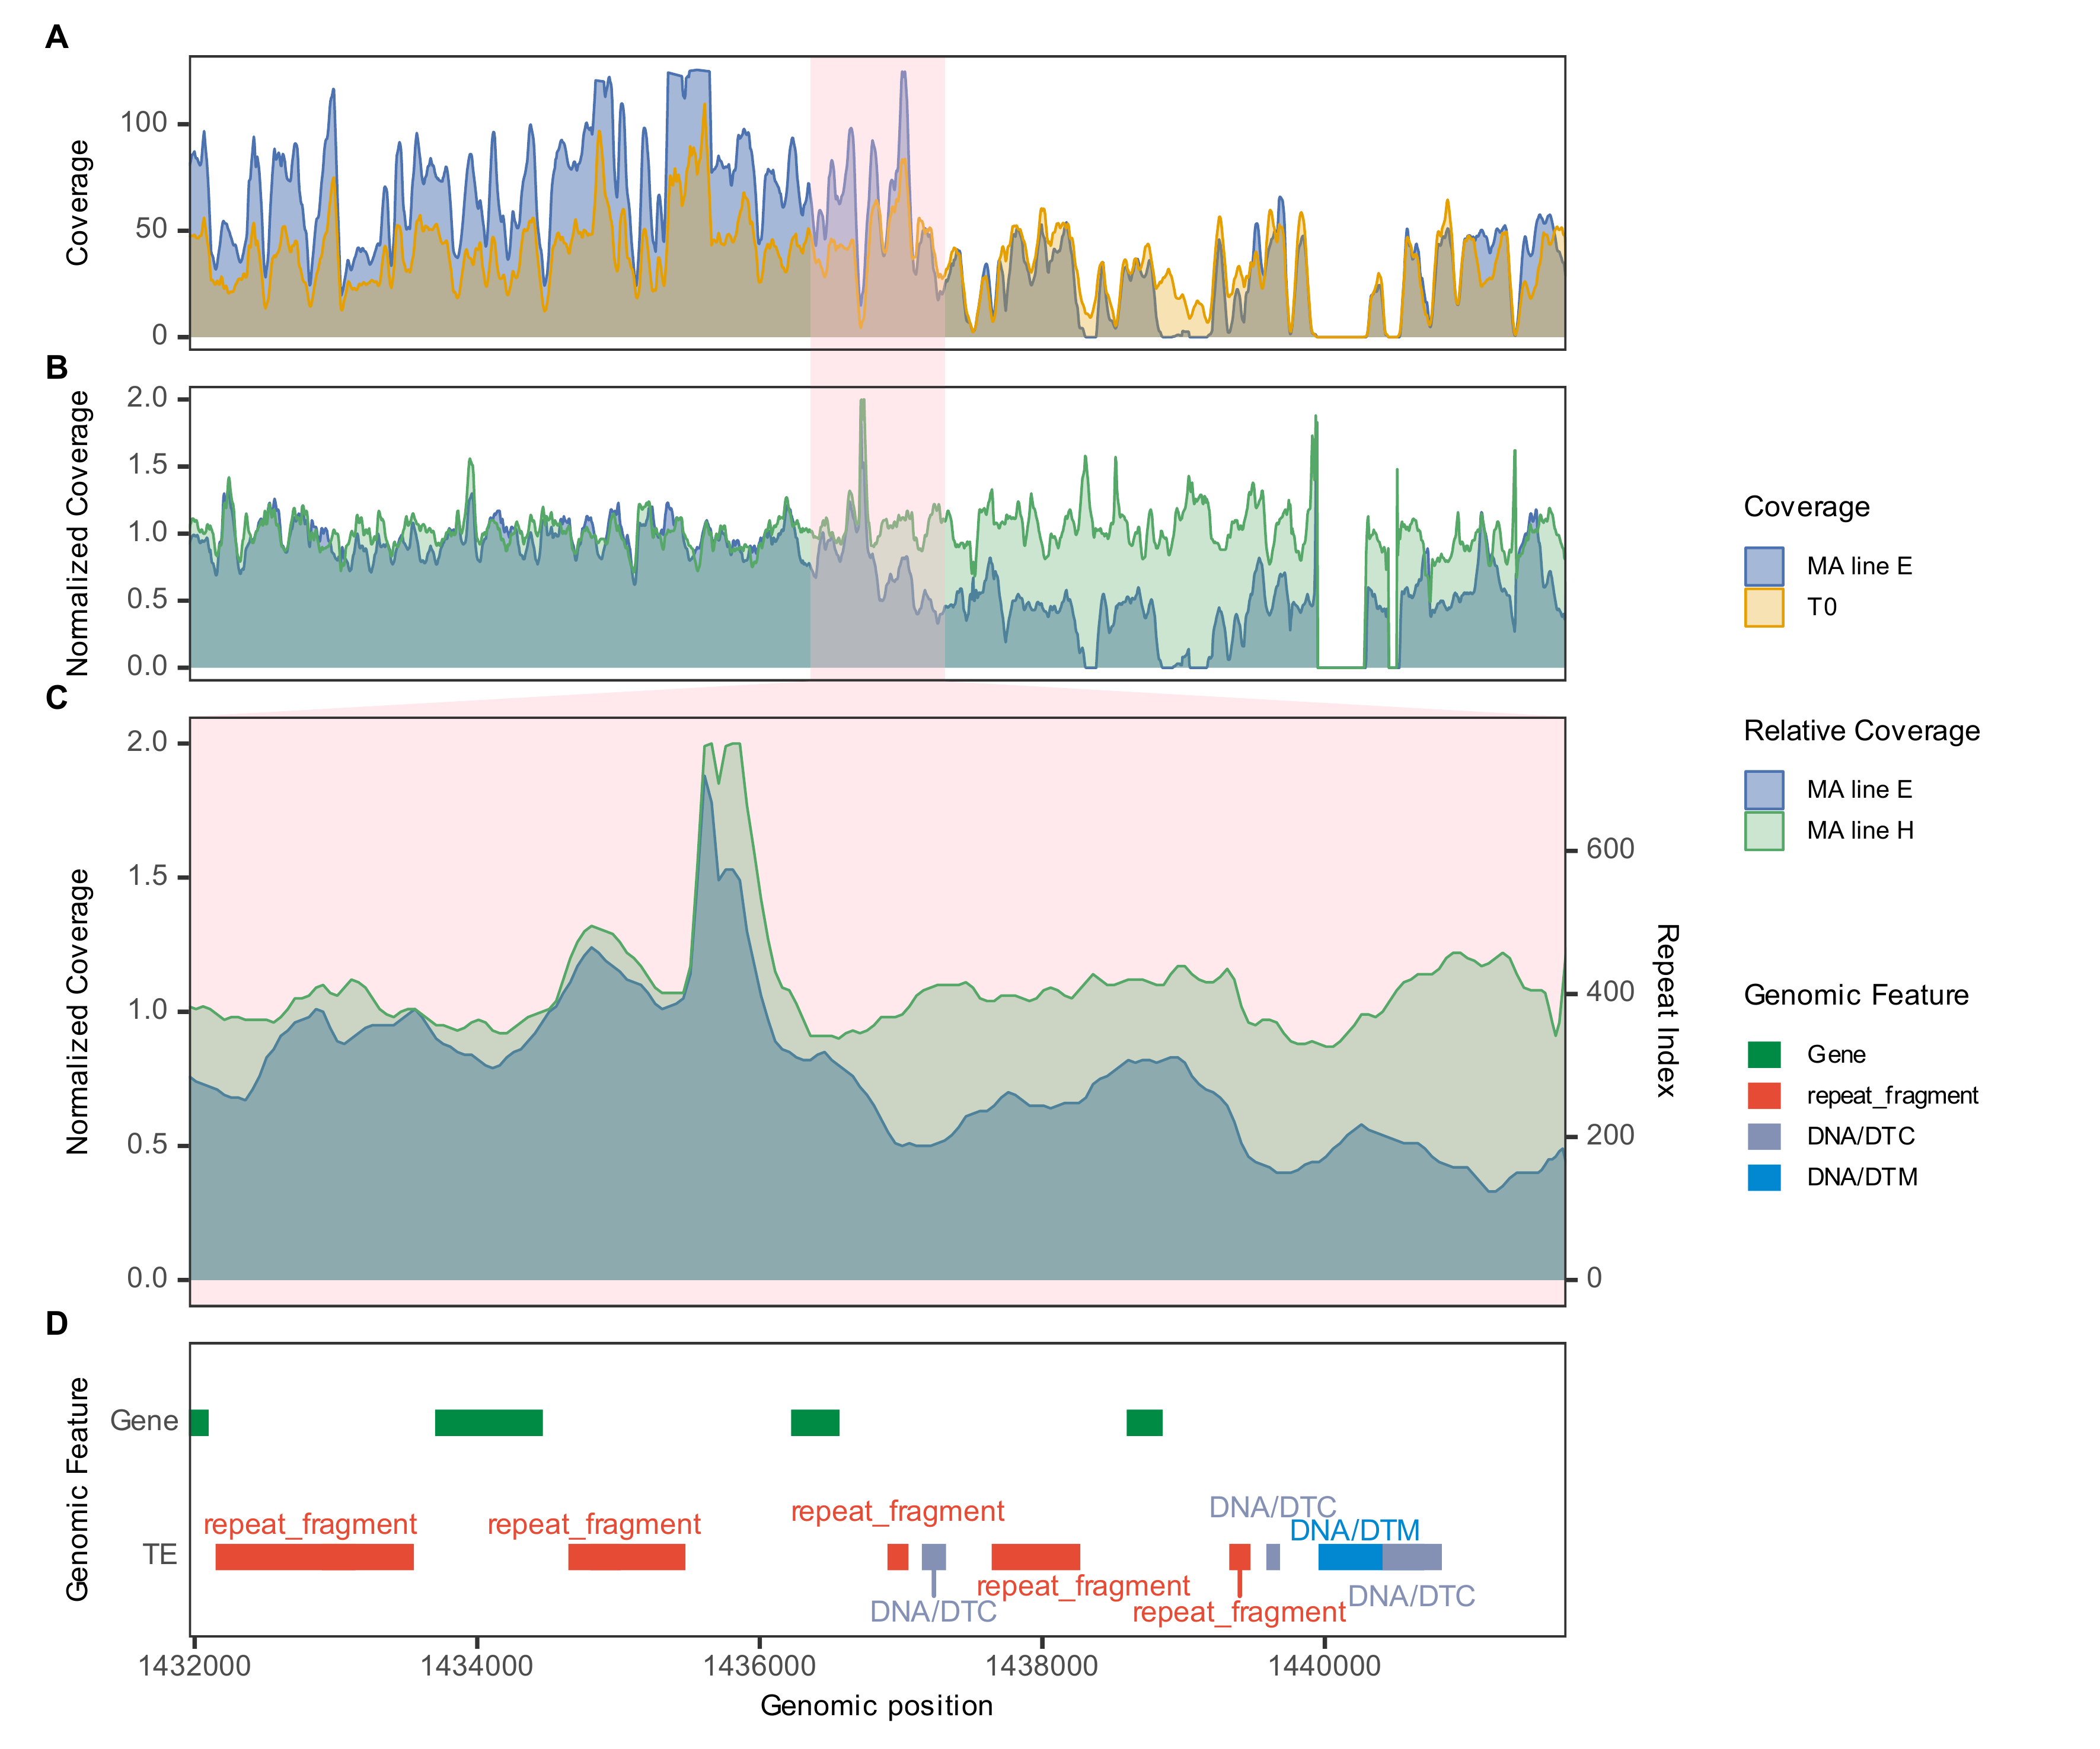
MA line E.SS15_RagTag.1436710
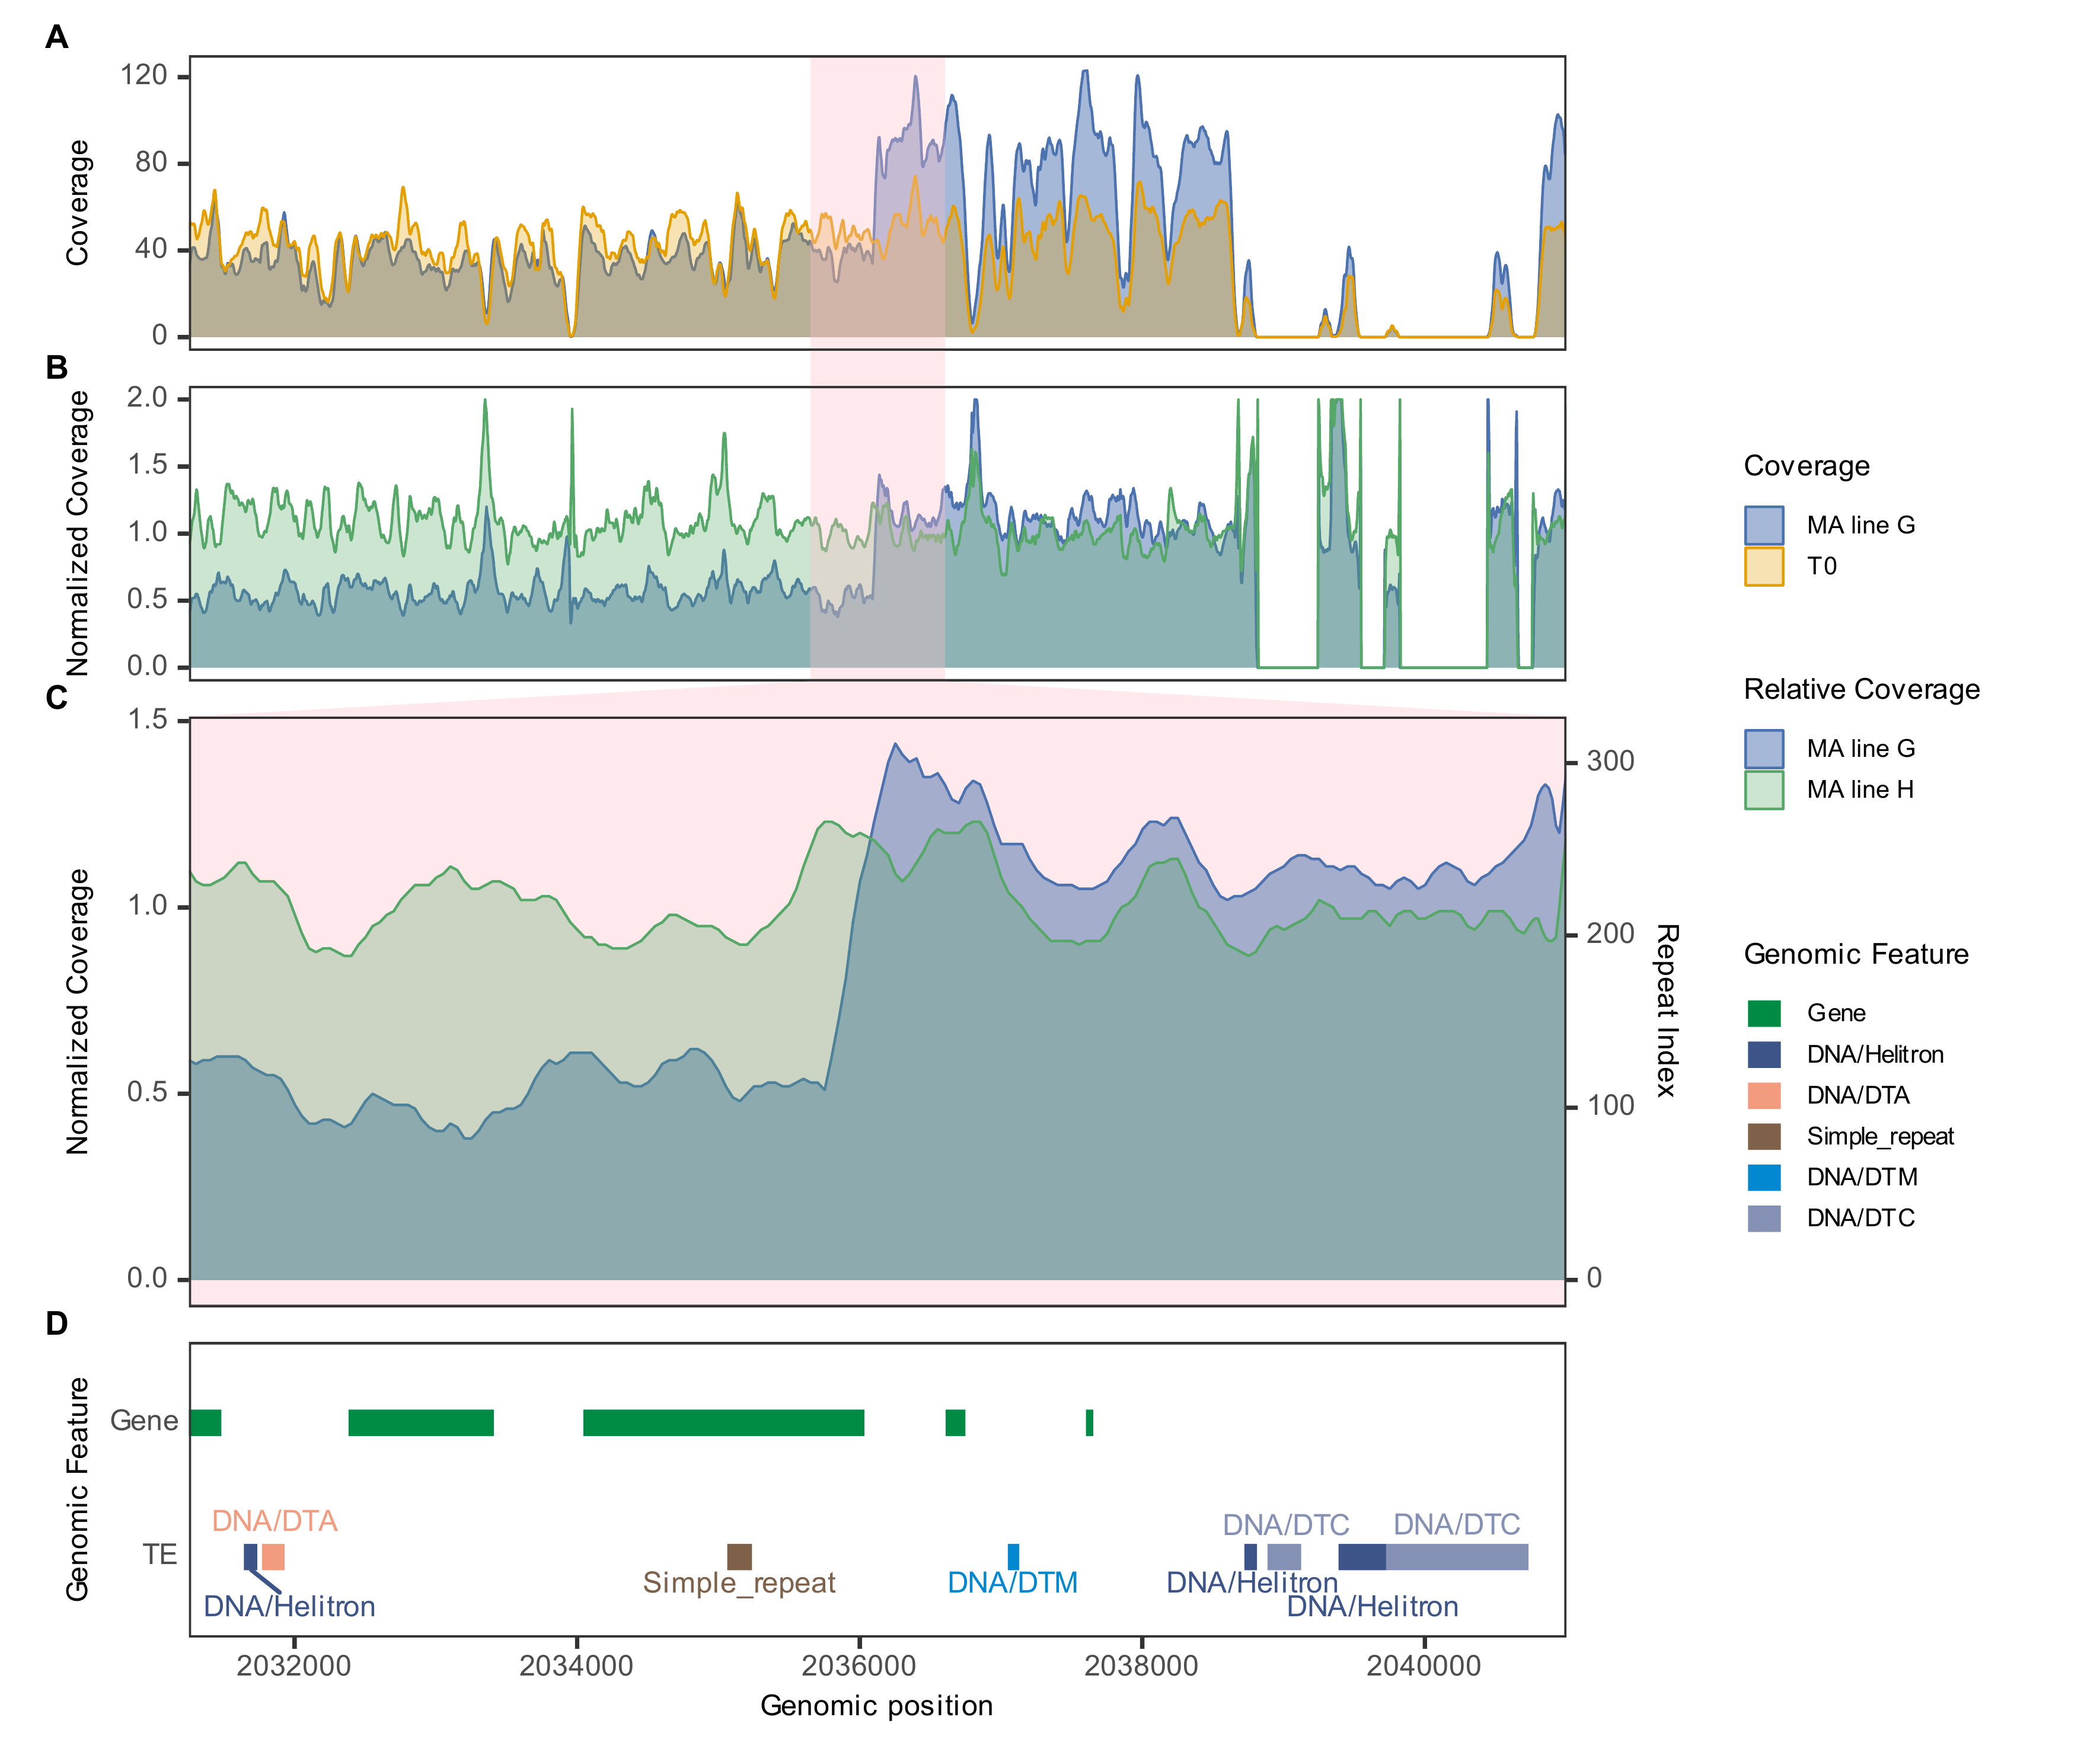
MA line G.SS02_RagTag.2036003
MA line G.SS17_RagTag.2431910
MA line J.SS21_RagTag.42910
MA line J.SS21_RagTag.817359
MA line N.SS11_RagTag.1530524
MA line N.SS17_RagTag.504197
MA line N.SS18_RagTag.3049089
MA line O.SS13_RagTag.271816
MA line R.SS05_RagTag.141942
MA line R.SS06_RagTag.311000
MA line R.SS10_RagTag.1439493
MA line R.SS10_RagTag.1582500
MA line S.SS11_RagTag.220447
MA line T.SS04_RagTag.2628650
MA line T.SS16_RagTag.1440305
MA line U.SS18_RagTag.2592391
MA line U.SS23_RagTag.616662
MA line Y.SS04_RagTag.5325348

