Additional file 1: Supplementary methods and figures

Multiple-imputation diagnostics
Covariate missingness, observed and imputed distributions, trace summaries, range checks, passive-constraint checks, fraction of missing information, and Monte Carlo error are reported in Tables S1–S3. The unchanged internal 0.10 standardized-drift screen flagged three cognition components (0.128, 0.166, and 0.174). It was an unplanned warning threshold rather than a validated convergence rejection rule. The traces showed no sustained trend; no out-of-range imputations or passive-constraint violations were found; and numerical error was small relative to total standard error. The initial alert and the author-authorized manual adjudication remain permanently documented in the project audit trail.
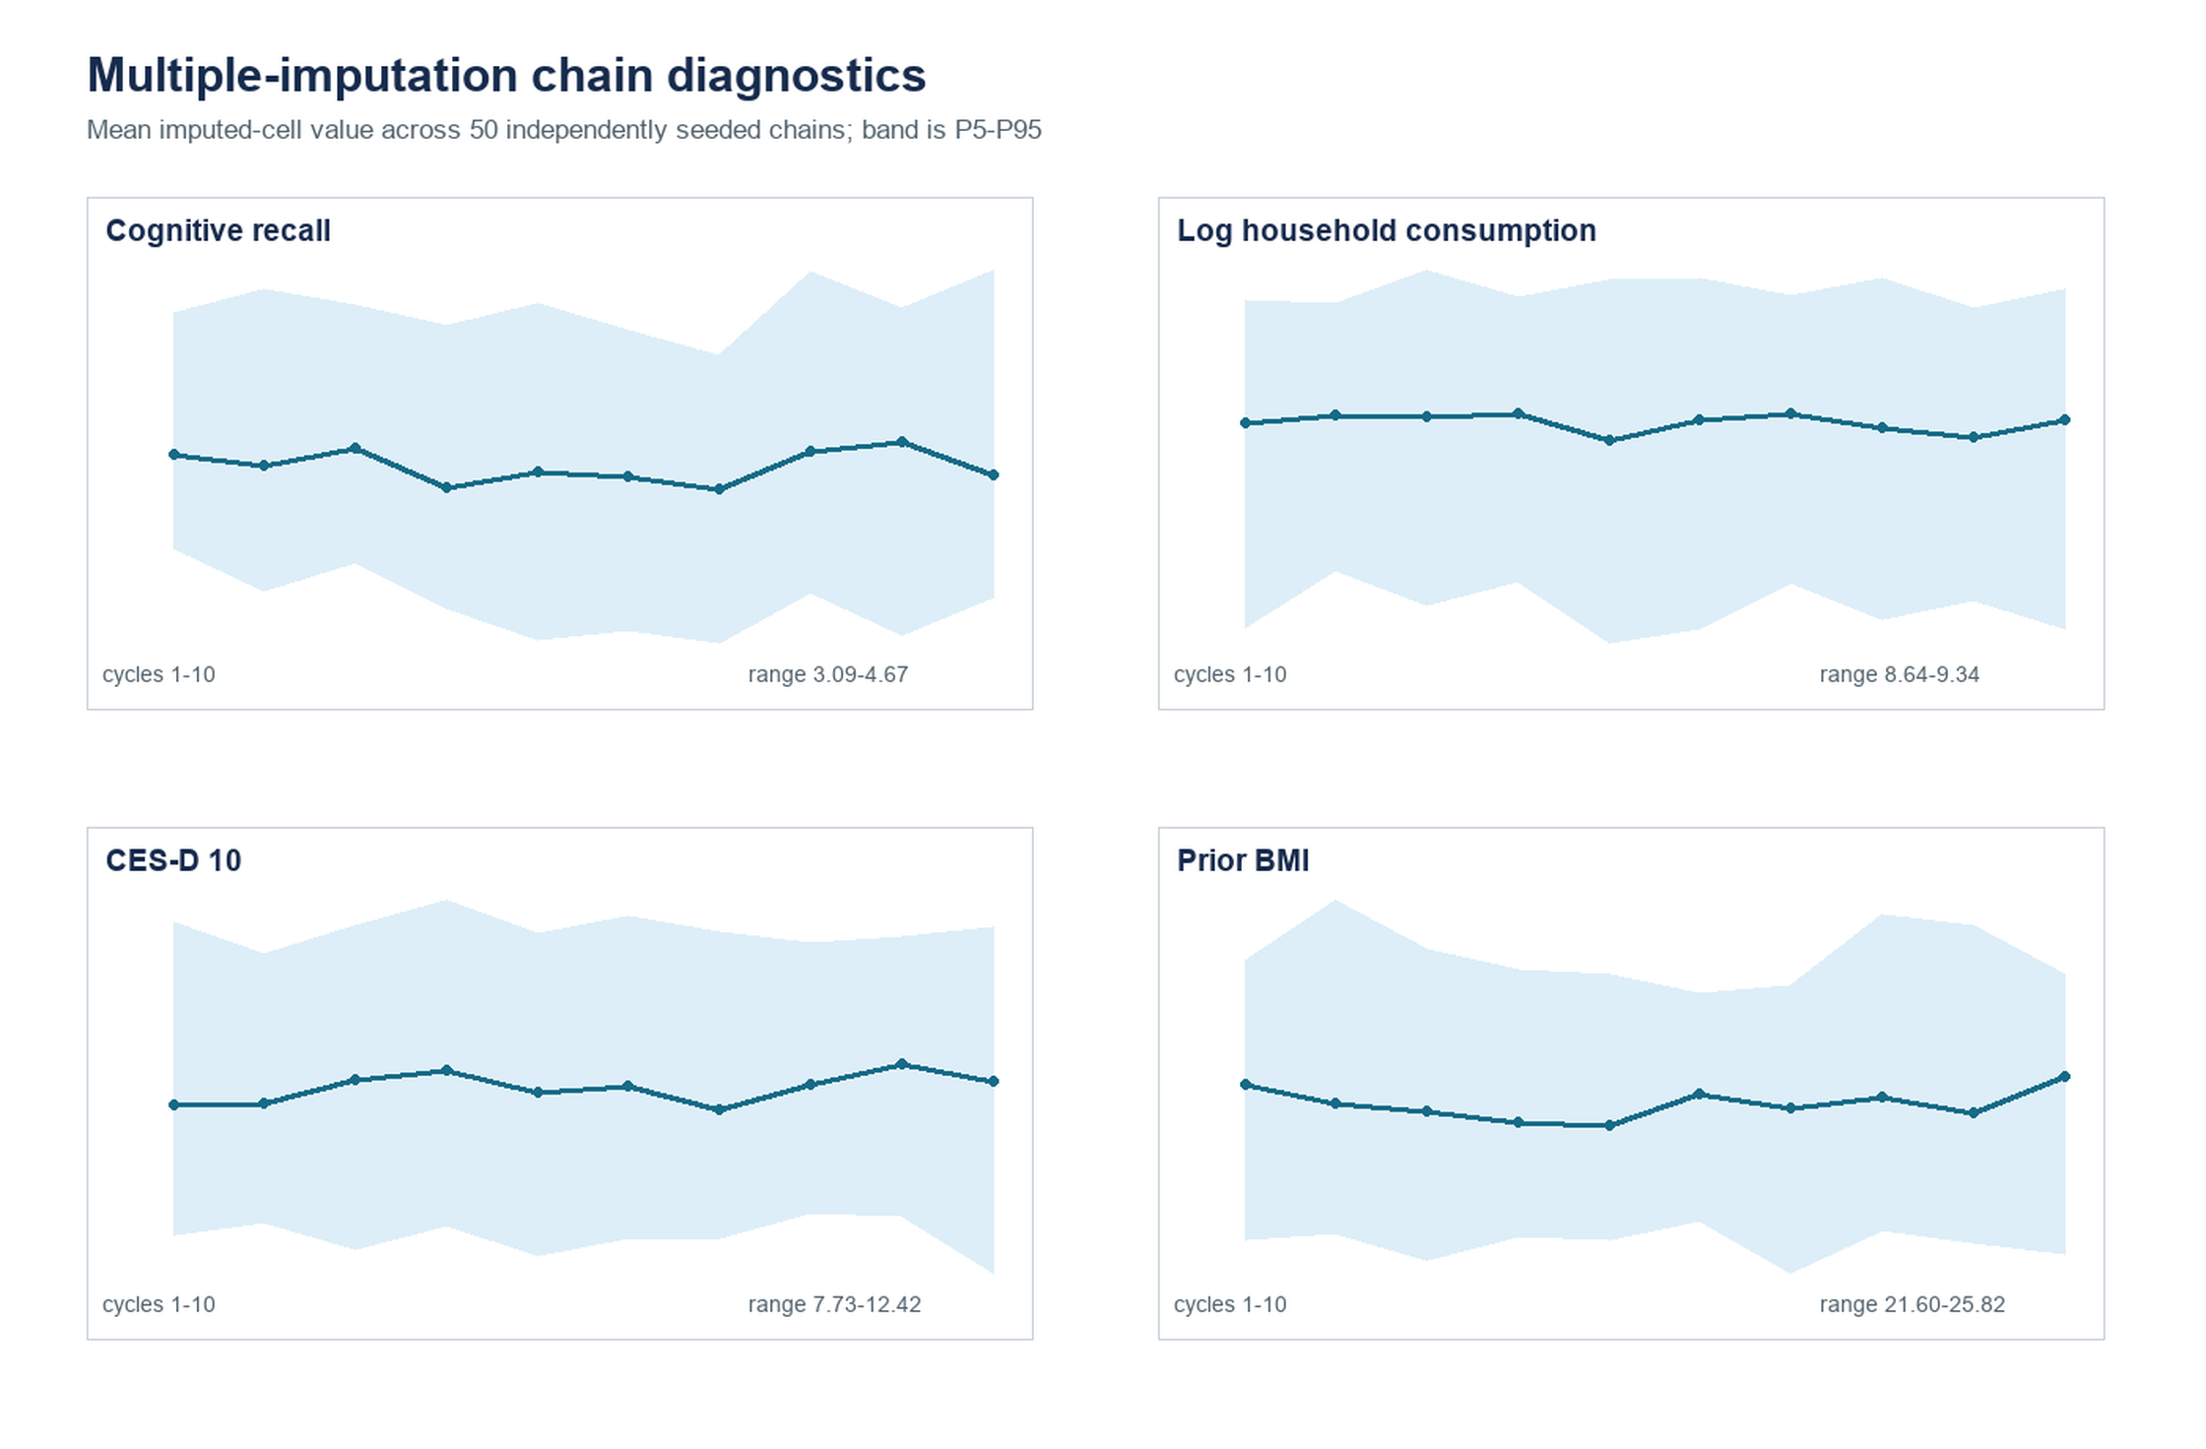
Figure S1. Multiple-imputation chain diagnostics. Lines show the mean imputed-cell value across 50 independently seeded chains over 10 cycles; shaded bands show the fifth to 95th percentiles. The displayed variables were selected for their missingness or substantive role. The plot is a diagnostic and does not establish that the missing-at-random assumption holds.

Temporal structure and identifying uncertainty
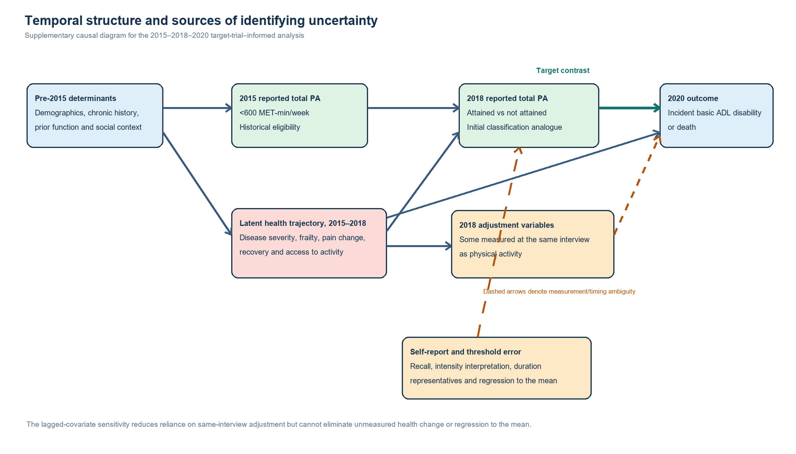
Figure S3. Temporal structure and sources of identifying uncertainty. The diagram separates historical eligibility, time-zero activity classification, and outcome follow-up while displaying possible influences of latent health change, contemporaneous adjustment variables, self-report error, and regression to the mean. Dashed arrows denote measurement or timing ambiguity rather than identified causal pathways.

