Supporting information
Lactobacillus plantarum RLL68 fermented black tea beverage attenuates high-fat-diet-induced non-alcoholic fatty liver by modulating hepatic lipid metabolism and gut microbiota

Ruili Li¹, Chong Xu⁴, Yifei Lu⁴, Anxin Sun⁴, Xinghu Lu⁴, Yifeng Liu ³, Jinzhi Han^{2,} *
1 College of Food and Biological Engineering, Fujian Polytechnic Normal University, Fuzhou, 350002, Fujian, China
2 Institute of Food Science and Technology, College of Biological Science and Engineering, Fuzhou University, Fuzhou 350108, Fujian, China
3 College of Food Science, Fujian Agriculture and Forestry University, Fuzhou, 350002, Fujian, China
4 Anhui New Simon Biotechnology Co., LTD, Suzhou 230088, Anhui, China
*Corresponding author: J.H. (hjz419@fzu.edu.cn).
.
.

1. Materials and methods
1.1 Quantitative Real-Time PCR (RT-qPCR)
The liver tissues of the mice were homogenized in TRIzol reagent (TransGen Biotech., Beijing, China). Subsequently, the RNA was extracted and reverse-transcribed into cDNA by using a HiScript II Q RT SuperMix kit (Novizan Biotechnology Co., Ltd., Nanjing, China). The quality of the resulting cDNA was assessed by using a NanoDrop 2000 Spectrophotometer (Thermo Fisher Scientific Inc., Waltham, USA). Quantitative PCR analysis was performed using HieffTM SYBR Green Master Mix and an RT-qPCR detection system (Applied Biosystems, Carlsbad, USA). The thermal cycling conditions were as follows: 95 ℃ for 2 min, followed by 40 cycles of 95 ℃ for 5 s, 60 ℃ for 30 s and 72 ℃ for 30 s. The melting curve was also generated from 65 ℃ to 95 ℃ with 0.5 ℃ s⁻¹ increments to exclude nonspecific amplification following the final reaction. The relative expression levels of the target genes, expressed as fold changes were calculated by using the 2^{−△△CT} method. The primers are provided in Table S2.
1.2 Western blot

The liver tissue samples of mice were subjected to homogenization in RIPA lysis buffer (Beyotime, Shanghai, China), with phenylmethylsulfonyl fluoride (PMSF) added to inhibit protease activity, and the homogenization process was conducted on an ice bath. After centrifugation at 12,000 g for 10 min at 4 ℃, the supernatant fractions were carefully collected. The protein concentrations in these supernatants were then determined using the Bicinchoninic Acid Protein Assay Kit (Beyotime, Shanghai, China). Next, the proteins are separated by 8% sodium dodecyl sulfate-polyacrylamide gel electrophoresis and subsequently transferred to nitrocellulose (NC) membranes for further analysis. To prevent non-specific antibody binding, the NC membranes were incubated in a blocking solution composed of 5% nonfat dry milk dissolved in Tris-buffered saline containing Tween 20 (TBST). The NC membranes were then incubated with primary antibodies specific to the target antigens and left overnight at 4 ℃ to ensure thorough binding. The following day, the membranes were incubated with horseradish peroxidase (HRP)-labeled secondary antibodies for 2 h at room temperature. After this incubation, the membranes were treated with a chemical developing agent to visualize the protein bands. Finally, the membranes were exposed using the MiniChem610 imaging system (SAGECREATION, Beijing, China). Both the primary and secondary antibodies used in this experiment were purchased from BOSTER Biological Technology co.ltd (Nanjing, China).
1.3 Metabolomic Analysis using UPLC-QTOF/MS
Initially, 0.75 mL of methanol was introduced to a homogenized liver tissue sample (100 mg) using an IKA homogenizer (Staufen, Germany). The mixture was then transferred into a glass tube with a Teflon-lined cap and vortexed. Then, 2.5 mL of methyl tert-butyl ether (MTBE) was added and the mixture was incubated for 1 hour at room temperature on a shaker. The phase separation was initiated by the addition of 0.625 mL of MS-grade water, followed by centrifugation at 1,000 g for 10 min after an additional incubation period of 10 min at room temperature. The organic phase (upper layer) was collected while the lower phase underwent re-extraction with a solvent mixture consisting of MTBE/methanol/water (10:3:2.5, v/v/v), and the upper layer was subsequently collected. After that, the combined organic phases were dried and dissolved in 100 μL of isopropanol for storage. Then the UHPLC-MS/MS analyses were performed using a Vanquish UHPLC system (Thermo Fisher, Germany) coupled with an Orbitrap Q ExactiveTM HF mass spectrometer (Thermo Fisher, Germany) in Novogene Co., Ltd. (Beijing, China). The samples were introduced onto a Thermo Accucore C30 column (150×2.1 mm, 2.6 μm) using a linear gradient over 20 min at a flow rate of 0.35 mL/min, with the column temperature maintained at 40 ℃. The mobile phase buffer A was composed of acetonitrile/water (6/4, V/V) containing 10 mM ammonium acetate and 0.1% formic acid, while buffer B was consisted of acetonitrile/isopropanol (1/9, V/V) with the same additives. The solvent gradient was in accordance with Table S1. The Q ExactiveTM HF mass spectrometer was operated in positive (negative) polarity mode with a sheath gas flow rate of 20 arbitrary units, sweep gas flow rate of 1 arbitrary unit, auxiliary gas rate of 5, spray voltage of 3 kV, capillary temperature of 350 ℃, heater temperature of 400 ℃, S-Lens RF level set to 50. The resolving power for full scan was set at 120000 with a scan range from m/z114 to m/z1700 and an automatic gain control target value of 1e6. For MS2 analysis using Top20 method the resolving power was set at 30000 and normalized collision energy values were set at both 25 and 30. The injection time was maintained at 100 ms, while the isolation window width remained constant at 1 m/z. The automatic gain control target for MS2 was set to 1e5, and dynamic exclusion was applied for 15 s. The raw data files obtained from UHPLC-MS/MS were subjected to processing using Compound Discoverer 3.01 (CD3.1, Thermo Fisher) for peak alignment, peak picking and quantitation of each metabolite. The key parameters were set as follows: retention time tolerance of 0.2 min, actual mass tolerance of 5 ppm, signal intensity tolerance of 30%, signal-to-noise ratio of 3, and minimum intensity threshold of 100000. Subsequently, the peak intensities were normalized against the total spectral intensity.

Table S1 The composition and content of ingredients in the fermented and non-fermented black tea beverage.
No | Ingredients | Non-fermented | Fermented
1 | Glucose | 6.46±0.42 mg/mL | 4.72±0.19 mg/mL
2 | Fructose | 0.41±0.012 mg/mL | 0.08±0.014 mg/mL
3 | Mannose | 0.122±0.001 mg/mL | 0.006±0.002 mg/mL
4 | Galactose | 0.010±0.004 mg/mL | 0.008±0.002 mg/mL
5 | Xylose | 0.74±0.012 mg/mL | 0
6 | Tartaric acid | 1.7891±0.1051 mg/mL | 2.8527±0.2161 mg/mL
7 | Formic acid | 0.3144±0.0679 mg/mL | 0.7919±0.3399 mg/mL
8 | Malic acid | 1.2924±0.2423mg/mL | 2.0605±0.4886 mg/mL
9 | Lactic acid | 0.8779±0.0262 mg/mL | 2.1064±0.4335 mg/mL
10 | Acetic acid | 1.2784±0.5494 mg/mL | 3.5343±0.1386 mg/mL
11 | Citric acid | 3.5112±0.5195 mg/mL | 7.8959±0.0607 mg/mL
12 | Succinic acid | 0.4071±0.1028 mg/mL | 3.1606±0.1028 mg/mL
13 | Propionic acid | 0.4018±0.091 mg/mL | 1.0082±0.1926 mg/mL
14 | Sar | 5.33±0.09 mg/L | 3.17±0.11 mg/L
15 | Asn | 3.33±0.57 mg/L | 3.05±0.14 mg/L
16 | His | 3.15±0.44 mg/L | 1.07±0.08 mg/L
17 | Ser | 1.35±0.21 mg/L | 1.03±0.45 mg/L
18 | Asp | 1.81±0.28 mg/L | 1.62±0.36 mg/L
19 | Phe | 1.67±0.31 mg/L | 1.11±0.21 mg/L
20 | Trp | 1.68±0.23 mg/L | 0.62±0.18 mg/L
21 | val | 1.23±0.44 mg/L | 1.21±0.17 mg/L
22 | Tyr | 1.11±0.26 mg/L | 1.01±0.09 mg/L
23 | Pro | 1.47±0.26 mg/L | 1.74±0.31 mg/L
24 | Leu | 1.87±0.37 mg/L | 0.87±0.11 mg/L
25 | Ala | 1.72±0.17 mg/L | 0.91±0.32 mg/L
26 | Ile | 1.98±0.13 mg/L | 0.58±0.22 mg/L
27 | Arg | 1.13±0.06 mg/L | 1.1±0.17 mg/L
28 | Lys | 1.41±0.33 mg/L | 0
29 | Glu | 1.61±0.23 mg/L | 0
30 | Nle | 3.13±0.56 mg/L | 0.69±0.08 mg/L
31 | Tau | 0.45±0.02 mg/L | 0.41±0.03 mg/L
32 | Thr | 1.33±0.21 mg/L | 0
33 | GABA | 0.34271±0.0016 mg/L | 0.562±0.014 mg/L
34 | L-Theanine | 176.03±4.00 mg/L | 132.35±11.18 mg/L
35 | Caffeine | 0.164±0.001 mg/L | 0.163753±0.001 mg/L

Table S2 Sequence of primers for quantitative real-time PCR of mice livers
Name | Sequence |  | Length
Acaca | Forward primer | GGAGGCGGATATCTGCTGAG | 235bp
Acaca | Reverse primer | GTATCTGAGCTGACGGAGGC | 235bp
HL | Forward primer | AGCTCCCTAAATGCAAGCTC | 288bp
HL | Reverse primer | CTCCCAAAGGGCTCTGTTCC | 288bp
Cpt1a | Forward primer | GACTCCGCTCGCTCATTCC | 377bp
Cpt1a | Reverse primer | ACGCCACTCACGATGTTCTT | 377bp
Lcat | Forward primer | CCGTGGCTGCACTCTATGAA | 110bp
Lcat | Reverse primer | CATGGGCAGCAAATGTACGG | 110bp
Acat1 | Forward primer | ACCGGGTTCTCTCCTGATGA | 453bp
Acat1 | Reverse primer | TGAGTTGGGCATGGTCTGTC | 453bp

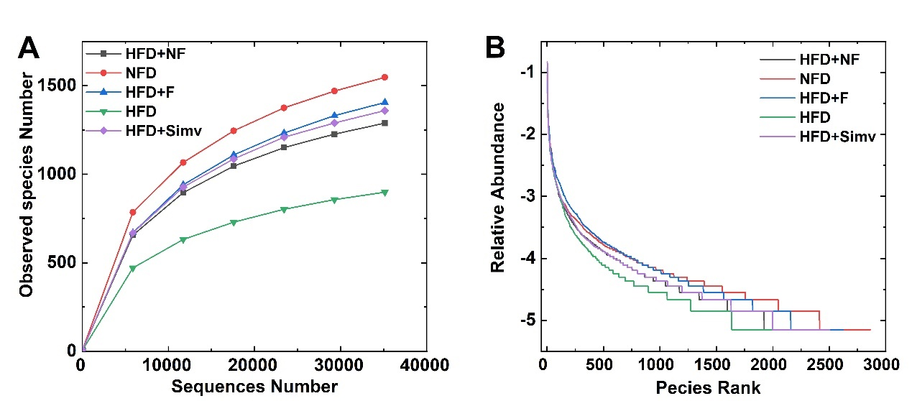
Figure S1 The species dilution curve (A) and hierarchical clustering curve (B) of the mice intestinal microbiota in different groups.
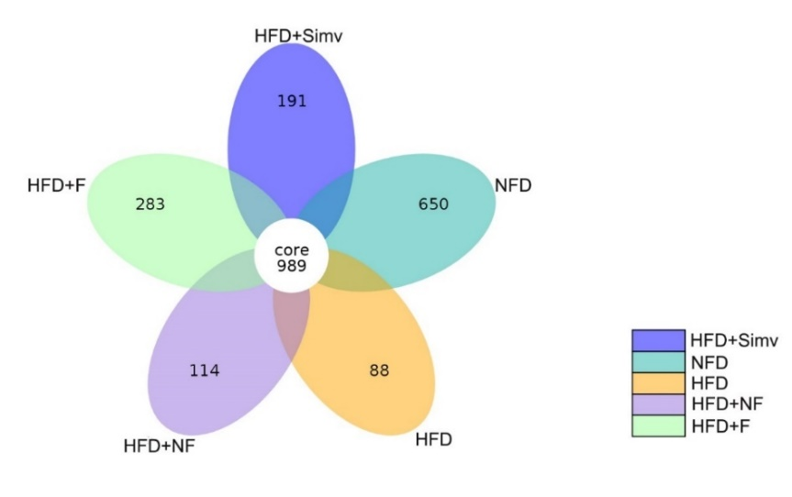Figure S2 The petal diagram of intestinal flora in mice.
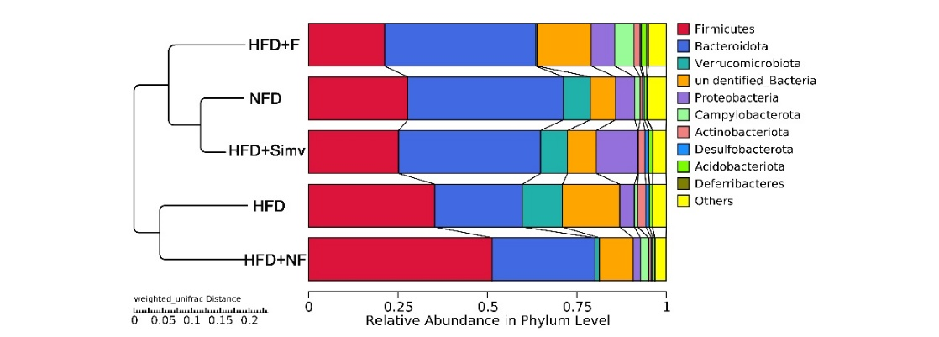Figure S3 The UPGMA clustering tree of intestinal flora at the phylum level.

