Kuroshio-Oyashio Extension Sea Surface Temperature Variability as a Precursor for Winter California Precipitation

Iris Badezet-Delory¹, Youngji Joh², Thomas L. Delworth², Emanuele Di Lorenzo³, Nathaniel C. Johnson²

¹Department of Physics, University of Chicago, IL, USA
²NOAA/OAR/Geophysical Fluid Dynamics Laboratory; Princeton, NJ, USA
³Department of Earth, Environmental, and Planetary Science, Brown University, Providence, RI, USA

Manuscript will be submitted to npj Climate and Atmospheric science

Corresponding authors: Iris Badezet-Delory (irisbd@uchicago.edu) and Youngji Joh (youngji.joh@noaa.gov)

Figure S1: Temporal evolution of the relationships between JFM California precipitation and Eastern Pacific ENSO indices. (top) 40-year moving regression coefficients (solid; mm d⁻¹ per standard deviation of the index) of JFM California precipitation onto the preceding OND EP-ENSO index (blue) and OND E-index (orange), with the corresponding linear trends (dashed); trend magnitudes and Monte Carlo p-values are indicated. (bottom) Monte Carlo null distributions (n = 10,000) of trends in the moving regression coefficients shown in (top) under a stationary AR(1) null hypothesis, for EP-ENSO (blue) and the E-index (orange), with the observed trends (solid vertical lines) and their negatives (dashed vertical lines) indicated.
Figure S2: Temporal evolution of the KOE–California precipitation relationship. (top) 40-year moving regression coefficients (solid; mm d⁻¹ per standard deviation of the index) of the ENSO-removed JFM California precipitation index onto the preceding SON KOE precursor index, with the linear trend (dashed); the trend magnitude and Monte Carlo p-value are indicated. (bottom) Monte Carlo null distribution (blue histogram; n = 10,000) of trends in the moving regression coefficient under a stationary AR(1) null hypothesis, with the observed trend (solid blue line) and its negative (dashed blue line) indicated.

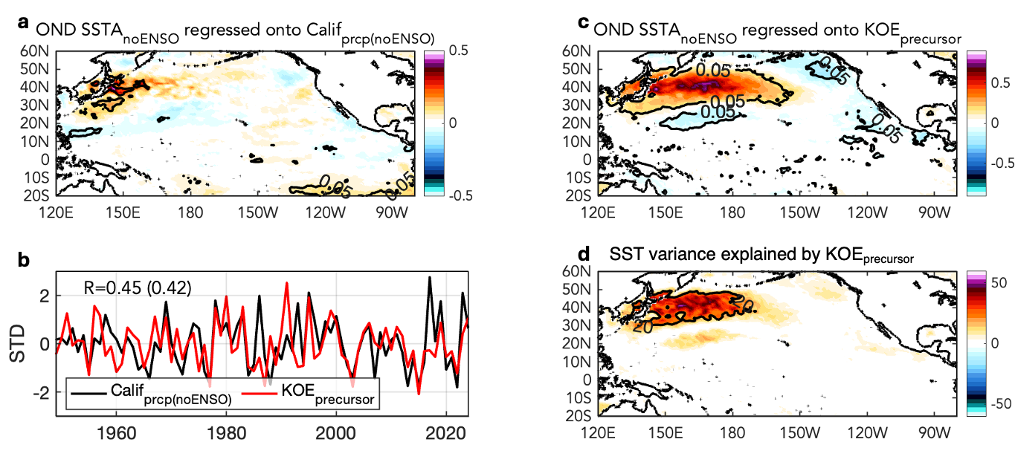
Figure S3: Identified preceding October-to-December ENSO-independent KOE SST precursor for JFM California precipitation. (a) Regression of preceding October-December (OND-1) SST anomalies (°C), with tropical forcing removed (see Methods), onto the ENSO-independent JFM California precipitation. (b) Comparison of the standardized timeseries of the ENSO-removed JFM California precipitation (black line) and the high-pass-filtered OND KOE precursor index (red line; cut off of 40 years). The correlation between the two-time series is shown in the upper-left corner, with the correlation using the non-high-pass-filtered KOE precursor in parentheses. (c) Regression of OND SST anomalies (°C), with tropical forcing removed, onto the identified KOE precursor in (b). (d) Fraction of variance (%) of OND SST anomalies (with ENSO removed) explained by the KOE precursor index. For panels (a) and (c), the contour indicates regions where regression coefficients are statistically significant at the 5% level. For panel (d), the contour indicates regions where the KOE index explains 20% of the SST variance.

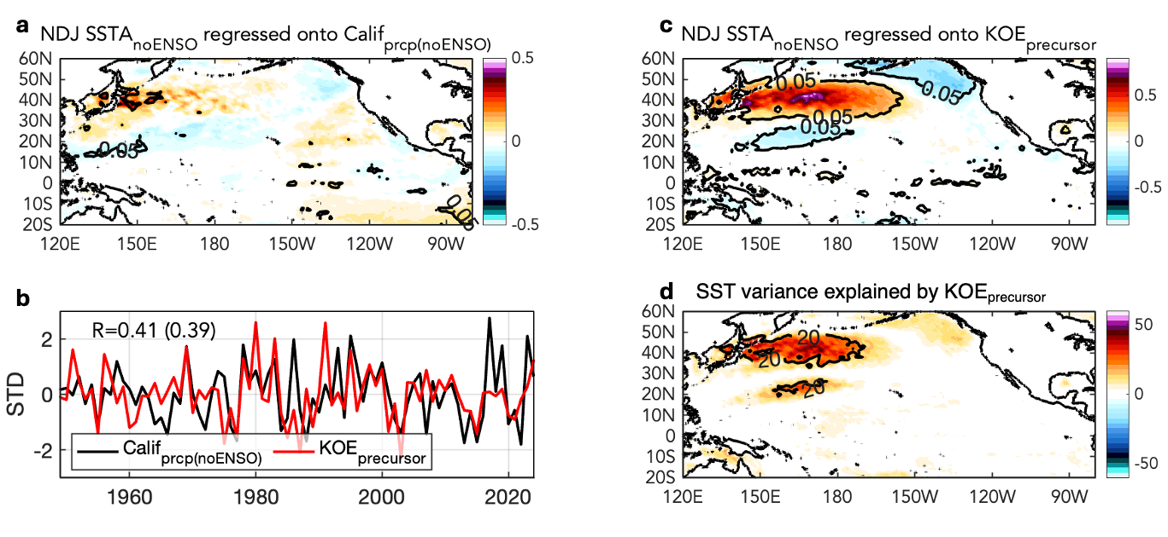
Figure S4: Identified preceding November-to-January ENSO-independent KOE SST precursor for JFM California precipitation. (a) Regression of preceding November-January (NDJ) SST anomalies (ºC), with tropical forcing removed (see Methods), onto the ENSO-independent JFM California precipitation. (b) Comparison of the standardized timeseries of the ENSO-removed JFM California precipitation (black line) and the high-pass-filtered NDJ KOE precursor index (red line; cut off of 40 years). The correlation between the two-time series is shown in the upper-left corner, with the correlation using the non-high-pass-filtered KOE precursor in parentheses. (c) Regression of NDJ SST anomalies (ºC), with tropical forcing removed, onto the identified KOE precursor in (b). (d) Fraction of variance (%) of NDJ SST anomalies (with ENSO removed) explained by the KOE precursor index. For panels (a) and (c), the contour indicates regions where regression coefficients are statistically significant at the 5% level. For panel (d), the contour indicates regions where the KOE index explains 20% of the SST variance.

Figure S5: Cross-validation performance of the multilinear regression framework. Distributions of cross-validated (a) correlation coefficient (R), (b) skill score, defined as one minus the ratio of the mean squared error to the variance of the target, and (c) root mean square error (RMSE, σ-normalized), from repeated 5-fold cross-validation of the multilinear regression model used to predict the JFM California precipitation index. The full time series is randomly partitioned into five non-overlapping folds, with each fold held out once as a validation set and the remaining four used for training; this procedure is repeated 10,000 times using independent random partitions. Blue histograms show the skill obtained when the reconstruction fitted over the full record is used as a single predictor; because its coefficients are estimated using all years, this provides an optimistic upper bound rather than a true out-of-sample estimate. Red histograms show the skill obtained when the OND E-index and SON KOE precursor index are used directly as predictors, with regression coefficients re-estimated within each training set, which is the appropriate out-of-sample benchmark. Vertical lines indicate the median across cross-validation iterations. All time series are linearly detrended and standardized prior to cross-validation.

Figure S6: Identified preceding SON ENSO-independent KOE SST precursor for JFM California precipitation from SPEAR_HI_25. (a) Regression of preceding SON SST anomalies (°C), with tropical forcing removed (see Methods), onto the ENSO-independent JFM California precipitation index. (b) Comparison of the standardized time series of the ENSO-removed JFM California precipitation (black line) and the high-pass-filtered SON KOE precursor index (red line; 40-year cutoff). The KOE precursor index is constructed following the same procedure as in the observations (see Methods). The correlation between the two time series is shown in the upper-left corner, with the correlation using the non-high-pass-filtered KOE precursor in parentheses. (c) Regression of SON SST anomalies (°C), with tropical forcing removed, onto the KOE precursor index in (b). (d) Fraction of total SON SST variance (%) explained by the KOE precursor index. For panels (a) and (c), contours indicate regions where regression coefficients are statistically significant at the 5% level. For panel (d), contours indicate regions where the KOE index explains 20% of the SST variance.

Figure S7. Regression of JFM precipitation anomalies onto the SON KOE precursor and the OND E-index. (Left) Regression of JFM precipitation anomalies (mm d⁻¹ per standard deviation of the index) onto the standardized SON KOE precursor index over North America, with the same field zoomed in over the western United States. (Right) As in (Left), but for the standardized OND E-index. Red boxes indicate the domain shown in the corresponding zoomed-in panels.

Figure S8: Seasonal precipitation variability over California from ERA5 data. Spatial distribution of the standard deviation of seasonal precipitation anomalies over California for (a) January-March (JFM), (b) April-June (AMJ), (c) July-September (JAS), and (d) October-December (OND) during the observational analysis period. The blue outline denotes the California state boundary.

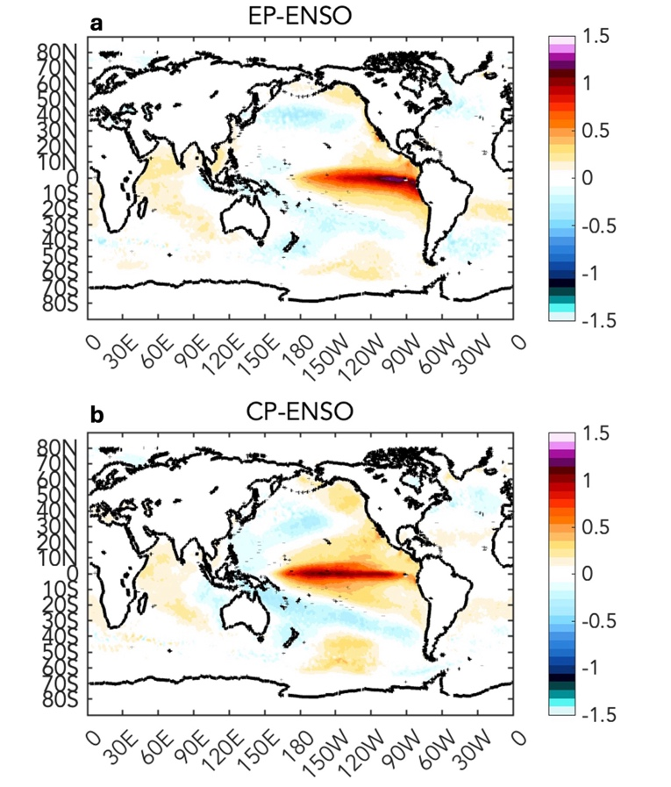
Figure S9: Spatial patterns of the E- and C-indices of Takahashi et al. (2011). (a, b) Regression of October–December (OND) ERA5 sea surface temperature anomalies onto the standardized OND E-index (a) and C-index (b) over 1940–2024 (°C per standard deviation of the index). The indices are defined as E = (PC1 − PC2)/√2 and C = (PC1 + PC2)/√2, where PC1 and PC2 are the leading two principal components of OND SST anomalies over the equatorial Pacific (120°E–70°W, 12.5°S–12.5°N).

Mode | KOE Correlation | p-value from AR(1) Monte-Carlo | Shared variance (R²)
Pacific Decadal Oscillation (PDO) | -0.376 | 0.0001 | 14.1%
Victoria Mode | 0.309 | 0.0045 | 9.5%
North Pacific Mode | 0.239 | 0.0241 | 5.7%
Pacific Meridional Mode | -0.088 | 0.412 | 0.8%
NPGO | -0.103 | 0.369 | 1.1%

Table S1: Relationship between the KOE SST precursor and major Pacific climate modes. Correlation coefficients and the corresponding fraction of shared variance (R²) are reported between the SON KOE SST index and concurrent SON indices of the Pacific Decadal Oscillation (PDO), Victoria Mode (VM), North Pacific Mode (NPM), Pacific Meridional Mode (PMM), and North Pacific Gyre Oscillation (NPGO). Statistical significance is assessed using an AR(1) Monte Carlo test that accounts for autocorrelation in both time series. Correlations are computed over the longest period common to each pair of indices (1950-2023, except NPGO, 1993-2023).

