Supplementary Section

Table S1. Compounds in the m/z 191 and m/z 217 mass fragmentograms
Hopanes | Abbreviation
C20 tricyclic terpane | C₂₀
C21 tricyclic terpane | C₂₁
C23 tricyclic terpane | C₂₃
C24 tricyclic terpane | C₂₄
C25 tricyclic terpane | C₂₅
C26 tricyclic terpane | C₂₆
C28 tricyclic terpane | C₂₈
C29 tricyclic terpane | C₂₉
18α(H),21β(H),22,29,30 trisnorhopane | T_{s}
17α(H),21β(H),22,29,30 trisnorhopane | T_{m}
17α(H), 21β(H)-30-norhopane | C₂₉
17α(H),21β(H)-hopane | C₃₀
17α(H), 21β(H)-homohopane (S) | S C₃₁
17α(H),21β(H)-homohopane (R) | R C₃₁
17α(H), 21β(H) bishomopane (S) | S C₃₂
17α(H), 21β(H)-bishomopane (R) | R C₃₂
17α(H), 21β(H)-trishomohopane (S) | S C₃₃
17α(H),21β(H)-trishomohopane (R) | R C₃₃
17α(H), 21β(H)-tetrakishomohopane (S) | S C₃₄
17α(H),21β(H)-tetrakishomohopane (R) | R C₃₄
Steranes
C27 5α(H),14β(H),17β(H)-cholestane (20R) | R C₂₇
C27 5α(H),14β(H),17βH)-cholestane (20S) | S C₂₇
C28 5α(H),14β(H),17β(H)-ergostane (20R) | R C₂₈
C28 5α(H),14β(H),17β(H)-ergostane (20S) | S C₂₈
C29 5α(H),14β(H),17β(H) stigmastane (20R) | R C₂₉
C29 5α(H),14β(H),17β(H)-stigmastane (20S) | S C₂₉

Table S2. Parameters used in the incremental lifetime cancer risk assessment
Exposure variable | Unit | Child | Adult | Reference
Dust ingestion rate (IR_{ingestion}) | mg day⁻¹ | 200 | 100 | US EPA (2011)
Skin adherence factor (AF) | mg cm⁻¹ | 0.2 | 0.07 | US EPA (2011)
Dermal exposure area (SA) | cm² day⁻¹ | 2800 | 5700 | US EPA (2011)
Exposure frequency (EF) | day year⁻¹ | 180 | 180 | Gope et al., 2018
Exposure duration (ED) | year | 6 | 24 | US EPA (2011)
Body weight (BW) | kg | 15 | 61.5 | Soltani et al., 2015
Average life span (AT) | day | 25550 | 25550 | Gope et al., 2018
Dermal adsorption fraction (ABS) | Unitless | 0.13 | 0.13 | US EPA (2011)
Inhalation rate (IR_{inhalation}) | m³ day⁻¹ | 10 | 20 | Soltani et al., 2015
Particle emission factor (PEF) | m³ kg⁻¹ | 1.36 × 10⁹ | 1.36 × 10⁹ | US EPA (2011)
CSF ingestion | mg kg⁻¹day⁻¹ | 7.3 | 7.3 | Gope et al., 2018
CSF inhalation | mg kg⁻¹day⁻¹ | 3.85 | 3.85 | Gope et al., 2018
CSF dermal | mg kg⁻¹day⁻¹ | 25 | 25 | Gope et al., 2018

Table S3. Diagnostic ratios and indices of n-alkanes, hopanes and steranes in deposited dust of Mashhad, Iran.
 | ∑n-alkane-DR |  |  |  | Hopane-DR |  |  |  |  | Sterane-DR
 | CPI | U:R | Pr:Ph | WNA% | C₂₉/C₃₀ | T_{S}/T_{S}+T_{m} | Homohopane index | Bishomohopane index | C₃₁-₃₅/C₃₀ | C₂₉αββ/(C₂₇αββ+C₂₈αββ) | C₂₈αββ/(C₂₇αββ+C₂₉αββ)
S1 | 0.83 | 7.71 | 0.57 | 3.70 | 0.54 | 0.52 | 0.42 | 0.55 | 2.79 | 1.37 | 0.29
S2 | 0.97 | 8.45 | 0.67 | 5.71 | 0.48 | 0.52 | 0.46 | 0.53 | 2.61 | 1.31 | 0.28
S3 | 0.95 | 6.13 | 0.36 | 6.13 | 0.44 | 0.51 | 0.54 | 0.54 | 2.23 | 1.10 | 0.30
S4 | 0.97 | 4.24 | 0.75 | 3.76 | 0.43 | 0.52 | 0.46 | 0.55 | 2.18 | 1.11 | 0.31
S5 | 0.94 | 5.44 | 0.43 | 9.58 | 0.35 | 0.66 | 0.51 | 0.54 | 2.39 | 1.15 | 0.25
S6 | 0.86 | 4.27 | 0.58 | 6.97 | 0.33 | 0.63 | 0.54 | 0.56 | 2.34 | 1.13 | 0.26
S7 | 0.73 | 5.98 | 0.30 | 6.40 | 0.30 | 0.55 | 0.58 | 0.57 | 2.00 | 1.00 | 0.28
S8 | 1.75 | 2.35 | 0.53 | 7.52 | 0.38 | 0.70 | 0.68 | 0.61 | 1.82 | 0.77 | 0.31
S9 | 0.96 | 5.70 | 0.75 | 11.06 | 0.40 | 0.61 | 0.49 | 0.55 | 2.49 | 1.22 | 0.26
S10 | 0.69 | 4.21 | 0.66 | 7.12 | 0.37 | 0.56 | 0.58 | 0.61 | 2.38 | 1.12 | 0.28
S11 | 0.83 | 3.24 | 0.51 | 10.39 | 0.39 | 0.59 | 0.71 | 0.56 | 2.13 | 0.94 | 0.27
S12 | 0.73 | 3.27 | 0.69 | 6.96 | 0.34 | 0.74 | 0.56 | 0.59 | 2.09 | 0.92 | 0.27
S13 | 1.59 | 2.44 | 0.34 | 9.08 | 0.45 | 0.69 | 0.70 | 0.50 | 2.14 | 1.02 | 0.24
S14 | 0.76 | 3.43 | 0.31 | 6.47 | 0.38 | 0.73 | 0.60 | 0.48 | 2.23 | 0.88 | 0.29
S15 | 0.72 | 4.73 | 0.53 | 7.06 | 0.29 | 0.66 | 0.57 | 0.60 | 1.86 | 0.90 | 0.29
S16 | 0.89 | 4.01 | 0.46 | 8.98 | 0.29 | 0.66 | 0.52 | 0.58 | 1.85 | 1.00 | 0.27
S17 | 0.79 | 3.65 | 0.57 | 6.73 | 0.31 | 0.67 | 0.53 | 0.60 | 2.11 | 0.84 | 0.29
S18 | 0.79 | 2.57 | 0.53 | 8.11 | 0.33 | 0.43 | 0.77 | 0.53 | 1.74 | 0.93 | 0.30
S19 | 1.16 | 4.92 | 0.63 | 7.63 | 0.34 | 0.38 | 0.48 | 0.34 | 1.44 | 0.82 | 0.29
S20 | 0.94 | 5.10 | 0.63 | 9.33 | 0.31 | 0.54 | 0.61 | 0.48 | 1.58 | 0.83 | 0.27
S21 | 0.92 | 2.39 | 0.52 | 8.67 | 0.33 | 0.57 | 0.71 | 0.51 | 1.76 | 1.01 | 0.30
S22 | 0.86 | 5.66 | 0.64 | 6.74 | 0.33 | 0.52 | 0.60 | 0.62 | 2.07 | 0.84 | 0.25
S23 | 0.90 | 2.16 | 0.61 | 13.02 | 0.28 | 0.53 | 0.75 | 0.47 | 1.70 | 0.94 | 0.30
S24 | 0.84 | 5.28 | 0.41 | 8.68 | 0.36 | 0.60 | 0.58 | 0.59 | 2.00 | 0.94 | 0.24
S25 | 0.88 | 3.42 | 0.55 | 9.27 | 0.29 | 0.53 | 0.69 | 0.44 | 1.83 | 1.02 | 0.26
S26 | 1.05 | 5.62 | 0.66 | 8.45 | 0.33 | 0.55 | 0.63 | 0.54 | 2.10 | 1.00 | 0.26
S27 | 1.77 | 4.98 | 0.50 | 6.08 | 0.37 | 0.58 | 0.70 | 0.53 | 2.18 | 0.99 | 0.27
S28 | 0.99 | 5.20 | 0.49 | 5.70 | 0.33 | 0.58 | 0.62 | 0.57 | 2.08 | 1.29 | 0.25
S29 | 0.85 | 3.79 | 0.62 | 9.04 | 0.38 | 0.46 | 0.55 | 0.46 | 2.40 | 1.09 | 0.28
S30 | 0.67 | 3.12 | 0.39 | 7.32 | 0.37 | 0.54 | 0.59 | 0.55 | 2.23 | 1.15 | 0.33
S31 | 0.79 | 4.44 | 0.58 | 7.12 | 0.57 | 0.42 | 0.58 | 0.58 | 2.48 | 1.07 | 0.29
S32 | 0.74 | 2.46 | 0.54 | 6.79 | 0.42 | 0.46 | 0.66 | 0.54 | 2.23 | 1.09 | 0.32
S33 | 0.78 | 5.30 | 0.64 | 6.89 | 0.60 | 0.57 | 0.57 | 0.58 | 2.54 | 1.33 | 0.26
S34 | 0.97 | 2.60 | 0.67 | 8.68 | 0.47 | 0.45 | 0.61 | 0.52 | 2.72 | 0.85 | 0.35
S35 | 0.80 | 2.24 | 0.82 | 9.04 | 0.48 | 0.38 | 0.75 | 0.57 | 1.85 | 1.04 | 0.37
S36 | 0.76 | 5.97 | 0.32 | 7.45 | 0.76 | 0.54 | 0.54 | 0.59 | 2.53 | 1.11 | 0.33
S37 | 0.70 | 8.39 | 0.56 | 6.54 | 0.66 | 0.57 | 0.54 | 0.58 | 2.63 | 1.08 | 0.33
S38 | 0.78 | 3.58 | 0.76 | 7.12 | 0.46 | 0.35 | 0.64 | 0.59 | 2.21 | 1.12 | 0.32
S39 | 0.83 | 3.69 | 0.51 | 8.18 | 0.58 | 0.57 | 0.54 | 0.57 | 2.53 | 0.91 | 0.32
S40 | 0.73 | 4.39 | 0.64 | 8.83 | 0.29 | 0.72 | 0.46 | 0.72 | 2.00 | 0.95 | 0.28

Table S4. Comparison of n-alkanes DRs in Mashhad deposited dust with PM and street dust of other cities in the world.
Urban locations | Sample type | CPI | U:R | %WNA | Reference
Mashhad, Iran | deposited dust | 0.84 - 1.52 | 2.16 – 8.45 | 3.7 – 11.6 | This study
Doha, Qatar | PM | 1.71 – 23.9 |  | 10.32–94.74 | Javad et al. 2019 (Javed et al., 2019)
Braga. Portugal | street dust | 1.11 ± 0.45 |  |  | Alves et al. 2018 (Alves et al., 2018)
Oporto and Coimbra, Portugal | PM | 1.37 – 1.57 | 1.34 – 1.62 | 19.1- 25.4 | Alves et al. 2014 (Alves et al., 2014)
Tehran, Iran | PM | 0.17 – 0.88 | 0.48 – 1.96 | 0.12 – 3.14 | Moeinaddini et al. 2014 (Moeinaddini et al., 2014)
Singapore | street dust | 0.8 ± 0.02 |  | 6.43 | Zhang et al. 2017 (Zhang et al., 2017)
Guangzhou, China | PM | 1.0 – 1.4 | 6.2 – 13.2 | 5.2–19.4 | Bi et al. 2002 (Wang et al., 2006)
Eight cities, Egypt | street dust | 0.99 – 2.12 | 0.48 – 4.10 |  | Mostafa et al. 2009 (Mostafa et al., 2009)
Kuala Lumpur, Malaysia | road dust | 1.82 |  | 29.29 | Omar et al. 2007 (Omar et al., 2007)
Athens, Greece | PM | 1.84 | 25.25 | 25.15 | Andreou et al. 2008 (Andreou et al., 2008)
Santiago, Chile | PM | 1.18 | 68 |  | Didyk et al. 2000 (Didyk et al., 2000)
Taipei, Taiwan | PM | 0.9 – 1.9 | 2.6 – 9.4 | 9 - 31 | Young &Wang 2002 (Young & Wang, 2002)
Delhi, India | PM | 1.6 – 2.3 | 8.9 – 14.3 | 22.6 – 41.2 | Yadav et al. 2013 (Yadav et al., 2013)

Table S5. Comparison of hopanes and steranes DRs in Mashhad deposited dust with other cities in the world.
Urban locations | Homehopane index | Bishomohopane index | C31-C35/C30 | Sterane  C28αββ/C27αββ+C29αββ | Sterane  C29αββ/C27 αββ+C28 αββ | Reference
Mashhad, Iran | 0.42 – 0.77 | 0.34 – 0.72 | 1.44 – 2.79 | 0.34 – 0.55 | 0.44 – 0.96 | This study
Singapore | 0.75 ± 0.02 | 0.77 ± 0.02 | 2.47 – 2.75 | - | - | Zhang et al. 2017 (Zhang et al., 2017)
Kuala Lumpur, Malaysia | 389 | - | - | - | - | Omar et al. 2007 (Omar et al., 2007)
Anzali, South of Caspian Sea | 0.41 – 0.74 | - | 1.11 – 5.29 | 0.11 – 0.41 | 0.41 – 1.83 | Azimi et al. 2018 (Azimi et al., 2018)
Doha, Qatar | 0.44 – 0.60 | 0.52 – 0.80 | - | 0.35 – 0.61 | 0.44 – 0.77 | Javad et al. 2019 (Javed et al., 2019)
Peninsular, Malaysia | - | - | 1.12 – 2.60 | - | - | Bahry et al. 2009 (Bahry et al., 2009)
Oporto and Coimbra, Portugal | 0.54 – 0.56 | 0.59 | - | - | - | Alves et al. 2014 (Alves et al., 2014)

Table S6 . Comparison of 16PAHs in Mashhad deposited dust (*) with street dusts (**) from other cities in the world (μg kg⁻¹).

City | Minimum | Maximum | Mean |  |  | Reference
Mashhad (Iran)* | 643.26 | 1580.79 |  | 945.80 | This study
Mashhad (Iran)** | 764 | 8986.7 |  | 2183.45 | (Najmeddin et al., 2018)
Ahvaz (Iran) ** | 49.3 | 16645 |  | 1031.5 | (Najmeddin & Keshavarzi, 2019)
Bandar Abbas (Iran) ** | 73.8 | 1339 |  | 362.33 | (Keshavarzi et al., 2018)
Kerman (Iran) ** | 165 | 5314.5 |  | 770.8 | (Abbasnejad et al., 2019)
Mahshahr (Iran) ** | 161 | 1996 |  | 769.6 | (Rastegari Mehr et al., 2016)
Isfahan (Iran) ** | 184.64 | 3221.72 |  | 1074.6 | (Soltani et al., 2015)
Tehran (Iran) ** | 130 | 1410 |  | 330 | (Saeedi et al., 2012)
Bushehr (Iran) ** | 73.6 | 9491 |  | 1116 | (Keshavarzi et al., 2020)
Lanzhou (China) ** | 1240 | 10,700 |  | 3900 | (Jiang et al., 2014)
Guangzhou (China) ** | 840 | 12,300 |  | 4800 | (Wang et al., 2011)
Cairo (Egypt) ** | 45 | 2610 |  | - | (Hassanien & Abdel-Latif, 2008)
Ulsan (Korea) ** | 112130 | 45750 |  | - | (Dong & Lee, 2009)
Newcastle (UK) ** | 590 | 46,000 |  | - | (Lorenzi et al., 2011)

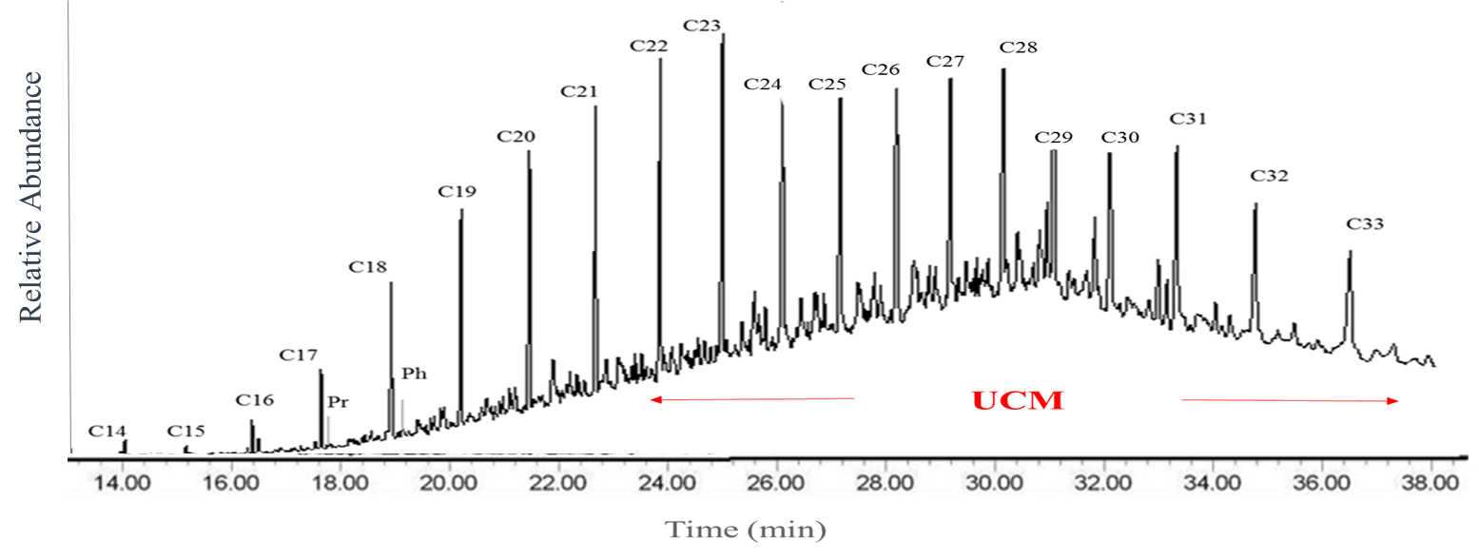
Fig. S1. GC–MS chromatograms of aliphatic hydrocarbons in deposited dust of Mashhad in the Northeast of Iran.

a. 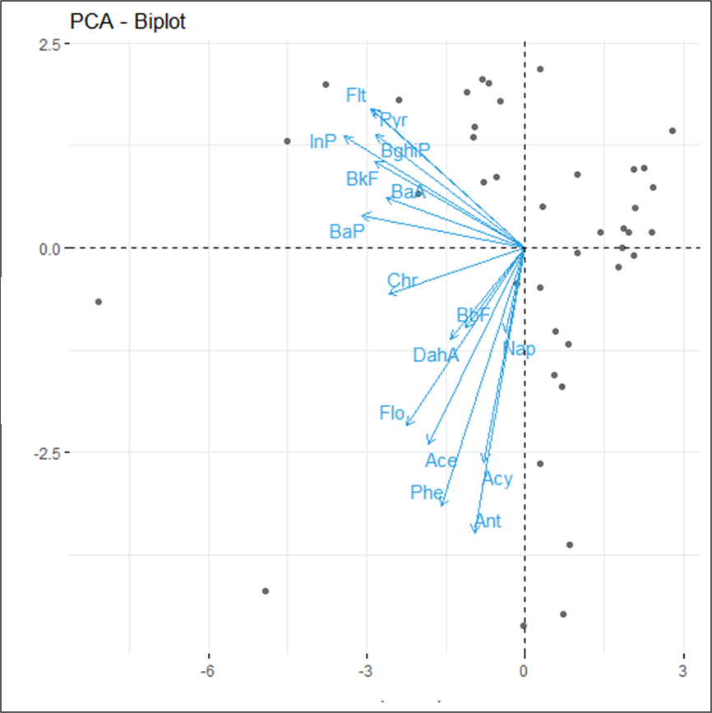
b.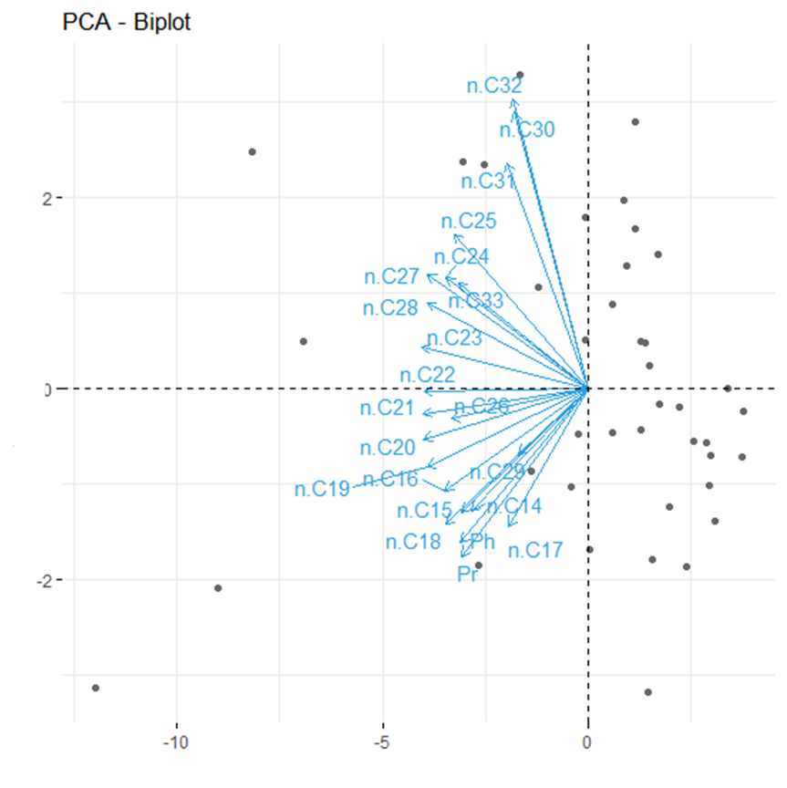

Fig. S2. PCA results of PAHs (a) and n-alkanes (b) in the analysis of deposited dust of Mashhad, Northeast Iran, PC1 vs PC2.

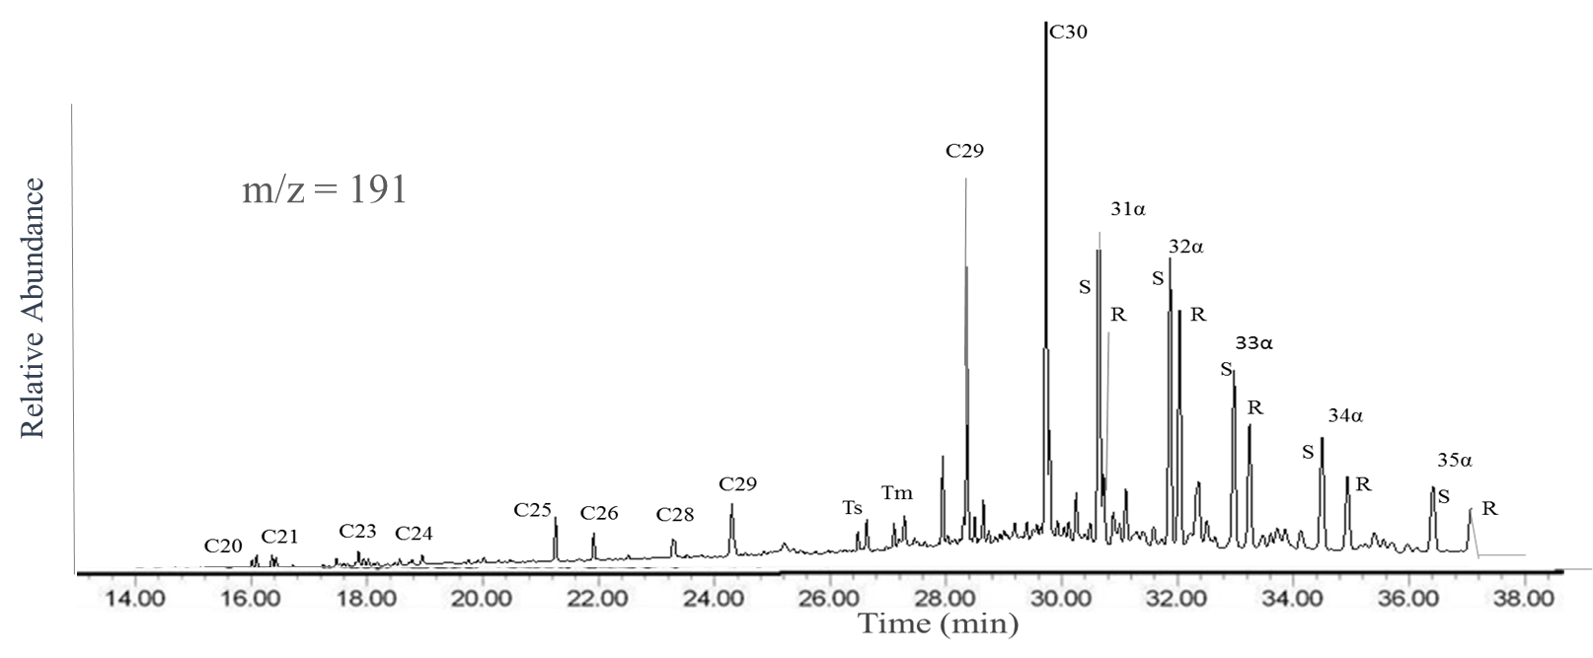

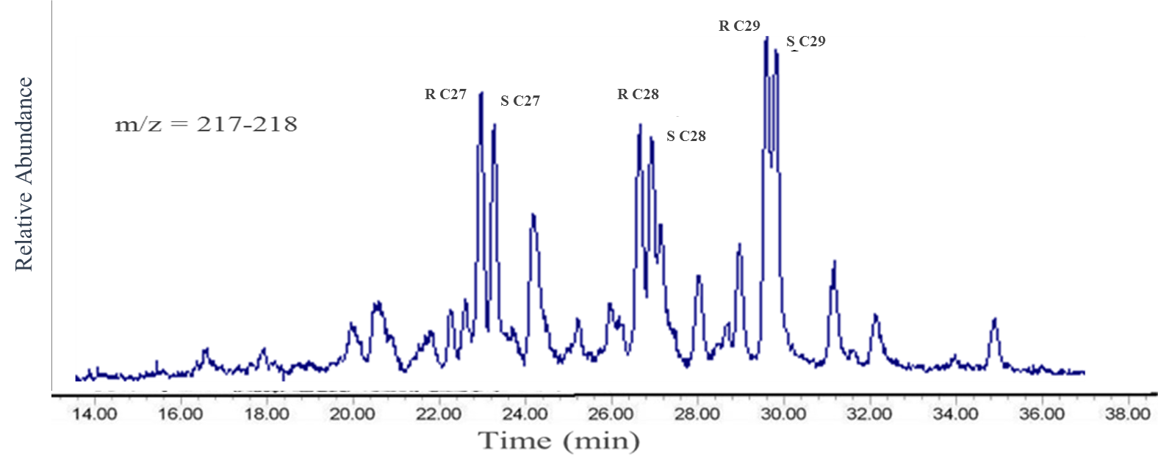
Fig. S3. Mass fragmentograms of m/z 191 (hopanes) and m/z 217-218 (steranes) for representative deposited dust of Mashhad in the Northeast of Iran.

