Supplementary Materials
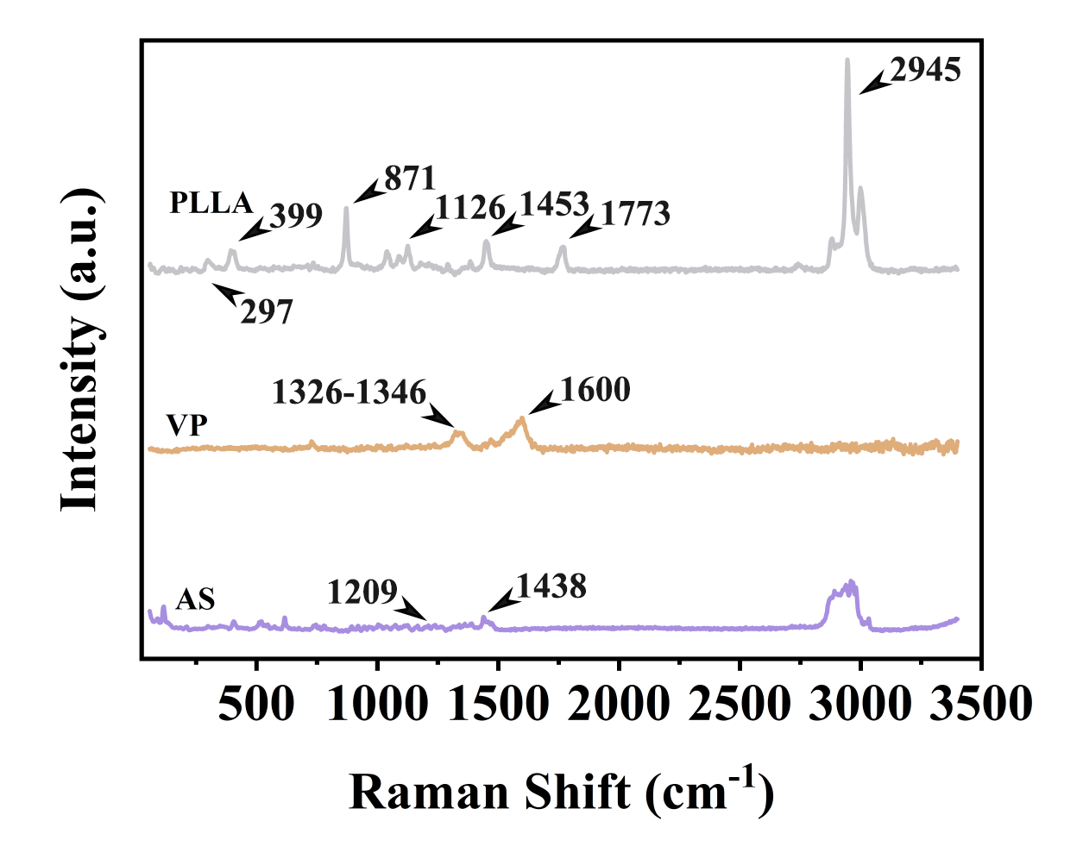
Figure S1. Raman spectra of PLLA particals VP and AS powders.
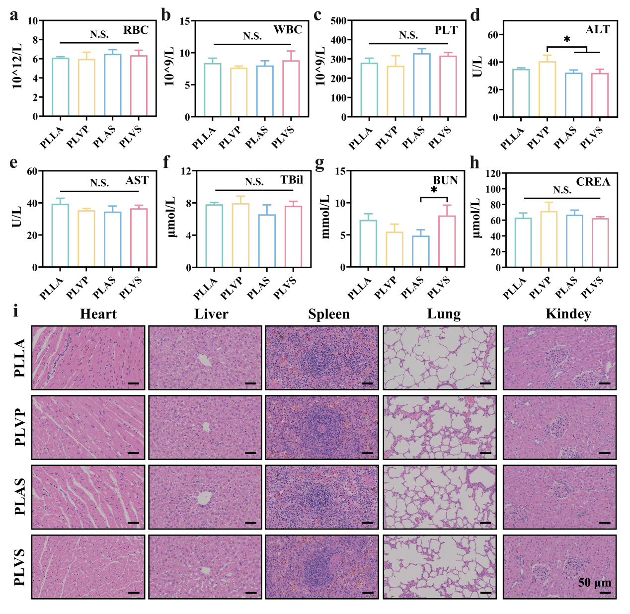
Figure S2. Biosafety validation in vivo. (a-c) Routine blood parameters including RBC, WBC and PLT. (d-h) Hepatic and renal biochemical indicators including ALT, AST, TBil, BUN and CREA. (i) H&E staining of major visceral organs, including heart, liver, spleen, lung and kidney, scale bar = 50 μm. Statistical significance: *P < 0.05; N.S., not significant.

