Estimating the sleep period time window based on a hip-worn accelerometer collected in children and adults.
Jairo H Migueles^{1,2}, Vincent T van Hees³, Michael J Stein⁴, Michael F Leitzmann⁴, Hansjoerg Baurecht⁴, and Claas Lendt^{4,5}
¹ Department of Physical Education and Sports, Faculty of Sport Sciences, Sport and Health University Research Institute (iMUDS), University of Granada, Granada, Spain.
² Department of Global Public Health, Karolinska Institutet, Stockholm, Sweden.
³ Accelting, Almere, The Netherlands.
⁴ Department of Epidemiology and Preventive Medicine, University of Regensburg, Regensburg, Germany
⁵ Sports Performance Research Institute New Zealand, School of Sport and Recreation, Auckland University of Technology, New Zealand

Supplementary Material

3-fold nested cross-validation of hyperparameters for HDCZA
Table S1: Root Mean Square Error (RMSE) results across nested cross-validation folds for each hyperparameter bound set tested in the HDCZA algorithm. The bound set with the lowest aggregated RMSE (mean × standard deviation) is highlighted in grey.
Fold | Bound Set | RMSE | HDCZA_threshold | spt_min_block_dur | spt_max_gap_dur | spt_max_gap_ratio
1 | 1 | 1.094 | 0.402 | 24 | 39 | 0.091
2 | 1 | 0.966 | 0.249 | 35 | 54 | 0.314
3 | 1 | 0.909 | 0.275 | 29 | 44 | 0.278
1 | 2 | 1.035 | 0.250 | 60 | 56 | 0.644
2 | 2 | 0.950 | 0.605 | 60 | 57 | 0.077
3 | 2 | 0.915 | 0.335 | 54 | 59 | 0.347
RMSE: root mean square error.

Confusion Matrices for the Quintile-based Agreement for the SPT duration
Table S2: Confusion matrix for quintile classification of SPT duration (HDCZA vs. reference). Cells show n, row %. Weighted Cohen’s kappa (squared) = 0.556, p <0.001. N = 519.
Reference quintile | Q1 | Q2 | Q3 | Q4 | Q5
Q1 | 53, 50.0% | 24, 22.6% | 17, 16.0% | 2, 1.9% | 10, 9.4%
Q2 | 10, 10.2% | 45, 45.9% | 23, 23.5% | 7, 7.1% | 13, 13.3%
Q3 | 10, 9.3% | 9, 8.3% | 52, 48.1% | 17, 15.7% | 20, 18.5%
Q4 | 8, 7.8% | 3, 2.9% | 18, 17.5% | 36, 35.0% | 38, 36.9%
Q5 | 9, 8.7% | 5, 4.8% | 6, 5.8% | 14, 13.5% | 70, 67.3%

Table S3: Confusion matrix for quintile classification of SPT duration (HorAngle vs. reference). Cells show n, row %. Weighted Cohen’s kappa (squared) = 0.575, p <0.001. N = 519.
Reference quintile | Q1 | Q2 | Q3 | Q4 | Q5
Q1 | 56, 56.6% | 31, 31.3% | 5, 5.1% | 3, 3.0% | 4, 4.0%
Q2 | 13, 12.6% | 42, 40.8% | 30, 29.1% | 7, 6.8% | 11, 10.7%
Q3 | 7, 6.5% | 10, 9.3% | 45, 41.7% | 31, 28.7% | 15, 13.9%
Q4 | 9, 8.6% | 7, 6.7% | 10, 9.5% | 40, 38.1% | 39, 37.1%
Q5 | 14, 13.5% | 4, 3.8% | 7, 6.7% | 17, 16.3% | 62, 59.6%

Linear Mixed Models for the Effect of Confounders on Algorithms’ performance
Table S4: Regression summary for the effect of confounders (i.e., age, sex, day type, and non-wear) on the estimation of sleep onset and wake-up time with the HDCZA and the HorAngle algorithms.
 |  | HDCZA |  |  |  | HorAngle
Outcome | Term | Estimate | Std. Error | t Value | P Value | Estimate | Std. Error | t Value | P Value
Sleep Onset | Intercept | -0.133 | 0.197 | -0.674 | 0.501 | 0.168 | 0.173 | 0.972 | 0.333
 | Age group (children) | 0.214 | 0.217 | 0.986 | 0.326 | 0.332 | 0.187 | 1.772 | 0.079
 | Sex (female) | 0.216 | 0.202 | 1.067 | 0.289 | 0.156 | 0.174 | 0.896 | 0.373
 | Weekend day | 0.312 | 0.162 | 1.919 | 0.056 | -0.026 | 0.156 | -0.165 | 0.869
 | Wrist non-wear (low) | -0.262 | 0.260 | -1.008 | 0.314 | -0.412 | 0.247 | -1.665 | 0.096
 | Wrist non-wear (moderate) | 0.110 | 0.398 | 0.277 | 0.782 | -0.323 | 0.377 | -0.856 | 0.392
 | Wrist non-wear (high) | 0.147 | 0.549 | 0.268 | 0.789 | -0.875 | 0.517 | -1.690 | 0.092
 | Hip non-wear (low) | -0.136 | 0.258 | -0.526 | 0.599 | -0.015 | 0.246 | -0.061 | 0.951
 | Hip non-wear (moderate) | -0.320 | 0.385 | -0.831 | 0.406 | -0.207 | 0.367 | -0.564 | 0.573
 | Hip non-wear (high) | -0.447 | 0.520 | -0.859 | 0.391 | -0.049 | 0.491 | -0.099 | 0.921
 | Non-wear mismatch | -0.139 | 0.254 | -0.547 | 0.584 | -0.740 | 0.240 | -3.088 | 0.002 **
Wake-up | Intercept | 0.372 | 0.142 | 2.613 | 0.009 ** | 0.167 | 0.180 | 0.926 | 0.356
 | Age group (children) | -0.366 | 0.151 | -2.420 | 0.016 * | -0.212 | 0.194 | -1.093 | 0.277
 | Sex (female) | -0.419 | 0.139 | -3.024 | 0.003 ** | -0.187 | 0.179 | -1.048 | 0.297
 | Weekend day | 0.163 | 0.145 | 1.128 | 0.260 | -0.035 | 0.172 | -0.205 | 0.838
 | Wrist non-wear (low) | 0.377 | 0.224 | 1.685 | 0.093 | 0.071 | 0.269 | 0.266 | 0.791
 | Wrist non-wear (moderate) | 0.556 | 0.340 | 1.633 | 0.103 | 0.167 | 0.409 | 0.409 | 0.683
 | Wrist non-wear (high) | 0.525 | 0.464 | 1.132 | 0.258 | -1.337 | 0.560 | -2.387 | 0.017 *
 | Hip non-wear (low) | -0.355 | 0.223 | -1.590 | 0.112 | 0.067 | 0.268 | 0.250 | 0.802
 | Hip non-wear (moderate) | -0.848 | 0.334 | -2.542 | 0.011 * | -0.469 | 0.399 | -1.174 | 0.241
 | Hip non-wear (high) | -1.698 | 0.441 | -3.847 | <0.001 *** | -0.057 | 0.532 | -0.107 | 0.915
 | Non-wear mismatch | 0.348 | 0.214 | 1.622 | 0.105 | -0.441 | 0.259 | -1.703 | 0.089

Visualisation of example nights
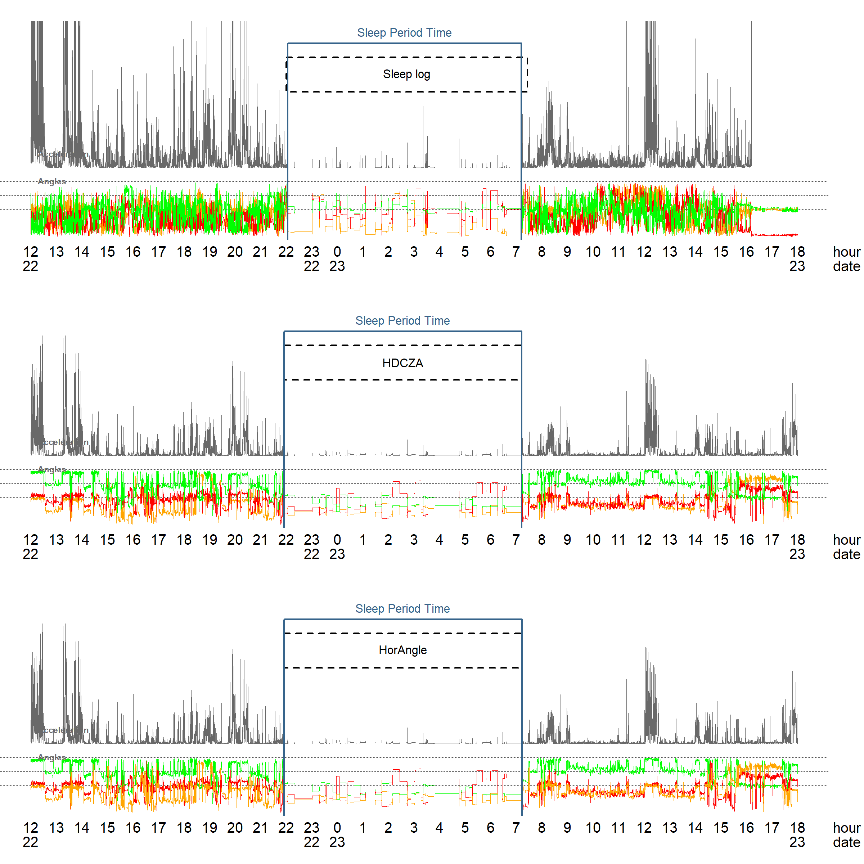
Figure S1: Classification of a example night guided by sleeplog in wrist data, and by HDCZA and HorAngle in hip data. In this example, both algorithms show a similar performance compared to the reference method.
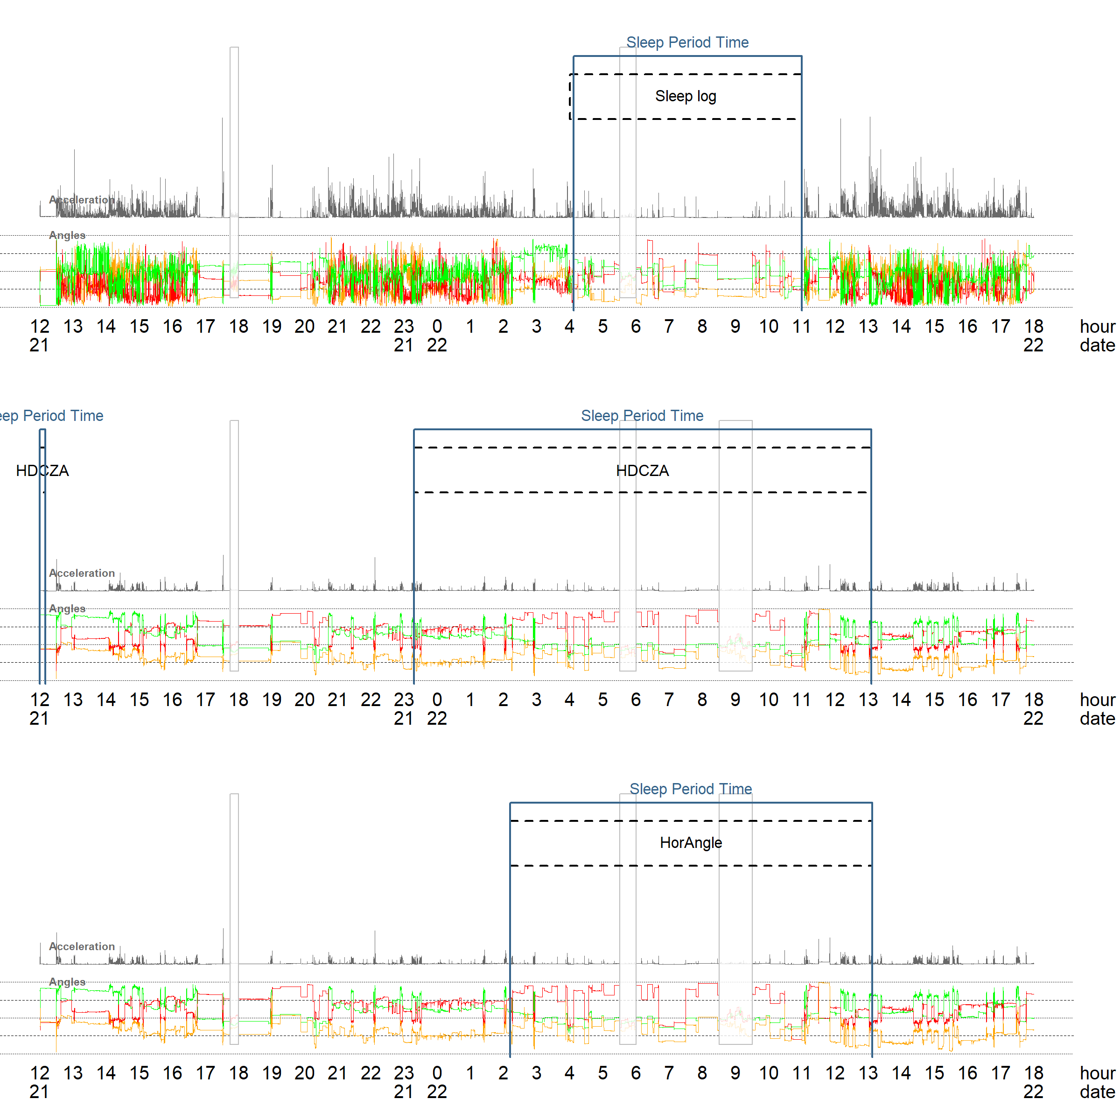
Figure S2: Classification of an example night guided by sleeplog in wrist data, and by HDCZA and HorAngle in hip data. In this example the HorAngle estimates are closer to the reference method than the HDCZA algorithm.
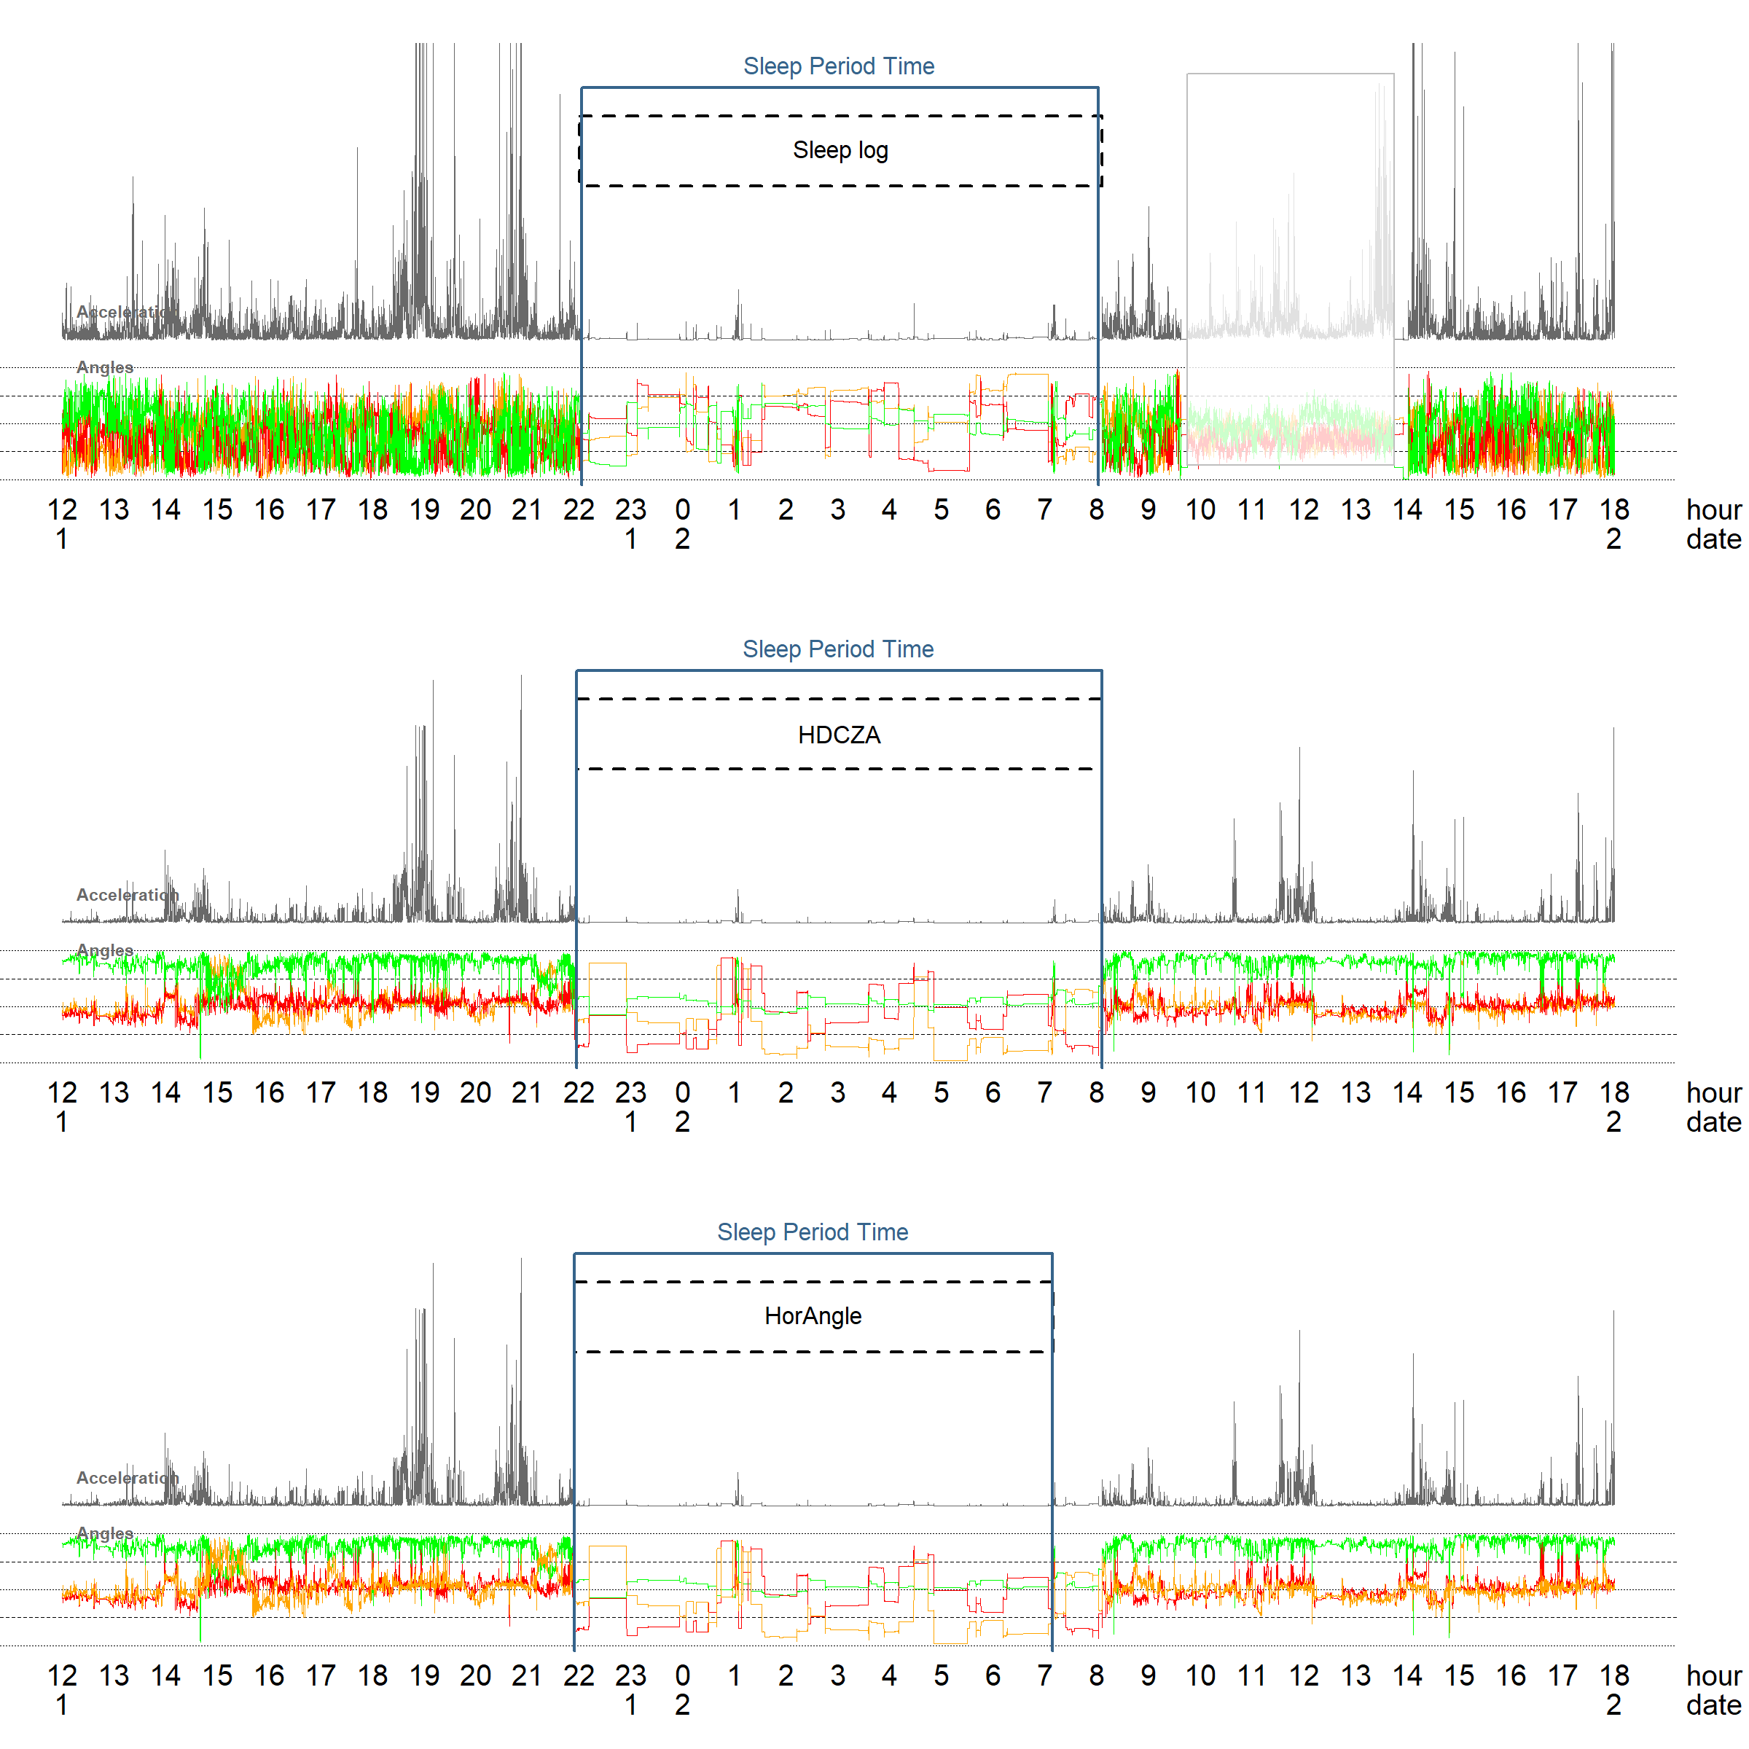
Figure S3: Classification of a example night guided by sleeplog in wrist data, and by HDCZA and HorAngle in hip data. In this example the HorAngle estimates wakeup time earlier than the reference method, while HDCZA seems to agree better with the reference method.

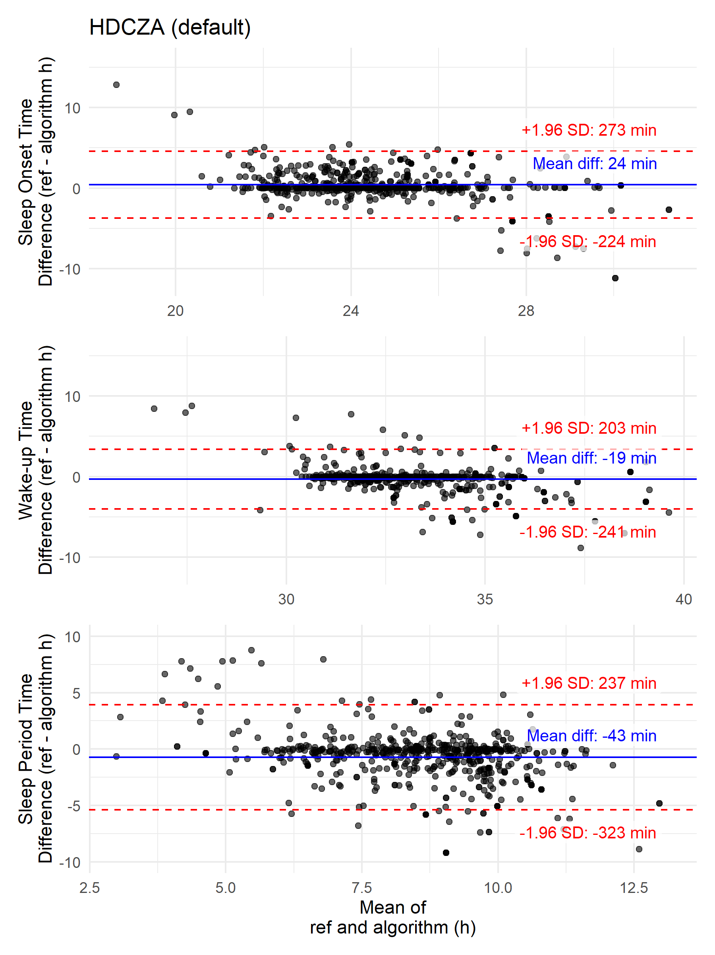
Figure S4: Bland Altman plots for the comparison of default HDCZA estimated sleep onset time, wake-up time, and SPT with reference values.

GGIR example calls applying the optimised parameters
# HDCZA optimised parameters
GGIR(
# SPT algorithm specification
HASPT.algo = "HDCZA",
# settings to ensure that guider window is the final SPT window
HASIB.algo = "vanHees2015",
anglethreshold = 100,
timethreshold = 1,
sib_must_fully_overlap_with_TimeInBed = c(FALSE, FALSE),
relyonguider = TRUE,
# Optimised parameters
HDCZA_threshold = 0.259,
spt_min_block_dur = 34,
spt_max_gap_dur = 52,
spt_max_gap_ratio = 0.282,
)
# HorAngle optimised parameters
GGIR(
# SPT algorithm specification
HASPT.algo = "HorAngle",
sensor.location = "hip",
# settings to ensure that guider window is the final SPT window
HASIB.algo = "vanHees2015",
anglethreshold = 100,
timethreshold = 1,
sib_must_fully_overlap_with_TimeInBed = c(FALSE, FALSE),
relyonguider = TRUE,
# Optimised parameters
HorAngle_threshold = 58,
spt_min_block_dur = 60,
spt_max_gap_dur = 20,
spt_max_gap_ratio = 0.034,
)

