Supplementary Material

1 Methods

1.1 Sample
A total of 247 individuals completed an online screening survey. After prescreening, 79 participants were recruited (39 ASD, 40 CTRL). Of these, 59 participants completed all four testing sessions (27 ASD, 32 CTRL). Fourteen participants dropped out prematurely due to missed or canceled appointments (seven ASD, seven CTRL), corresponding to a dropout rate of 17.72%. Of these, 12 individuals (six ASD, six CTRL) discontinued after the first session, while two participants (one ASD, one CTRL) completed two sessions before dropping out. Data from dropouts was retained for analysis. A total of 258 testing sessions were conducted. Of these, six sessions from six participants were excluded from the analysis: Four participants (three ASD, one CTRL) reported side effects and chose to discontinue, all of whom were female and had received naltrexone. Two male participants in the ASD group were excluded from analysis, one due to low cognitive functioning (IQ = 79) and another due to a positive opiate drug test. Data from an additional four sessions from four participants in the CTRL group was lost due to technical difficulties (malfunctioning of eye-tracking software). This resulted in a final sample of N = 73 (ASD = 34; CTRL = 39) participants across 248 sessions.
ASD participants were not excluded for comorbid disorders or medication intake, but type of disorder and medication were recorded during prescreening. In the ASD group, 23 participants reported comorbid diagnoses, with depression (n = 12) and attention deficit hyperactivity disorder (ADHD; n = 10) most frequently mentioned. Correspondingly, the most common medications included selective serotonin/noradrenaline reuptake inhibitors (SSRIs/SNRIs; n = 19), stimulants (n = 8), and neuroleptics (n = 6). In total, 20 ASD participants reported regular medication use, with the number of medications ranging from one to four per individual.

1.2 Demographics and Questionnaires
Gender was self-reported as male, female, or non-binary. Because only one participant identified as non-binary, analyses involving Sex were restricted to male and female participants; for consistency, we refer to this variable as Sex throughout. A chi-square test of Sex distribution showed no significant difference between groups in the final sample, χ²(1) = 3.51, p = .061 (see Table 1 in main text). Of those participants who completed all sessions, marginally more females were in the ASD group (15 F, 12 M) and more males in the CTRL group (18 M, 14 F). However, this difference was again not significant, χ2(1) = 0.41, p = .52. Ages ranged from 18 to 70 (M = 31.36, SD = 12.10) with a marginal age difference between groups, which was not statistically significant, t(62) = 1.78, p = .080, see Table 1. Verbal IQ, assessed with the Mehrfachwahl-Wortschatz-Intelligenztest [1], was not significantly different between groups, t(54) = 1.45, p = .154. Consistent with ASD diagnoses, significant differences were observed for autism spectrum quotient (AQ) and the social interaction anxiety scale (SIAS) [2]. Scores on the interpersonal reactivity index (IRI) [3] and its subscales were significantly different between groups, except for the “Empathetic Concern” and the “Personal Distress” subscales (see Table 1). Scores on the state-trait anxiety inventory (STAI-t) [4] were significantly different, t(56) = 2.84, p = .006, indicating higher anxiety levels in the ASD group, consistent with individual reports of comorbid generalized anxiety disorder in the ASD group (two mentions). In contrast, despite individual reports of comorbid depression, the group difference for the Beck depression inventory (BDI) [5] was not significant, albeit approaching significance, t(55) = 1.81, p = .075. Generally, more negative and less positive affect was observed in the Positive and Negative Affect Schedule (PANAS) [6] in the ASD group in earlier sessions. This difference appears to have subsided in later sessions.
Sympathy ratings were measured using a questionnaire where participants evaluated the experimenter on four dimensions. One item was used for each dimension. Specifically, participants were asked whether the experimenter seemed to be an interesting, good, kind and open-minded person. Each item was rated on a 7-point scale, ranging from "not at all" to "very much." For use as a control variable in statistical analyses, the mean of these measures over all sessions was used as a measure of sympathy, that is, how sympathetic the experimenter was perceived during the experiment.
To measure autistic traits, a German shortened version of the Autism Spectrum Quotient (AQ-k) (Freitag et al. 2007) was used. The AQ-k contains 33 items (e.g., “I prefer to do things on my own rather than with others.”) and is suitable for adults and adolescents aged 16 years and above with normal intellectual functioning. For screening purposes of ASD in clinical practice, a cut-off of 17 was proposed (Freitag et al. 2007). Items were scored using a binary system, with scores of 0 or 1 for each item, resulting in a maximum score of 33. Higher scores indicate higher levels of autistic traits. Additionally, scores were computed for three subscales, social interaction and spontaneity, imagination, and, communication and reciprocity (Freitag et al. 2008).
Social anxiety was measured using the social interaction anxiety scale (Heimberg et al. 1992). This questionnaire consists of 20 items (e.g., “I feel tense if I am alone with just one other person” or “I have difficulty making eye contact with others”). Items were scored using a 5-point Likert-scale, with a maximum score of 80. Higher scores indicate higher levels of social anxiety. A score of 34 is commonly used as a cutoff suggesting social anxiety disorder (SAD) (Heimberg et al. 1992).
We focused on these two questionnaires in our analyses, as they were most relevant to our research objectives, while other questionnaire measures reported in Table 1 (BDI, STAI-t, IRI, PANAS) primarily served to compare groups as control variables.

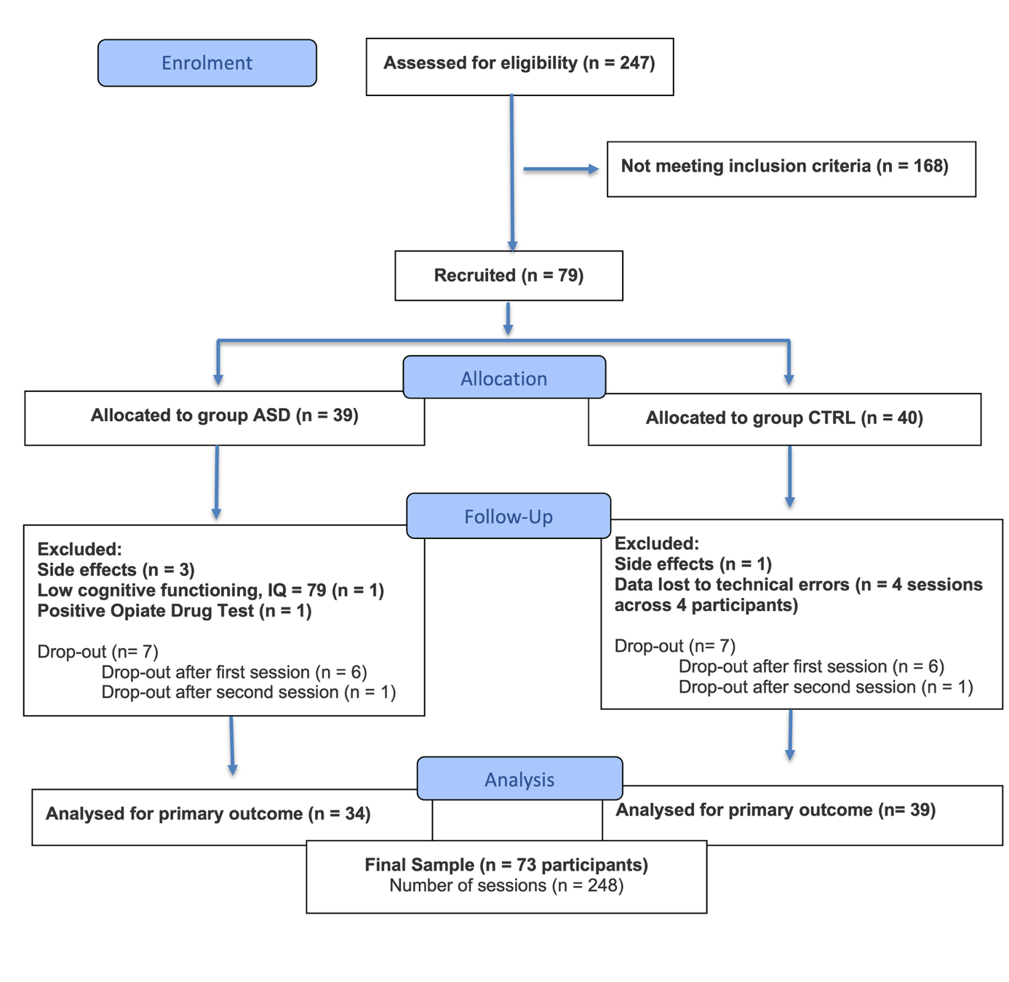
Figure S1 – Participant recruitment flowchart (adapted from CONSORT guidelines)

1.3 Eye-Tracking Interview
A team of seven trained experimenters conducted the interviews, ensuring that each participant was consistently paired with the same experimenter across all sessions. To reduce potential differences in gaze behavior based on the sex of the interaction partner, participants were always interviewed by an experimenter of the same sex. The interviews took place in a quiet lab setting, where both the participant and the experimenter were seated approximately 1 m apart at a table. Each session followed a semi-structured interview format, during which 13 scripted questions were read aloud by the experimenter from a printed list. These questions were designed to simulate natural conversation and were adapted from previous studies investigating social attention during face-to-face interactions (Auyeung et al. 2015). Questions were categorized into two types: closed questions (1–6), simple yes/no questions requiring minimal elaboration, and open questions (7–13), designed to encourage longer responses and greater social engagement. To maintain a natural flow of conversation, experimenters were permitted to use brief follow-up remarks, but were instructed to ensure the total interview duration remained between 7 and 10 min. A full list of interview questions is provided below.
The average interview duration was M = 9.47 min. A difference in interview duration between groups was observed, with slightly shorter interviews in the ASD group, M = 8.76, compared to the CTRL group M = 9.63, t = -2.49, p = .013. Because the primary eye-tracking outcome was relative fixation duration, the analysis focused on proportional viewing allocation rather than absolute interview length or fixation count. To confirm that interview duration did not account for the results, we repeated the main eye-tracking model with interview duration added as a covariate. Interview duration was not a significant predictor, χ²(1) = 0.30, p = .582, and the Group × AOI effect remained significant, χ²(3) = 16.38, p < .001.

1.4 Interview Questions
Instructions for the participant (guideline):
“We will now have a short conversation. Please make yourself comfortable, so you will be able to sit in the same position for the next few minutes. Please try to avoid large movements of your head, but small movements like nodding are okay. I will ask you a couple of questions and later, you will have the opportunity to ask me some questions as well. The idea is to have as relaxed and natural a conversation as possible. If you are ready, I will now start with the first question.”

Interview Questions:
- Did you sleep well last night?
- Did you dream about anything?
- Have you eaten at a restaurant in the past week?
- Were you out in nature last week?
- Have you read a book in the past week?
- Did you watch a movie or TV show recently?
- What did you do last weekend?
- Could you tell me what you plan to do next weekend?
- What was the most interesting event you experienced in the past week?
- When you woke up this morning, were you looking forward to participating in this study, or did it feel more like an obligation?
- Could you tell me about your journey to the lab, did anything interesting happen on the way?
- How did you feel after receiving the medication?
- Do you have any questions you would like to ask me?

1.5 Eye Tracking
The eye tracking procedure follows our previous work (Buehler et al. 2024). Eye-tracking data was collected using the Pupil Labs Core system, a mobile head-mounted eye tracker with two infrared pupil cameras and a forward-facing world camera. Pupil cameras captured eye movements at a 120 Hz sampling rate. To estimate gaze direction, we used an approach based on a 3D model of the eye (Kassner et al. 2014), which accounts for head movement and slippage of the headset, improving the stability of gaze estimations. Participants were instructed to minimize large head movements, though natural conversational behaviors such as nodding or shaking the head were permitted.

1.6 Data Preprocessing and Face Detection
To preprocess the data, we extracted fixations using the fixation detection algorithm provided by the Pupil Labs player software (Kassner et al. 2014). Fixations were detected using a maximum dispersion threshold of 1.5° VA, with durations ranging from 80 ms to 220 ms. Blinks (short drops in pupil detection confidence) were excluded during preprocessing using the blink detector plugin. Furthermore, all fixations below a confidence threshold of 0.8 were removed.
To locate facial AOIs, face detection was performed using a multi-task convolutional neural network (MTCNN) with the OpenCV and facenet-pytorch package in python. This process identified the position of the experimenter’s face and facial landmarks such as the eyes and corners of the mouth in each frame. Ellipses were fitted to the face, eyes, and mouth based on the bounding box returned by the face detection model. The size and shape of these ellipses adjusted dynamically to the orientation of the head and detected facial landmarks. Fixations were then mapped to AOIs frame by frame using a custom python script. Lastly, fixation duration was calculated for each region of interest by summing the total time spent fixating that region during a session. This value was then divided by the total fixation duration across all regions in the same session, yielding relative fixation duration for each region.
Relative fixation duration served as the primary dependent variable in the eye-tracking analyses. The Python scripts used for face detection in this study are publicly available in an online repository (https://github.com/raimund-buehler/face_detection_small) and described in more detail in our previous work (Buehler et al. 2024).

1.7 Pharmacological Procedure
Drugs were supplied by the General Hospital of Vienna (AKH). Naltrexone (Dependex, 50 mg) was administered orally in pill form. Oxytocin (Syntocinon, 5 IU/mL) was administered via a nebulizer (Pari 128 G1000 Sinus 2, Pari, Germany). The solution was applied to both nostrils for an interval of 5 min each, resulting in an applied dosage of 10 IU or 2 ml solution.
This dose, which is lower than the conventional 24 IU often encountered in oxytocin studies, was chosen for several reasons: First, previous research, mostly by Quintana and colleagues, has suggested that lower doses of oxytocin are more effective in eliciting behavioral effects of social cognition and attention, compared to higher doses (Martins et al. 2022; Quintana et al. 2016; Quintana et al. 2015). Another critical consideration is the interactive effect of naltrexone on oxytocin, which increases the potential for cross-activation of vasopressin receptors that occur at higher doses of oxytocin (Neumann and Landgraf 2012). Vasopressin receptors have been implicated in social behavior (Neumann and Landgraf 2012; Quintana et al. 2021; Rilling et al. 2012), and their activation could confound the behavioral effects of oxytocin. Thus, the lower dose was chosen due to the effectiveness of lower doses suggested by recent literature and the goal of avoiding cross-activation of vasopressin receptors under simultaneous administration of naltrexone.
A pill with mannitol filler or a saline solution (0.9% NaCl) was administered in placebo conditions via the same route of administration (i.e., oral intake and nebulizer) of the active drug. Thus, participants always received a pill and nebulizer solution in each session. The duration until peak plasma levels was accounted for in the timing of drug administration (naltrexone was administered 50 min and oxytocin 20 min before the start of testing) (Gonzalez and Brogden 1988; Gossen et al. 2012).
At the end of each session, participants were asked to guess the type of medication that was received, separately for the pill and the nebulizer. Blinding was successful for the pill, as indicated by a non-significant chi-square test, χ²(1) = 2.72, p = .10. Regarding the nebulizer, the chi-square test was significant, χ²(1) = 6.40, p = .01, indicating that blinding was potentially compromised. Oxytocin tends to have minimal side effects, the placebo nebulizer solution was visually indistinguishable from the oxytocin solution and was administered using the same device, volume, and timing; however, subtle olfactory differences cannot be fully excluded.
When examining nebulizer blinding for individual medication conditions (with and without naltrexone), the chi-square test was only significant for the OXT vs. PLA comparison, χ²(1) = 6.91, p = .009, while the BOTH (nebulizer containing oxytocin) vs. NAL (nebulizer containing placebo) comparison was not significant, χ²(1) = 0.60, p = .44.
 |  | Received
 |  | Oxytocin | Placebo
Guessed | Oxytocin | 37 | 20
Guessed | Placebo | 27 | 41
 |  | Received
 |  | Oxytocin | Placebo
Guessed | Oxytocin | 41 | 34
Guessed | Placebo | 21 | 25

Contingency table for nebulizer in OXT vs. PLA  χ²(1) = 6.91, p = .009. | Contingency table for nebulizer in BOTH vs. NAL, χ²(1) = 0.60, p = .44.

If participants had been able to reliably discern the medication by smell, this effect should have shown in a significant result in both comparisons. An alternative interpretation for the significant result is a response bias towards placebo in the PLA condition, rather than the ability to discern nebulizer solutions: In the PLA condition, participants were most likely to correctly identify placebo (41/61 = 67%). Since participants may not have been consciously aware of a medication effect in the PLA condition, they may have guessed 'placebo' more often, inflating correct placebo responses and driving the significant chi-square test. Thus, while participants may have been able to identify the nebulizer condition by smell, alternative explanations, such as a response bias towards placebo, seem plausible.

1.8 Cortisol Samples
Participants were asked to collect saliva in their mouths and refrain from swallowing for 2 min, ensured by a timer. Saliva was then transferred into a SaliCap container via a small plastic straw. Samples were stored in a freezer at −30°C until analysis. After thawing, SaliCaps were centrifuged at 3,000 rpm for 5 min. Salivary concentrations were measured using commercially available chemiluminescence immunoassay with high sensitivity (IBL International, Hamburg, Germany). The intra and interassay coefficients for cortisol were below 8%. In 10% of samples (79 samples), a dual estimation of cortisol levels was conducted, with an average deviation between estimations of M = 3%.

1.9 Model selection and diagnostics
For the primary eye-tracking analysis, we compared a set of theoretically motivated beta-regression models. These models all used relative fixation duration as the dependent variable and included the core predictors Group, AOI, Medication, Sex, and Session. Candidate models differed in whether additional medication-by-sex or AOI-by-medication-by-sex interactions were included. The selected model provided the best fit according to AIC while avoiding unnecessary higher-order interactions. More complex models did not improve fit.
Model | Fixed-effects structure | AIC | Delta AIC
Preferred | Group × AOI × Medication + Group × AOI × Sex + Session | -1014.59 | 0
Add Medication × Sex | Preferred + Medication × Sex | -1009.36 | 5.23
Add AOI × Medication × Sex | Preferred + AOI × Medication × Sex | -996.52 | 18.07
Full four-way | Group × AOI × Medication × Sex + Session | -975.46 | 39.13
Model diagnostics were assessed using simulation-based residual checks. These included tests for residual uniformity, dispersion, outliers, and zero inflation. No major violations were detected. Additional overdispersion checks also did not indicate problematic model fit.
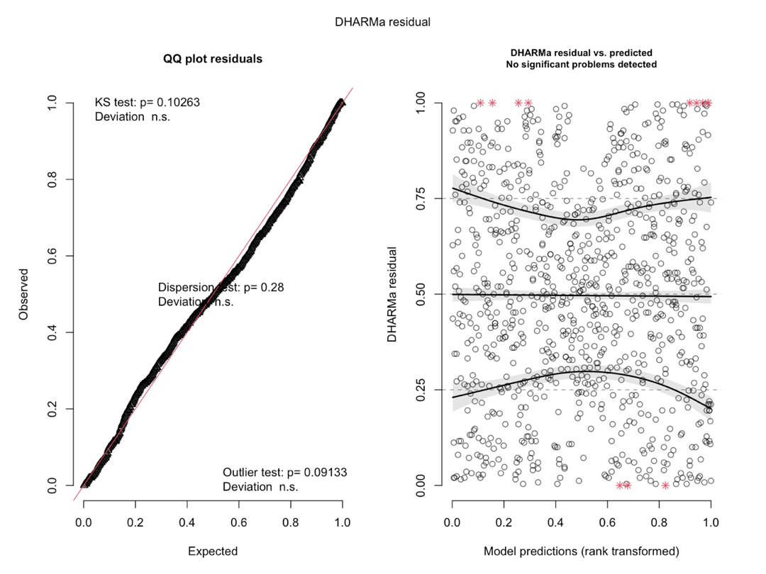
Figure S2 – Diagnostic checks for the primary fixation-duration beta-regression model. Simulated residual diagnostics computed with DHARMa. Left: quantile–quantile plot of scaled residuals against the uniform expectation, with tests for uniformity (Kolmogorov–Smirnov p = .103), dispersion (p = .28), and outliers (p = .091). Right: scaled residuals against rank-transformed model predictions, with quantile regression fits at the 0.25, 0.50, and 0.75 quantiles; no significant deviation was detected.

2 Supplementary Results

2.1 Cortisol
Salivary cortisol was measured at three time points during each session: baseline (T1), pre-task (T2), and post-task (T3). Raw cortisol values were log-transformed prior to analysis. Outliers exceeding 1.5 times the interquartile range were removed before model fitting. We first analyzed raw cortisol levels using a linear mixed model including group, medication, timepoint, and their interactions, with repeated measurements nested within participant and session:
Log(Cortisol) ~ Group × Medication × Timepoint + (1 | Subject / Session)
This model confirmed the pattern reported in the main text. Cortisol declined overall across the session, Timepoint: F(2, 476.39) = 69.72, p < .001. This time course was altered by medication, Medication: F(3, 173.93) = 8.11, p < .001; Medication × Timepoint: F(6, 476.46) = 10.49, p < .001. Sessions involving naltrexone (BOTH, NAL) showed an increase from T2 to T3, whereas placebo and oxytocin sessions showed a decline over time. There was no evidence that the medication effect differed by group, Group × Medication: F(3, 173.93) = 1.90, p = .132. To quantify cortisol reactivity, we focused on the baseline-independent T2-T3 difference score, reflecting change from pre-task to post-task. This measure was analyzed using a linear mixed model with group, medication, and their interaction as fixed effects and a random intercept for participant:
T2-T3 cortisol change ~ Group × Medication + (1 | Subject)
The T2-T3 model showed a robust main effect of medication, F(3, 185.03) = 11.65, p < .001. Cortisol reactivity was higher in naltrexone-containing sessions (NAL, BOTH) than in non-naltrexone sessions (PLA, OXT). There was no evidence for a group effect or a Group × Medication interaction, F(3, 185.03) = 0.52, p = .672, indicating that naltrexone increased cortisol reactivity similarly across groups.
Finally, we explored whether T2-T3 cortisol reactivity was associated with fixation allocation to the eyes. The exploratory model initially indicated a Group × T2-T3 interaction, χ²(1) = 9.25, p = .002, suggesting that the association between cortisol reactivity and eye gaze differed between groups. However, this effect was not robust to trimming extreme T2-T3 values. After trimming the outer 2.5% of T2-T3 values, the interaction was no longer significant, χ²(1) = 1.12, p = .290; after trimming the outer 5%, it was absent, χ²(1) = 0.003, p = .957. Thus, while naltrexone reliably increased cortisol reactivity, the analyses did not provide robust evidence that cortisol reactivity explained gaze effects.
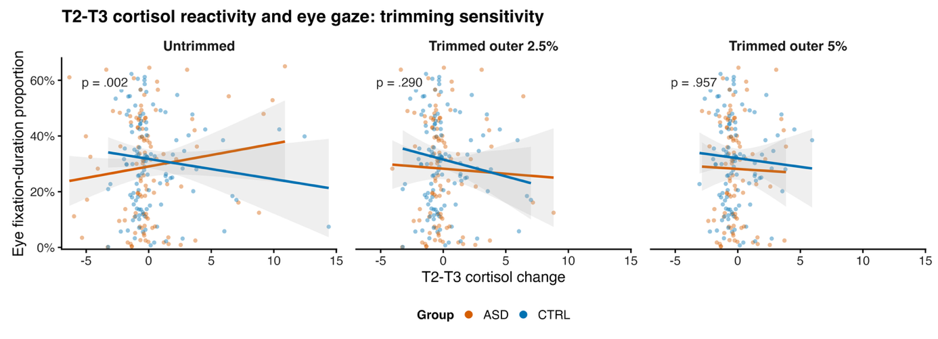

Figure S3 – Sensitivity of the group × cortisol-reactivity interaction to trimming of extreme reactivity values. Each panel shows the association between cortisol change between timepoints T2 and T3 and the proportion of fixation duration directed toward the eyes, separately for ASD (orange) and CTRL (blue), with points representing individual sessions, lines showing linear fits, and shaded bands showing 95% confidence intervals. Panels differ in how extreme cortisol-reactivity values were handled: untrimmed (225 observations from 69 participants), trimming the outer 2.5% of the T2–T3 distribution at each tail (213 observations from 68 participants), and trimming the outer 5% at each tail (201 observations from 68 participants). Annotated p-values refer to the group × T2–T3 interaction term in the corresponding model.

2.2 Sensitivity Analyses

2.2.1 Eye Tracking Accuracy
After excluding the 10 sessions with the poorest eye-tracking accuracy, the main gaze pattern remained significant. In the full sample, ASD participants still showed greater background gaze allocation than CTRL participants, p = .012. The Sex-stratified pattern also remained consistent: females showed lower gaze allocation to the eyes in ASD than CTRL, p = .008, and greater background gaze allocation in ASD than CTRL, p < .001, whereas no significant group differences were observed in males, ps ≥ .477. Thus, the main group-by-AOI pattern was not driven by the lowest-accuracy recordings.
Figure S4 – Sensitivity analysis excluding the ten sessions with the poorest eye-tracking accuracy. The ten sessions with the largest mean calibration error in degrees of visual angle were removed (seven CTRL and three ASD sessions, leaving 220 of 230 sessions from 67 of 68 participants; one ASD participant contributed only a single session and was therefore excluded entirely). Half-violin plots show the distributions of participant-level proportions of fixation duration, averaged across sessions and medication conditions, and horizontal marks indicate arithmetic group means. Asterisks indicate ASD–CTRL contrasts from a beta-regression model using the same fixed-effects specification as the primary analysis, refitted on the reduced dataset: * p < .05, ** p < .01, and *** p < .001. All six subgroup-by-region contrasts reproduce the significance pattern of the primary analysis, and effect magnitudes are essentially unchanged, indicating that the reported group differences are not attributable to sessions with poor gaze-tracking quality.

2.2.2 Comorbidities and Prescribed Medication
To ensure appropriate N for comparisons, medications were grouped as no medication record (N = 12), SSRI/SNRI only (N = 6), and other/multiple medications (N = 13). Comorbidities were grouped as no disorder record (N = 9), ADHD only (N = 8), depression only (N = 6), and other/multiple disorder types (N = 8). For gaze behavior, we found that the currently reported main finding of a group difference driven by Sex survived when medications and disorders were accounted for: Group × AOI × Sex: χ²(3) = 23.1, p < .001. The effect of study medication remained non-significant: Group × AOI × Study Medication: p = .690. Furthermore, medication or comorbidity did not affect pharmacological responsiveness: Medication Type × AOI × Study Medication: χ²(18) = 3.14, p = 1.000 and Comorbidity Type × AOI × Study Medication: χ²(27) = 9.96, p = .999. There was evidence that the AOI profile varied to some extent across prescribed medications and comorbidity types (Medication Type × AOI, χ²(6) = 28.30, p < .001; Comorbidity Type × AOI, χ²(9) = 30.81, p < .001, see Figure S5). Exploratorily, these interactions appeared to reflect relatively greater background gaze in the SSRI/SNRI-only and depression-only subgroups, with correspondingly lower gaze to eyes and/or mouth. However, due to the small group sizes, these results should be interpreted cautiously.
Similarly, we did not observe evidence that prescribed medication or comorbidity affected pharmacological responsiveness in cortisol reactivity (T2-T3 change): Medication Type × Study Medication: χ²(6) = 4.57, p = .600 and Comorbidity Type × Study Medication: χ²(9) = 14.2, p = .115. Taken together, the reported results in the main paper seem robust towards prescribed medications and disorder types.
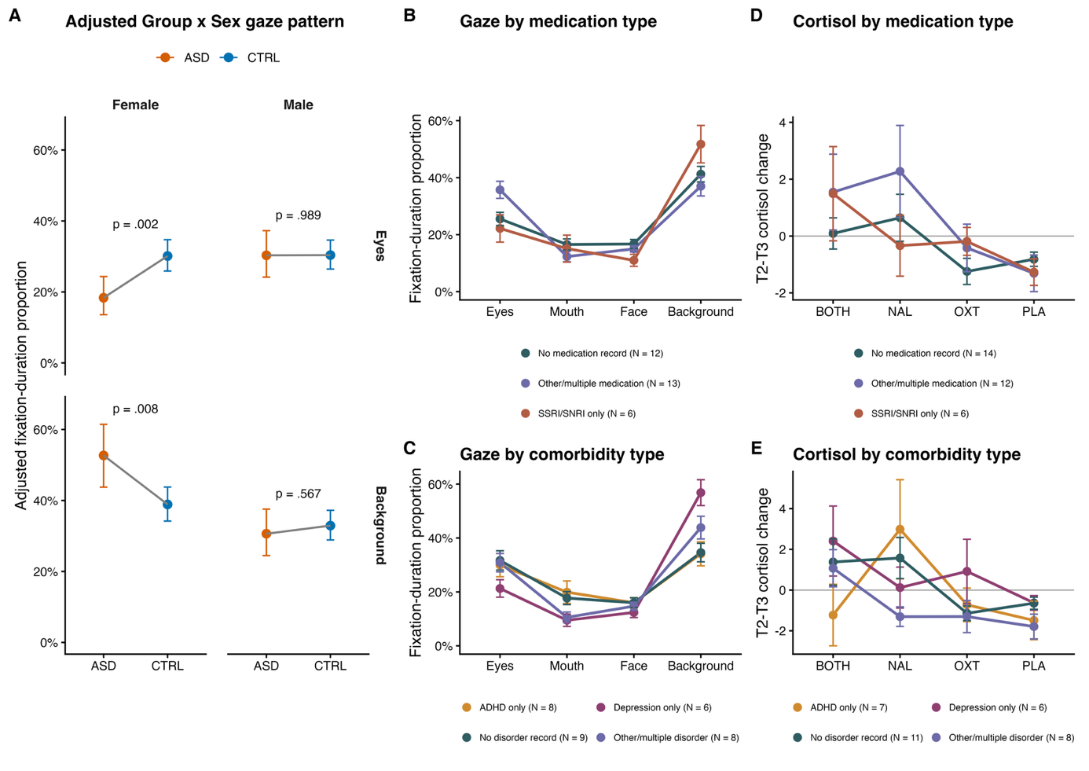
Figure S5 – Exploratory gaze allocation patterns by prescribed medication and comorbidity subgroup. A Group × sex differences in fixation-duration proportion for the eyes (top) and background (bottom) after adjusting for ASD-specific medication and comorbidity indicators, which were entered as AOI-interacting covariates in the primary beta-regression model. Points show estimated marginal means on the response scale with 95% confidence intervals, evaluated at the reference profile (no recorded medication and no recorded comorbidity); annotated p-values refer to the ASD–CTRL contrast within each sex. B, C Observed mean fixation-duration proportions across all four AOIs within the ASD group, stratified by prescribed medication type (B) and comorbidity type (C). D, E Observed mean T2–T3 cortisol change by medication condition within the ASD group, stratified by prescribed medication type (D) and comorbidity type (E). In panels B–E, points show observed means, error bars show ±1 SEM, and legend labels give the number of contributing participants. After adjustment, the female ASD–CTRL differences remained significant for both the eyes (p = .002) and the background (p = .008), while male contrasts remained non-significant (p = .989 and p = .567), indicating that the sex-specific group differences are not attributable to medication use or comorbidity profile.

2.2.3 Menstrual Cycle Phase
Menstrual-cycle phase was computed from the self-reported first day of the last menstrual bleeding, the participant-specific cycle length, and the date of each testing session. To avoid unreliable estimates of short cycle subphases, we classified sessions only into two broad phases: follicular (cycle day ≤ cycle length - 15) and luteal (cycle day ≥ cycle length - 14). The final analysis included female participants with available phase information (N = 25; follicular: ASD = 14, CTRL = 10; luteal: ASD = 12, CTRL = 10). In the eyes-only model, there was no evidence for a main effect of menstrual phase, χ²(1) = 0.17, p = .680, or interactions of phase with group, χ²(1) = 0.75, p = .388, study medication, χ²(3) = 0.67, p = .881, or Group × Study Medication, χ²(3) = 1.12, p = .772. In the full AOI model, menstrual phase also did not significantly affect gaze patterns or medication effects (all phase-related ps ≥ .181). Thus, menstrual-cycle phase did not appear to explain group differences in gaze behavior or pharmacological effects in the present data.
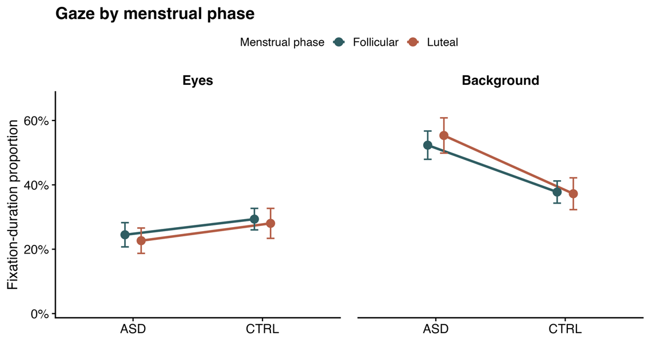
Figure S6 – Sensitivity analysis of menstrual-cycle phase effects on gaze allocation. Mean proportion of fixation duration directed toward the eyes (left) and background (right) for female participants, shown separately by diagnostic group and by menstrual cycle phase. Points show observed means and error bars show ±1 SEM. Cell sizes were 14 (ASD, follicular), 12 (ASD, luteal), 10 (CTRL, follicular), and 10 (CTRL, luteal) participants. Menstrual phase was not associated with fixation-duration allocation in the corresponding beta-regression model and no higher-order interaction involving phase reached significance.

2.2.4 Session Order and Carryover Effects
Additional sensitivity analyses examined possible effects of session order and carryover across crossover visits. Session number was included in the main model, and no evidence for a general session-order effect was found, Wald χ²(3) = 0.14, p = .987. A separate carryover model tested whether the medication condition from the previous session predicted relative fixation duration in the next session. This analysis showed no evidence for a carryover effect of previous medication, χ²(3) = 0.17, p = .982, and allowing previous medication effects to vary by AOI did not improve model fit, LRT χ²(12) = 13.04, p = .366. Carryover predictors likewise showed no evidence for effects of previous naltrexone, χ²(1) = 0.04, p = .835, or previous oxytocin, χ²(1) = 0.01, p = .915. Thus, we found no evidence for carryover effects.

2.2.5 Fixation Rate Outcome
We also conducted the eye-tracking analysis using fixation rate, defined as fixations per second, rather than relative fixation duration. The fixation-rate analysis showed a broadly similar group-by-AOI pattern to the primary relative-fixation-duration analysis, with a significant Group × AOI interaction, F(3, 945) = 3.00, p = .030. Follow-up contrasts showed higher fixation rates to the eyes in controls compared with autistic participants, t(945) = 1.97, p = .050, most clearly in females, t(945) = 3.33, p < .001. The corresponding background effect was weaker, t(945) = -1.87, p = .062. Nonetheless, the fixation-rate analysis broadly supported the primary interpretation of lower gaze allocation to the eyes and greater background gaze allocation in the ASD group. Similar to the main model, medication-related terms were not significant in this analysis, including Medication, p = .607, Group × Medication, p = .909, AOI × Medication, p = .962, and Group × AOI × Medication, p = .937.
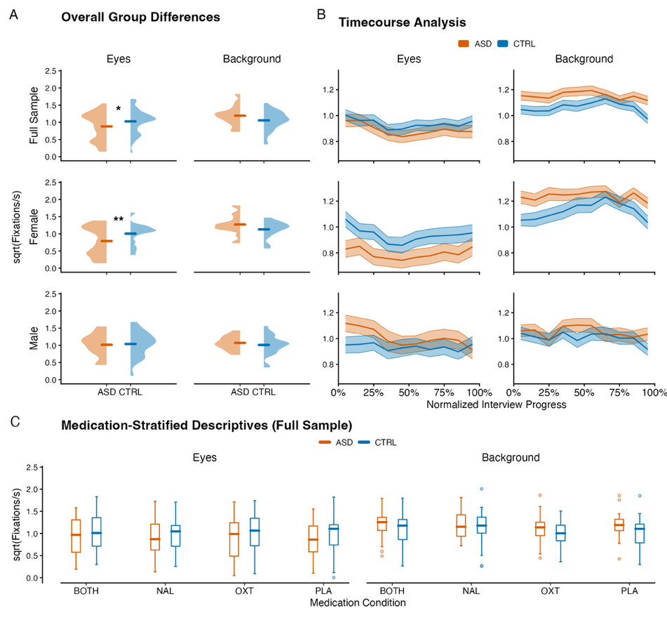
Figure S7 – Fixation-rate sensitivity analysis. Rows in panels A and B correspond, from top to bottom, to the full sample, females, and males. Orange denotes ASD and blue denotes CTRL. A Participant-level distributions of the fixation rate directed toward the eyes and background, averaged across medication conditions. Half-violin plots show the observed distributions and horizontal marks indicate arithmetic group means. Asterisks indicate ASD–CTRL contrasts estimated from a linear mixed-effects model with a by-participant random intercept: * p < .05, ** p < .01, and *** p < .001. B Fixation-rate time courses across non-overlapping 10%-wide bins of normalized interview progress. Lines show observed means and ribbons show ±1 SEM. C Descriptive full-sample summaries stratified by medication condition. Group differences in fixation rate were confined to the eyes region and driven by female participants (full sample p = .030; females p = .002; males p = .980), mirroring the sex-specific pattern observed for fixation duration. BOTH = naltrexone plus oxytocin; NAL = naltrexone plus placebo; OXT = placebo plus oxytocin; PLA = double placebo.

References
Auyeung B, Lombardo MV, Heinrichs M, Chakrabarti B, Sule A, Deakin JB, Bethlehem RAI, Dickens L, Mooney N, Sipple JAN, Thiemann P, Baron-Cohen S (2015) Oxytocin increases eye contact during a real-time, naturalistic social interaction in males with and without autism. Translational Psychiatry 5: e507. https://doi.org/10.1038/tp.2014.146
Buehler R, Ansorge U, Silani G (2024) Social attention in the wild - fixations to the eyes and autistic traits during a naturalistic interaction in a healthy sample. Scientific Reports 14: 30102. https://doi.org/10.1038/s41598-024-79210-8
Freitag CM, Konrad C, Häberlen M, Kleser C, von Gontard A, Reith W, Troje NF, Krick C (2008) Perception of biological motion in autism spectrum disorders. Neuropsychologia 46: 1480–1494. https://doi.org/10.1016/j.neuropsychologia.2007.12.025
Freitag CM, Retz-Junginger P, Retz W, Seitz C, Palmason H, Meyer J, Rösler M, von Gontard A (2007) Evaluation der deutschen Version des Autismus-Spektrum-Quotienten (AQ) - die Kurzversion AQ-k. Zeitschrift für Klinische Psychologie und Psychotherapie 36: 280–289. https://doi.org/10.1026/1616-3443.36.4.280
Gonzalez JP, Brogden RN (1988) Naltrexone: A Review of its Pharmacodynamic and Pharmacokinetic Properties and Therapeutic Efficacy in the Management of Opioid Dependence. Drugs 35: 192–213. https://doi.org/10.2165/00003495-198835030-00002
Gossen A, Hahn A, Westphal L, Prinz S, Schultz RT, Gründer G, Spreckelmeyer KN (2012) Oxytocin plasma concentrations after single intranasal oxytocin administration – A study in healthy men. Neuropeptides 46: 211–215. https://doi.org/10.1016/j.npep.2012.07.001
Heimberg RG, Mueller GP, Holt CS, Hope DA, Liebowitz MR (1992) Assessment of anxiety in social interaction and being observed by others: The social interaction anxiety scale and the Social Phobia Scale. Behavior Therapy 23: 53–73. https://doi.org/10.1016/S0005-7894(05)80308-9
Kassner M, Patera W, Bulling A (2014) Pupil. ACM, pp 1151–1160
Martins D, Brodmann K, Veronese M, Dipasquale O, Mazibuko N, Schuschnig U, Zelaya F, Fotopoulou A, Paloyelis Y (2022) "Less is more": A dose-response account of intranasal oxytocin pharmacodynamics in the human brain. Prog Neurobiol 211: 102239. https://doi.org/10.1016/j.pneurobio.2022.102239
Neumann ID, Landgraf R (2012) Balance of brain oxytocin and vasopressin: implications for anxiety, depression, and social behaviors. Trends in Neurosciences 35: 649–659. https://doi.org/10.1016/j.tins.2012.08.004
Quintana DS, Lischke A, Grace S, Scheele D, Ma Y, Becker B (2021) Advances in the field of intranasal oxytocin research: lessons learned and future directions for clinical research. Molecular Psychiatry 26: 80–91. https://doi.org/10.1038/s41380-020-00864-7
Quintana DS, Westlye LT, Alnæs D, Rustan ØG, Kaufmann T, Smerud KT, Mahmoud RA, Djupesland PG, Andreassen OA (2016) Low dose intranasal oxytocin delivered with Breath Powered device dampens amygdala response to emotional stimuli: A peripheral effect-controlled within-subjects randomized dose-response fMRI trial. Psychoneuroendocrinology 69: 180–188. https://doi.org/10.1016/j.psyneuen.2016.04.010
Quintana DS, Westlye LT, Rustan ØG, Tesli N, Poppy CL, Smevik H, Tesli M, Røine M, Mahmoud RA, Smerud KT, Djupesland PG, Andreassen OA (2015) Low-dose oxytocin delivered intranasally with Breath Powered device affects social-cognitive behavior: a randomized four-way crossover trial with nasal cavity dimension assessment. Translational Psychiatry 5: e602–e602. https://doi.org/10.1038/tp.2015.93
Rilling JK, DeMarco AC, Hackett PD, Thompson R, Ditzen B, Patel R, Pagnoni G (2012) Effects of intranasal oxytocin and vasopressin on cooperative behavior and associated brain activity in men. Psychoneuroendocrinology 37: 447–461. https://doi.org/10.1016/j.psyneuen.2011.07.013

