Supporting Information
Overcoming conventional trade-offs in strain sensing with physics-guided inverse design of aperiodic architected nanocomposites
V. Naenen, S. De Smedt, A. Kaidarova, R. Cardinaels, F. Molina-Lopez
Department of Materials Engineering, KU Leuven, Kasteelpark Arenberg 44, 3001, Leuven, Belgium.
E-mail: francisco.molinalopez@kuleuven.be

Strain sensing performance
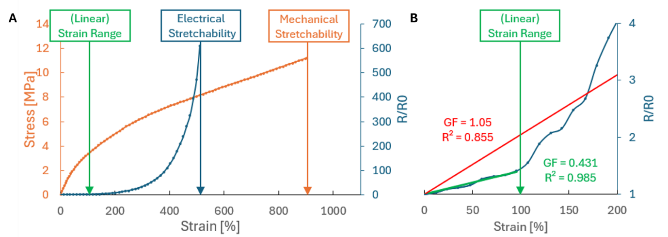
Figure S1. (A) Sensing behavior comprises the mechanical (stress, orange) and electrical (normalized resistance, blue) behavior²⁷. When stretchability is reported, it might refer to mechanical stretchability (maximum observable strain before mechanical fracture) or electrical stretchability (maximum observable strain before an electrical open circuit, e. g. due to fracture of the percolation network).
(B) When considering the inherently non-linear electrical behavior, a smaller strain range can be defined where the electrical behavior is sufficiently linear (e.g. R² above 0.98), giving the linear strain range. For comparison, the linear fitting of the same curve for less stringent linearity (R² above 0.85) is represented in red, demonstrating larger strain range and sensitivity.

Theory on Linearity of Percolated Nanocomposites
The $R(ε)$ response of percolated composites has unavoidable nonlinearity, arising from:
(1) geometric changes in sample dimensions (Pouillet’s effect)
(2) changes in intrinsic resistivity due to strain-induced modification of tunneling distances within the conductive network.

Geometric contribution (Pouillet effect)
For an unstrained sample, the electrical resistance is
$R_{0}=\frac{ρ_{0}L_{0}}{T_{0}W_{0}}$. (Eq. S1)
Here, $ρ_{0}$, $L_{0},T_{0},W_{0}$ are the unstrained resistivity, length, thickness and width.

When uniaxial strain $ε$ is applied along the length, the strained dimensions (denoted by ‘) are
$L^{'}=L_{0}(1+ε),T^{'}=T_{0}(1+ε)^{-ν},W^{'}=W_{0}(1+ε)^{-ν},$ (Eq. S2)
where $ν$ is the Poisson ratio.

The strained resistance is
$R^{'}=\frac{ρ^{'}L^{'}}{T^{'}W^{'}},$ with $ρ^{'}$ the resistivity. (Eq. S3)

Normalizing by the unstrained resistance gives
$\frac{R^{'}}{R_{0}}=\frac{ρ^{'}}{ρ_{0}}(1+ε)^{1+2ν}.$ (Eq. S4)

For incompressible materials, such as elastomeric matrices ($ν≈0.5$):
$\frac{R^{'}}{R_{0}}=\frac{ρ^{'}}{ρ_{0}}(1+ε)^{2}.$ (Eq. S5)

As a consequence, even if resistivity were constant, the geometric term $\left(1 + ε)^{2}\right.$ already produces a nonlinear resistance–strain response.

Tunneling contribution
In percolated nanocomposites, resistivity also changes with strain due to changes to the tunneling between adjacent conductive fillers. The tunneling-dependent resistivity is
$ρ'(d)=Ae^{βd},$ (Eq. S6)
where $d$ is the interparticle separation, $A$ a pre-factor, and $β=\frac{2}{ℏ}\sqrt{2mϕ}$ is a tunneling decay constant that depends on electron mass $m$ and barrier height $ϕ$.
The normalized resistivity scales as
$\frac{ρ^{'}}{ρ_{0}}∼e^{β(d-d_{0})}.$ (Eq. S7)
Thus, both $ρ^{'}/ρ_{0}$ and its derivative are exponential in nature, adding a second, strongly nonlinear contribution to resistance under strain.
Conclusion. Both the geometric term $\left(1 + ε)^{1+2ν}\right.$and tunneling-controlled resistivity term $e^{β(d-d_{0})}$ introduce inherent nonlinearity. In real percolated nanocomposites, the exponential tunneling contribution amplifies the geometrical quadratic behavior, making nonlinear resistance–strain $R(ε)$ curves an intrinsic feature of the material system.

Benchmarking
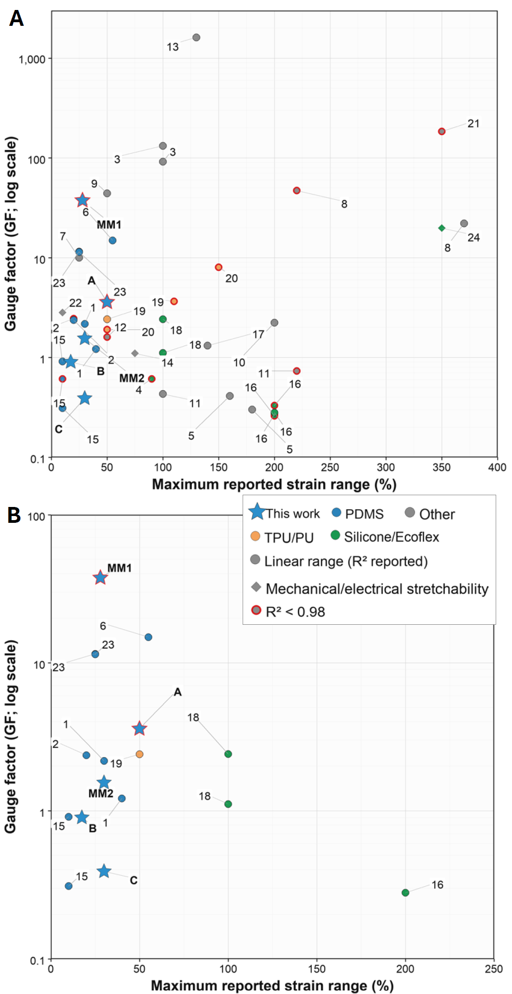
Figure S2. Literature comparison of GF, strain range and linearity. (A) All reported sensors. Circles denote linear strain ranges evaluated using the definition adopted in this manuscript (the strain interval starting at 0%, where linear regression has a sufficiently large R² value), whereas diamonds denote the maximum mechanical or electrical stretchability reported (see Fig. S1). Colors indicate sensor class. “Other” comprises non-bulk sensor architectures, including CNT coatings deposited on substrates and electrospun fibrous mats containing ultrasonically embedded CNTs. These exotic sensor architectures can demonstrate superior sensitivity but often struggle with difficult processability, scalability or environmental stability. Moreover, their behavior is highly material- and architecture-specific, not allowing for versatility in tailoring the performance towards other applications, nor the accurate prediction of their behavior for modified architectures or for alternate sensing modes. Red outlines identify values with poor linearity (R² < 0.98). Numbers correspond to the references in Table S1. This work (blue star markers) consists of 2 classes of PDMS-based nanocomposites: the representative metamaterials (MM1 and MM2) generally show enhanced sensitivity for a similar strain range and linearity compared to the homogeneous composites (A,B,C) that they are made of. (B) Only nanocomposite sensors (no ‘other’ architectures).

Table S1. Benchmarking of CNT-based longitudinal piezoresistive strain sensors.
Material system / composition | Strain range | GF | R² | Fabrication method | Ref.
MetaMaterial (MM)  MM1 = CAC  MM2 = CCC//CCB//CBB | 28%  30% | 37.5  1.55 | >0.85  >0.98 | Direct Ink Writing (DIW) of concentration-graded CNT/PDMS inks | This  work
Starting material (CNT/PDMS)  A = 0.23vol%  B = 0.52 vol%  C = 0.82 vol% | 50%  17%  30% | 3.59  0.9  0.39 | 0.85  0.98  0.98 |  | This  work
CNT/PDMS | 30%  40% | 2.17  1.21 | 0.987  0.992 | Solution blending + mold casting/curing | 1
CB–CNT/PDMS | 20%  20% | 2.45  2.37 | 0.972  0.988 | Hybrid filler dispersion (n-hexane) + casting on geotextile fabric | 2
CNT/PDMS | 100%  100% | 132  91.8 | 0.993  0.991 | Self-segregated CNT/PDMS dip-coat onto elastic medical bandage | 3
CNT/Ecoflex | 90%* | 0.61* | >0.97* | Solution mixing + printing into silicone substrate | 4
CNT fiber /Ecoflex | 160%  180% | 0.41  0.3 | >0.99  >0.99 | Dry-spinning of CNT fiber from CNT forest, transferred to Ecoflex | 5
Ag@CNT/PDMS | 55%* | 14.9* | >0.98* | Template method (dip-coating CNT/Ag network into PDMS mold) | 6
CNT/TPU | 25% | $≈$ 10 | >0.98 | Electrospun wavy TPU fiber + CNT deposition | 7
CNTs (P-DATPU/CNTs)  /Dopamine-mod. TPU | 370%  220% | 22.0  47.1 | 0.997  >0.9 | Electrospinning + dopamine functionalization + suction filtration of CNTs | 8
CNT@AgNPs/ TPU | 50%* | 44.1* | >0.98* | Electrospinning + dip-coat CNT + in-situ AgNO3 | 9
CNT-Ppy/ WSP | 200%* | 2.23* | >0.98* | CNT dip-coat + in-situ PPy polymization on fabric | 10
CNT/ Dopamine-mod. TPU(DATPU/CNTs) | 100%*  220%* | 0.43*  0.73* | >0.98*  >0.97* | Electrospinning + dopamine modification + ultrasonication-assisted CNT deposition | 11
CNT/TPU | 50%* | 1.6* | 0.97* | Electrospun TPU film + dip-coat ultrasound CNT | 12
MWCNTs yarn/  Dopamine-mod. SEBS/ | 130%* | 1612* | 0.99* | Electrospun SEBS yarn + dopamine modification + CNT coating, twisted into yarn | 13
Carbon nano-onion + CNT / SEBS | 75% | ~1.1 | - | Solution-processed all-carbon ink, dip/blade-coated | 14
CNT@CNC/PDMS | 10%  10% | 0.91  0.31 | 0.99  0.99 | Sustainable emulsion method; segregated structure around PDMS microspheres | 15
MWCNT/Ecoflex | ~200%*  ~200%* | 0.33*  0.28* | 0.916*  0.985* | Solution mixing/casting of MWCNT/Ecoflex composite | 16
MWNT/SWNT/ TPU yarn | 140%* | 1.31* | 0.994* | Electrospun TPU fiber yarn decorated with CNTs | 17
CNT / silicone rubber | 100%  100% | 2.42  1.11 | 0.990  0.984 | CNT network embedded in silicone rubber thin film | 18
CNT/TPU | 110%*  50%* | 3.65*  2.41* | 0.97*  0.99* | Templated porous CPC with microdome surface (TPU + CNT) | 19
CNT/rGO core-sheath fiber /PU | 50%*  150%* | 1.90*  6.18* | 0.93*  0.9* | Coaxial wet-spinning, encapsulated core-sheath fiber | 20
CNT/MXene/TPU | 350% | 184 | <0.9 | Multilayer electrospin + spray (brick-and-mortar) | 21
CNT/ Waterborne-PU (WPU-BP) | 10% | 2.82 | - | Vacuum filtration of WPU- CNT buckypaper | 22
MWCNT/CB/PDMS | 25%* | 11.41* | 0.999* | Solution blend and molding of ternary composite | 23
CNT/liquid-metal/Fe-powder/Ecoflex | 40% | 4 | 0.989 | Direct Ink Writing (DIW) / 4D printing | 24
Aligned CNT film | 280% (fracture ) | 0.04 | - | Aligned CVD- CNT film, fractured under stretch | 25
*Self-calculated values. Linear regression was performed over progressively increasing strain ranges until R² < 0.98. The GF and the corresponding strain range satisfying R² < 0.98 are reported. Grey shading denotes textile-/bandage-architectured sensors.

Rheological properties relevant for DIW printing
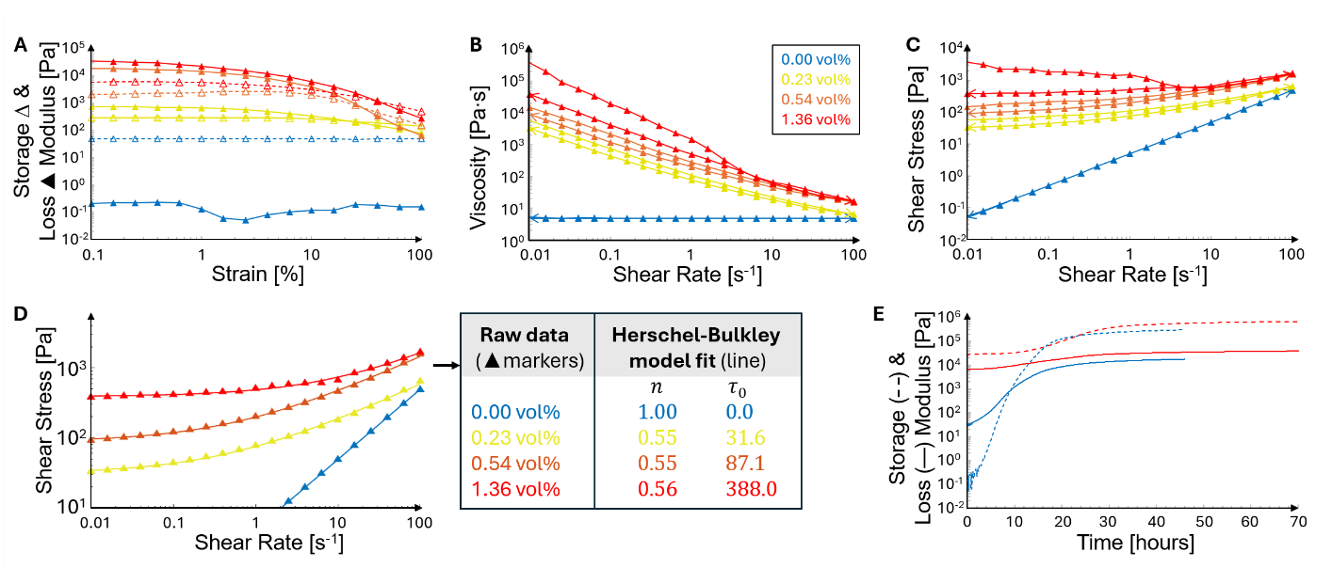
Figure S3. Rheology study of CNT-PDMS inks. (A) Strain amplitude sweeps to determine the LVR; (B) Flow curve of viscosity vs. shear rate, showing both up- and downwards ramps;
(C,D) Flow curve of shear stress vs. shear rate (up- and downwards ramps), and the Herschel-Bulkley model fits; (E) Time sweep to characterize curing kinetics.
Rheological measurements (Figure S3) were used to evaluate whether the inks satisfy the key requirements for DIW printing: (i) a measurable linear viscoelastic region (LVR) for predictable ink behavior under printing-relevant deformation, (ii) shear-thinning for easy extrusion, (iii) a finite yield stress for shape retention, and (iv) curing kinetics compatible with layer-by-layer deposition²⁴.
(i) Linear viscoelastic region (LVR). The strain-amplitude sweeps in Figure S3A provide insight into the LVR at small strains, where storage and loss moduli (G’ and G”) are constant.
Pure PDMS exhibits liquid-like behavior across the entire strain range, with $G^{'}<G^{''}$ and both moduli remaining nearly constant up to 100 % strain. In contrast, the composite inks display a reduced LVR in which $G^{'}$ remains constant and exceeds $G^{''}$, followed by a sharp decrease in $G^{'}$ as the applied strain disrupts the percolated CNT network. The extent of the LVR further decreases with CNT loading: the 0.23 vol% ink maintains linear behavior up to several percent strain, whereas the 0.55 vol% and 0.82 vol% inks show LVR limits near ~1 % strain. This trend is characteristic of nanocomposite systems, in which stronger filler networks undergo earlier structural breakdown with increasing deformation. A strain amplitude of 0.5 % was thus selected for all frequency sweeps to ensure measurements were performed well within the LVR.
(ii) Shear-thinning behavior for extrusion. The shear-rate sweeps in Figure S3B showed that whereas PDMS ink viscosity was constant, as expected for a Newtonian fluid, all the composite inks exhibited pronounced shear-thinning, with viscosity decreasing by one to two orders of magnitude across the printing-relevant shear-rate range (10-100 s⁻¹). This behavior is essential for DIW: the ink must flow easily through the nozzle under high shear, yet recover to a high viscosity that hinders flow immediately after deposition.
At low shear rates (< 0.1 s⁻¹), viscosity increases strongly with CNT loading, reflecting the formation of a progressively stronger filler network. The 0.23 vol% ink shows the onset of network formation, whereas the 0.55 vol% and 0.82 vol% inks exhibit much higher zero-shear viscosities, consistent with a percolated microstructure. As shear rate increases, inks thin rapidly to viscosities suitable for extrusion through a 1.63 mm nozzle (10-200 Pa∙s).
The shear-stress curves in Figure S3B show smooth, monotonic behavior with minimal hysteresis between upward and downward sweeps (especially below filler concentration of 1.36 vol%), indicating limited thixotropy – the CNT network rebuilds rapidly after shear cessation, which is critical for maintaining filament shape during DIW.
(iii) Yield stress for shape retention. The shear-stress curves of the inks (Figure S3C) exhibit two characteristic regions: a low-shear plateau, where stress remains nearly constant, and a flow regime, where stress increases consistently with shear rate. These regions are described by the Herschel–Bulkley model (Figure S3D)
$τ=τ_{0}+k{\dot{γ}}^{ n},$ (Eq. S8)
where τ is the shear stress, $τ_{0}$ the yield stress, $\dot{γ}$ the shear rate, k is the consistency index, and n is the flow index. Taking the decimal logarithm and distinguishing between low and high shear rate regimes, we have:
$\log_{10}{τ}\sim \log_{10}{τ_{0}}=constant$ (for small $\dot{γ}$) (Eq. S9 )
$\log_{10}{τ}\sim n\log_{10}{\dot{γ}}+constant'$ (for large $\dot{γ}$) (Eq. S10)
From there, it can be seen that the plateau height corresponds to the yield stress $τ_{0}$ and the slope of the flow regime corresponds to the flow index $n$. $τ_{0}$ increases sharply with CNT loading, from 0 Pa for pure PDMS to 30 Pa (0.23 vol%), 87 Pa (0.54 vol%), and 338 Pa (1.36 vol%, downward sweep curve). These values demonstrate the formation and progressive strengthening of a percolated CNT network. The yield stress falls within the range required for DIW (10²–10³ Pa) to ensure filament stability, shape retention, and resistance to gravitational collapse.
The flow regime reveals the material’s behavior once yielding has occurred. Pure PDMS shows $n≈1$, confirming Newtonian liquid behavior and explaining its inability to retain shape after DIW. In contrast, all composite inks exhibits $n≈0.55$, indicating pronounced shear-thinning (n < 1): the inks thin rapidly under extrusion-level shear rates (10-100 s⁻¹), enabling smooth flow through the nozzle while maintaining solid-like behavior at rest. This combination of finite yield stress and low flow index is ideal for DIW printing.
Oscillatory frequency sweeps (Figure 1F) corroborate this interpretation: composite inks show a frequency-independent $G^{'}$plateau with $G^{'}>G^{''}$, consistent with a percolated elastic network capable of sustaining a finite yield stress, whereas pure PDMS remains liquid-like with $G^{'}<G^{''}$. The flow point corresponds to the strain amplitude at which $G^{'}=G^{''}.$
(iv) Curing kinetics compatible with layer-by-layer deposition. Curing behavior was evaluated through time sweeps at 10 rad s⁻¹ and 0.5 % strain (Figure S3E). Pure PDMS shows a $G^{'}\text{–}G^{''}$crossover at ~9 h and reaches a plateau after ~30 h. In contrast, the composite inks are solid-like from the start (no crossover), reflecting the reinforcing effect of the MWCNT network, and reach their plateau after ~40 h, indicating a cross-linking delay induced by the presence of the fillers. At elevated temperatures (50–80 °C), curing accelerates to timescales of minutes. This motivated the use of a 60 °C heated print bed, which ensures rapid interlayer bonding and structural stabilization without premature curing inside the nozzle.

Electrical conductivity of CNT-PDMS films

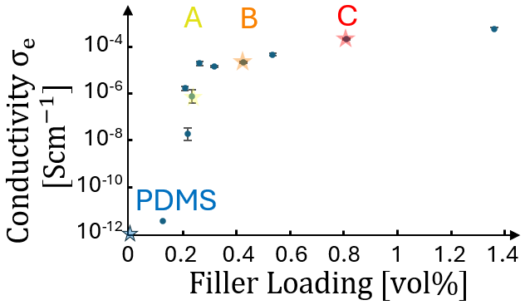
Figure S4. Electrical conductivity of CNT-PDMS composites as a function of filler loading, showing a percolation transition around 0.2 vol%.

Analytical model development
The framework establishes sensor design through the progression of:
SI6.1 - Construct constitutive curves of constituent cell materials
SI6.2 - Propagate constituent cell behavior to network response
SI6.3 - Evaluate network response and performance screening

Construct constitutive curves of constituent cell materials
For each constituent material, multiple samples were measured experimentally (SI6.1.1), their data was then combined to construct the constitutive $σ\left(ε\right)$and $R(ε)$ curves (SI6.1.2).
Experimental measurement
Mechanical. Uniaxial tensile testing was performed according to ASTM D638 (Instron 5943, strain rate 0.5 % s⁻¹, air-pressure-controlled grips at 2 atm).
Electrical. Resistance was recorded in a four-wire configuration (Keysight B2961B, 10 µA). Gold-sputtered contacts were covered with liquid metal (Galinstan) to ensure low-impedance connection to the copper electrodes embedded in the tensile clamps, as shown in Figure S5.
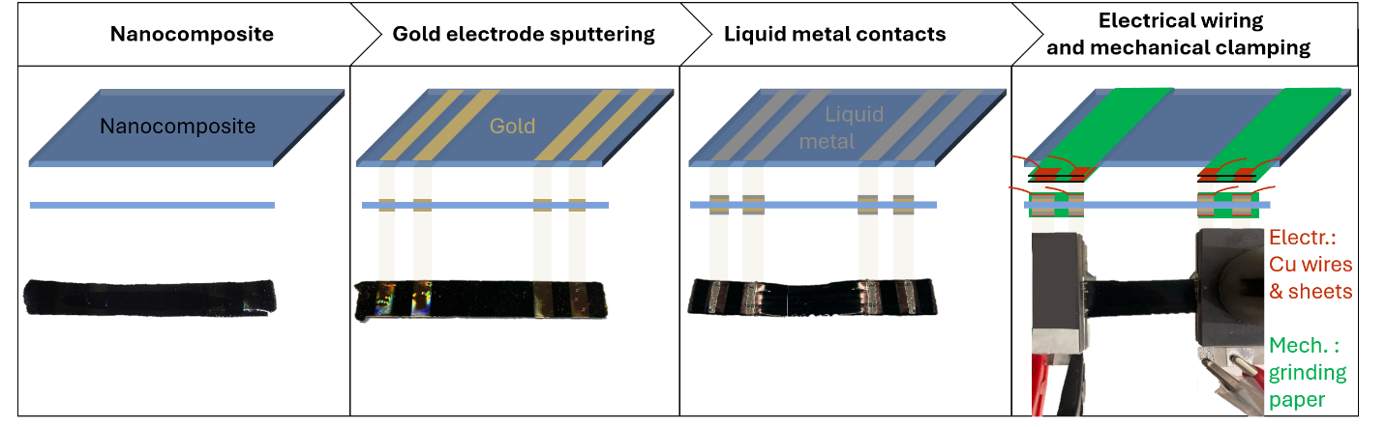
Figure S5 Fabrication and electrical interfacing of samples for electromechanical testing.
Electromechanical. Mechanical and electrical signals were recorded during tensile testing, and triggered simultaneously for a common time reference, as shown in Figure S6A. The electrical data ($t_{e},R(t_{e})$) was synchronized to the mechanical data ($t_{m},ε(t_{m}),σ(t_{m})$) by interpolation: $R(t_{m})=\text{interp}(t_{e},R(t_{e}),t_{m})$, obtaining the $σ(ε)$ and $R(ε)$ curves (Figure S6B).
Dimensions. Optical microscopy accurately measured sample length and width. Thickness was calculated as $t=\frac{Volume}{Surface Area}= \frac{mass/density}{length*width}$. Mass was measured on a microbalance, and density via the Archimedes method. The gauge length was determined from the toe region of the $σ(ε)$ curve, corresponding to the clamp separation where the sample becomes taut.
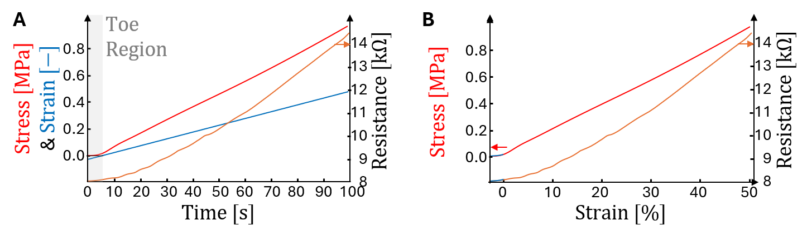
Figure S6. (A) Time synchronization of mechanical and electrical data (the toe region related to the initial sample slack was discarded). (B) The resulting $σ(ε)$ and $R(ε)$ curves of a sample.
Construct constitutive curves
For each constituent material, the constitutive $R(ε)$ curve was reconstructed from the $R(ε)$ curves of its samples. Simple averaging (mean or log-mean of R) was not suitable due to large sample-to-sample variation in baseline resistance $R_{0}$ (unstrained): When individual samples failed at a certain strain, severe vertical shifts of the mean occurred, distorting the group behavior into a stepwise shape as shown in Figure S7(red). To resolve this, the shape and baseline $R_{0}$ of the $R(ε)$ curve were reconstructed independently, using a derivative-integration method (related to elastic functional data analysis – EFDA²⁸) in log-space, $r=\log{R}$:
i) Shape. Each sample’s curve $r_{i}(ε)$ is differentiated to find the sample slope $s_{i}\left(ε\right)$, cancelling baseline $R_{0}$ offsets¹⁹. The constitutive slope is the average sample slope: $\overset{ˉ}{s}\left(ε\right)=AVG\left[s_{i}\left(ε\right)\right]$.
The constitutive curve is reconstructed by integration: $\overset{ˉ}{r}(ε)=∫\overset{ˉ}{s}(ε) dε+\text{cte}.$
ii) Baseline $r_{0}$. The integration constant $\text{cte}$ defines the baseline resistance of the $R(ε)$ curve. It is the average baseline $r_{0}$ of the unstrained samples: $cte=AVG\left[r_{i}\left(ε=0\right)\right]$.
The constitutive curve in Figure S7(green) has a representative shape for the samples over a large strain range. The mechanical response $σ(ε)$ was treated analogously. Confidence bands were estimated using bootstrap resampling. For a set of 𝑁 samples, 300 resamples of size 𝑁 were generated with replacement, and reconstructed. The 95% confidence band was defined by the 2.5th and 97.5th percentiles across these 300 reconstructions.
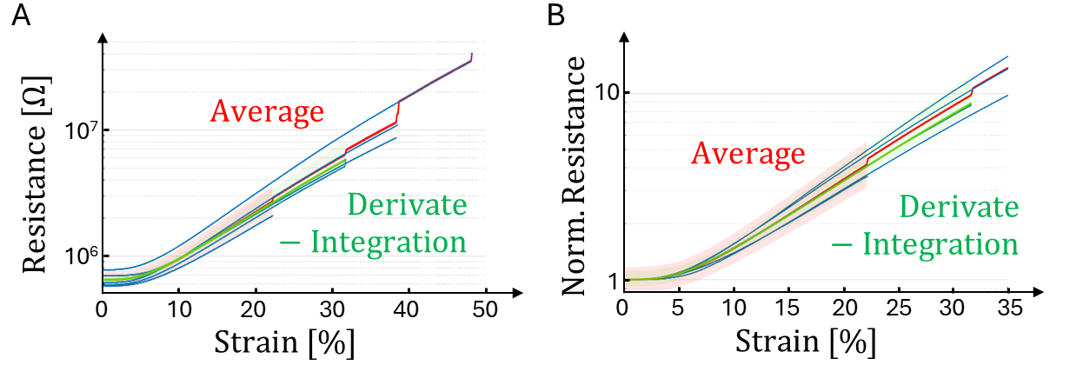
Figure S7. (A) Extraction of a constitutive $R(ε)$ curve from a set of samples (blue lines). Simple averaging (red curve) is distorted by baseline $R_{0}$ differences, while the derivative-integration method (green curve) yields a consistent curve over a wide strain range. Shaded area for 95% confidence bands.
To efficiently implement the analytical model, the reconstructed constitutive curves for $σ(ε)$ and $logR(ε)$ were approximated by 3rd-order polynomials (all with R² above 0.99). $σ(ε)$ was constrained to pass through the origin, reflecting zero stress at zero strain. These closed-form
Polynomials provide the constitutive curves as direct inputs to the analytical model (SI6.2).

Propagate constituent cell behavior to network response

Computation of model prediction
The metamaterial is modeled as a hierarchical resistor network with three levels:
Network. A network consists of branches in parallel. Given the resistance of each branch at the imposed strain $R_{\text{branch},j}(ε_{\text{branch}})$, the network resistance follows the parallel rule,
$\frac{1}{R_{\text{network}}(ε_{\text{global}})}=\sum_{j}{\frac{w_{j}}{R_{\text{branch},j}(ε_{\text{branch}})}}$ (Eq. S11)
where $w_{j}$ is the number of branches of type $j$ in the network. Branches directly experience the imposed global strain (iso-strain condition), $ε_{\text{branch}}=ε_{\text{global}}$.
Branch. A branch consists of cells in series. Given the resistance of every cell $R_{\text{cell},i}(ε_{\text{cell},i})$, the branch resistance follows the series rule,
$R_{\text{branch}}(ε_{\text{global}})=\sum_{i}{v_{i}R_{\text{cell},i}}(ε_{\text{cell},i})$ (Eq. S12)
where $v_{i}$ is the number of cells of constituent material $i$ (e.g. A, B and C) in the branch.
Cell. The cell resistance $R_{\text{cell},i}=R_{i}(ε_{\text{cell},i})$ is extracted experimentally for each constitutive material and fitted analytically by a third order polynomial (section SI6.1). Thus, the problem reduces to determining the cell strain $ε_{\text{cell},i}$. Each material’s constitutive stress-strain $σ_{i}(ε)$ fitted polynomial is analytically inverted using Cardano's method, giving $ε_{i}(σ)$. All cells in a branch share the same stress (iso-stress condition): $σ_{cell}=σ_{branch}$. The cell strain is
$ε_{\text{cell},i}=ε_{i}(σ_{branch})$ (Eq. S13)
Now that the cell strain $ε_{\text{cell},i}$ is expressed as a function of a branch stress, the model simply calculates the corresponding branch strain $ε_{\text{branch}}$ ($=ε_{\text{global}}$) and branch resistance $R_{\text{branch}}$ over a $σ_{\text{branch}}$ grid as follows:
- $ε_{\text{branch}}(=ε_{\text{global}})$ is the average of the cell material strains,
$ε_{\text{global}}\left(σ_{branch}\right)=ε_{\text{branch}}\left(σ_{branch}\right)=\frac{1}{n_{\text{cells}}}\sum_{i}{v_{i}ε_{i}(σ_{branch})}$ (Eq. S14)

- $R_{\text{branch}}$ is the sum of the cell material resistances,
$R_{\text{branch}}\left(σ_{branch}\right)=\sum_{i}{v_{i}}R_{i}\left(σ_{branch}\right)=\sum_{i}{v_{i}}R_{i}[ε_{i}(σ_{branch}]$ (Eq. S15)

This process yields a branch-specific table of ($σ_{\text{branch}},ε_{\text{global}},R_{\text{branch}}$) triplets, from which each actual $R_{\text{branch}}\left(ε_{\text{global}}\right)$ value can be evaluated by interpolation. The calculated $R_{\text{branch}}\left(ε_{\text{global}}\right)$ curves are shown as the solid lines in Figure S10, along with the experimental data (dashed lines with 95% confidence bands). This protocol replaces the need of solving a nonlinear system for every branch and strain point. Finally, by plugging the interpolated $R_{\text{branch}}\left(ε_{\text{global}}\right)$ in Eq. S11, $R_{\text{network}}(ε_{\text{global}})$ is calculated.

Mechanical validation – Branch and Cell Strain
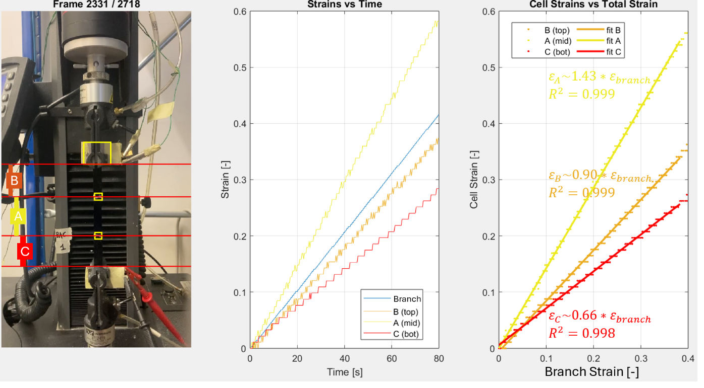
Figure S8. Image-based cell strain measurement, where cell lengths are tracked during tensile testing. Each cells relative strain is estimated as the slope of the $ε_{cell}-ε_{branch}$ curve via linear regression.
Figure S8 and video SI1 show how local cell strains were measured during tensile testing. Three thin reference marker lines were applied at the cell transitions, and their vertical positions were tracked in every frame using rigid 2D normalized cross-correlation. For each frame, the distances between the top clamp, internal white markers, and bottom clamp were measured to determine the cell lengths. Engineering strains were computed as $ε_{i}=\frac{L_{i}-L_{i,0}}{L_{i,0}}$($L_{i,0}$ is the initial length from the first frame) and plotted against the global strain. The relative cell strain was obtained as the slope of the linear regression of $ε_{i}$ versus $ε_{\text{global}}$.
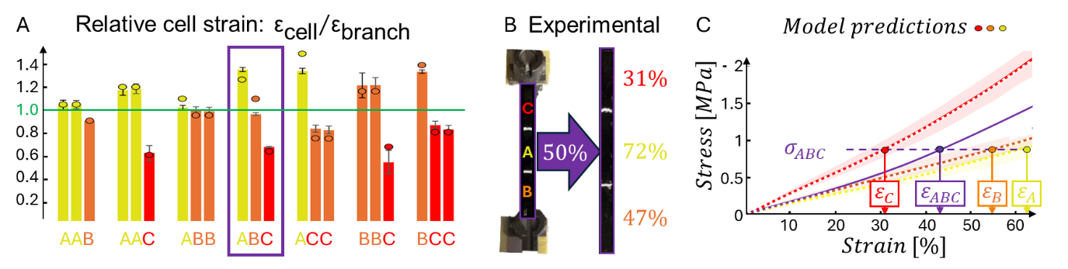
Figure S9. Strain redistribution in three-cell branches. (A) Relative cell strain for all branch types fabricated. The bars indicate experimental values and the circles predicted values.
(B) Picture showing the experimental observation of local cell strains obtained via image-based strain tracking during tensile testing. (C) Model-predicted local cell strains based on the iso-stress condition.

Electrical validation – Branch resistance
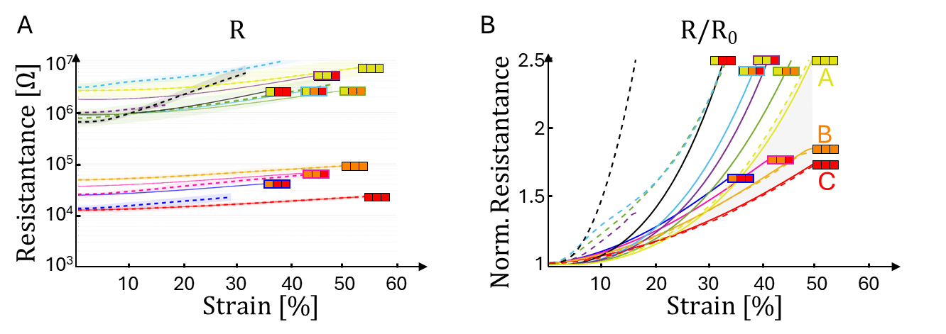
Figure S10 Electromechanical response of all branch types: (normalized) resistance versus strain.
The model predictions (solid lines) are compared to experimental curves (dashed lines with shaded area for 95% confidence interval), reconstructed by the derivative-integration method in SI6.1. The branch configuration is indicated by the three constituent cells (A: yellow, B: orange, C: red). The curves with three equally-colored cells represent the homogeneous constituent materials.

Combinatorial design space and computational cost
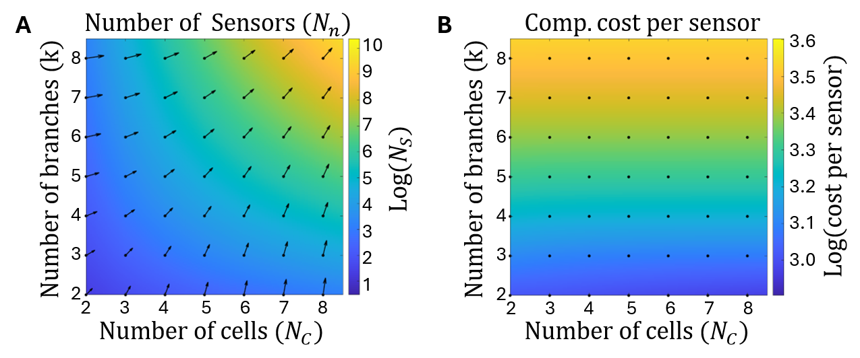
Figure S11. (A) combinatorial growth of the number of network architectures $N_{n}$ and (B) the computational cost per predicted network, as functions of the number of cells $N_{C}$ and branches $k$ (for a fixed number of constituent materials $N_{m}$ of 3). The gradient arrows in panel A point out the relative importance of including one more branch (y-axis) or cell (x-axis) for increasing the number of networks. The rapid growth of the design space highlights the impracticality of exhaustive experimental screening and motivates the use of the analytical physics-guided framework for inverse design.
Cells in series share identical stress, and branches in parallel share identical strain. Only the amount of each material in a branch and of each branch in a network matter, not their ordering. The number of branch/network configurations follows combinations-with-repetition counting. For branches composed of $N_{c}$ cells drawn from $N_{m}$ constituent materials, the number of distinct branch configurations is $N_{b}=\left({N_{c}+N_{m}-1 \atop N_{c}}\right).$ For networks composed of $k$ branches drawn from $N_{b}$ branch types, the number of distinct networks is $N_{n}=\left({k+N_{b}-1 \atop k}\right).$ These expressions grow combinatorially with both $N_{c}$ and $k$. Even for moderate values, the configuration space becomes extremely large (e.g., reaching 53 thousand unique networks for only five cells per branch and five branches per network), as demonstrated in Figure S11A. Such spaces are impractical to explore experimentally, motivating analytical prediction of the relation between architecture and global sensor behavior. Crucially, since the architecture-to-response mapping is fully analytical, predicting without additional fitting or experimental work, so the problem shifts from prediction feasibility to computational efficiency.

The computational cost is separated into two stages:
Branch prediction cost. This stage resolves the nonlinear strain redistribution in branches. For each branch type ($N_{B}$), the model evaluates strain redistribution across $N_{C}$ cells over a grid of $S$ stress datapoints. Here, each cell’s $σ(ε)$ and $R(ε)$ constitutive relations are discretized for selected stress points to find cell strain and cell resistance. These cell values are combined to obtain discrete values of branch strain and branch resistance, which are mapped onto a common strain grid via interpolation to construct a branch library: $R_{\text{branch}\text{,i}}(ε_{global})$. Operations scale linearly with the number of cells $N_{C}$ and stress points S, giving a per-branch and total cost of:
$T_{\text{branch,i}}=O\left(N_{C}S\right);$ $T_{\text{branches}}=N_{B}*T_{\text{branch,i}}=O(N_{B}N_{C}S)$ (Eq. S16)

Network prediction cost. The network response is obtained by combining k branch resistances in parallel. Operations scale linearly with both $k$ and $S$, giving a per-network and total cost of:
$T_{\text{network,i}}=O\left(kS\right);$ $T_{\text{networks}}=N_{N}*T_{\text{network,i}}=O(N_{N}kS)$. (Eq. S17)
The total computational cost scales as:
$T_{\text{total}}=T_{\text{branches}}+T_{\text{networks}}=O(N_{B}N_{C}S)+O(N_{N}kS)$. (Eq. S18)
The exploration efficiency —i.e., the cost per evaluated network— is shown in Figure S11B:
$\frac{T_{\text{total}}}{N_{N}}=O\left(\frac{N_{B}N_{C}S}{N_{N}}\right)+O\left(kS\right).$ (Eq. S19)

The first term represents the branch-library overhead, scaling only linearly with $N_{B}$ and $N_{C}$.
In contrast, the number of networks $N_{N}$ grows combinatorially with both $N_{B}$ and $k$. For metamaterial designs ($k≥2$), this combinatorial growth ensures that $N_{N}$ is much larger than $N_{B}N_{C}$. Consequently, the branch-library overhead becomes rapidly amortized when computing the cost per candidate network, and the per-network cost approaches $O(kS)$. Increasing $k$ raises the number of networks but also increases the per-candidate cost roughly linearly. In contrast, increasing $N_{C}$ expands the design space combinatorially while adding only limited evaluation cost. Importantly, increasing N_{C} enhances the nonlinear strain-redistribution within branches rather than the less interesting averaging effect produced by larger $k$. As a result, increasing $N_{C}$ is a particularly efficient exploration strategy: it yields a much richer set of electromechanical behaviors at nearly the same per-network computational cost.

Evaluate network response and performance screening
The key metrics are linearity (R²), sensitivity (GF) and linear strain range. For every strain $ε_{\text{end}}$, regression over the interval $\left[0 , ε_{\text{end}}\right]$ yields three interdependent metrics: (1) R², the linearity. (2) ${GF}_{\text{fit}}$, the regression slope. (3) $ε_{\text{end}}$, the strain range. Thus, a sensor does not possess a single GF or R²; instead, it traces a trajectory in the $\left(ε_{\text{end}}, {GF}_{\text{fit}}, R^{2}\right)$ space, shown in Figure S12A.
Reported strain range and gauge factor in manuscript Figure 3(E,F). To compare sensor performance, the 3D trajectory was reduced to a single representative point per sensor.
This required a consistent rule for selecting a meaningful combination of $\left(ε_{\text{end}}, {GF}_{\text{fit}}, R^{2}\right)$. Because linearity is essential for practical sensing, a minimum linearity (e.g., $R^{2}≥0.98$, green region in Figure S12B) was imposed to find the strain range that behaves sufficiently linearly. The corresponding $ε_{\text{end}}$ defines the linear strain range, where GF is the slope of that regression.
Interdependent metrics. Because linearity, sensitivity, and strain range are interdependent, sensor performance should be evaluated in the 3D space rather than through a single metric. Each sensor’s trajectory in $\left(ε_{\text{end}}, {GF}_{\text{fit}}, R^{2}\right)$ allows performance selection by a 3D plane-sweep:
1) If linearity is the only limitation, we draw a perpendicular plane to the $R^{2}$ direction (normal vector $\vec{n}=(0,0,1)$) and place it at the desired R² point. All points below the plane have insufficient linearity and are eliminated.
2) If sensitivity is the only limitation, the protocol above must be followed but with a plane whose normal vector is the ${GF}_{\text{fit}}$ direction $\vec{n}=\left(0,1,0\right)$.
3) If strain range is the only limitation, the protocol above must be followed but with a plane whose normal vector the $ε_{\text{end}}$ direction $\vec{n}=(1,0,0)$.
4) In general, the three metrics matter. We assign weights to the relative importance of each to define a normal vector $\vec{n}=\left(w_{ε},w_{GF},w_{R^{2}}\right).$ Sweeping a perpendicular plane along $\vec{n}$ identifies the points – and sensors – furthest along this direction, representing optimal performance. Figure S12A shows an example sweep for $\left(w_{ε},w_{GF},w_{R^{2}}\right)=(1,0.1,1)$. The plane-sweep procedure is equivalent to projecting each point $\left(ε_{\text{end}}, {GF}_{\text{fit}}, R^{2}\right)$ onto $\vec{n}$ and ranking them by the projection score: $\left(ε_{\text{end}}, {GF}_{\text{fit}}, R^{2}\right)*\vec{n}$, where the score signifies combined performance.
This geometric viewpoint naturally handles the interdependence of the three metrics, which is highly valuable because it enables multi-objective optimization.
The network response is computed analytically and deterministically, enabling pre-selection of promising sensor candidates prior for fabrication, rather than experimental iteration over sensor prototypes, and rational narrowing of the design space.
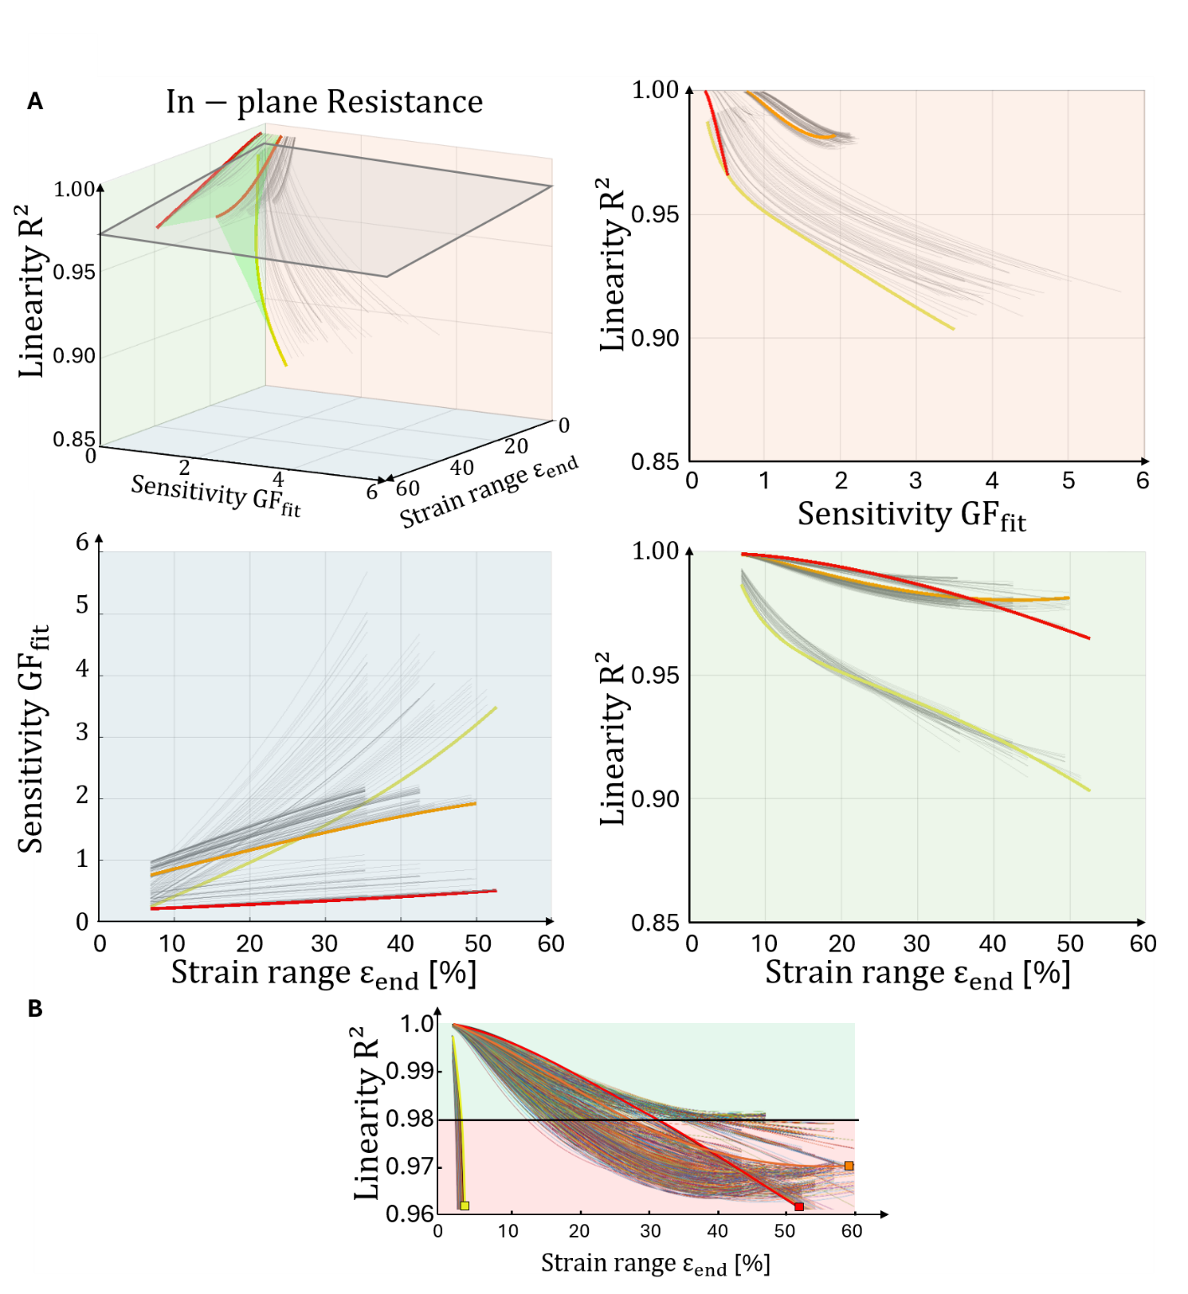
Figure S12 In-plane resistance sensing, with performance metrics extracted from the predicted $R(ε)$.
(A) Each sensor produces a 3D trajectory in $\left(ε_{\text{end}}, {GF}_{\text{fit}}, R^{2}\right)$ space, enabling multi-objective optimization of the 3 interdependent metrics. To visualize their position in 3D, projections onto the three principal planes (blue, red, green) are added. These also demonstrate how the meta gauges escape the envelope of their constituent materials (green planes connecting constituent material trajectories), most notably in the $ε_{\text{end}}-{GF}_{\text{fit}}$ (blue) plane. (B) Linearity-based selection for the data reported in Figure 3. Each sensor’s trajectory in $\left(ε_{\text{end}}, {GF}_{\text{fit}}, R^{2}\right)$ space is visualized in 3D, along with projections onto the three principal planes (blue, red, green).

 |  |  | Branch  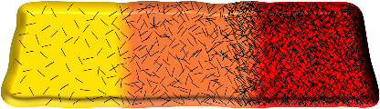 | Network  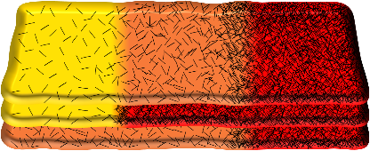
Mechanical | 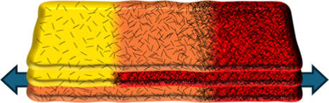 | In-Plane  Tensile Strain | Parallel (Iso-Stress, Reuss)  $$E_{branch}^{-1}=∑E_{cell}^{-1}$$ | Series (Iso-Strain, Voight)  $$E_{netw}=∑E_{branch}/k$$
Mechanical | 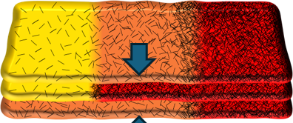 | Through-Plane  Compr. stress | Series (Iso-Strain, Voight)  $$E_{branch}=∑E_{cell}/k$$ | Parallel (Iso-Stress, Reuss)  $$E_{netw}^{-1}=∑E_{branch}^{-1}$$
Functional |  | In-plane  Resistance | Series  $$R_{branch}=∑R_{cell}$$ | Parallel  $$R_{netw}^{-1}=∑R_{branch}^{-1}$$
Functional |  | In-plane  Capacitance | Parallel  $$C_{branch}^{-1}=∑C_{cell}^{-1}$$ | Series  $$C_{netw}=∑C_{branch}$$
Functional |  | Through-plane  Resistance | Parallel  $$R_{branch}^{-1}=∑R_{cell}^{-1}$$ | Series  $$R_{netw}=∑R_{branch}$$
Functional |  | Through-plane  Capacitance | Series  $$C_{branch}=∑C_{cell}$$ | Parallel  $$C_{netw}^{-1}=∑C_{branch}^{-1}$$

Alternative sensing modes of metamaterials
Table S2. Overview of metamaterial architectures for sensing modes and corresponding physical laws.
These systems combine mechanical (in-plane strain or through-plane compression) and functional loading (in-plane or through-plane, resistance $R$ or capacitance $C$). k is the number of branches. For piezoelectric materials, in-plane voltage would show behavior similar to in-plane $R$ (branch series and network parallel). Non-traditional behavior can be attained with these architectures.
The sensitivity or gauge factor is now in fact a transverse gauge factor, where the electrical response is measured in one direction while the mechanical strain is applied in another.
Similar to in-plane resistance sensing, the metamaterials exhibit unconventional behavior in through-plane sensing for both resistance (Figure S13) and capacitance (Figure S14). This is evident as the metamaterial designs (grey lines) fall outside the envelope between the three starting materials, represented as green planes in the 3D visualization.
However, unlike in-plane resistance sensing - where metamaterials displayed higher sensitivity and/or linearity (blue and red projections in Figure S12) - through-plane sensing shows a consistent trade-off: higher linearity comes at the expense of lower sensitivity (red projections in Figure S13 and Figure S14) This trade-off arises from the fundamental physical laws: Through-plane sensing is dominated by the cell with the lowest resistance $R_{branch}^{-1}=\sum{R_{cell}^{-1}}$ and highest capacitance ($C_{branch}=\sum{C_{cell}}$), which corresponds to the C material. In contrast to in-plane resistance, where the electrically dominant A material (the softest) experiences strain amplification to boost sensitivity, the electrically dominant C material (the stiffest) in through-plane sensing undergoes strain reduction, reducing sensitivity.
Through-plane sensing demonstrates superior linearity (R² > 0.98 for most designs) when compared to in-plane sensing (R² > 0.96 for most designs, though some highly sensitive A material-based designs dip to R² > 0.9). Although all sensors maintain extreme linearity (R² > 0.98) across a broad strain range, through-plane sensing exhibits markedly lower sensitivity. Its maximum GF reaches around 1.2 for capacitance and -0.5 for resistance at the maximum strain range $ε_{\text{end}}$, compared to the GF of 3-5 achieved by in-plane resistance sensing. Importantly, the objective is not universally to maximize sensitivity; different applications may instead prioritize response stability, extreme linearity, or reduced electromechanical coupling. For example, the through-plane capacitance sensing mode has a range of metamaterials that have lower sensitivity and higher linearity than the constituent materials, making them more suitable for strain-invariant stretchable electronics such as amplifiers and transistors.

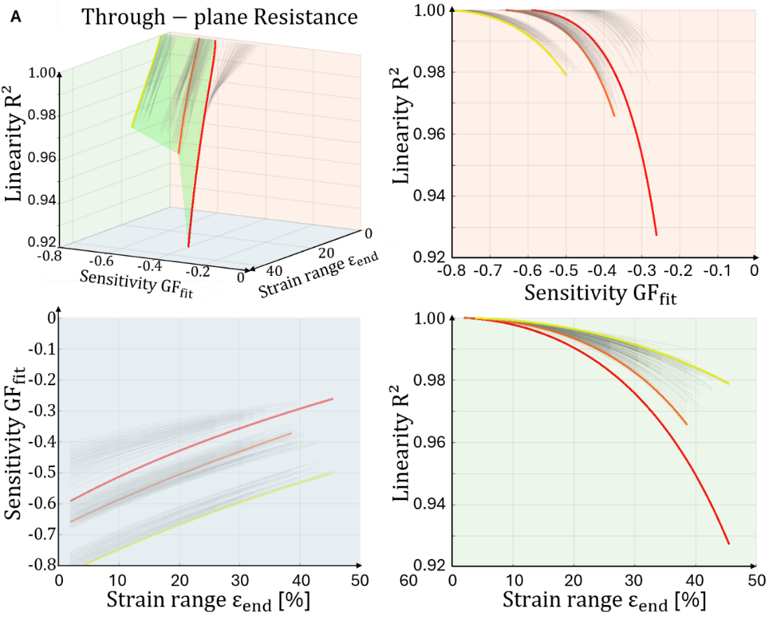
Figure S13 Through-plane resistance sensing. Each sensor’s trajectory in $\left(ε_{\text{end}}, {GF}_{\text{fit}}, R^{2}\right)$ space is visualized in 3D, along with projections onto the three principal planes (blue, red, green).
The sensitivity or gauge factor is now in fact, a transverse gauge factor, where the electrical response is measured in one direction while the mechanical strain is applied in another.
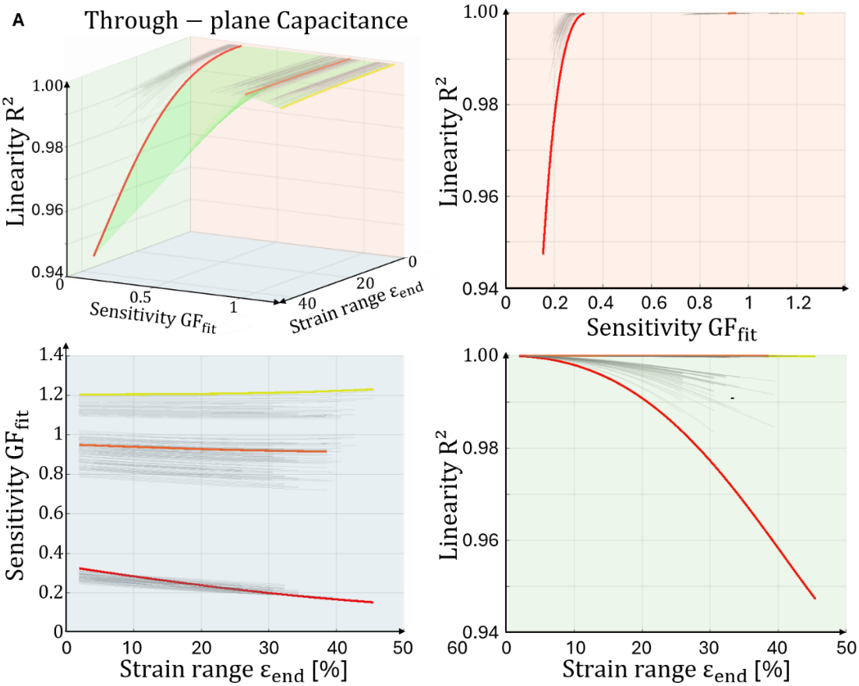
Figure S14 Through-plane capacitive sensing. Each sensor’s trajectory in $\left(ε_{\text{end}}, {GF}_{\text{fit}}, R^{2}\right)$ space is visualized in 3D, along with projections onto the three principal planes (blue, red, green).
The sensitivity or gauge factor is now, in fact, a transverse gauge factor, where the electrical response is measured in one direction while the mechanical strain is applied in another.

Application: Strain Tracking and Regression
Video SI2 illustrates how sensor strain was extracted by tracking the relative motion of the two clamp fixtures during breathing. For each video frame, the distance between the clamps was determined using a two-stage tracking procedure, applied to the stripe pattern on each clamp. First, a course update on the pattern positions by applying 2D normalized cross-correlation, with the stripe pattern as template. Second, the pattern position and orientation are refined using the known geometric ratios of black-white stripes (Thales theorem). From the exact pattern positions, the clamp-to-clamp distance (in pixel units) is computed. A conversion factor (mm/px) is computed using the real dimensions of the printed pattern, to obtain the real clamp‑to‑clamp distance [mm].. Engineering strain is computed as $ε_{i}=\frac{L_{i}-L_{0}}{L_{0}},$ where $L_{0}$ is the minimum observed length (where the strap and sensor are not slack).
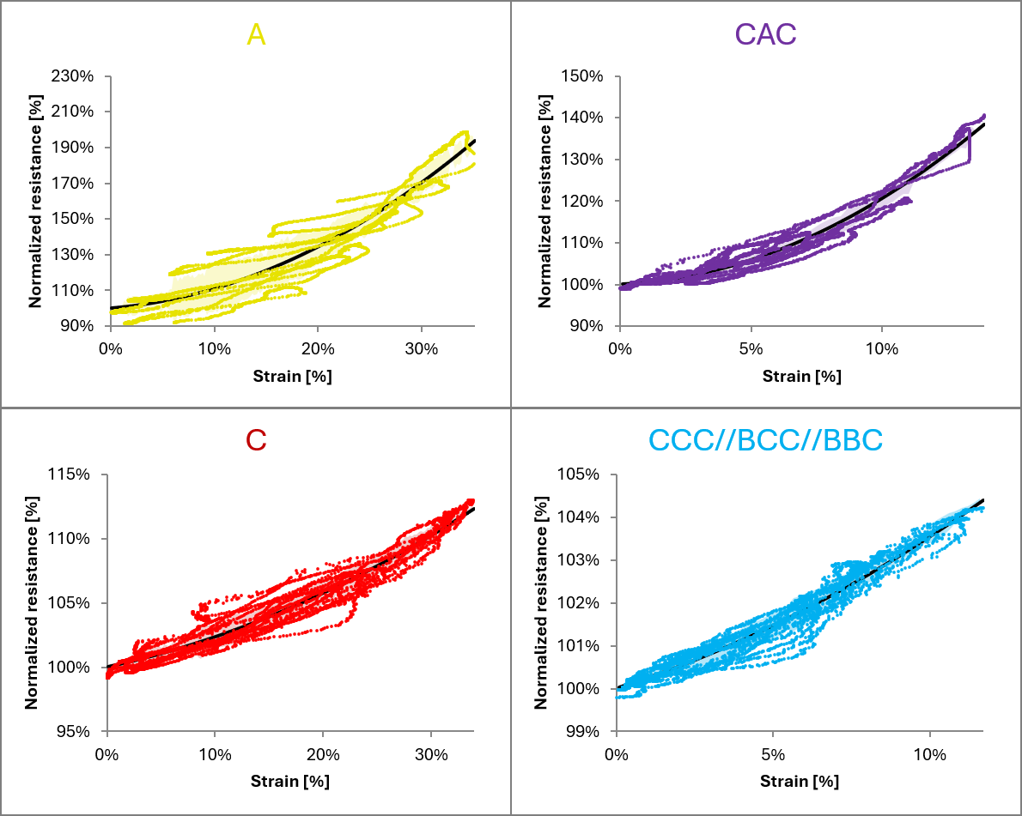
Figure S15 Regression of normalized resistance vs strain, for the four measured sensors.
The regression curves and 95% prediction intervals presented in Figure 4C were calculated from the raw dataset of (strain, resistance) Vs. time, shown in Figure 4B.
The 2nd order polynomials were only used to illustrate concisely the general behavior, i.e. the sensitivity (average slope) and linearity (curvature) of the sensors. The intercept (b₀) was set to 1 to impose that R=R₀ for the unstrained sensors.

References – supporting information
1. Du, J. et al. Optimized CNT-PDMS Flexible Composite for Attachable Health-Care Device. Sensors 20, 4523 (2020).
2. Cui, X. et al. Sensing performance and mechanism of flexible sensing-enabled CB-CNT/PDMS geosynthetics for soil deformation monitoring. Geotext. Geomembr. 54, 348–361 (2026).
3. Liu, L. et al. Highly stretchable, sensitive and wide linear responsive fabric-based strain sensors with a self-segregated carbon nanotube (CNT)/Polydimethylsiloxane (PDMS) coating. Prog. Nat. Sci.: Mater. Int. 32, 34–42 (2022).
4. Amjadi, M. & Park, I. Carbon nanotubes–Ecoflex nanocomposite for strain sensing with ultra-high stretchability. In 2015 28th IEEE International Conference on Micro Electro Mechanical Systems (MEMS) 744–747 (IEEE, 2015).
5. Ryu, S. et al. Extremely Elastic Wearable Carbon Nanotube Fiber Strain Sensor for Monitoring of Human Motion. ACS Nano 9, 5929–5936 (2015).
6. Zhang, Q. et al. Highly Sensitive and Stretchable Strain Sensor Based on Ag@CNTs. Nanomaterials 7, 424 (2017).
7. Nankali, M. et al. Highly stretchable and sensitive strain sensors based on carbon nanotube–elastomer nanocomposites: the effect of environmental factors on strain sensing performance. J. Mater. Chem. C 8, 6185–6195 (2020).
8. Wang, Y. et al. Fabrication of high-performance wearable strain sensors by using CNTs-coated electrospun polyurethane nanofibers. J. Mater. Sci. 55, 12592–12606 (2020).
9. Huang, A. et al. Durable washable wearable antibacterial thermoplastic polyurethane/carbon nanotube@silver nanoparticles electrospun membrane strain sensors by multi-conductive network. Adv. Compos. Hybrid Mater. 6, 101 (2023).
10. Dou, L. et al. Weft-Knitted Spacer Fabric for Highly Stretchable–Compressible Strain Sensor, Supercapacitor, and Joule Heater. Nanomaterials 12, 3684 (2022).
11. Wang, Y. et al. Fabrication of ultra-high working range strain sensor using carboxyl CNTs coated electrospun TPU assisted with dopamine. Appl. Surf. Sci. 566, 150705 (2021).
12. Wang, X., Qu, M., Wu, K., Schubert, D. W. & Liu, X. High sensitive electrospun thermoplastic polyurethane/carbon nanotubes strain sensor fitting by a novel optimization empirical model. Adv. Compos. Hybrid Mater. 6, 63 (2023).
13. Zhou, B. et al. A Highly Sensitive and Flexible Strain Sensor Based on Dopamine-Modified Electrospun Styrene-Ethylene-Butylene-Styrene Block Copolymer Yarns and Multi Walled Carbon Nanotubes. Polymers 14, 3030 (2022).
14. Nemala, S. S. et al. Electrically Conductive Nanocarbon/Elastomer Composite Inks for Flexible and Wearable Strain Sensing. Small 21, e06844 (2025).
15. Jia, B. et al. Flexible strain sensors based on carbon nanotubes/polydimethylsiloxane composites with a segregated structure prepared by sustainable emulsion method. Polym. Eng. Sci. 65, 1093–1105 (2025).
16. Mai, H., Mutlu, R., Tawk, C., Alici, G. & Sencadas, V. Ultra-stretchable MWCNT–Ecoflex piezoresistive sensors for human motion detection applications. Compos. Sci. Technol. 173, 118–124 (2019).
17. Li, Y. et al. Continuously prepared highly conductive and stretchable SWNT/MWNT synergistically composited electrospun thermoplastic polyurethane yarns for wearable sensing. J. Mater. Chem. C 6, 2258–2269 (2018).
18. Amjadi, M., Yoon, Y. J. & Park, I. Ultra-stretchable and skin-mountable strain sensors using carbon nanotubes–Ecoflex nanocomposites. Nanotechnology 26, 375501 (2015).
19. Wang, G. et al. Thermoplastic Polyurethane/Carbon Nanotube Composites for Stretchable Flexible Pressure Sensors. ACS Appl. Nano Mater. 6, 9865–9873 (2023).
20. Xu, Y. et al. Encapsulated core–sheath carbon nanotube–graphene/polyurethane composite fiber for highly stable, stretchable, and sensitive strain sensor. J. Mater. Sci. 56, 2296–2310 (2021).
21. Guo, H. et al. Nacre-mimetic electronic skin based on multilayered Ti3C2Tx/carbon nanotubes/thermoplastic polyurethane fibrous mat with self-powered ability for postural correction training. Sci. China Mater. 68, 4253–4262 (2025).
22. Chen, R. et al. Waterborne polyurethane toughened carbon nanotube paper with excellent Joule heating properties and strain-sensing potential. Carbon Lett. 35, 2423–2434 (2025).
23. Yin, F., Ye, D., Zhu, C., Qiu, L. & Huang, Y. Stretchable, Highly Durable Ternary Nanocomposite Strain Sensor for Structural Health Monitoring of Flexible Aircraft. Sensors 17, 2677 (2017).
24. Hou, Y., Zhang, H. & Zhou, K. Ultraflexible Sensor Development via 4D Printing: Enhanced Sensitivity to Strain, Temperature, and Magnetic Fields. Adv. Sci. 12, 2411584 (2025).
25. Zhou, J., Xu, X. & Lubineau, G. Devices and methods relating to fragmented carbon nanotube sensors. US patent 11,073,385 (2021).

