Supplementary Materials
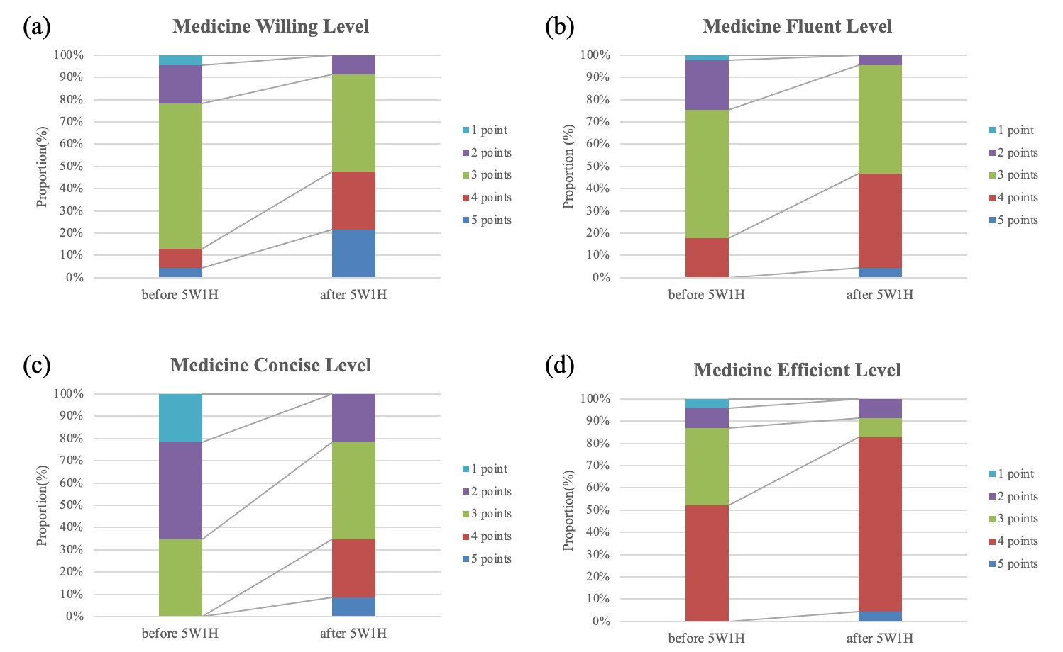
Supplementary Figure S1. Score distribution comparisons before and after the 5W1H intervention in Group 2 (students who had completed Internal Medicine clerkship). The four evaluated domains are: (a) Willingness, (b) Fluency, (c) Conciseness, and (d) Efficiency. For each domain, stacked bar charts show the percentage of students at each Likert score (1–5 points), where a rightward shift in the distribution indicates overall improvement. The sample size for this subgroup is n=23.
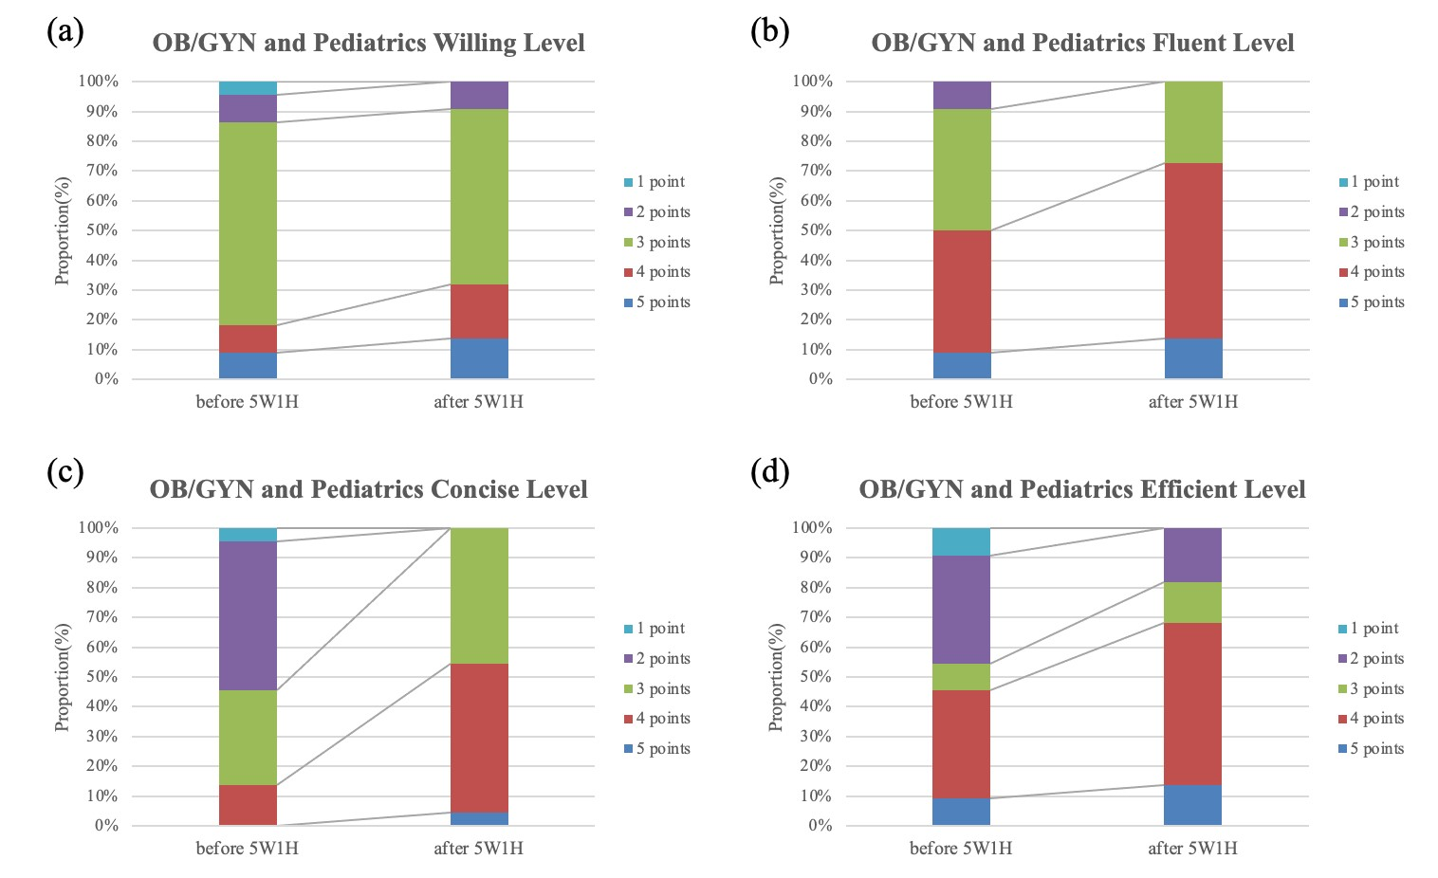
Supplementary Figure S2. Score distribution comparisons before and after the 5W1H intervention in Group 3 (students who had completed OB/GYN and Pediatrics clerkships). The four evaluated domains are: (a) Willingness, (b) Fluency, (c)
Conciseness, and (d) Efficiency. For each domain, stacked bar charts show the percentage of students at each Likert score (1–5 points), where a rightward shift in the distribution indicates overall improvement. The sample size for this subgroup is n=22.

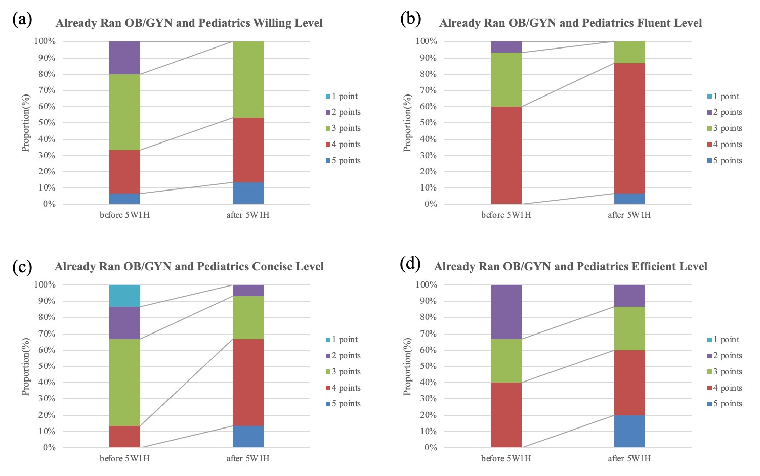

Supplementary Figure S3. Score distribution comparisons before and after the 5W1H intervention in Group 4 (students who had completed Internal Medicine, OB/GYN and Pediatrics clerkships). The four evaluated domains are: (a) Willingness, (b) Fluency, (c) Conciseness, and (d) Efficiency. For each domain, stacked bar charts show the percentage of students at each Likert score (1–5 points), where a rightward shift in the distribution indicates overall improvement. The sample size for this subgroup is n=15.

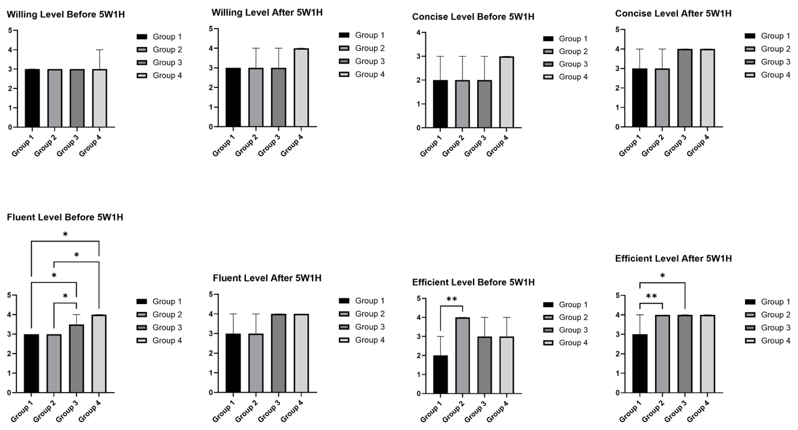
Supplementary Figure S4. Intergroup Comparison of Willingness, Fluency,
Conciseness, and Efficiency Scores Before and After the 5W1H Intervention Across
Groups 1–4. Data presented as median (IQR). Group 1 (n=43) represents novice students; Group 2 (n=23), Group 3 (n=22), and Group 4 (n=15) represent experienced students with varying prior clinical clerkships. Between-group differences were evaluated using the Kruskal-Wallis test with Dunn’s multiple comparisons. *p < 0.05; **p < 0.01.


Group B
%
41.75
IM completed
n = 23
OB/GYN and
Pediatrics
completed
n = 22
IM, OB/GYN and
Pediatrics completed
n = 15
Group A
58.25
%
Participant Characteristics
Group B
Group A
IM completed
OB/GYN and Pediatrics completed
IM, OB/GYN and Pediatrics completed

Supplementary Figure S5. Baseline characteristics and cohort classification of the medical students. The pie chart displays the proportion of students in the novice cohort (Group B) and the experienced cohort (Group A). The adjacent stacked bar chart further breaks down the experienced cohort (Group A) based on their specific prior clinical clerkship experiences.

Domain | Covariate (Pre-test) | F (1,100) | p-value
Willingness | Pre-Willingness | 1.94 | 0.166
Fluency | Pre-Fluency | 0.274 | 0.602
Conciseness | Pre-Conciseness | 1.65 | 0.202
Efficiency | Pre-Efficiency | 5.26 | 0.024

Supplementary Table S1. ANCOVA results comparing post-intervention score between Group A and Group B, controlling for baseline scores.

Domain | Group 2 (n=23) Pre- /Post-(IQR) | p-value | Group 3 (n=22) Pre- /Post-(IQR) | p-value | Group 4 (n=15) Pre- /Post-(IQR) | p-value
Willingness | 3(3-3) / 3(3-4) | 0.001 | 4(3-4) / 4(4-4) | 0.109 | 3(3-4) / 4(3-4) | 0.0312
Fluency | 3(3-3) / 3(3-4) | 0.0032 | 4(3-4) / 4(3-4) | 0.0078 | 4(3-4) / 4(4-4) | 0.0312
Conciseness | 2(2-3) / 3(3-4) | <0.0001 | 2(2-3) / 4(3-4) | <0.0001 | 3(2-3) / 4(3-4) | 0.0001
Efficiency | 4(3-4) / 4(4-4) | 0.0469 | 3(2-4) / 4(3-4) | 0.002 | 3(2-4) / 4(3-4) | 0.0078

Supplementary Results

The score distributions before and after the 5W1H intervention for each experienced subgroup are presented in Figures S1-S3 (Group 2, Group 3, and Group 4, respectively). Kruskal-Wallis tests were performed to compare the scores of Groups 1–4 at baseline, post-intervention, and for score changes (Figure S4). Initially, the groups showed significant differences in Fluency (p = 0.0013) and Efficiency (p = 0.0079). Dunn's multiple comparison test indicated that Groups 3 and 4 had notably higher baseline Fluency than Groups 1 and 2, while Group 2 also scored significantly higher in Efficiency than Group 1. These differences are consistent with the expected influence of more extensive prior clerkship experience. There were no significant baseline differences across groups for Willingness and Conciseness.

Following the intervention, significant intergroup differences persisted in Efficiency (p = 0.0012), with Group 1 remaining lower than Groups 2 and 3. No significant differences were found for Willingness, Fluency, or Conciseness post-intervention.

Score change did not differ significantly between groups in any domain (all p > 0.10), indicating that the degree of improvement following the 5W1H intervention was similar across all four groups regardless of prior clerkship experience.

