ADDITIONAL MATERIAL
Method 1. Wearable flexible strain sensors. 2
Table 1. Sensor performance. 7
Figure 1. Flowchart of data acquisition, data processing and data transmission. 8
Figure 2. Resistance Monitor. 9

Method 1. Wearable flexible strain sensors.
- Preparation method and performance calculations for wearable flexible strain sensors
The wearable flexible strain sensor used in this study consisted of short multi-walled carbon nanotubes (SMWCNTs), an Ecoflex 00-30 silicone substrate, and liquid-metal flexible electrodes, assembled in a sandwich-like structure. Ecoflex 00-30 was first cured to form the flexible substrate; the SMWCNT conductive material was then printed onto the cured Ecoflex surface to form a continuous strain-sensitive conductive network that could reconfigure under deformation. Liquid-metal electrodes were connected to both ends of the conductive layer to acquire resistance signals, and the device was finally encapsulated with an upper Ecoflex layer. The sensing mechanism can be understood as the mechanical transfer of substrate deformation to the surface conductive network. When the sensor is stretched, bent, or compressed, the tube-to-tube contact points, overlapping pathways, and tunneling distances within the printed SMWCNT network change reversibly; the opening and closing of local microcracks also modulate electron transport channels, thereby inducing macroscopic resistance changes. The output therefore reflects the combined effects of conductive-path rearrangement, contact-resistance variation, and tunneling-resistance variation.
The main performance metrics of the wearable flexible strain sensor were sensitivity (gauge factor, GF), linearity (R²), and hysteresis (δ_{H}), calculated as follows:
$$\text{GF=}\frac{\text{∆R/}{\text{R}}_{\text{0}}}{\text{ε}}$$
- where ${\text{R}}_{\text{0}}$ denotes the initial resistance of the sensor under no load, $\text{∆R}$ denotes the resistance change before and after deformation, and $\text{ε}$ denotes the applied external strain ($\text{ε }$= 50%).
$${\text{R}}^{\text{2}}\text{=1-}\frac{\sum{{\text{(}{\text{R}}_{\text{i}}\text{-}{\text{R}}_{\text{i}}^{\text{'}}\text{)}}^{\text{2}}}}{\sum{{\text{(}{\text{R}}_{\text{i}}\text{-}\overline{\text{R}}\text{)}}^{\text{2}}}}$$
- where ${\text{R}}_{\text{i}}$ denotes the experimentally measured value, ${\text{R}}_{\text{i}}^{\text{'}}$ denotes the value calculated from the fitted curve, and $\overline{\text{R}}$ denotes the arithmetic mean of the measured values.
$${\text{δ}}_{\text{H}}\text{=}\frac{\text{∆}{\text{H}}_{\text{Max}}}{{\text{Y}}_{\text{FS}}}$$
- where $\text{∆}{\text{H}}_{\text{Max}}$ denotes the maximum difference in the relative resistance-change rate between the forward stroke (loading) and reverse stroke (unloading) under the same strain condition, and ${\text{Y}}_{\text{FS}}$ denotes the full-scale output range of the relative resistance-change rate.
- Trimmed-mean sampling strategy for noise reduction
To suppress the influence of random noise on the acquired results, multiple consecutive samples were collected for each single-channel measurement. The sampled values were sorted in ascending order using an insertion-sort algorithm. After removing a predefined number of extreme samples from both ends of the sorted sequence, the arithmetic mean of the remaining samples was taken as the final ADC sampling value for that channel. Let N denote the total number of samples in a single measurement, M denote the number of extreme samples removed from each end, and Si (i = 0, 1, ..., N - 1) denote the sorted sampling sequence. The final effective sampling value, val, was calculated as follows:
$$\text{val=}\frac{\text{1}}{\text{N-2M}}\sum_{\text{i=M}}^{\text{N-M-1}}{{\text{S}}_{\text{i}}}$$
- Voltage-divider resistance conversion and operating-condition determination method
Resistance was calculated based on the voltage-divider principle, in which a fixed reference resistor and the resistor under test were connected in series. The resistance of the reference resistor was denoted as ${\text{R}}_{\text{ref}}$, and the system supply voltage was denoted as ${\text{V}}_{\text{DD}}$. According to the voltage-divider circuit, the resistance ${\text{R}}_{\text{x}}$ of the resistor under test was calculated as follows:
$${\text{R}}_{\text{x}}\text{=}\frac{{\text{v}}_{\text{ADC}}\text{∙}{\text{R}}_{\text{ref}}}{{\text{V}}_{\text{DD}}\text{-}{\text{V}}_{\text{ADC}}}$$
- where the input voltage ${\text{v}}_{\text{ADC}}$ corresponding to the ADC sample was obtained from the sampling code value val, the ADC full-scale code ${\text{ADC}}_{\text{Max}}$, and the supply voltage ${\text{v}}_{\text{DD}}$ as follows:
$${\text{v}}_{\text{ADC}}\text{=}\frac{\text{val∙}{\text{v}}_{\text{DD}}}{{\text{ADC}}_{\text{Max}}}$$
To identify extreme operating conditions of the channel, upper and lower thresholds were set for the sampling code value. When the sampled value was below the lower threshold, the channel was determined to be short-circuited and the output resistance was set to 0. When the sampled value was above the upper threshold, the channel was determined to be open-circuited and the output flag value was set to -1.
- Data transmission method
The system utilized a Bluetooth Low Energy (BLE) link for wireless communication and data transmission. Acquisition and transmission were controlled through character commands ('1' and '0') received via the Nordic UART Service (NUS), while a global millisecond-level timer maintained the sampling interval. The BLE module adopted fast advertising in limited discoverable mode with optimized connection parameters for stable wireless communication. During operation, the acquired resistance signals were periodically packaged into BLE data frames and transmitted to the host computer. To improve transmission reliability, a compact packet format and retransmission mechanism were implemented, while timing information was appended to each acquisition cycle for synchronization.

Table 1. Sensor performance.
Number | Sensitivity | Linearity | Hysteretic (%)
1 | 12.9495 | 0.9945 | 10.8400
2 | 8.8187 | 0.9994 | 13.1700
3 | 8.0964 | 0.9969 | 11.9200
4 | 7.7059 | 0.9973 | 13.0200
5 | 11.3859 | 0.9967 | 13.0800
6 | 9.5850 | 0.9988 | 12.4600
7 | 8.3227 | 0.9982 | 13.3700
Mean | 9.5520 | 0.9974 | 12.5514
Std | 1.9358 | 0.0016 | 0.9026

Figure 1. Flowchart of data acquisition, data processing and data transmission.
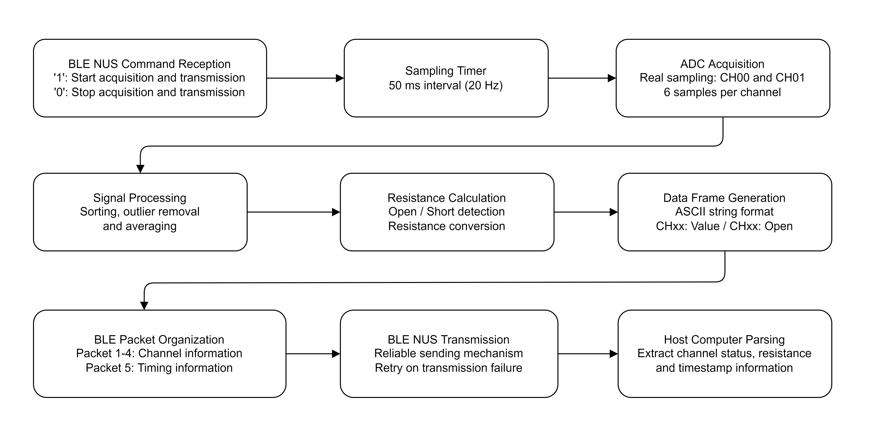

Figure 2. Resistance Monitor.
